- Mark the difference of “” (double quotes) and ‘’ (single quotes)
  - 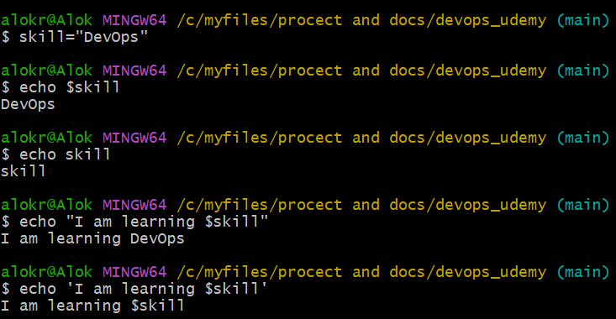
  - $<variable_name> is executed inside “” not inside ‘’.
- YAML
  - 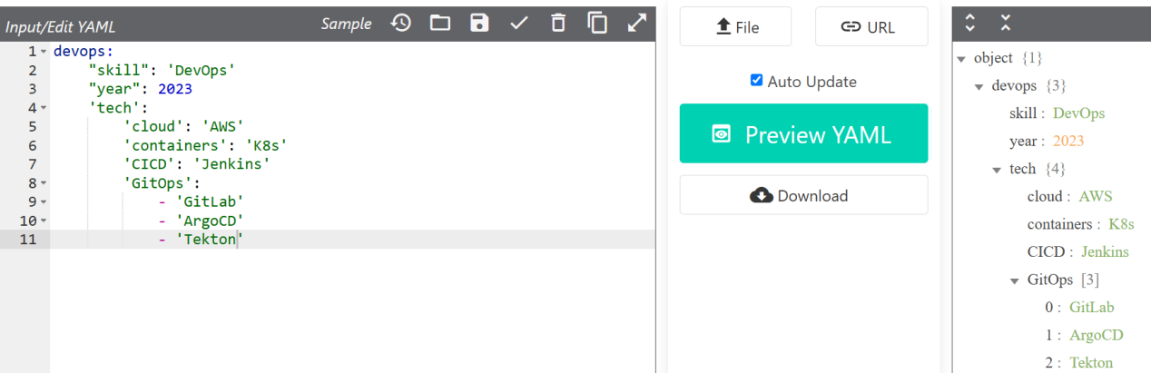
  - Don’t give any brackets.
  - There should be one space after : (colon)
  - Properly indent.
  - Single quote or Double quote or No quote.. both are acceptable.
  - 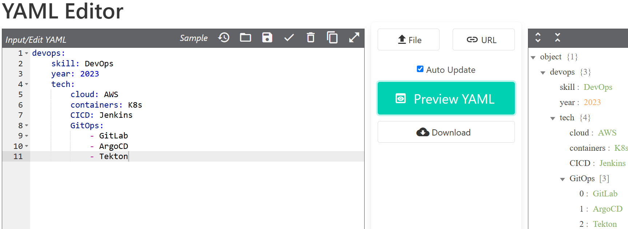
  - Comma is not acceptable.
  - For list, - and a space should be given.
  - 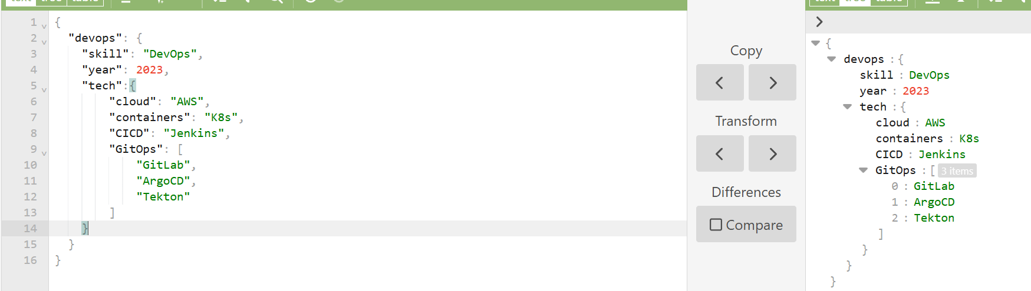
    - This is same as above, just the difference is.. this is JSON and above is YAML

