GITHUB CLI COMMANDS
- Simple commands for creating/modifying any file/files and push that to remote repository.
  - git init
    - When you create a folder in your local machine, it is not a local git repository by default.
    - Use this command to make that directory a local git repository.
    - You must see a folder .git.
    - This folder keep the track of all things that is happening or was happened inside your repository.
    - Executing the git init command does nothing but create a .git folder in your directory.
    - Without that .git folder, you can’t execute any git command like git add or git commit or anything.
    - 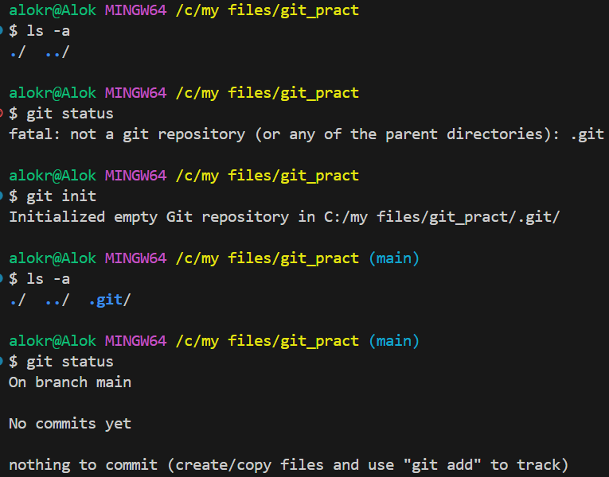
      - You can see here, before git init, there was no .git folder, that’s why I was unable to execute any git command.
      - After executing git init, one folder .git got created and then git got to know that this folder is a git repository.
  - git add
    - This command make the untracked changes (like adding any new file, or modifying any file, or deleting any file inside the working directory) as tracked.
    - 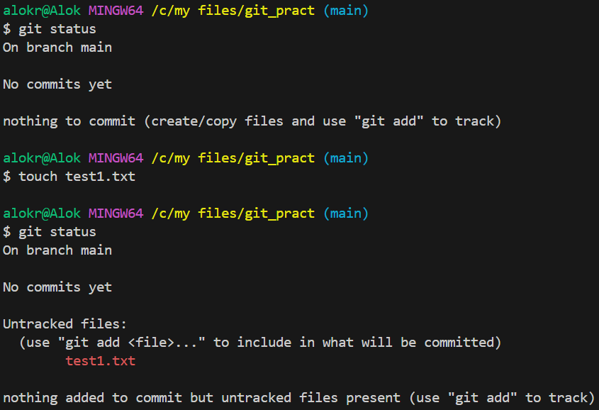
    - You can see, I created one file, so now it’s showing as an untracked file as git doesn’t know this file.
    - 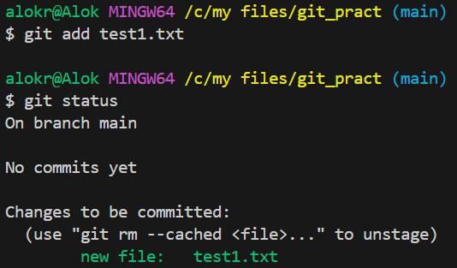
    - Now, I added this file using git add command, and now git was able to track this file. So, its telling to commit this file so that it’ll be updated in the local repo.
  - git commit
    - This command will update the tracked changes (changes that was added using git add command) to your local repository (means inside .git folder) against a comment that you give while executing git commit command.
    - 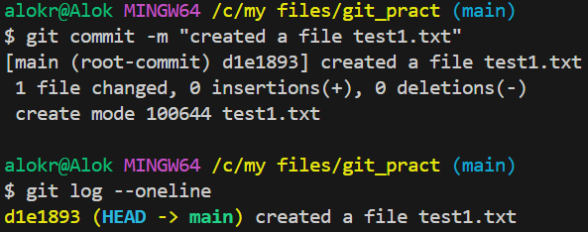
    - I committed that change (means creation of file test1.txt) and when I executed the command git log, it displayed my commit and what was done in that commit.
      - That’s why giving a proper message while executing git commit is a good practice to know why that commit was made for.
  - I created one git repository in the github (remotely) and I want to connect my this local repo to that remote repo. (it has to be done once only)
    - git remote add origin <url of the remote repo>
  - After connecting with the remote repo, you can push the changes into the remote repository.
    - Till git commit, all the changes were happening locally.
    - When you execute git push, it’ll update the remote repository.
    - 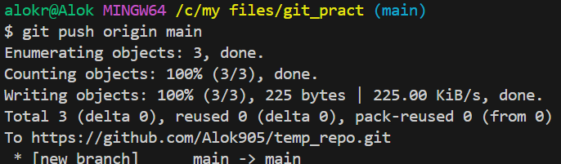
    - 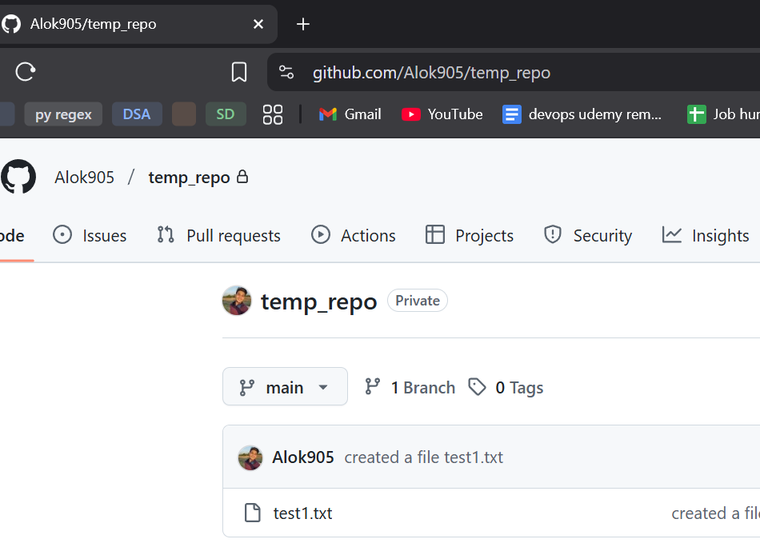
- Stages:
  - Working directory:
    - It is your local project where you add/edit/delete files.
    - Changes that are not tracked after the previous commit.
    - Mostly you’ll see modified and untracked files.
    - git status
      - This command can be used to see the status of your current working directory.
    - 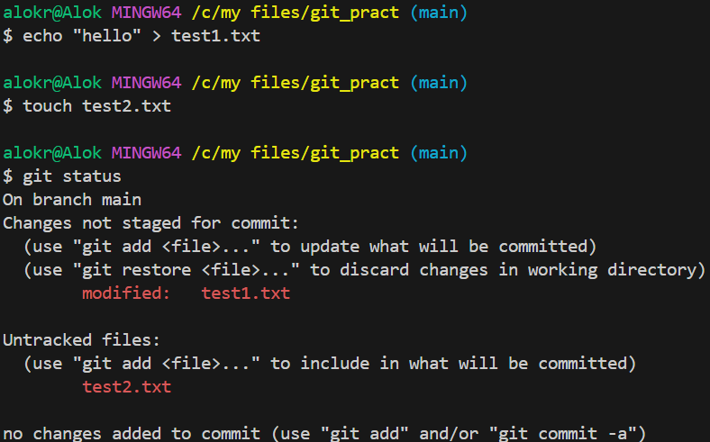
      - I added some texts inside the test1.txt (which is already tracked by git) and created a new file test2.txt.
      - As git knows test1.txt file, but it sees that something has been changed inside that file, so it marks it as modified.
      - Where as, git doesn’t know abou the file test2.txt as it is created now only, so it marks it as untracked.
  - Staging Area:
    - After executing git add command, the untracked/modified files go to staging area.
    - Its kind of a bucket where all the modifications are collected which will be submitted in the next commit.
    - Suppose you added/modified something in your working directory and added those to staging area. And again added/modified something in the working directory but didn’t stage those.
      - Now if you commit, then only the modifications those were staged will be committed. Not those which were modified but didn’t stage.
      - 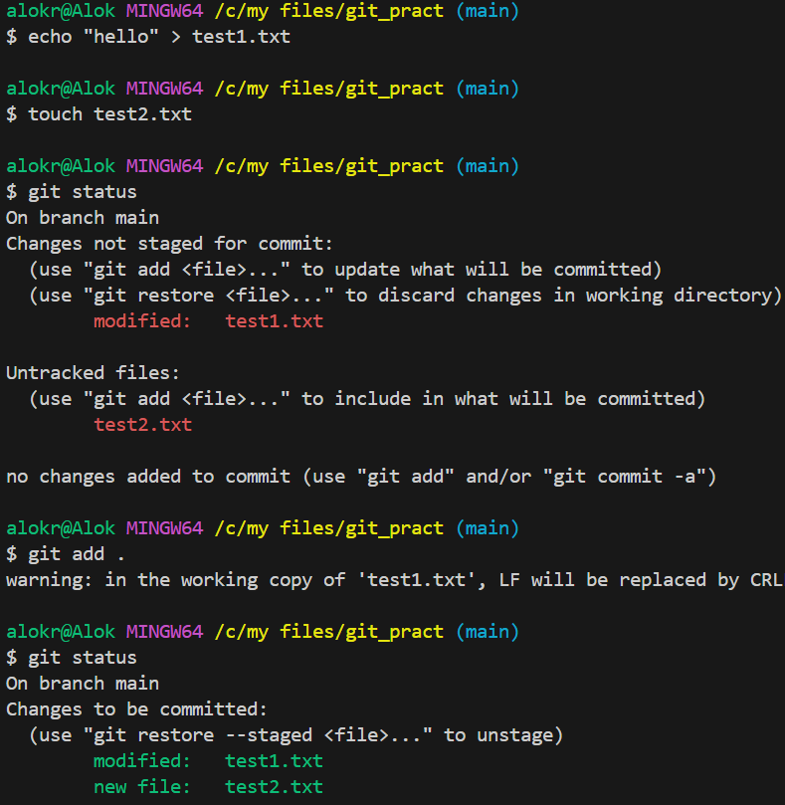
        - I added the files test1.txt and test2.txt into staging area using command git add .
          - . means you are staging all the changes that you made your working directory.
      - 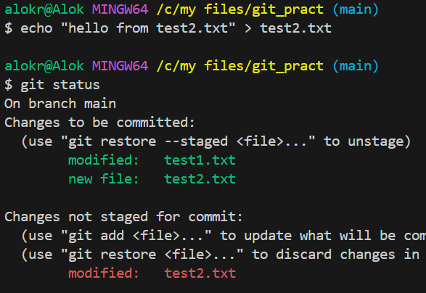
        - Now I added some text inside test2.txt and not staging it.
        - Green color texts shows what are inside the staging area, and red color shows the changes which are not staged yet.
      - 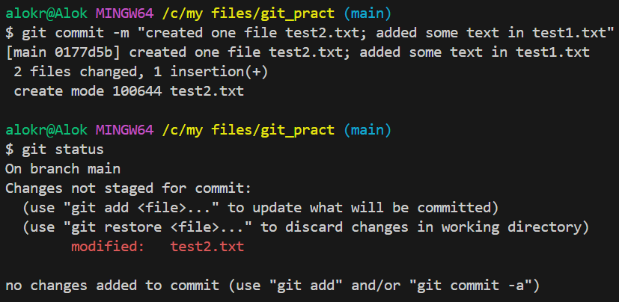
        - Now you can see, only the staged modification got committed, the changed which were not staged are still there.
  - Local Repository:
    - Whatever you commit, it stays in your local repository (you can think it is stored inside the .git folder)
    - But the remote repository is still not aware about this.
  - Remote Repository:
    - After the commit, when you push the changes, it goes to the remote repository.
    - After this, your local repository and remote repository will be in sync.
    - 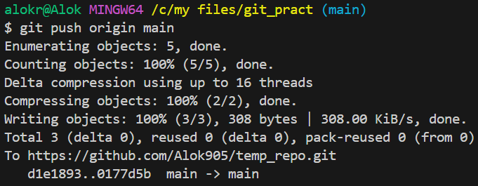
      - Now it is updated in the remote repository.

- If you have made some changes in a file, and want to revert it back as it is there in the last commit then use git restore command.
  - 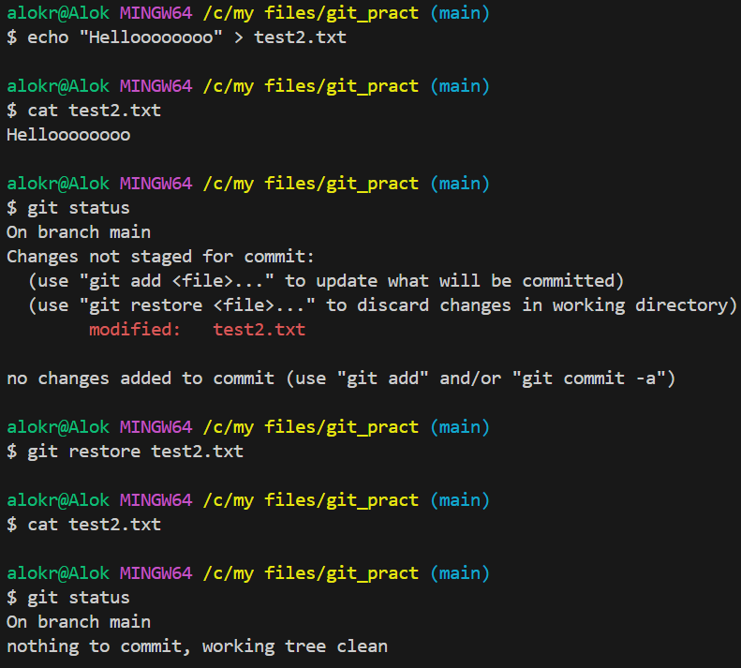
- If you have staged some modification and want to undo those; means you want to transfer the changes from staging area to the working directory then you can use the command git restore --staged <filename>
  - 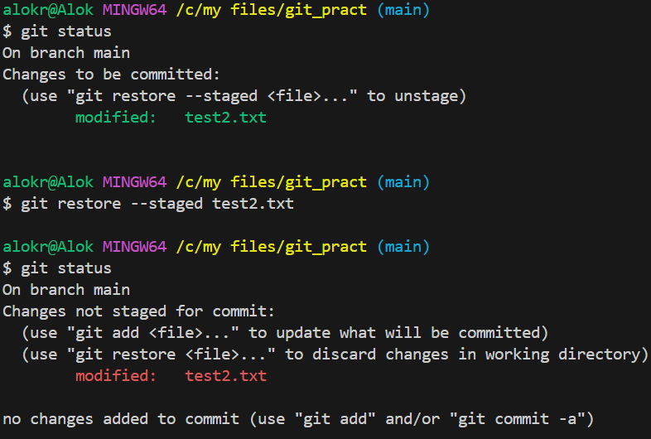
    - Here, the changes in the file was staged. Then I executed git restore --staged test2.txt command and now the staged changes became unstaged.
- If you have made a commit but the code but now want to revert back to the previous commit.
  - Let the commits are C1 -> C2 -> C3 -> C4 -> C5
    - Latest commit is C5
  - You want to go back to C3 (let)
  - The command for doing this is: git reset --hard <commit id>
  - 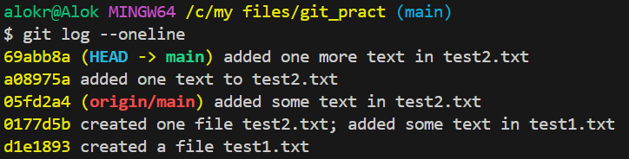
    - These are my current commits. I want to go back to 05fd2a4.
  - 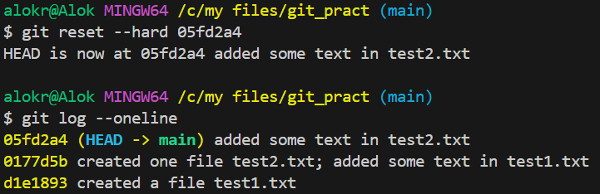
    - All the commits made after 05fd2a4 got deleted.
    - You can see one text “HEAD is now at 05fd2a4 …”
      - HEAD is nothing but just one pointer that points to the latest commit.

- One more scenario; let you have some commits C1 -> C2 -> C3 -> C4 -> C5; you want to undo the changes made in the commit C5 but don’t want to delete C5.
  - I just want to add one more commit which will contain the things undoing the changes done in C5.
  - Here, you can use git revert command.
  - 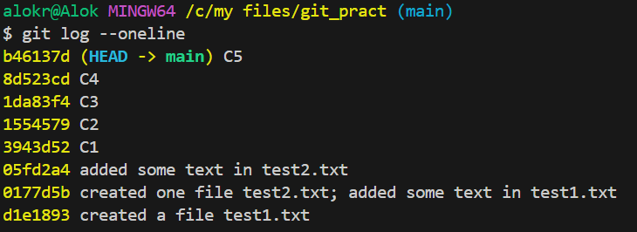
    - I made some changes in the file.
    - 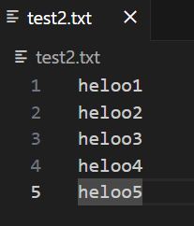
      - This is my file; Every line is a different commit. Means
        - added hello1 and committed. (C1)
        - Added hello2and committed. (C2) … and like this till C5
    - Now I want to undo the commit C5 (means I want to remove heloo5 from the file)
      - The command will be: git revert HEAD (OR) git revert b46137d
        - As HEAD is pointing to b46137d commit only (latest commit).
      - After executing this command, one editor will be opened.
        - 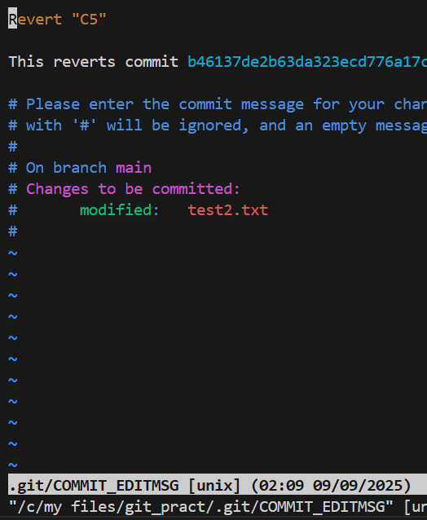
          - You can write the commit message inside this and save it.
      - 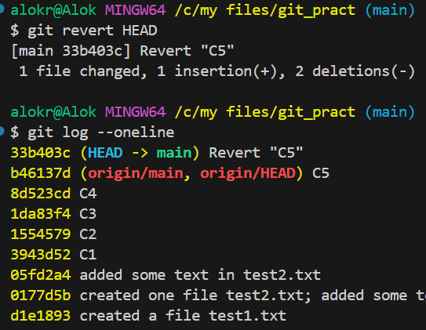
        - Now, one more commit got added undoing the changes of commit C5.
      - 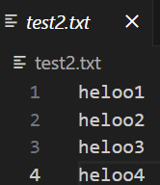(hello5 was added in C5, which is not there now)
    - It is helpful if you don’t want to delete the commit. Means later someone can see what had been done in that commit.
    - If you want to revert C3 here, it will give conflict; as after C3, you are changing the same file in commits C4, C5;
      - In simple term, C4 and C5 are built on top of C3 in this case.
      - So, it’ll give conflict.
      - 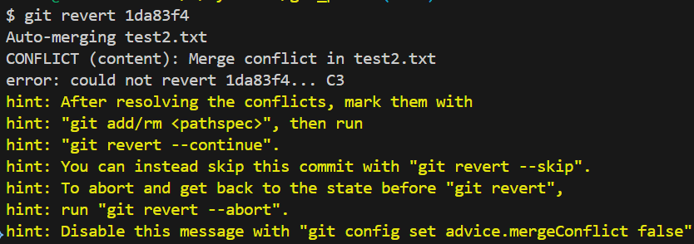
    - If the later commits (C4, C5 in this case) would not be changing the same file that C3 was doing, then reverting would be successful.
      - All the changes in the commits C1 to C5 were made in test2.txt.
      - Now, I am adding one commit in test1.txt
        - 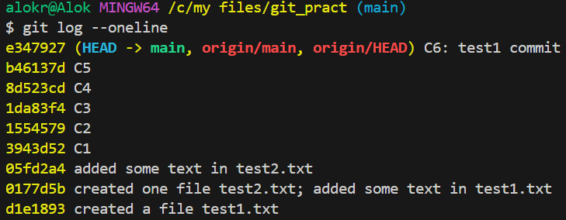
          - C6: did some changes in test2.txt file
        - Now, if I try to revert the commit C5, then it’ll work fine.
          - 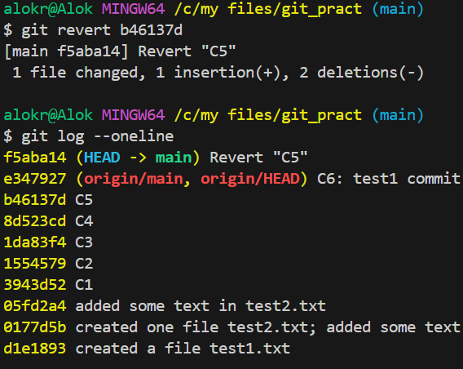
          - It worked because the commit C5 was not hindering the commit C6; because both were made in different files.

- git pull
  - If the remote repository has been updated with some extra commits by other collaborators i.e.
    - Local repo : C1 -> C2 -> C3 -> C4 -> C5
    - Remote repo : C1 -> C2 -> C3 -> C4 -> C5 -> C6 -> C7
    - In this case, you need to update your local repo with the remote repo and then do your required changes. Otherwise it’ll give conflicts while pushing to the remote repo.
    - Command: git pull origin <branch name>
      - If I want to update my main branch then: git pull origin main
  - Conflict scenario (assume every changes are being done in a single file):
    - Initial condition:
      - Local repo : C1 -> C2 -> C3 -> C4 -> C5
      - Remote repo : C1 -> C2 -> C3 -> C4 -> C5
    - I deleted a line in remote repo and committed; But in local repo added some extra texts in that same line and committed;
      - So now, both will conflict; as the same line has been changed in both local and remote repo.
      - For example:
        - (remote repo; deleted the line “hello3”)
        - 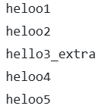(added some extra text on the same line “hello3_extra”)
      - Local repo : C1 -> C2 -> C3 -> C4 -> C5 -> Cx
        - 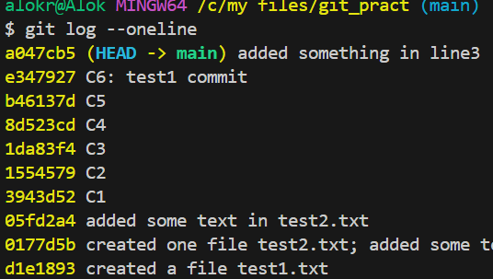
          - commits: …… e347927 -> a047cb5
      - Remote repo : C1 -> C2 -> C3 -> C4 -> C5 -> Cy
        - 
          - commits: …… e347927 -> 6c75a2f
      - Now, in local and remote repo, latest commits are different.
        - 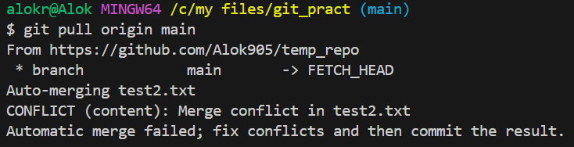
      - 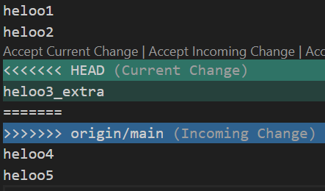
        - You’ll get something like this. Need to fix the merge conflict and then merge.
      - So, its better to pull the changes from the remote repo before working to avoid the merge conflicts.

Branches
- Some basic commands:
  - git branch <new branch name>
    - It’ll just create a branch but doesn’t switch to that new branch.
  - git switch <branch name>
    - It’ll switch to a pre-existing branch.
  - git checkout -b <new branch name>
    - It’ll create a branch and switch to that branch.
- 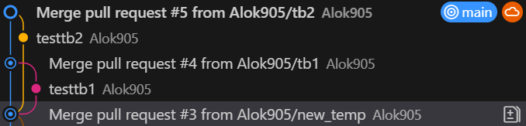
(Lets analyse these things …)
  - main branch has commits: C1 -> C2 -> C3 -> C4 -> C5
  - I created 2 branches at this point tb1, teb2 (you can see in the image)
    - In both the branches created one file i.e. in tb1 one file and in tb2 another file.
    - Staged those changes, committed and pushed.
    - Created 2 merge requests (one per each branch)
  - So now:
    - main : C1 -> C2 -> C3 -> C4 -> C5
    - tb2 : C1 -> C2 -> C3 -> C4 -> C5 -> Cx
    - tb3 : C1 -> C2 -> C3 -> C4 -> C5 -> Cy
  - I merged tb1 with the main branch (accepted the merge request).
    - You can see tb1 was merged to the main branch, so that one commit got created in main branch.
    - 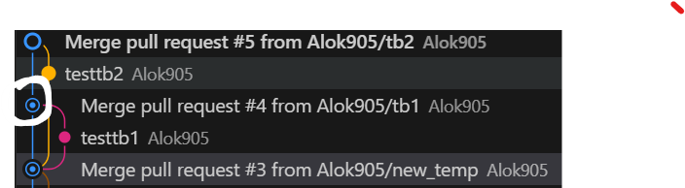
  - After that I merged tb2 to the main branch. So one more commit got created in the main branch.
    - 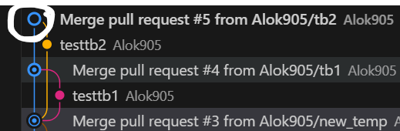
  - As these 2 branches (tb1 and tb2) were not interfering with each other or main branch’s changes; so they got merged easily without any conflict.
- One more case:
  - Initially:
    - main : C1 -> C2 -> C3 -> C4 -> C5
    - branch1 : C1 -> C2 -> C3 -> C4 -> C5
  - After this:
    - main : C1 -> C2 -> C3 -> C4 -> C5 -> Cx
    - branch1 : C1 -> C2 -> C3 -> C4 -> C5 -> Cy
    - Here, main branch created one file (let) and branch1 created one file (means no conflict)
    - 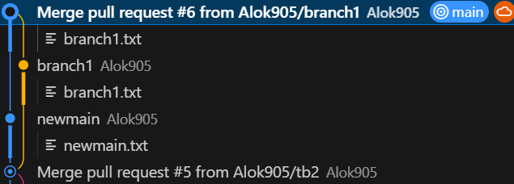
    - Between creating of branch branch1 and merging it to main branch, there is one commit present in main branch. But branch1 was not updated with that commit but still it got merged to main branch without any conflict.
    - Because, only the changes mentioned in the merge request that was created from the branch branch1 will be updated to the main branch; not all the files present in branch1 will be updated in main branch.
- Let there is a file check.txt inside the main branch having some contents inside it.
  - 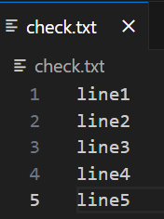
  - Created one branch my_branch and made the following changes:
    - 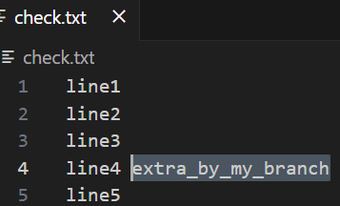
  - Switched to main branch and made the following changes:
    - 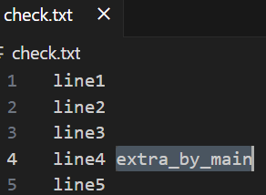
  - Now we can see, both the changes are conflicting each other.
    - Main : C1 -> C2 -> C3 -> C4 -> C5 -> Cx
    - my_branch : C1 -> C2 -> C3 -> C4 -> C5 -> Cy
    - But in this case, the commits Cx and Cy are conflicting eachother.
  - So, If I try to merge my_branch to main branch, then it’ll give conflicts:
    - 