- server.xml
  - whatever port you give in the <Connector ... >, will server your website.
  - <ip>:<port>
  - you can give protocol inside the <Connector ...>
    - HTTP/1.1 : simplest, default, good for small apps.
    - NIO : better for many concurrent connections.
    - AJP : for reverse proxy setups (Apache/Nginx → Tomcat).
    - HTTP/1.1 : Default HTTP connector using the blocking I/O (BIO) or NIO implementation. Handles normal HTTP requests.
    - org.apache.coyote.http11.Http11NioProtocol : Non-blocking I/O (NIO) HTTP connector. Better for handling many simultaneous connections efficiently.
    - org.apache.coyote.http11.Http11Nio2Protoco : Uses Java NIO2 (asynchronous I/O). Advanced, can scale better for high-load servers.
    - org.apache.coyote.http11.Http11AprProtocol : Uses APR/native libraries for maximum performance. Requires Tomcat Native library installed.
    - AJP/1.3 : Connects Tomcat to a web server like Apache HTTPD using AJP protocol (common in production).
  - Sometimes, you might see redirectPort inside Connector:
    - 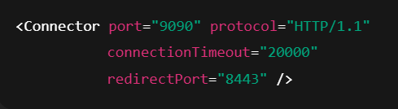
    - redirectPort="8443" → If a request comes in on 9090 that requires HTTPS, Tomcat will automatically redirect it to port 8443, where you would typically have an HTTPS connector configured.
    - 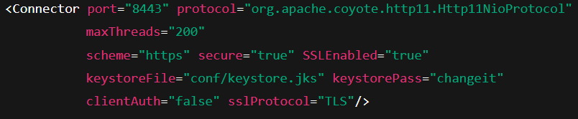
    - So in short: redirectPort points to the HTTPS port that handles secure traffic when needed.

- Process to host a single web app in apache tomcat:
  - Go to /tmp/ directory (optional) and download the tar.gz file of tomcat of whatever version you want.
  - Extract that file using tar -xzvf <tar file name> command.
  - Now create a folder which will serve the web site (usually we take inside /opt/ directory)
    - I created /opt/tomcat/
  - Copy all the files inside the extracted file into this path i.e. to /opt/tomcat/
  - Now create one user for tomcat (it is not necessary; even you can run Tomcat as root or any other user; but for security point of view, it’s a good practice to create a dedicated user for running tomcat)
    - I created one tomcat
    - useradd -r -m -U -d /opt/tomcat -s /bin/false tomcat (in RPM based linux)
    - Here /opt/tomcat is the home directory of the user tomcat.
      - It is not required. For consistency like every user should have a home directory, it is created. (but completely optional)
  - Now, make the user tomcat owner of /opt/tomcat/ directory along with all the sub-folders and files inside it.
    - chown -R tomcat:tomcat /opt/tomcat
  - There are shell scripts to run or shutdown tomcat inside the bin folder i.e. /opt/tomcat/bin
    - You need to give executable permission to all those files.
    - chmod +x /opt/tomcat/bin/*.sh
  - Now, delete everything present inside the directory /opt/tomcat/webapps/ and copy the .war (build file) file into this and rename that as ROOT.war.
  - You can run the file startup.sh to run tomcat, or better create a tomcat.service file for this.
    - Create the tomcat.service file inside /etc/systemd/system/ directory.
    - You can see in the file, there is a property called User and Group.
      - If you have created the user, give that against that User and Group field.
    - If you are creating multiple tomcat to host multiple websites independently, then also the Environment variable names (not the values) mentioned inside the tomcat.service file will not be changed.
      - This variable will be limited to this service only
      - Even if any other service is using same variable, that’ll not interfere with this.
      - Means, these are local to the service.
      - Just there values needs to be changed like directories and all.
      - Also, select the proper openjdk version.
    - 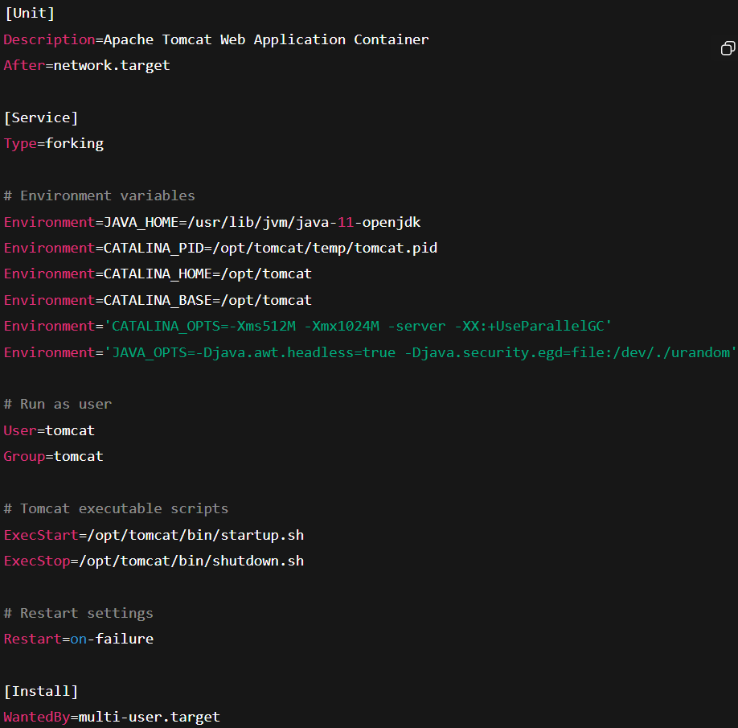
  - Now,
    - systemctl daemon reload
    - systemctl start tomcat
  - After starting tomcat, it’ll extract that ROOT.war and one folder called ROOT will be created there.
  - Now, the website is hosted. You can access it with the port (mentioned inside the server.xml) file. (default: 8080)

- Multiple tomcats to host multiple web-apps independently:
  - In my case, I created the following folders
    - /opt/tomcat_v1
    - /opt/tomcat_v2
  - Then follow the steps as previous, copy the respective web-apps build file (.war) into the respective folder’s webapps/ directories.
  - Now, you need to configure the ports to which the web-apps will listen:
    - /opt/tomcat_v{*}/conf/server.xml , The following ports should be unique for all the tomcat files:
      - <Server port="8005" shutdown="SHUTDOWN"> (port (shutdown port))
      - <Connector port="8080" protocol="HTTP/1.1" connectionTimeout="20000" redirectPort="8443" maxParameterCount="1000" /> (port and redirectPort)
  - Also, inside the tomcat_v{*}.service files will contain the proper path values.
  - One user can be used for all the tomcat instances, but better to create different user for different instances.

- The above case was for hosting different websites in different tomcat instances independently.
  - But if you want to host all web-apps in same tomcat instance i.e. all the web-apps will be listening to same port.
  - Just copy the .war files of all the web-apps and paste those inside webapps/ folder.
  - Then in browser http://<ip>:<port>/<filename> , you can access the website.
    - <filename>.war will decide the route of the webapps.
  - 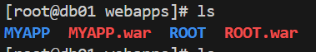
    - In this case,
      - http://<IP>:<Port>/ : it’ll serve the web-app having name as ROOT.
      - http://<IP>:<Port>/MYAPP : It’ll serve the web-app having name as MYAPP.

- ss -tulnp
  - ss → socket statistics tool (modern replacement for netstat).
  - Options:
    - -t → show TCP sockets.
    - -u → show UDP sockets.
    - -l → show only listening sockets (services waiting for connections).
    - -n → show ports as numbers (skip DNS/service name resolution).
    - -p → show process using the socket (requires root).

