* **setx JAVA_HOME "C:\Program Files\Java\jdk-21"**
  + It is used to set the environment variable permanently.
* How the Java code works?
  + Java Code (**.java**) ------<compiler (javac)>------ Byte Code (**.class**)
  + Byte Code goes into JVM (JVM accepts only byte code)
  + JVM only run only one file.
    - It says, even if you have 1000 files, you need to tell me which is the first file that I’ll run.
    - That file needs to have **main** *method*.
  + Whenever you run a **.java** file, one **.class** file will get created. It is the Byte Code file.
* To run a java code (file name is let: Hello.java)
  + If you run this using **javac Hello.java**, one file will be created depending upon the *classname* used inside the **Hello.java**.
  + 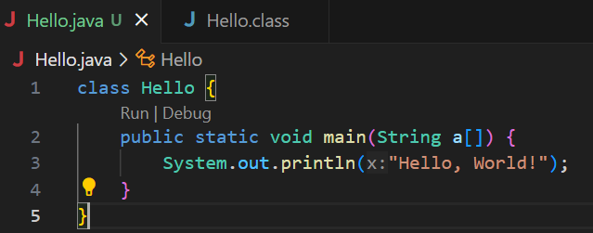
  + Here I gave the *classname* same as the *filename*.
  + But, it doesn’t matter what is the filename; you can give the *classname* different.
  + But, the **.class** file will be created with the *classname* that is mentioned inside the **.java** file.
  + 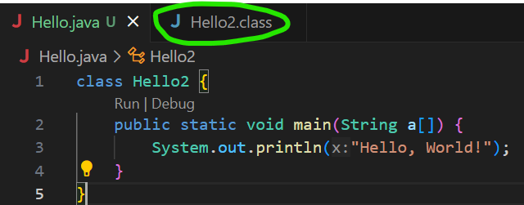
    - You can see here, I gave the class name *Hello2*, and the file got created is *Hello2.class*.
    - But, if you are creating **public** class, then the **filename** must be **same** as the **classname**.
  + First you need to run the command **javac Hello.java**
    - It’ll create the **.class** file.
  + Then, run the **.class** file using **java** **Hello**
    - Here, don’t write *java Hello.class*
* JVM(Java Virtual Machine) is present inside JRE(Java Runtime Environment).
  + When you need to run something, it might requires some libraries.
  + JRE provides that.
  + JVM is just a part of JRE.
  + Kitchen Analogy:
    - The kitchen provides the environment to cook a dish.
    - Utensils and Ingredients are like the libraries and resources JRE provides.
* **JVM < JRE < JDK** (inner to outer layer)
  + JVM present inside JRE and JRE present inside JDK.
  + JDK is used by developers to develop the code and all.
  + If you want to run your application in any other system, that doesn’t require JDK. Only JRE should be there to run the application.
  + 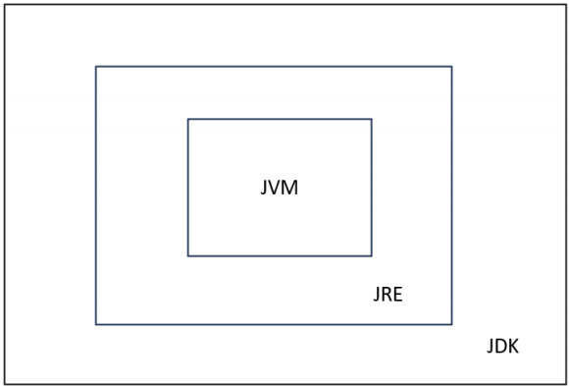
* Is JVM like a virtual machine on top of OS?
  + Yes and No:
  + ✅ Yes: It behaves like a virtual computer for Java bytecode. That’s why Java is “Write Once, Run Anywhere.”
  + ❌ No: It doesn’t emulate hardware or run another OS. It sits on top of the real OS, using system calls, memory, CPU instructions, etc.
  + So, JVM is an abstraction layer, not a full-blown VM like VirtualBox.
* **Variables**
  + Primitive
    - Integer (byte(1), short(2), int(4), long(8)) (for long: you need to write **l** as suffix)
    - Float (double(8), float(4)) (**2.3** => double, **2.3f** => float) (default is *double*)
    - Character (2 bytes)
    - Boolean (doesn’t work like 0 and 1; only **true** and **false** works)
    - 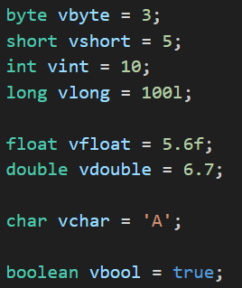
    - NOTE: you can’t double quotes in **char** variables. That is only for **string**.
    - 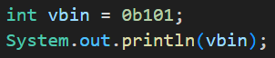
      * You can also write in binrary format, when you execute this, output will be **5**.
      * As 101 = 5
      * For hexadecimal, use **0x** as prefix.
    - Unlike C++, in Java also if you print **(int)(ch)** where ch is char variable, it’ll print the ASCII value of that character.
    - Higher sized variables can’t be assigned to smaller sized variables; but vice-versa is possible.
      * Ex: int can’t be assigned to short; but short can be assigned to int.
      * If you are assigning larger to smaller, then you need to do type casting.
        + 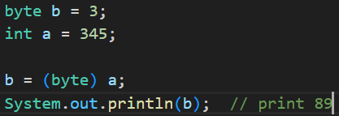 (345 % 256 = 89)
    - Type promotion:
      * lets say you have 2 byte variables 10, 30.
  + When you multiply these and store the result in a variable, it’ll automatically become int (as 300 is not in the scope of byte variable).
* **Some points to be remembered**
  + Just like C++, here also, when you divide 2 inegers, it’ll return a integer value only. Not float number.
  + Operators (arithmetic, logical, ternary and all), Conditional statement (if, else if, else) are same as C++.
  + **switch case** statement is also same as C++.
  + string + int + int => for example: “abcdef “ + 5 + 6 => “abcdef 56”
    - It’ll concatenate.
  + 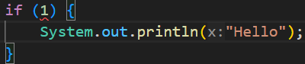
    - This is wrong. It’ll give error that *can’t convert int into boolean*.
* **Classes and Objects**
  + - 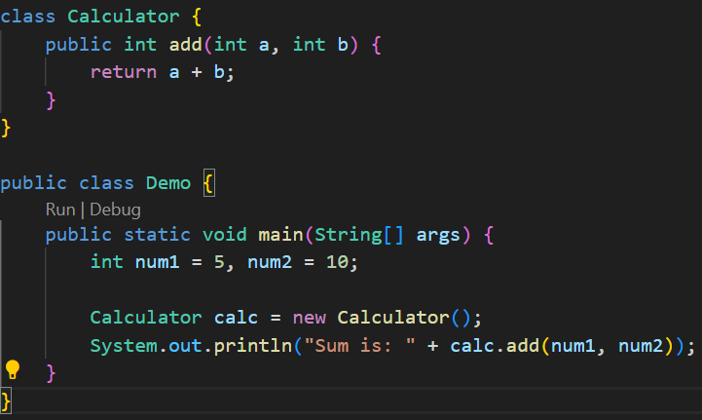
      * You can’t run this directly using **java filename.java**, you need to compile and run separately.
      * Bcs, when you compile it, 2 .class files will be created i.e. Calculator.class and Demo.class.
* **JDK JRE JVM**
  + JDK: Java Development Kit
  + JVM: Java Virtual Machine
  + JRE: Java Runtime Environment
  + Compilation happens in JDK, Running happens in JVM.
  + Most of the time, you’ll be using some built-in libraries; in this case JRE comes into play.
    - One extra layer outside JVM, which is JRE, stays there to provide the libraries during the run.
* **Methods**
  + While creating a method, you should provide a proper access modifier.
  + 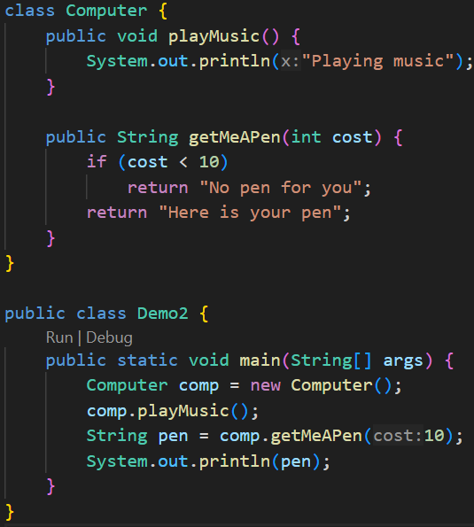
  + **Method Overloading**
    - 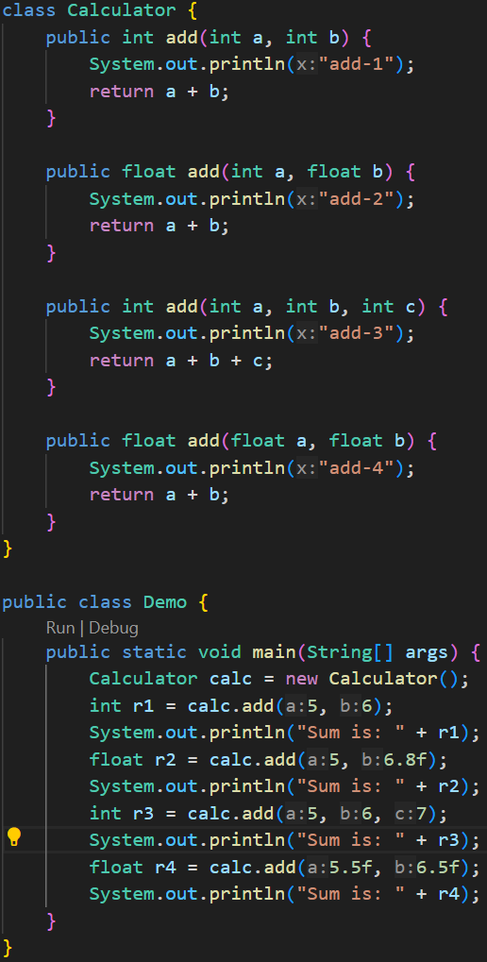 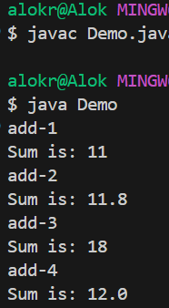
      * Number of arguments, type of arguments, type of return type: depending upon these, method overloading can be done.
* **Stack and Heap**
  + Inside JVM, there are 2 types of memory.
    - Stack (Last-In-First-Out)
    - Heap (open space)
  + 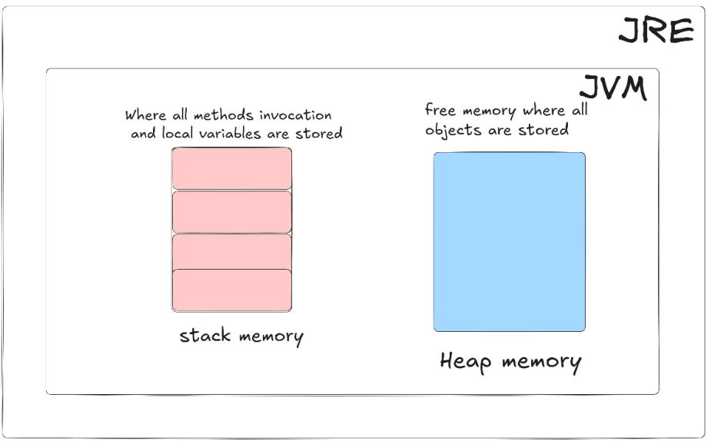
  + 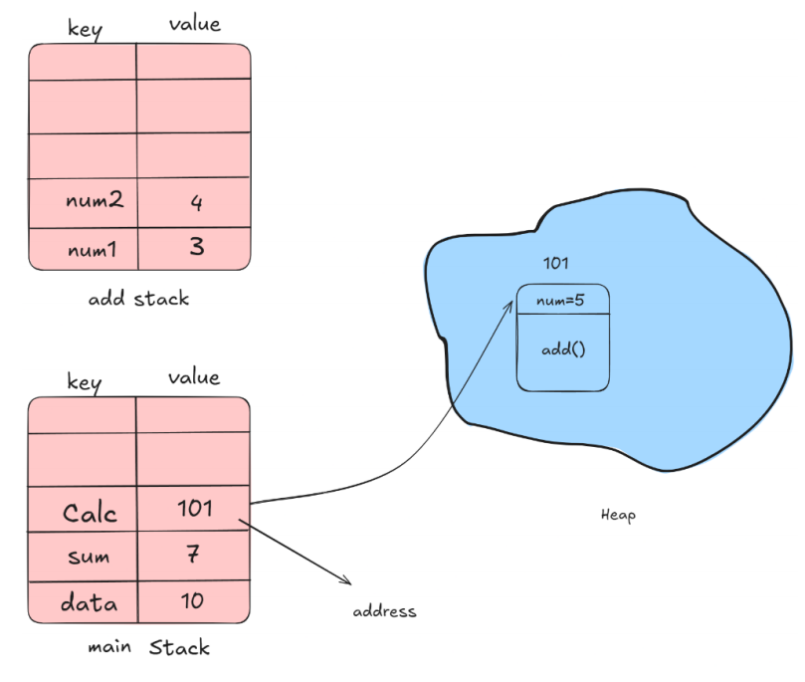
    - Each method takes its own stack like main method, add method (consider previous example)
    - The stack is having 2 partitions: left side is for key and right side is for value.
    - Whenever you create an object out of a class, it is created inside the Heap.
      * In the heap, inside the memory block that the object acquires, is having 2 parts.
        + One is for **properties** (instance variables)
        + One is for **method definitions**
    - When you call the method using the object, the method gets loaded inside the Stack, create its own local variables and gets executed.
    - Note: the instance variables inside a class will be staying inside the heap only.
    - 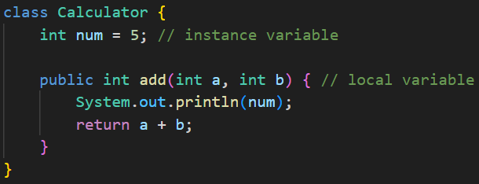
    - Instance variables are specific to objects, not class. Means, each objects will have independent instance variables.
      * Because, each objects will be having different memory blocks inside the heap.
    - The reference of the object inside heap, is stored inside the stack.
* In Java, everything, which is an object, gets created inside Heap.
  + Ex: Array,
* **Array**
  + **int arr[]** and **int[] arr**
    - These both are exactly same
    - But, **int[] arr** is preferable; as it shows **arr** is of **int[]** type.
    - First one i.e. **int arr[]** is derived from C/C++ style; which is 100% correct in Java.
  + 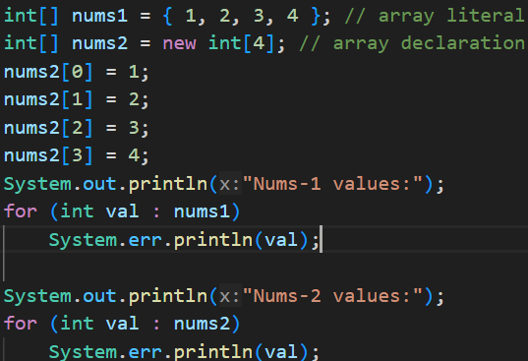
    - These are 2 types of Array declaration.
    - Both are **fixed sized** only.
    - An non-initialized array’s values will be **0**.
  + 2D Array:
    - 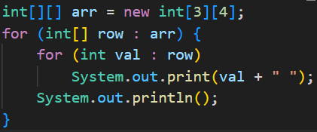 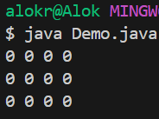
    - Arrays are not having dynamic sized (for dynamic size, ArrayList is used)
    - But in case of 2D array, we can create an Array having different sized rows.
    - 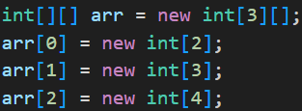
      * Just don’t mention the column size while creating a 2D array and after that initialize the rows.
      * It is called  **jagged** array.
      * 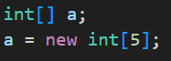
        + It’s just like this.
      * We are creating an array of sized **3** *(new int[3][])* where each value is of type **int[]**. After that we are initializing those.
  + **Array of Objects:**
    - 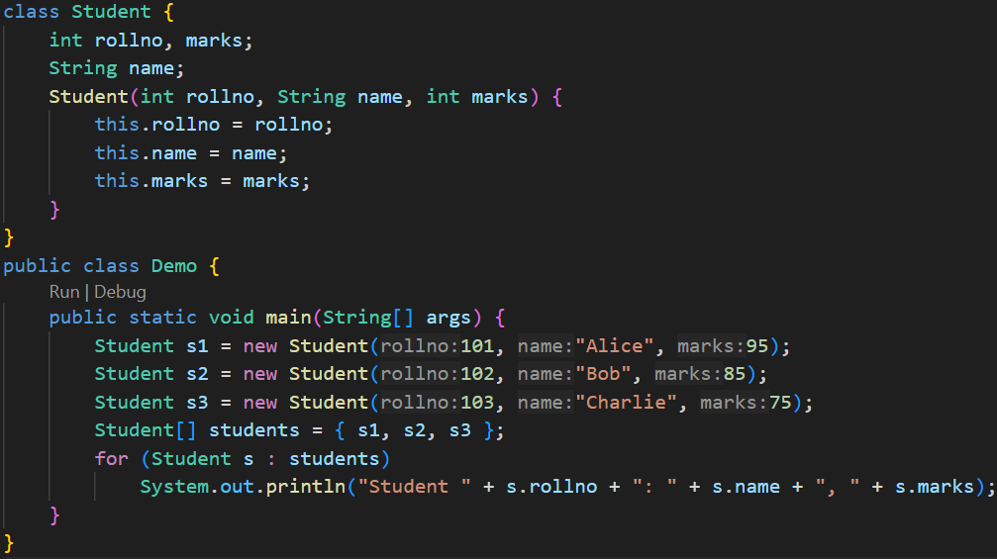
    - 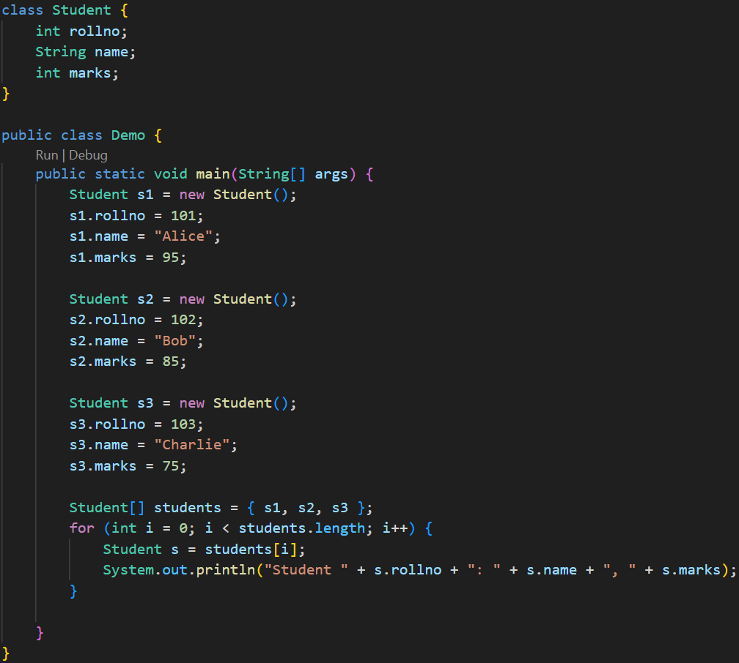
  + **Drawbacks of Array:**
    - You can’t change the size of the array.
    - O(n) for searching.
* **Strings**
  + 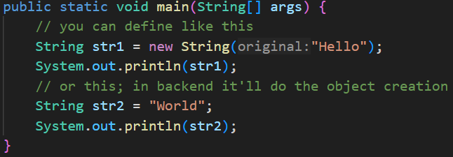
  + When you create a string variable, one object of type **String** will be created in heap and your variable will store the reference of that object.
  + One part is there inside Heap called as **String Constant Pool**,
    - Whenever you assign one *string value* to a variable, one *constant string literal* will get created inside that String Constant Pool and reference of that will be stored in a variable.
  + **Immutable Strings:**
    - Lets you create **String** variables having same value, then both the variable will be storing the reference of same *string literal* as in side the String Constant Pool, all the strings stored are unique.
    - 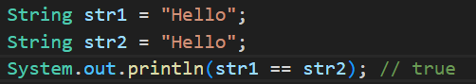
    - Whenever you assign one *string literal* to a variable, it first checks inside the String Constant Pool;
      * if that particular literal is not present then it creates one and store its reference inside the variable.
      * If present, if just store the reference of existing string literal in the variable.
      * For concatenation: there are the following cases:
      * 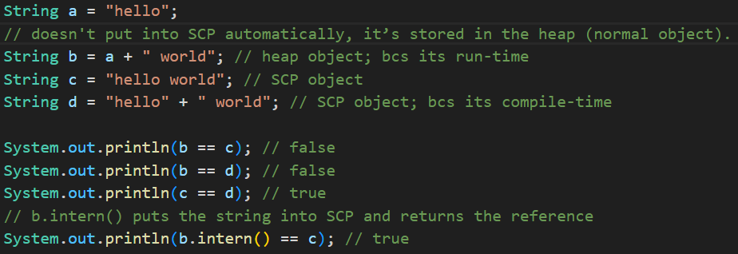
  + **Mutable Strings:**
    - **StringBuffer** is used to create mutable strings.
    - 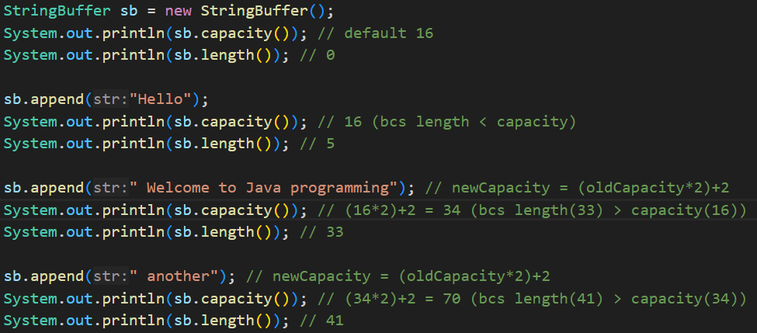
      * By default, the capacity is 16.
      * If the string size exceeds the capacity, then the capacity will be increased with the formula: **New Capacity = (Old Capacity) * 2 + 2**
* **NOTE** Inside a non-static method, use of **this** keyword to access the **instance variables** is optional. (**this** is required in case of naming conflict; constructor is example here)
  + 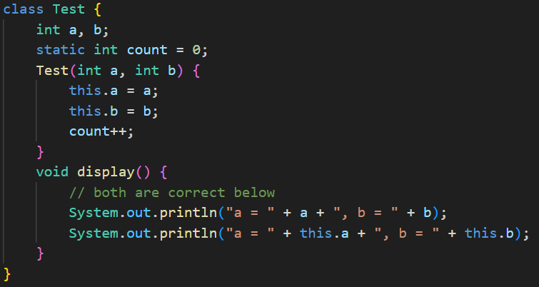
* **static** keyword:
  + Static variables is shared among all the objects.
  + Static variables are stored in the Method Area (a part of JVM memory), not on the Heap.
  + You can call access the static variables using objects as well; but it is not preferable.
  + You should access the static variables using class only
    - **ClassName.StaticVariableName**
  + 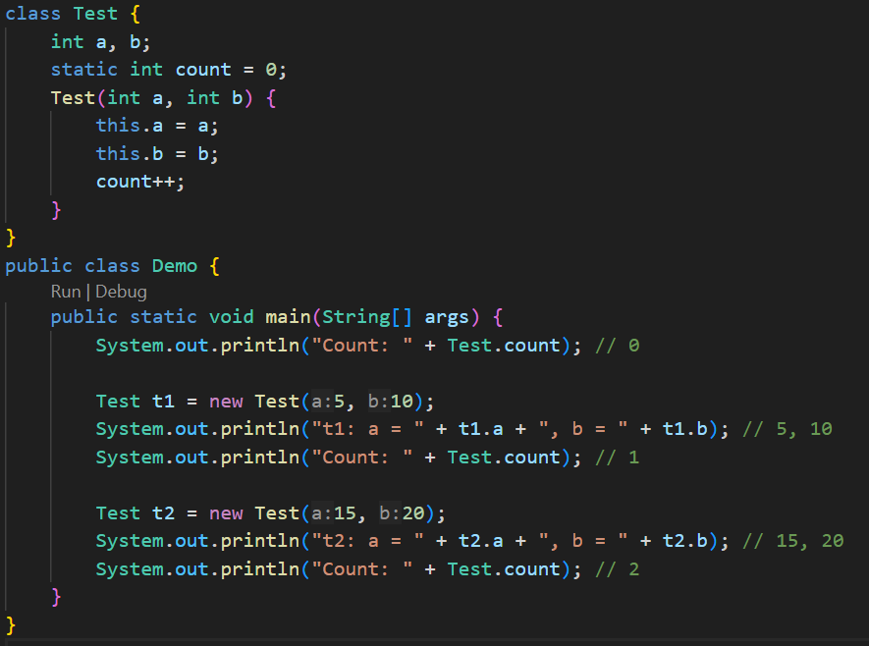
    - Example of Static Variable.
  + From a **static method**, you can’t access the **instance variables**. Because instance variables are specific to the objects but **static method** is specific to class; not objects.
    - If you want to access the instance variables, then you can pass the object as an argument to the **static method**.
    - 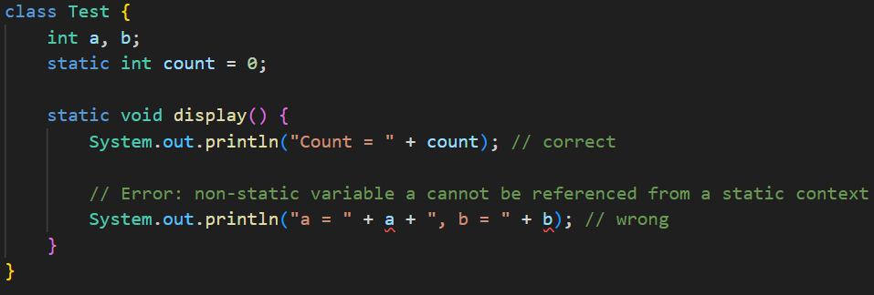
    - 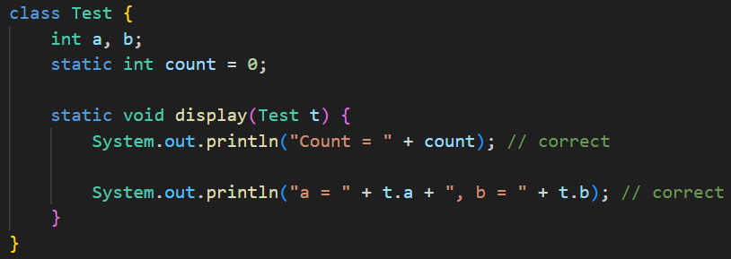
      * Now it is correct.
    - If you create any variable inside a static method, then after the method is executed then the variable will be gone.
* **Static Block**
  + Whenever you instantiate a object with a class, then first the class gets loaded then the object will be created.
    - If you are instantiating more than one object with a single class, then **loading of class will happen only once**.
      * When the first object will be created, class will be loaded;
      * after that when 2nd object will be created, it sees the class is already loaded; so now only object creation will happen.
    - There is a **static block**, where you can assign values to the **static variables**. This block gets called when the class is loaded.
    - It means, even if you are creating **n** number of objects **(or)** you call any static method of that class **n** times, **static block** will be executed only once.
      * If there is no object getting created, then static block will not be executed.
    - 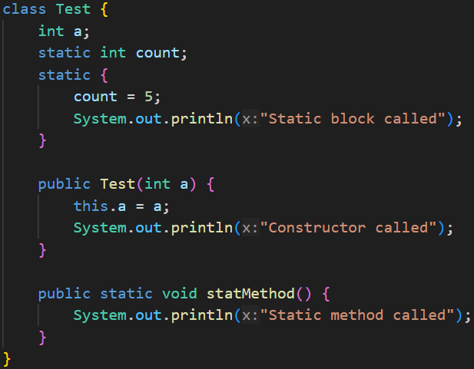
      * This is the class having static block.
    - 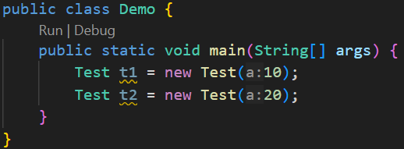 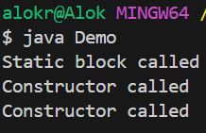
      * Because, class was loaded only once.
    - 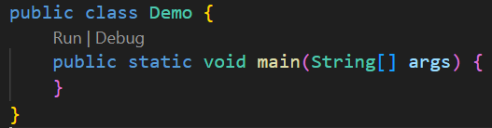 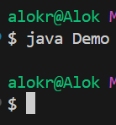
      * Because, as no object was created; so class loading didn’t happen.
    - 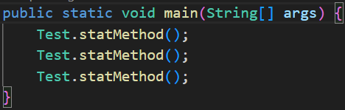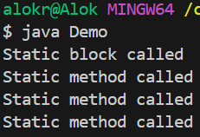
      * Because, only during the first static method call, class was loaded.
    - 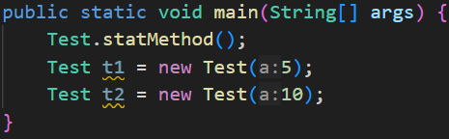 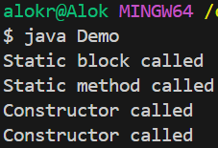
      * When static method got called, class was loaded; so while instantiating objects, it didn’t require to load the class.
    - If you want to load the class even if no **static method** got called or **no object** got instantiated; then you can use **Class.forName**
      * It load the class to the memory using class loader.
  + fdf