**“Reliance will continue to play a leading role in Gujarat’s growth story”**

- Mukesh D Ambani, Chairman and Managing Director, RIL   
10th Vibrant Gujarat Summit

**RIL Chairman and Managing Director Mukesh D Ambani** addressed dignitaries at the **10th Vibrant Gujarat Summit** on January 10, 2024.

He highlighted Reliance's contributions to the state's development over the years, as well as plans for the future.

Further, he spoke on connectivity developments and retail expansions. He also announced that India would be bidding for Olympics 2036.

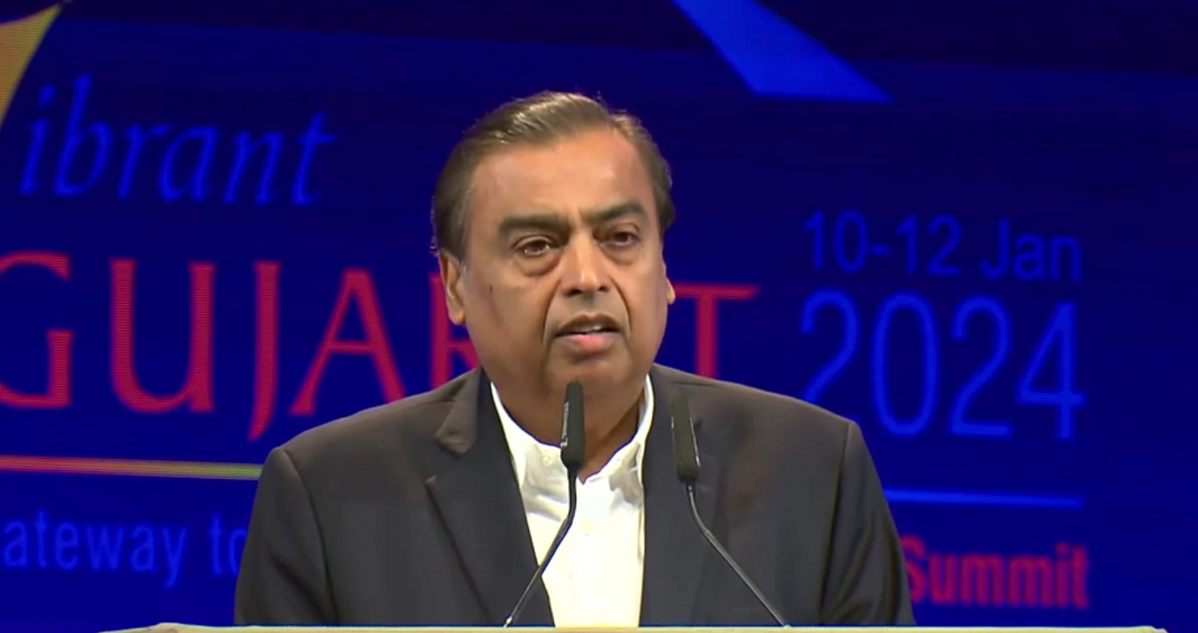

[Embed the video in the same page – either take the video from the folder, or the R-World URL: https://rworld.ril.com/ci/video-details/473]

**“Most Respected Prime Minister Shri Narendrabhai,** 

**Honourable Chief Minister Shri Bhupendrabhai Patel ji,** 

**Distinguished guests and dignitaries from all over the world,** 

**Ladies and gentlemen,**

Welcome to Gujarat and the 10th Vibrant Gujarat Summit, the most prestigious investor summit in the world today.

No other summit of this kind has continued for 20 long years — and going from strength to strength.

This is a tribute to our Prime Minister Shri Narendrabhai Modi’s vision and consistency.

I have been one of the fortunate few to have participated in every single edition of Vibrant Gujarat.

I have come from the City of the Gateway of India to the Gateway of Modern India’s Growth - Gujarat.

I am a proud Gujarati,

मने गुजराती होवानो अभिमान छे

When foreigners think of NEW INDIA, they think of a New Gujarat -- નવું ગુજરાત

How did this transformation happen?

Because of one leader.

Our beloved leader who has emerged as the greatest global leader of our times.

And he is Shri Narendrabhai Modi, the Most Successful Prime Minister in India’s history.

**Most Respected Shri Narendrabhai Modi *ji*,**

When you speak, the whole world not only listens but applauds you.

My friends abroad ask me: What is the meaning of the slogan that millions of Indians are chanting: *MODI HAI TO MUMKIN HAI?*

I tell them: It means, India’s Prime Minister makes the Impossible Possible with his vision, determination and execution!

They agree, and they also say: *“MODI HAI TO MUMKIN HAI!”*

**My Esteemed Friends,**

I will never forget what my father Dhirubhai Ambani used to tell me in my childhood:

“Gujarat is your MATRUBHOOMI, and Gujarat should always remain your KARMABHOOMI.”

Today, let me declare yet again: Reliance was, is, and will always remain a Gujarati company.

Each of Reliance’s business is striving to fulfil the dreams of my seven crore fellow Gujaratis.

**Reliance has invested over $150 billion (Rs 12 lakh crore) in creating world-class assets and capacities across India in the last 10 years.**

Of this, more than one third has been invested in Gujarat alone.

**Honourable Chief Minister Shri Bhupendrabhai Patel *ji*,**

Today I would like to make five commitments to the people of Gujarat.

**First,** Reliance will continue to play a leading role in Gujarat’s growth story with significant investments in the next ten years.

Specifically, Reliance will contribute to making Gujarat a global leader in Green Growth.

We will help Gujarat’s target to meet half of its energy needs through renewable energy by the year 2030.

For this, we have started building the Dhirubhai Ambani Green Energy Giga Complex over 5,000 acres in Jamnagar.

This will generate a large number of green jobs and enable production of green products and materials and will make Gujarat a leading exporter of green products. 

And we are ready to commission this in the second half of **2024 itself**.

**Second,** Reliance Jio completed the fastest rollout of 5G infrastructure anywhere in the world.

Today, Gujarat is fully 5G enabled – something that most of the world does not yet have.

This will make Gujarat a global leader in digital data platforms and AI adoption. 

The 5G-enabled AI revolution will make Gujarat’s economy more productive, more efficient and more globally competitive.

Besides generating millions of new employment opportunities, it will produce AI-enabled Doctors, AI-enabled Teachers and AI-enabled Farming, which will revolutionise Healthcare, Education and Agricultural productivity in the State of Gujarat.

This will benefit every Gujarati in urban as well as rural areas, since to my mind AI also means an 'All Inclusive' growth.

**Third,** Reliance’s Retail will further accelerate its mission to bring quality products to consumers and simultaneously empower lakhs of kisans and small merchants.

Our Retail business improves the quality of life of all households of Gujarat with better products and services.

**Fourth**, Reliance will make Gujarat a pioneer in New Materials and the Circular Economy.

As a first step, Reliance is setting up India’s first and world-class carbon fibre facility at Hazira.

And finally, **Fifth**, Prime Minister Modi ji has announced that India will bid for 2036 Olympics.

In preparation for that, Reliance and Reliance Foundation will join forces with several other partners in Gujarat to improve education, sports and skills infrastructure that will nurture the champions of tomorrow in various Olympics sports.

**Most Respected Prime Minister Shri Narendrabhai Modi *ji*,**

Before I conclude, permit me to articulate a conviction that resides in the heart of everyone in this hall and most Indians.

As Chief Minister of Gujarat, you used to say—Bharat ke vikas ke liye Gujarat ka Vikas—and that is how you made Gujarat India’s growth engine.

Now as Prime Minister of India, your mission is – *Duniya ke Vikas ke liye Bharat ka Vikas.*

You are working on the mantra of global good and make India the world's growth engine.

The story of your journey from Gujarat to the Global Stage in just two decades is nothing short of a modern epic.

Today, and in today’s India, is the best time for young people to enter the economy to innovate and to provide ease of living and ease of earning to hundreds of millions of people. 

The coming generations will indeed be thankful to Prime Minister Modi for being both a nationalist and an internationalist.

You have laid a solid foundation for ‘Vikasit Bharat’ ─ India as a fully developed nation in Amrit Kaal.

No power on earth can stop India from becoming a 35 trillion-dollar economy by 2047.

And as I see Gujarat alone will become a 3-trillion-dollar economy.

Therefore, I am confident … Every Gujarati is confident…

And Every Indian is confident …

That the **Modi Era** will take India to new summits of prosperity, progress and glory.

**Thank you very much Sir.** 

***Jai Gujarat!*** 

***Jai Jai Garvi Gujarat!*** 

***Jai Hind*!"**