**“Reliance has proudly partnered in Tamil Nadu’s growth over the years”**

- Mukesh D Ambani at the Tamil Nadu Global Investors’ Meet

Addressing dignitaries at the **Tamil Nadu Global Investors’ Meet** on January 7, 2024, RIL Chairman and Managing Director Mukesh D Ambani highlighted Reliance's contributions to the state while also focusing on the newer investments in renewable energy and green hydrogen.

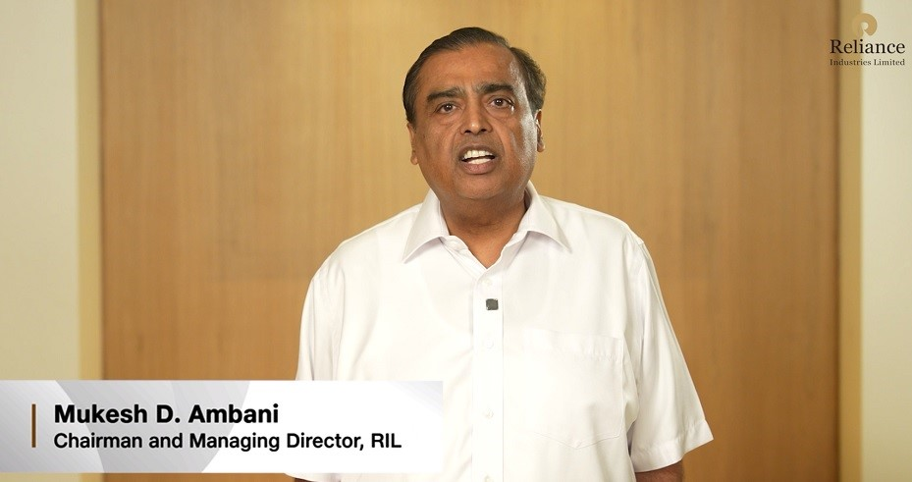

Watch the full address.

[Link to R-World video: <https://rworld.ril.com/ci/video-details/471>]

**“Honorable Chief Minister of Tamil Nadu Shri M K Stalin, my industry colleagues from India and across the globe,**

**Ladies and Gentlemen,**

*Vannakam*, a very good morning to each and every one of you.

It was my ardent desire to attend this summit, but owing to unavoidable circumstances, I could not make it.

My deep apologies.

Tamil Nadu has always been a land of rich cultural and intellectual heritage.

In modern times, its richness is enhanced multifold by shining progress in industry, agriculture, and services.

It is also contributing to all-round progress and prosperity of India.

Under the leadership of Thiru Stalin, Tamil Nadu has become one of the most business-friendly states in the country.

Therefore, I have every reason to believe it will soon become a trillion-dollar economy, which is the apt slogan of this summit.

**Friends,** **Reliance has proudly partnered in Tamil Nadu’s growth over the years.**

We have opened nearly 1,300 retail stores across the state, investing over Rs 25,000 crores.

Jio has invested over Rs 35,000 crores in Tamil Nadu, bringing the fruits of digital revolution to 35 million subscribers in every town and village in the state.

In December, **Jio completed the fastest roll out of 5G, anywhere in the world.**

This will enable Tamil Nadu to reap the benefits of artificial intelligence and other breakthrough fourth industrial revolution technologies, which will further accelerate its economy.

Reliance has partnered with Canada’s Brookfield asset management and US-based Digital Reality to set up a state-of-the-art data centre, that will be opened next week.

Reliance has committed to making new investments in Tamil Nadu in renewable energy and green hydrogen.

We shall work closely with the state government to promote sustainable development, which is necessary to save Mother Earth from the climate crisis.

I am confident that the state government will support our forthcoming initiatives with viable policies.

I wish this summit a glorious success.

Thank you.”