Dear Friends,

After IIT, Mech I did my MBA from IIM Calcutta and a long stint with Hindustan Lever. Then in 1990 I left them to do MS in Computer Science in the US. I then took on programming job with a consulting firm – ZS Associates (co founded by Prabha Sinha, IIT Kharagpur probably 68 batch.) After leaving them I set up my own show and developed custom systems for clients. I was always keen to try my hand at computer games so during spare time while working as well as full time since retiring, I have been learning HTML and Javascript and associated technologies.

I have developed a small game which I want you all to try playing if you have the time and are so inclined.

I have hosted it at iittrain.herokuapp.com

The main objective of the game is to set up a railway system and make it as successful as possible. In this game you have no competition. You just try and do the best.

See what you can do in, say 500 periods, of playing this game.

Here are instructions to get you started:

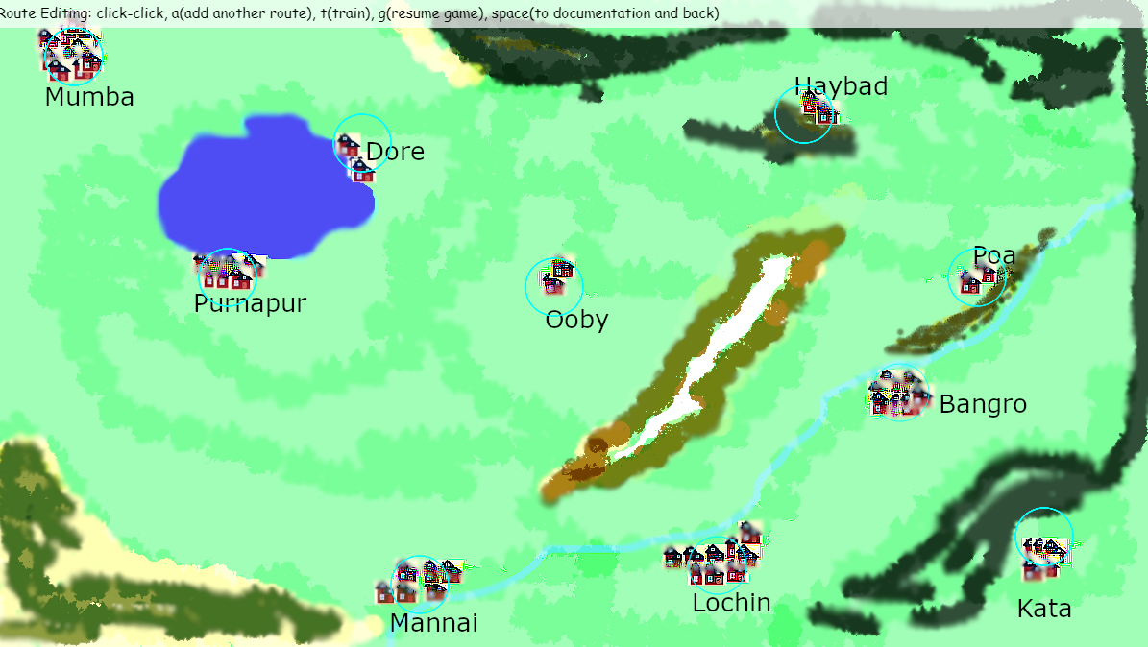

1. You will see this screen when you start. At the top it tells you that you are in Route Editing mode.
2. Click inside the blue circle in Mannai
3. Next click in the blue circle in Lochin.
4. Next click in the blue circle in Bangro.
5. By doing this you have created a route from Mannai to Bangro via Lochin.
6. For the time being say we want this as our route and do not want to add any more cities on the route
7. Now press the g key. The explanation in the top of the screen says it is to resume game.
8. When you do this the top line displays Running state as shown below.

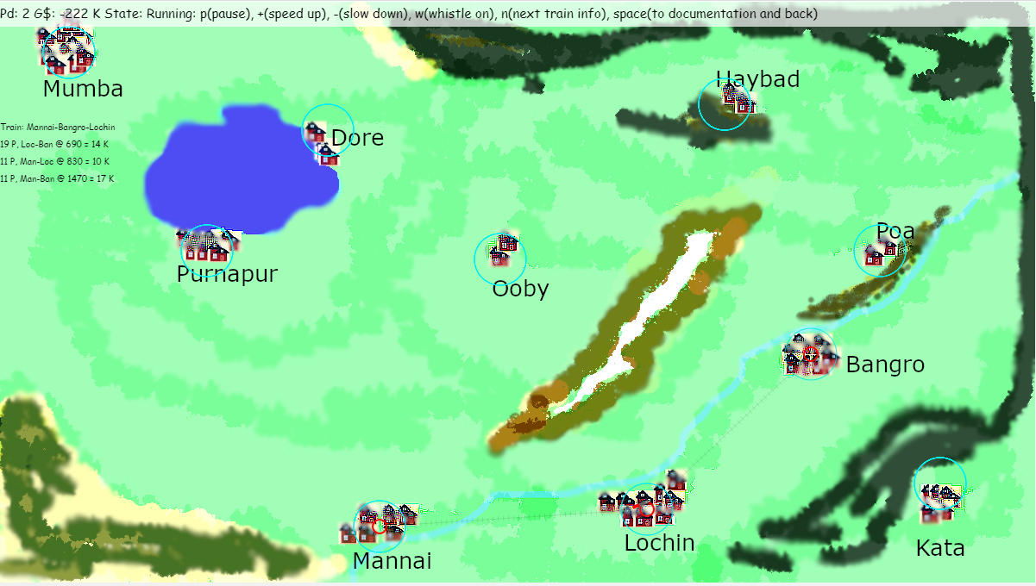

1. Also within 10 seconds or so a train will leave the Mannai station. With just one coach. If the coach is dark red then the train is going to full capacity (each coach accommodates only 30 passengers). If it is light red/pink then it is not filled to capacity.
2. Also on the left of the screen (In the area below Mumba) the game will display the number of Passengers that boarded the train at Mannai for Bangro and Lochin and the amound of money that you earned.
3. Note that the overall information is provided in the top of the screen. It shows that you are in Period 2 and you have G$ -222. Well this comes from the fact that in this game you start with 1,000,000 Game $. Laying of the track, Engine, Passenger coach and the three stations in those 3 cities cost you money. You should see that figure improving as time goes on and ticket sales come in.
4. Let us say that you realize that you are missing out on ticket sales because there is only one coach. No problem.
5. Pause the game by pressing the p key.
6. Then click on the r key to get into the Route Editing state.
7. Then click on the t key to get into the Train Editing mode. You will now see the following:

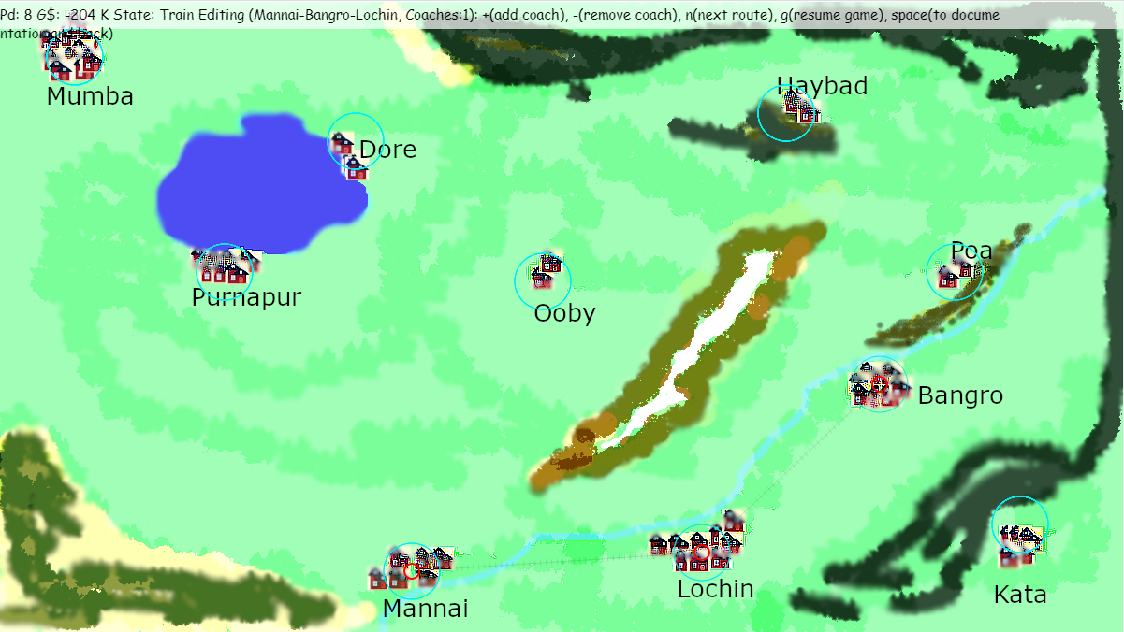

The banner at the top clearly tells you that you are editing Mannai-Bangro via Lochin train and that it currently has 1 coach. Press the + key till you get the desired number of coaches.

1. Having done this you again press the g key. You should now see the train having the specified number of coaches. You will be back in the Running state with the train or trains moving from station to station earning you Game $$.
2. If the game is proceeding too slowly for your taste, press the + key in the Running state
3. To read about the game in detail press the Space bar. Press Space bar again to come back to the Graphics screen