***K-Nearest Neighbors***

**K-Nearest Neighbors** is an algorithm for supervised learning. Where the data is 'trained' with data points corresponding to their classification. Once a point is to be predicted, it takes into account the 'K' nearest points to it to determine it's classification.

***Here's an visualization of the K-Nearest Neighbors algorithm.***

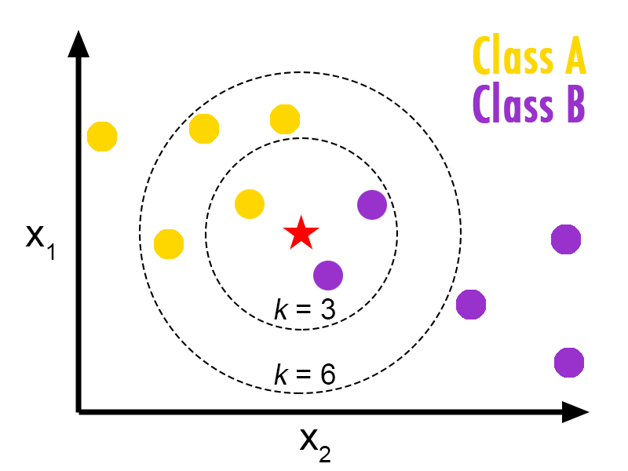

In this case, we have data points of Class A and B. We want to predict what the star (test data point) is. If we consider a k value of 3 (3 nearest data points) we will obtain a prediction of Class B. Yet if we consider a k value of 6, we will obtain a prediction of Class A.

In this sense, it is important to consider the value of k. But hopefully from this diagram, you should get a sense of what the K-Nearest Neighbors algorithm is. It considers the 'K' Nearest Neighbors (points) when it predicts the classification of the test point.

***About dataset***

Imagine a telecommunications provider has segmented its customer base by service usage patterns, categorizing the customers into four groups. If demographic data can be used to predict group membership, the company can customize offers for individual prospective customers. It is a classification problem. That is, given the dataset, with predefined labels, we need to build a model to be used to predict class of a new or unknown case.

The example focuses on using demographic data, such as region, age, and marital, to predict usage patterns.

The target field, called **custcat**, has four possible values that correspond to the four customer groups, as follows: 1- Basic Service 2- E-Service 3- Plus Service 4- Total Service

Our objective is to build a classifier, to predict the class of unknown cases. We will use a specific type of classification called K nearest neighbour.

### *Train Test Split*

Out of Sample Accuracy is the percentage of correct predictions that the model makes on data that the model has NOT been trained on. Doing a train and test on the same dataset will most likely have low out-of-sample accuracy, due to the likelihood of being over-fit.

It is important that our models have a high, out-of-sample accuracy, because the purpose of any model, of course, is to make correct predictions on unknown data. So how can we improve out-of-sample accuracy? One way is to use an evaluation approach called Train/Test Split. Train/Test Split involves splitting the dataset into training and testing sets respectively, which are mutually exclusive. After which, you train with the training set and test with the testing set.

This will provide a more accurate evaluation on out-of-sample accuracy because the testing dataset is not part of the dataset that have been used to train the data. It is more realistic for real world problems.

### *Accuracy evaluation*

In multilabel classification, **accuracy classification score** function computes subset accuracy. This function is equal to the jaccard_similarity_score function. Essentially, it calculates how match the actual labels and predicted labels are in the test set.

Train set Accuracy: 0.5475

Test set Accuracy: 0.32

## Practice

Can you build the model again, but this time with k=6?

Train set Accuracy: 0.5475

Test set ccuracy: 0.32

#### **What about other K?**

K in KNN, is the number of nearest neighbors to examine. It is supposed to be specified by User. So, how we choose right K? The general solution is to reserve a part of your data for testing the accuracy of the model. Then chose k =1, use the training part for modeling, and calculate the accuracy of prediction using all samples in your test set. Repeat this process, increasing the k, and see which k is the best for your model.

We can calucalte the accuracy of KNN for different Ks.