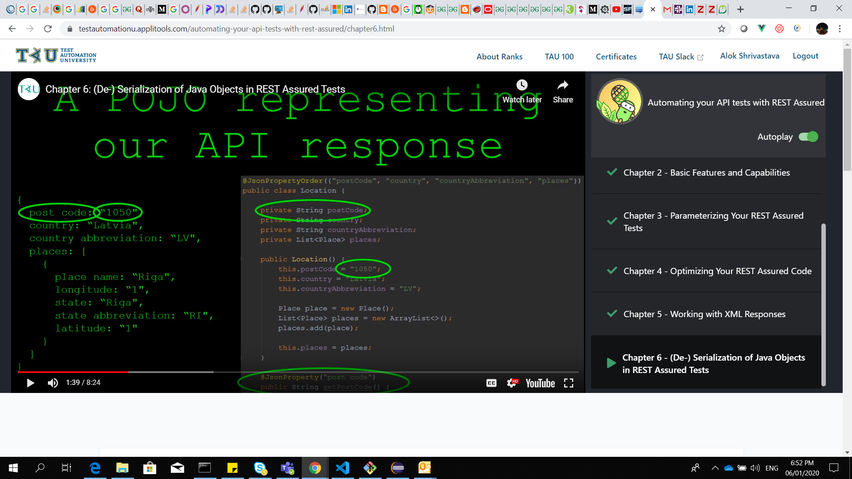

If we have space in node and want to convert in pojo then use jsonproperty

Deserilization : API response to java object

Serilization : java object to API/json object.

Validation using pojo :

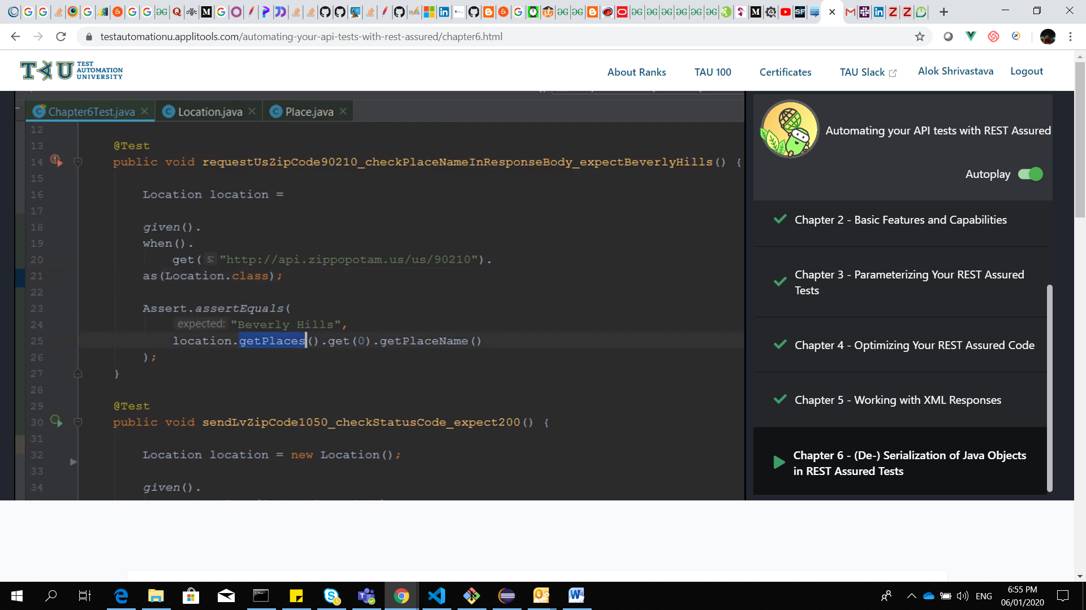

https://www.smashingmagazine.com/tag/javascript/. https://www.smashingmagazine.com/ is the root-endpoint and /tag/javascript is the path.

The **502 Bad Gateway** error is an HTTP status code that means that one server on the internet received an invalid response from another server.

The way for loop is processed is as follows

1 First, initialization is performed (i=0)

2 the check is performed (i < n)

3 the code in the loop is executed.

4 the value is incremented

5 Repeat steps 2 - 4

Patah parameter :

public static Response getUsersWithPathParam(int id) throws Exception {

return given().spec(REQUESTSPECIFICATION).pathParam("id", id).when()

.get(BASE_URL + "/{id}");

}

# How can a RuntimeExceptiom (i.e. ClassNotFoundException) be a checked exception in Java? As far as I know all RuntimeExceptions are unchecked exceptions.

ClassNotFoundException[[1]](https://www.quora.com/How-can-a-RuntimeExceptiom-i-e-ClassNotFoundException-be-a-checked-exception-in-Java-As-far-as-I-know-all-RuntimeExceptions-are-unchecked-exceptions#UnPwP) is **not** a subclass of runtime exception, hence it is a checked exception:

All subclasses of Error are also unchecked exceptions,

but those are related to JVM operations and if you are getting an Error your program is most likely in a screwed state already.

1. java.lang.Object
2. --java.lang.Throwable
3. ----java.lang.Error
4. ------java.lang.LinkageError
5. --------java.lang.NoClassDefFoundError
6. Class ClassNotFoundException
7. java.lang.Object
8. -- java.lang.Throwable
9. ----java.lang.Exception
10. ------java.lang.ReflectiveOperationException
11. --------java.lang.ClassNotFoundException

Object i = Integer.valueOf(42);

String s = (String)i; // ClassCastException thrown here.

* [java.lang.Object](https://docs.oracle.com/javase/7/docs/api/java/lang/Object.html)
  + [java.lang.Throwable](https://docs.oracle.com/javase/7/docs/api/java/lang/Throwable.html)
    - [java.lang.Exception](https://docs.oracle.com/javase/7/docs/api/java/lang/Exception.html)
      * [java.lang.RuntimeException](https://docs.oracle.com/javase/7/docs/api/java/lang/RuntimeException.html)
        + java.lang.ClassCastException
* Class.forName() gives you the class object, which is useful for reflection. The methods that this object has are defined by Java, not by the programmer writing the class. They are the same for every class. Calling newInstance() on that gives you an instance of that class (i.e. calling Class.forName("ExampleClass").newInstance() it is equivalent to calling new ExampleClass()), on which you can call the methods that the class defines, access the visible fields etc.

**501 (Not Implemented)**

500 is the generic REST API server error response

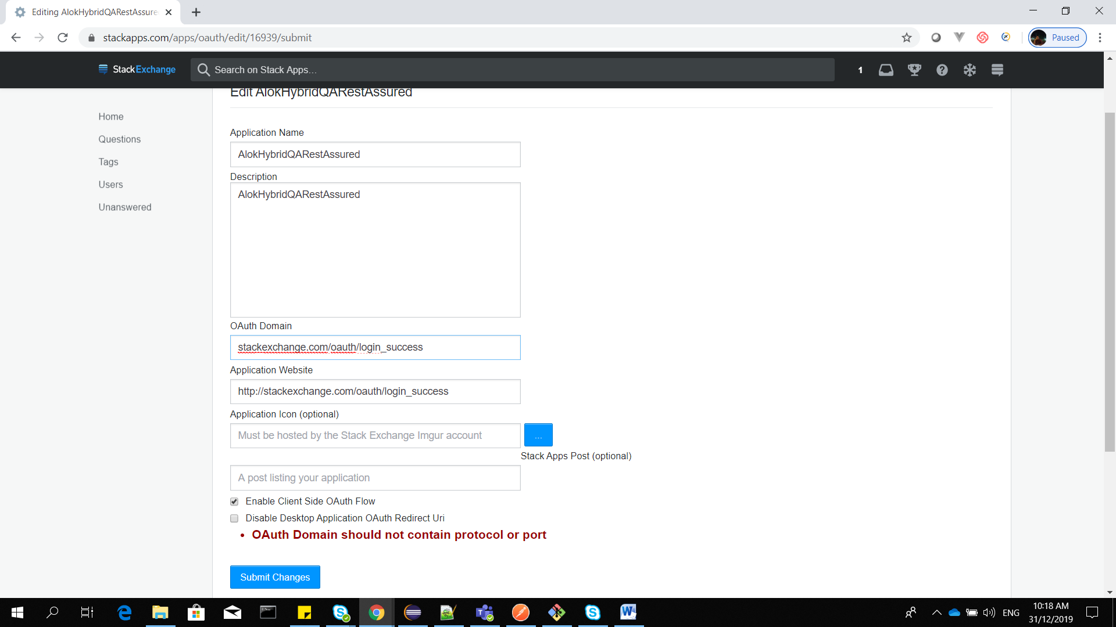

[www.stackexchange.com](http://www.stackexchange.com) /// for them which doent have their own app. Application website

[www.stackexchange.com/oauth/login_success](http://www.stackexchange.com/oauth/login_success) : redirect uri for ouath domain

Check ‘enable client side aouth flow ‘ for default.

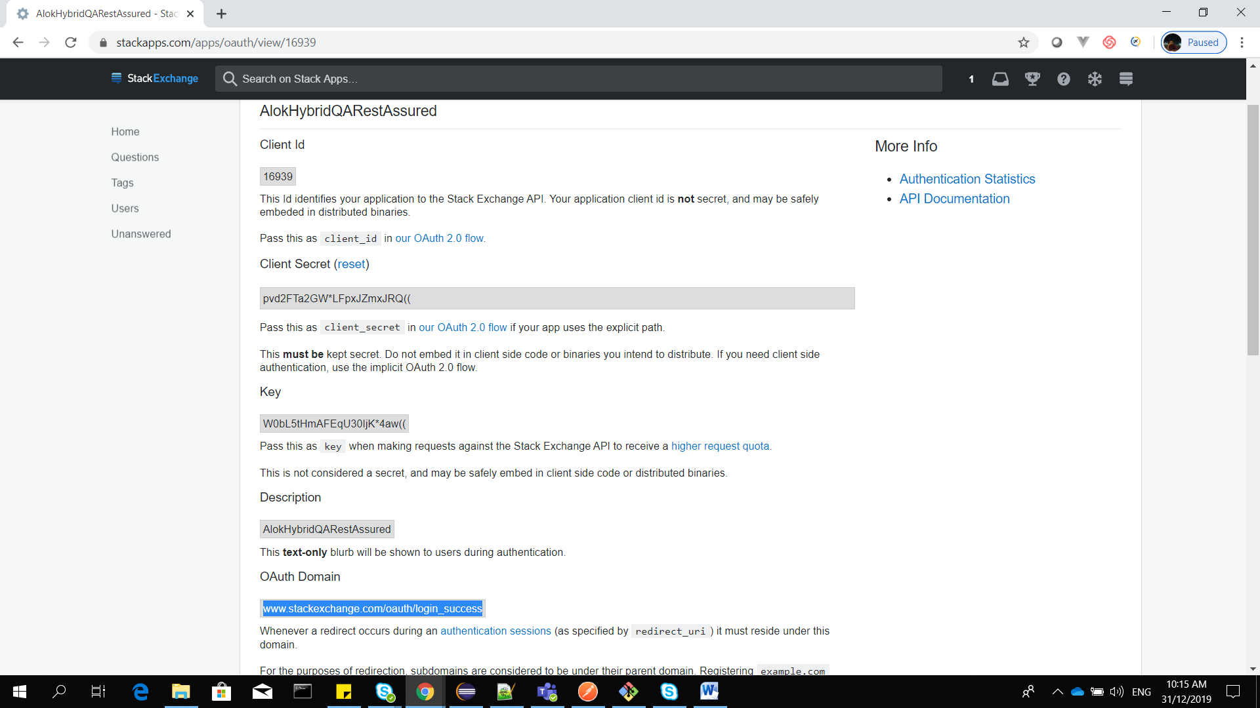

<https://api.stackexchange.com/docs/authentication>

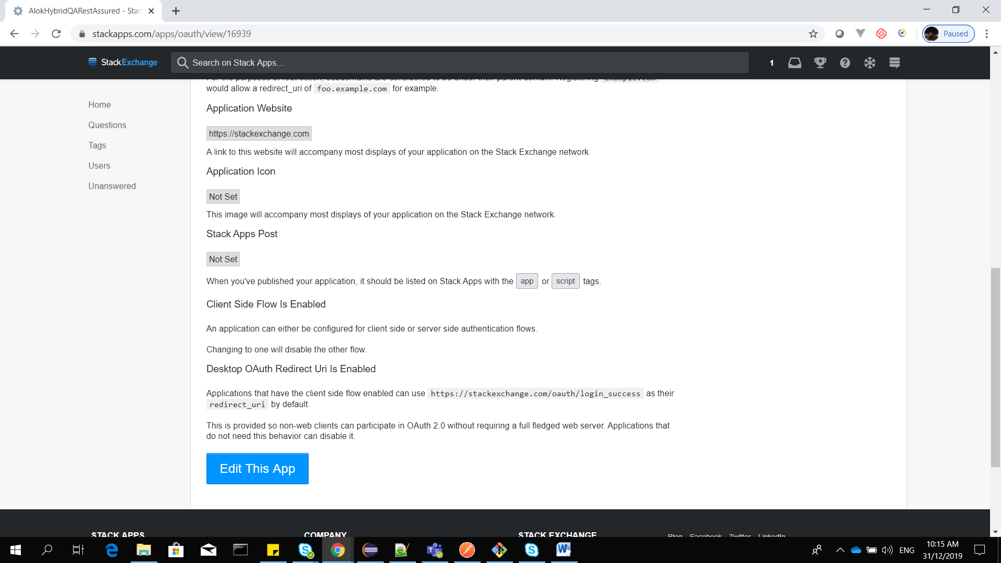

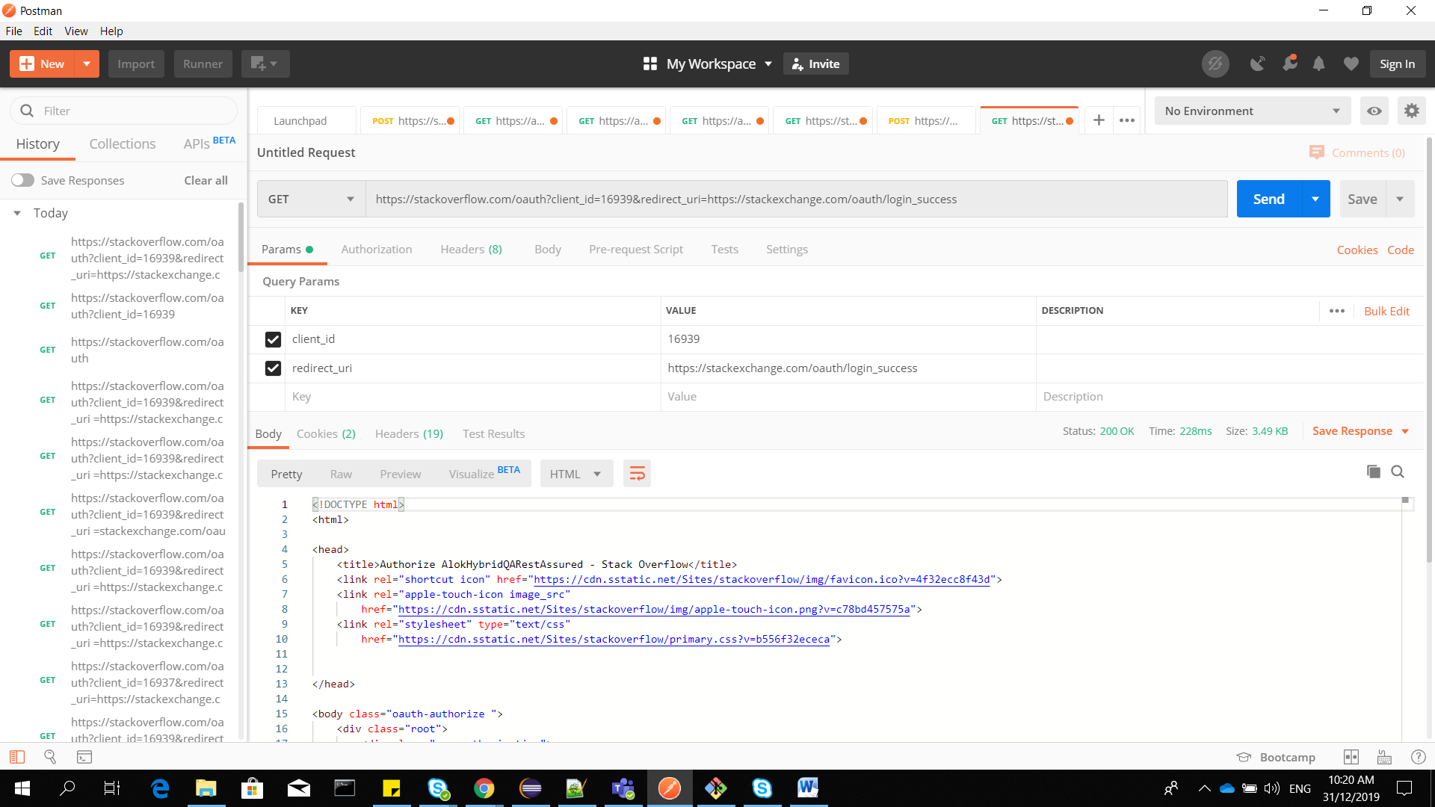

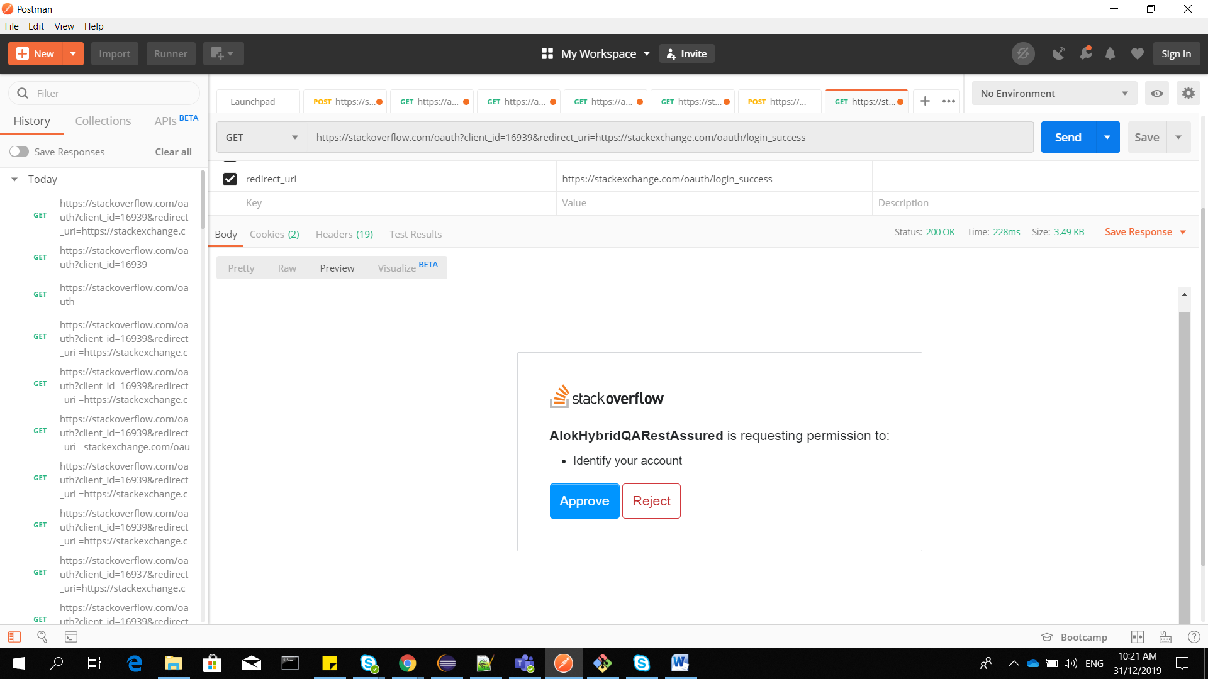

Copy get request URL and paste in chrome

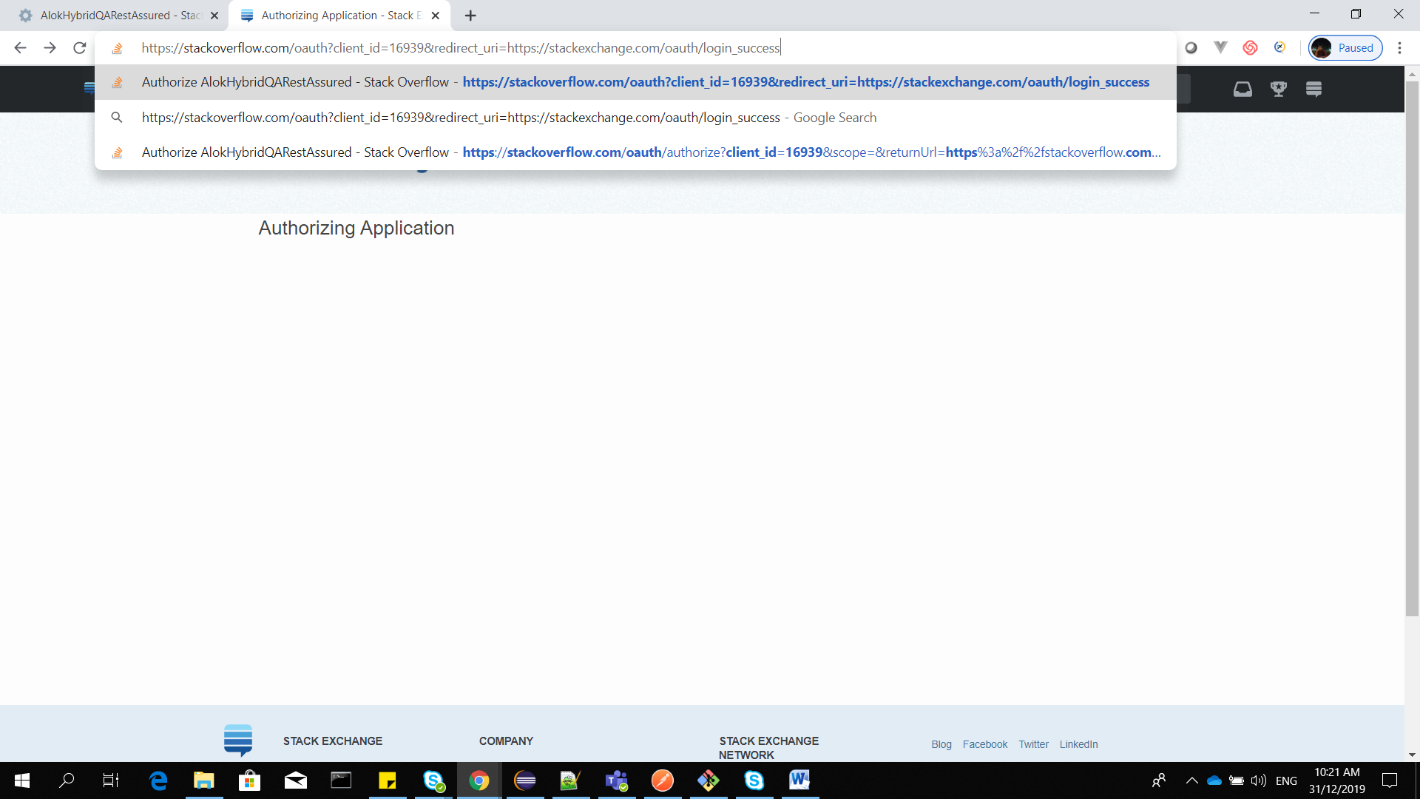

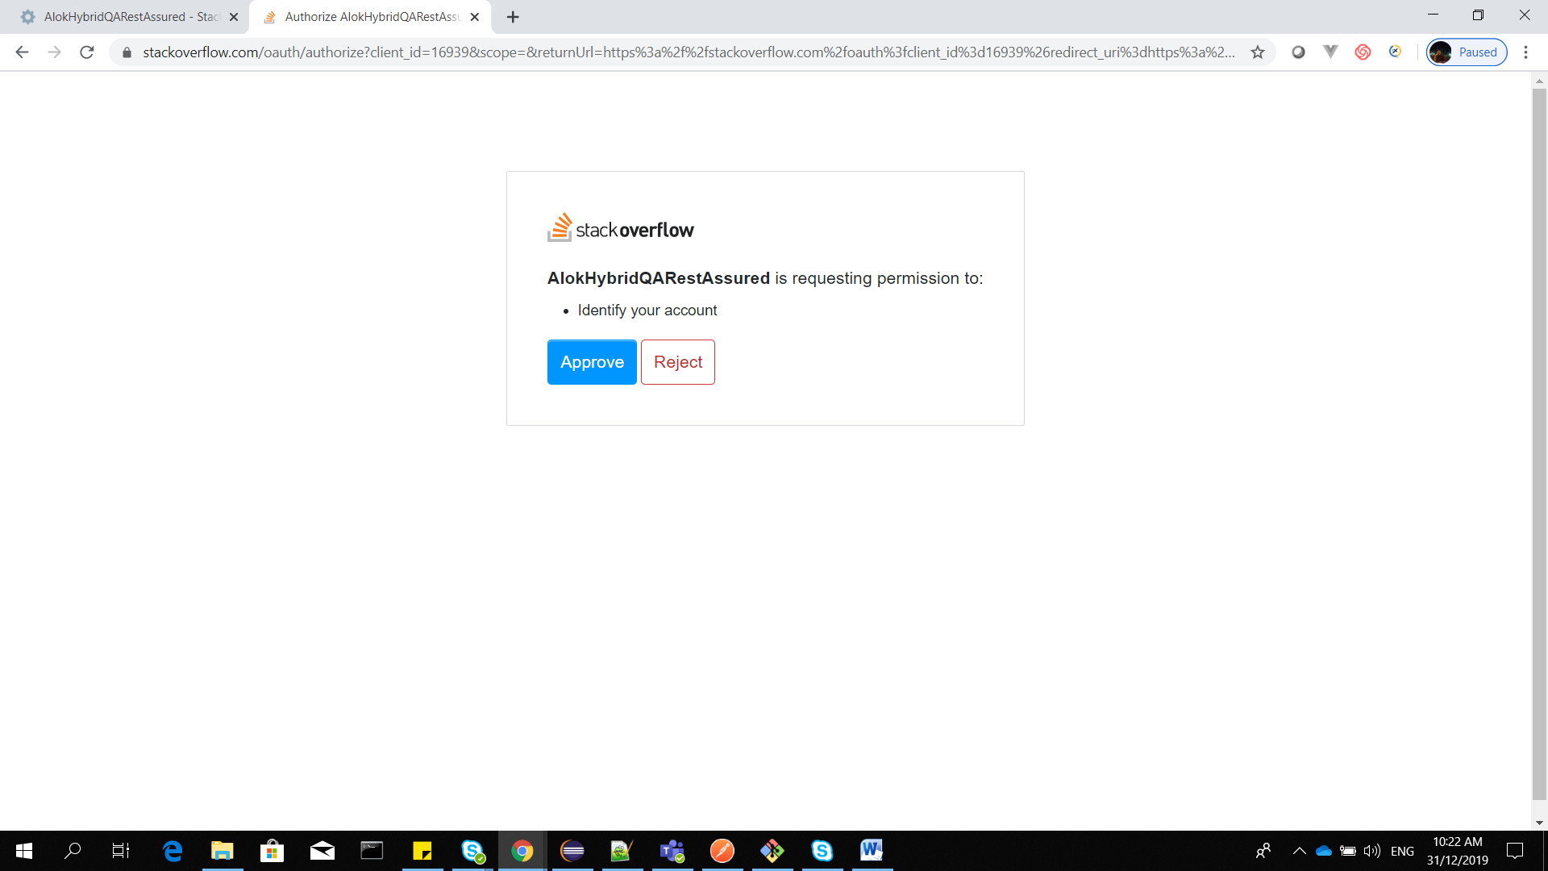

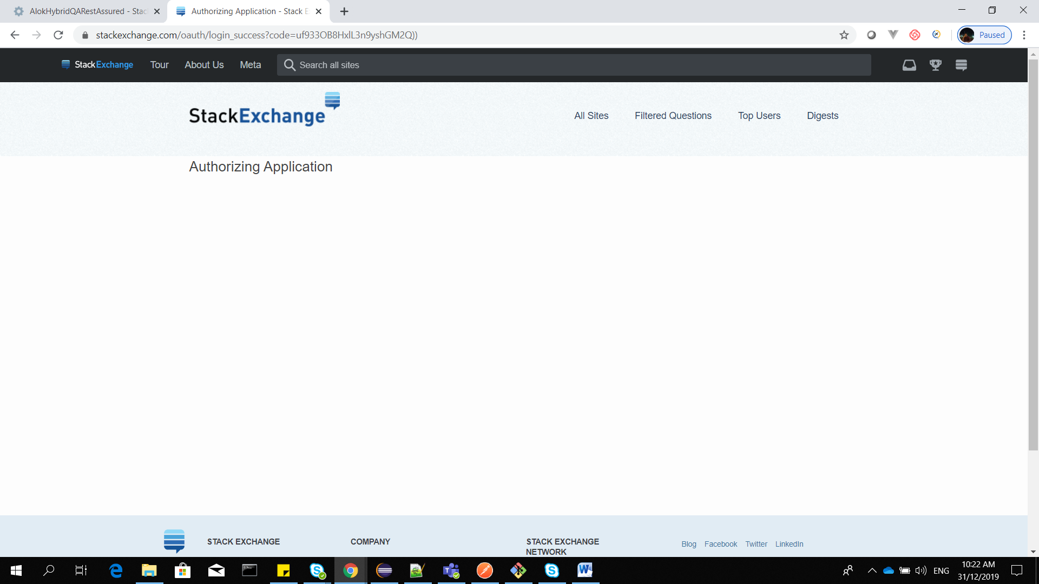

Copy the code from redirect URI.

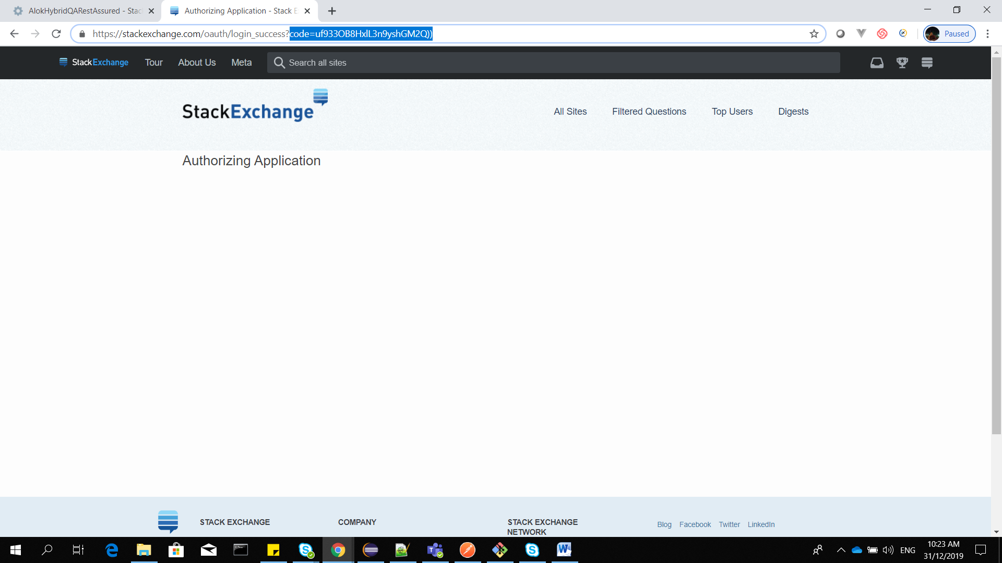

THIS IS EXPLICIT FLOW FOR SERVER SIDE APPLICATION.

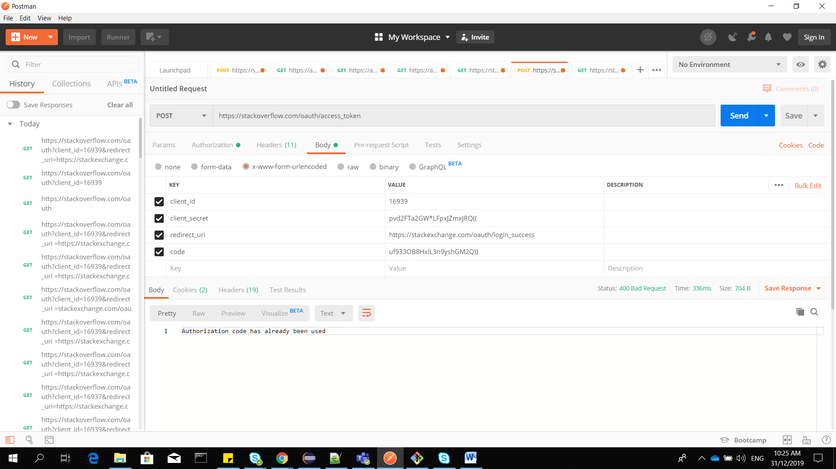

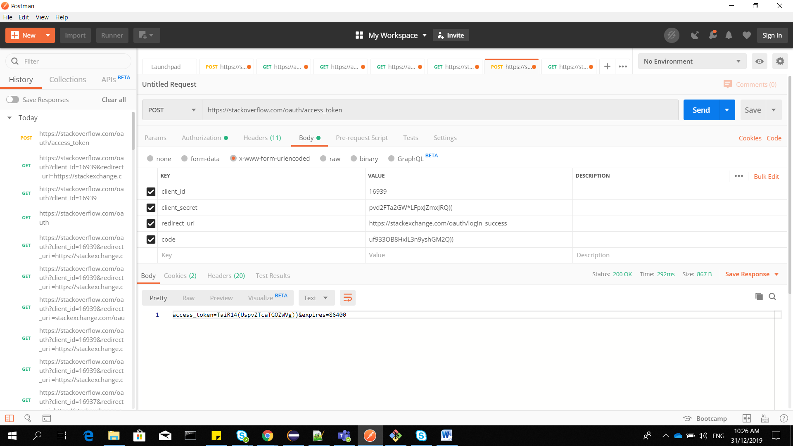

IMPLICIT FLOW FOR CLIENT SIDE APPLICATION .

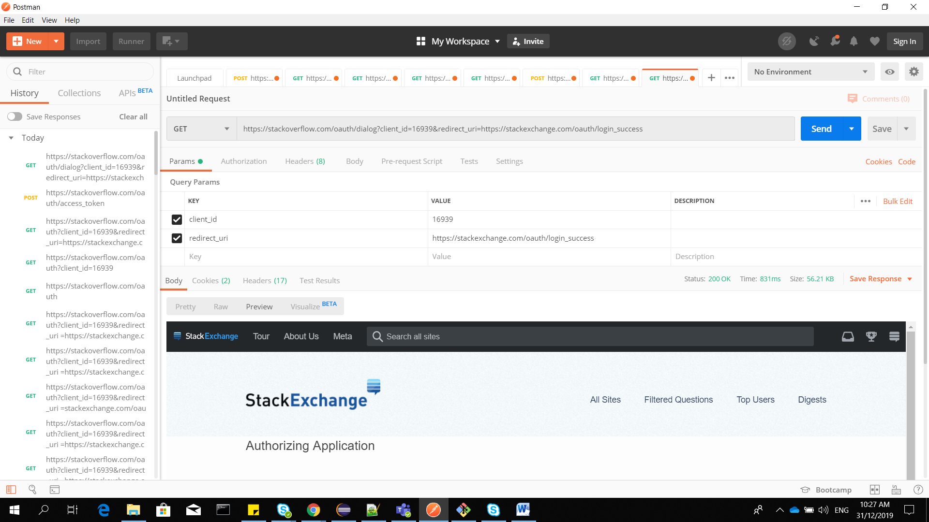

OPEN A GET URL IN CHROME : WE WILL GET ACCESS TOKEN DIRECTLY .

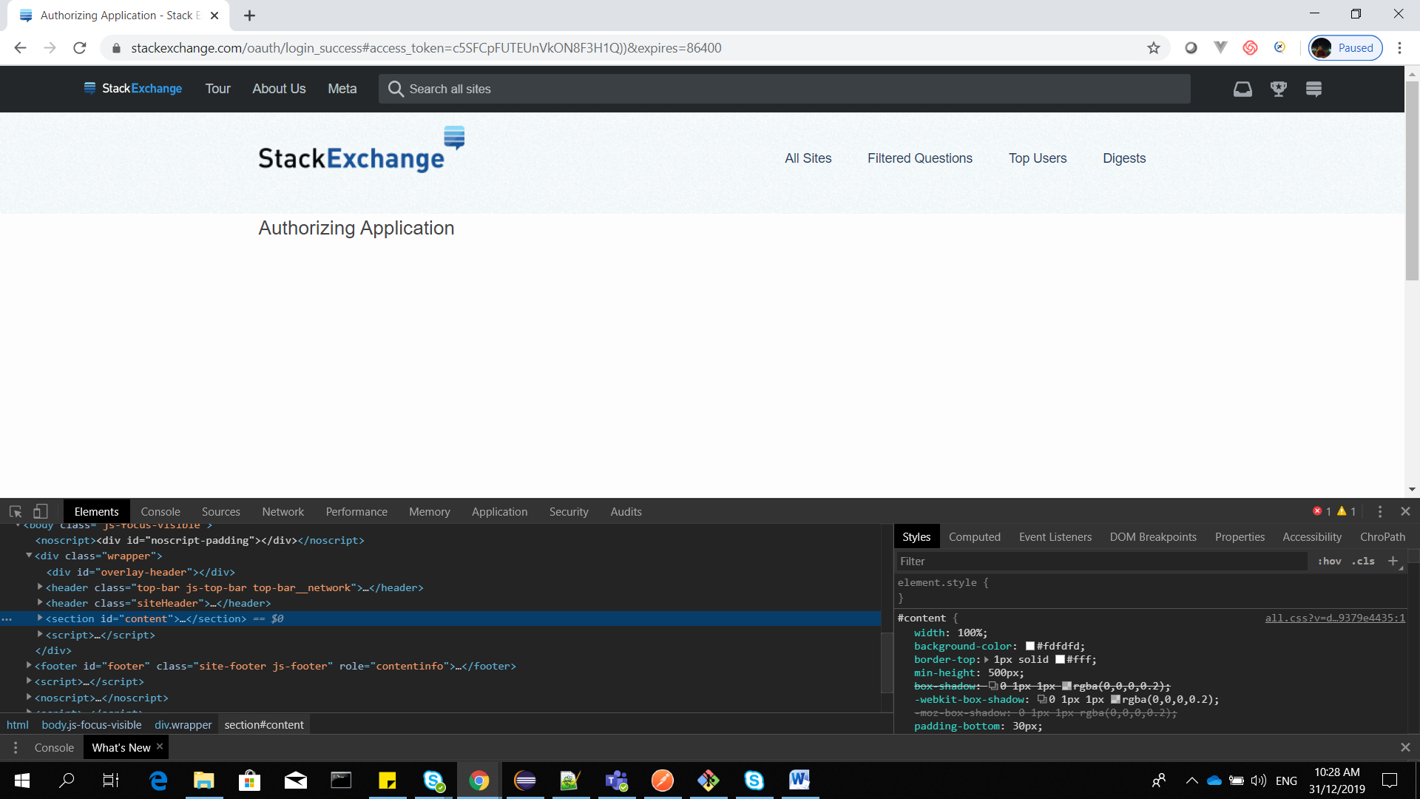

Can access the application as below

