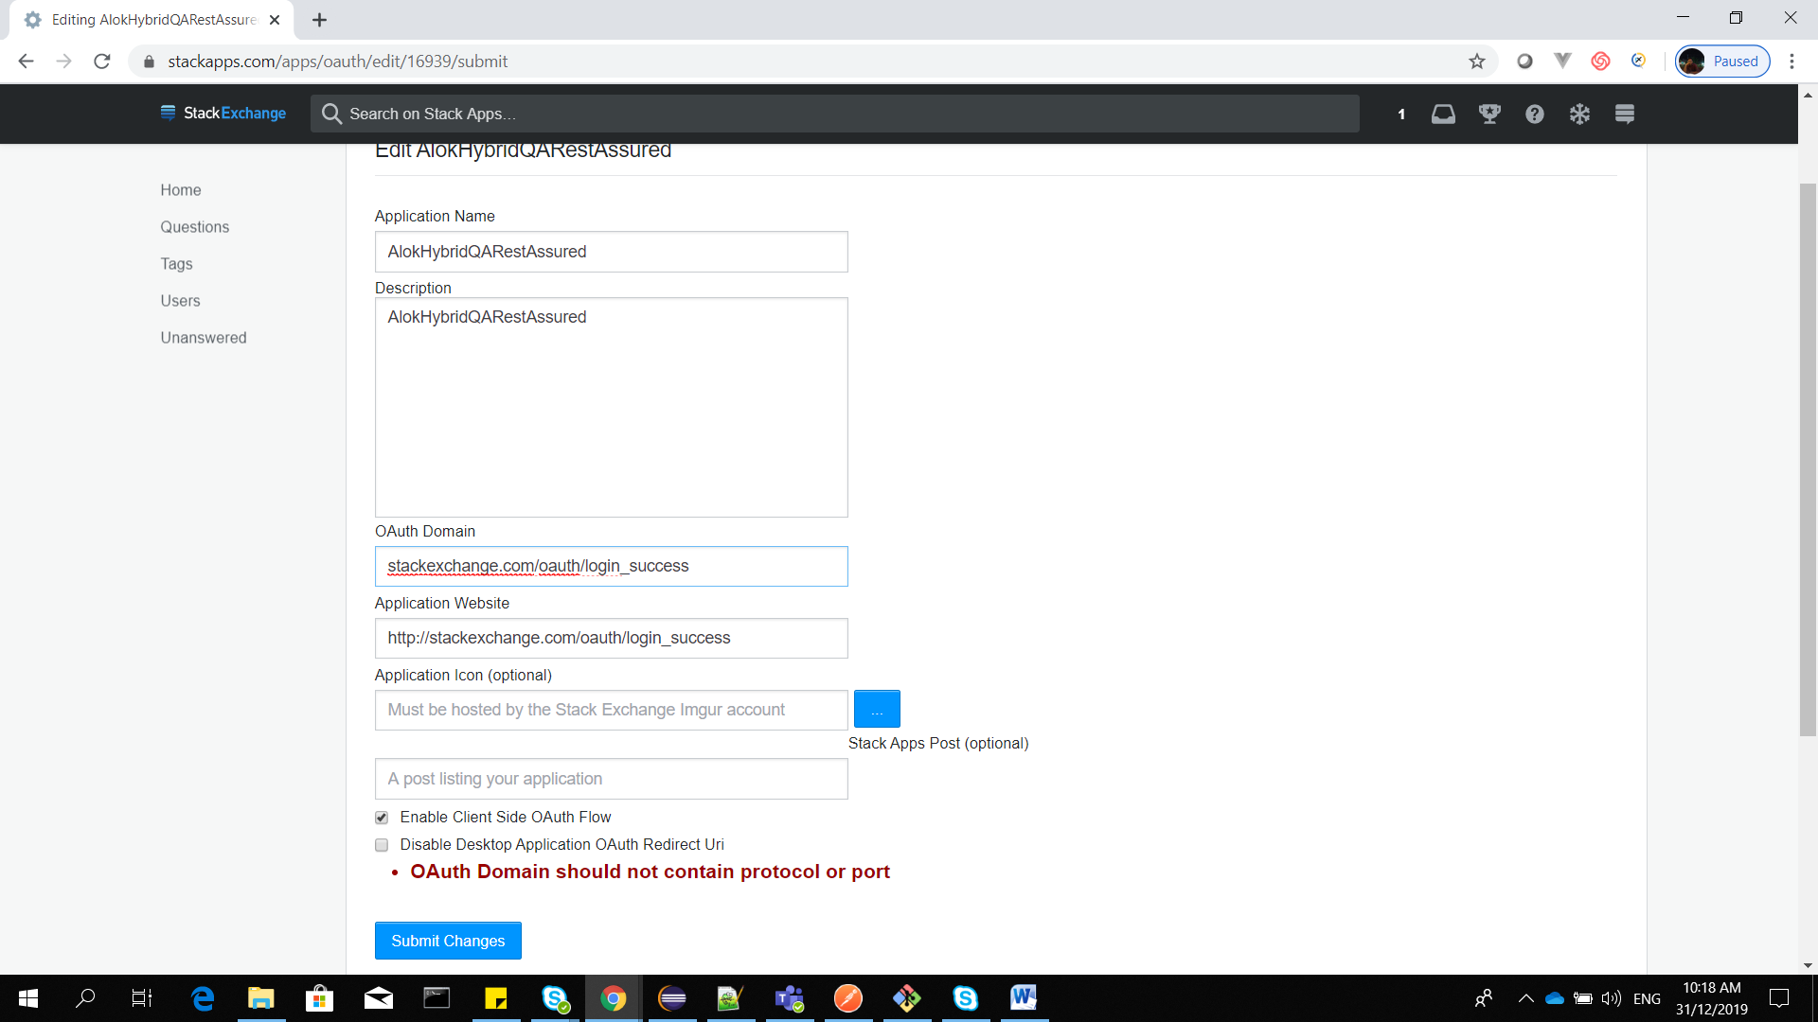

[www.stackexchange.com](http://www.stackexchange.com) /// for them which doent have their own app. Application website

[www.stackexchange.com/oauth/login_success](http://www.stackexchange.com/oauth/login_success) : redirect uri for ouath domain

Check ‘enable client side aouth flow ‘ for default.

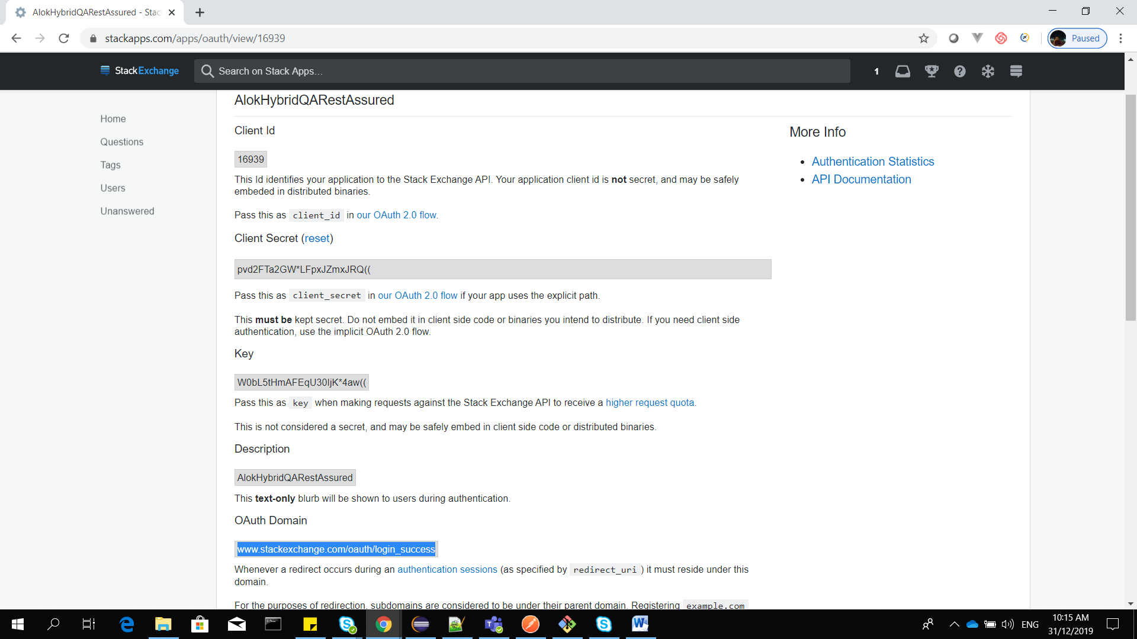

<https://api.stackexchange.com/docs/authentication>

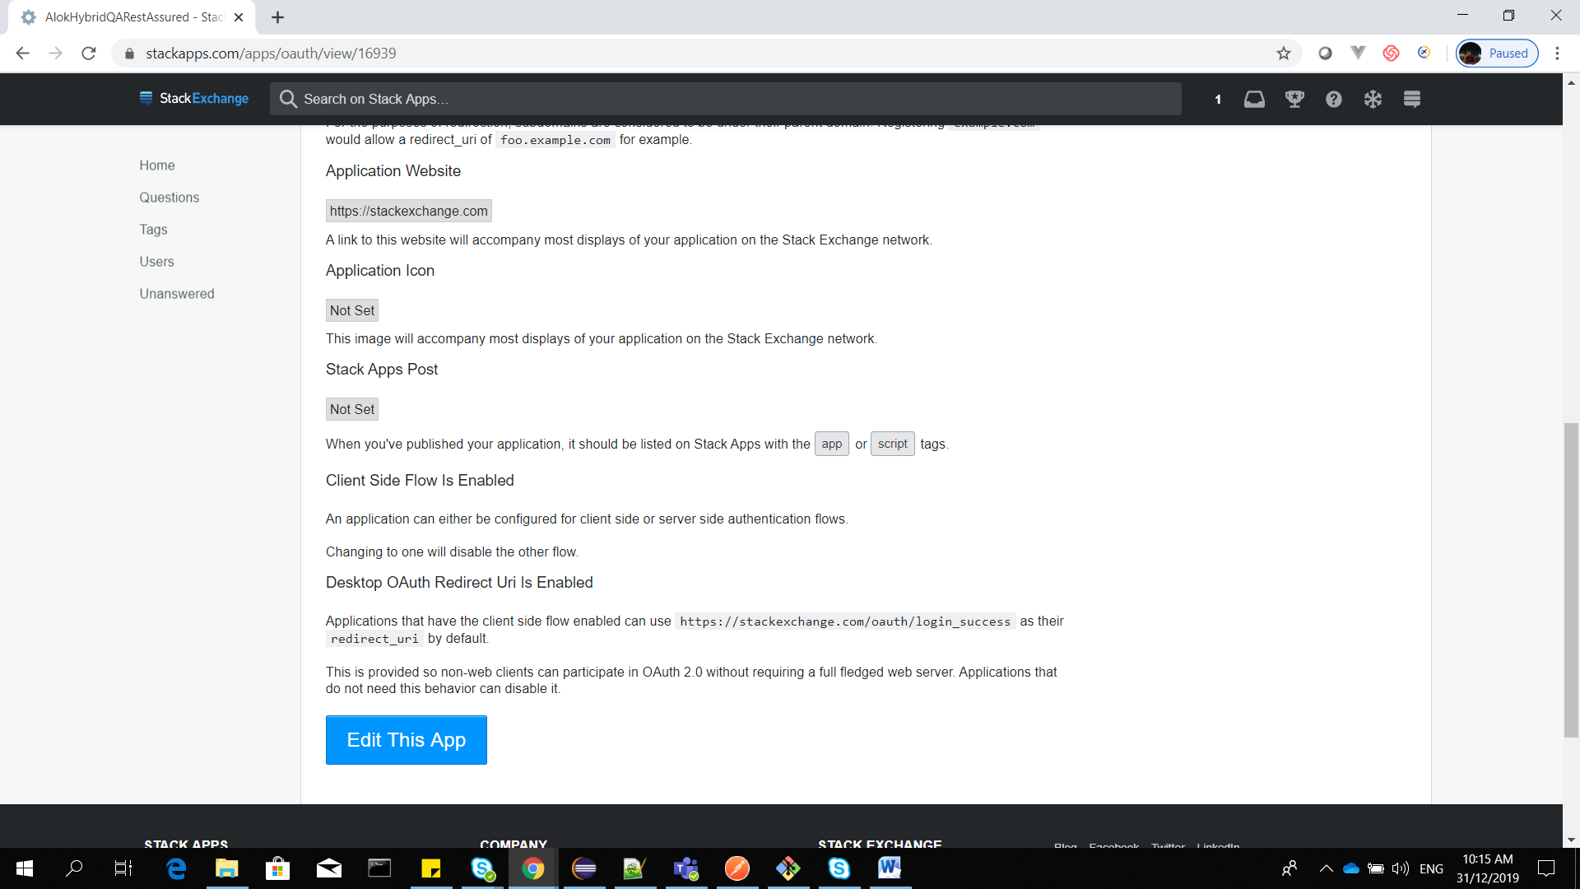

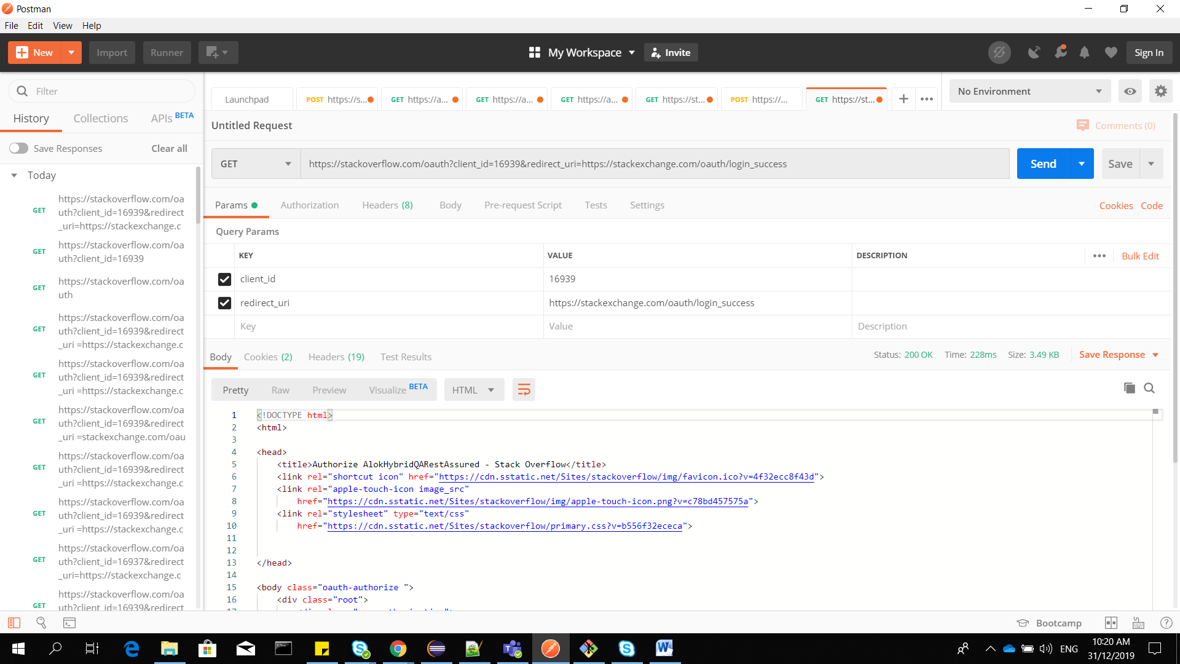

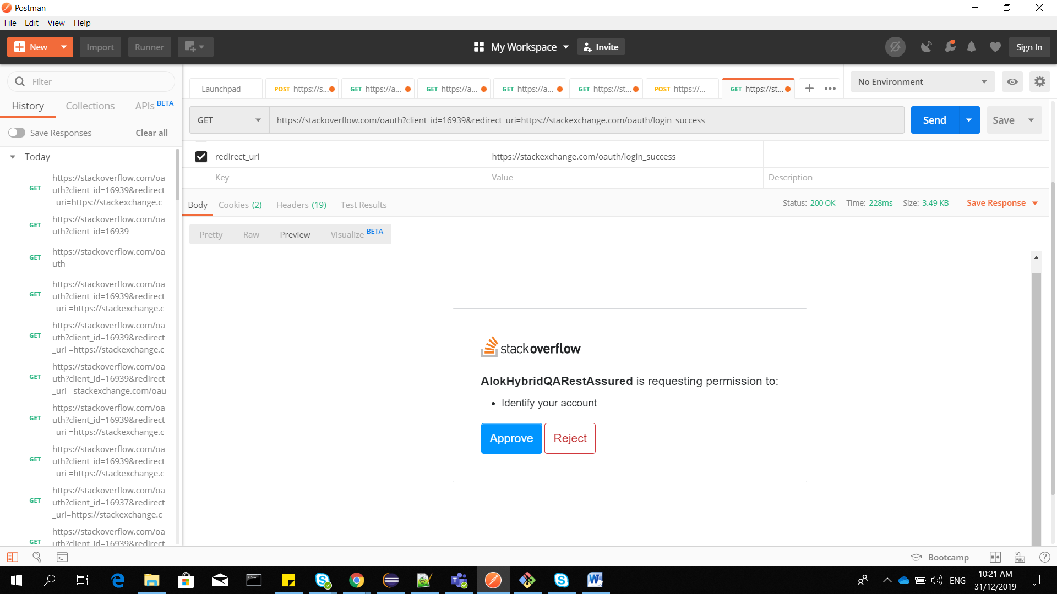

Copy get request URL and paste in chrome

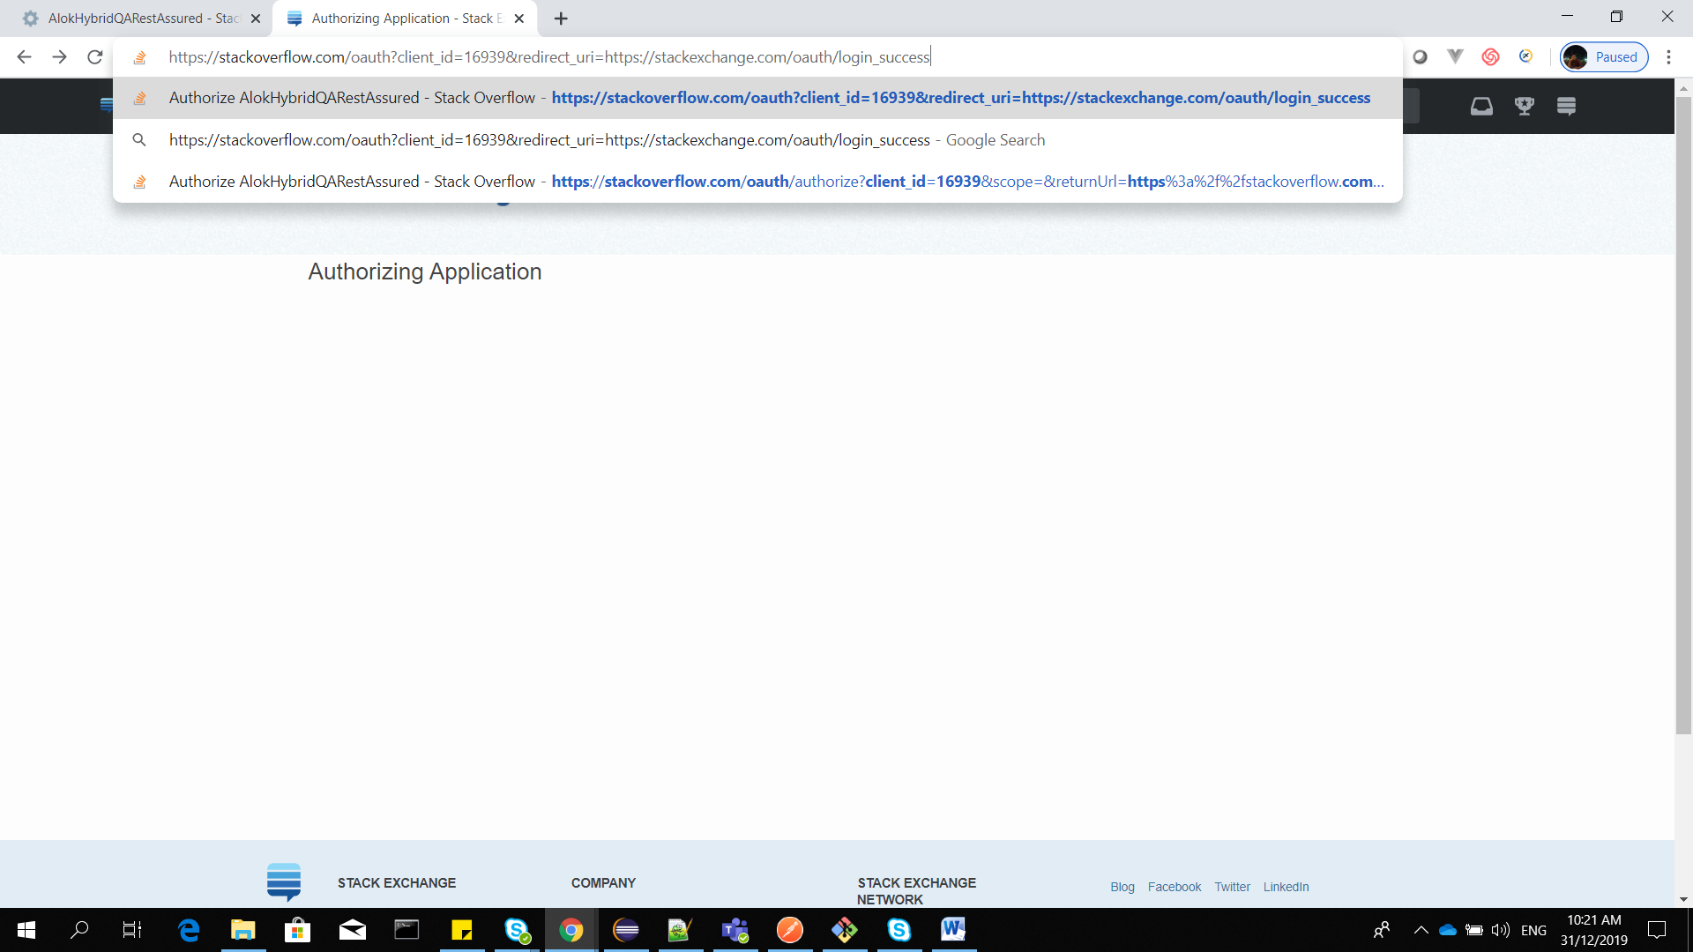

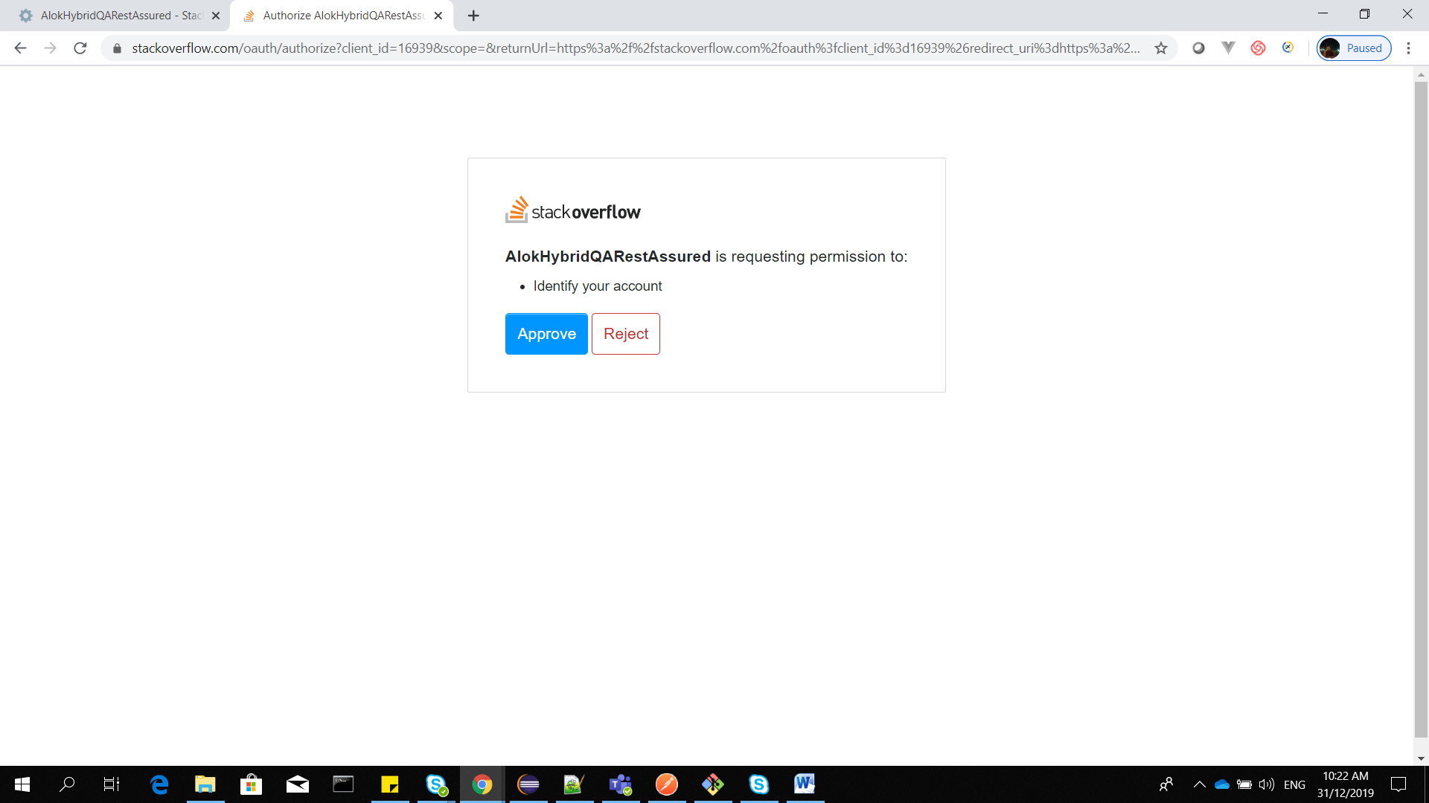

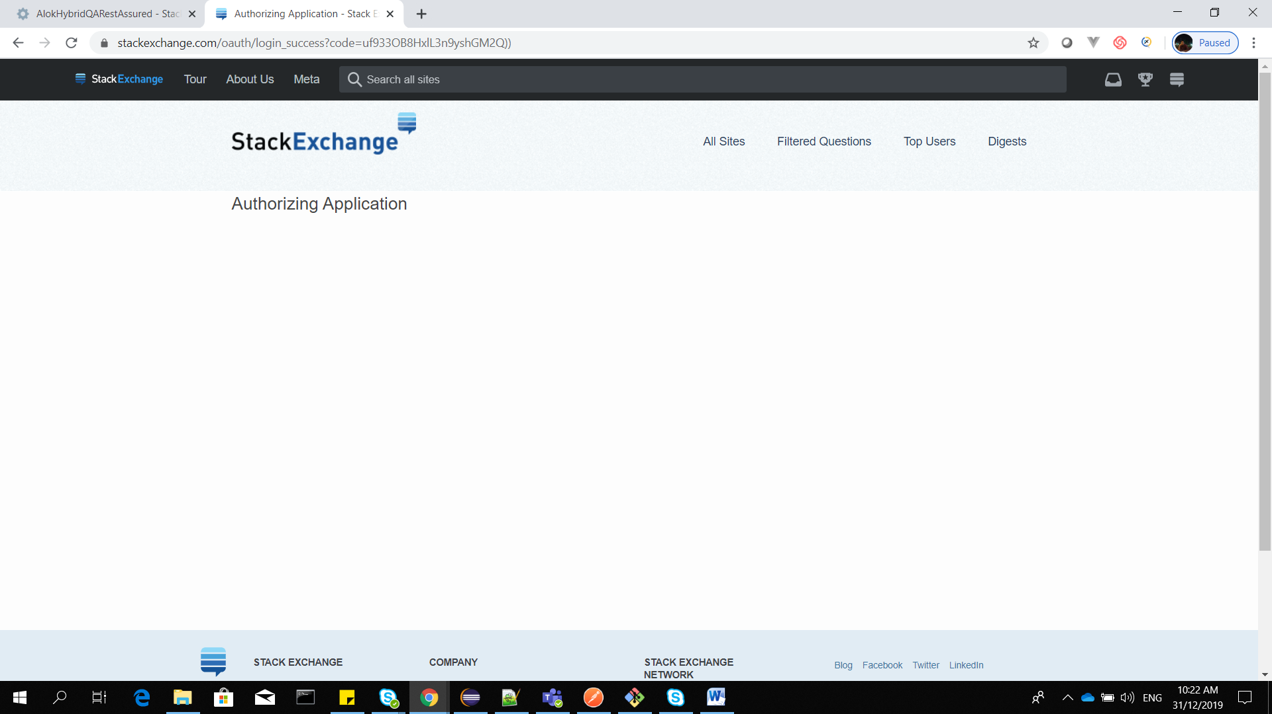

Copy the code from redirect URI.

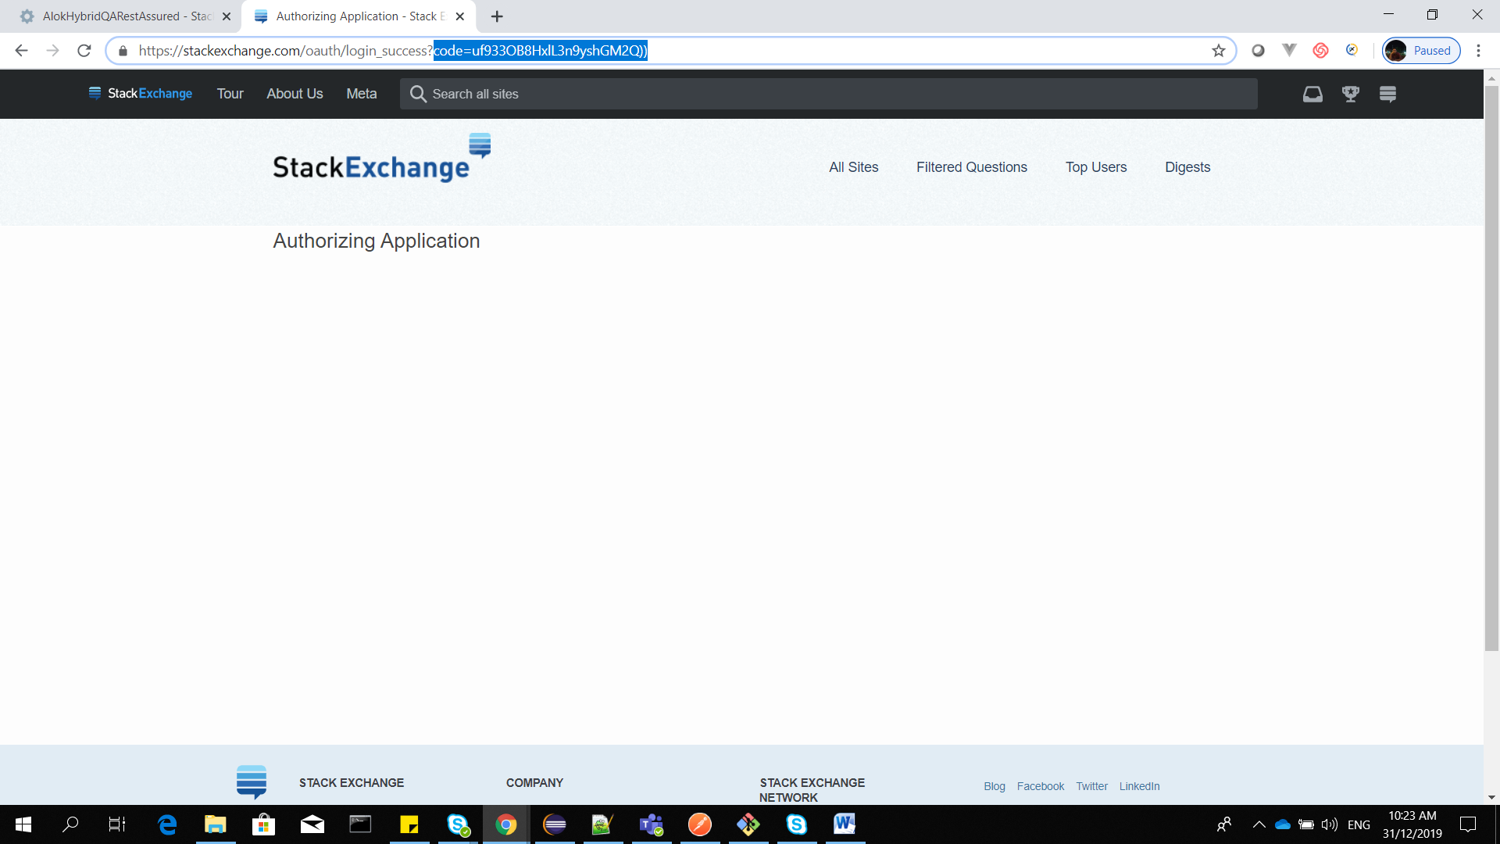

THIS IS EXPLICIT FLOW FOR SERVER SIDE APPLICATION.

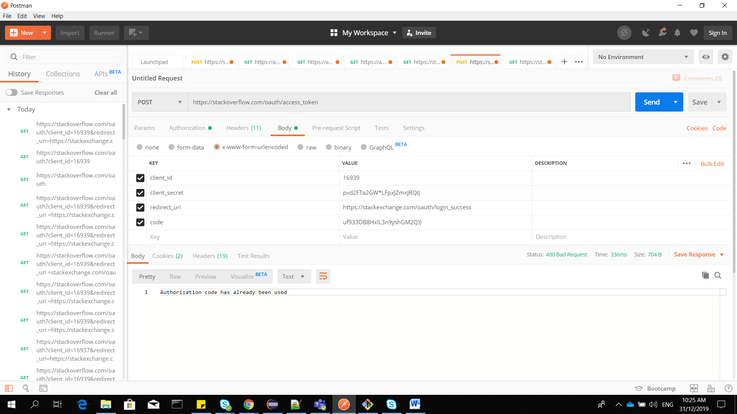

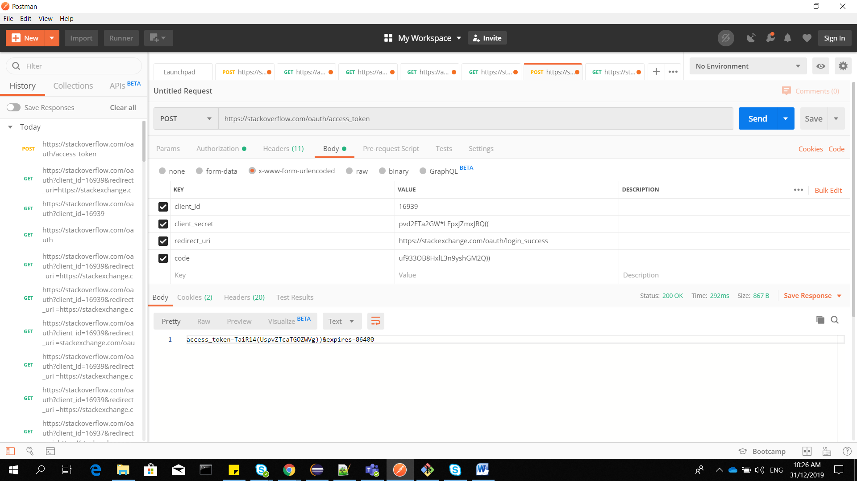

IMPLICIT FLOW FOR CLIENT SIDE APPLICATION .

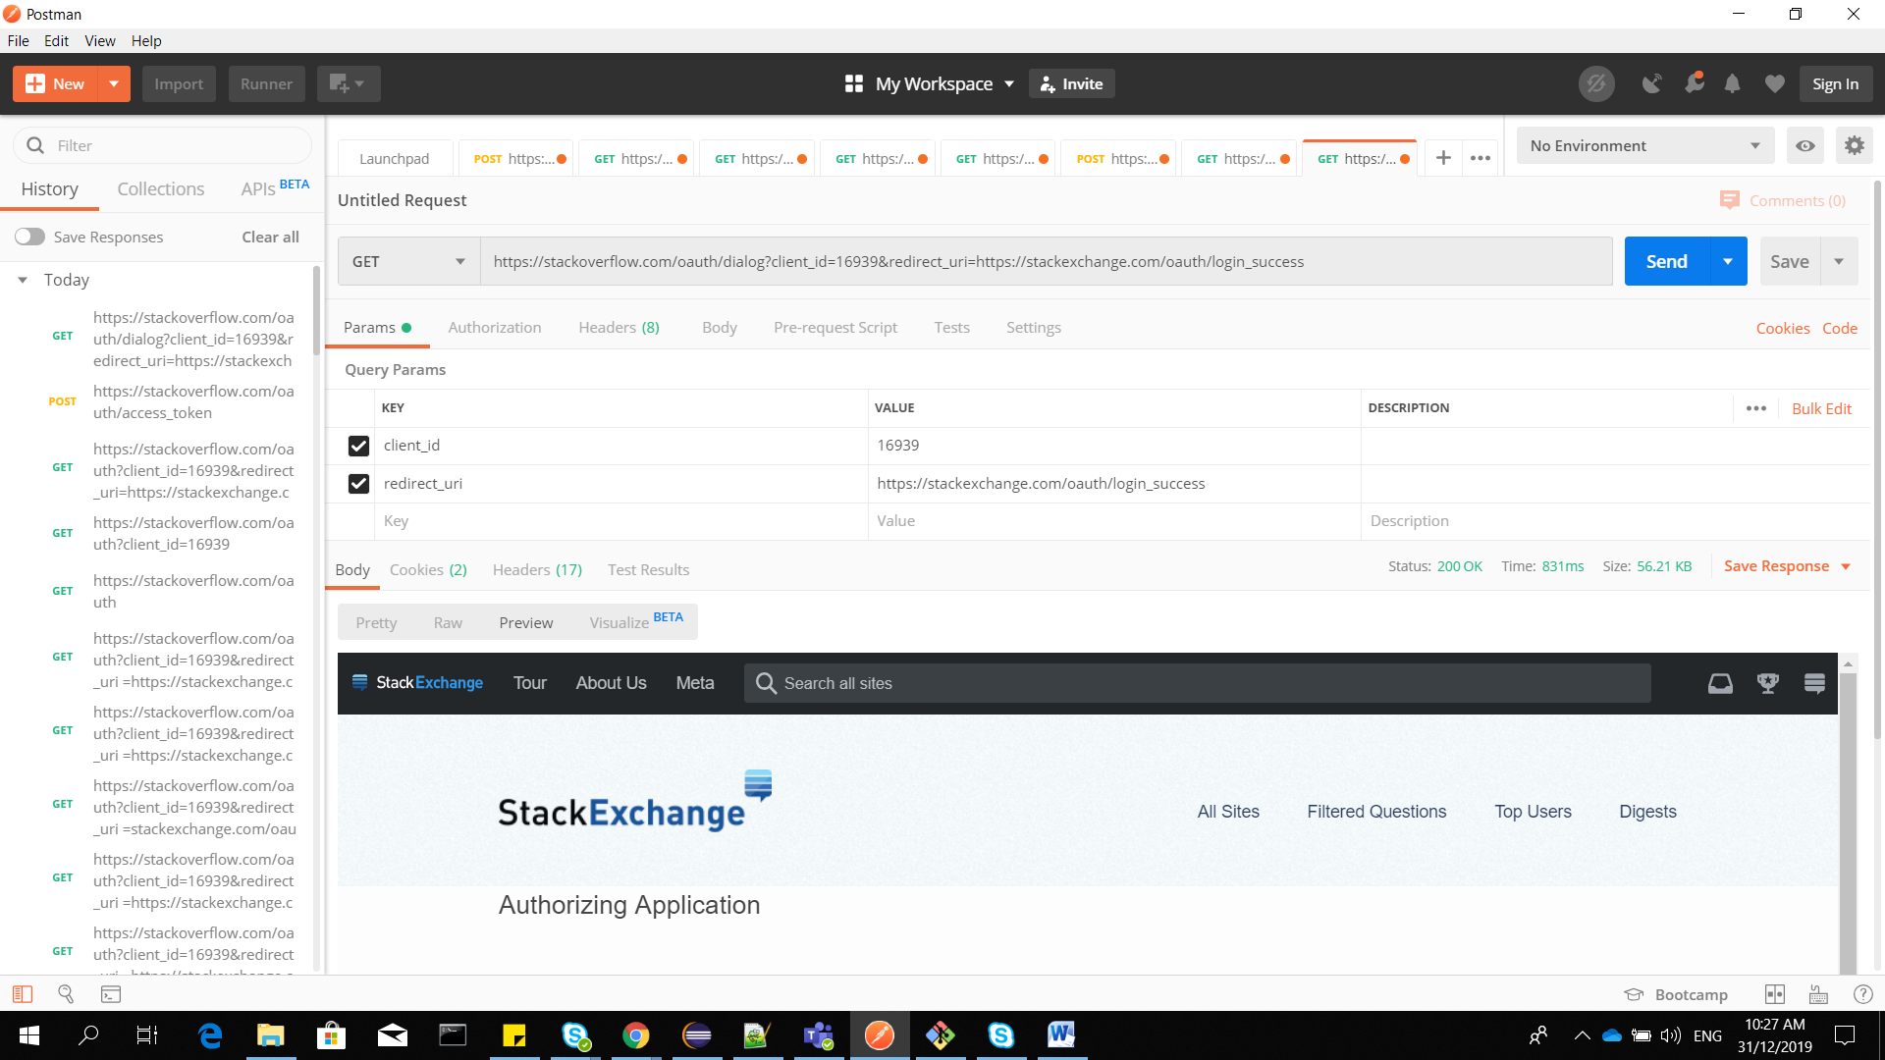

OPEN A GET URL IN CHROME : WE WILL GET ACCESS TOKEN DIRECTLY .

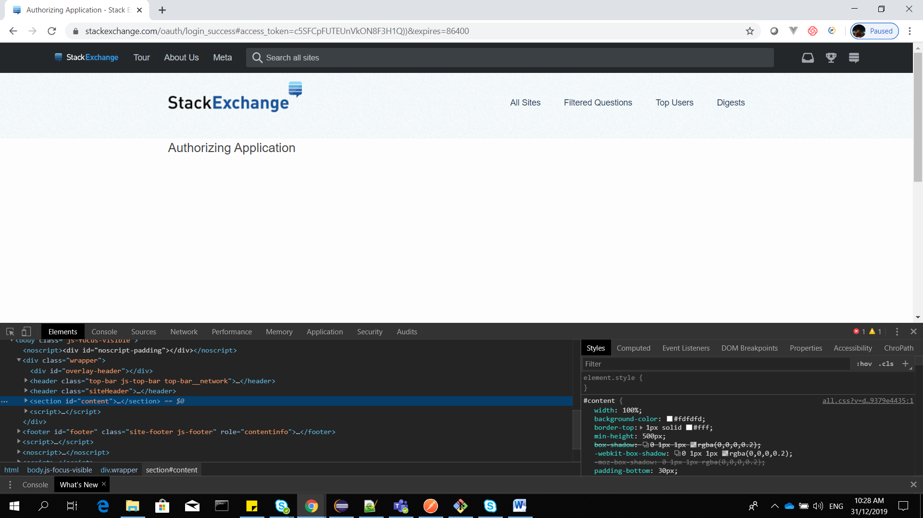

Can access the application as below

