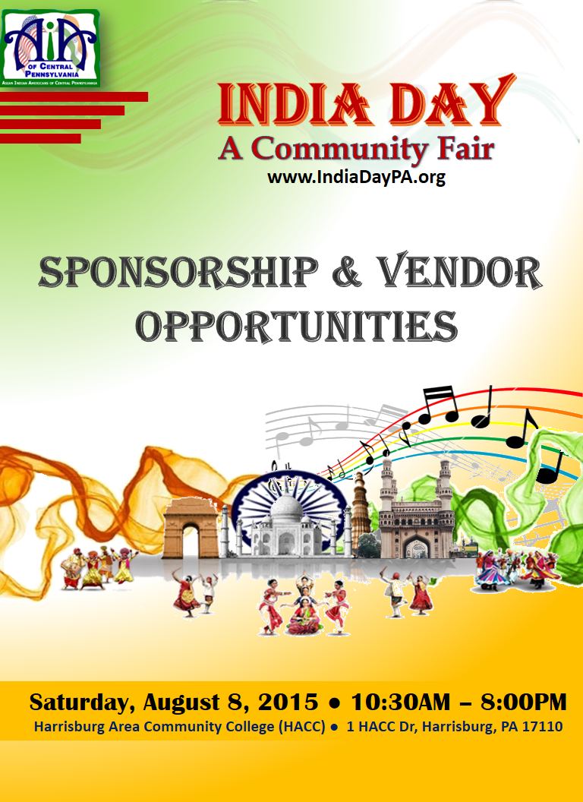

* **Scope**

**------------------**

India Day is one of the most well attended events in the Harrisburg area where all communities come together to experience the rich Indian culture and heritage. Since 1996, Asian Indian Americans of Central PA (AIACPA) has been organizing this event at the Forum auditorium in Harrisburg attracting audience from all over Central Pennsylvania.

Last year, the India Day became “**India Day – A Community Fair**”. The event included Indian music, classical, folk and Bollywood dances, variety of ethnic food, apparels and jewelry from India, and many more attractions. It was held at HACC campus in Harrisburg and was attended by estimated 10,000+ people.

This year also, **India Day** - **A Community Fair** will be held at HACC, Harrisburg Campus on Saturday, August 8th, 2015. The HACC campus includes ample free parking, 400 seat auditorium for performances, lot of room for vendors, live cooking, dining and socializing area, easy access, open green space to stroll, a large tent for outdoor activities and mela (fair) atmosphere.

* **Why sponsor India Day Fair**

**------------------**

For 2015, “**India Day – A Community Fair**” we expect to surpass 2014 estimated 10,000 visitors from all the local communities to enjoy, learn and appreciate rich cultural heritage of India.  Becoming a sponsor/vendor for this event will ensure that your information reaches all these visitors/participants. Each of you will have the ability to directly communicate your message and increase brand recognition by supporting this event.

* **About AIACPA**

**------------------**

Asian Indian Americans of Central Pennsylvania (AIACPA) is a non-profit organization that helps promote cultural richness and education commitment for Central Pennsylvania region. To enable the many events and the causes, AIACPA deeply depends on its partner sponsor’s for their financial support. The organization has been very successful in meeting its objectives in the past 23 years and currently serving over 5,000 Asian Indian families, many organizations, and other families by organizing educational and medical seminars, cultural events, and formal networking events. To enable the many events and the causes, AIACPA, a non-profit organization consistently depends on its partner sponsor’s for their financial support.

**SPONSORSHIP OPPORTUNITIES**

**SPONSORSHIP OPPORTUNITIES**

1. **Premium package $1000**

* Two tables (L Shaped) for vendor display of your company
* Sponsorship of one session of entertainment program
* Full page premium color advertisement in information brochure
* Display of your banner behind your booth

**B. Entertainment Program sponsorship $500**

* Sponsorship of one session of entertainment program
* Display of the sponsor name throughout the session

**C. Premium Color Advertisement in Information Brochure $500**

* Your full page color advertisement in the event brochure

**D. Black & White Advertisement in Information Brochure $250**

* Your B&W full page advertisement in the event brochure

**VENDOR OPPORTUNITIES**

**VENDORS OPPORTUNITIES**

1. **Standard Booth for Food Vendors $400**

* 15 x 10 feet space
* 2 tables (L Shaped) of 6’ each for vendor/display
* Display of your banner behind your booth
* Opportunity to showcase your products and services
* Reach a diverse local community
* Brand awareness before and after the event
* Connect with prospective buyers

1. **Standard Booth for Service Vendors/non-food Vendors $250**

* 10 x 10 feet space
* 2 tables (L Shaped) of 6’ each for display
* Display of banner behind booth
* Opportunity to showcase your products and services
* Reach a diverse local community
* Brand awareness before and after the event
* Connect with prospective buyers

1. **Standard Booth for Jewelry Vendors $500**

* 15 x 10 feet space
* 3 tables (L Shaped) of 6’ each for display
* Display of banner behind booth
* Opportunity to showcase your products and services
* Reach a diverse local community
* Brand awareness before and after the event
* Connect with prospective buyers

1. **Discounted Rate for Multiple Booths**

* For 2 booths of one type, discount of $50 will be given on total cost
* For 3 booths of one type, discount of $100 will be given on total cost

**If you are interested in being a sponsor/vendor, please complete the registration form below. If you have questions, feel free to contact any of the members below:**

**Mr. Virendra Trivedi (President): (717) 756-1034**

**Mr. Pankaj Agarwal: (717) 329-1468**

**Ms. Mridula Mishra: (717) 592-0803**

**Ms. Shabnam Sachdeva: (717)343-9412**

**Mr. Deep Gupta (Chairman): (717) 903-0375**

**Mr. M.G. Patel: (717) 817-2984**

**Mr. Punit Lochan: (717) 315-9900**

**Ms Sue Mukherjee: (717) 329-2773**

**VENDOR OPPORTUNITIES**

**REGISTRATION FORM**

**Name of Business:** ___________________________________

**Contact Person Name:** _____________________________________________

**Address:** ________________________________________________________

__________________________________________________________

**Tel:** _______________________ **Email:** _______________________________

**Number of Booths you need:** _________________ **Total Amount Enclosed $** ____________

*(Make checks payable to ‘****AIACPA****’ & mail to* ***5602 Pinehurst Way Mechanicsburg, PA 17050*** *with this completed registration form)*

**Please provide the following:**

1. Items you plan to sell/display: _____________________________________________

____________________________________________________________________________

1. 110 Volt Electrical outlets needed: _________________________________________
2. Any other special request: ________________________________________________

**I hereby acknowledge and accept all the Terms & Conditions set by AIACPA.**

________________________

Signature of Business Owner

Name: _____________________

Contact Phone: _______________

Email: _______________________

**VENDOR OPPORTUNITIES**

**TERMS & CONDITIONS**

1. Cancellation Policy: On cancellation, AIACPA will only refund booth charges if cancellation is communicated to AIACPA in writing prior to July 15, 2015.
2. All vendors must meet any applicable fire, safety, health and public safety codes/requirements as required by the HACC, and local, state, and federal governments.
3. It is the sole responsibility of the vendor to obtain all required Tax ID’s and remit all necessary taxes to the authorities.
4. Vendor must obtain necessary permit and certificate to conduct the business in City of Harrisburg.
5. Vendor must provide copy of liability insurance to AIACPA by July 15th with AIACPA and HACC listed as an additional insurers.
6. **Vendor is NOT allowed:**

* To use any kind of audio/public address system.
* To display banners outside their booths.
* To distribute any material from outside their booth.
* To pursue any type of fund raising by any means.

1. Decorations and cleanup of the booths is the responsibility of the vendor. All electrical appliances (if requested and permitted), plugs, extensions etc. must be properly secured and taped so that it is not a safety hazard to anyone. In case a vendor is not able to leave the booth as it was handed over to them, any cost to fix it will be responsibility of the vendor.
2. Food vendors must ensure to provide adequate napkins, plates, plastic ware, etc. to their clients.
3. Vendors are responsible to bring their own table covers & skirts
4. Please remember “India Day – A Community Fair” is a community and family event. Vendors are expected to exhibit items which are generally accepted at family events.
5. AIACPA reserves the right to remove any unwanted material or deny a booth to a vendor for not meeting guidelines.

**AIACPA wishes to keep wholesome family fun**