Artificial Intelligence (INT404)

**15 puzzle game**

Report file by:-

Name: Alok Tiwari

Reg. No: 11805178

Roll No. 67

**INTRODUCTION**

**15 Puzzle Game:**

The 15-puzzle (also called Gem Puzzle, BossPuzzle, Game of Fifteen, Mystic Square and many others) is a [sliding puzzle](https://en.wikipedia.org/wiki/Sliding_puzzle) that consists of a frame of numbered square tiles in random order with one tile missing. The puzzle also exists in other sizes, particularly the smaller 8-puzzle. If the size is 3×3 tiles, the puzzle is called the 8-puzzle or 9-puzzle, and if 4×4 tiles, the puzzle is called the 15-puzzle or 16-puzzle named, respectively, for the number of tiles and the number of spaces. The object of the puzzle is to place the tiles in order by making sliding moves that use the empty space.

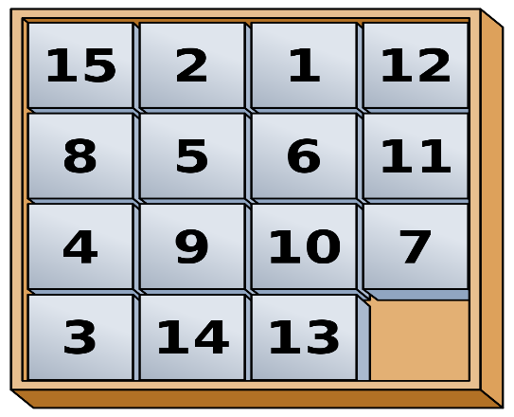

**MODULEs COVERED BY ME**

1. I created the function convert to tuple
2. Convert to list
3. Convert to match
4. Def solve function which solves the puzzle game. Bfs search technique is used to solve this game

**METHODOLOGY AND TECHNIQUE USED**

1. First we created a class board to represent the 15 puzzle game board
2. After that to represent the board on the console of python, we created a function represent(__repr__)
3. To move the empty block we created the four functons that are up,down,left,right.
4. In order to make this a real game, we created the shuffle function using random function, which randomly shuffles the whole board and such that there is a game to solve
5. Finally we implemented the function to solve the board using the breadth for search(BFS) technique since we want to find the shortest path to reach our goal.

**SCREENSHOts of OUTPUT**

When we print the board method on the console, it looks like this:

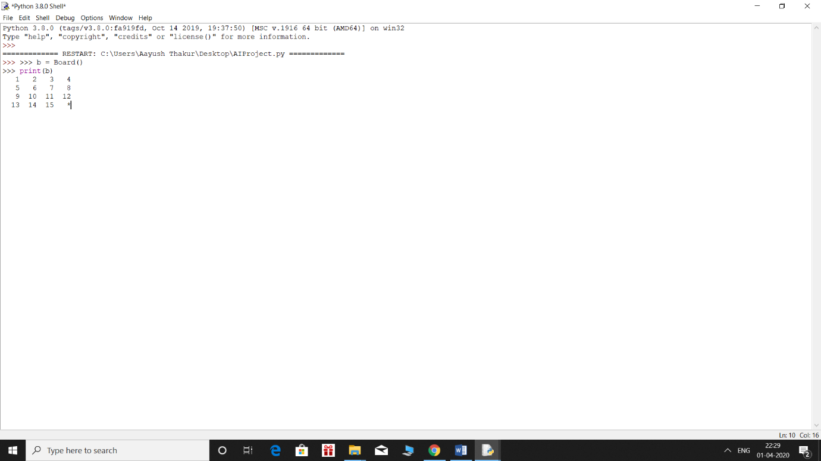

After moving the board looks like this:

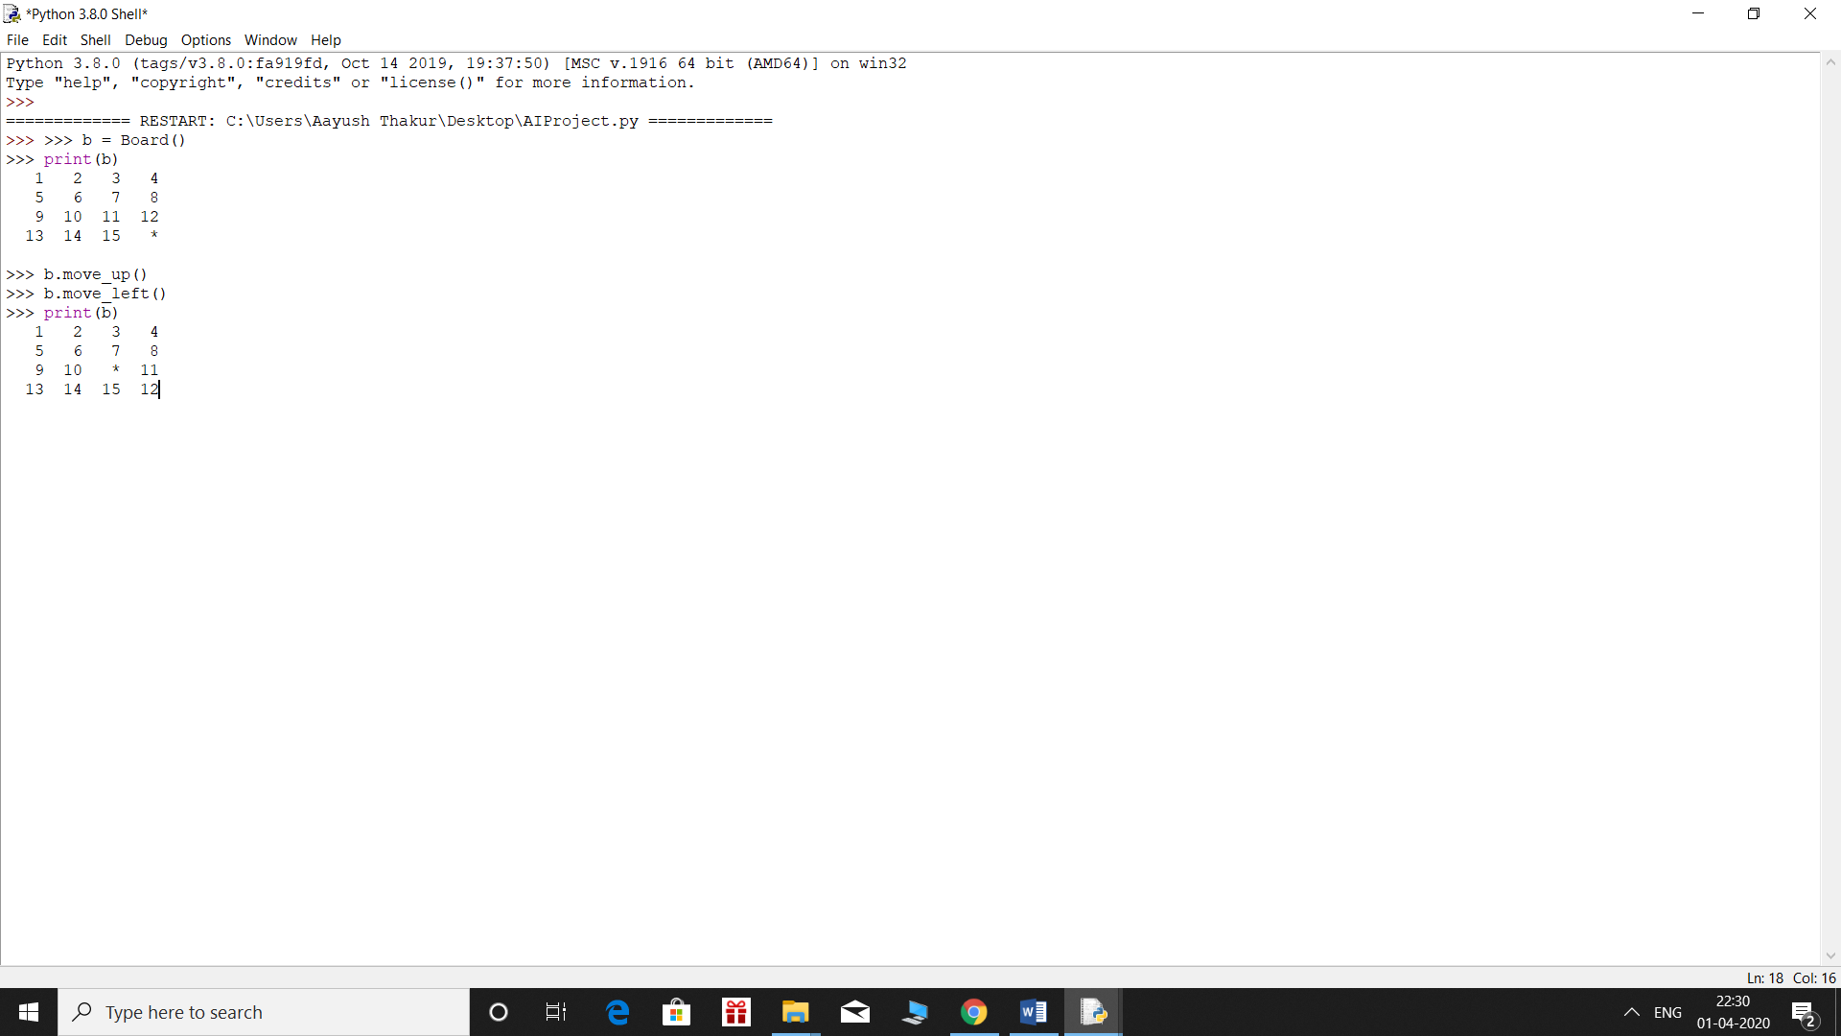

Board after shuffled 100 times: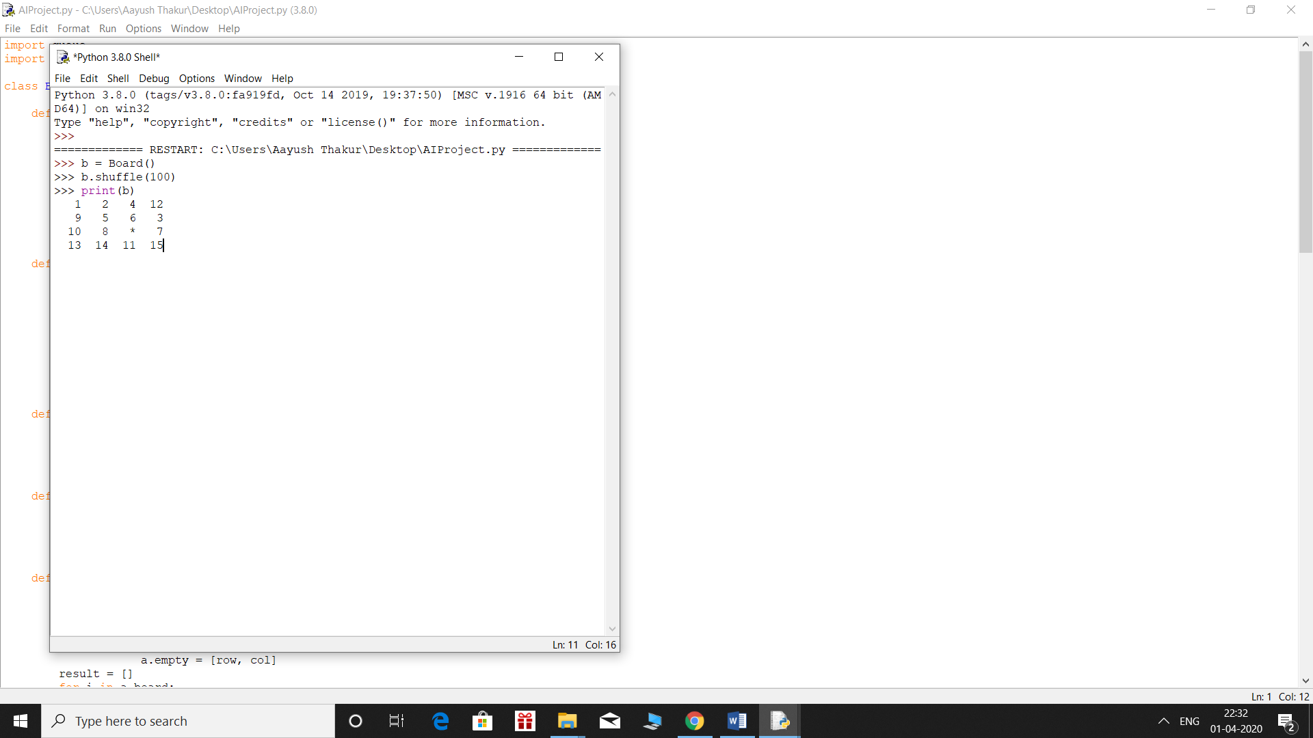

FINAL COMPLETE OUTPUT:

