**Task 5: Git & GitHub Tutorial with Commands.**

Q1. What is Git?

Git is a version control system used to track changes in source code during software development.

Q2. What is GitHub?

GitHub is a cloud-based hosting service that lets you manage Git repositories and collaborate with others.

**For Installation**

Download Git from: <https://git-scm.com/downloads>

To verify installation: git –version

**Commands:**

1. git init

Initializes a new Git repository in your project folder.

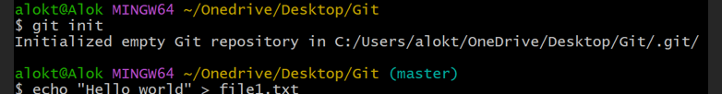

1. git config --global user.name “Alok Kumar Tarini”

Set your name.



1. git config --global user.email “aloktarini28911@gmail.com”

Set your email.



1. git status

Shows the current state of the working directory and staging area.

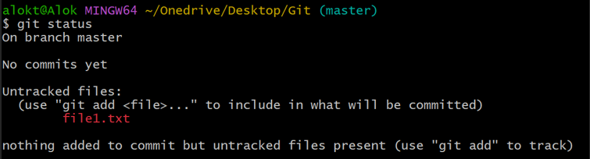

1. git add <file>

Adds a specific file to the staging area.



1. git commit -m "message"

Saves the staged changes with a message.

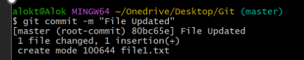

1. git log

Shows the commit history.

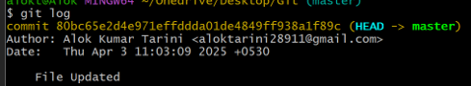

1. git branch

Lists all local branches.



1. git branch <branch_name>

Creates a new branch.



1. git checkout <branch_name>

Switches to a different branch.



1. git checkout -b <branch_name>

Creates and switches to a new branch.

1. git merge <branch_name>

Merges changes from the specified branch into the current branch.

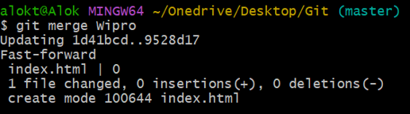

1. git branch -d <branch_name>

Deletes a branch.

1. git rm <file_name>

Deletes the file from your working directory.



1. git ls-files

Exist in the index/staging area.



1. touch filename.txt

Create filename.txt if it doesn't exist.

If it already exists, it updates the last modified timestamp (without changing content).



1. echo "Hello, Alok!"

Prints the message to the terminal.

1. echo "This is a test" > file.txt

Writes "This is a test" into file.txt, **overwriting** if it already exists.



1. echo "Another line" >> file.txt

**Appends** "Another line" to the existing file content.

