**Course Introduction: Django Framework**

Welcome to this course on the Django framework! This course is designed to help you advance your existing knowledge of web development technologies by combining them to create dynamic web applications using Django.

**Overview of Daily Web Activities:**

* Many daily activities can be performed online through various devices like phones, computers, and tablets.
* Web applications often store data in a database, accessed by programming languages like Python.
* Data is retrieved from the database and sent to users through web pages using HTML.

**Course Goal:**

* As an aspiring developer, you will leverage your knowledge of Python, HTML, CSS, and databases to build a dynamic web application with Django.

**Introduction to Django**

**What is Django?**

* Django is an open-source web framework written in Python, used for building large-scale backend web applications.
* To work effectively with Django, you need a good understanding of databases, Python, HTML, and CSS.
* Additionally, you'll learn new tools, concepts, and workflows throughout this course.

**Learning Approach:**

* You will take on the role of a junior developer working for the fictitious restaurant Little Lemon.
* This role-play will provide real-world scenarios to apply your newly acquired knowledge.
* You will work through challenges and implement solutions, focusing on the tools and features of the Django framework.

**Project Scenario:**

* Little Lemon wants to transition from a static website to a dynamic web application.
* Your team is tasked with building the next version of the website using Django.
* You will build a prototype of the new web application and present it to the development team.

**Course Structure**

**Module Breakdown:**

1. **Introduction to Django:**
   * Learn why Django is popular for backend development.
   * Understand the basics of creating a Django web application.
   * Learn about projects and apps within Django, using command-line tools like **django-admin** and **manage.py**.
   * Explore the Model-View-Template (MVT) pattern and code reusability in Django.
2. **Views:**
   * Understand what a view is and how to process HTTP requests.
   * Learn about request and response objects, HTTP methods (GET, PUT, POST, DELETE), and URL patterns.
   * Handle common HTTP errors and learn about class-based views for reusability.
3. **Models:**
   * Use the Django admin panel to manage users and groups.
   * Interact with the database using the QuerySet API.
   * Create forms and bind data to objects using the form API.
   * Set up a MySQL database and apply migrations.
4. **Templates:**
   * Create and use templates to generate HTML.
   * Integrate third-party libraries into your Django app.
   * Explore debugging and testing in Django.
5. **Final Project:**
   * Recap key elements of the course.
   * Complete a project to create a data-driven web application for Little Lemon Restaurant.

**Course Delivery**

**Learning Resources:**

* The course includes many videos to guide you through the learning process.
* You can watch, pause, rewind, and re-watch videos to reinforce your skills.
* Supplement your learning with course readings and exercises.
* Self-check your progress with knowledge quizzes.
* Engage with classmates through discussion prompts to share knowledge and overcome challenges together.

**Study Tips:**

* Commit to a regular and disciplined approach to learning.
* Create a study schedule with dedicated times for the course.
* Treat your study sessions like regular attendance at a learning institute.

**Summary:**

* This course provides a comprehensive introduction to Django and prepares you for a career in backend development.
* By the end of the course, you will have built a dynamic web application and gained valuable skills in Django development.

**Django Framework Overview**

**Introduction to Web Application Frameworks**

When building web applications, developers and development teams have two main choices regarding their code:

1. **Build everything from scratch.**
2. **Use a web application framework.**

A web application framework acts as a toolkit containing all the essential components needed for application development. Using a framework allows developers to focus on the application's unique features instead of spending time developing common features such as user login/authentication and admin dashboards.

**Django Framework Overview**

* **Open Source and Python-Based:** Django is an open-source web development framework written in Python.
* **Origins:** It was initially created for a newspaper publisher's web application, making it excellent for projects requiring **high volumes of text content, media files, and heavy traffic**.
* **Rapid Growth:** Its open-source nature has contributed to its rapid growth and adaptation, leading to its use in a wide variety of web applications.

**Features and Benefits of Django**

* **Integration and Support:** Django allows easy integration with many tools and languages, supported by other Python libraries.
* **Robustness and Security:** It provides robust, secure, adaptable, and scalable functionalities.
* **Components:** Key features include templates, libraries, and APIs that are manageable and scalable.
* **Versatility:** Django is popular in multiple industries, including publishing, eCommerce, healthcare, finance, transport, travel, and social media.

**Use Cases for Django**

1. **Machine Learning and Artificial Intelligence:**
   * Django can deploy machine learning algorithms using APIs, RPCs, and WebSockets.
   * It can handle multiple API endpoints, each with several ML models, enabling fast integration and deployment.
2. **Scalable Web Applications:**
   * Django's ease of scalability makes it popular among tech companies and for web applications with unpredictable user base sizes.
   * Social media apps like **Instagram use Django to handle increasing memory and resource management demands.**
3. **Software as a Service (SaaS) Applications:**
   * Django is suitable for platforms providing services **like data storage, app stores, and version control systems.**
   * It **supports asynchronous views**, allowing services to run concurrently, enhancing performance.
4. **Over-the-Top (OTT) Media Platforms:**
   * Django is used for audio and video streaming services due to its robust and scalable nature.

**Advantages of Django**

* **Cost-Effective:** Being open-source, Django is free, significantly reducing company costs.
* **Fault Tolerance:** It offers good fault tolerance, making it suitable for large projects.
* **Supportive Community:** Django has a supportive open-source community, comprehensive documentation, and strong security features.
* **Avoiding Redundancy:** Similar to Python, Django helps developers avoid reinventing the wheel by providing pre-built solutions for common problems.

**Summary**

In this overview, you learned why Django is a favored framework for building web applications. It provides a robust, scalable, and secure environment that enables developers to focus on creating unique features without worrying about common functionalities. Its versatility and wide industry adoption make it a powerful tool for modern web development.

* **Understanding Basic Website Structure:**
  + Websites consist of HTML (structure), CSS (style), and JavaScript (interaction).
  + Static websites may only need CSS, JavaScript, and image folders.
  + Proper project structure makes updates easier.
* **Complex Web Applications:**
  + Require state management and data storage.
  + Frameworks like Django help manage complex functionality by reducing repetitive coding tasks.
* **Django Framework:**
  + Created following best practices.
  + Structures web applications for easier development.
  + Includes a development server to simplify configuration.
* **Key Concepts in Web Development:**
  + Internet Protocols: HTTP is used for web content requests and responses.
  + Web Server: Required to serve web pages.
  + Stateless Web: Requires a database for storing and retrieving data.
* **Django Project Structure:**
  + A project represents the entire web application.
  + Commands auto-generate the project structure for configuration and settings.
  + Organizes Python files and folders to focus on code rather than configuration.
* **Django Apps:**
  + Sub-modules within a project for specific functionality.
  + Self-contained and reusable across different projects.
  + Follow the DRY principle (don't repeat yourself).
  + Apps include models, views, templates, static files, URLs, and middleware.
  + Generated using the start app command and must be added to the installed apps setting.
  + Application registry maintains metadata in an app config instance for each installed application.
* **Example Structure:**
  + A social media application as a project.
  + Separate apps for news feed, comments, friends list, user page, etc.
* **Developer Focus:**
  + Projects contain many apps.
  + Apps are feature-targeted, each suited to one specific thing.
  + Course will involve working with a project containing only one app.
  + Understanding of all terms and components will develop throughout the course.
* **Understanding Web Frameworks:**
  + Web frameworks provide a structured approach to building web applications.
  + They simplify application development and provide a clean structure.
  + Frameworks promote code reusability and facilitate rapid development.
* **Back-End Development with Django:**
  + Django is a high-level free, open-source Python web framework.
  + It encourages rapid development and clean pragmatic design.
  + Developed by experienced developers, Django takes care of many web development tasks, allowing developers to focus on app logic.
* **Benefits of Using Django:**
  + Speed: Django speeds up development by reducing the amount of code required.
  + Features: Django comes with many features out of the box, such as user authentication, content administration, sitemaps, and RSS feeds.
  + Security: Django helps developers avoid common security mistakes and provides internal middleware for protection against attacks.
  + Scalability: Django allows for flexible data storage configurations, enabling quick and flexible scaling.
* **Three-Tier Architecture:**
  + Modern applications are built using the three-tier architecture.
  + Three logical parts include the presentation tier, application tier, and data tier.
  + The presentation tier is where users interact with the application through user interfaces.
  + The data tier consists of database servers for storing and retrieving information.
  + The application tier ties the presentation and data tiers together, handling data transfer between them.
* **Logical vs. Physical Parts:**
  + The three tiers can run on the same web server, though they are logically separate.
* **Conclusion:**
  + Django is a popular choice for developers due to its speed, features, security, and scalability.
  + The three-tier architecture provides a modular approach to building web applications, with distinct layers for presentation, application logic, and data storage.

•  **Static vs. Dynamic Websites:**

* Static websites only need website files uploaded to a web server.
* Dynamic websites require data retrieval and rendering in the browser.

• **Django Views:**

* Views in Django create logic to present data to users.
* A view is a function handling web requests and returning responses.(like html document)

• **HTTP Request Response:**

* For static files, the server returns the file's content for rendering.
* For dynamic files, a Python function (view) in Django handles the request.

• **Creating a View in Django:**

* Import **HTTPResponse** from **django.http**.
* Define a view function (e.g., **home**) that takes an **HTTP request** object.
* Store the HTML content in a variable.
* Return the content using **HTTPResponse**.

• **View Function Logic:**

* Can process emails, forms, database data, transform data, render templates.
* Should be placed in **views.py** for best practice.(can change any name other than views.py)

• **URL Mapping (Routing):**

* View functions need to be mapped to URLs to work.
* Create **urls.py** in the app directory.
* Import **path** function and **views.py**.
* Use **URL patterns** list to map URLs to view functions.
* The **path** function links routes to views.

• **Key Concepts:**

* View function names and variable names are flexible.
* Proper naming conventions help maintain code readability.
* Routing connects URL paths to their respective view functions.

**W2.2**

* **Homepage Request Handling:**
  + Websites return a homepage when the domain name is requested.
  + In Django, a view function is created to handle HTTP requests and return responses.
* **URL Configuration in Django:**
  + URL configuration maps URLs to views using **urls.py**.
  + Exists at both the project and app levels.
* **URLconf (URL Configuration):**
  + A Python module for designing app URLs.
  + Created and updated in the **urls.py** file.
  + Best practice to have **urls.py** at both project and app levels.
* **Request Handling Process:**
  + User request first handled by the project's **urls.py**.
  + Project's **urls.py** references app's **urls.py** using the **include** function.
* **Include Function:**
  + Allows project-level **urls.py** to access app-level URLs.
  + Path in project-level **urls.py** uses **include** to reference app's **urls.py**.

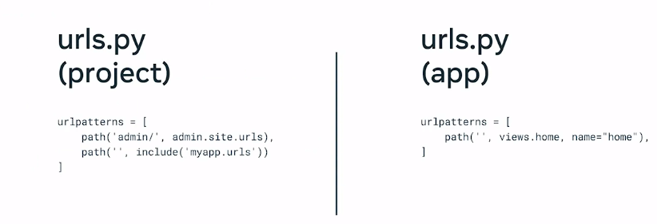

* **Step-by-Step Implementation:**
  + Create a project and app (**myapp**).
  + Run development server (**python3 manage.py runserver**).
  + Create a view in **views.py**:
    - Import **HTTPResponse** from **django.http**.
    - Define **home** function returning **HTTPResponse** with a string.
  + Create **urls.py** in app directory:
    - Import **path** from **django.urls**.
    - Define **URL patterns** list with **path** mapping URLs to views.
    - Import views with **from . import views**.
  + Configure project-level **urls.py**:
    - Import **include** function.
    - Add **path** with **include** pointing to app's **urls.py**.
* **Example Implementation:**
  + In **views.py**:
    - python

Copy code

from django.http import HttpResponse def home(request): return HttpResponse("Welcome to the Little Lemon restaurant")

* + In app-level **urls.py**:
    - python

Copy code

from django.urls import path from . import views urlpatterns = [ path('', views.home), ]

* + In project-level **urls.py**:
    - python

Copy code

from django.urls import path, include urlpatterns = [ path('', include('myapp.urls')), ]

* **Outcome:**
  + Running the development server and accessing the local host URL displays the message "Welcome to the Little Lemon restaurant".
* **Summary:**
  + URL configuration in Django maps URLs at the project level to views at the app level using **urls.py** and the **include** function.

**Key Points from the Passage**

**Overview of HTTP and HTTPS:**

* **HTTPS (Hypertext Transfer Protocol Secure):**
  + Indicated by a lock icon beside the URL in a web browser.
  + Secure version of HTTP using encryption to protect data.
* **HTTP (Hypertext Transfer Protocol):**
  + Core protocol for web communication.
  + Transfers web resources like HTML, images, and styles.
  + Operates on a request-response model.

**HTTP Request Components:**

* **Method:** Action the client wants to perform (e.g., GET, POST, PUT, DELETE).
  + **GET:** Retrieve information.
  + **POST:** Send data to the server.
  + **PUT:** Update existing resource.
  + **DELETE:** Remove a resource.
* **Path:** Location of the resource on the web server.
* **Version:** HTTP protocol version (1.1 and 2.0 are common).
* **Headers:** Additional information about the request (e.g., server name, content type).

**HTTP Response Components:**

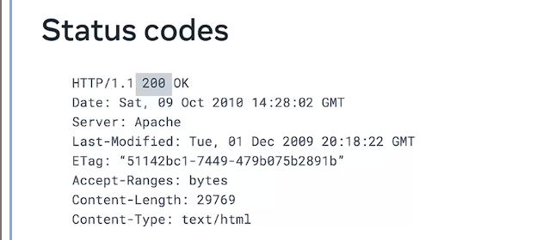

* **Status Code:** Indicates if the request was successful (ranges from 100 to 599).
* **Message Body:** Contains the response content (e.g., HTML document, image file).
* **Status Message:** Text representation of the status code.

**HTTP Status Codes:**

* **Informational (100-199):** Provisional responses (e.g., 100 CONTINUE).
* **Successful (200-299):** Request was successfully processed (e.g., 200 OK).
  + GET: Resource found.
  + POST: Resource successfully transmitted.
  + PUT: Resource successfully updated.
  + DELETE: Resource successfully deleted.
* **Redirection (300-399):** Resource moved to a different path.
  + **301 Moved Permanently:** Resource permanently moved.
  + **302 Found:** Resource temporarily moved.
* **Client Error (400-499):** Issues with the request from the client.
  + **400 Bad Request:** Invalid syntax or bad data.
  + **401 Unauthorized:** Authentication required.
  + **403 Forbidden:** Valid request but insufficient permissions.
  + **404 Not Found:** Resource not found.
* **Server Error (500-599):** Issues on the server side.
  + **500 Internal Server Error:** Generic server failure.

**HTTPS:**

* **Encryption:** Ensures secure communication.
* **Behavior:** Similar request-response model as HTTP but with encrypted content.

**Summary:**

* **HTTP:** Protocol for data exchange on the web.
  + **Requests:** Method, path, version, headers.
  + **Responses:** Status code, message body.
* **HTTPS:** Secure version using encryption to protect data.
* **Usage:** HTTP and HTTPS requests and responses have similar content but HTTPS ensures security through encryption.

Migrations

1. **Model and Querying Data**:
   * Developers can use models to query data directly from code instead of writing SQL commands.
   * Django provides a history of changes to the code base through models.
2. **Django Migrations**:
   * Migrations help with version control of the model code base.
   * Each model in a project has a full history of its creation, additions, and changes.
3. **Schema Changes**:
   * Web application development often requires small incremental changes (e.g., adding attributes or changing attribute names).
   * Migrations ensure that schema changes are applied and updated across all databases.
4. **Applying Migrations**:
   * Developers create changes directly in the model and then apply the migration using migration scripts.
   * Migrations prevent repetition, aligning with Django's "Don't Repeat Yourself" principle.
5. **Migration Files**:
   * Migration files are stored in a migration folder and update automatically after running a migration.
   * The **show migrations** command displays the details of migrations, which are listed with an auto-incremental prefix (e.g., 0001).
6. **Migration Process**:
   * After making changes, developers run the **make migrations** command followed by the **migrate** command.
   * Django creates a **django_migrations** table to track applied migrations, including app, file name, and timestamp.
7. **Migration Table Structure**:
   * The **django_migrations** table includes columns for ID (auto-incremented), app name, migration file name, and timestamp.
8. **Command Specific Migrations**:
   * Migrations can be applied to a specific app by including the app name after the **make migrations** command.
9. **Migration File Contents**:
   * Migration files contain Python code with two main parts: dependencies (previous migrations) and operations (actions performed).
   * Common operations include **CreateModel**, **DeleteModel**, **AddField**, **AlterField**, and **AddIndex**.
10. **Operations and Corresponding SQL Queries**:
    * Example: **DeleteModel** operation generates an SQL query like **DELETE TABLE Customers**.
11. **Summary**:
    * The video covers the history of changes in Django migrations and their role in version control of the model code base.
12. **Understanding Foreign Keys**:
    * Foreign keys in Django are ORM fields representing database table columns.
    * They are used to create relationships between tables.
13. **Example Scenario**:
    * Building an online menu for the Little Lemon restaurant.
    * Creating a table for menu items and categorizing them by cuisine.
14. **Creating Models**:
    * Create two models: one for menu categories and one for menu items.
    * Assign categories to menu items using a one-to-many relationship with foreign keys.
15. **Models Implementation**:
    * In **models.py**, create the **MenuCategory** model with an attribute called **MenuCategory name**.
    * Create the **Menu** model with attributes: **menu_item**, **name**, **price**, and **category_id**.
16. **Assigning Fields**:
    * Use **CharField** for menu item names and **IntegerField** for prices.
    * Add a foreign key to **category_id** using **models.ForeignKey**.
17. **Foreign Key Configuration**:
    * The first field in the foreign key is the class to connect to.
    * The second field is the **on_delete** setting, e.g., **models.PROTECT**.
    * Add a default argument **default=None**.
18. **Updating Admin Configuration**:
    * Update **admin.py** for required imports and register the models.
    * Ensure **settings.py** in the app configuration is updated.
19. **Running Migrations**:
    * Run the server and perform migrations.
    * Migrate the two models created.
20. **Checking the Database**:
    * Open **db.sqlite3** and explore **myapp_menu** and **myapp_menu categories**.
    * Categories listed with IDs (e.g., Italian, Greek, Turkish) correspond to menu items via **category_id_id**.
21. **Improving Readability**:
    * Add **related_name** attribute to the foreign key for intuitive referencing.
    * **related_name="category_name"** makes the menu list the category name instead of **category_id_id**.
22. **Deletion Protection**:
    * With **on_delete=models.PROTECT**, deleting a category does not remove associated menu items.
23. **Summary**:
    * The video covers implementing a one-to-many relationship using foreign keys in Django models.

Forms

1. **Purpose of Web Applications**:
   * **Data Collection**: Web applications often need to gather various types of data from users. This includes personal details for login and authentication, information required during registration for new users, and specifics about orders in online shopping scenarios.
2. **Data Collection with HTML Forms**:
   * **HTML Form Tags**: Forms on the web use HTML tags to define elements where users can input data. These elements include text fields, checkboxes, radio buttons, etc.
   * **Data Submission**: When users submit a form, the data entered is sent to the server for processing. This is typically done via HTTP methods such as GET or POST.
3. **Forms in Django**:
   * **Form Class**: Django provides a form class that developers can use to define forms. This class helps in automatically generating the necessary HTML for form elements based on the class attributes.
   * **Model Forms**: Django can generate forms directly from database models. This reduces the likelihood of errors since the form fields are derived from the model’s schema.
4. **Form Submission**:
   * **POST Request**: The most common method for submitting forms in Django is via a POST request. This method sends the form data in the request body, which the server then processes.
   * **Server-Side Processing**: The backend code handles the incoming data, performing actions such as validation, saving data to a database, or executing business logic.
5. **Creating Basic Forms**:
   * **Example Form**: A basic HTML form to submit a user’s name might include a text input for the name and a submit button.
   * **Form Attributes**: The **action** attribute specifies the URL where the form data should be sent, and the **method** attribute defines the HTTP method (e.g., POST).
6. **Challenges with HTML Forms**:
   * **Complexity**: Manually coding large and complex forms can be difficult and error-prone.
   * **Consistency**: Ensuring that form element names or IDs match the expectations of the backend code can be challenging and lead to bugs.
7. **Advantages of Django Form Class**:
   * **Attribute Definition**: Developers define form fields as class attributes, which Django uses to generate the appropriate HTML elements.
   * **Form Management**: Changes to the form structure are easier to manage since they are centralized in the form class.
   * **Consistency**: The form class ensures that the form fields and their names match what the backend expects, reducing errors.
8. **Example of Form Class**:
   * **NameForm Example**: Create a class **NameForm** that inherits from **forms.Form**.
   * **Field Definition**: Define a field, such as **your_name = forms.CharField(max_length=100)**, which will generate a text input element with validation for a maximum length.
9. **Rendering Forms**:
   * **Manual Form Tags**: While the form class generates input fields, developers need to manually add the form tags (**<form>...</form>**) in the template.
   * **Templating**: Use Django’s templating system to include form fields within the form tags in the HTML file.
10. **Benefits for Developers**:
    * **Ease of Management**: Using form classes makes it easier to update and manage forms.
    * **Object-Oriented Programming (OOP)**: Forms can be split into subclasses, making them modular and easier to handle, especially for complex forms.
11. **Forms with Models**:
    * **Model Representation**: A Django model represents a database table. Fields in the model correspond to columns in the table.
    * **Model to Form**: Django can convert a model into a form, ensuring that the form fields match the database schema.
    * **Error Reduction**: This automatic generation helps eliminate errors that could occur if form fields were manually coded.
12. **Persistence of Data**:
    * **POST Method**: The data submitted via the form using the POST method needs to be stored, often in a database.
    * **User Data**: For example, when registering a new user, details like email, password, and other personal information need to be saved.
13. **Code Structure**:
    * **forms.py**: The code for model-based forms is typically placed in a file named **forms.py** within a Django application.
    * **Model Form Implementation**: This file will contain the form classes that implement the structure of the models they are based on.
14. **Learning Scope**:
    * **Video Content**: The video provides an introduction to using forms in Django, covering the basics of form classes and model forms.
    * **Advanced Features**: There are more advanced features and techniques related to forms in Django, which are beyond the scope of the introductory video but can be explored through additional reading and resources provided at the end of the lesson.

Forms **1.2**

1. **HTML Forms in Web Applications**:
   * Web applications collect data using HTML forms.
   * Forms consist of various elements like input fields, radio buttons, drop-down lists, and checkboxes.
   * Data collected from these forms is sent to the server for processing.
2. **Example Scenario**:
   * Building a customer form for a manager at Little Lemon, containing fields for the customer's name and age.
   * The form will have three input elements: name, age, and a submit button.
3. **Django Form Class**:
   * Django uses a Form class to define the structure and processing logic of forms.
   * Form fields are the building blocks of forms and are crucial for both models and visual representation.
4. **Common Django Form Fields**:
   * **CharField**: Accepts string input, similar to HTML text input.
   * **EmailField**: Accepts email-formatted input, similar to HTML email input.
   * **IntegerField**: Accepts integer input, similar to HTML number input.
   * **MultipleChoiceField**: Offers multiple options, similar to HTML select/option elements.
   * **FileField**: Allows file uploads, similar to HTML file input.
5. **Core Field Arguments**:
   * **Required**: Indicates if the field is mandatory (default is true).
   * **Label**: Specifies a label for the field.
   * **Initial**: Sets an initial value for the field.
   * **Help-Text**: Provides descriptive text for the field.
6. **Building Effective Forms**:
   * Different forms require different data types, like feedback forms or survey forms.
   * Choosing the appropriate field type is essential for effective form design.
7. **Creating a Form in Django**:
   * Start by setting up a Django project and creating a **forms.py** file.
   * Import the **forms** package and define a form class with various fields.
8. **Exploring Form Fields in the Browser**:
   * Create a demo form with a **CharField** and render it in the browser.
   * Modify the form field attributes and observe the changes in real-time.
9. **Form Customization**:
   * Use widgets to change the default behavior of form fields.
   * Example: Change a text input to a textarea and adjust its size using attributes like **rows**.
10. **Email Field Example**:
    * Replace a **CharField** with an **EmailField** to collect email addresses.
    * Observe built-in validation that ensures correct email format.
11. **Adding Labels**:
    * Use the **label** parameter to provide meaningful labels for form fields.
12. **Date Field Example**:
    * Use a **DateField** with a date input widget to allow date selection via a calendar.
13. **ChoiceField Example**:
    * Use **ChoiceField** with a drop-down menu for multiple options.
    * Change to **RadioSelect** to display options as radio buttons.
14. **Exploring More Form Fields**:
    * The examples cover some common form fields.
    * Refer to Django documentation for a comprehensive list of form fields and customization options.
15. **Summary**:
    * The video teaches how to use form fields in Django to handle various data types correctly.
    * Encourages further exploration of Django documentation for advanced form handling techniques.

This passage emphasizes the practical aspects of creating and customizing forms in Django, highlighting common form fields and their uses, as well as how to set up and test these forms in a web application.

Creating Forms

1. **Introduction to Django Forms**:
   * Developers use Django's form class to generate HTML for form elements automatically.
   * This video tutorial focuses on creating and rendering forms using Django's form class, and explores some features like validation.
2. **Setting Up the Form**:
   * **File Creation**: Start by creating a **forms.py** file inside the app directory.
   * **Form Scenario**: Create a form for Little Lemon's website that allows employees to log their entry times.
3. **Creating the Form Class**:
   * **Importing Forms**: Use **from django import forms** to import the necessary module.
   * **Defining the Form Class**: Create a class called **InputForm** that inherits from **forms.Form**.
   * **Form Fields**:
     + **First Name and Last Name**: Character fields with a max length of 200.
     + **Shift**: A choice field for selecting between morning, afternoon, and evening shifts.
     + **Time Log**: A **TimeField** to log entry times.
   * **Choices Constant**: Define the shift choices as a constant iterable of tuples.
4. **Form Code Example**:

python

Copy code

from django import forms SHIFTS = [ ('morning', 'Morning'), ('afternoon', 'Afternoon'), ('evening', 'Evening') ] class InputForm(forms.Form): first_name = forms.CharField(max_length=200) last_name = forms.CharField(max_length=200) shift = forms.ChoiceField(choices=SHIFTS) time_log = forms.TimeField()

1. **Creating the View**:
   * **Importing the Form**: Import the form in **views.py** using **from app_directory.forms import InputForm**.
   * **View Function**:
     + Create a function **form_view**.
     + Instantiate the form and assign it to a variable.
     + Create a context dictionary to pass the form instance.
     + Render the form using the **render** function, specifying **home.html** as the template.
2. **View Code Example**:

python

Copy code

from django.shortcuts import render from app_directory.forms import InputForm def form_view(request): form = InputForm() context = {'form': form} return render(request, 'home.html', context)

1. **Creating the Template**:
   * **Template Directory**: Create a **templates** folder inside the app directory.
   * **HTML Form**: Create **home.html** with an HTML form using the POST method and including a CSRF token for security.
2. **Template Code Example**:

html

Copy code

<form method="post"> {% csrf_token %} {{ form.as_p }} <input type="submit" value="Submit"> </form>

1. **Updating URLs and Settings**:
   * **URLs**: Update **urls.py** to include the path for the form view.
   * **Settings**: Ensure **settings.py** includes the app in the **INSTALLED_APPS** list.
2. **Running the Server**:
   * Use the command **python manage.py runserver** to start the server.
   * Navigate to the form's URL in the browser to see the form rendered on the webpage.
3. **Form Rendering and Validation**:
   * Initially, the form displays without styling.
   * Modify **home.html** to use **form.as_p** for better structure.
   * Django provides basic form validation (e.g., required fields).
4. **Customizing Form Fields**:
   * **Making Fields Optional**: Set **required=False** for optional fields.
   * **Adding Help Text**: Use **help_text** to provide additional information for form fields.
5. **Styling the Form**:
   * Inline styling can be added directly in the HTML template for basic visual adjustments.
   * Example: Adding a background color to the form.
6. **Conclusion**:
   * Django forms simplify and automate much of the form creation process.
   * The video demonstrates form creation and rendering, but form processing and saving are covered later in the course.
7. **Learning Outcomes**:
   * Understand how to create a form using Django's form class.
   * Learn how to render a form using a Django template.
   * Explore basic form validation and customization options in Django.

Sure! Here's a detailed summary of the process described in the passage for using Django's ModelForm to save form data into a database:

1. **Introduction to ModelForm**:
   * You have learned how to create models and forms using Django's class implementations.
   * ModelForm combines models and forms, allowing you to save form data directly to a database.
2. **Example Scenario**:
   * Create a reservation form for Little Lemon restaurant using ModelForm.
3. **Creating the ModelForm**:
   * **Import the Model**: Import the model you want to bind with your form.
   * **Meta Class**: Add implementation details using a Meta class within the form.
   * **Form Instance**: Create an instance of the form.
4. **Code Implementation**:
   * **Form Removal and Model Creation**:
     + Remove the shifts attribute from the existing form.
     + Copy the form content to **models.py** and reconfigure it to match a model definition.
     + Rename the class from **LogForm** to **Logger** to represent the model.
5. **Model Definition**:

python

Copy code

from django.db import models class Logger(models.Model): first_name = models.CharField(max_length=200) last_name = models.CharField(max_length=200) time_log = models.TimeField()

1. **Creating the ModelForm**:
   * **Clear forms.py**: Delete the existing form content.
   * **Import the Model**: **from .models import Logger**.
   * **Define the ModelForm**: Create a class **LogForm** that inherits from **forms.ModelForm**.
   * **Meta Class**: Specify the model and fields in the Meta class.
2. **ModelForm Code Example**:

python

Copy code

from django import forms from .models import Logger class LogForm(forms.ModelForm): class Meta: model = Logger fields = '__all__'

1. **Register the Model in Admin**:
   * **Update admin.py** to register the Logger model.

python

Copy code

from django.contrib import admin from .models import Logger admin.site.register(Logger)

1. **Update the View**:
   * **Basic Configuration**: Ensure the form is rendered using the context dictionary.
   * **Handle POST Requests**: Add code to handle form submission and save the data.
   * **Check Form Validity**: Use **form.is_valid()** to validate and **form.save()** to save the data.
2. **View Code Example**:

python

Copy code

from django.shortcuts import render, redirect from .forms import LogForm def form_view(request): if request.method == 'POST': form = LogForm(request.POST) if form.is_valid(): form.save() return redirect('success_url') # Redirect after POST else: form = LogForm() return render(request, 'home.html', {'form': form})

1. **Run Migrations and Server**:
   * **Migrate the Database**: Run migrations to create the database table.
   * **Start the Server**: Use **python manage.py runserver** to start the server.
   * **Test the Form**: Navigate to the form URL, fill in the details, and submit the form.
2. **Verification**:
   * **Check the Database**: Use an SQLite Explorer to verify that the form data has been saved into the database table.
3. **Conclusion**:
   * The example demonstrates how to use ModelForm to create a form and save the data to the corresponding database table.
   * ModelForm simplifies the process by combining the model and form logic into one class and handling form data persistence.

This summary outlines the process of creating, rendering, and processing a ModelForm in Django, providing a step-by-step guide based on the passage.

1. **Don't Repeat Yourself (DRY) Principle:**
   * Avoid duplication in code to prevent maintenance issues and logical contradictions.
   * Each distinct concept or piece of data should have a single source of truth.
2. **Template Inheritance in Django:**
   * Efficient method to manage common elements (e.g., headers, footers) across multiple pages.
   * Build a base template with common elements assigned to blocks, which can be reused.
3. **Header and Footer:**
   * Header: Contains company name, logo, navigation menu, and user login section.
   * Footer: Includes company/contact details, navigation links, and copyright information.
   * Consistent placement of header and footer enhances user experience and navigation.
4. **Template Inheritance Tags:**
   * **Include Tag:**
     + Used to reference sub-templates (e.g., header, footer).
     + Updates to sub-templates are done once and reflected across all pages.
     + Allows conditions for different renderings using template strings or variables.
     + Independent rendering process without shared state between included templates.
   * **Extends Tag:**
     + Establishes a **parent-child relationship** between templates.
     + Allows child templates **to override blocks** or content from the parent template.
     + Can use **string literals or variable values** to determine the parent template.
5. **Example Use:**
   * Base template for the Little Lemon website, containing common sections (header, footer).
   * Use of **include** and **extends** tags to manage and render these sections efficiently.
6. **Advantages of Template Inheritance:**
   * Saves time by reusing blocks of content.
   * Simplifies updates and ensures consistency across web pages.
   * Enhances maintainability and scalability of web applications.

By following these principles and utilizing template inheritance effectively, developers can create scalable, maintainable, and efficient web applications.

1. **Definition and Importance of Debugging:**
   * Debugging involves identifying, isolating, and solving errors in code.
   * It is crucial for understanding the internal workings of an application.
2. **Challenges of Debugging in Django:**
   * Web projects have multiple interlinked files and dependencies, making debugging complex.
   * Errors in Django can occur at various stages, such as **missing views, incorrect templates, missing imports, inaccessible resources, or syntax errors.**
3. **Django Debugger:**
   * Enabled by default and provides detailed error information in the form of a yellow page.
   * Configured through the **settings.py** file with the **DEBUG** flag.
   * Should not be used in production to avoid exposing sensitive information.
4. **Debugging Steps and Tools:**
   * Launch the development server to identify errors (e.g., 404 errors due to unconfigured URLs).
   * Use the console log to track Python-specific errors.
   * Ensure correct imports and arguments in functions to prevent errors that are not immediately obvious.
5. **Handling Specific Errors:**
   * Missing imports can cause parts of the template to disappear without obvious error messages.
   * Missing CSRF tokens result in "**forbidden CSRF verification failed**" errors.
   * Misconfigured template names result in "template does not exist" errors, which provide exception location and traceback stack details.
6. **Utilizing Tracebacks:**
   * Tracebacks provide sequential order of code execution with highlighted error lines.
   * Can be converted to a cleaner view and shared publicly for further assistance.
7. **Systematic Approach to Debugging:**
   * Debugging requires patience and a systematic approach.
   * Practice helps reduce the number of errors encountered and improves troubleshooting skills.
8. **Third-Party Libraries:**
   * Django can integrate with third-party Python libraries to aid in debugging.

By following these steps and utilizing available tools, developers can effectively debug Django applications and improve their troubleshooting skills.

1. **Importance of Testing:**
   * Testing evaluates **metrics for quality, reliability, and performance, saving developers time.**
   * It ensures the application meets its requirements and performs as expected.
2. **Difference Between Debugging and Testing:**
   * Debugging focuses on identifying and removing errors and bugs.
   * Testing assesses the overall quality, reliability, and performance of the application.
3. **Testing Options in Django:**
   * Various testing packages and tools are compatible with Django.
   * Unit testing is a popular method to test isolated pieces of code such as functions, classes, or methods.
4. **Unit Testing Basics:**
   * Tests target granular features, producing pass, fail, or error results.
   * Use the **unittest** module in Python, which Django extends with the **TestCase** class.
5. **Creating Unit Tests in Django:**
   * Create a test class that inherits from **TestCase**.
   * Import necessary modules and the model to be tested.
6. **Example: Testing a Reservation Model:**
   * **Models Definition:**
     + Create a **Reservation** model with fields like **first_name**, **last_name**, and **booking_time**.
     + Use **auto_now=True** to automatically log the current time for **booking_time**.
   * **Test Case Class:**
     + Define a **ReservationModelTest** class inheriting from **TestCase**.
     + Use the **setUpTestData** method to set initial data for testing.
     + Write test methods such as **test_fields** to check data types and **test_timestamps** to verify timestamps.
7. **Running Tests:**
   * Use **python manage.py test** to run all tests.
   * Use specific commands to run tests for particular files, classes, or methods.
   * Example commands:
     + **python manage.py test reservations**
     + **python manage.py test reservations.tests.ReservationTestCase**
     + **python manage.py test reservations.tests.ReservationTestCase.test_seat_count**
8. **Organizing Tests:**
   * Small projects may use a single **tests.py** file.
   * Larger projects may organize tests into multiple files like **test_models.py** and **test_views.py**.
9. **Example Walkthrough in VS Code:**
   * Create a **Reservation** model in **models.py**.
   * Write tests in **tests.py** to check model fields and timestamp.
   * Run migrations if a new model is created.
   * Use **assert** statements to validate test conditions.
   * Decorate class methods with **@classmethod**.
10. **Debugging Tests:**
    * Modify a field type to observe test failures and assertion errors.
    * Understand test results: dots (**.**) indicate passes, and **f** indicates failures.
11. **Additional Testing Options:**
    * Django supports many configurations and testing options for comprehensive testing beyond basic unit tests.

By implementing these testing strategies and utilizing Django's built-in testing framework, developers can ensure their applications are robust, reliable, and performant.

IBM COURSE DJANGO AND SQL

1. **Definition of Data**:
   * **Concept**: Data is a collection of facts in various forms, such as words, numbers, or pictures.
   * **Importance**: Data is a critical asset for businesses, used and collected in numerous areas (e.g., banking, credit card companies, PayPal).
2. **Importance of Data**:
   * **Usage**: Data is used everywhere and must be secure and accessible quickly.
   * **Solution**: Databases are used to manage, store, and access data efficiently.
3. **What is a Database?**:
   * **Definition**: A database is a collection of data or information designed for input, storage, search, retrieval, and modification.
   * **Function**: Facilitates organized and efficient data management.
4. **Database Management System (DBMS)**:
   * **Definition**: A set of programs that creates and maintains a database.
   * **Function**: Allows storing, modifying, and extracting information using querying.
   * **Example**: Finding inactive customers using a query to retrieve data from the database.
5. **Interchangeable Terms**:
   * **Note**: Although a database and DBMS are different, the terms are often used interchangeably.
6. **Types of Databases**:
   * **Factors Influencing Choice**: Data type and structure, querying mechanisms, latency requirements, transaction speeds, and intended use.
7. **Relational Databases (RDBMS)**:
   * **Structure**: Organized into tables with rows and columns, following a well-defined schema.
   * **Optimization**: Optimized for operations and querying involving multiple tables and large data volumes.
   * **Query Language**: Uses Structured Query Language (SQL).
8. **Non-Relational Databases (NoSQL)**:
   * **Emergence**: Developed to handle the volume, diversity, and speed of modern data generation.
   * **Influences**: Advances in cloud computing, the internet of things, and social media.
   * **Features**: Built for speed, flexibility, and scale; allows schema-less or free-form data storage.
   * **Usage**: Commonly used for big data processing.

These points highlight the significance of data, the role of databases and DBMS in managing data, and the differences between relational and non-relational databases.

Relational Databases

1. **Definition and Structure of Relational Databases**:
   * **Concept**: Relational databases organize data into tables that can be linked based on common data fields.
   * **Example**: A Customer Table with columns like Customer ID, Name, Address, and Phone. A Transaction Table with columns like Transaction Date, Customer ID, Amount, and Payment Method. These tables can be linked via the Customer ID.
2. **Linking Tables**:
   * **Purpose**: Linking tables based on common fields allows for complex queries that can generate new tables from existing data, enabling comprehensive data analysis and reporting.
   * **Example**: Generating a customer statement by querying the Customer Table and Transaction Table based on Customer ID.
3. **Structured Query Language (SQL)**:
   * **Usage**: SQL is the standard language for querying relational databases, allowing for efficient data retrieval and manipulation.
   * **Advantage**: Capable of processing large volumes of data quickly and efficiently.
4. **Advantages of Relational Databases**:
   * **Optimized Storage and Retrieval**: Designed to handle large volumes of data with optimized storage and querying capabilities.
   * **Data Integrity**: Enforces data types and values to ensure consistency and integrity.
   * **Security**: Provides controlled access and ensures compliance with data governance standards.
   * **Scalability**: Ranges from small desktop systems to massive cloud-based systems.
   * **Popular Systems**: Examples include IBM DB2, Microsoft SQL Server, MySQL, Oracle Database, PostgreSQL, and cloud-based services like Amazon RDS, Google Cloud SQL, and SQL Azure.
5. **Key Features**:
   * **Flexibility**: SQL allows adding columns, tables, and other changes while the database is running.
   * **Reduced Redundancy**: Minimizes data duplication by linking tables, e.g., customer information appears only once in the Customer Table.
   * **Ease of Backup and Recovery**: Offers easy export/import options and continuous mirroring for cloud databases.
   * **ACID Compliance**: Ensures atomicity, consistency, isolation, and durability of transactions, maintaining data accuracy and consistency.
6. **Use Cases**:
   * **Online Transaction Processing (OLTP)**: Suitable for high-rate transaction tasks, supporting many users with frequent updates and fast response times.
   * **Data Warehousing**: Optimized for online analytical processing (OLAP) to analyze historical data for business intelligence.
   * **IoT Solutions**: Ideal for collecting and processing data from edge devices needing a lightweight database solution.
7. **Limitations**:
   * **Semi-Structured and Unstructured Data**: Not suitable for extensive analytics on such data types.
   * **Schema Requirements**: Migration between RDBMSs requires identical schemas and data types.
   * **Field Length Limitations**: Restricts the amount of information stored in a data field.
   * **Data Evolution**: Despite advancements in big data, cloud computing, IoT, and social media, RDBMS remains predominant for structured data.

By understanding these points, one can appreciate the role, advantages, and limitations of relational databases in managing and processing structured data efficiently.

**Non_Relational Databases**

1. **Definition and Concept of NoSQL**:
   * **Term**: NoSQL stands for "Not Only SQL" or sometimes "Non SQL."
   * **Design**: It is a non-relational database design providing flexible schemas for data storage and retrieval.
   * **Popularity**: NoSQL databases have gained popularity with the rise of cloud computing, big data, and high-volume web and mobile applications.
2. **Characteristics of NoSQL Databases**:
   * **Flexible Schemas**: Allows for storing data in a schema-less or free-form fashion, accommodating structured, semi-structured, and unstructured data.
   * **Specific Data Models**: Built for specific data models without traditional row-column table design with fixed schemas.
   * **Querying**: Typically do not use SQL for querying, though some may support SQL or SQL-like interfaces.
3. **Types of NoSQL Databases**:
   * **Key-Value Store**:
     + **Structure**: Data is stored as key-value pairs.
     + **Use Cases**: Ideal for storing user session data, user preferences, real-time recommendations, targeted advertising, and in-memory data caching.
     + **Examples**: Redis, Memcached, DynamoDB.
   * **Document-Based**:
     + **Structure**: Each record and associated data are stored within a single document.
     + **Use Cases**: Suitable for e-commerce platforms, medical records, CRM platforms, and analytics platforms.
     + **Examples**: MongoDB, DocumentDB, CouchDB, Cloudant.
   * **Column-Based**:
     + **Structure**: Data is stored in columns rather than rows; columns that are accessed together are grouped into column families.
     + **Use Cases**: Good for systems with heavy write requests, time series data, weather data, and IoT data.
     + **Examples**: Cassandra, HBase.
   * **Graph-Based**:
     + **Structure**: Uses nodes (circles) to store data and edges (arrows) to represent relationships.
     + **Use Cases**: Effective for visualizing and analyzing connected data, social networks, real-time recommendations, network diagrams, fraud detection, and access management.
     + **Examples**: Neo4J, CosmosDB.
4. **Advantages of NoSQL Databases**:
   * **Handling Large Volumes**: Efficiently handles large volumes of structured, semi-structured, and unstructured data.
   * **Distributed Systems**: Can run as distributed systems across multiple data centers, leveraging cloud computing infrastructure.
   * **Scalability and Performance**: Offers scale-out architecture with cost-effective hardware, adding capacity and performance by adding new nodes.
   * **Agility and Flexibility**: Simplified design and better control over availability and scalability, enabling quicker iterations and deployments.
5. **Comparison with Relational Databases (RDBMS)**:
   * **Schemas**: RDBMS uses rigid schemas, whereas NoSQL databases are schema-agnostic.
   * **Cost**: Maintaining RDBMS is expensive compared to NoSQL databases, which are designed for low-cost hardware.
   * **ACID Compliance**: RDBMS supports ACID compliance for transaction reliability and crash recovery, while most NoSQL databases do not.
   * **Maturity and Risk**: RDBMS is a mature, well-documented technology with predictable risks, whereas NoSQL is newer and still evolving.
6. **Use Cases for NoSQL**:
   * **Mission-Critical Applications**: Increasingly used for critical applications due to their scalability, flexibility, and ability to handle diverse data types.
   * **Modern Applications**: Suitable for applications requiring high performance, scalability, and flexibility.

By understanding these points, one can appreciate the role, advantages, and limitations of NoSQL databases in managing and processing data in modern, high-volume applications efficiently.

**Relational Data Concepts**

1. **Introduction to Database Models**:
   * **Purpose**: The video covers different types of database models, how data is mapped to tables, and how relationships between tables are defined.
   * **Objectives**: By the end of the lesson, you will be able to explain the relational model's advantages, map entities and attributes to tables, differentiate between entities and attributes, identify common data types, and understand primary keys' function.
2. **Relational Model**:
   * **Popularity**: The relational model is the most used data model for databases because it allows for data independence.
   * **Advantages**:
     + **Logical Data Independence**: Changes in the logical structure of the database do not affect the physical data.
     + **Physical Data Independence**: The physical storage of data is independent of its logical structure.
     + **Physical Storage Independence**: Changes in the storage structure do not affect the database's logical structure.
3. **Entity Relationship (ER) Data Model**:
   * **Alternative Model**: The ER model is an alternative to the relational model, used as a tool to design relational databases.
   * **Concept**: Represents databases as collections of entities and relationships between them.
   * **Example**: In a library database:
     + **Entities**: Books, Authors, Copies, Borrowers.
     + **Relationships**: Books can have multiple authors, and each copy of a book can be borrowed by one borrower at a time.
4. **Building Blocks of ER Diagram**:
   * **Entities**: Objects that exist independently (e.g., Book, Author).
     + **Representation**: Entities are drawn as rectangles in an ER diagram.
   * **Attributes**: Data elements that characterize the entity (e.g., Book Title, Edition).
     + **Representation**: Attributes are drawn as ovals in an ER diagram.
5. **Mapping Entities to Tables**:
   * **Process**: Entities become tables, and attributes become columns in those tables.
   * **Example**: The "Book" entity becomes the "Book" table with attributes like Title, Edition, and Year becoming columns.
6. **Data Types for Attributes**:
   * **Characters**: Varchar (variable length) and Char (fixed length).
   * **Numbers**: Integer, Decimal.
   * **Timestamps**: Date, Time.
   * **Example**: In the "Book" table, the Title might use Varchar, Edition might use Integer, and ISBN might use Char.
7. **Primary Keys and Foreign Keys**:
   * **Primary Key**: Uniquely identifies each row in a table, preventing duplication of data.
     + **Function**: Provides a way to define relationships between tables.
   * **Foreign Key**: A primary key from another table, creating a link between tables.
8. **Advantages of the Relational Model**:
   * **Data Independence**: Both logical and physical data independence ensure changes in the database structure do not affect data retrieval or storage.
   * **Entity-Attribute Mapping**: Entities are independent objects with multiple characteristics (attributes), and this structure maps to relational tables and columns.
   * **Common Data Types**: Include characters (Char, Varchar), numbers (Integer, Decimal), and timestamps (Date, Time).
9. **Examples of Mapping and Data Types**:
   * **Entities to Tables**: Books, Authors, Borrowers, Loans, Copies.
   * **Attributes to Columns**: Titles (Varchar), Editions (Integer), Years (Numeric), ISBN (Char).

By understanding these points, one can grasp the relational model's key concepts, how entities and attributes are mapped to tables, the significance of primary and foreign keys, and the common data types used in relational databases.

**COUNT Function**: The first expression we'll discuss is **COUNT**. **COUNT** is a built-in database function that retrieves the number of rows that match the query criteria. For example, to get the total number of rows in a given table:

sql

Copy code

SELECT COUNT(*) FROM tablename;

Let's say you have a table called **MEDALS** with a column called **COUNTRY**, and you want to retrieve the number of rows where the medal recipient is from Canada. You can issue a query like this:

sql

Copy code

SELECT COUNT(COUNTRY) FROM MEDALS WHERE COUNTRY = 'CANADA';

**DISTINCT Keyword**: The second expression is **DISTINCT**. **DISTINCT** is used to remove duplicate values from a result set. For example, to retrieve unique values in a column:

sql

Copy code

SELECT DISTINCT columnname FROM tablename;

In the **MEDALS** table mentioned earlier, a country may have received a gold medal multiple times. To retrieve the list of unique countries that received gold medals, you can use:

sql

Copy code

SELECT DISTINCT COUNTRY FROM MEDALS WHERE MEDALTYPE = 'GOLD';

This query removes all duplicate values of the same country, showing each country only once.

**LIMIT Clause**: The third expression is **LIMIT**. **LIMIT** is used to restrict the number of rows retrieved from the database. For example, to retrieve just the first 10 rows in a table:

sql

Copy code

SELECT * FROM tablename LIMIT 10;

This can be very useful to examine the result set by looking at just a few rows instead of retrieving the entire result set, which may be very large. For example, to retrieve just a few rows from the **MEDALS** table for a particular year:

sql

Copy code

SELECT * FROM MEDALS WHERE YEAR = 2018 LIMIT 5;

**Django**

In this video, we will briefly introduce you to Django, a powerful web framework. After watching this video, you will be able to:

* Describe the key features and nature of the Django web framework.
* Identify the types of web applications that can be built using Django.

**What is Django?**

Django is a high-level, accessible, and open-source Python web framework. It follows the Model-View-Controller (MVC) pattern, which helps developers build web applications quickly and efficiently. Django was created to enable rapid development and code reusability.

**Types of Web Applications You Can Build with Django:**

Using Django, you can build almost any type of web application, including:

* Content Management Systems (CMS)
* Social media platforms
* Business applications
* New websites

A common phrase to describe Django is "batteries included" due to its comprehensive nature. Django provides a wide range of features and functionalities out-of-the-box.

**Key Features of Django:**

1. **Object-Relational Mapping (ORM):** Django's ORM layer allows you to define your data models using Python classes, making it easier to work with databases and perform operations such as querying, inserting, updating, and deleting records.
2. **Template Engine:** Django has a built-in template engine that enables developers to separate business logic from presentation logic.
3. **Administration Interface:** Django provides an automatically generated administration interface based on the models in your application. This interface is user-friendly and can be customized to fit specific requirements.
4. **Security:** Django offers robust security features, including protection against common web vulnerabilities such as Cross-Site Scripting (XSS), Cross-Site Request Forgery (CSRF), and SQL injection. It also provides mechanisms for password hashing and user session management.
5. **Authentication and Authorization:** Django includes built-in mechanisms for managing user accounts, including registration, login, and password management. It also provides fine-grained authorization controls to define user permissions and access restrictions.
6. **Modularity:** Django is expandable with modules, also known as Django apps or packages. These reusable components can be integrated into your Django projects to add specific functionality. Examples include Django's support for language localization using the gettext module and third-party packages like Django Simple Captcha for captcha integration.
7. **Stateless Architecture:** Django promotes a "share nothing" or stateless architecture. Each web server instance handles requests and responses autonomously without relying on shared resources or maintaining any server-side state between requests. This architecture makes scaling easy because it manages user sessions, allowing developers to add more instances of an application without losing data.
8. **Testing Support:** Django supports various types of tests, including unit, integration, and functional tests. Its testing framework includes a test runner, detailed test reports, and utilities to facilitate writing and executing tests.
9. **Platform Independence:** Built on Python, Django is platform-agnostic, meaning it can run on many platforms. This allows developers to choose the hosting platform that best suits their needs and infrastructure. Django applications can run on almost all cloud providers.

**Community and Famous Web Applications:**

The success of Django owes much to its dedicated community of users, including developers, designers, and enthusiasts worldwide. This community continuously enhances and advances the framework, resulting in regular updates and new features.

Several famous web applications have been built using Django, including:

* **Instagram:** A popular social media platform for sharing photos and videos.
* **Spotify:** A leading music streaming platform.
* **YouTube:** The popular video-sharing platform has incorporated Django into its architecture.
* **The Washington Post:** A renowned news publication using Django for its content management system.

**Welcome to Object-Oriented Analysis and Design (OOAD)**

After watching this video, you will be able to:

1. Explain what objects and classes are.
2. Describe the purpose of a class diagram.
3. Explain object-oriented design in relation to software architecture.

**Object-Oriented Analysis and Design (OOAD)**

OOAD is an approach for analyzing and designing a software system using object-oriented programming (OOP) languages such as Java, C++, or Python. At the core of OOAD are objects. Objects contain data and behaviors that define the actions the object can perform.

**Objects and Classes**

* **Objects:** These are instances that contain data and behaviors. For example, consider an object that represents a patient named Nia Patel. If Nia needs to cancel an appointment, we need to create an object for her.
* **Classes:** A class is a blueprint or template for creating objects. Before creating Nia, we need a generic version of a patient object called a class. For instance, the Patient class is the blueprint from which Nia, as an instance, is created.

**Instantiation and Attributes**

* **Instantiation:** The process of creating an object from a class.
* **Attributes:** These are properties and methods defined in the class. For example, the Patient class might have a variable called **lastName** as a placeholder for actual last names, which are set when an object is instantiated.

**Example: Patient Class**

The Patient class might include:

* Properties like **firstName**, **lastName**, and **appointmentDate**.
* Methods like **makeAppointment()** and **cancelAppointment()**.

When the object Nia Patel is created, her attributes are set to specific values, and methods can be called to perform actions like canceling her appointment.

**Object-Oriented Analysis and Design (OOAD) Usage**

OOAD is suitable for systems that can be broken down into interacting objects. This approach allows multiple developers to work on different parts of an application simultaneously. Visual UML (Unified Modeling Language) diagrams are often used to represent both the static structure and dynamic behavior of the system.

**Class Diagram**

* **Class Diagrams:** These are structural UML diagrams that show the relationships between classes in an object-oriented design. Each box in a class diagram represents a class and includes its attributes (properties and methods).
* **Relationships:** Class diagrams also depict relationships between classes, such as inheritance. A subclass inherits the properties and methods of its parent class but can also have additional properties and methods.

**Example of a Class Diagram**

Consider a class diagram for medical personnel:

* **MedicalPersonnel (parent class):** General attributes and methods for medical staff.
* **Nurse, Doctor, Technician (subclasses):** Inherit from MedicalPersonnel but have additional attributes and methods.
* **Specialist (subclass of Doctor):** Inherits from Doctor and can perform all actions that a doctor can, along with additional specialized actions.

**Summary**

In this video, you learned:

* **OOAD** is the process of planning a software system based on interacting objects.
* **Objects** contain data and behaviors.
* **Classes** are blueprints for objects.
* **Class diagrams** are structural UML diagrams that show relationships between classes in object-oriented design.

Thank you for watching this vid

Object-Relational Mapping (ORM)

Object-Relational Mapping (ORM) tools are widely used in modern software development to bridge the gap between object-oriented programming languages and relational databases. ORM tools provide a convenient and efficient way to interact with databases using programming language objects and concepts, eliminating the need for developers to write complex and repetitive SQL queries.

Programming languages have their own ORM tools that simplify database operations and streamline the development process. This reading will teach you about some widely used ORM tools for different programming languages.

**Python**

* Django is a Python web framework with a built-in ORM that provides a high-level Application Programming Interface (API) for interacting with databases. Django offers features like model definition, query construction, database migrations, and automatic query optimization.
* SQLAlchemy is a popular and comprehensive ORM library in Python, providing a flexible and expressive API for working with databases. SQLAlchemy offers high-level and low-level ORM approaches, allowing developers to choose the level of abstraction needed.
* web2py is an open-source, full-stack web framework written in Python that aims to simplify web application development by providing an all-in-one solution that includes a web server, a database abstraction layer, and a web-based development environment.

**Java**

* Hibernate is widely used for Java applications as it offers a powerful and feature-rich API for mapping Java objects to relational databases. Hibernate supports various database systems and provides advanced features like lazy loading, caching, and transaction management.
* EclipseLink is another popular tool for Java. It's an open-source framework that offers extensive support for mapping Java to relational databases. EclipseLink supports features like Java Persistence API (JPA), caching, advanced query capabilities, and integration with various application servers.
* Apache OpenJPA is an open-source implementation of the JPA specification. It facilitates mapping Java classes to relational database tables and provides transparent persistence of Java objects.

**.NET**

* Entity Framework is Microsoft's ORM framework for .NET applications. It provides an easy-to-use API for mapping .NET objects to relational databases. Entity Framework supports different database providers, offers query capabilities, and includes features like code-first and database-first approaches for model creation.
* Dapper is a micro-ORM for .NET that focuses on performance and simplicity. It provides a lightweight and efficient API for querying databases. Dapper is suitable for scenarios where direct control over SQL queries and execution is desired.
* NHibernate is a widely used ORM tool for the .NET platform. It's inspired by the Hibernate ORM tool for Java. NHibernate bridges object-oriented programming in .NET and relational databases, allowing developers to interact with databases using .NET objects.

**Ruby**

* ActiveRecord is the default ORM in Ruby on Rails, a popular web framework in Ruby. It offers a convention-over-configuration approach, making mapping Ruby objects to database tables easy. ActiveRecord provides features like model associations, query generation, and database migrations.
* Sequel is a flexible and feature-rich ORM tool for Ruby that emphasizes simplicity and a SQL-centric approach. Sequel supports various database systems, offers advanced query capabilities, and provides plugins for additional functionality.
* DataMapper focuses on simplicity, flexibility, and ease of use. It aims to provide a clean and intuitive API for working with databases in Ruby applications. DataMappr features include flexible mapping, data abstraction, querying, and repository pattern.

**PHP**

* Propel is a high-performance ORM tool for PHP that focuses on code generation and simplicity. It provides a code-first approach, where PHP classes and objects define the database schema. Propel generates efficient SQL queries and offers features like lazy loading, eager loading, and caching.
* CakePHP includes a built-in ORM component that provides a powerful and intuitive API for working with databases, offering features like database abstraction, query building, and association management.
* Eloquent is the default ORM provided by the Laravel framework, a popular PHP framework. It offers a straightforward and expressive syntax for defining database models and relationships. Eloquent simplifies database operations, including querying, data retrieval, and database migrations, and supports different database engines.

**Object Relational Mapping**

In this video, we will explain how ORM can simplify application development with databases. After watching this video, you will be able to:

1. Describe the difference between the SQL paradigm and the object-oriented programming (OOP) paradigm.
2. Explain the core concepts of ORM.
3. List the pros and cons of ORM.

**Integrating Databases with Application Code**

Software developers often use databases as the main data repository for their applications, requiring them to integrate SQL into their application code. SQL statements must be assembled in application code and executed in the database system using database APIs. The retrieved database rows are returned to application code as a Cursor, a special control data structure for iterating over rows in a database.

**Example: Online Course Database**

Consider an online course database containing two entities: Course and Learner. The relationship between them is many-to-many, meaning one course can have many learners enrolled, and one learner can enroll in many courses. This relationship is persisted in an associative table.

**Executing SQL in Python Code**

First, create a connection to an embedded SQLite database. This is the empty online course database. Next, create a Cursor object from the connection context. Then, send and execute SQL. Start with an Insert statement to create and insert a learner record. Once the Insert statement is assembled, call Cursor to execute methods to run the SQL. Finally, create a SELECT statement to query the learner record just inserted, and use Cursor-Fetch-One to retrieve the first row. The output shows the learner row that was just inserted.

**OOP vs. SQL Paradigm**

In modern application development, OOP is mainstream and quite different from SQL. Unlike SQL, which models entities using tables, rows, and columns, OOP models entities using classes and objects. For example:

* **Course entity**: Defined as a class with attributes like name and description, and a list of learners.
* **Learner entity**: Defined as a class with attributes like first name, last name, date of birth, and occupation, along with methods like **printProfile**.

**Mapping Data with OOP and SQL**

To create a Learner object from a database using both paradigms:

1. Execute a SQL SELECT statement to get the first Learner row.
2. Create an object by calling its default constructor.
3. Manually map each column to each class attribute.
4. Call the **printProfile** method to print the object.

This manual mapping can become complicated with complex data relationships.

**Core Concepts of ORM**

ORM bridges the gap between OOP and SQL, enabling developers to use OOP languages to access databases. ORM libraries or tools can map and transfer data stored in a relational database as rows into objects or objects into rows. This reduces developers’ workload by allowing them to focus on object operations.

**Example: ORM Simplifying SQL**

Using ORM to get all learners enrolled in the "Introduction to Python" course involves:

1. Calling the get method in the Course class to find the course by name.
2. Retrieving all its learners.

This simplifies the process compared to writing complex SQL joins and handling both paradigms.

**ORM Libraries**

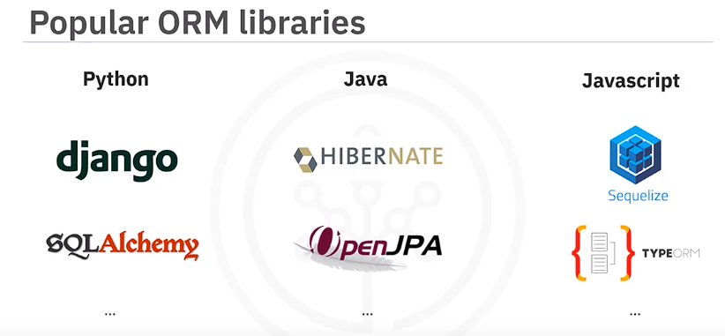

There are ORM libraries for almost all popular languages:

* Python: Django Model, SQLAlchemy
* Java: Hibernate, OpenJPA
* JavaScript: Sequelize, TypeORM

In this course, we’ll focus on Django Model.

**Pros and Cons of ORM**

**Pros:**

* Your class designs define the databases.
* You can use databases without writing SQL.
* Use a single ORM interface to manage multiple database systems.
* Speeds up application delivery.

**Cons:**

* Imperfect mapping due to different modeling concepts.
* Increased code coupling; any database change requires changes to both application logic and data access logic.
* Debugging can be challenging due to hidden implementation details.
* May reduce application performance; the extra translation layer doesn't guarantee optimized SQL statements.

**Summary**

In this video, you learned:

* SQL and OOP model data differently.
* ORM bridges the gap between SQL and OOP.
* ORM allows application developers to use databases without writing SQL code.
* ORM can speed up application development.
* Disadvantages of ORM include imperfect mapping, increased code coupling, and difficulty in debugging.

**[Music] Welcome to Django Model**

In this video, we will introduce Django ORM (Object Relational Mapping), a powerful library for Python that can significantly simplify your application development with databases. After watching this video, you will be able to:

* Explain the core concepts of Django ORM.
* Convert your entity-relationship diagrams into Django models.

**Understanding ORM**

Recall that ORM can make the developer’s life easier by abstracting databases and automatically mapping objects and methods to tables and SQL queries. Django ORM, a component of the Django web application framework, helps speed up application development by providing a convenient way to interact with databases using Python code.

**Django ORM Basics**

In Django ORM, each Django model maps to a database table. When you create a class object, it represents a table row, and each field in the class represents a table column. Schema and tables are automatically generated once model classes are defined.

**Example: User Class**

For example, we can define a User class, which is a subclass of the Django model. Django will create a corresponding User table in the database by generating “table create” statements and creating columns based on the class fields. In our example, a **first_name** column will be created based on the **first_name** field.

Each field in a model should be defined using a Field class, and Django maps each field to a column type. For instance, **first_name** is defined as a character field and will be converted into **varchar**, while **date_of_birth** is a date field and will be converted into **date**. We define the metadata for each column, such as type and constraints, by specifying parameters in a Django Field class. For example, for the **first_name** field, we use the **max_length** parameter to specify the length for **varchar**.

Once we have defined models and fields, Django ORM will generate schema and “table create” statements. Fields like **first_name**, **last_name**, and **date_of_birth** are converted into columns. Each field has customization parameters such as **null**, **blank**, **default**, or **primary_key**.

**Modeling Relationships in Django**

. Django ORM supports common relationships such as

One-To-One,

Many-To-One,

and Many-To-Many.

**One-To-One Relationship Example**

Suppose we have an Instructor and User ER diagram. The User class holds common fields, such as name or date of birth, and the Instructor class has special fields like **is_full_time** or **total_number_of_learners**. One instructor can have basic information stored in one User class, and one user can have only one role, such as Instructor or Learner.

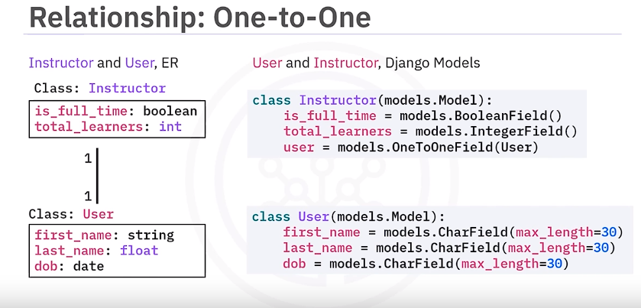**Many-To-One Relationship Example**

Consider a Project and Course ER diagram. The Project class represents a course project with fields like **project_name** and **grade**. The Course class represents an online course entity with fields such as **name** and **description**. A **projects** field in the Course class represents a set of course project objects.

To create models in Django:

1. Define the models **Project** and **Course**.
2. Add a **Course** field in the **Project** model as a foreign key to establish the Many-To-One relationship.

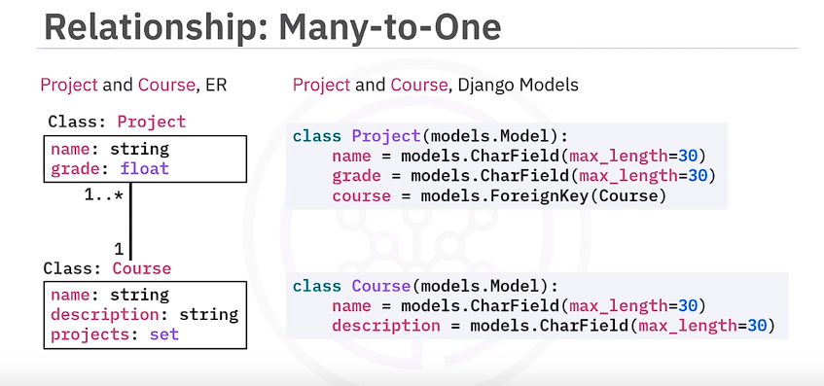

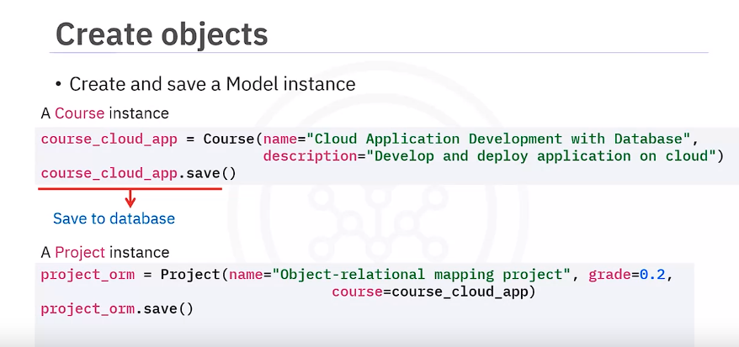

**Many-To-Many Relationship Example**

For a Many-To-Many relationship, consider a Course and Learner ER diagram. One course may have many learners enrolled, and one learner may enroll in many courses. To model this relationship:

1. Add a Many-To-Many field in one of the models, typically the one that will be edited most often (e.g., the **Course** model).

If extra information is needed about the relationship, such as the enrollment date, you can specify an intermediate model. For example, use an **Enrollment** model to govern the Many-To-Many relationship with the **through** argument.

**Model Inheritance in Django**

Model inheritance in Django works similarly to Python inheritance:

* Use multi-table inheritance when each model should have its own database table.
* Use abstract base classes to hold common information that will be visible only through child models.
* Use proxy models to modify the behavior of a model without changing its fields.

For multi-table inheritance, subclass the parent model (e.g., **Instructor** from **User**). Django will create a new **Instructor** table and a One-To-One field in the **Instructor** class.

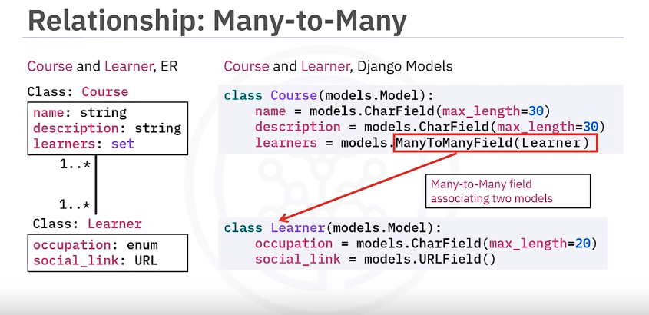

**Putting It All Together**

After defining entities and relationships for your online course database, Django will automatically create these database tables and foreign keys. For example:

* The **User** table is the base table with ID as the primary key.
* The **Learner** table inherits from **User** and has a Many-To-Many relationship with **Course** through the **Enrollment** table.
* **Instructor** and **Course** also have a Many-To-Many relationship.
* **Project** and **Course** have a Many-To-One relationship.

With Django ORM, you can now perform read, update, and delete operations on the data.

**Summary**

In this video, you learned that:

* In Django ORM, each model maps to a database table.
* Each field maps to a column type such as INT, VARCHAR, or DATE.
* Each field has customization parameters.
* Django ORM supports common relationship patterns such as One-To-One, Many-To-One, and Many-To-Many.

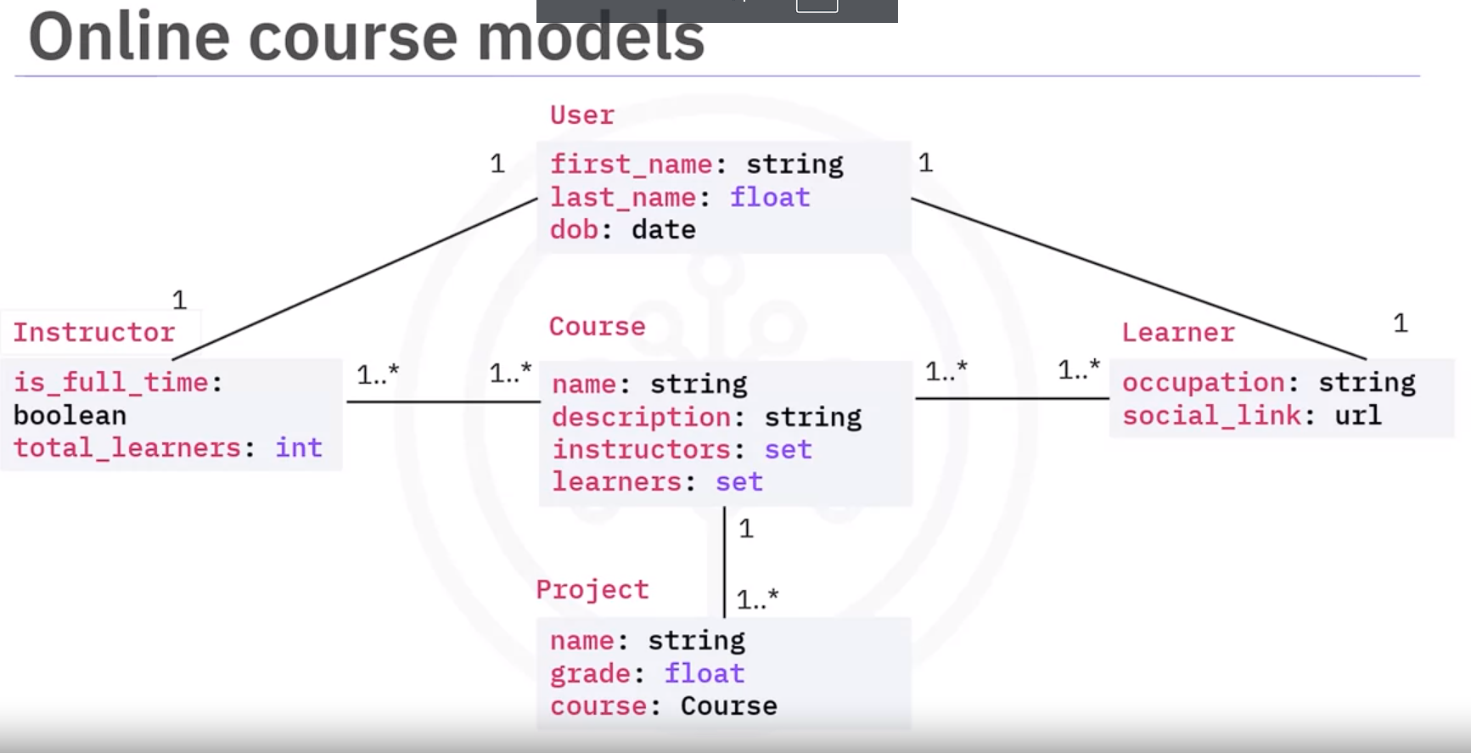

**Creating Objects**

In a Django model, you create an object and call the model’s **save** method to insert it into the database as a record.

python

Copy code

# Creating and saving a course object course_cloud_app = Course(name="Cloud Applications") course_cloud_app.save()

If the object contains references to another model, such as a Foreign Key or Many-to-Many field, you use the related model reference to create the relationship.

python

Copy code

# Creating a project and associating it with a course project = Project(name="Project 1", course=course_cloud_app) project.save()

**Reading Objects**

To read all objects for a model (equivalent to **SELECT \*** in SQL), you construct a QuerySet using a Manager on your model class. The default model manager is **objects**.

python

Copy code

# Getting all course records all_courses = Course.objects.all()

To get a subset of records, use the **filter** method, which can include many lookup parameters, similar to SQL WHERE conditions.

python

Copy code

# Filtering for part-time instructors part_time_instructors = Instructor.objects.filter(is_full_time=False)

You can further refine QuerySets using the **exclude** method to remove records that match certain criteria.

python

Copy code

# Excluding part-time instructors and filtering for specific conditions instructors =

Instructor.objects.exclude(is_full_time=False).filter(total_number_of_learners__gt=30000, first_name__startswith='J')

For single record queries where only one object is expected, use the **get** method.

python

Copy code

# Getting an instructor by first name instructor_john = Instructor.objects.get(first_name="John")

**Querying Related Objects**

Django handles SQL JOINs automatically when querying related records. You can create lookup parameters on related fields using double underscores.

python

Copy code

**# Finding courses with an instructor named John courses_with_john = Course.objects.filter(instructors__first_name="John")**

**Updating Objects**

Update records by modifying object fields and calling the **save** method.

python

Copy code

# Updating a learner's date of birth

learner = Learner.objects.get(id=1)

learner.date_of_birth = "1985-03-16"

learner.save()

You can also update related fields like Foreign Keys and Many-To-Many fields.

python

Copy code

# Adding a learner to a course

course = Course.objects.get(id=1)

learner = Learner.objects.get(id=2)

course.learners.add(learner)

**Deleting Objects**

To delete records, call the **delete** method on a model object or a QuerySet.

python

Copy code

# Deleting a course object

course_to_delete = Course.objects.get(id=1)

course_to_delete.delete()

**Summary**

In this video, you learned that with Django APIs, you can perform CRUD operations on database objects without writing SQL queries. You can create, read, update, and delete objects using Django Model APIs, making it easier to manage your database interactions.

By leveraging Django ORM, developers can focus more on application logic and less on database-specific details, streamlining the development process and improving productivity.

After watching this video, you will be able to:

* Use Django Model APIs to access and delete related objects.

All our online course models are related. The **User** model has a One-To-One relationship with **Instructor** and **Learner**. The **Course** model has a Many-To-Many relationship with **Instructor** and **Learner**, and a Many-To-One relationship with **Project**. We’ll show you how to handle these related models using Django Model APIs.

**Forward and Backward Relationships**

Django only requires you to define a model relationship on one side. For example, you only need to define the **Learner** model as having a One-To-One field reference to the **User** model. This explicit reference is called “forward access.” Under the hood, Django will create a backward relationship from **User** to **Learner** so you can also access **Learner** from the **User** model. This is an implicit reference or “backward access.”

**Example: One-To-One Relationship**

To access the common information about a learner such as first or last name, we need to get its user object. Since we already defined a **User** reference in the **Learner** model, we can easily get the **User** from **Learner** explicitly.

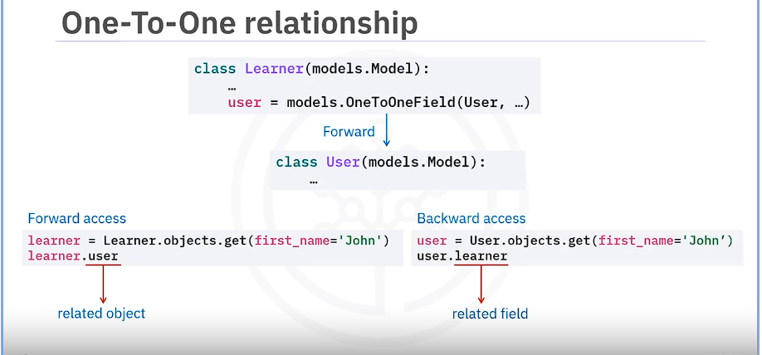An inheritance relationship is like a One-To-One relationship. The **Learner** class inherits from the **User** class. We can access **Learner’s** parent **User** reference with **user_ptr**, which is created by Django with the model name “user” plus a **_ptr** suffix.

python

Copy code

learner = Learner.objects.get(id=1) user = learner.user_ptr # Accessing the parent User

**Example: One-To-Many or Many-To-One Relationship**

A One-To-Many or Many-To-One relationship is defined using a Foreign Key field. Here we have defined a forward reference from **Project** to **Course**. Now we can access the course for a project explicitly.

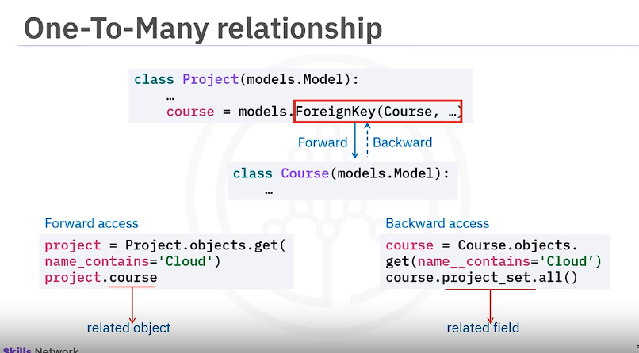

**Example: Many-To-Many Relationship**

Handling Many-To-Many related objects works like other relationships. In this example, **Course** model has a Many-To-Many field pointing to **Instructor** as an explicit reference. We can access the instructors of a course via this forward access.

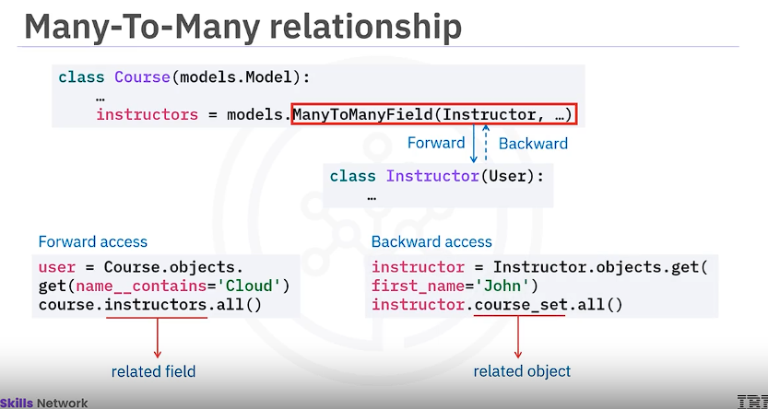**Deleting Related Objects**

Previously we explained that you delete an isolated object by simply calling the delete method. However, what if the objects are related? For example, one course may have many course projects via the Foreign Key Field, and one course project belongs to one course. If we delete a course, what will happen to those course projects belonging to it?

Django supports different deletion behaviors based on how you set the “on delete” options. We can put the **on_delete** option in the Foreign Key field as a parameter. Let’s see how each option works when deleting a **Course** object with related **Project** objects.

* **CASCADE**: It will delete all course projects if the course object is deleted.
* **PROTECT**: Protects a course object from deletion if it still has any associated course projects.
* **SET_NULL**: Keeps the course projects for future use. This is only available if we allow the foreign key to be null.
* **SET_DEFAULT** or **SET**: Assigns the projects to a default course or a different course when the related course has been deleted.
* **DO_NOTHING**: Does nothing to related projects when the course has been deleted. This option is discouraged because the projects will be orphan objects; they still point to a non-existent course object.

**Additional Django Methods for Related Objects**

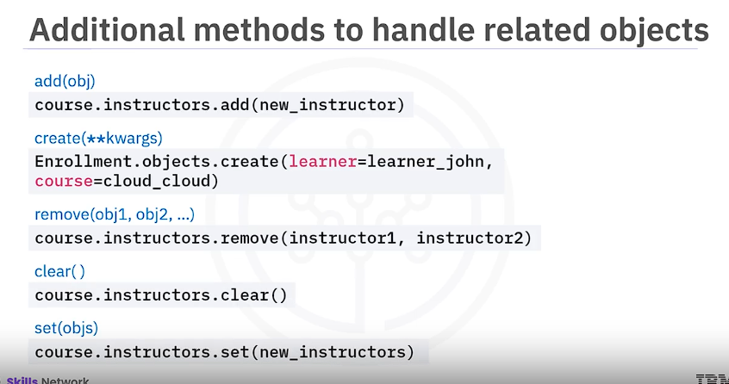**Summary**

In this video, you learned that:

* The Django Model provides a convenient API to read or manipulate related objects.
* Django only requires you to define the relationship on one side, called a forward or explicit relationship.
* When you define a forward relationship, Django will automatically create a backward or implicit relationship.
* The “on delete” options specify what happens to related objects when an object is deleted.

By understanding and utilizing these relationships and methods, you can efficiently manage related objects in your Django applications.

Top of Form