Sure, let's elaborate on each point while including a definition of Python:

Python is an **interpreted, object-oriented, high-level programming language with dynamic semantics**. Its high-level built in data structures, combined with dynamic typing and dynamic binding, make it very attractive for Rapid Application Development, as well as for use as a scripting or glue language to connect existing components together.

1. **Identify the users of Python:**
   * Python, a high-level, general-purpose programming language, is utilized across various industries, including data science, AI and machine learning, web development, and IoT.
   * Major organizations like IBM, Wikipedia, Google, Yahoo!, CERN, NASA, Facebook, Amazon, Instagram, Spotify, and Reddit heavily rely on Python for their operations.
2. **List the benefits of using Python:**
   * Python, known for its clear and readable syntax, is highly favored by both beginners and experienced programmers alike.
   * Due to its simplicity and expressiveness, Python allows developers to achieve the same functionality with significantly less code compared to other programming languages.
   * Python boasts a vast global community and an extensive repository of documentation, providing ample support and resources for developers of all skill levels.
   * Python offers a rich ecosystem of libraries and tools tailored for various tasks, such as databases, automation, web scraping, text and image processing, machine learning, data analytics, and artificial intelligence.
3. **Describe the diversity and inclusion efforts of the Python community:**
   * Python community is committed to promoting diversity and inclusion within the tech industry.
   * Guided by a code of conduct established by the Python Software Foundation, the community ensures a safe and inclusive environment for all members, both online and in-person.
   * Initiatives like PyLadies are dedicated to creating supportive and inclusive spaces for individuals interested in learning Python, with a particular emphasis on increasing the involvement of women in the open-source community.
4. **Highlight Python's usage and popularity in the tech industry:**
   * Python, recognized as the most widely used and popular programming language in the data science industry, is a powerhouse of a language.
   * Surveys, including the 2019 Kaggle Data Science and Machine Learning Survey, indicate that over 80% of data professionals worldwide utilize Python regularly for their work.
   * Python finds applications in diverse domains, including data science, AI, machine learning, web development, and IoT, owing to its versatility and extensive library support.
   * Supported by a large, global community and the Python Software Foundation, Python continues to be a preferred choice for developers worldwide.
5. **Specific tools and libraries for data science and AI in Python:**
   * Python offers a comprehensive suite of scientific computing libraries, such as Pandas, NumPy, SciPy, and Matplotlib, which are essential for performing data analysis and visualization tasks.
   * For artificial intelligence and machine learning, Python provides powerful frameworks like TensorFlow, PyTorch, Keras, and Scikit-learn, enabling developers to build and deploy sophisticated AI models.
   * Python's versatility extends to Natural Language Processing (NLP), with libraries like the Natural Language Toolkit (NLTK) facilitating the development of text analysis and processing applications.
6. **Reiteration of Python's clear syntax and community support:**
   * Python's clear and readable syntax makes it an ideal choice for developers seeking a language that is easy to learn and understand.
   * The extensive support and resources offered by Python's global community and the Python Software Foundation ensure that developers have access to the assistance and guidance they need to succeed in their Python projects.

Top of Form

Certainly, let's elaborate on each point extracted from the passage:

1. **Describe how to run, insert, and delete a cell in a notebook:** This refers to the basic functionality of a Jupyter notebook where users need to understand how to execute code cells, add new cells for inputting code or text, and remove cells if needed. Running cells executes the code within them, inserting cells allows for adding new content, and deleting cells removes unnecessary or unwanted content.
2. **Work with multiple notebooks:** Users should know how to handle multiple notebooks simultaneously, which involves tasks such as opening, navigating between, and organizing them effectively within the Jupyter environment.
3. **Present the notebook, and shut down the notebook session:** This involves two key aspects - presenting the notebook's content effectively, possibly using features like Markdown for formatting, and shutting down the notebook session once work is completed to release system resources.
4. **Launch a notebook using the Skills Network virtual environment:** Specific to the Skills Network virtual environment, users are instructed on how to initiate a Jupyter notebook session within this environment to start working.
5. **Change the name of the notebook:** Users are shown how to rename a notebook file, which is essential for better organization and clarity, especially when working with multiple notebooks.
6. **Print "hello world" in a new notebook:** This is a basic programming exercise often used as an initial step to verify that the environment is set up correctly and functioning as expected.
7. **Run cells using the Run button or shortcut (Shift + Enter):** Users are provided with methods to execute the code within cells either through clicking the 'Run' button or by using a keyboard shortcut for efficiency.
8. **Run selected cells or all cells:** Users are shown how to execute either specific cells or all cells in a notebook, depending on their needs.
9. **Add code by inserting a new cell:** Inserting a new cell allows users to add additional code or text input to the notebook, thus extending its functionality.
10. **Delete a cell:** Users are instructed on how to remove unnecessary cells from the notebook, which helps maintain clarity and organization.
11. **Move cells up or down:** This refers to rearranging the order of cells within the notebook, which can be helpful for better structuring the content or adjusting the flow of execution.
12. **Work with a single notebook:** Users are guided on basic operations within a single notebook, such as executing code, adding content, and organizing cells.
13. **Work with multiple notebooks by opening new notebooks and moving them around:** Instructions are provided on how to manage multiple notebooks simultaneously, including opening new ones, arranging them within the interface, and performing tasks across different notebooks.
14. **Assign variables and perform operations in multiple notebooks:** Users learn how to work with variables and perform operations across different notebooks, which could involve sharing data or results between them.
15. **Communicate results by adding Markdown for titles and text descriptions:** Markdown is introduced as a tool for enhancing the presentation of results within the notebook, allowing users to add titles, descriptions, and other formatted text to improve clarity and readability.
16. **Create line plots and convert cells into slides for presentation:** Users are shown how to create visualizations like line plots within the notebook and how to convert notebook cells into presentation slides for sharing or presenting findings.
17. **Deliver code, visualization, text, and outputs as part of a project using slides functionality:** The slides functionality in Jupyter allows users to package their code, visualizations, text, and outputs into a cohesive presentation format suitable for sharing or presenting project findings.
18. **Shut down notebooks to release memory individually or all at once:** Users are instructed on the importance of shutting down notebooks to release system memory once work is completed, preventing unnecessary resource usage.
19. **Confirm notebook shutdown by observing "no kernel" at the top right:** A visual indicator is provided to confirm that a notebook session has been successfully shut down, ensuring users do not inadvertently leave sessions running, which could consume resources unnecessarily.

Sure, here's an elaboration on each point extracted from the passage:

1. **Importing Pandas**:
   * Pandas is a powerful library in Python used for data manipulation and analysis.
   * To use Pandas, it must be imported into your Python script or notebook using the **import** statement.
   * The common convention is to import Pandas and alias it as **pd**, which makes it easier to reference throughout your code.
   * Example:

pythonCopy code

**import pandas as pd**

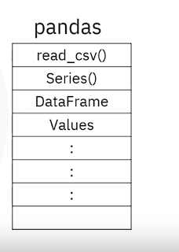

1. **Loading Data**:
   * Pandas provides various functions for loading different types of data formats, such as **CSV files, Excel files, JSON, SQL databases, etc.**
   * One commonly used function is **read_csv()** which reads data from a CSV file and creates a DataFrame, a two-dimensional labeled data structure with columns of potentially different types.
   * Example:

pythonCopy code

df = pd.read_csv('file.csv')

1. **DataFrames**:
   * A DataFrame is a **tabular data structure in Pandas, similar to a spreadsheet or database table, with labeled axes (rows and columns).**
   * DataFrames can be created from various data sources such as **CSV files, Excel files, dictionaries, lists, etc.**
   * Example:

pythonCopy code

data = {'Name': ['Alice', 'Bob', 'Charlie'], 'Age': [25, 30, 35]}

df = pd.DataFrame(data)

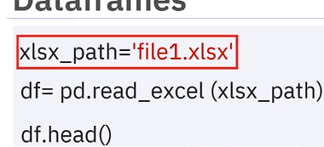

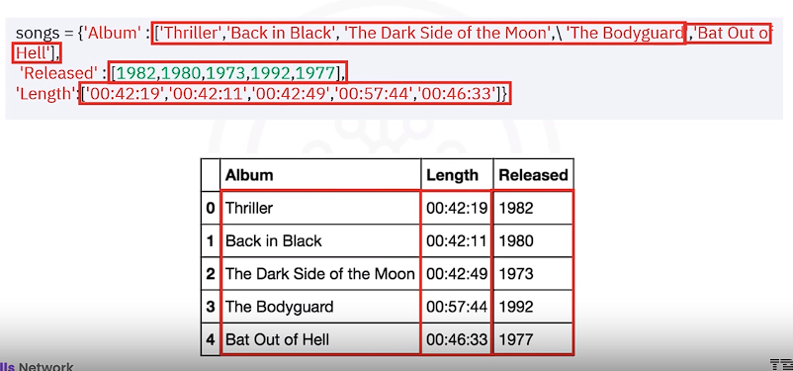

1. **Exploring DataFrames**:
   * DataFrames have various methods and attributes to explore and understand the data.
   * **head()** method is commonly used to view the first few(5) rows of the DataFrame.
   * Example:

pythonCopy code

print(df.head())

1. **Accessing Data**:
   * Data within DataFrames can be accessed using different methods, such as **integer-based indexing (iloc[]) or label-based indexing (loc[]).**
   * **iloc[]** is used to access data by integer-based index.
   * Example:

pythonCopy code

print(df.iloc[0]) # Access first row

1. **Indexing**:
   * Indexing in Pandas refers to identifying or selecting particular rows or columns from a DataFrame.
   * Indexing can be done using integer-based indices or label-based indices.
   * Custom indices can also be assigned to DataFrames using the **set_index()** method.
   * Example:

pythonCopy code

df.set_index('Name', inplace=True) # Set 'Name' column as index

1. **Slicing DataFrames**:
   * Slicing allows you to select specific rows or columns from a DataFrame based on certain criteria.
   * Slicing can be done using integer-based indices or label-based indices.
   * Sliced data can be assigned to new DataFrames for further analysis.
   * Example:

pythonCopy code

sliced_df = df.iloc[1:3, 0:2] # Select rows 1 to 2 and columns 0 to 1

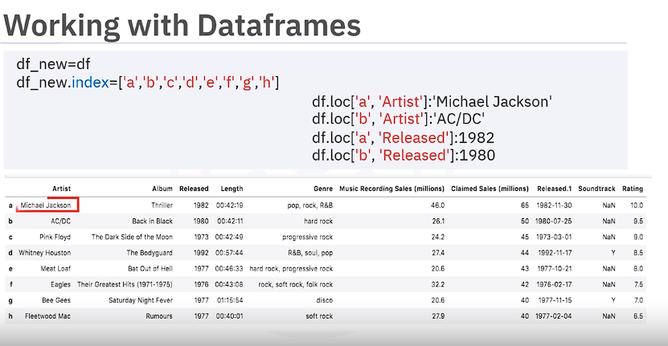

1. **Further Learning**:
   * Pandas is a vast library with many features and functionalities.
   * To become proficient in Pandas, it's essential to practice and explore additional examples and exercises available in tutorials, documentation, and online resources.
2. **Introduction to NumPy**:
   * NumPy, which stands for Numerical Python, is a fundamental package for numerical computing in Python.
   * It provides high-performance multidimensional array objects (ndarrays) and tools for working with these arrays.
   * NumPy is widely used in fields such as data science, machine learning, engineering, and scientific computing due to its efficiency and versatility.
3. **Array Creation**:
   * NumPy arrays are similar to Python lists but more efficient for numerical computations.
   * Arrays are **homogeneou**s, meaning they contain elements of the same data type, unlike Python lists which can contain elements of different types.
   * Arrays can be created using various methods in NumPy, such as **numpy.array()**, **numpy.arange()**, **numpy.zeros()**, **numpy.ones()**, etc.
4. **Array Attributes**:
   * NumPy arrays have *several attributes* that provide information about the array's **shape, size, data type, etc.**
   * **dtype**: Indicates the data type of the array elements (e.g., integer, float, etc.).
   * **size**: Represents the total number of elements in the array.
   * **ndim**: Specifies the **number of dimensions (or axes) of the array. Rank of an array**
   * **shape**: Provides the size of the array along each dimension as a tuple.
5. **Indexing and Slicing**:
   * NumPy arrays support indexing and slicing operations similar to Python lists.
   * Elements of an array can be accessed using square brackets **[ ]**, and indices start from 0.
   * Slicing allows selecting portions of the array using start, stop, and step parameters within square brackets **[start:stop:step]**.
6. **Basic Operations**:
   * NumPy provides efficient implementations of basic mathematical operations on arrays, such **as addition, subtraction, multiplication, and division.**
   * These operations are performed element-wise, meaning corresponding elements of two arrays are operated on together.
7. **Universal Functions**:
   * Universal functions (ufuncs) in NumPy are functions that operate element-wise on arrays.
   * They include mathematical functions like **np.sin()**, **np.cos()**, **np.exp()**, and statistical functions like **np.mean()**, **np.max()**, etc.
   * Ufuncs offer optimized performance and allow for concise and efficient code when working with arrays.
8. **Visualization with Matplotlib**:
   * Matplotlib is a popular plotting library in Python used for creating static, interactive, and animated visualizations.
   * It can be used in conjunction with NumPy to visualize data and mathematical functions.
   * Functions like **np.linspace()** are used to generate evenly spaced numbers over a specified interval, which are then used to plot functions like sine waves.
9. **Further Learning**:
   * NumPy is a powerful library with many advanced features and functionalities.
   * Learning resources such as tutorials, documentation, and online courses can help deepen understanding and proficiency in NumPy.

By mastering NumPy's capabilities in one-dimensional arrays, practitioners can efficiently perform various numerical computations and data manipulations essential for scientific computing and data analysis tasks.

**API (Application Programming Interface):**

* The analogy of a function is helpful. Imagine an API as a pre-built function you can call in your program. You don't need to know how the function works internally, just what inputs it takes and what outputs it produces.
* APIs can be used for various purposes:
  + Accessing and retrieving data from external sources (like weather data or social media feeds)
  + Utilizing functionalities of other programs (like sending emails or text messages)
  + Integrating different software components within a larger application

**REST APIs (Representational State Transfer API):**

* REST APIs follow a specific architectural style for communication over the internet.
* Think of it like a set of rules for how two people should talk to each other to get things done.
* Here's a breakdown of the conversation between a client and a web service using a REST API:
  + The client initiates the conversation by sending a **request** to the web service's **endpoint**.
  + This request specifies what data or functionality the client needs. It's often sent as an HTTP **message containing a JSON file with instructions.**
  + The web service receives the request, processes it, and sends back a **response** containing the requested data or a confirmation message. The response is also usually sent as an HTTP message with a JSON file.

**Example using PyCoinGecko:**

* This section demonstrates how to use a Python library (PyCoinGecko) to interact with the CoinGecko API, which provides cryptocurrency data.
* The script highlights several key points:
  + **Focus on Functionality:** Libraries like PyCoinGecko simplify interaction with APIs by handling the low-level details. This allows developers to focus on what matters - collecting and analyzing the data.
  + **Data format (JSON):** Many APIs use JSON (JavaScript Object Notation) to represent data. It's a lightweight and human-readable format for exchanging information between programs.
  + **Data Manipulation with pandas:** The script uses pandas, a popular Python library, to convert the retrieved JSON data into a pandas DataFrame. This makes the data easier to work with and analyze.
  + **Data Visualization with Plotly:** Finally, the script uses Plotly, a Python library for creating interactive visualizations, to create a candlestick chart of the Bitcoin price data.

1. **Uniform Resource Locator (URL):**
   * A URL is a reference to a web resource that specifies its location and how to retrieve it.
   * It consists of three main parts:
     + Scheme: **Specifies the protocol used to access the resource**, such as HTTP or HTTPS.
     + Internet address or Base URL: The domain name or IP address of the server hosting the resource.
     + **Route: The specific location or path to the resource on the server.**
   * For example, in the URL "http://www.example.com/images/logo.png", "http" is the scheme, "[www.example.com](http://www.example.com/)" is the internet address, and "/images/logo.png" is the route.
2. **Request and Response Process:**
   * The process by which clients (such as web browsers) request resources from servers and receive responses.
   * Clients send HTTP requests to servers specifying the resource they want.
   * Servers process the requests and send back HTTP responses containing the requested resources.
   * HTTP messages typically include headers for additional information and may contain a request or response body for data exchange.

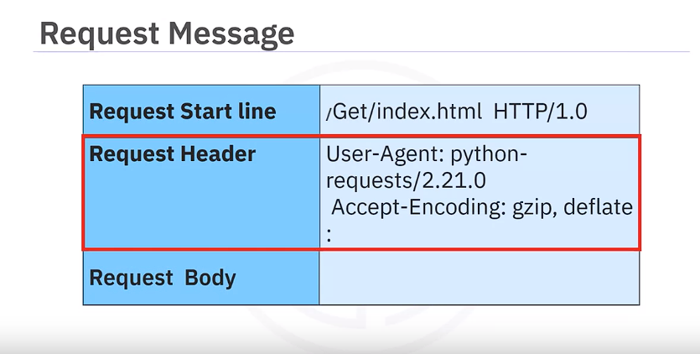

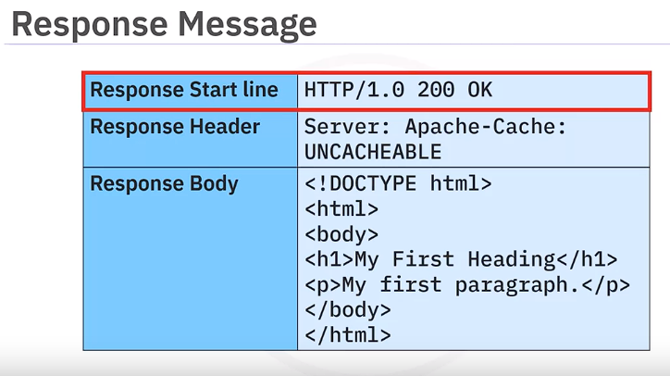

1. **HTTP Methods:**
   * HTTP defines several methods or verbs that indicate the desired action to be performed on a resource.
   * The most common methods include:
     + GET: Retrieve data from the server.
     + POST: Submit data to the server to create or update a resource.
     + PUT: Updates data already on server
     + DELETE: Deletes data from the server
     + Other methods include: PATCH, HEAD, OPTIONS, etc.
2. **Status Codes:**
   * Status codes are three-digit numbers included in HTTP responses to indicate the outcome of the request.
   * They are grouped into different classes:
     + 1xx: Informational responses.
     + 2xx: Successful responses (e.g., 200 for OK).
     + 3xx: Redirection responses.
     + 4xx: Client error responses (e.g., 401 for Unauthorized).
     + 5xx: Server error responses (e.g., 501 for Not Implemented).
     + 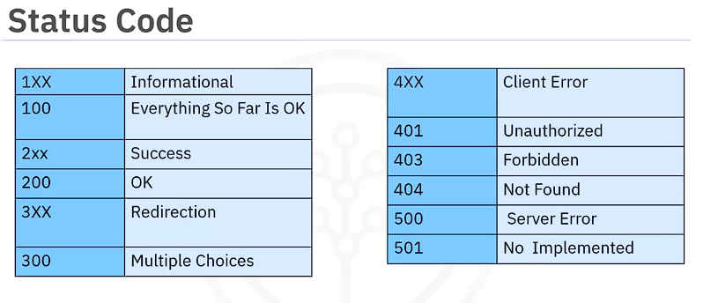
   * Status codes provide a quick overview of whether the request was successful or encountered an error.
3. **Using Python for HTTP Requests:**
   * Python can be used to interact with web servers by sending HTTP requests and processing responses.
   * Common libraries like **requests** can be utilized to make GET and POST requests, retrieving data from servers or submitting data to them.

Overall, this transcript provides a comprehensive overview of the HTTP protocol, covering its fundamental concepts, request-response flow, methods, status codes, and practical application using Python.