* This module covers the basics of machine learning models, including their definition, components, and applications.
* The module is divided into five main topics:
  + Defining machine learning models and their parameters
  + Understanding loss functions and gradient descent
  + Experimenting with models in a sandbox environment
  + Evaluating model performance outside of training
  + Using linear models for regression and classification

**Key concepts:**

* **Machine learning model:** A mathematical function with parameters that learns from data to make predictions.
* **Parameter:** A real-valued variable that changes during model training to improve its performance.
* **Hyperparameter:** A setting that is fixed before training and does not change afterwards.

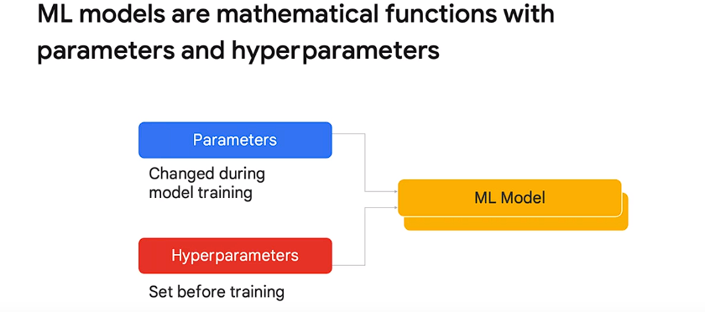

* **Linear model:** A simple model that represents the relationship between features and labels as a straight line.
* **Loss function:** A function that measures the error between the model's predictions and the true labels.
* **Gradient descent:** An optimization algorithm that iteratively adjusts the model's parameters to minimize the loss function.
* **Generalization:** The ability of a model to perform well on unseen data, not just the data it was trained on.

**Additional details:**

* The module discusses how linear models can be extended to higher dimensions using hyperplanes.
* It also covers how linear models can be used for both regression (predicting continuous values) and classification (predicting discrete classes).
* The concept of generalization is introduced as a critical property of machine learning models.

**Problem:** Predicting baby health before birth to provide appropriate care immediately after delivery.

**Data:** Baby weight and mother's age from the US natality dataset.

**Modeling approach:**

* **Label:** Baby weight (continuous numeric value).
* **Feature:** Mother's age.
* **Model:** Initially a linear model (later addressed as underfitting and non-ideal).

**Key points:**

* Scatterplots are limited for large datasets and visual interpretation.
* Quantile plots provide insights into group trends and are efficient for large datasets.
* The data reveals a non-linear relationship between mother's age and baby weight.
* Least squares regression is inefficient for large datasets, prompting the introduction of gradient descent.
* Gradient descent optimizes parameters in high-dimensional spaces using loss functions.

**Further questions:**

* What are the limitations of a linear model in this scenario?
* How does gradient descent work in practice?
* What other loss functions can be used besides least squares?

I hope this summary is helpful!

**Introduction:**

* Previously defined models as mathematical functions with parameters and hyperparameters.
* Discussed how analytical methods for finding optimal parameters don't scale well.
* Introduced the need for a measure to compare different points in parameter space.

**Loss Functions:**

* Defined as functions that assess the quality of predictions for a group of data points.
* Compose individual error terms into a single number for model evaluation.

**Mean Squared Error (MSE):**

* Popular loss function for regression problems.
* Squares individual errors to eliminate negative values.
* Calculates the average of squared errors.
* Easy to interpret due to units matching the original data (e.g., pounds squared).

**Root Mean Squared Error (RMSE):**

* Square root of MSE.
* Provides units easier to understand than MSE (e.g., pounds).
* Lower RMSE indicates better model performance.

**Limitations of MSE/RMSE:**

* Unsuitable for classification problems with categorical labels.
* Treat errors of opposite signs as canceling each other out, not ideal for capturing contradictory evidence.

**Cross-Entropy Loss:**

* Commonly used for classification problems.
* Penalizes incorrect predictions more heavily, aligning with our intuition.
* Has separate terms for positive and negative examples based on the label.
* Example calculation provided for understanding the formula.

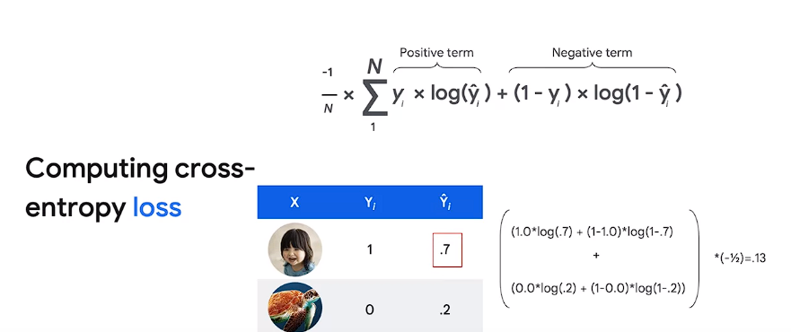

**Applications:**

* Comparing different models to identify the best fit.
* Finding the optimal set of parameters (best point in parameter space) for a given model.

**Additional points:**

* The choice of loss function depends on the problem type (regression vs. classification).
* Cross-entropy assigns higher penalties for worse predictions.
* The example uses image classification as a specific case.

**Optimization Framework Introduction**:

* + The passage starts by framing optimization as a search in parameter space.
  + It introduces the concept of loss functions as a means to compare points within this space.

1. **Gradient Descent**:
   * Gradient descent is introduced as the process of navigating the parameter space using the loss function.
   * It involves walking down the surface formed by the loss function.
   * The passage acknowledges that the surface might not be perfectly known and discusses how loss values are evaluated at specific points in the parameter space.
2. **Decomposition of the Problem**:
   * The problem of finding the minimum is broken down into two questions: which direction to move and how far to step.
   * Initially, a simplifying assumption is made to use a fixed size step.
3. **Algorithm Overview**:
   * A simple algorithm is proposed: while the loss is greater than a tiny constant, compute the direction and update the parameters accordingly.
   * It emphasizes the iterative nature of the process: compute direction, update parameters, and recompute the loss.
4. **Visualizing Loss Surface**:
   * The analogy of a contour map is used to illustrate the loss surface.
   * Steps taken by the algorithm are represented as dots moving towards the minimum.
   * The importance of step size is highlighted: too small and training might take forever, too large and the process may not converge.
5. **Step Size Adjustment**:
   * The passage discusses how the slope of the curve can guide the choice of step size.
   * It explains how slope indicates the direction and magnitude of movement: steeper slopes require larger steps.
6. **Algorithm Adjustment**:
   * An adjustment to the algorithm is proposed: replacing the constant step size with a step size determined by the derivative.
   * The algorithm now computes derivatives to update parameters, aiming for better convergence.
7. **Empirical Performance**:
   * Despite the algorithm's theoretical soundness, empirical performance can vary.
   * The passage notes that in some cases, the algorithm may take too long, find sub-optimal minima, or fail to finish.
   * It emphasizes that these challenges don't mean the algorithm doesn't work, but rather that it may not excel in certain scenarios.

These points summarize the main concepts and discussions presented in the passage regarding optimization, gradient descent, and the challenges associated with its practical implementation.

Here are the main points extracted from this passage:

1. **Scenario Setup**:
   * The passage sets the scenario of troubleshooting a loss curve during model training.
   * It emphasizes the importance of efficient training to avoid wasting time, especially in scenarios where training can take hours or days.
2. **Loss Curve Analysis**:
   * Two common loss curve shapes are described:
     + Rapid drop followed by smoothing, indicating large steps initially and smaller steps later.
     + Gradual decrease, indicating slow progress towards the minimum.
   * In both cases, the step size is identified as the issue: too big or too small.
3. **Introduction of Learning Rate**:
   * The concept of a scaling parameter, referred to as the learning rate, is introduced to address the step size issue.
   * Learning rate adjustment leads to classic gradient descent.
   * Learning rate is described as a hyperparameter set before training begins.
4. **Hyperparameter Tuning**:
   * The passage mentions hyperparameter tuning as a method to determine the best value for parameters like the learning rate.
   * Learning rate is typically set as a fraction significantly less than one.
5. **Implementation of Gradient Descent**:
   * A specific formulation of gradient descent is presented, where the learning rate is incorporated into the parameter update step.

These points summarize the main concepts presented in the passage regarding troubleshooting loss curves, the role of the learning rate in gradient descent, and the process of hyperparameter tuning.

Top of Form

Here are the key points from the passage:

1. **Non-Determinism in ML**:
   * ML models might not produce the same output even with identical settings due to non-deterministic behavior.
   * This can be disconcerting for programmers accustomed to deterministic settings.
2. **Convexity of Loss Surface**:
   * Loss surfaces can be convex or non-convex.
   * Convex surfaces have a single minimum, while non-convex surfaces may have multiple minima.
   * Multiple minima mean there are equivalent points in parameter space, which can affect model training.
3. **Time Complexity in Model Training**:
   * Three primary steps in the training algorithm: derivative calculation, parameter updating, and loss checking.
   * Derivative calculation's cost is proportional to the number of data points and parameters.
   * Updating parameters' cost is determined solely by the number of parameters.
   * Loss checking's time complexity is proportional to the number of data points and the complexity of the model.
4. **Improving Training Time**:
   * Two main ways to improve training time: **adjusting the number of data points used for derivative calculation and the frequency of loss checking**.
   * Mini-batch gradient descent reduces the number of data points used for derivative calculation by sampling from the training set.
   * Mini-batch gradient descent is memory-efficient, parallelizable, and less time-consuming compared to batch gradient descent.
   * The size of mini-batches and the frequency of loss checking are hyperparameters that can be tuned for optimal performance.
   * Strategies for reducing the frequency of loss checking include time-based and step-based approaches.
5. **Decoupling Model Training Steps**:
   * By reducing the frequency of loss checking and introducing mini-batching, the training process decouples parameter updates from loss checking.
   * This separation allows for more efficient model training.

These points summarize the strategies and considerations for improving model training time, including addressing non-determinism, understanding loss surface properties, managing time complexity, and optimizing training procedures.

Top of Form

Here are the main points from the passage:

1. **Introduction to Inappropriate Minima**:
   * Inappropriate minima are points in parameter space that reflect strategies not suitable for generalization or representing the true relationship in the data.
   * Skewed datasets with imbalanced classes can lead to inappropriate strategies becoming more attractive during optimization.
2. **Example of Inappropriate Strategy**:
   * Using the example of predicting parking spot occupancy from images, an inappropriate strategy would be to predict all spots as occupied, especially in a dataset with imbalanced classes.
   * Such strategies fail to capture the true relationship between features and labels, leading to poor generalization.
3. **Challenge of Perfect Loss Functions**:
   * It's tempting to think that a perfect loss function could solve the problem of inappropriate minima, but such perfection is not achievable.
   * Perfect loss functions might not be differentiable, posing challenges for gradient descent optimization.
4. **Role of Performance Metrics**:
   * Performance metrics are used after training to evaluate models based on their ability to generalize and meet business goals.
   * They provide a more direct connection to business objectives and are easier to understand than loss functions.
5. **Benefits of Performance Metrics**:
   * Performance metrics are simpler and more understandable, often based on countable statistics.
   * They are directly linked to business goals, ensuring that model evaluation aligns with practical objectives.
6. **Types of Performance Metrics**:
   * Three performance metrics are mentioned: confusion matrices, precision, and recall.
   * Each metric serves a specific purpose in evaluating model performance and addressing different aspects of classification tasks.

Here are the important points extracted from the passage:

1. **Purpose of Dataset Splitting**: Splitting datasets allows testing models against real-world scenarios by withholding subsets from training.
2. **Challenges of Dataset Splitting**:
   * Deciding where to divide a massive dataset for training and testing purposes.
   * Ensuring repeatability and uniformity in splitting the dataset.
3. **Example Dataset**: Airline On-time performance data from the US Bureau of Transportation Statistics is used as an example dataset, containing 70 million flights.
4. **Random Sampling in SQL**:
   * SQL's RAND function can be used for **random sampling.**
   * Random sampling poses issues in **repeatability and uniformity.**
5. **Hash Function for Splitting**:
   * Using hash functions, like Farm fingerprints in BigQuery, ensures repeatability.
   * Hashing on date or other relevant fields allows consistent splitting.
6. **Considerations for Splitting**:
   * Splitting based on factors such as date or airport, ensuring the primary prediction factors are not lost in the splitting process.
7. **Developing Machine Learning Models**:
   * Initial development should be done on small datasets for quicker iterations.
   * Full dataset utilization for training can be done later in the development process.
8. **Uniform Sampling**:
   * Sampling a subset of a large dataset requires methods to ensure uniformity and repeatability.
   * Modulo operations are used to ensure uniform sampling.

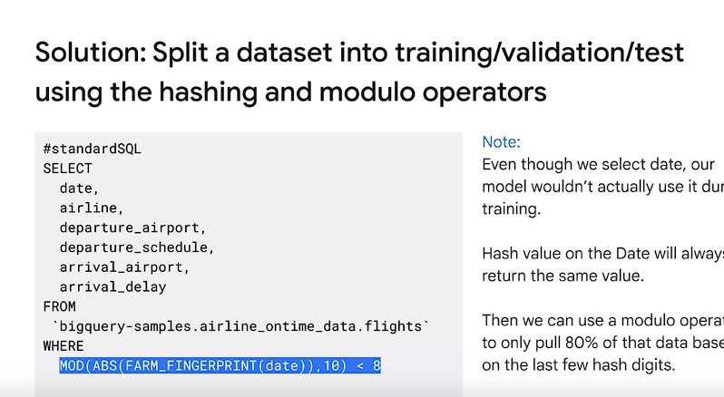

1. **Prototyping and Scaling**:
   * Prototyping involves working with smaller datasets for efficient code debugging.
   * Full-scale training is done once the model is properly debugged and validated.

These points cover the significance of dataset splitting, challenges, methods to ensure repeatability and uniformity, considerations for splitting, and strategies for model development and sampling.