**ELECTROCHEMISTRY**

Electrochemistry is the branch of chemistry which deals with the

transformation of electrical energy to chemical energy and vice versa. In

brief it deals with the chemical applications of electricity.

|  |  |  |
| --- | --- | --- |
| Electrical Energy |  | Chemical Energy |

•Electric current is a flow of electrons generated by a battery, when the circuit is completed.

Electrolysis is one process where electrical energy causes chemical changes. It is carried out in an apparatus called electrolytic cell.

•Certain chemical reactions takes place in a vessel and produce electric energy. The device is called **electrochemical cell**.

•**Electrolytic cell:** A device which converts electrical energy to chemical energy   
•**Electrochemical cell:** A device which converts chemical energy to electrical energy. •**Electrolyte:** These are the substances which dissociates into ions completely or partially on dissolving in a suitable solvent. Electrolytes are of two types:

**Strong electrolytes**: The electrolytes which completely dissociates in solution at all concentrations. Their conductance is very high**.** Eg. NaCl, HCl, NaOH.

**Weak Electrolytes**: The electrolyte which partially dissociates at moderate concentration. Their conductance is low as they dissociate only to a small extent even at very high dilutions. Eg: CH3COOH, NH4OH, sparingly soluble salts like AgCl, AgBr, AgI, BaSO4, PbSO4 etc.

•**Conductance:** The capacity of a conductor to allow the passage of current through it called conductance. It is a property of conductor which facilitates flow of electricity through it.

i.e. The reciprocal of resistance is called conductance.

|  |
| --- |
| **Conductance (G) =** 1/R |

**Units:** Ohm.-1 , **siemens** or **mhos.**

•**Electrolytic Conductance:**   
Electrolytic conductance is flow of electricity through solution of electrolyte . It is due to the Migration of ions when potential difference is applied between the two electrodes “the ease with which electricity flows through a solution is called the conductance of the solution”

**ELECTROCHEMICAL CELL OR GALVANIC CELL**

A galvanic cell is a system in which a spontaneous oxidation and reduction reaction occurs and generates electrical energy. Eg. Daniel cell

**Construction of Galvanic Cell**

•A galvanic cell is made up of two half cells.

•One is oxidation or anodic half- cell and other one is reduction or cathodic half cell. Daniel cell is an example of galvanic cell having zinc and copper electrodes.

•The first half cell consists of zinc electrode dipped in ZnSO4 solution

•The second half is made of copper electrode dipped in copper sulphate solution.

•Both half cells are connected externally by metallic conductor and internally by a bent glass tube having saturated solution of a strong electrolyte (KCl) called salt bridge.

•It acts as a bridge between the two half cells.

**Working of Galvanic cell:**

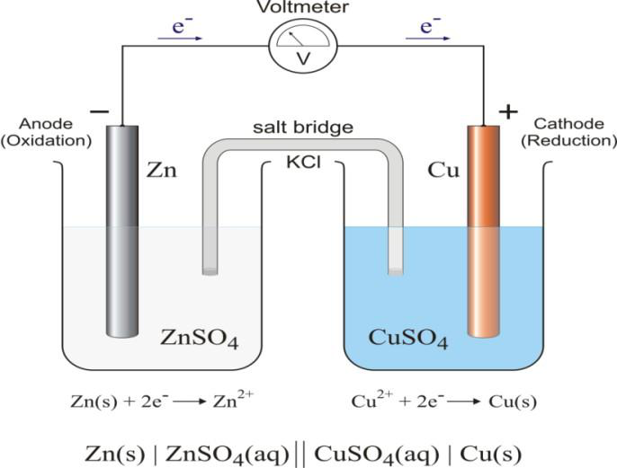

When two half cells are connected externally by a wire through a voltmeter, spontaneous redox reaction takes place at the electrode.

**At anode:** Oxidation takes place with the liberation of two electrons.

Zn  Zn+2 + 2e- (oxidation or de-electronation)

**At cathode:** Reduction occurs and cuprous ion is reduced to metallic copper.

|  |  |  |  |  |
| --- | --- | --- | --- | --- |
| Cu+2 | + | 2e- | Cu | (reduction or |

electronation) The overall reaction is

Zn + Cu+2 Zn+2 + Cu

As the connection is complete, the flow of electrons will be externally from anode to cathode and internally from cathode to anode through the salt bridge. The flow of current is due to the difference in electrode potentials of both the electrodes. The potential difference in the cell is called the EMF and is measured in volts.

**Representation of a galvanic cell:**

**Anode Half-Cell || Cathode Half-Cell**   
**Electrode | Anode Soln || Cathode Soln | Electrode**

Zn(*s*) | Zn2+ (1 M) || Cu2+ (1 M) | Cu(*s*)

**Salt bridge:** Salt bridge is a U shaped glass tube containing concentrated solution of an inert electrolyte such as KCl, KNO3 and K2SO4 or paste of inert electrolyte (whose ions do not take part in redox reaction and do not react with the electrolyte) in agar–agar medium or gelatin.

**Functions of salt bridge:**

1.Salt bridge helps to complete the circuit by allowing the ions to flow from one solution to the other without mixing the two solutions.

2.It helps to maintain electrical neutrality of the solution in the half cells.

**ELECTRODE POTENTIAL**

•When a metal rod is dipped in its salt solution (electrolyte), the metal atom tends either to lose electrons (oxidation) or to accept electrons ( •The tendency of an electrode tolose or gain electrons when it is in contact with solution of its own ions is called electrode potential. It may be of two types: oxidation potential and reduction potential.

•**Reduction potential:** The tendency of an electrode to gain electrons and to get reduced is called *reduction potential, i*ts value is +x volts.

•**Oxidation potential:** Similarly the tendency of an electrode to lose electrons and to get oxidized is called *oxidation potential,* its value is –x volts   
•The potential develop between electrode and electrolyte by the formation of charges and these charges are formed Helmholtz electrical double layer, through which potential develop between electrode and electrolyte.

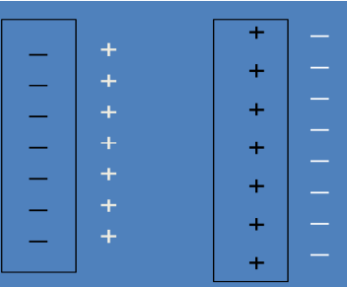

Anode Cathode   
**Single electrode potential**   
The potential of half-cell i.e. the potential difference between the metal and its salt solution in which it is dipped is called single electrode potential. It cannot be measured directly.

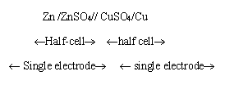

**Cell potential or EMF of a Cell**   
The difference in the electrode potentials of the two electrodes of the cell is termed as Electromotive Force (EMF) of the cell or cell potential.

EMF = Reduction potential of cathode- reduction potential of anode **Ecell = Ecathode – Eanode**

EMF of the cell may be defined as the potential difference between the two terminals of the cell when no current is allowed to flow in the circuit.

**Standard electrode potential:**   
If the metal electrode is suspended in a ionic solution of 1M (molar) concentration or unit activity and temperature is kept at 25oC under 1atm pressure, then potential develop between

electrode and ionic solution is known as standard electrode potential. It is represented by E o. The standard electrode potential of two half cell are represented by Eo (M/Mn+ ) or E o (Mn+ / M).

**ELECTROCHEMICAL SERIES**

When the various metals are arranged in the order of their increasing values of standard reduction potential on the hydrogen scale, the arrangement is called the electrochemical series

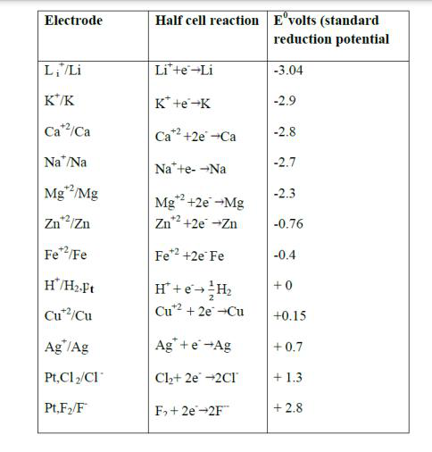

**Higher the negative value of standard reduction potential, stronger will be the reducing agent.**

**Higher the positive value of standard reduction potential, stronger will be the oxidizing agent.**

**Application of Electrochemical series**

i) **Calculation of the EMF of the cell:** EMF of the cell can be calculated using the following formula:

**EMF or Ecell = E°reduction cathode – E°reductionanode**   
ii) **Predicting anode and cathode:** an electrode with lower reduction potential is called anode while the electrode with higher reduction potential is called cathode.

For eg. In Galvanic cell the reduction potential of Zn and Cu are -0.76V and 0.34V respectively. Therefore, Zn acts as anode and Cu acts as cathode.

iii) **Spontaneity of reaction:** If EMF of the cell is positive then redox reaction is spontaneous and if EMF of the cell is negative then redox reaction is non-spontaneous.

**DIFFERENCES BETWEEN GALVANIC CELL AND**

**ELECTROLYTIC CELL**

|  |  |
| --- | --- |
| **Galvanic cell / Electrochemical cell** | **Electrolytic cell** |
| In this cell, chemical energy is converted into electrical energy. | In this cell electrical energy is converted in to chemical energy |
| In this cell anode is –ve electrode and cathode is +ve electrode. | In this cell anode is +ve electrode and cathode is –ve electrode. |
| Salt bridge is required. | . Salt bridge is not required. |
| This process is reversible and spontaneous. | |  |  |  |  |  |  | | --- | --- | --- | --- | --- | --- | | This | process | is | irreversible | and | not |   spontaneous. |
| EMF of the cell is +ve. | EMF of the cell is –ve. |

**CONCENTRATION CELL**

**“**A concentration cell is a type of **galvanic cell** in which the two electrodes are made of the same material and are dipped into electrolytes of the same composition but with different

concentrations**”.** When electrons move from a higher concentration to a lower concentration, voltage is created. The Eºcell of the cell can be calculated either by the Nernst equation or simply by:

**Eºcell = Eºcathode – Eºanode**

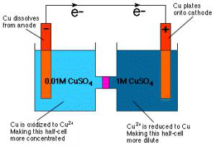

**TYPES OF CONCENTRATION CELL**

**1.Electrode Concentration Cells**   
• Two similar electrode at different conc. are dipped in same solution e.g. two hydrogen electrodes at unequal pressure are immersed in same solution of hydrogen ions.In these cells,   
• The potential difference is developed between two like electrodes at different concentrations dipped in the same solution of the electrolyte.

Ex: Pt/H2 (p1) | solution of H+ ions |H2(p2)/Pt

The reactions occurring are

**At cathode:** 2H+ + 2e– → H2(p2)(Reduction)

**At anode:** H2 (p1) → 2H+ + 2e–(Oxidation)

**Net reaction:** H2(p1) → H2(p2)

|  |  |  |  |
| --- | --- | --- | --- |
| Ecell = –0.0295 log |  | = 0.0295 log |  |

When p2 <p1, the [EMF](https://www.pw.live/chemistry-formulas/formula-for-emf-of-the-cell) is positive so that the whole process is spontaneous.

**2.Electrolyte Concentration Cells**

In these cells, the two electrodes of the same metal are dipping in solutions of metal ions of different concentrations. One such cell is represented as   
 Zn/Zn2+ (c1)|| Zn2+(c2)/Zn

The electrode reactions are   
**At cathode:** Zn2+ (c2) + 2e− → Zn(s) (Reduction)   
**At anode**: Zn(s) → Zn2+(c1) + 2e– (Oxidation)   
**Net reaction:** Zn2+(c2) → Zn2+(c1)   
The emf of the cell is given by the following expression at 25o C:

|  |  |
| --- | --- |
| • |  |

**These are of two types:**

•Electrolyte concentration cell with transference •Electrolyte concentration cell without transference

**CORROSION**

➢ The process of decay of metal by environmental attack is known as corrosion.

➢ Metals undergo corrosion and convert to their oxides, hydroxides, carbonates, sulphides, etc.

➢ Examples:- ➢ i) Rusting of iron – when iron is exposed to the atmospheric conditions, a layer

of reddish scale and powder of Fe3O4 is formed.

➢ ii) Formation of green film of basic carbonate- [CuCO3 + Cu(OH)2] on the surface of copper

when exposed to moist air containing CO2.

➢ The corrosion of metals is measured in the units of milli/inches/year or mm/year.

Corrosion-Oxidation

|  |  |  |
| --- | --- | --- |
| **Metal** |  | **Metallic Compound + Energy** |
| Metallurgy-Reduction |

Corrosion is an oxidation process and it is reverse of metal extraction.

**Causes of corrosion**

1. The metals exist in nature in the form of their minerals or ores in the stable combined forms as

oxides, chlorides, silicates, carbonates and sulphides.

2. During the extraction of metals, these ores are reduced to metallic state by supplying

considerable amount of energy.

3. Hence the isolated pure metals are in excited states than their corresponding ores.

4. So metals have natural tendency to go back to their combined state (minerals/ores).

5. When metal is exposed to atmospheric gases, moisture, liquids etc, the metal surface reacts

and forms more thermodynamically stable compounds.

**Effects of corrosion**

1. Wastage of metal in the form of its compounds.

2. The valuable metallic properties like conductivity, malleability, ductility etc. are lost due to corrosion.

3. Life span and efficiency of metallic parts of machinery and fabrications is reduced

**Theories of corrosion**

1. Dry corrosion   
2. Wet corrosion   
**Dry corrosion or Chemical corrosion:** The direct chemical action of environment on the surface of metal in absence of moisture is known as dry corrosion. This type of corrosion occurs mainly through the direct chemical action of atmospheric gases like O2, halogens, H2S, SO2, N2 or anhydrous inorganic liquid with the metal surface.

**Example**: (i) Silver materials undergo chemical corrosion by Atmospheric H2S gas.

(ii) Iron metal undergo chemical corrosion by HCl gas.

**There are three types of chemical Corrosion:**   
 1. Oxidation corrosion   
2. Corrosion due to other gases   
3. Liquid metal corrosion   
**Wet Corrosion or Electrochemical Corrosion**   
• The direct chemical action of environment on the surface of metal in presence of conducting liquid with the formation of electrochemical cells.

• It a common type of corrosion which occurs usually in aqueous corrosive environment

• Occurs when metal comes in contact with a conducting liquid.

• Formation of galvanic cell on the surface of metal generating anodic and cathodic areas • At anode oxidation takes place liberating electrons.

• Electrons at anode are transported to cathodic area where H+ or O2 and H2O consumes the electrons generating non-metallic ions like OHor O2-  
• Metallic (M+ ) and non metallic (OHor O2- ) diffuse towards each other and results in the formation of corrosion product in between the anodic and cathodic area.

Mechanism: Electrochemical corrosion involves flow of electrons between anode and cathode. The anodic reaction involves dissolution of metal liberating free electrons.

M→Mn+ + ne-   
The cathodic reaction consumes electrons with either evolution of hydrogen or absorption of oxygen which depends on the nature of corrosive environment.

**Wet corrosion takes place in two ways.**

1. Evolution of Hydrogen   
2. Absorption of Oxygen   
**Evolution of Hydrogen:**This type of corrosion occurs in acidic medium.

Eg: Rusting of iron metal in acidic environment takes place in the following way:

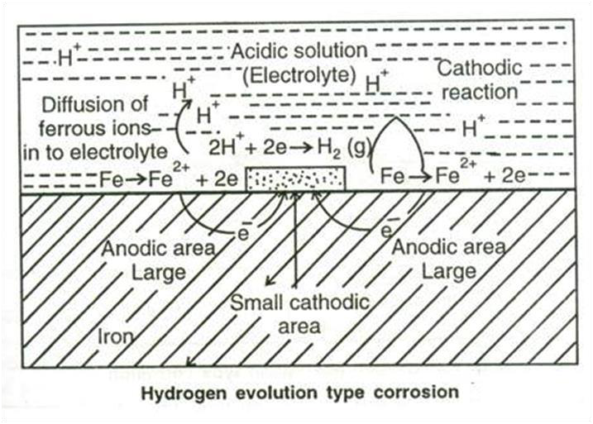

At Anode dissolution of iron to ferrous ion takes place with the liberation of electrons



The electrons released at anode flow through the metal from anode to cathode, where as H+ ions of acidic solution take up these electrons and eliminated as hydrogen gas.





This type of corrosion causes “displacement of hydrogen ions from the acidic solution by metal ions.

In hydrogen evolution type corrosion, the anodic areas are large and cathodic areas are small.

**Absorption of Oxygen:**

•This type of corrosion takes place in basic or neutral medium in presence of oxygen. •For example, rusting of iron in neutral or basic aqueous solution of electrolyte in presence of atmospheric oxygen.

•Usually the surface of iron is coated with a thin film of iron oxide.

•If the film develops cracks, anodic areas are created on the surface and the rest of the metal surface acts as cathodes.

•It shows that anodic areas are small and the cathodic areas are large.



•The released electrons flow from anode to cathode through iron metal.



• 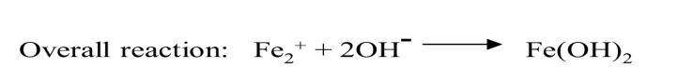

•If enough oxygen is present, ferrous hydroxide is easily oxidized to ferric hydroxide and then to hydrated ferric oxide which is known as rust.

4Fe(OH)2 + O2 + 2H2O → 4Fe(OH)3   
 Fe(OH)2+O2+2H2O→4Fe(OH)3→Fe2O3.3H2O

Rust (hydrated ferric oxide)

The product called rust corresponds to Fe2O3.3H2O.

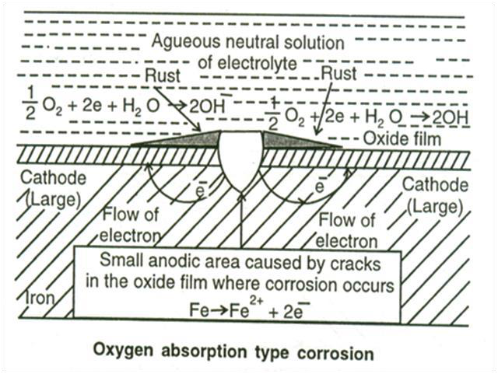

**Factors effecting corrosion**

The rate and extent of corrosion depends upon various factors due to nature of metal and nature of corroding environment.

**Factors due to nature of metal**

1. **Purity of the metal:** Heterogeneity of the metal is due to the presence of impurities which form tiny electrochemical cells at the exposed parts. The anodic parts get corroded.

2. **Electrode potentials:** metals with higher reduction potentials do not corrode easily. They are noble metals like gold, platinum and silver. Whereas the metals with lower reduction potentials readily undergo corrosion (eg. Zn, Mg, Al etc.).

3. **Position of metal in galvanic series:** Metals which possess low reduction potentials and occupy higher end of galvanic series undergo corrosion easily.

4. Metals which possess high reduction potentials and occupy lower end of galvanic series do not undergo corrosion and they get protected.

• When two metals are in electrical contact in presence of an electrolyte, then the metal which is more active undergoes corrosion.

• The rate of corrosion depends on the difference in their position in Galvanic series. Greater the difference more will be the extent of corrosion at anode.

5. **Hydrogen over voltage:** when a cathode reaction is hydrogen evolution type, the metal with Lower hydrogen over voltage on its surface is more susceptible for corrosion, since the liberation of hydrogen gas is easy at this condition. Hence the cathodic reaction is very fast which in turn Makes anodic reaction fast. Hence the rate of corrosion increases. Higher the over voltage, lesser is the corrosion.

6. **Physical state of metal:** Metals with small grain size have more tendencies to undergo corrosion. Metal with more stress/strain also undergoes corrosion easily.

**7. Nature of surface film:** If the corrosion product formed is more stable, insoluble and nonporous, it acts as protective layer and prevents further corrosion (Eg. Ti, Al and Cr). If the corrosion product is porous, volatile and soluble, it further enhances the corrosion (Fe, Zn and Mg).

**Corrosion control methods**

1. Proper designing   
2. Using Pure metals   
3. Using metal alloys   
 4. Use of inhibitors   
5. Modifying Environment   
6. Cathodic protection   
7. Application of protective coatings   
**Cathodic Protection:** The method of protecting the base metal by forcibly making it to behave like a cathode there by corrosion does not occur is called as cathodic protection. There are two types of cathodic protection   
 (a) Sacrificial anodic protection   
(b) Impressed current cathodic protection   
**Sacrificial anodic protection**   
• In this protection method, the metallic structure to be protected (base metal) is connected by a conducting wire to a more anodic metal so that all the corrosion is concentrated at this more anodic metal.

• The more anodic metal itself gets corroded slowly, while the parent structure (cathodic) is protected. The more active metal so employed is called sacrificial anode. The corroded sacrificial anode is replaced by a fresh one, when consumed completely.

• The artificially made anode thus gets corroded gradually protecting the original metallic structure. Hence the process is known as sacrificial anodic protection.

• Metals commonly employed as sacrificial anode are Mg, Zn, Al and their alloys which possess low reduction potential and occupies higher end in electrochemical series.

Eg: A ship-hull which is made up of steel is connected to sacrificial anode (Zn-blocks) which undergoes corrosion leaving the base metal protected.

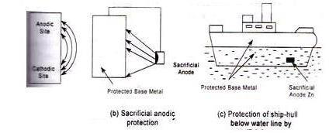

Fig. anode method: Ship hull and underground water pipeline

Eg. The underground water pipelines and water tanks are also protected by sacrificial anode method. By referring to the electrochemical series, the metal with low reduction potential is connected to the base metal which acts as anode.

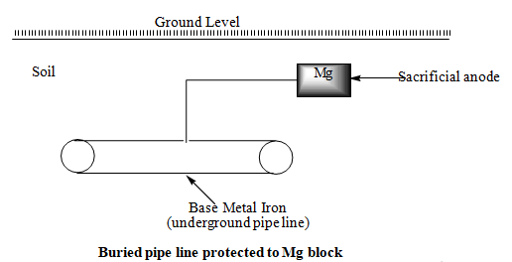

**Applications of Sacrificial anodic protection:**

By referring to the electrochemical series, the metal with low reduction potential is connected to the base metal which acts as anode.

1.To protect underground pipelines- Buried pipe line protected by connecting to Mg block   
2.Protection of ship hulls and other marine devices.

3.Protection of water tank- by suspending Zn or Mg rods, body of the tank made cathode and protected.

**Advantages:**

1.It is a simple method.

2.It does not require external power.

3.It has low maintenance and installation cost   
4.Cathodic interferences are minimum.

**Disadvantages:**

1.More than one anode is required some times.

2.It does not work properly in high corrosive environment.

3.Sacrificial anode must be replaced periodically as and when it is consumed

**b. Impressed current method**

• In this method, an impressed current is applied in opposite direction to nullify the corrosion current, and

convert the corroding metal from anode to cathode.

• The impressed current is slightly higher than the corrosion current. Thus the anodic corroding metal

becomes cathodic and protected from corrosion.

• The impressed current is taken from a battery or rectified on A.C. line. The impressed current protection

method is used for water tanks, water & oil pipe lines, transmission line towers etc.

**Metallic coatings**

The surface of the base metal is coated with another metal (coating metal). Metallic coatings are broadly

classified into anodic and cathodic coatings.

1.**Anodic coating:** the metal used for the surface coating is more anodic than the base

metal which is to be protected.

• For example, coating of Al, Cd and Zn on steel surface are anodic because their electrode potentials are lower than that of the base metal iron. Therefore, anodic coatings protect the underlying base metal sacrificially.

• The formation of pores and cracks over the metallic coating exposes the base metal and a galvanic cell is formed between the base metal and coating metal. The coating metal dissolves anodically and the base metal is protected.

**2.Cathodic coating:**

• Cathodic coatings are obtained by coating a more noble metal (i.e. metals having higher electrode potential like Sn, Au, Ag, Pt etc.) than the base metal. They protect the base metal as they have higher corrosion resistance than the base metal due to cathodic nature.

• Cathodic coating protects the base metal only when the coating is uniform and free from pores.

• The formation of pores over the cathodic coating exposes the base metal (anode) to environment and a galvanic cell is set up. This causes more damage to the base metal.