Technion – Israel Institute of Technology



HW2

Autonomous Navigation and Perception

086762

|  |  |  |
| --- | --- | --- |
| Alon Spinner | 305184335 | alonspinner@gmail.com |
| Dan Hazzan | 308553601 | danhazzan@campus.technion.ac.il |

April 12, 2022

# Question 1 – Theoretical questions

Given:

$$A≐\{a_{0:L-1}\}$$

And assume motion and observation models are:

$$p\left(x_{k} \right|x_{k-1} , a_{k-1} ) , p\left(z \right|x )$$

{ $denoting r\left(a,b\right)=\int{r\left(x,a\right)b[x]}dx$ where $b\left[x_{k}\right]=p\left(x_{k} | a_{0:k-1},z_{1:k})\right)$}

## Objective function explicitly for the above considered setting:

$$J\left({b[x}_{k}\right],a_{k:k+L-1})=\underset{z_{k+1:k+L}}{\underbrace{E}}\{\sum_{l=0}^{L-1}{r\left(b\left[X_{k+l }\right],a_{k+l}\right)+r(b\left[x_{k+L}\right])\}}$$

$$\{denoting b\left[x_{k}\right]=p(x_{k}|a_{0:k-1},z_{1:k})$$

## Derive a recursive formulation that expresses $J\left({b[x}_{0}\right],a_{0:0+L-1})$:

Given: $a_{0:L-1}∈A$

$$J\left({b[x}_{0}\right],a_{0:L-1})=\underset{z_{1:L}}{\underbrace{E}}\{\sum_{l=0}^{L-1}{r\left(b\left[X_{l }\right],a_{l}\right)+r(b\left[x_{L}\right])\}}\underset{Linearity}{\underbrace{=}}$$

$$\underset{\begin{aligned}1. Linearity \\ 2. assuming we \\ know: b\left[x_{0}\right]=p(x_{0}) \\ \end{aligned}}{\underbrace{=}}E\{r\left({b[x}_{0}\right],a_{0})\}+\underset{z_{1:L}}{\underbrace{E}}\{\sum_{l=1}^{L-1}{r\left(b\left[X_{l }\right],a_{l}\right)+r(b\left[x_{L}\right])\}}$$

$$\underset{sufficient statistic}{\underbrace{=}} r(b_{0},a_{0})+\int{p\left(z_{1:L} | b_{0},a_{0:L-1 }\right)\left[\sum_{l=1}^{L-1}{r\left(b_{l},a_{l}\right)+r(b_{L})}\right] }dz_{1:L}$$

$$\underset{Chain rule+indep.}{\underbrace{=}}r{(b}_{0},a_{0})+ \int{p\left(z_{1} | b_{0},a_{0 }\right)p(z_{2:L}|b_{0},a_{1:L-1}, z_{1})\left[\sum_{l=1}^{L-1}{r\left(b_{l},a_{l}\right)+r(b_{L})}\right] }dz_{1:L}$$

$$= r{(b}_{0},a_{0})+\int{\int{p\left(z_{1} | b_{0},a_{0 }\right)p(z_{2:L}|b_{0},a_{1:L-1}, z_{1})\left[\sum_{l=1}^{L-1}{r\left(b_{l},a_{l}\right)+r(b_{L})}\right] }dz_{2:L}dz_{1}}$$

$$\underset{indep.}{\underbrace{=}} r{(b}_{0},a_{0})+\int{p\left(z_{1} | b_{0},a_{0 }\right)\int{p(z_{2:L}|b_{0},a_{1:L-1}, z_{1})\left[\sum_{l=1}^{L-1}{r\left(b_{l},a_{l}\right)+r(b_{L})}\right] }dz_{2:L}dz_{1}}$$

$$\{denoting(we don^{'}t need to add r\left(a_{1},b_{1}\right)?) \underset{z_{2:L}}{\underbrace{E}}\{\sum_{l=1}^{L-1}{r\left(b\left[X_{l }\right],a_{l}\right)+r(b\left[x_{L}\right])\}}=\int{p(z_{2:L}|b_{0},a_{1:L-1}, z_{1})\left[\sum_{l=1}^{L-1}{r\left(b_{l},a_{l}\right)+r(b_{L})}\right] }dz_{2:L}$$

$$= r{(b}_{0},a_{0})+\int{\underset{Probability of objective function}{\underbrace{p\left(z_{1} | b_{0},a_{0 }\right)}}∙}\underset{Value of objective function}{\underbrace{J(b_{1},a_{0:L-1})dz_{1}}}$$

$V_{0}^{π}\left(b_{0}\right)=\underset{z_{1:L}}{\underbrace{E}}\{\sum_{l=0}^{L-1}{r\left(b\left[X_{l }\right],a_{l}\right)+r\left(b\left[x_{L}\right]\right)|a_{l}=π(b_{l})\}}$

$V_{0}^{π}\left(b_{0}\right)=r\left(b_{0},π\left(b_{0}\right)\right)+\underset{z_{1:L}}{\underbrace{E}}\{\sum_{l=1}^{L-1}{r\left(b\left[X_{l }\right],a_{l}\right)+r\left(b\left[x_{L}\right]\right)\left|a_{l}=π\left(b_{l}\right)\right\}}=$

$$=r\left(b_{0},π\left(b_{0}\right)\right)+\int{p\left(z_{1:L} | b_{0},π\left(b_{0:L-1}\right)\right)}\left[\sum_{l=1}^{L-1}{r\left(b_{l},π\left(b_{l}\right)\right)+r(b_{L})}\right]dz_{1:L}$$

$$=r\left(b_{0},π\left(b_{0}\right)\right)+\int{p\left(z_{1} | b_{0},π\left(b_{0}\right)\right)}p\left(z_{2:L} | b_{0},π\left(b_{0:L-1)}\right),z_{1}\right)\left[\sum_{l=1}^{L-1}{r\left(b_{l},π\left(b_{l}\right)\right)+r(b_{L})}\right]dz_{1:L}$$

$$=r\left(b_{0},π\left(b_{0}\right)\right)+\int{p\left(z_{1} | b_{0},π\left(b_{0}\right)\right)}\int{p\left(z_{2:L} | b_{0},π\left(b_{0:L-1)}\right),z_{1}\right)\left[\sum_{l=1}^{L-1}{r\left(b_{l},π\left(b_{l}\right)\right)+r(b_{L})}\right]dz_{2:L}dz_{1}}$$

$$=r\left(b_{0},π\left(b_{0}\right)\right)+\int{p\left(z_{1} | b_{0},π\left(b_{0}\right)\right)}V_{1}^{π}\left(b_{1}\right)dz_{1}$$

1. In the objective function formulation J, we assume a set of known actions. The value of $V^{π}$ uses a policy $π\left(b\right)$ to create actions as such, actions are generated online and $π$ can be optimized inline.

# Hands-on tasks – question 1

Given:

1. Mobile robot navigating in a 2D environment.
2. Motion and observation models ( $p\left(x_{k+1} | x_{k},a_{k}\right), p(z_{k}|x_{k}))$ are given by: $x_{k+1=f\left(x_{k},a_{k}\right)+w , z_{k}=h\left(x_{k}\right)+v }$

$w\sim N\left(0,Σ_{w}\right) , v\sim N(0,Σ_{v})$

$f\left(x_{k},a_{k}\right)=F∙x_{k}+a_{k} with F=I_{2x2} and a_{k}ϵR^{2}$

$z_{k}∈R^{2} and h\left(x_{k}\right)=x_{k}$

$b\left(x_{0}\right)≐p\left(x_{0}\right)=N(μ_{0},Σ_{0})$

We decided to implement a “Kalman filter” (ProbabilisticRobotics chapter 3.2.1).

From the question we can tall that:

1. $p(x_{t+1}|u_{t}, x_{t})$ linear function in its arguments with added Gaussian noise
2. $p(z_{t}| x_{t})$ linear function in its arguments with added Gaussian noise

$bel\left(x_{0}\right)≐p\left(x_{0}\right)=N\left(μ_{0},Σ_{0}\right)$

Now, when we know we hold the 3 above we can tall that the posteriors are Gaussian and can apply Kalman filter algorithm shown (from “ProbabilisticRobotics” book) below:

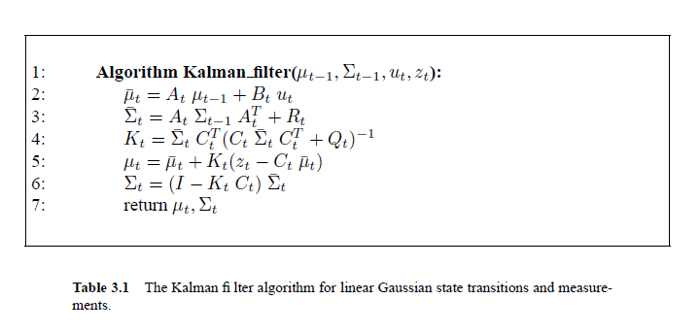

Figure : Kalman filter algorithm

Given a robot state $x$ and action $a$ we can generate the next state i.e $x^{'}\sim p(x^{'}|x,a)$ such:

$x^{'}=F∙x+a+w , w=noise\sim N(0,Σ_{w})$

## 

According to the observation model we can generates an observation i.e $z\sim p(z|x)$ such:

$$z=H∙x+a+v , v=noise\sim N(0,Σ_{v})$$

1. Julia
2. Julia

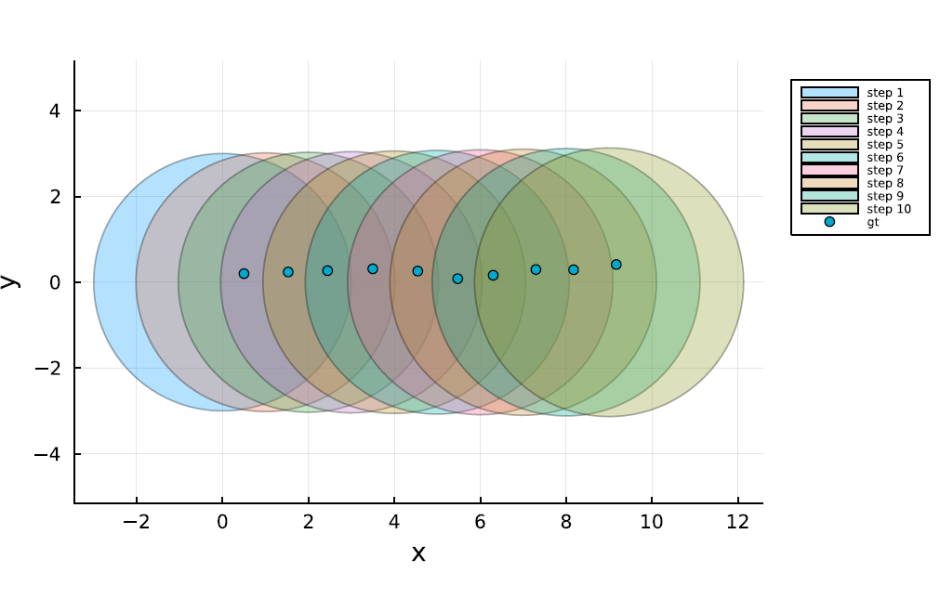

Figure 2: Ground Truth trajectory and the correspondence propagated beliefs

Its Hard to see in figure 3, but the covariance does exist after the first step.

As expected, the covariance is much smaller than the covariance in section iii.

Figure 3: Ground Truth trajectory and the correspondence posterior beliefs

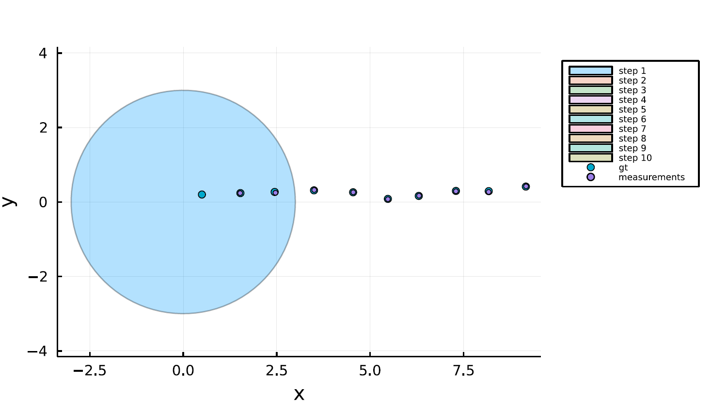

# Hands-on tasks – question 2

The observations are derived from:

$z_{k}=h\left(x_{k}\right)+v , v\sim N(0,Σ_{v})$