Technion – Israel Institute of Technology



HW5

Numerical Methods

019003

|  |  |  |
| --- | --- | --- |
| Alon Spinner | 305184335 | alonspinner@gmail.com |
| Oren Elmakis | 311265516 | orenelmakis@gmail.com |

December 30, 2021

# Question 1

Assuming the system is in steady state, we can assume that the power input must equal the power output. Hence, we will impose equilibrium between the in and out heat fluxes on our control volumes.

We will denote as heat flux, with units of .  
 will be power per unit length

will be power per unit length

From ‘Heat ’

Newton’s convection law:

Fourier’s Convection law:

Figure 1 A plate consisting of two materials with different properties

## Section a

We were asked to use the control volume approach for calculating the boundary equations on points boundary points.

### Point 1

We created a control volume of size .

Hence the balance equation is:

### Point 2 –

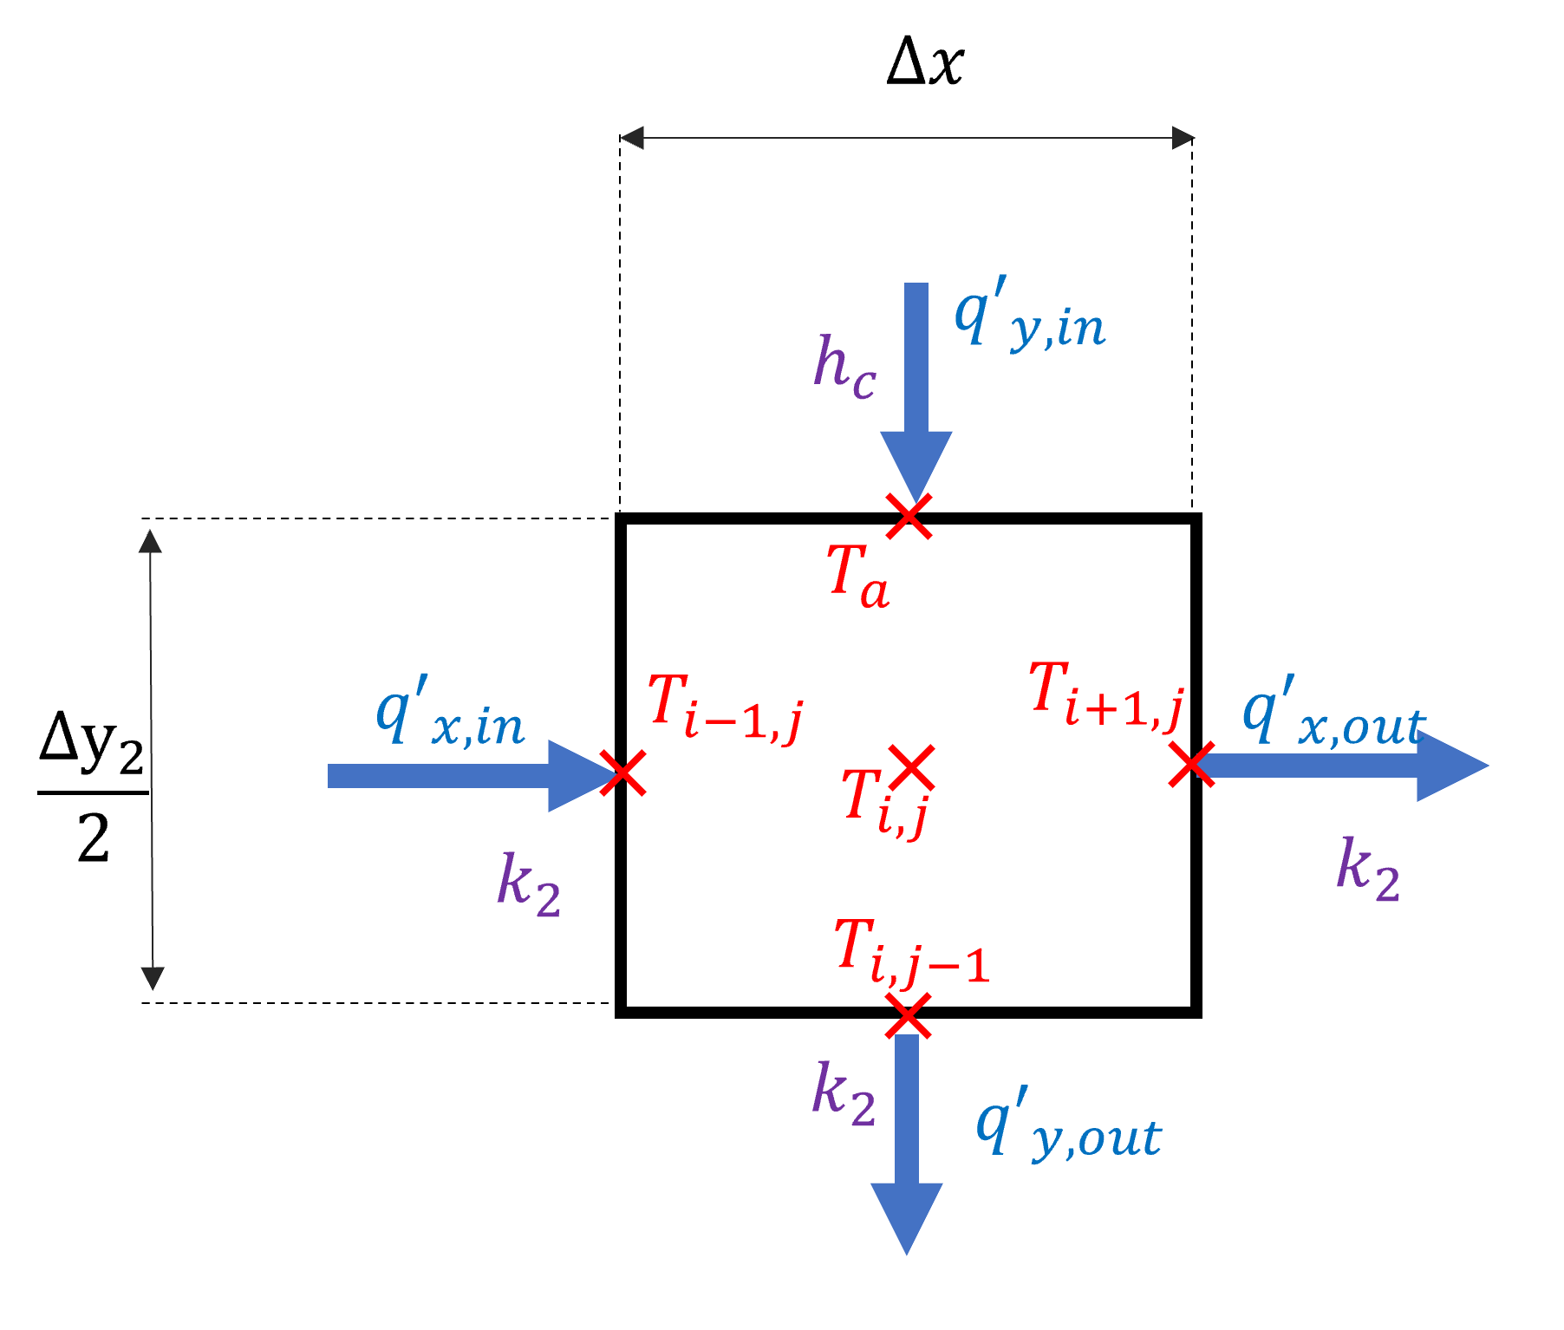We created a control volume of size .

Hence the balance equation is:

according to the second material grid and *,* we get

### Point 3 –

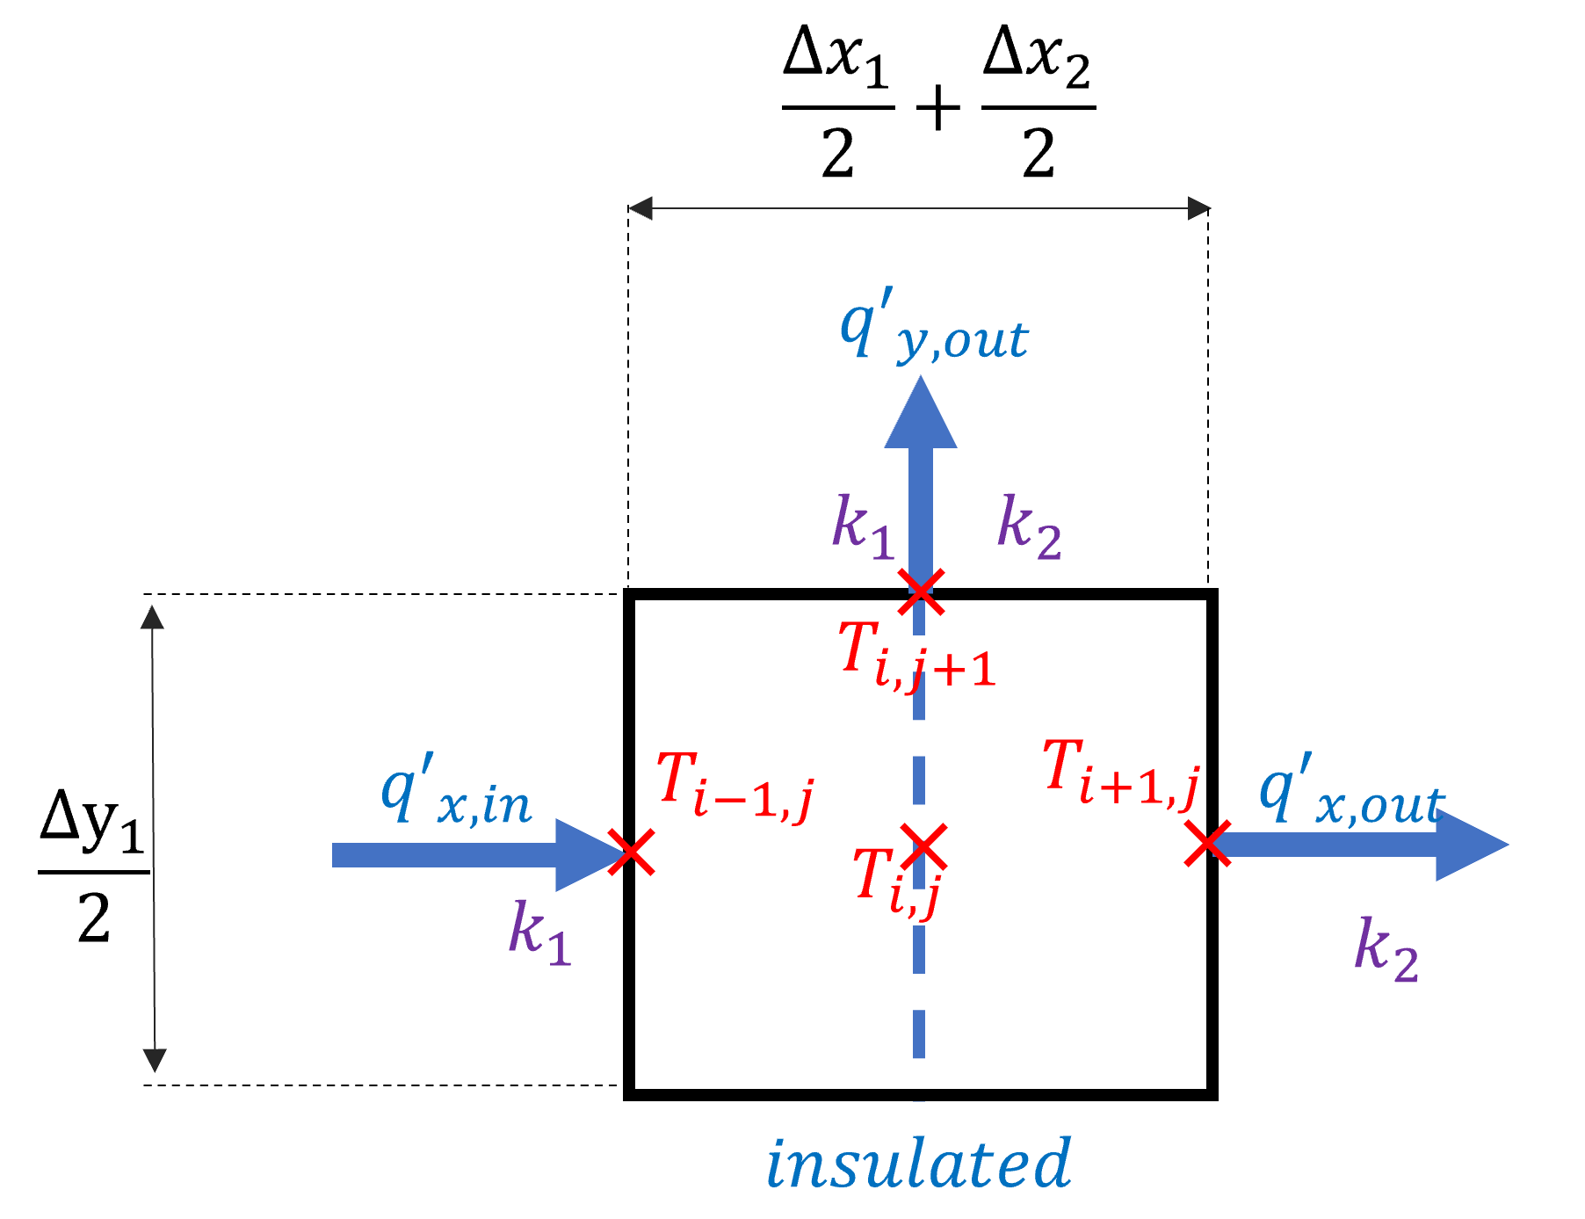We created a control volume of size .

Hence the balance equation is:

The grid is

### Point 4 –

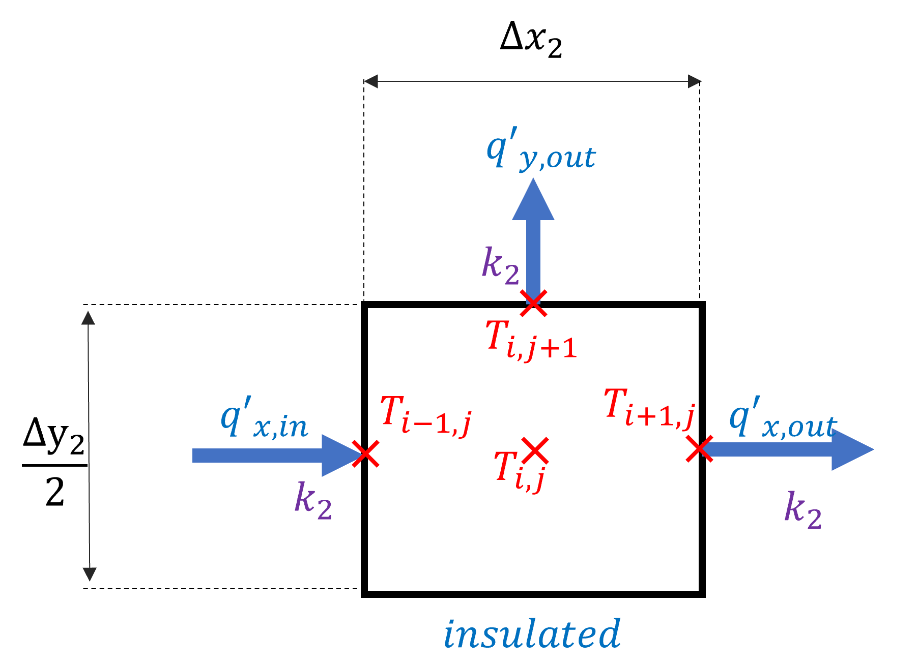We created a control volume of size .

Hence the balance equation is:

According to the second material given grid and

## Section b

We were asked to formulate the equations of points 5,6,7:

### Point 5 –

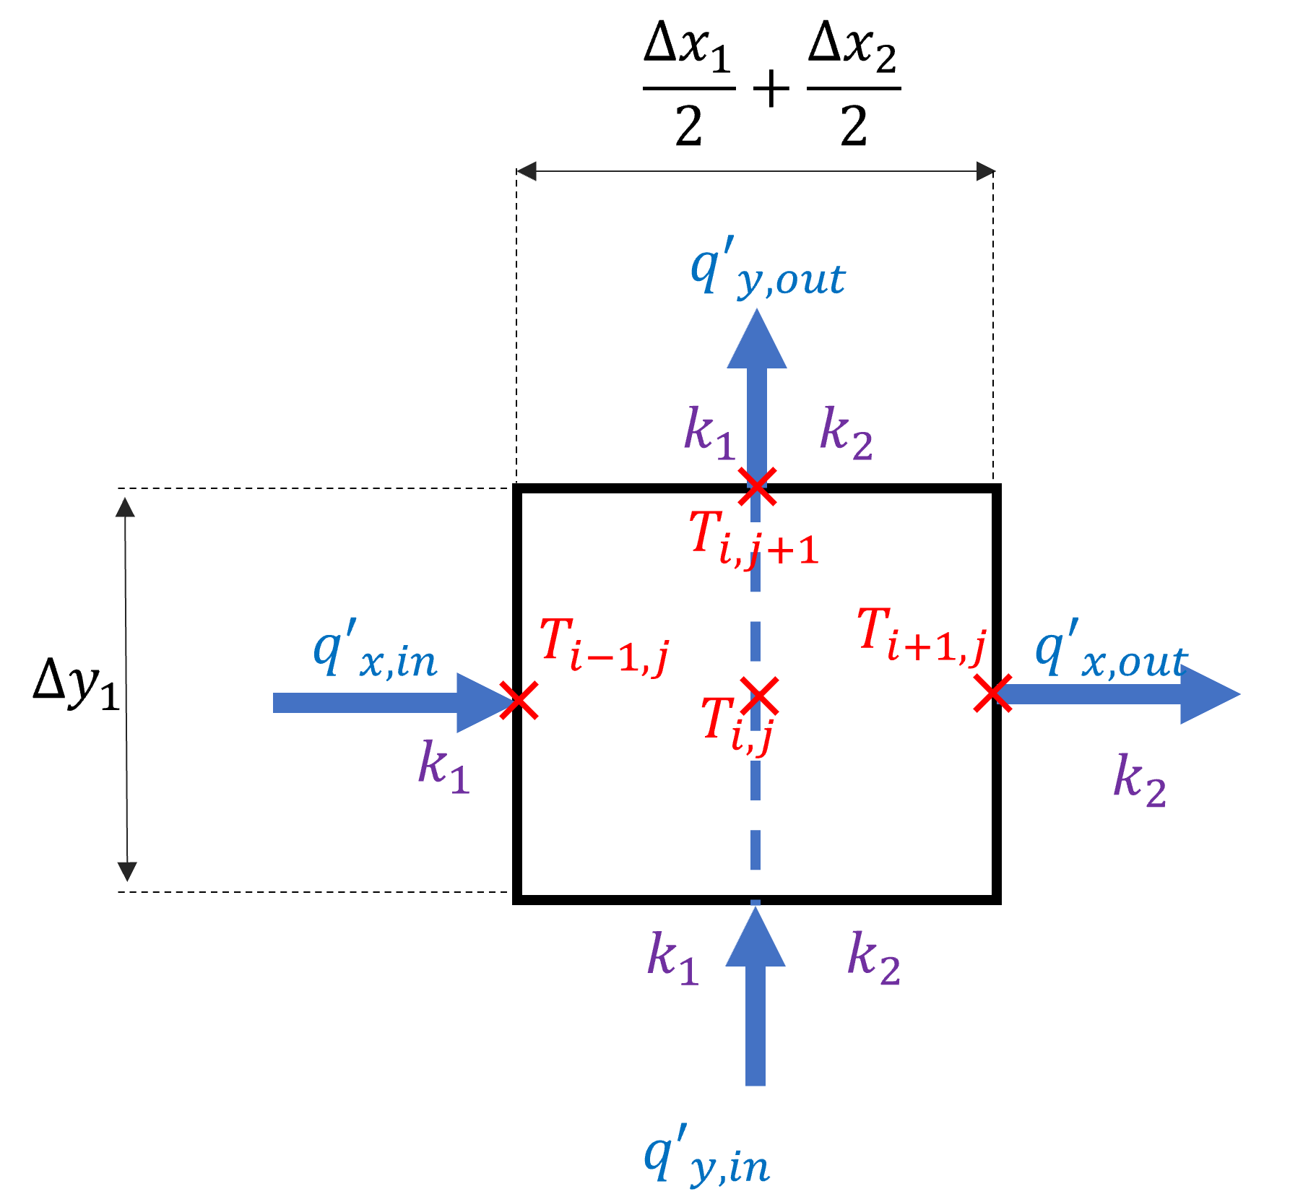We created a control volume of size .

Hence the balance equation is:

The grid size is

### Point 6 –

According to the figure of the plate

### Point 7 –

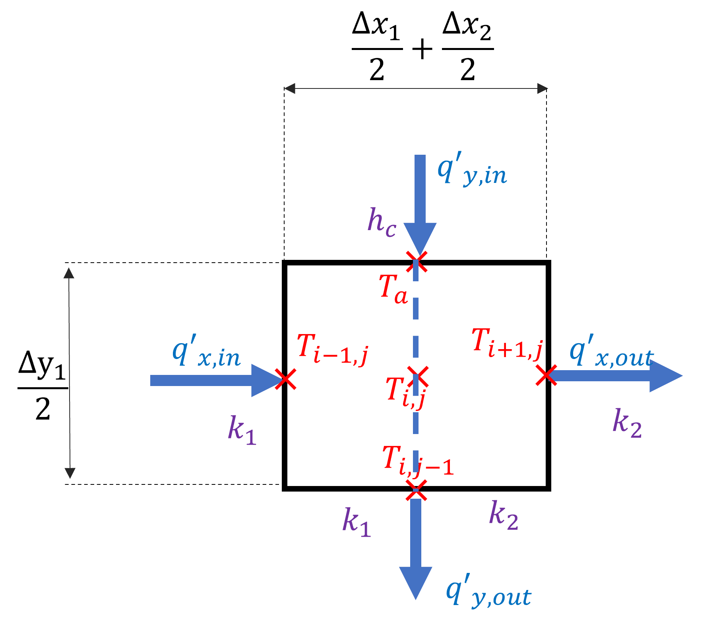We created a control volume of size .

Hence the balance equation is:

The grid size is

## Section c

We will open the equation using the finite difference approach with second order central difference.

The steps of and are equal, thus

We can arrange the equation as follows (keep remember that in material 1(

Multiply by , and we get the control volume.

## Section d

|  |  |  |
| --- | --- | --- |
|  |  |  |
| a | b | c |

The change in the Thermal conduction value in the materials causes difference in the heat distribution.

* Comparing figures (a) and (b), It shows that the material with the higher thermal conductivity will have a more even temperature distribution. The reason figures (a) and (b) aren’t symmetric are because of the bottom boundary conditions.
* Figure (c) presents a scenario of high convection, which causes high heat flux that gets into materials one and two, causing temperature increase. Having the same thermal conductivity for both materials, the difference between the system’s sides are only due to the bottom boundary conditions.

# Question 2 –

## Section a

The equation is given as

The first derivative is based on time forward differentiation

Accordingly, the explicit form of the partial second derivative is an upward triangle, with time propagation on the top, for index

The implicit representation form is based on an inverted triangle,

Crank Nicolson method uses a dummy point that is in the middle of the time step and represented as a combination of the time propagation and the previous state:

## Section b

We were asked to solve the heat transfer function using the explicit method.

First, we have to formulate the boundary conditions of both sides:

In according to the conservation of heat equation:

From Fourier’s law

In , the outward flux is known

And the central nodes equations for temperature distribution

The convergence and stability of the explicit method is

As a result, of using , the which causes to diverge is

The following figure demonstrates the time-location distribution of the 1D heated rod with and :

|  |  |
| --- | --- |
|  |  |

The code is attached rod_explicit.m

## Section c

The boundary conditions are the same as in section a:

However, now we don’t have the

And the boundary condition of the end of the rod:

The central nodes equation is:

The following figure demonstrates the time-location distribution of the 1D heated rod with and which is equal to the results of the explicit:

|  |  |
| --- | --- |
|  |  |

The code is attached rod_CN.m

## Section d

In this question, we were asked to implement the methods of explicit and crank Nicolson for solving the 1D heated rod PDE. The main difference between the methods is the performing complexity and the stability. In comparison to the Crank Nicolson, which requires a tridiagonal algebraic solution, the explicit method implementation is straightforward. However, in contrast to the Crank Nicolson method that has unconditional stability, the explicit approach is restricted to stability term of .

The temperature distribution over the rod is increases via the heating from . The left boundary dissipates heat to the environment via convection, while the right boundary has a constant heat flux out. As can be noted from the temperature difference in the figure above, the convection dissipation is more effective than the constant heat transfer on the right side.

# Question 3 –

## Section a

Given that we have to prove the ADI scheme for inner points, the PDE equation for plate

The first step is forward differentiation of

time propagation of in the direction

And using second order central difference OF explicitly

Consequently, with and define the results

after some order

The second step from

time propagation of in the direction

With remain the same.

Consequently, with and define the results

And after ordering

## Section b

The initial condition is

and we got three trivial boundary conditions

And another Neumann condition

We will use dummy point outside the domain (to keep the accuracy of the method, using central derivative)

Now, we can substitute the result to the ADI equation for the first step over direction.

The second direction equation.

## Section d

According to the value of , , and the value of

|  |  |
| --- | --- |
|  |  |
|  |  |
|  |  |

The heat distribution can be seen initially starting in the low right corner (, where the temperature of the boundary condition is . The function added to the equation of the heat distribution is a heat source that amplifies the temperature in the center of the plate and causes a local warming peak, as shown in the following figure.

Moreover, the dissipation direction is towards the edges, where the temperature is low.

The code is attached ADI.m