Kalman Test on a basic Pendulum System

# Problem Introduction

Let us imagine a pendulum system of a charged bulb exited by an initial drop from an initial state and an electrical field controlled by a scientist.

To measure the state of the system, a linear encoder was placed undeath the charged mass with a resolution of . We sample it at .  
A full-scale measurement of the encoder would be around .

This is a bad sensor.   
It is as good as laying sticks on the ground and having a little kid eyeball the bulb.

Friction is negligible in this system, but the experiment is done on a windy day and it thought that the winds can cause a meaningful change to the angular velocity.  
The wind’s direction changes quickly to the point where it may be considered as a random process.

An experiment was made to measure the wind’s effect:  
Release the bulb from and measure its position in time using the encoder.  
From the maximal position use a simple pendulum model and roughly estimate the angular velocity.  
After a full day of experimenting it was shown that

**How accurately can we estimate the state of the system using a dynamic model and the measurements?**

**Bonus:  
What electric field should the scientist input for every initial state if his objective is to bring the bulb to a halt as quickly as possible?**

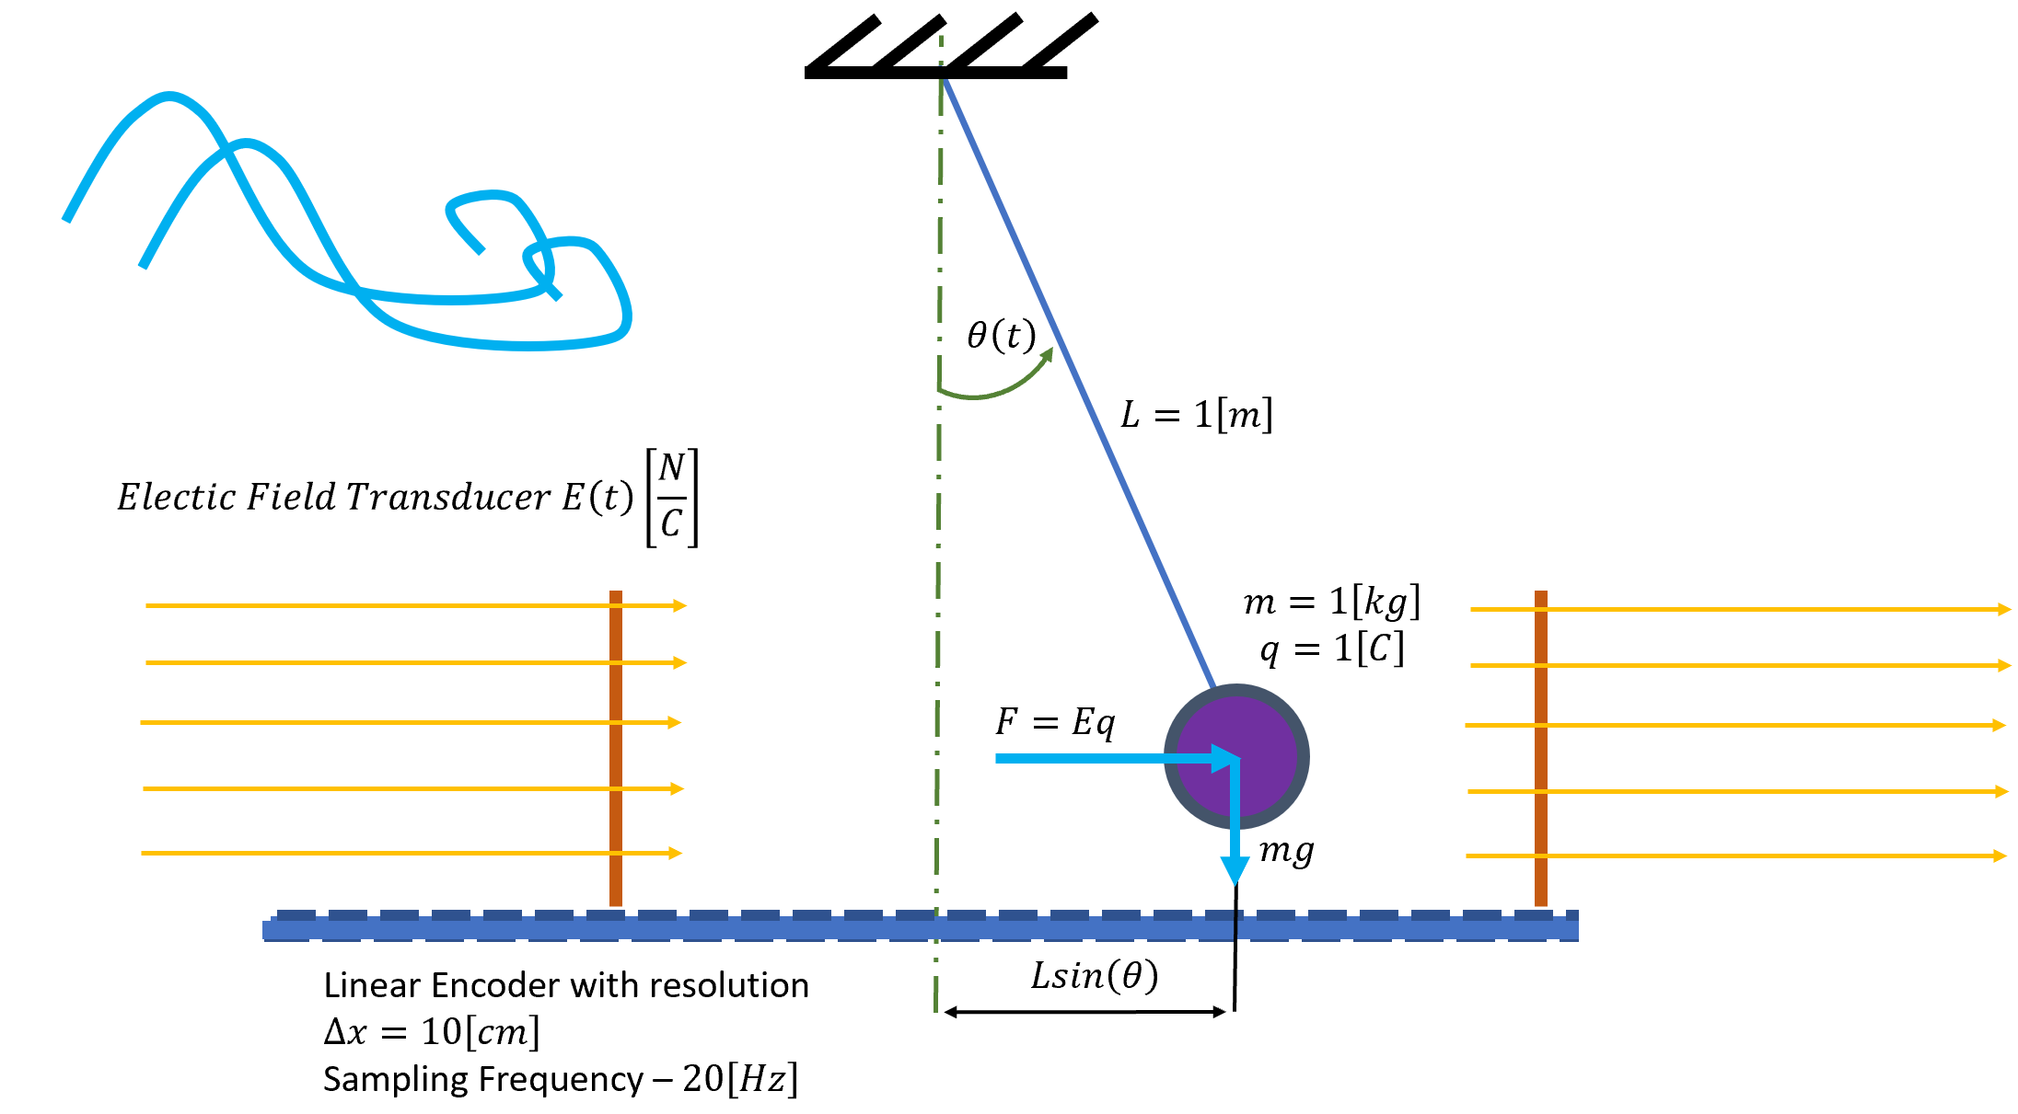

To simplify things, let us work with a dumbed down system where the force is directly controlled by the scientist rather than the electrical field.

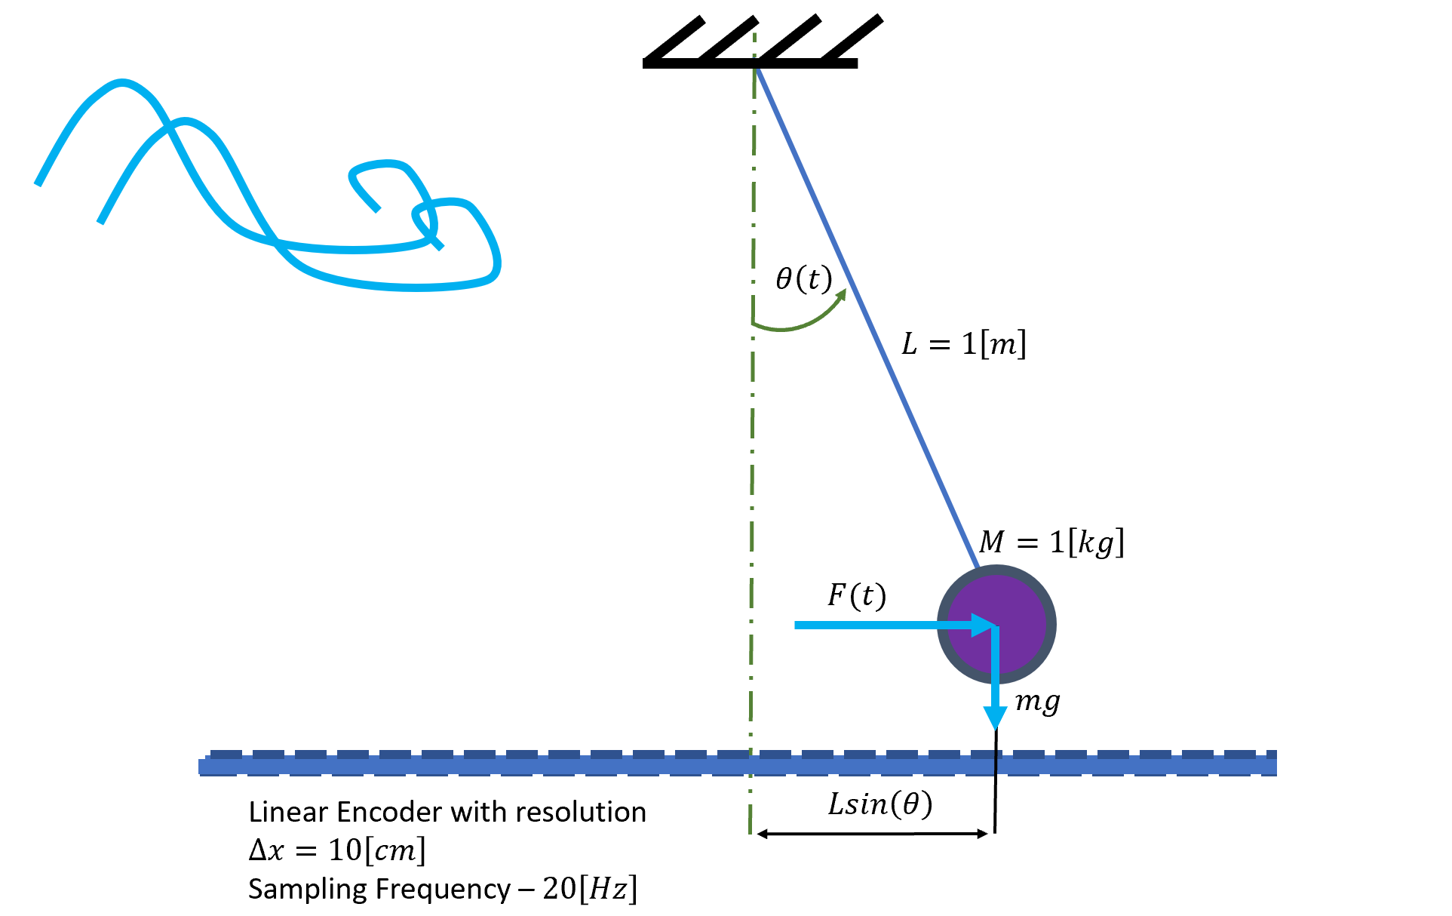

# Dynamic Model Derivation

Using Newton’s second law:

In Simulink:

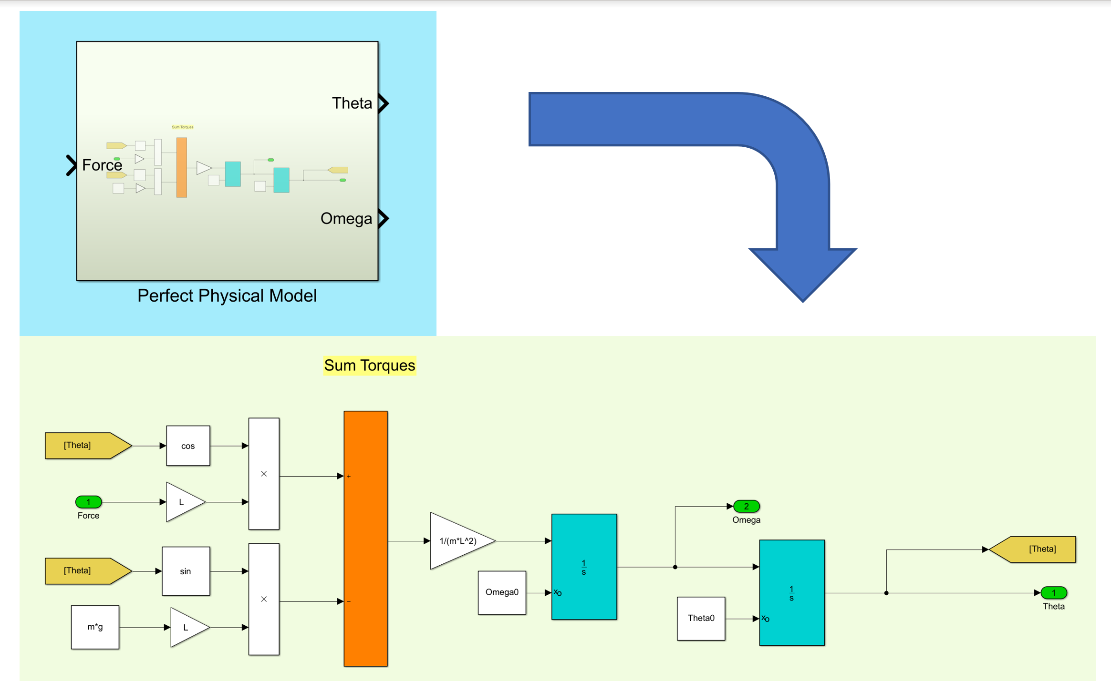

Sanity Test:

For and a small initial a natural frequency. The system will oscillate about a natural frequency.  
Let’s drive it:

Small initial allows for small angle approximation

Solving the ODE:

Substituting numbers in:

The period of the system:

To complete the physical model, I added the wind’s effect.

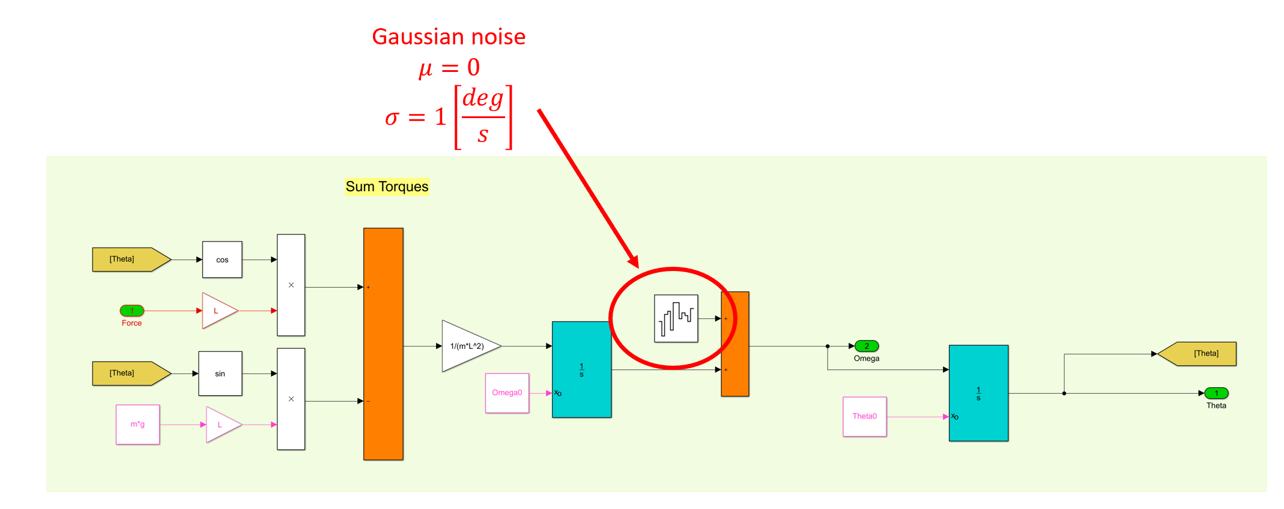

# System Measurement

To simulate the measurement, we take the continuous state of and compute the perfect measurement:

We then discretize the measurement to the resolution and finally add really gaussian low noise to it. The noise here is mostly caused by the electricity in the sensor, but it is proportional to the full scale.

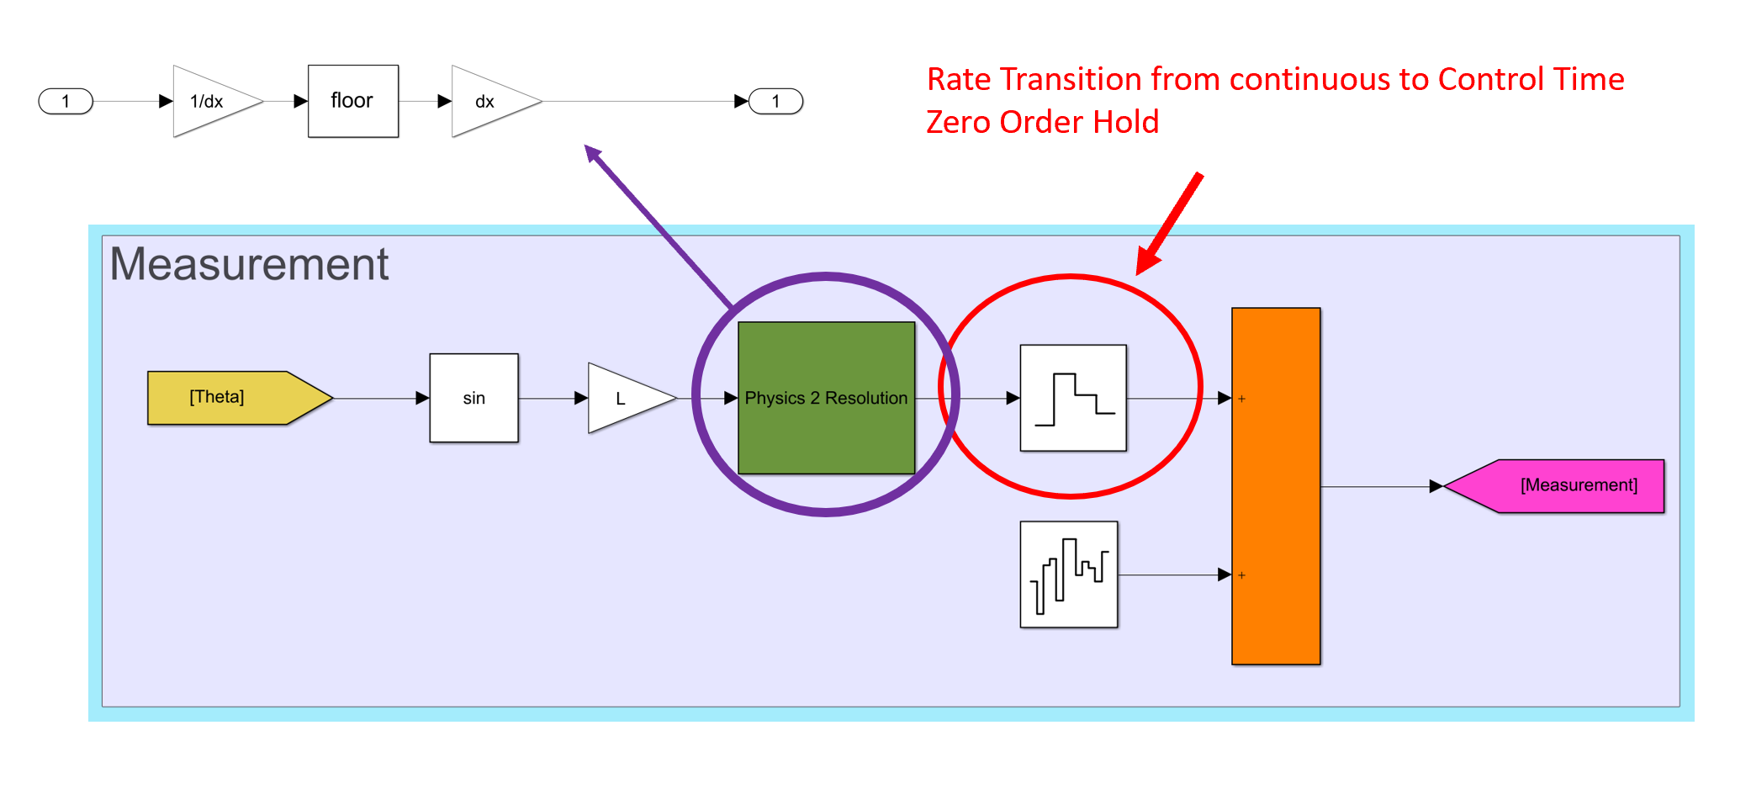

# References

<https://www.mathworks.com/help/control/ug/multirate-nonlinear-state-estimation-in-simulink.html>