Technion – Israel Institute of Technology

Faculty of Mechanical Engineering



Project – Part 2

Vibration Theory

034011

June 20, 2021

# Abstract

A wind turbine with three blades was modeled as a point mass atop a cantilever beam.   
To compute the maximal stress in the turbine’s mast as a function of wind speed, and the system’s modal properties, the force exerted on the turbine was modeled as a sum of two harmonic forces where one has a frequency three times as the other in correlation to the number of blades on the turbine.  
In addition, two types of systems were checked:   
one where only the mast, transmission, generator and blades were modeled, and another one where a dynamic mass damper was added.  
Stress was calculated using the dynamic linear system frequency response properties around a stable equilibrium.   
We have found that the maximal stress in the original system crosses the allowed amount of 108Mpa around one specific wind speed. The system with the mass damper never crosses the allowed stress.  
A simulation was created to validate the results visually.

Contents

1Abstract 1

Part A 3

1.1Finding the mass's equation of motio 3

1.1.1Position and velocity of mass center 3

1.1.2Kinetic Energy and Mass Matrix 3

1.1.3Dissipation function and Damping matrix 4

1.1.4Potential Energy and Stiffness Matrix 4

1.1.5The system's generalized equation of motion 6

1.2Natural frequencies, modes and modal form 6

1.2.1Natural frequencies and modes 6

1.3Defining the modal form 7

1.4Modal damping ratio 7

1.5Modal equation of motion in state space representation and modal response to initial conditions 7

1.6Analytic response to harmonic inputs 8

1.6.1Solving for general coordinates using modal summation and frequency response 9

1.6.2Graphing the maximal stress in the beam as a function of wind speed 10

2Part B 12

2.1Calculating the new equation of motion 13

2.1.1Position and velocity of the dynamic mass absorber 13

2.1.2New kinetic energy and mass matrix expressions 14

2.1.3New potential energy and stiffness matrix expressions 15

2.1.4New dissipation function and damping matrix expressions 15

2.2Choosing the mass damper’s spring constant 15

3Simulation 17

4Conclusion 17

5Bibliography 17

# Part A

We modeled the turbine as a point mass, representing the transmission, generator and blades and a rigid massless beam connected to a massless cantilever beam as the mast.

Where:



The movement of the turbine’s blades causes a damping force to be exerted on them:



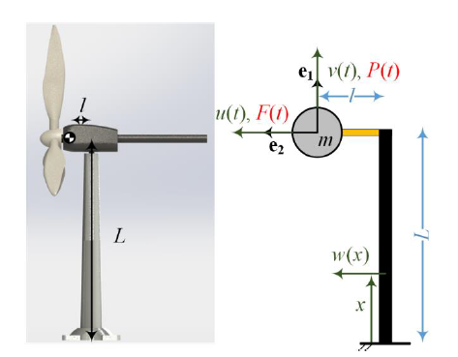

Figure -Turbine simplified model

## Finding the mass's equation of motion

It is assumed throughout part A that equilibrium  exists, and we are working around it.

### Position and velocity of mass center

For a stationary co-ordinate system, we can define the equation of position and velocity.



### Kinetic Energy and Mass Matrix

the kinetic energy of the system:



Equation 1-kinetic energy   
  


Equation 2-General mass matrix

We calculated the mass matrix for the generalized co-ordinates are . Using Equation 2.



### Dissipation function and Damping matrix

The dissipation function and its related matrix are defined as follows:



Equation 3-dissipation function



Equation 4-damping matrix

Which brings us to:



### Potential Energy and Stiffness Matrix

Neglecting the amount of energy stored in the beam from shear and tension loads, the beam's potential energy could be described by the term:



Equation 5-potential energy

The Stiffness Matrix would then be calculated as such:



Equation 6-stiffness matrix

The beam's deflection profile could be described by a third-degree polynomial:

 where x is defined in Figure 1.

To find  we had defined boundary conditions and solved a set of linear algebraic equation.

Boundary conditions and the derived equations:





The deflection profile was then found to be:



Equation Beam Deflection function

Using Equation 5 and Equation 6we have obtained the beam's potential energy and stiffness matrix:





### The system's generalized equation of motion

We used virtual work to find the system’s generalized forces:





The equation of motion takes the form:



Equation 8-equation of motion

Substituting the matrices with their explicit values would then give rise to the equation of motion:



## Natural frequencies, modes and modal form

### Natural frequencies and modes

To find the natural frequencies and modes we solved the next determinant around the equilibrium :



The solution for this equation had given us eigenvalues and eigenvectors that translate to the natural frequencies of the system and its modes. Using Matlab we computed:



## Defining the modal form

We then re-defined the generalized co-ordinates:



By substituting this relation to Equation 8 and multiplying the equation by  we have obtained the mass normalized modal equation of motion around the equilibrium :



## Modal damping ratio

In this specific system our two modes are orthogonal, in exception to the general bi-orthogonal form, which brings about a diagonal matrix . Its numeric form is stated in ‎1.3

Calculating the modal damping ratio is as follows , which comes to:



## Modal equation of motion in state space representation and modal response to initial conditions

To find the state space representation we have defined a state space vector:



The chosen state vector allows us to write the following for initial conditions simulations:



The initial conditions given are grouped in the table below:

Table -initial conditioins

|  |  |  |  |  |
| --- | --- | --- | --- | --- |
|  |  |  |  |  |
| 1 |  | 0 |  | 0 |
| 2 | 0 | -1.5 | 0 | -33.3 |
| 3 |  | 0 |  | 0 |

Noting that  and  we transformed the initial conditions  to  and ran the simulation with a sampling frequency 

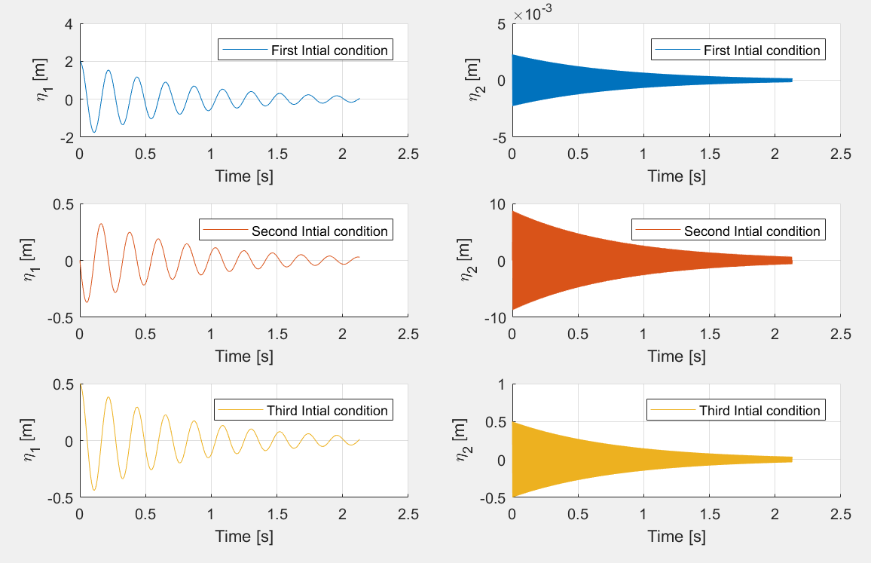

Figure Modal response to initial conditions

As is shown, all modes respond to the initial conditions with respect to their natural frequency. In addition, the ratio of the amplitude of the response correlates to the ratio of the amplitude of the initial conditions -  has a stronger affinity to  while  has a stronger affinity to  . This is self-explanatory when looking on the relation .

## Analytic response to harmonic inputs

The steady flow  results in two harmonic forces who act on the turbine blades



### Solving for general coordinates using modal summation and frequency response

Going back to section ‎1.3, we coined the modal equation around the equilibrium :



A diagonal  allowed us to convert the matrix-syntax equation to a system of two independent ODEs.  
To solve the system, modal transfer functions were derived each of the resulting ODEs from the diagonal transfer function matrix.





In turn a summation term arose:



In the same manner, we could then write:



Equation 9 Modal Summation Solution

To solve for  we used the SDOF frequency response theorem which states that for an input of the form  the output will be , where  is the transfer function  .

For Convenience, we coined terms for the phase and magnitude of the modal transfer functions:



We calculated  for the input 

Where 



### Graphing the maximal stress in the beam as a function of wind speed

To calculate  in Matlab, we took a different approach than what was presented in ‎1.6.1.

We first wrote the generalized forces in complex representation and then followed by splitting the argument to two different vectors. Each vector will be analyzed as a sole input to the linear system. The sum of their outputs will produce the generalized coordinates



Given that the output for  is of the form  respectfully, where  are complex numeric vectors indicating amplitude and phase, we derived a simpler matrix based solution:





To insure fast and yet sufficiently accurate calculations, we made sure that the time vector used for each wind speed iteration follows:



We then used the beam’s deflection function from Equation 7 to calculate the torque in the critical section using Euler -Bernoulli beam theory for each :



and the maximum stress in the section by  .

To conclude, we graphed  as a function of this wind speed 

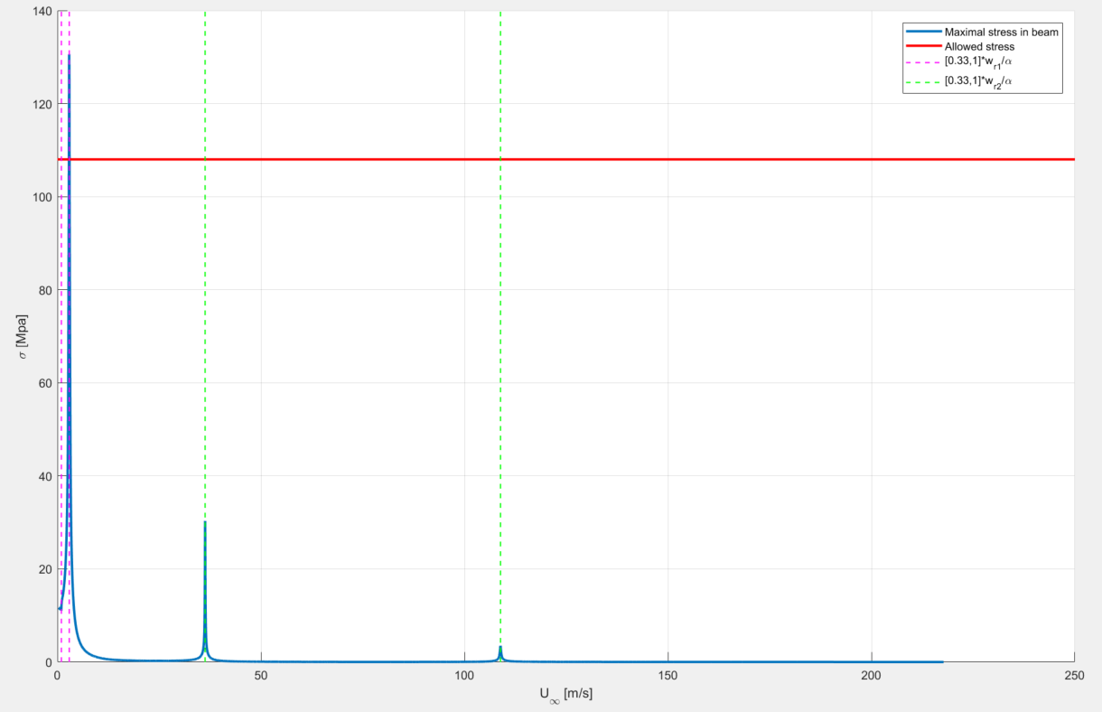

Figure Maximum stress in beam as a function of wind speed

As can be seen, the maximal stress peaks around the resonance frequencies of the system.  
Unsurprisingly, the maximal stress around the first natural frequency – which correlates more to the bending of the beam than its elongation (though unmodeled) – is the highest and is in fact the only place where the graph crosses the allowed stress.

Without computing fatigue, and judging from these results alone, one would suggest that the engine should be brought to p-0a halt when the wind hits speeds of  .

# Part B

A dynamic mass absorber is added to the system.

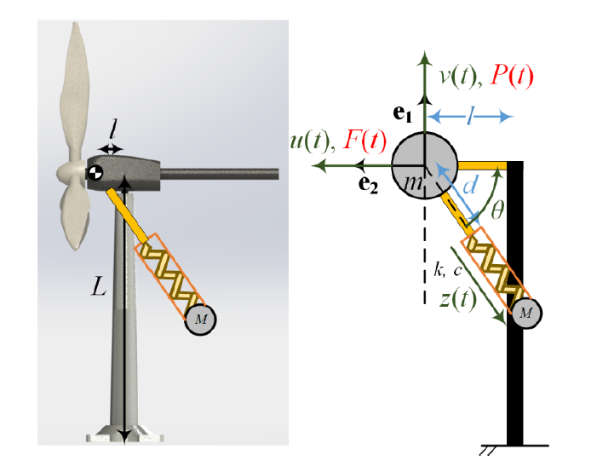

Figure Turbine with dynamic mass absorber – sketch

The mass absorber’s relevant parameters, shown in Figure 4 are as follows:



It is assumed throughout part B that equilibrium  exists, and we are working around it.

## Calculating the new equation of motion

### Position and velocity of the dynamic mass absorber

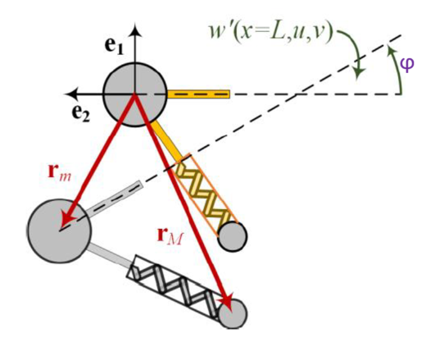

Figure Building the Position and velocity of the dynamic mass absorber

W first wrote the position of the dynamic mass absorber:



Where  indicates the radial direction of the mass absorber with respect to the inert axes, and  is the springs elongation.

As  is a function of time and is of the plane  , we found an equivalent form for it using a rotation matrix:



The geometry encourages us to define an angle , which then brings the rotation matrix formation:



We then multiplied to obtain





Substituting the term into the general expression of the dynamic mass position vector yields:



We then took the time derivative for the velocity:



### New kinetic energy and mass matrix expressions

We used Equation 2to derive the general mass matrix for a new generalized coordinates vector  .

To do so, we first calculated the term for new kinetic energy of the system



We then used Equation 2 to calculate the mass matrix.



### New potential energy and stiffness matrix expressions

Noting that the beam's potential energy is unchanged, the only difference in potential energy is added the mass dampers spring



The new stiffness matrix is then recalculated using Equation 6:



### New dissipation function and damping matrix expressions

We calculate the dissipation function as follows:



The damping matrix is then recalculated using Equation 4:



## Choosing the mass damper’s spring constant

Since the system w/o the damper presents issues when the input forces activate its first mode, we decided to tune the damper’s spring constant to that mode’s frequency.



Choosing such  will ensure that during the system’s resonance, the spring will achieve resonance as well - moving with a maximal amplitude and dispersing the maximum amount of energy.

To ensure that the chosen  reduces the maximal stressing in the beam by a sufficient amount, and that there is no collision between the two masses, we simulated the new system response to different wind speeds in the same manner explained in ‎1.6.2 . using the equilibrium 

We used a generalized forces vector  , as there is no new external force exerting itself.

Note: The modal damping matrix  was not diagonal, but the members outside its diagonal were insignificant (two magnitudes difference).

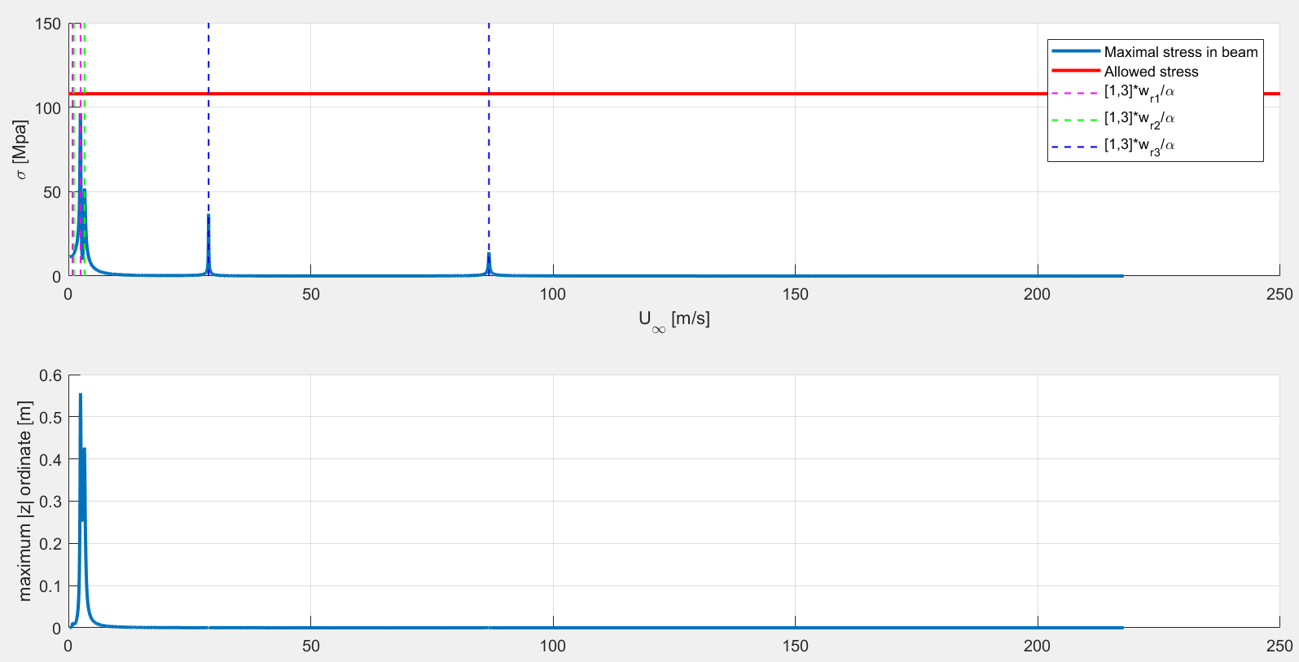

Figure Verification of chosen stiffness for mass damper

The dynamic mass damper with the chosen  does indeed increase its amplitudes without collision where planned, and manages to reduce the maximal stress in the beam below the allowed  for all relevant windspeeds.  
focusing on the first natural frequency clearly shows that the Q factor of the mass damper is higher than that of the system in its first mode resonance, and so we obtain a “notch” in the stress response.

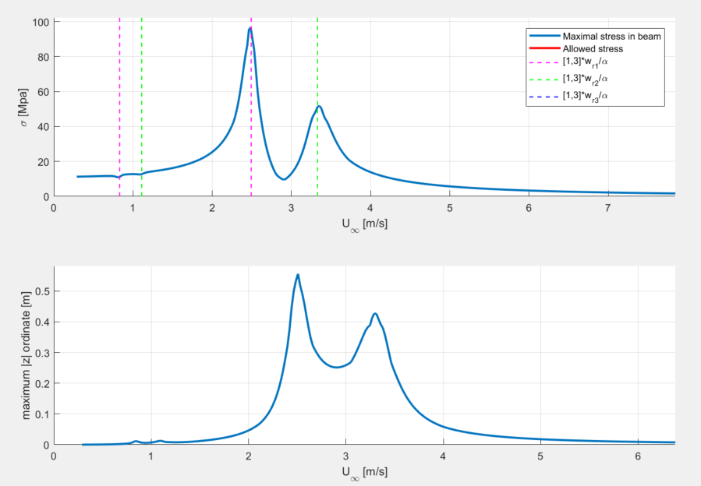

Figure Chosen mass damper's effect

# Simulation

A simulation was built to show the effect that the wind speed has on the modeled turbine for both systems checked. The simulation verifies our results visually, and clearly shows the difference between the two systems, and between different choices of spring stiffness for the mass damper.

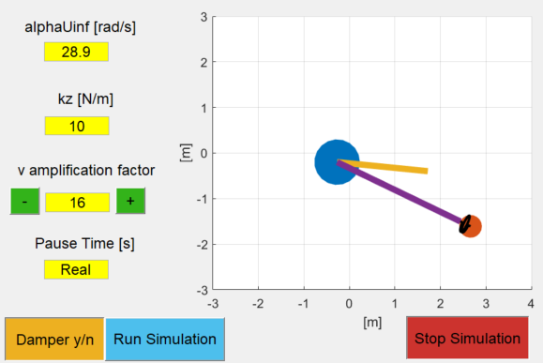

Figure 8 Simulation GUI

# Conclusion

The mass-damped system stress analysis clearly shows that it is good design and smart modeling. The chosen spring stiffness for the mass damper ensures that the maximal stress levels in the beam will be under the required .

We will also note that the separation of the two original natural frequencies has enabled us to find such an easy solution.

# Bibliography

William T.Thomson, Marie Dillon Dahleh. (1998). *Theory of Vibration with Applications.* Prentice Hall.

פלמור, ז. (1993). *מערכות לינאריות.*

פרופ' י. ליפשיץ. (n.d.). *מכניקת מוצקים 2.* הפקולטה להנדסת מכונות טכניון.