Technion – Israel Institute of Technology

Faculty of Mechanical Engineering



Project – Part 3

Vibration Theory

034011

June 20, 2021

# Abstract

We performed modal analysis, and vibration response and stress analysis to harmonic excitation by wind on a given turbine. For that purpose, the turbine was modeled as a point mass connected to a mast via steel beam. The dynamic model was derived via the Rayleigh-Ritz method using Chebyshev polynomials.

For windspeeds under  we deemed only the first 5 natural frequencies to be of significance:



Our analysis shows that Under 108 allowed stress, the turbine will fail if placed in areas which invoke windspeeds of the following magnitude:



We finish the report with recommendations for design to allow for a vaster working area (windspeed wise).

Contents

1Abstract 1

2Analysis 3

2.1Contribution of the strain potential energy to the stiffness matrix 4

2.2Contribution of the beam and mast to the mass matrix 5

2.2.1The point mass contribution to the kinetic energy and mass matrix 6

2.3 Constraints analysis for n=2 6

2.4Homogenous EOMs for n=2 8

2.5Force contribution to virtual work and the generalized forces calculation 8

2.6Determining the number of base functions required for satisfactory analysis with load established by wind speeds up to 60Km/h 9

2.7Maximal stress in the turbine’s structure as a function of windspeed 11

3Conclusion 15

4Bibliography 16

# Analysis

We modeled the turbine as a point mass connected to a mast via steel beam. The point mass represents the transmission, generator and blades. It is important to note that the relative angle between the mast and beam is stiff at their joint. The dynamic model was derived via the Rayleigh-Ritz method.

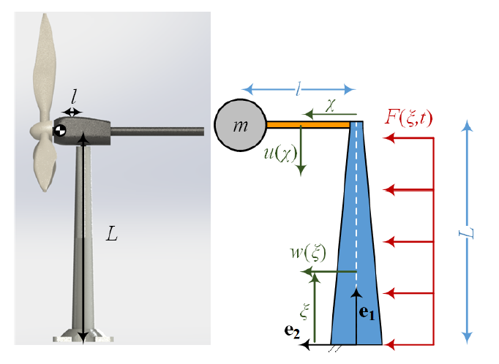

Figure 1-Turbine simplified model

Where:



Mast geometry and deflection function:





Equation 1 Deflection of mast

Beam geometry and deflection function:





Equation 2 Deflection of beam

It is important to point out that both deflection functions are composed by the same amount of **orthogonal** base functions and weights , and that

## Contribution of the strain potential energy to the stiffness matrix

To define the stiffness matrix, we first defined the vector of general ordinates:



Equation 3 General ordinates vector

So that



Given that the potential energy stored in a cantilever beam of length  and deflection  follows:



The strain potential energy in the system was calculated to be



Where the area moments of inertia are:



Substituting the deflection functions and Inertia with their equivalent terms from Equation 1 and Equation 2, it follows that:

  
computing the contribution of the strain potential energy by  then yielded:



## Contribution of the beam and mast to the mass matrix

The kinetic energy stored in the beam and mast due to their deflection follows:  


where the cross-section areas are:



Substituting the deflection functions with their equivalent from Equation 1and Equation 2 then produces:



The kinetic energy connected to the rigid body motion of the beam:

  
summing up the two expressions will yield the beam’s and mast’s contribution to the kinetic energy.



Computing the contribution to the mass matrix with 



### The point mass contribution to the kinetic energy and mass matrix

assuming small angles, the velocity of the point mass was written as such:



We then derived the point mass’ contribution to the kinetic energy as a function of the generalized ordinates



Calculating the point mass’ contribution to the mass matrix:



Rewriting the terms in an index form we obtained the contribution to the mass matrix:



## Constraints analysis for n=2

As both the beam and mast are welded in their base joints, the deflection functions must fulfil:



Note: the relation between  and  was already established when calculating the stiffness and mass matrices. Why were we not allowed to add those relations in the constraint’s matrix?!

We computed the Chebyshev base functions for n=2 via the Matlab function provided:



Inserting the base functions into the constraints equations yields:



Writing the constraints in matrix form:



After applying 4 constraints on 6 base functions, we will obtain 2 new base functions, one for the beam and one for the mast, who represent the deflection modes.

Dictating that , where  is the generalized ordinates vector from Equation 3 the new modes will take the form 



Plotting the modes with the provided function Plot Turbine then yields:

Table 1 Shape Modes of beam and mast for n=2

|  |  |
| --- | --- |
| Mast cantilever first mode | Beam cantilever first mode |
|  |  |

It is no surprise that the first shape modes of the system are essentially the first shape modes of its parts.

## Homogenous EOMs for n=2

The homogenous equation of motion of the system, neglecting damping:



Denoting  and applying the constraints we wrote:



Inserting numbers:



## Force contribution to virtual work and the generalized forces calculation



The force contribution to the virtual work was calculated as such:



And the generalized forces:



Working with the same constraint-null-space as in ‎2.4 we then established the constrained generalized forces



## Determining the number of base functions required for satisfactory analysis with load established by wind speeds up to 60Km/h

We first calculated the maximal radial frequency



To properly represent the system under the given load, we decided on including every mode which has a radial frequency below in the model.

We solved for radial frequency and respective modes iteratively, starting with n=2 (4 base functions) and up to n=20 (16 base functions before constraints) using the same method demonstrated in ‎2.3.

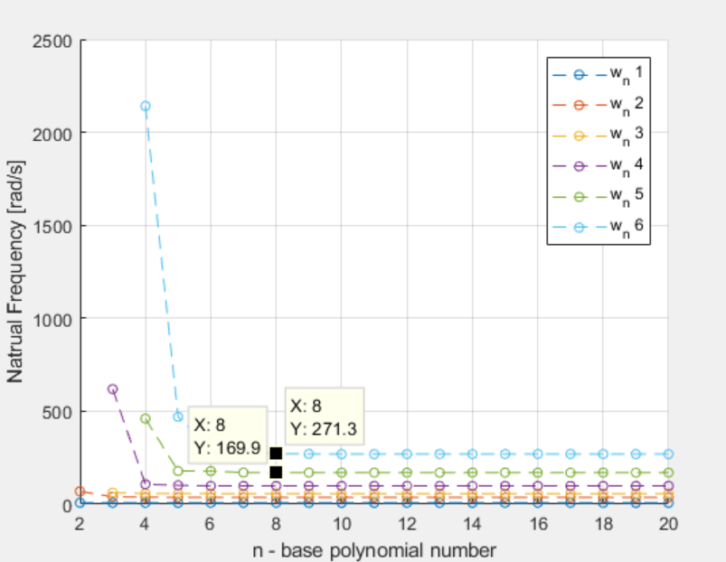

Figure 2 Natural frequency convergence as a function of base polynomials

As is shown above, the first 5 modes have radial frequency below , and they converge to their values rather well under . If the natural frequencies converge with a factor , the modes themselves converge by factor  , or in other words 

Eyeballing the situation, we decided to solve the system for the first 5 modes calculated under  .

Thus, the significant natural frequencies are given in the table below:

Table 2 First five natural frequencies of the system

|  |  |  |  |  |  |
| --- | --- | --- | --- | --- | --- |
|  | 1 | 2 | 3 | 4 | 5 |
|  | 7.22 | 36.61 | 57.93 | 98.01 | 169.9 |

We also present a table with the first five mode’s shapes and a theorized explanation for their existence and order.  
 As the turbine is composed of two smaller systems -the mast and the beam & point mass, it is only rational to assume that the turbine’s natural frequencies will correspond to its sub-systems natural frequencies. To establish our theory, we created a mode time simulation which can be viewed in the code under %% Simulation for Q6  
for further verification, one must calculate the natural frequencies of the mast and beam & point mass themselves and make a compresence.

Table 3 First five shape modes of the system

|  |  |  |
| --- | --- | --- |
| Theorized Explanation – Cantilever modes | Mast first mode | Mast second mode |
| Mode Shape |  |  |
| Beam first mode | Mast third mode  Beam second mode | Mast fourth mode |
|  |  |  |

Even with the intelligent engineered geometry of the mast, it is not surprising that the beam has higher frequencies than the mast, as it is much smaller and is made of the same material. If the cross section of the mast would have been as it is with the beam, we could have expected an almost full frequency separation.

## Maximal stress in the turbine’s structure as a function of windspeed

adding modal damping of  to the mass normalized modal EOM:



Where



The generalized ordinates  are defined in Equation 3, and, are the orthonormal constraints null space and the generalized forces respectively.

To solve the system, using frequency response theorem, we denoted ,and  . The radial frequency fulfills  according to the force acting on the turbine (‎2.5).

Solving for :



As we decided on calculating only by the first five modes, computed for ,  
We zeroed out elements in the diagonal transfer matrix 



For each windspeed, after computing  , we calculated the maximal stress along the mast and beam using their respective deflection equations. The maximal stress in the beam/mast sections were calculated as such:



 young modulus. See Equation 1and Equation 2 for the deflection equations.

To simulate the maximal stress response for each wind speed, we decided on the following resolutions:

Table 4 Resolution for simulation

|  |  |  |
| --- | --- | --- |
|  | Amount of Points | Resolution |
|  | 400 |  |
|  | 20 |  |
|  | 20 |  |

We decided on the amount of examination points for the wind speed by calculating the Q factor for the first mode.



Going for the safe side, we decided on multiplying the amount by 10.  
  
As for the beam and mast - we only expect a fourth cantilever mode (as explained in ‎2.6) and so having 20 simulation nodes is staying way inside the safe side.

time steps calculated by the following algorithm:



The resulting graph below:

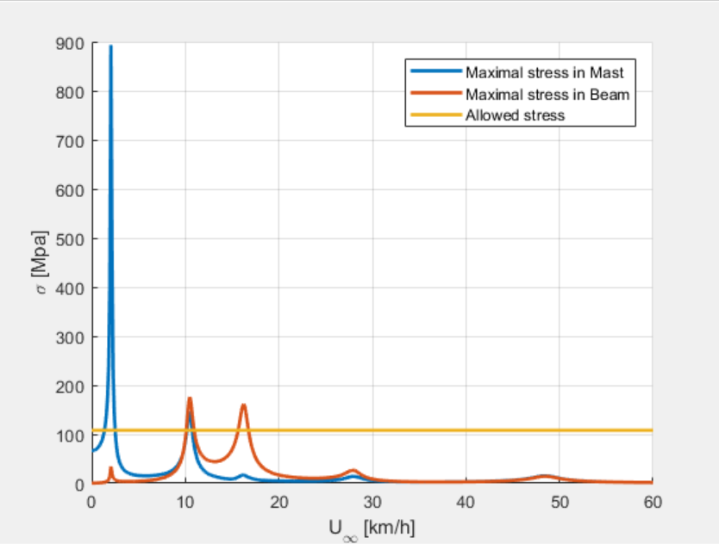

Figure 3 Maximal Stress in the Beam and Mast as function of windspeed

The first five natural frequencies show phenomenally well in the graph.

The graph also shows correlation between the stress in the beam and the stress in the mast; The beam maximal stress increases when the mast is resonating and vice versa. This is most definitely a result of the point mass placed on the edge of the beam.

As for the windspeeds where the turbine is in danger:



We also present a graph showing the location of the maximal stress in the beam/mast per windspeed:

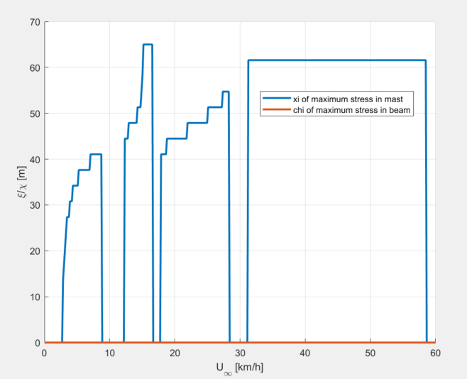

Figure 4 location of maximum stress in beam/mast vs windspeed

The location of the maximal stress in the mast varies according to the active mode, while the maximum stress in the beam always stays at its harness.

# Conclusion

We used Rayleigh-Ritz method with Chebyshev polynomials to calculate the turbine’s dynamic response to windspeed up to , which under the model enacts as an exiting force on the mast with up to  radial frequency.  
Deeming that only natural frequencies under  have significance under the circumstances, we simulated the dynamic model with the first 5 natural frequencies of the system:



Our analysis shows that Under 108 allowed stress, the turbine will fail if placed in areas which invoke windspeeds of the following magnitude:



It would be wise to group the first three natural frequencies together as much as possible. In this case, stiffening the mast would be rather difficult, and so we recommend adding mass to the point mass or enlarging the beam in an optimization process.

# Bibliography

William T.Thomson, Marie Dillon Dahleh. (1998). *Theory of Vibration with Applications.* Prentice Hall.

פלמור, ז. (1993). *מערכות לינאריות.*

פרופ' י. ליפשיץ. (n.d.). *מכניקת מוצקים 2.* הפקולטה להנדסת מכונות טכניון.