Technion – Israel Institute of Technology



HW5

Vision Aided Navigation

086761

|  |  |  |
| --- | --- | --- |
| Alon Spinner | 305184335 | alonspinner@gmail.com |
| Sher Hazan | 308026467 | sherhazan@campus.technion.ac.il |

December 21, 2021

## Question 1: Factor graph, variable elimination and Bayes net. Consider a SAM problem where a robot travels through an unknown environment and captures observations using its onboard sensors. Assume the robot starts at time , with a known prior and consider motion and observation models and , respectively, where denotes the landmark. The robot moves according to given controls and observes a single landmark at time instances and .

### a: Write the joint pdf corresponding to the above scenario until time

### b: Draw the corresponding factor graph.

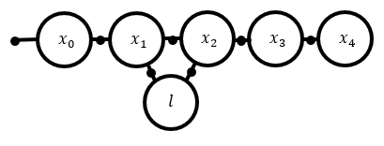

### c: Eliminate the factor graph into a Bayes net, assuming elimination order:

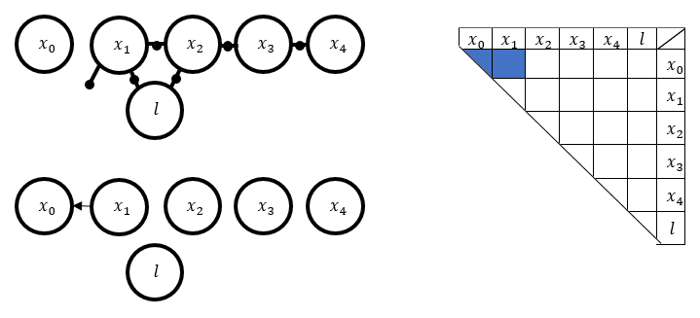

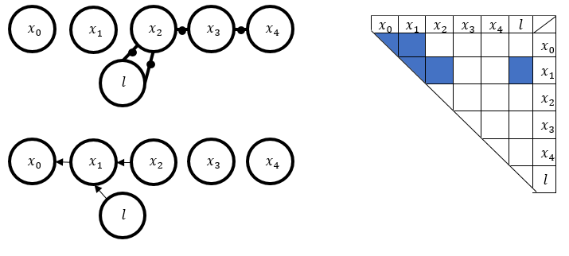

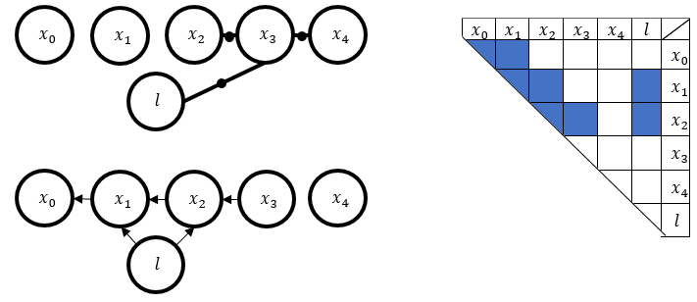

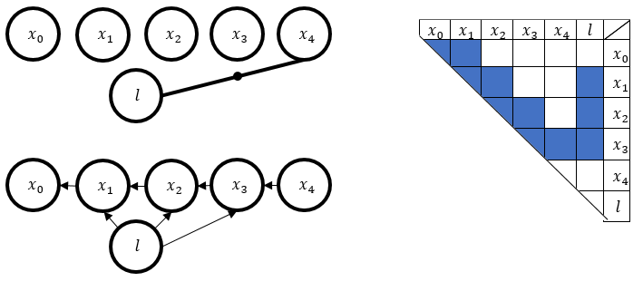

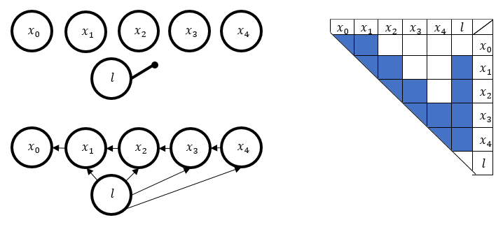

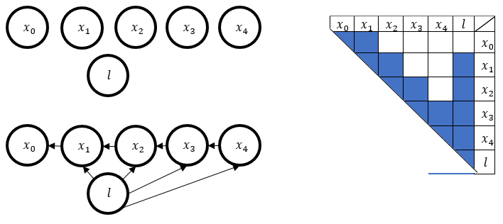

### d: Repeat the previous clause using a different variable elimination order:

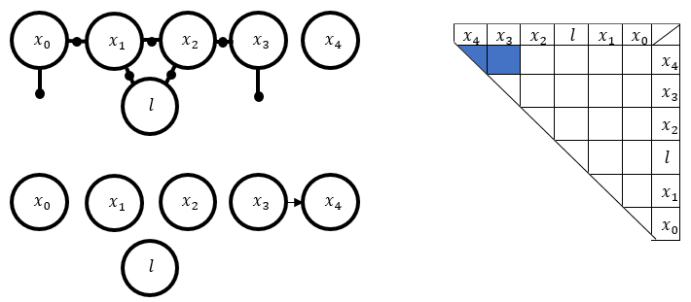

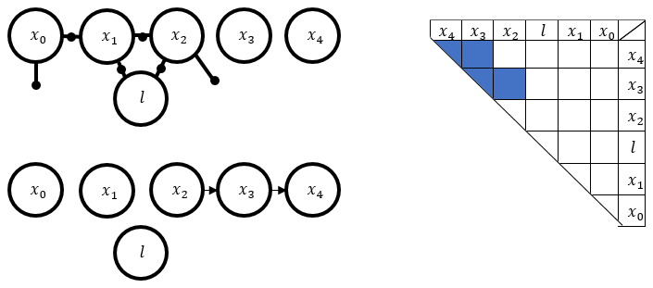

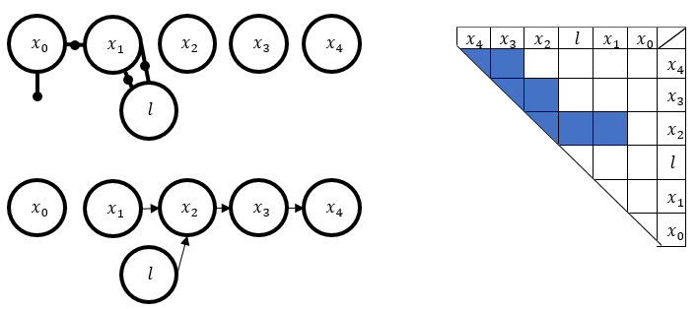

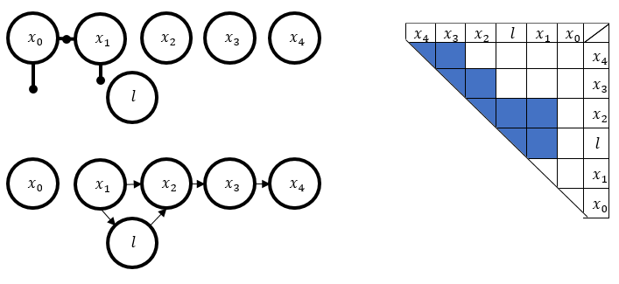

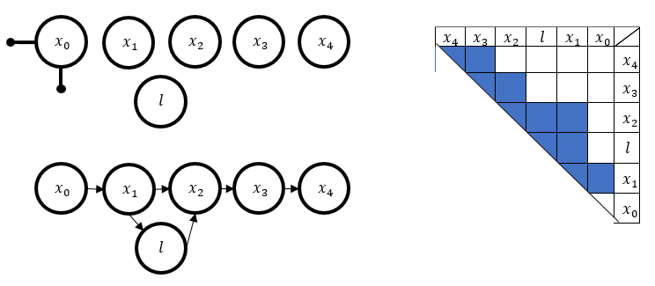

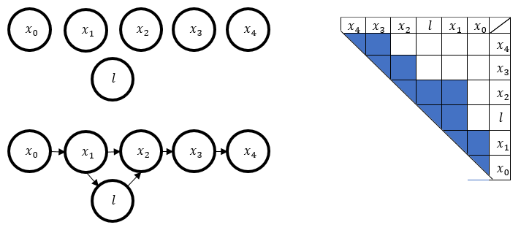

### e: Which of the two elimination orders you would prefer in terms of estimation accuracy and computational aspects?

## Question 2: Incremental factorization. Consider now the robot, from question 1, executes command and moves to a new location; denote its new pose by . Assume the robot observes again the landmark from the new location.

### a: Draw the factor graph of the problem and indicate the new factors and variable nodes.

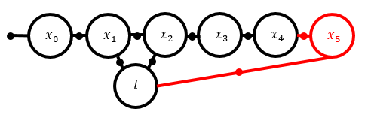

### b: Consider the Bayes net from question 1(c) with elimination order Perform incremental factorization by updating this Bayes net with the new information using the elimination order:

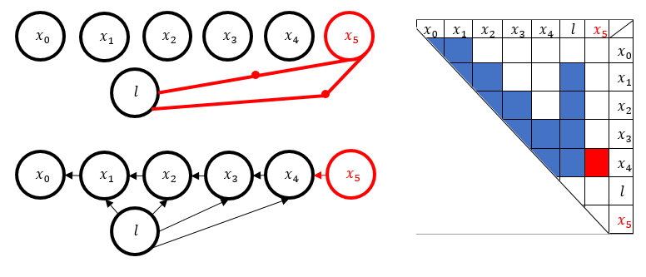

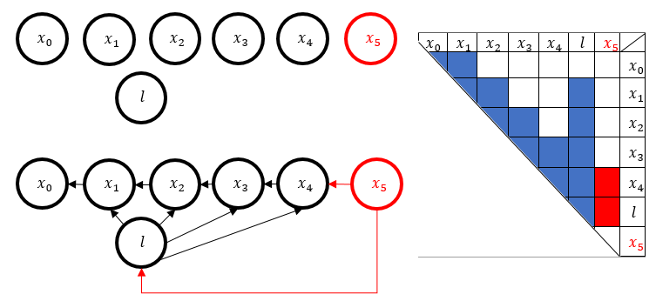

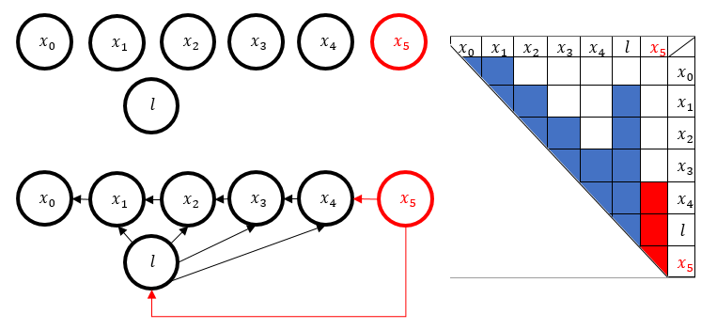

### c: Show the corresponding updated square root information matrix

