

Naked, but not Afraid

Gamer-Chan's
exclusive interview
with the developers of
the new Amy Rose
open world adventure.

At Nudist Games Conference 2004, our skilled team of
journalists got a chance to view and even play a prototype of
the new Sonic spinoff game starring Amy Rose, Sonic's boy-crazy
fangirl, stripped of everything except her trusty hammer, left alone
in a strange world.

The last time took control of this boy-crazy Sonic fangirl, she was in a leading role of Team Rose in Sonic Heroes. However, this game seems to take place somewhere between Sonic Adventure 1 and Sonic Adventure 2's era, going back slightly. The game is an open world survival-stealth-action game, with DNA from the Sonic Series, Metal Gear Solid Series, and several other sources of inspiration.
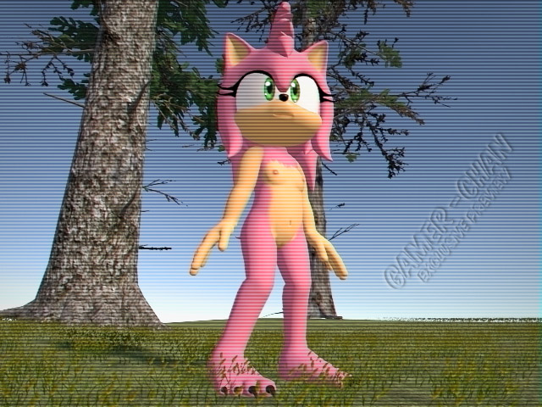
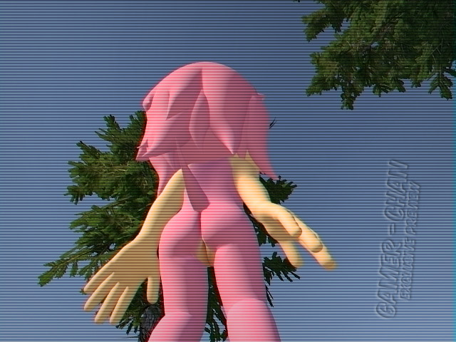
The first thing noted by the interviewers was the lack of visible onscreen HUD elements. It's unsure if it's not done yet, or if this game is going for a minimalist approach to user interface to save screen real estate. The second most prominent feature is how detailed Amy's model is. The hardware it's running on is currently undisclosed, but what we saw definitely made our jaws hit the floor faster that Sonic the Hedgehog.

