**Activity_main.xml**

<?xml version="1.0" encoding="utf-8"?>  
<androidx.constraintlayout.widget.ConstraintLayout xmlns:android="http://schemas.android.com/apk/res/android"  
 xmlns:app="http://schemas.android.com/apk/res-auto"  
 xmlns:tools="http://schemas.android.com/tools"  
 android:layout_width="match_parent"  
 android:layout_height="match_parent"  
 tools:context=".MainActivity">  
  
 <EditText  
  
 android:id="@+id/t1"  
 android:layout_width="349dp"  
 android:layout_height="61dp"  
 android:ems="10"  
 android:inputType="number"  
 app:layout_constraintBottom_toBottomOf="parent"  
 app:layout_constraintEnd_toEndOf="parent"  
 app:layout_constraintHorizontal_bias="0.661"  
 app:layout_constraintStart_toStartOf="parent"  
 app:layout_constraintTop_toTopOf="parent"  
 app:layout_constraintVertical_bias="0.071" />  
  
 <EditText  
 android:id="@+id/t2"  
 android:layout_width="349dp"  
 android:layout_height="59dp"  
 android:ems="10"  
 android:inputType="number"  
 app:layout_constraintBottom_toBottomOf="parent"  
 app:layout_constraintEnd_toEndOf="parent"  
 app:layout_constraintHorizontal_bias="0.661"  
 app:layout_constraintStart_toStartOf="parent"  
 app:layout_constraintTop_toTopOf="parent"  
 app:layout_constraintVertical_bias="0.199" />  
  
 <Button  
 android:id="@+id/button"  
 android:layout_width="96dp"  
 android:layout_height="51dp"  
 android:onClick="sum"  
 android:text="+"  
 app:backgroundTint="@android:color/holo_blue_dark"  
 app:layout_constraintBottom_toBottomOf="parent"  
 app:layout_constraintEnd_toEndOf="parent"  
 app:layout_constraintHorizontal_bias="0.238"  
 app:layout_constraintStart_toStartOf="parent"  
 app:layout_constraintTop_toTopOf="parent"  
 app:layout_constraintVertical_bias="0.341" />  
  
 <Button  
 android:id="@+id/button2"  
 android:layout_width="96dp"  
 android:layout_height="51dp"  
 android:onClick="minus"  
 android:text="-"  
 app:backgroundTint="@android:color/holo_blue_dark"  
 app:layout_constraintBottom_toBottomOf="parent"  
 app:layout_constraintEnd_toEndOf="parent"  
 app:layout_constraintHorizontal_bias="0.758"  
 app:layout_constraintStart_toStartOf="parent"  
 app:layout_constraintTop_toTopOf="parent"  
 app:layout_constraintVertical_bias="0.341" />  
  
 <Button  
 android:id="@+id/button3"  
 android:layout_width="96dp"  
 android:layout_height="51dp"  
 android:onClick="multiply"  
 android:text="*"  
 app:backgroundTint="@android:color/holo_blue_dark"  
 app:layout_constraintBottom_toBottomOf="parent"  
 app:layout_constraintEnd_toEndOf="parent"  
 app:layout_constraintHorizontal_bias="0.238"  
 app:layout_constraintStart_toStartOf="parent"  
 app:layout_constraintTop_toTopOf="parent"  
 app:layout_constraintVertical_bias="0.454" />  
  
 <Button  
 android:id="@+id/button4"  
 android:layout_width="96dp"  
 android:layout_height="51dp"  
 android:onClick="div"  
 android:text="/"  
 app:backgroundTint="@android:color/holo_blue_dark"  
 app:layout_constraintBottom_toBottomOf="parent"  
 app:layout_constraintEnd_toEndOf="parent"  
 app:layout_constraintHorizontal_bias="0.758"  
 app:layout_constraintStart_toStartOf="parent"  
 app:layout_constraintTop_toTopOf="parent"  
 app:layout_constraintVertical_bias="0.454" />  
  
 <TextView  
 android:id="@+id/ans"  
 android:layout_width="wrap_content"  
 android:layout_height="wrap_content"  
 android:text="00.00"  
 app:layout_constraintBottom_toBottomOf="parent"  
 app:layout_constraintEnd_toEndOf="parent"  
 app:layout_constraintHorizontal_bias="0.589"  
 app:layout_constraintStart_toStartOf="parent"  
 app:layout_constraintTop_toTopOf="parent"  
 app:layout_constraintVertical_bias="0.591" />  
  
 <TextView  
 android:id="@+id/textView"  
 android:layout_width="wrap_content"  
 android:layout_height="wrap_content"  
 android:text="RESULT :"  
 app:layout_constraintBottom_toBottomOf="parent"  
 app:layout_constraintEnd_toEndOf="parent"  
 app:layout_constraintHorizontal_bias="0.418"  
 app:layout_constraintStart_toStartOf="parent"  
 app:layout_constraintTop_toTopOf="parent"  
 app:layout_constraintVertical_bias="0.591" />  
  
</androidx.constraintlayout.widget.ConstraintLayout>

**MAINACTIVITY.java**

package com.example.calculator;  
  
import androidx.appcompat.app.AppCompatActivity;  
  
import android.os.Bundle;  
import android.view.View;  
import android.widget.EditText;  
import android.widget.TextView;  
  
public class MainActivity extends AppCompatActivity {  
 private EditText t1;  
 private EditText t2;  
 private TextView ans;  
 @Override  
 protected void onCreate(Bundle savedInstanceState) {  
 super.onCreate(savedInstanceState);  
 setContentView(R.layout.*activity_main*);  
 t1 = (EditText)findViewById(R.id.*t1*);  
 t2 = (EditText)findViewById(R.id.*t2*);  
 ans = (TextView)findViewById(R.id.*ans*);  
 }  
  
  
 public void sum(View view) {  
 try {  
 double num1 = Double.*parseDouble*(t1.getText().toString());  
 double num2 = Double.*parseDouble*(t2.getText().toString());  
 double res = num1 + num2;  
  
 ans.setText(String.*valueOf*(res));  
 }catch (Exception error1){  
  
  
 }  
 }  
  
 public void minus(View view) {  
try{  
 double num1 = Double.*parseDouble*(t1.getText().toString());  
 double num2 = Double.*parseDouble*(t2.getText().toString());  
 double res = num1 -num2;  
  
 ans.setText(String.*valueOf*(res));}  
catch (Exception error1){  
  
}  
 }  
  
 public void multiply(View view) {  
 try {  
 double num1 = Double.*parseDouble*(t1.getText().toString());  
 double num2 = Double.*parseDouble*(t2.getText().toString());  
 double res = num1 * num2;  
  
 ans.setText(String.*valueOf*(res));  
  
 }catch (Exception error1){  
  
 }  
 }  
  
 public void div(View view) {  
 try {  
 double num1 = Double.*parseDouble*(t1.getText().toString());  
 double num2 = Double.*parseDouble*(t2.getText().toString());  
 double res = num1 / num2;  
  
 ans.setText(String.*valueOf*(res));  
 }catch(Exception error1){  
  
 }  
 }  
}

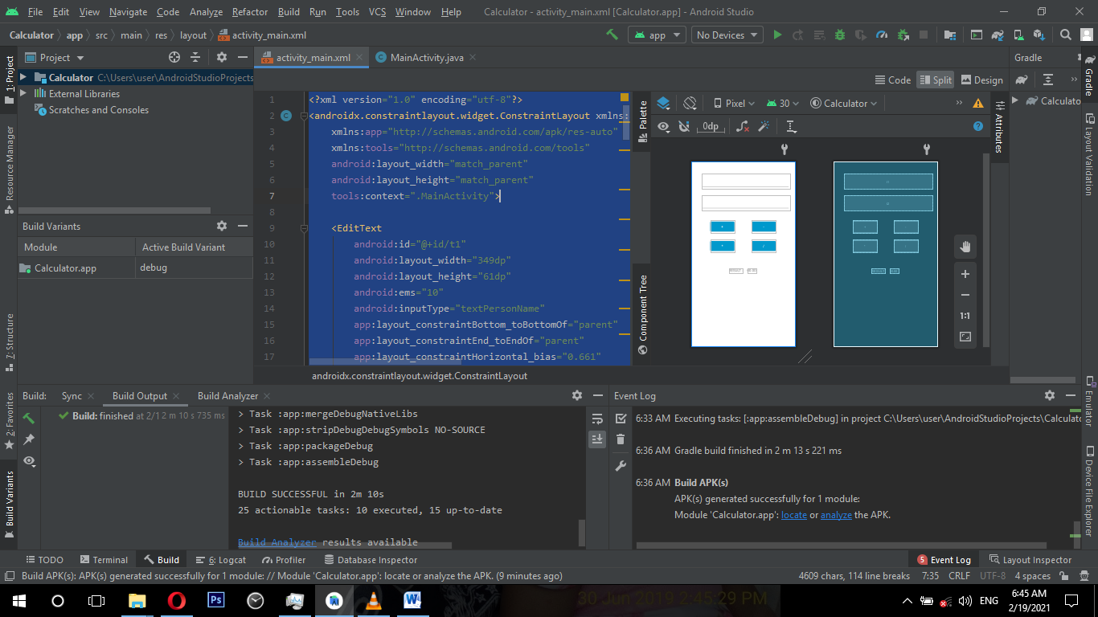**Screenshots :**

