CS 499 Enhancement One Narrative
Software Design and Engineering
Travlr Getaways Full Stack Application

Alondra Paulino Santos
CS 499 Computer Science Capstone
Southern New Hampshire University
October 11, 2026

Artifact Overview
For Enhancement One, I selected the Travlr Getaways full-stack web application that I originally developed as my CS 465 final project during summer 2026. The artifact uses a MongoDB, Express, Angular, and Node.js architecture and includes a public travel site and an administrator application. I selected this artifact because it represents a complete software system rather than an isolated exercise. It gave me the opportunity to demonstrate front-end development, server-side validation, API design, database integration, authentication, authorization, testing, and communication with both customers and staff users.
The original artifact allowed an authenticated administrator to add, edit, and delete trips. It demonstrated basic CRUD functionality, but it did not provide customers with a structured way to search the catalog or ask a question about a specific trip. The original implementation also did not provide enough evidence that monetary values were stored exactly, that authorization was checked against a user’s current role, or that failure paths were handled safely. My enhancement moved the application beyond basic functionality by creating a more complete and secure customer-to-staff workflow.

Reason for Selecting the Artifact
I chose Travlr Getaways because it connects directly to my goal of becoming a software engineer. It shows how several parts of a production-style application work together and how a change in one layer affects the others. For example, adding customer inquiries required changes to the public interface, routes, controllers, validation utilities, database models, the protected Angular administrator interface, and automated tests. This made the artifact appropriate for demonstrating software design and engineering rather than only visual changes.
The artifact also allowed me to respond directly to instructor feedback. The feedback asked for specific implementation evidence, exact validation rules, an explanation of authentication and API security, before-and-after examples, test results, and clear design decisions and trade-offs. The following sections explain what I implemented and connect each claim to evidence in the appendix.

Enhancement Goals
Goal | How the enhancement addressed it
Improve customer value | Added trip search, combined filtering, deterministic sorting, trip-linked inquiry forms, and confirmation references.
Improve data integrity | Added strict server-side validation, exact Decimal128 price storage, bounded values, and allowlisted updates.
Improve security | Separated authentication from authorization, checked the current database role for every protected request, and returned safe errors.
Improve maintainability | Centralized validation and search construction, preserved the existing application architecture, and added repeatable automated tests.
Improve evidence and communication | Documented exact rules, design trade-offs, functional behavior, negative paths, and automated results for technical and nontechnical readers.

Implemented Enhancements

Trip Search, Filtering, and Sorting
I added a public search interface that allows customers to search by trip name or resort, set inclusive minimum and maximum prices, select a departure-date range, and choose an allowlisted sort order. Search text is limited to one scalar value of no more than 100 characters. Regular-expression metacharacters are escaped so text such as an asterisk is treated literally instead of becoming an executable pattern. Date filters accept real YYYY-MM-DD calendar dates, require the ending date to be on or after the starting date, and include the entire ending day. Price and date filters can be combined, and the form retains the customer’s choices after submission. Every allowed sort includes MongoDB _id as a unique tie-breaker so repeated requests return a stable order.

Exact Price Handling
I replaced permissive price handling with an exact monetary contract. A trip price must be a finite JSON number from 0 through 999,999,999.99 and may contain no more than two decimal places. Blank values, booleans, currency symbols, grouped strings, excessive decimal places, and out-of-range values are rejected before database access. Valid values are stored as MongoDB Decimal128 and serialized as numeric JSON values for the application. This design prevents silent rounding and binary floating-point errors while preserving correct numeric sorting and filtering.

Customer Inquiry Workflow
I added an inquiry action to each public trip. The form displays the selected trip and clearly explains that the submission is an inquiry rather than a booking. A successful submission creates a New inquiry, generates a customer reference number, and redirects to a confirmation page protected by a signed, short-lived receipt. The confirmation does not expose a MongoDB identifier and cannot be opened by simply guessing another customer’s reference number.

Staff Inquiry Workflow
Authenticated staff can open a protected inquiry inbox, review customer questions, filter them by status, move through paginated results, and update an inquiry to New, In progress, or Closed. The status controller accepts only the status field. It cannot be used to overwrite the customer’s name, email, message, trip, or reference number. This produces a useful operational workflow while limiting the authority of each request.

Authentication, Authorization, and Safe Failure Handling
The application treats authentication and authorization as separate decisions. JWT middleware first authenticates the requester. Staff-only middleware then retrieves the account from MongoDB and checks its current role before a protected inquiry read, trip mutation, or status update is allowed. Checking the database on every protected request means a revoked staff role stops working immediately, even when the user still has a previously issued token. Public registration always creates a customer account, so a client cannot assign itself a staff role by including one in the request.
I also limited error exposure. Invalid inputs return bounded field messages, while database failures return generic responses rather than raw queries, connection details, or stack traces. Legacy trip descriptions are sanitized so only paragraph markup is retained. These decisions protect customer data and reduce the opportunity for malformed input to change application behavior.

Exact Validation Rules
Input or operation | Implemented rule | Failure behavior
Customer name | Trimmed string, 2–100 characters; control characters rejected. | Field-specific error; reflected value bounded to 100 characters.
Email address | Trimmed, maximum 254 characters, with one local portion, @, and a domain containing a period. | Field-specific valid-email message.
Traveler count | Whole number from 1 through 20. | Zero, negatives, decimals, text, and arrays rejected.
Inquiry message | Trimmed text, 10–2,000 characters; disallowed control characters rejected. | Field-specific error; reflected value bounded to 2,000 characters.
Trip price | Finite number from 0 through 999,999,999.99 with at most two decimal places; stored as Decimal128. | HTTP 400 before database access; no rounding or coercion.
Search text | Single scalar value, trimmed, maximum 100 characters; regex characters escaped. | Unknown, repeated, or unsupported parameters return HTTP 400.
Price filters | Inclusive bounds; maximum must be greater than or equal to minimum. | Invalid or reversed bounds return field errors.
Date filters | Real YYYY-MM-DD dates; end must be on or after start and includes the entire end day. | Impossible dates and reversed ranges rejected.
Sort selection | Departure asc/desc, price asc/desc, or name asc; _id is a deterministic tie-breaker. | Unknown sort values return HTTP 400.
Inquiry status | Only new, in_progress, or closed; PATCH body may contain only status. | Invalid IDs/updates return 400; missing records return 404.

Testing and Verification
I verified the enhancement with layered testing instead of relying only on screenshots. Screenshots demonstrate the user-visible workflow, while unit and integration tests verify behaviors that are difficult to prove visually, including Decimal128 storage, rejection before database access, safe failures, role revocation, and authorization boundaries. All suites passed during final verification on October 10 and 11, 2026. The HTTP 400, 401, 403, 404, and 503 entries visible in the integration logs are intentional negative-path assertions, not failures.
Test suite | Result | Evidence provided
Backend unit tests | 15 passed; 0 failed | Inquiry normalization, exact prices, description sanitization, search validation, stable sorting, and controller rejection.
Angular tests | 8 files; 16 tests passed | Components, services, numeric price forms, add/edit behavior, trip listing, and inquiry-list behavior.
Price and CRUD integration | Passed | Create/read/update/delete, invalid price rejection, Decimal128 storage, numeric sorting/filtering, and display.
Search integration | Passed | Combined filters, inclusive dates, literal text, retained values, empty results, validation, and safe 503 messages.
Customer inquiry integration | Passed | Trip binding, validation, persistence, signed receipt, confirmation, and staff-only status behavior.
Staff integration | Passed | 401/403 protection, pagination, filtering, updates, registration role, and immediate role revocation.

Before-and-After Analysis
Area | Before | After
Trip discovery | Static catalog without customer-controlled search, ranges, or explicit sorting. | Combined validated search and filters with retained criteria and deterministic sorting.
Price handling | Basic per-person field without evidence of exact storage or malformed-value rejection. | Exact Decimal128 storage, strict two-decimal validation, and tested numeric filtering/sorting.
Customer communication | No trip-linked inquiry or confirmation workflow. | Validated inquiry, generated reference, signed receipt, and confirmation page.
Administrator workflow | Trip CRUD only. | Trip management plus protected inquiry inbox, pagination, filtering, and status updates.
Security evidence | Login supported administration, but screenshots did not prove current-role checks or negative paths. | Database-backed current-role authorization and tests for 401, 403, invalid updates, and revocation.
Testing evidence | Screenshots primarily demonstrated CRUD use. | Six automated suites verify successful behavior, validation boundaries, database behavior, security, and safe failure.

Only two useful screenshots from the original artifact were retained. They document the original administrator list and edit form. There was no original screenshot of the public travel page. For behaviors that were not captured visually, the submitted source code serves as the baseline, and the enhanced screenshots and automated tests provide the strongest evidence of the completed changes.

Design Decisions and Trade-Offs
I selected Decimal128 instead of binary floating-point storage because prices must retain exact cents during sorting, filtering, and updates. This required conversion logic at the database and API boundaries, but it prevents silent precision loss and makes the stored representation match the meaning of the field.
I preserved the existing server-rendered customer site and expanded the Angular administrator application. This reduced migration risk and respected the original architecture while establishing clear public and staff responsibilities. The trade-off is that two interfaces must be maintained and tested, which I addressed with backend, integration, and Angular test suites.
I used a signed, short-lived receipt for confirmation instead of exposing database identifiers. I also chose to check the current database role on every staff request instead of trusting only a role recorded in an older token. These decisions add a small amount of processing and implementation complexity, but they reduce information exposure and ensure that removed privileges stop working immediately.
The application uses browser validation for immediate guidance and repeats the rules on the server. This duplicates some validation logic, but the duplication is intentional: browser messages help nontechnical customers correct mistakes, while server validation protects the system from modified clients and direct API requests.

Connection to the Computer Science Program Outcomes

Course Outcome 1: Collaboration and Decision-Making
This enhancement supports collaboration by presenting the same workflow in forms appropriate for different audiences. Customers receive plain-language search controls, validation feedback, and a reference number. Staff receive an organized inbox, status filters, and explicit save actions that support consistent decisions. Technical collaborators receive the validation contract, endpoint behavior, design trade-offs, and test evidence needed to review or maintain the system. By connecting customer questions to staff decisions without exposing internal identifiers, the solution helps technical and nontechnical users contribute to one shared process.

Course Outcome 2: Professional Communication
I used written, visual, and technical communication throughout the enhancement. The public pages explain the purpose and limits of the inquiry process, the administrator interface explains when a status change takes effect, and the evidence appendix shows observable results. This narrative and the revised design document communicate the architecture, validation rules, security decisions, and test outcomes in language that can be understood by an instructor, developer, employer, or nontechnical stakeholder.

Course Outcome 3: Computing Solutions and Algorithmic Principles
The search feature demonstrates the design and evaluation of a computing solution with explicit constraints. It constructs database queries only from validated, allowlisted inputs; combines text, price, and date criteria; escapes regex characters; and produces deterministic results with a unique tie-breaker. The design uses database-side filtering and sorting instead of retrieving the entire collection and sorting it in application memory. That choice scales with the database query engine and avoids unnecessary transfer and processing. I evaluated the solution through combined-filter, empty-result, invalid-input, safe-failure, and numeric-order integration tests.

Course Outcome 4: Techniques, Skills, and Tools
The enhancement applies full-stack development skills across Express controllers and middleware, Mongoose schemas and Decimal128 data, Handlebars pages, Angular components and services, JWT authentication, role-based authorization, and automated tests. I used these tools to deliver business value: customers can find relevant trips and request information, while staff can manage the resulting work in a controlled interface. Centralized validation and repeatable tests also make future maintenance safer.

Course Outcome 5: Security Mindset
I anticipated how malformed input, stale permissions, mass assignment, unsafe error messages, regular-expression characters, and exposed identifiers could be abused. I mitigated those risks through strict server validation, allowlisted fields and sort values, literal search handling, current-role authorization, signed confirmation receipts, sanitized descriptions, and generic failure responses. Negative-path tests verify not only that valid users succeed but also that unauthenticated, unauthorized, invalid, and revoked requests fail safely.

Reflection
Enhancing this artifact helped me understand that software engineering is not complete when a feature works once on the screen. A maintainable solution needs an explicit data contract, protected trust boundaries, predictable failure behavior, and evidence that the important paths continue to work. The most valuable part of this enhancement was connecting user-visible behavior to server rules and automated verification.
I also learned that documentation is part of implementation. My original work showed functionality, but it did not make every design decision easy to evaluate. By documenting exact rules, security responsibilities, test outcomes, and trade-offs, I can now explain why the solution is reliable and how another developer could continue the work. The final artifact better represents the quality of work I want to present to employers after graduation.

Evidence Appendix
The following figures document the original artifact, the enhanced customer and staff workflows, and the final automated verification. Test receipt values were redacted before capture, and no passwords or production credentials are included.
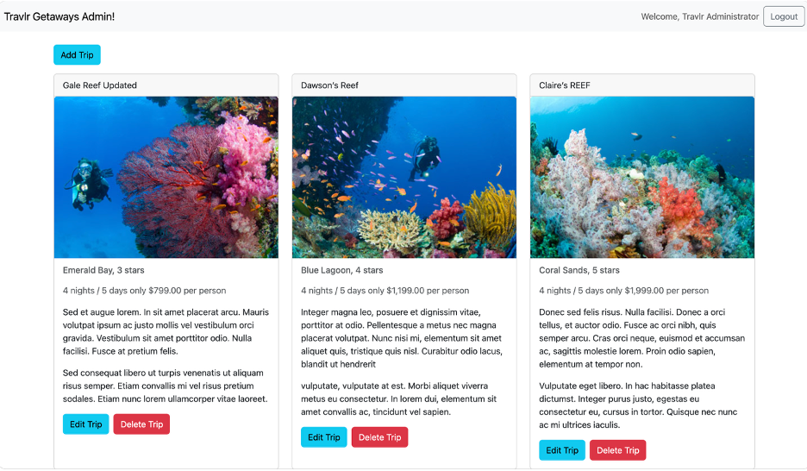
Figure 1. Original administrator trip list demonstrating the baseline CRUD interface.

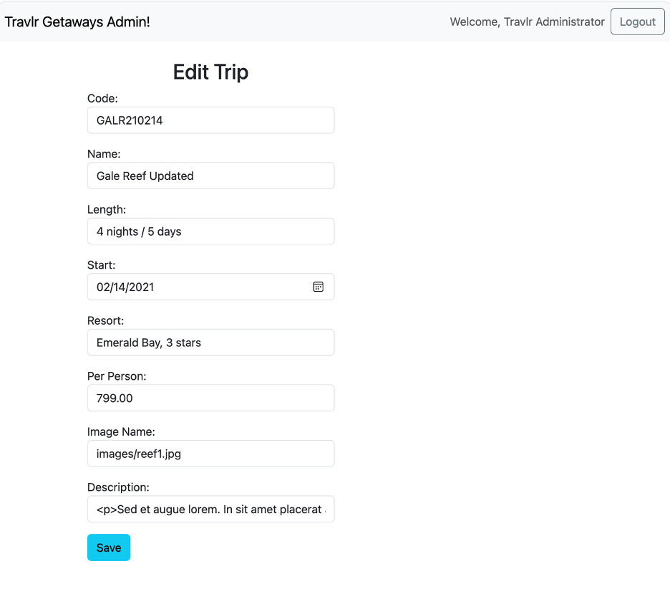
Figure 2. Original trip edit form before the documented validation, exact-price, inquiry, and testing enhancements.

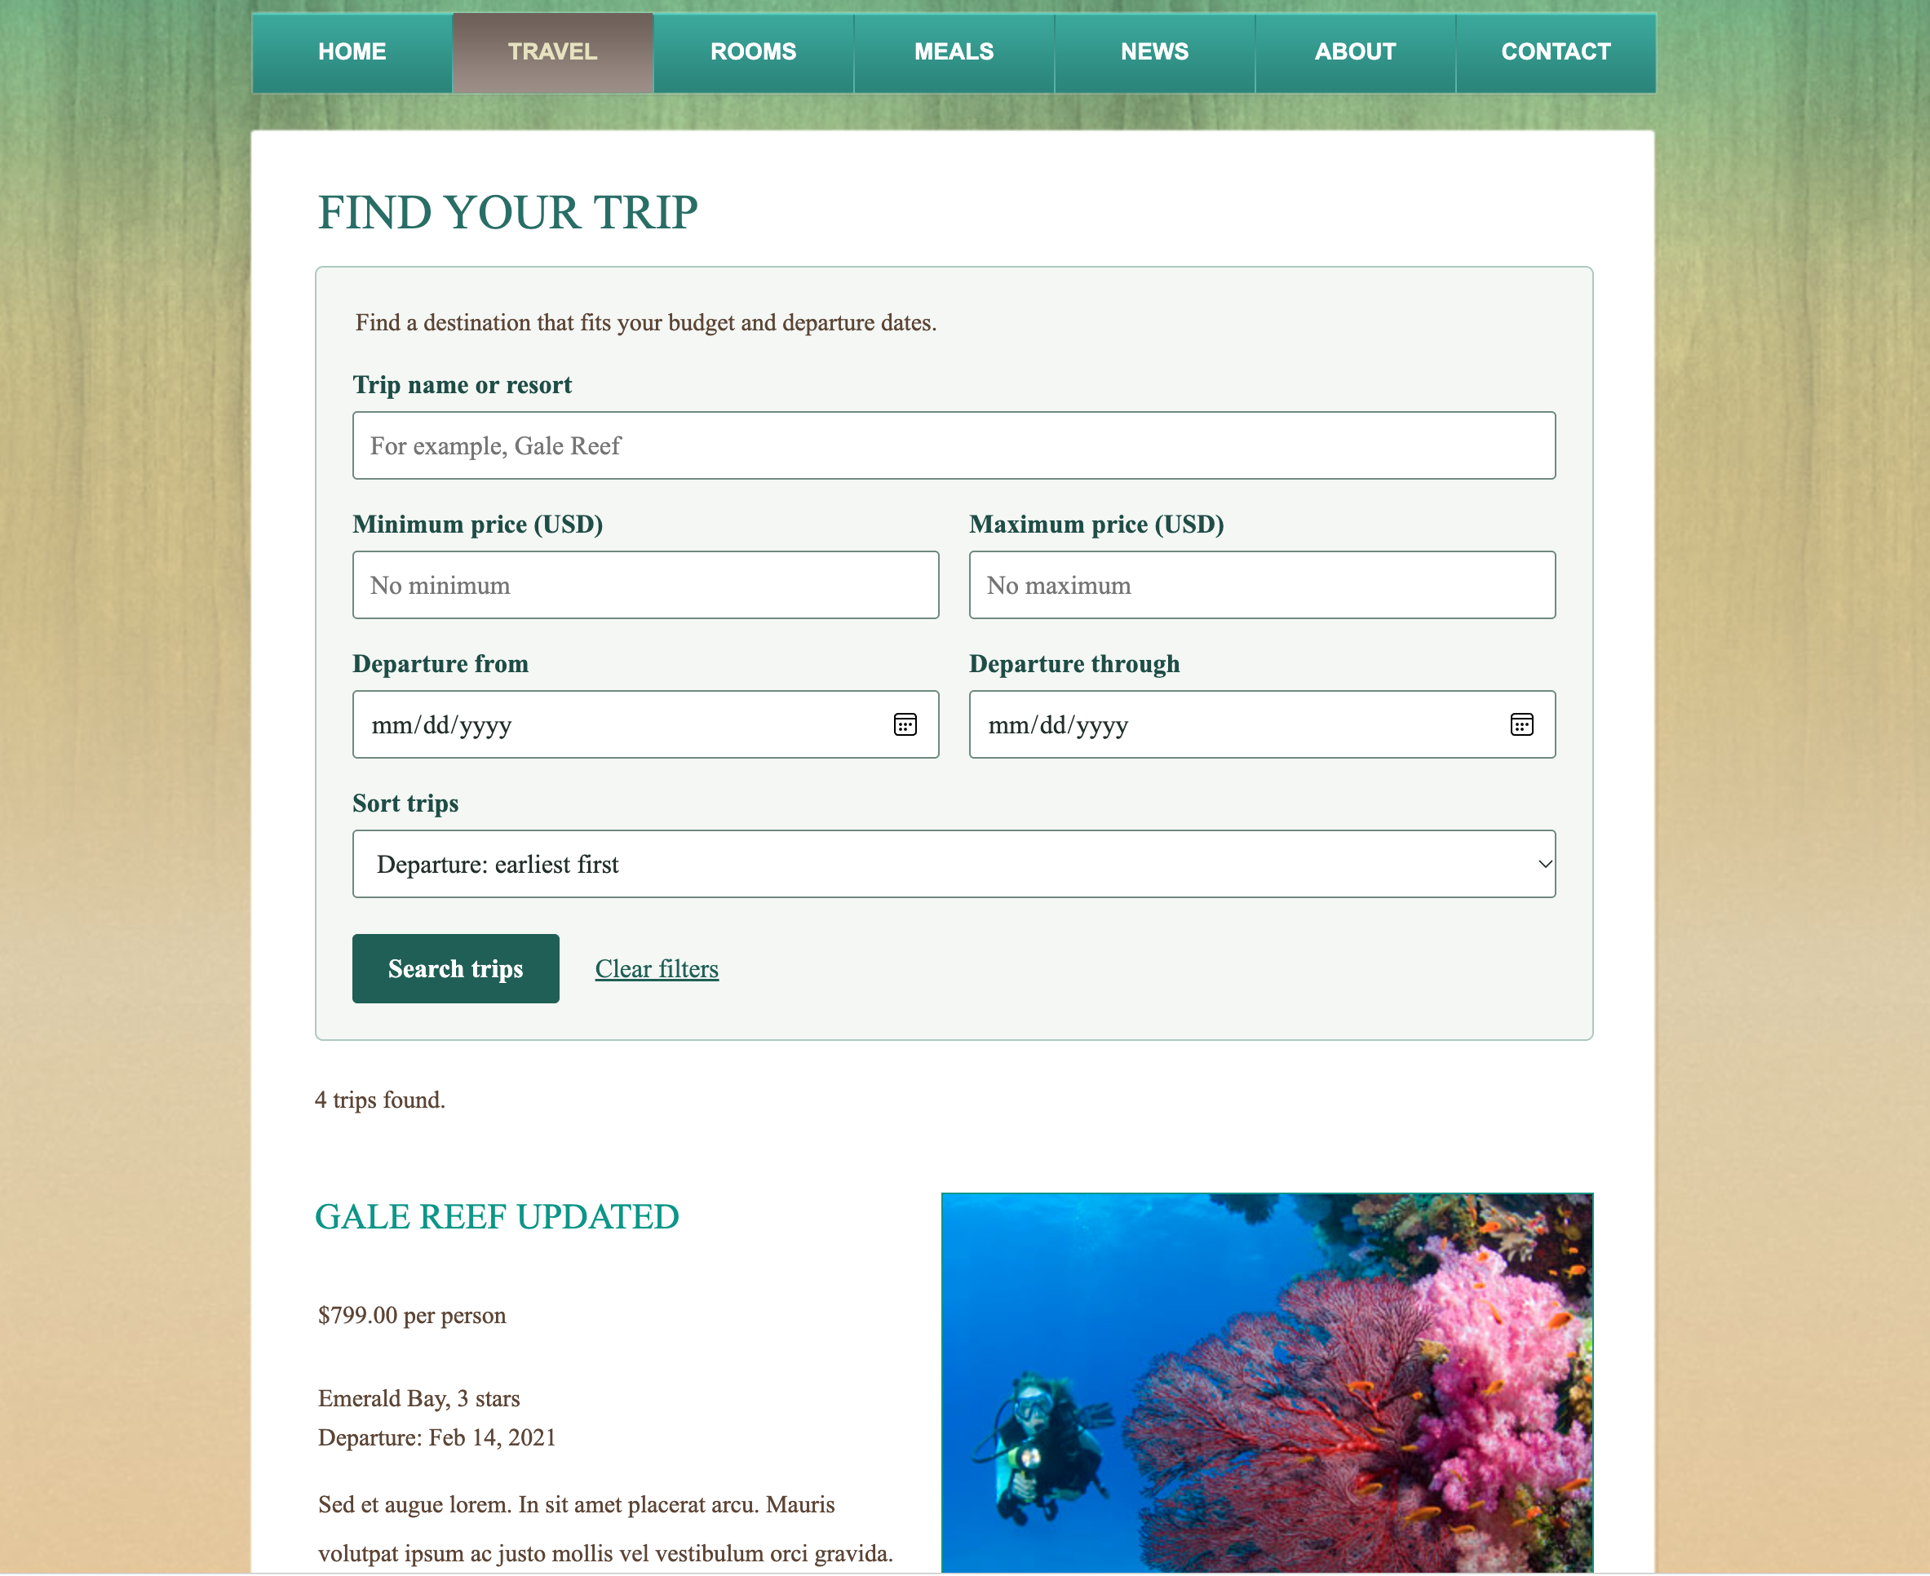
Figure 3. Enhanced public trip search and filtering controls with four matching trips.

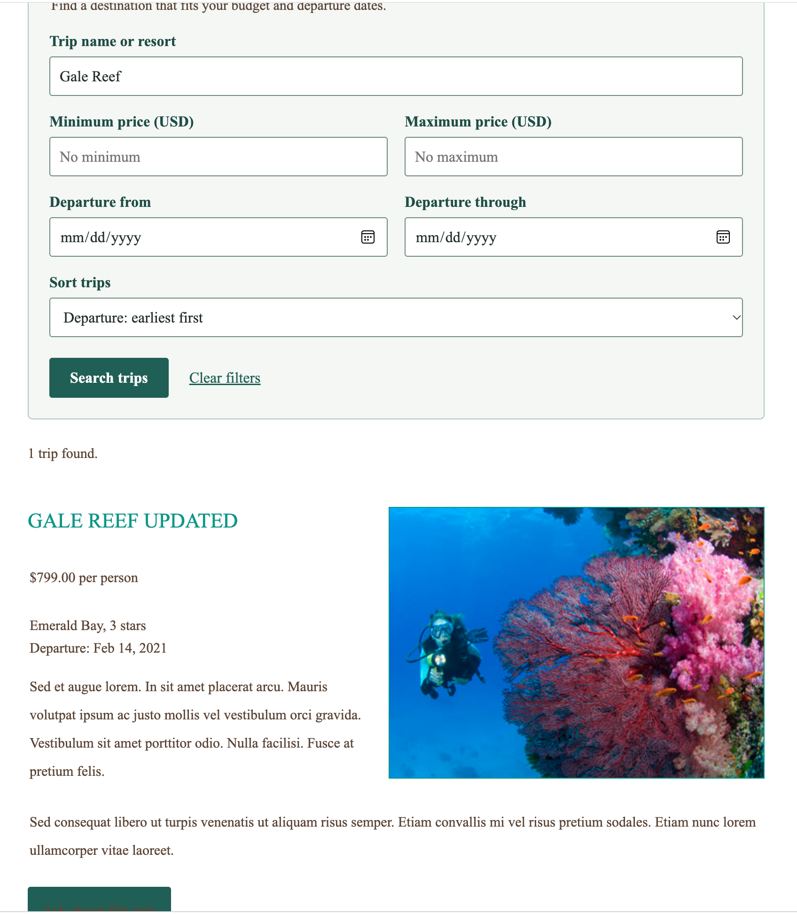
Figure 4. Literal Gale Reef search returning one matching trip with correctly formatted currency.

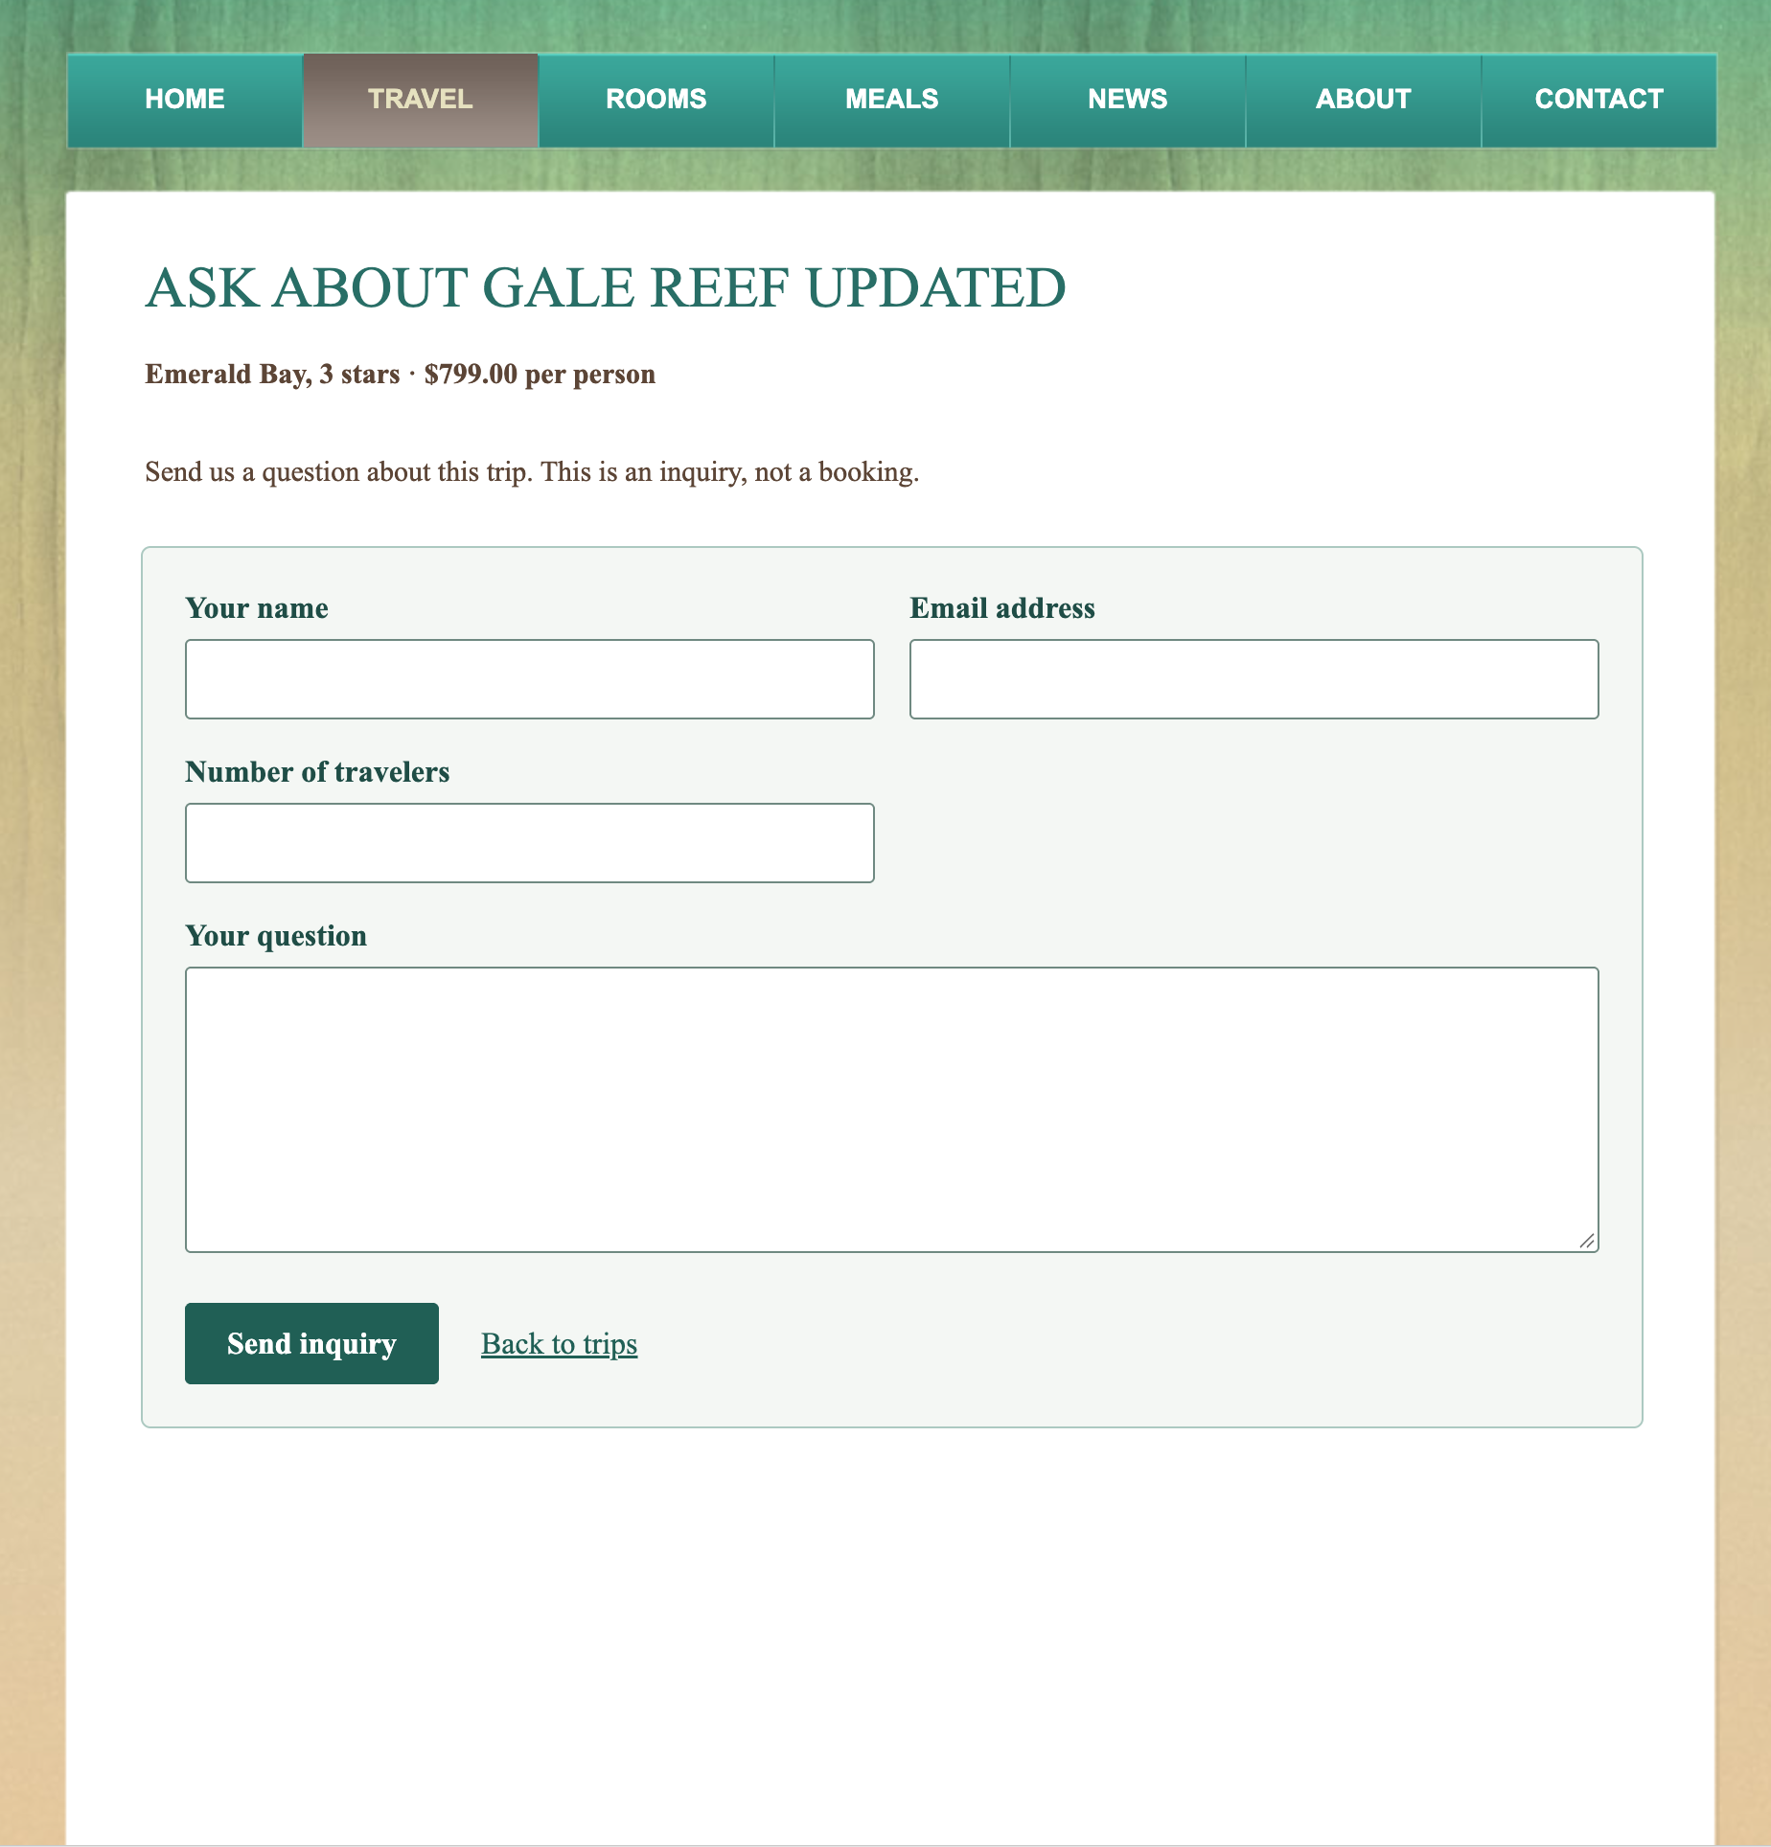
Figure 5. Trip-specific customer inquiry form with traveler count and clear non-booking language.

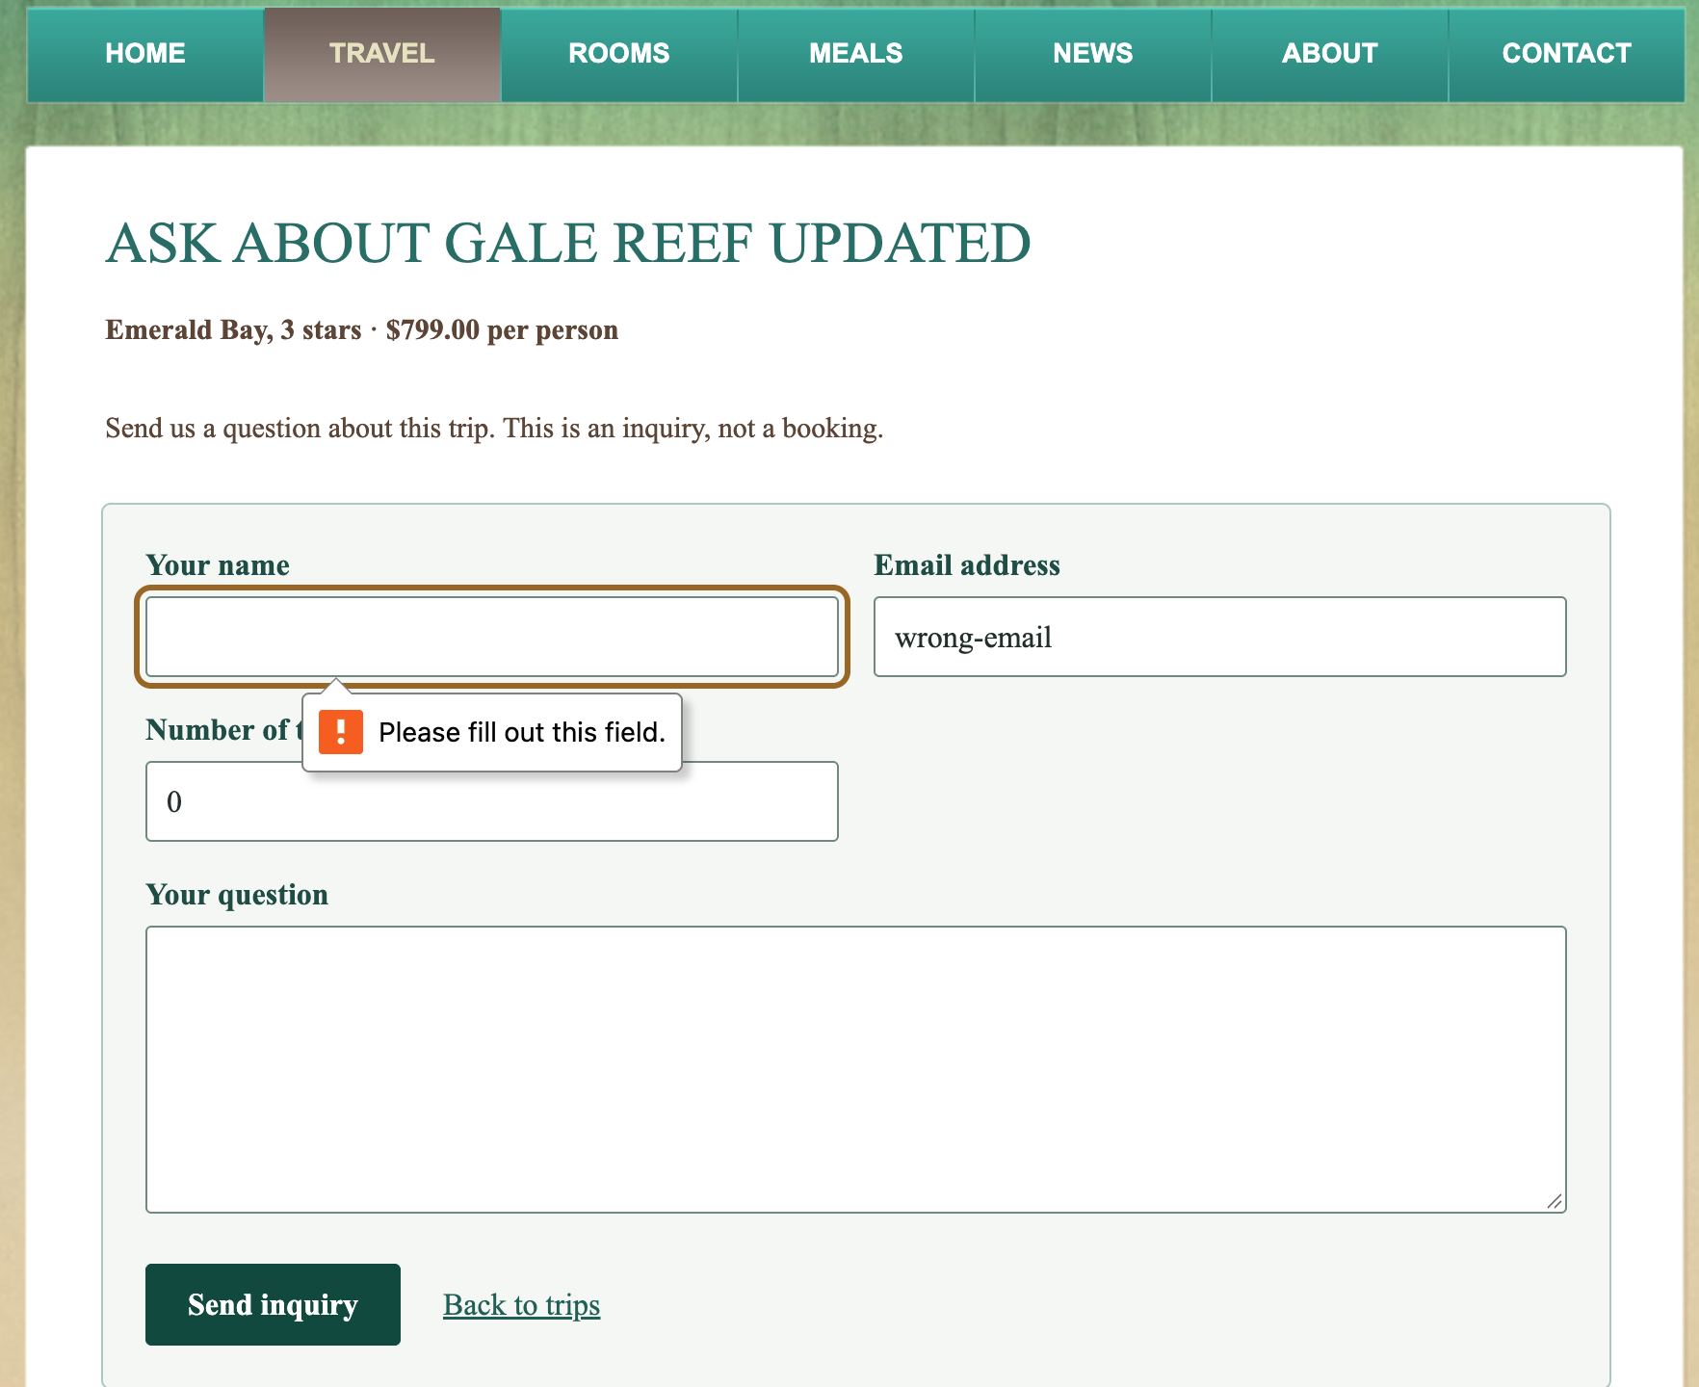
Figure 6. Browser validation preventing submission when the required customer name is missing.

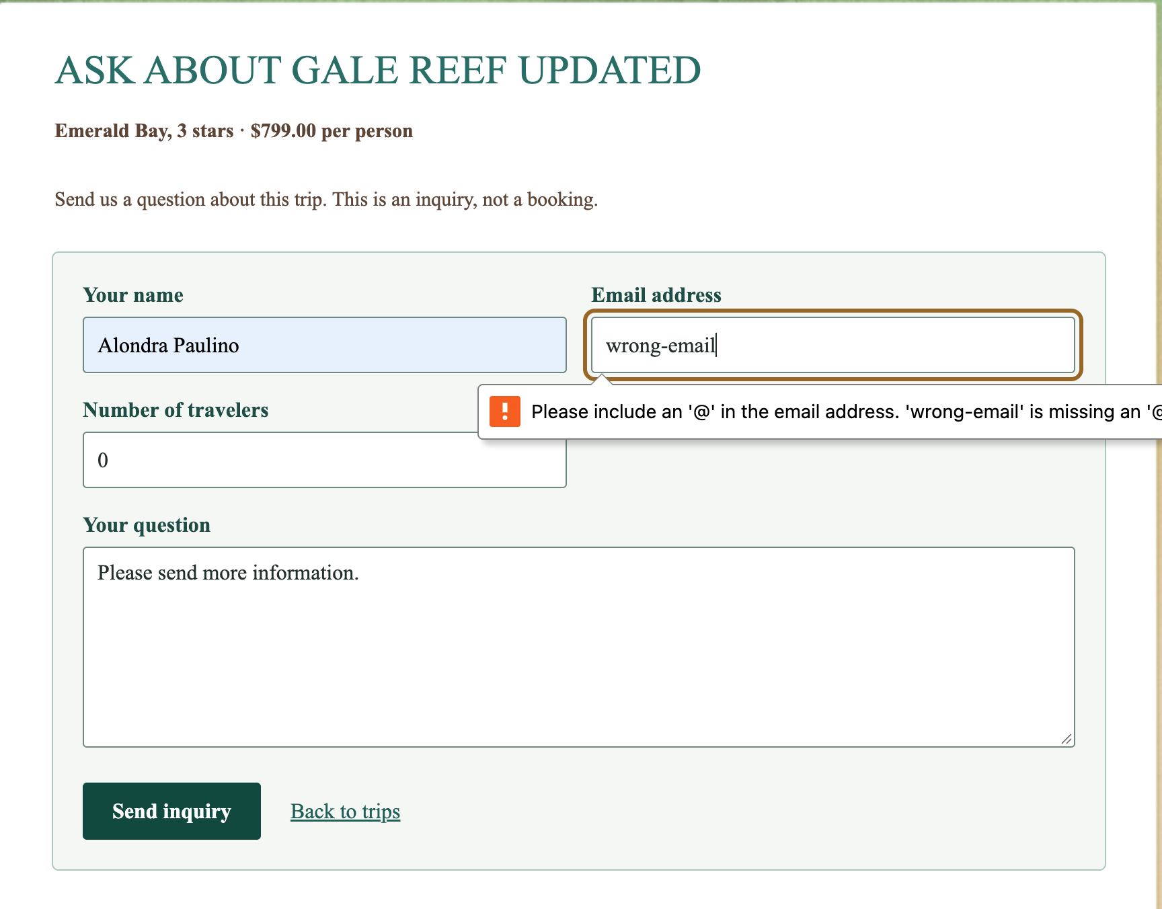
Figure 7. Browser validation identifying an invalid email address.

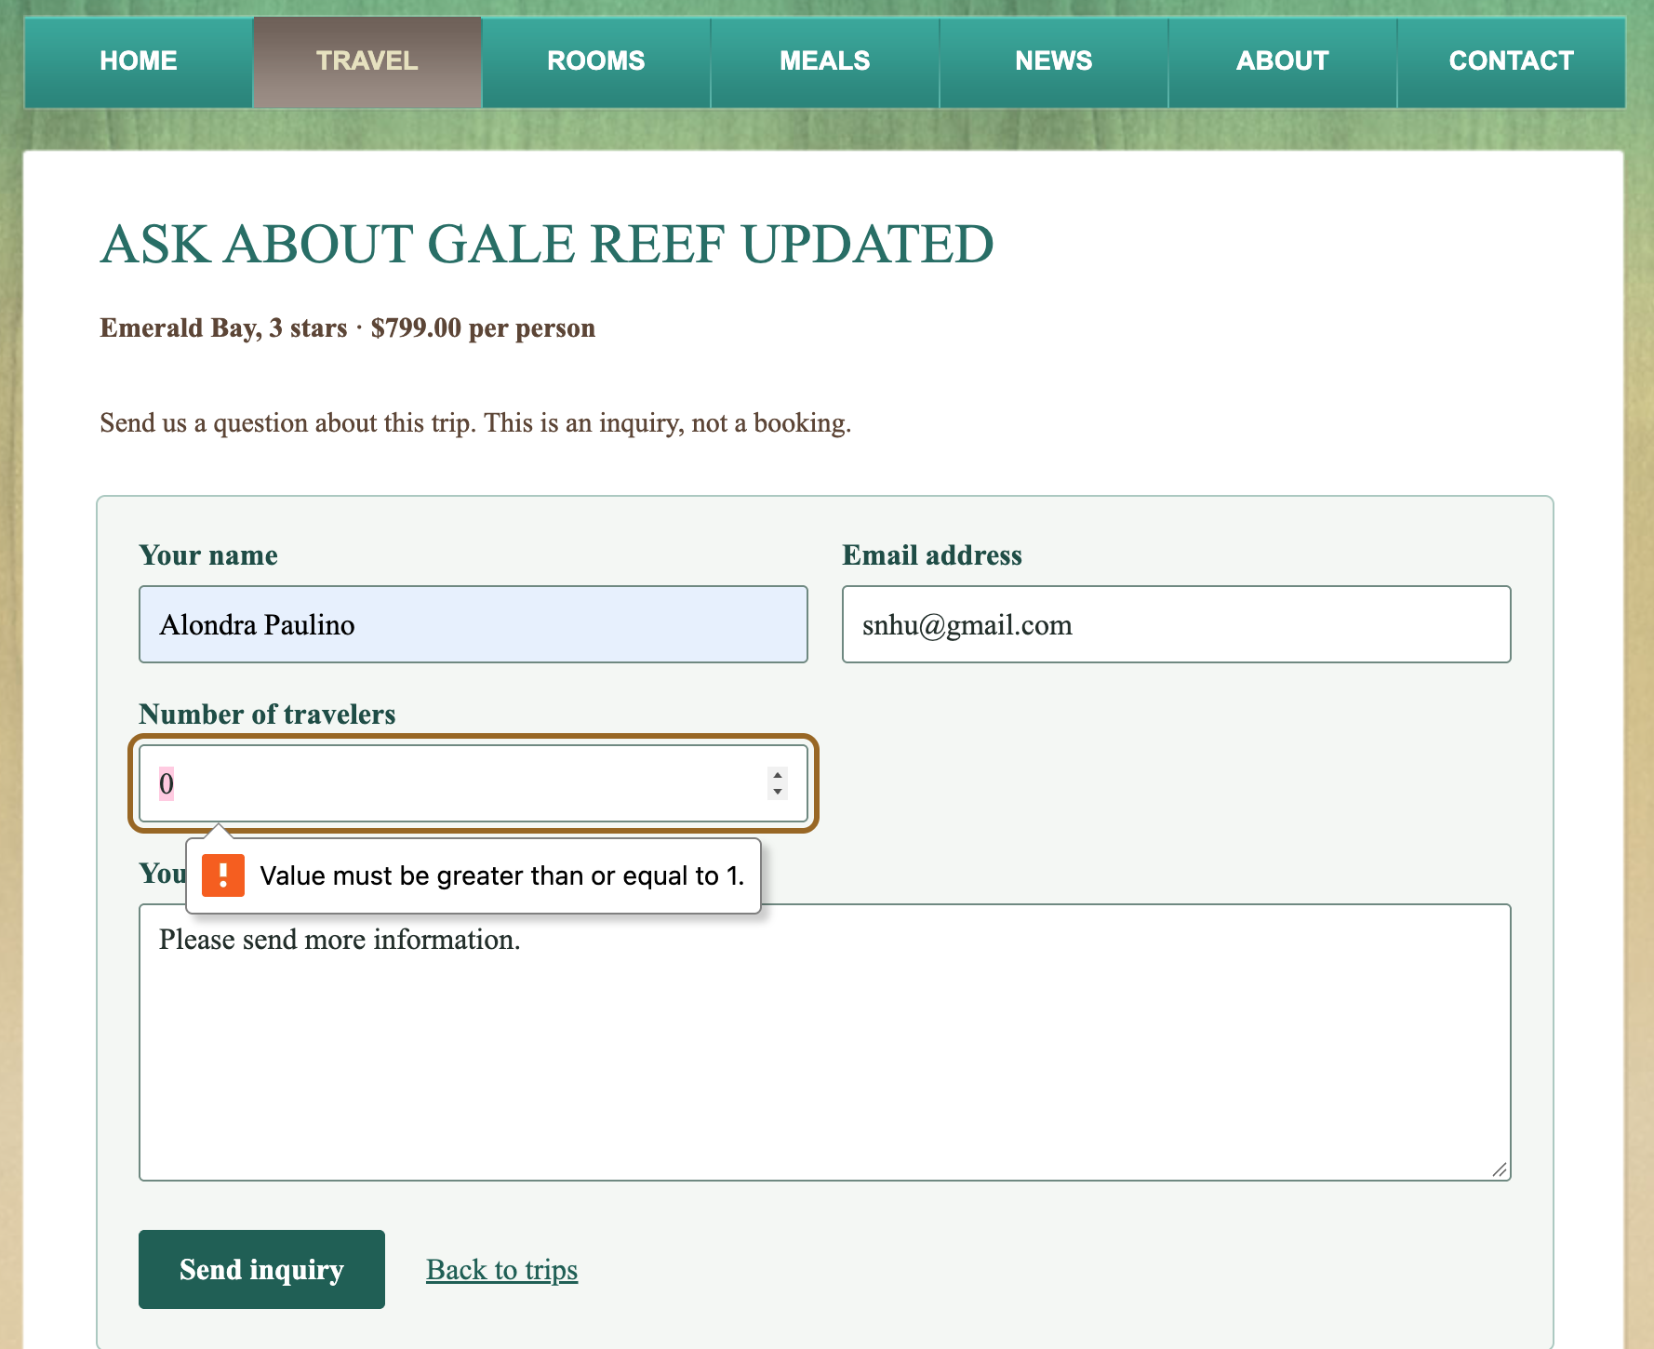
Figure 8. Browser validation enforcing a minimum of one traveler.

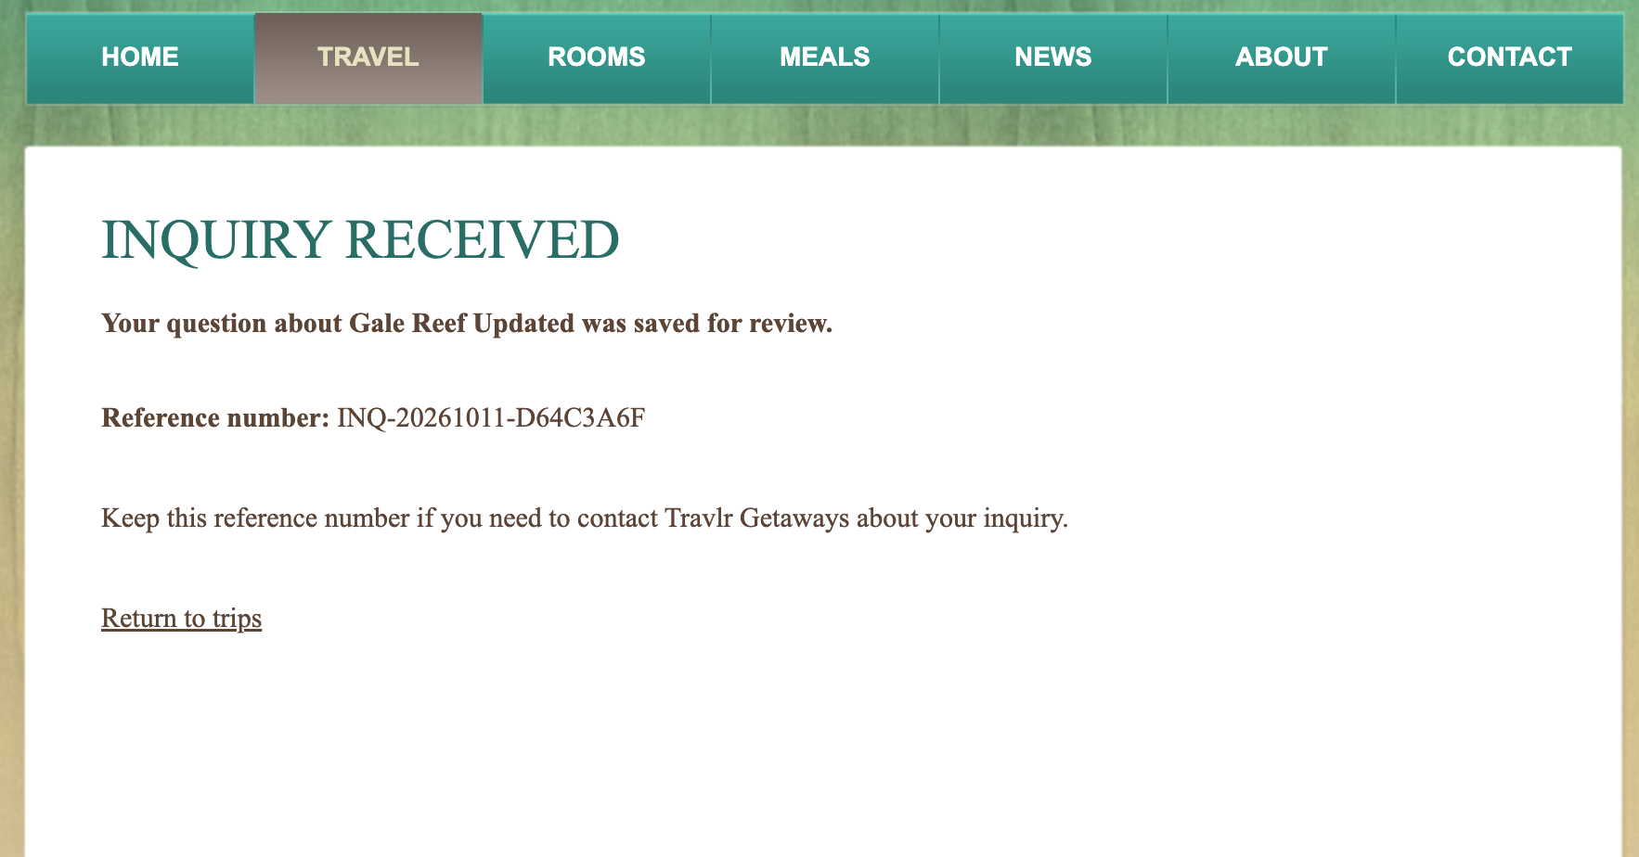
Figure 9. Saved-inquiry confirmation with generated customer reference number.

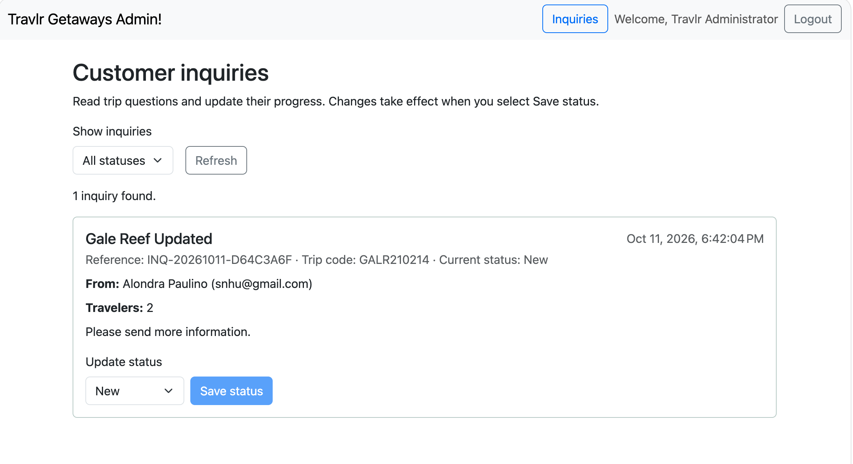
Figure 10. Protected staff inquiry inbox showing the submitted question and New status.

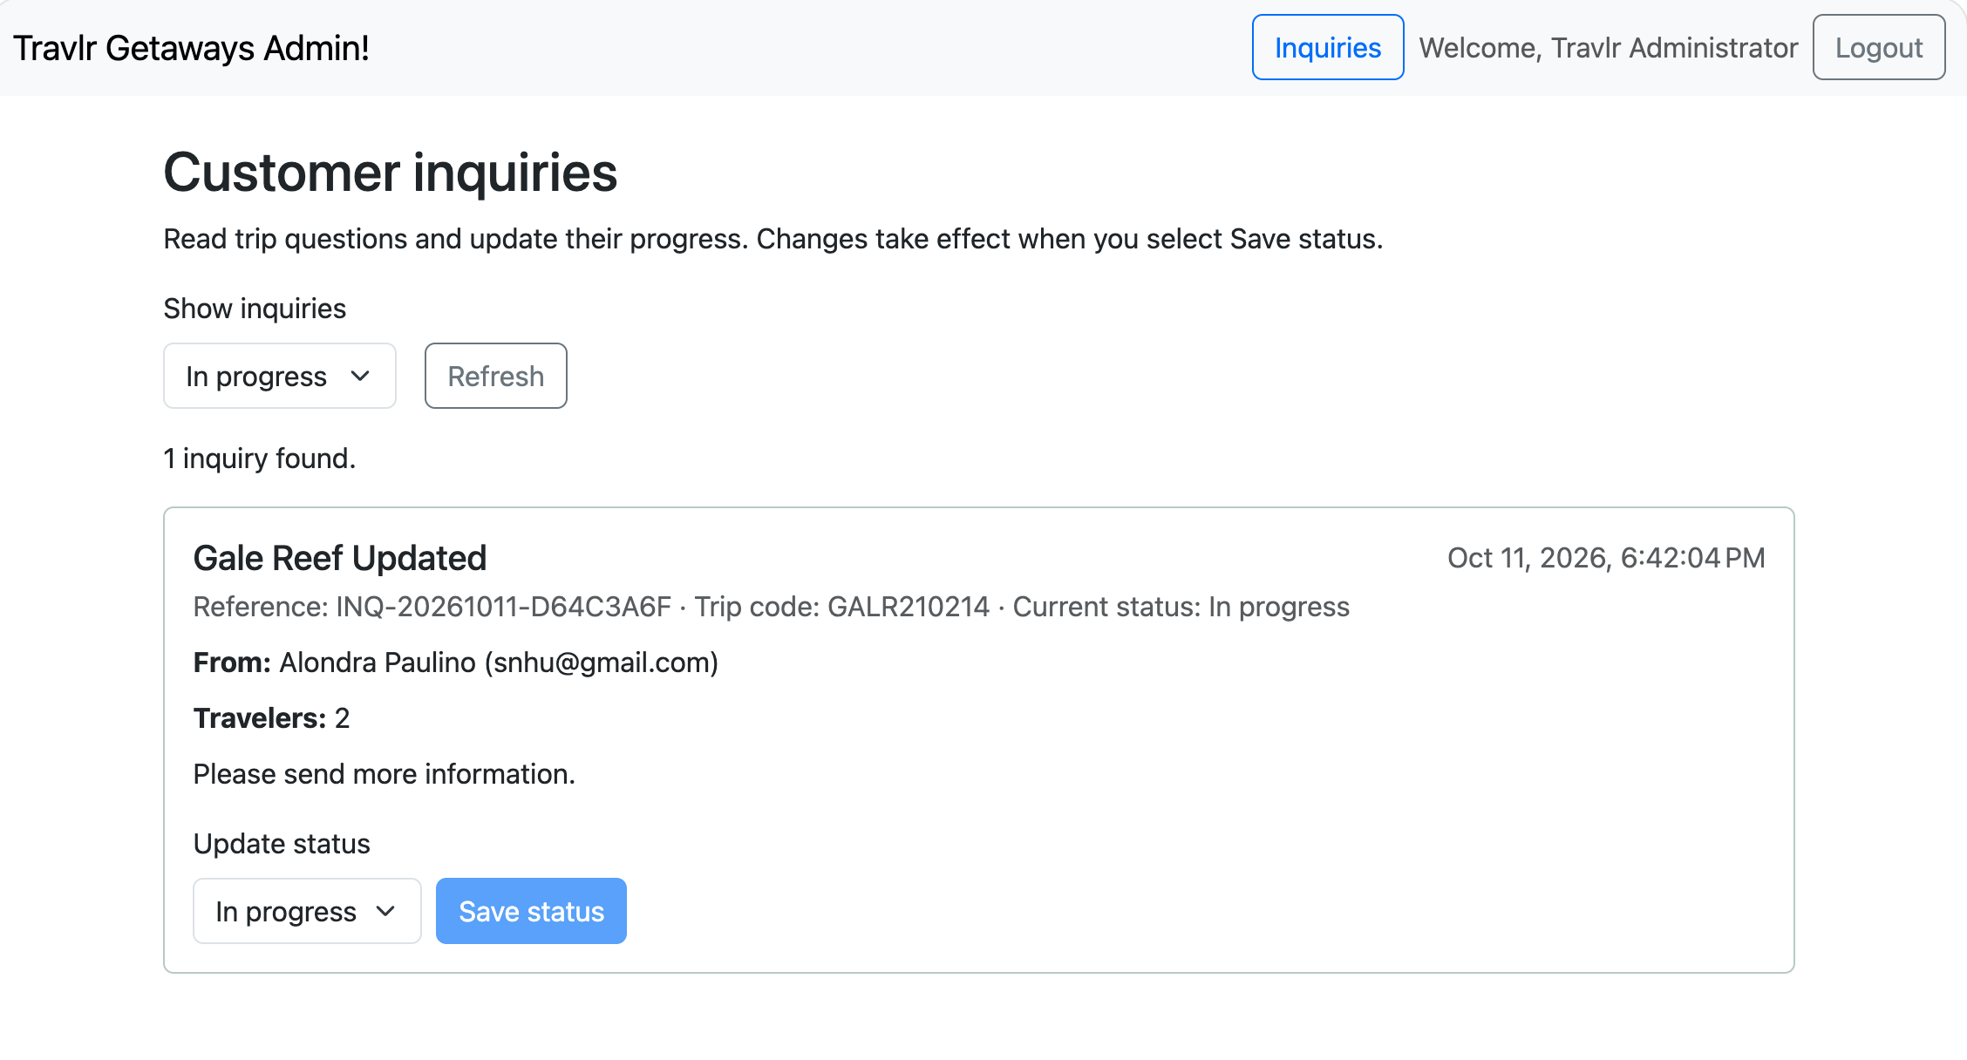
Figure 11. Staff status filtering and the saved In progress workflow update.

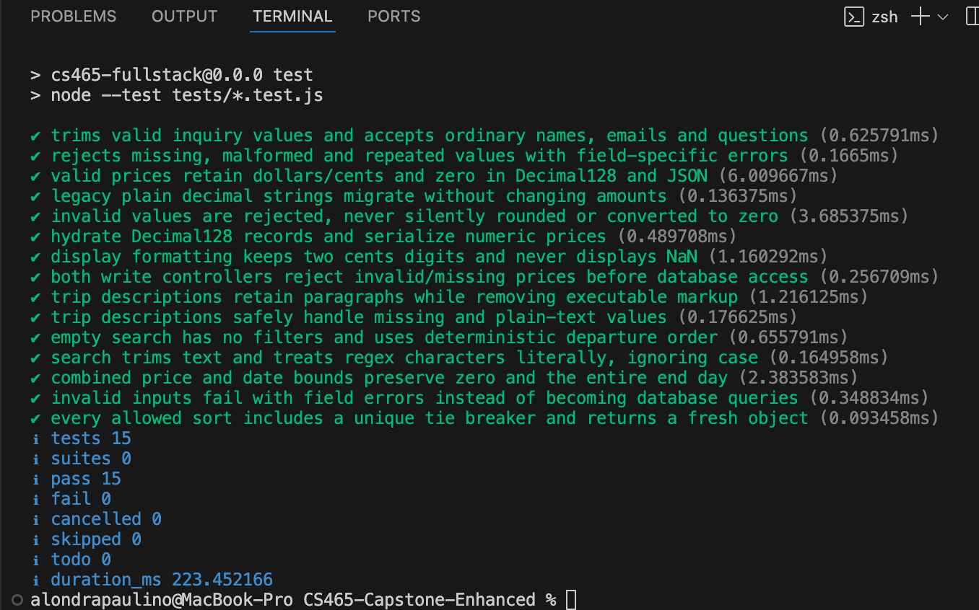
Figure 12. Backend unit-test run with 15 tests passed and no failures.

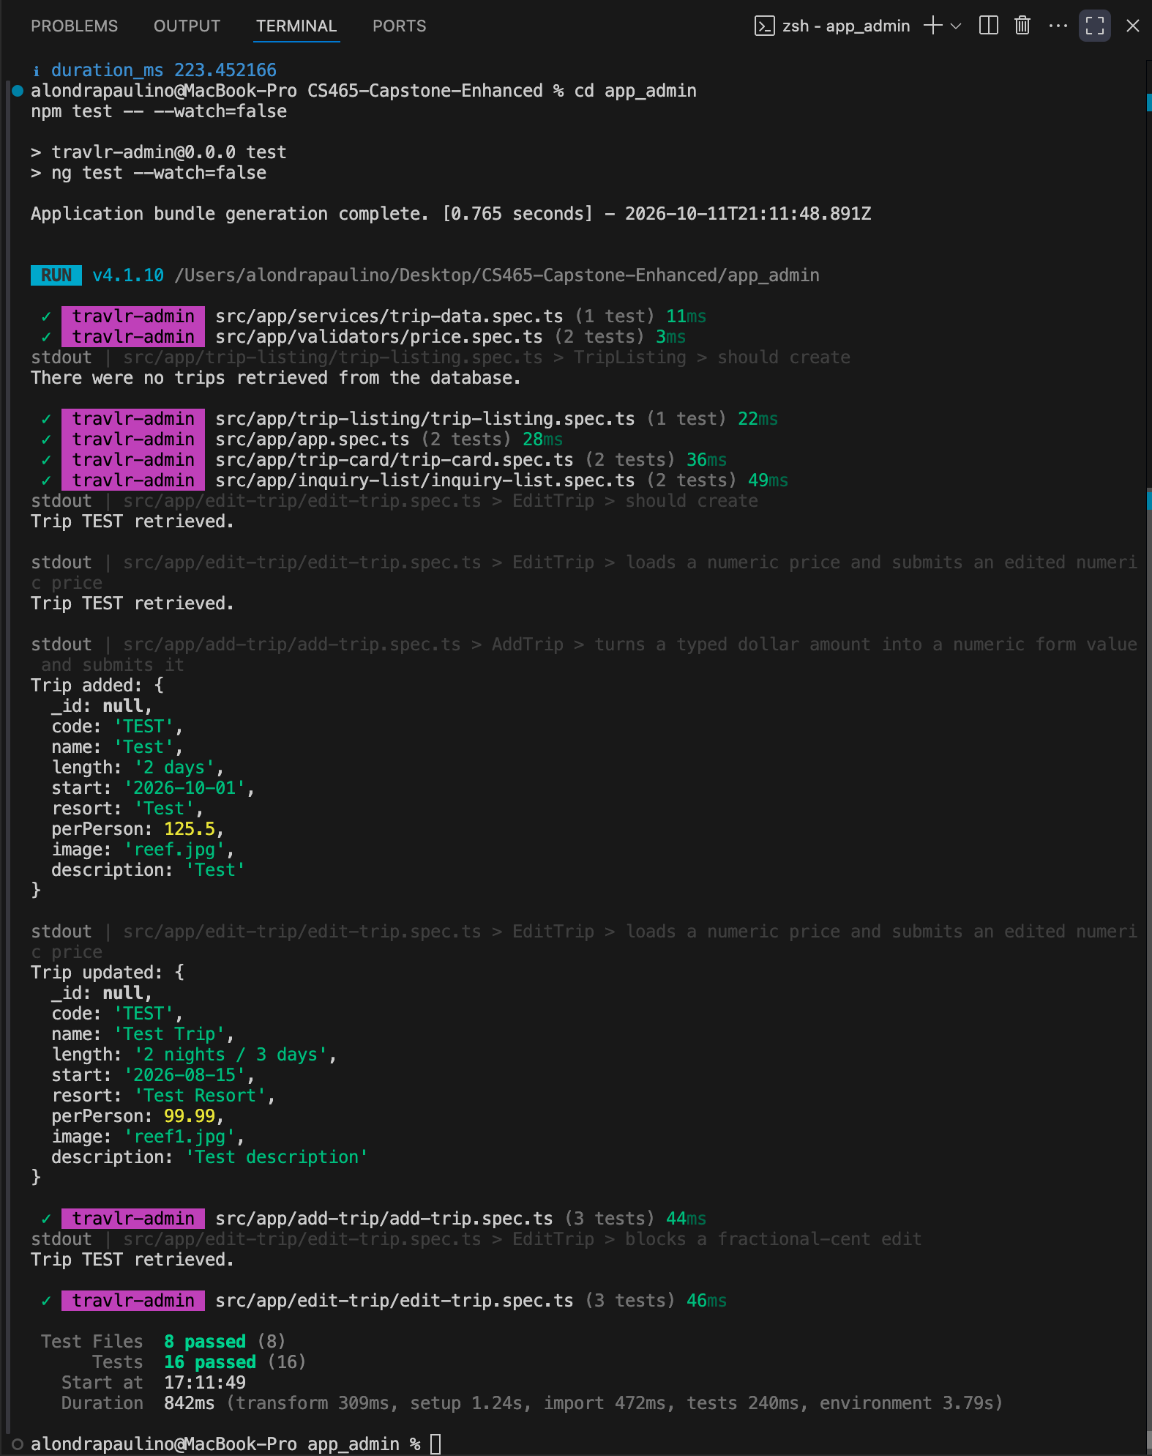
Figure 13. Angular test run with eight test files and 16 tests passed.

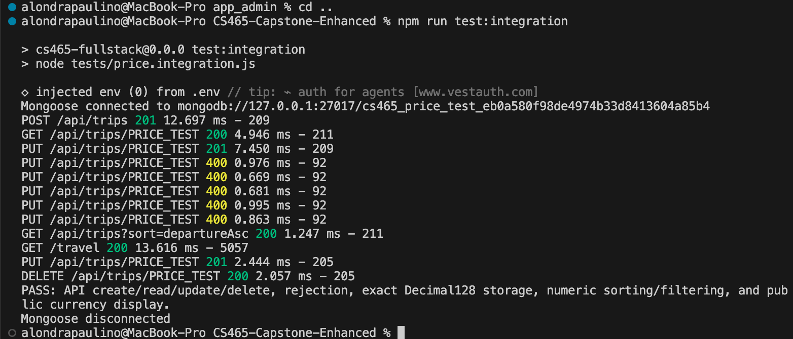
Figure 14. Price and CRUD integration evidence covering Decimal128 storage, rejection, sorting, filtering, and display.

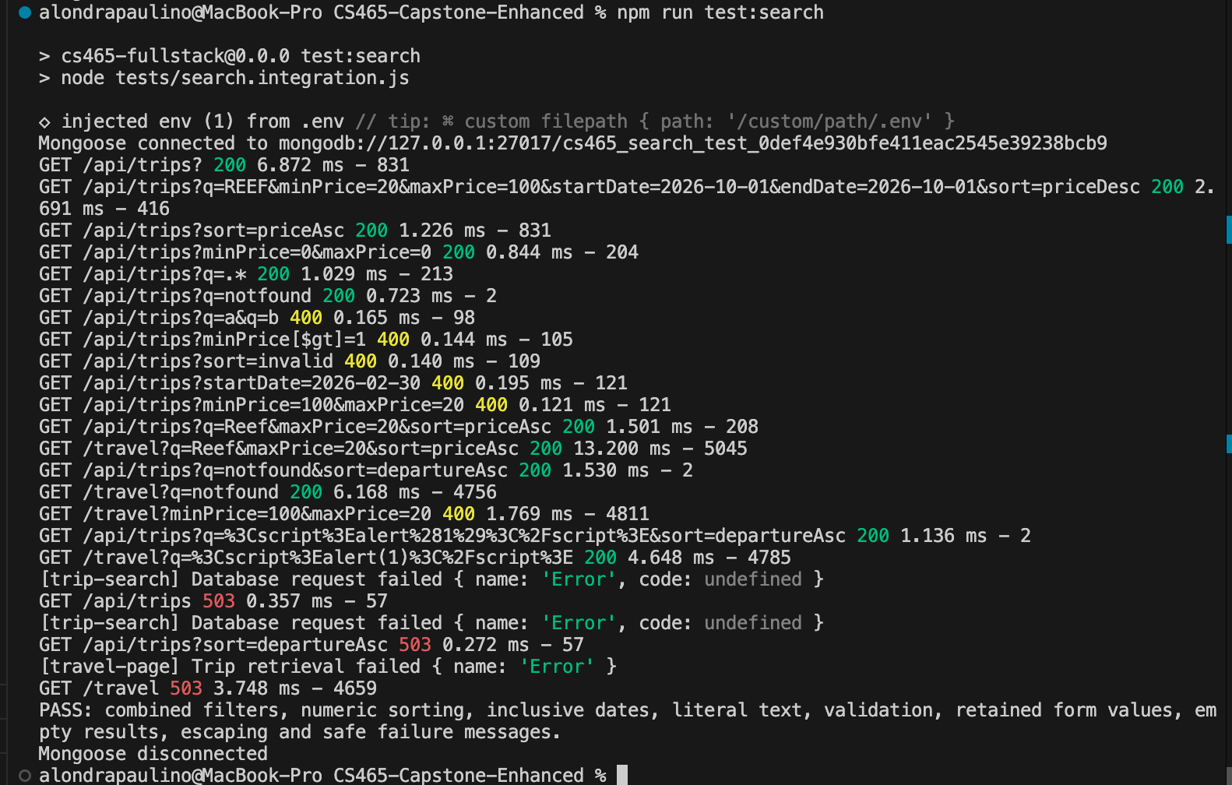
Figure 15. Search integration evidence covering filters, validation, escaping, empty results, and safe failures.

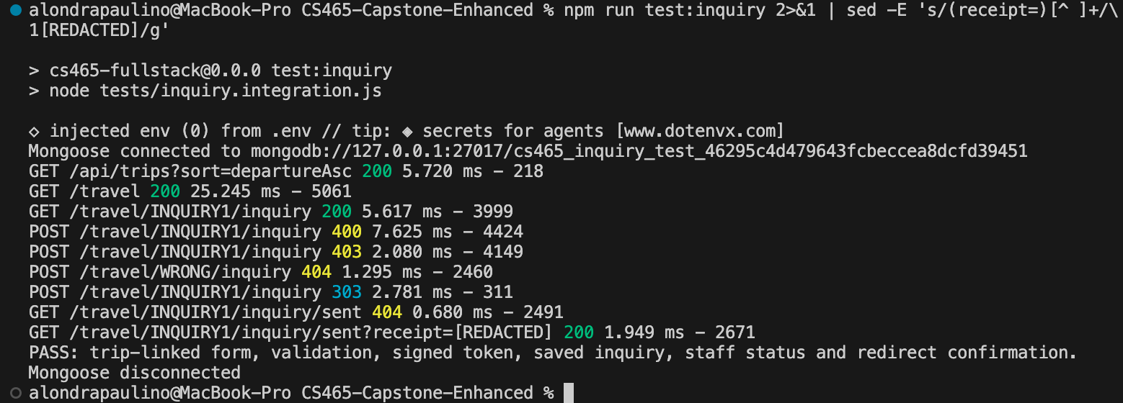
Figure 16. Customer inquiry integration evidence with the signed receipt value redacted.

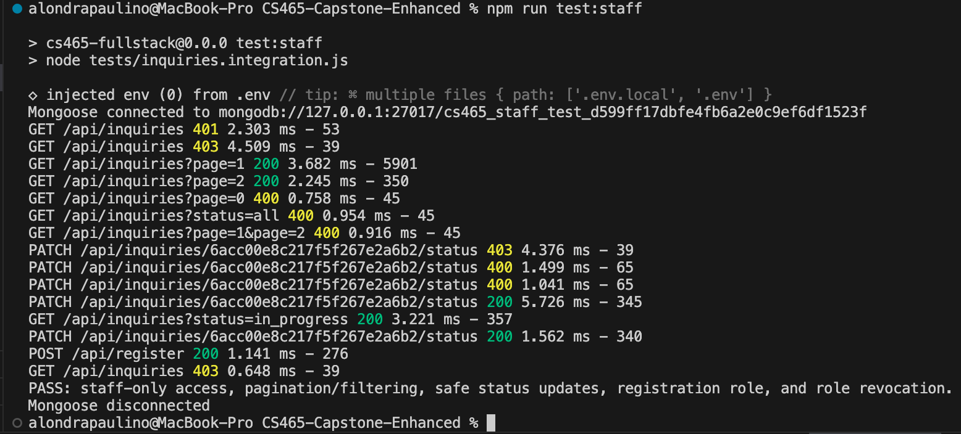
Figure 17. Staff integration evidence covering authentication, authorization, pagination, filtering, updates, and role revocation.

