CS 499 Milestone Four Database Enhancement Narrative
Alondra Paulino Santos
CS 499 Computer Science Capstone
Category Three Databases
October 4, 2026

Artifact Description
The artifact I selected is the Grazioso Salvare Animal Rescue Dashboard, which I originally created in CS 340 Client Server Development in February 2026. The original project uses Python, MongoDB, PyMongo, Dash, Plotly, and Dash Leaflet to help users explore Austin Animal Center records. It provides rescue-category filters, a searchable and sortable table, a breed-distribution chart, and a map of the selected animal. A separate AnimalShelter class provides create, read, update, and delete operations for the MongoDB animals collection. This artifact therefore combines persistent data storage, database access logic, and a visual interface that supports rescue-planning decisions.

Justification and Skills Demonstrated
I selected this artifact because it demonstrates more than a basic database connection. It shows how stored data can be validated, queried, summarized, and presented to a user in a practical application. The original dashboard worked, but it retrieved all matching documents before the browser displayed only one page. Its chart calculated breed counts from application data, its credentials were written directly in the notebook, and a database exception could appear to the interface as the same empty list produced by a successful query with no matches. These limitations gave me meaningful opportunities to demonstrate database design, efficiency, security, testing, and technical communication.
The enhanced data-access layer now validates approved query and sorting fields, performs sorting, skip, limit, and counting in MongoDB, and adds the document identifier as a stable sorting tiebreaker. Only the requested page is transferred to the dashboard. A MongoDB aggregation pipeline applies the same validated criteria, groups matching records by breed, sorts the groups, and returns the ten largest groups. This allows the chart to describe the complete filtered result even though the table displays a single database page. The dashboard also preserves document identifiers as safe strings, validates map coordinates, and reports no matches separately from a database failure.
The security improvements remove credentials from source code and load them through environment configuration. The dashboard converts only approved comparison expressions into MongoDB queries instead of forwarding arbitrary commands. Page sizes are bounded, technical errors are logged without being displayed to the user, and empty update and delete queries are rejected to reduce the risk of modifying an entire collection by mistake. The restored Grazioso Salvare logo and revised heading also improve the professional presentation without changing the database functionality.
The validation responsibilities are deliberately separated by layer. The user interface parses only the supported filter syntax and checks coordinates before creating a map marker so users receive immediate, presentation-specific feedback. The data-access layer remains the authoritative boundary for every database request: it revalidates permitted fields and operators, constrains page and aggregation sizes, constructs safe queries, and translates database failures without exposing connection details. MongoDB is responsible for executing filtering, deterministic sorting, counting, aggregation, and indexed retrieval. Interface validation therefore improves usability but is never treated as a security boundary because a client request can bypass the interface. Coordinate checks currently protect the map from invalid stored values; if this application later accepts coordinate creates or updates, the same geographic bounds should also be enforced in the API and with MongoDB schema validation so invalid values cannot be persisted.

Implementation and Testing Evidence
I verified the enhanced application against the course MongoDB dataset containing 10,000 animal records. The All Animals view reported all 10,000 matching records and supported database-driven pagination and sorting. The Water Rescue filter returned 17 matching animals, the Mountain or Wilderness Rescue filter returned 5, and the Disaster or Individual Tracking filter returned 4. In each view, the table, full-result breed chart, and selected-animal map updated together. These results provide direct evidence that the filter definitions, server-side queries, aggregation pipeline, pagination logic, and coordinate handling work with the live dataset.
I also ran twelve automated tests, and all twelve passed. The tests cover approved query boundaries, deterministic sorting, database paging, aggregation construction, document-identifier conversion, protection against empty update and delete operations, rescue-filter translation, and coordinate validation. The test run produced one Dash deprecation warning about a component that may move to a separate package in a future major release. The warning does not represent a failed test or an error in the current application, but it identifies a future maintenance consideration.
The index comparison provided measurable performance evidence. Before the candidate index was created, each rescue query examined all 10,000 documents. After creating the compound index on animal type, sex upon outcome, age upon outcome in weeks, and breed, the Water Rescue query examined 17 documents instead of 10,000 and decreased from 16 milliseconds to 4 milliseconds. The Mountain or Wilderness query examined 5 documents and the Disaster or Tracking query examined 4, with both reporting less than 1 millisecond of execution time. I decided to retain the index because the dashboard frequently reads and filters rescue records, and the large reduction in documents examined outweighs the additional index storage and maintenance required during inserts and updates.

Course Outcome Alignment
This enhancement meets the outcomes I planned to address in Module One. It supports Course Outcome Three because I designed and evaluated a computing solution that combines validated query construction, deterministic sorting, server-side pagination, counting, aggregation, and evidence-based index analysis. The baseline and candidate measurements allowed me to evaluate the trade-off among query efficiency, index storage, and write-maintenance cost instead of assuming that an index would automatically improve the application.
The enhancement supports Course Outcome Four because I used MongoDB, PyMongo, Python, Dash, automated tests, live application testing, and query execution statistics to deliver functionality that helps users locate and interpret rescue candidates. It supports Course Outcome Five through environment-based credentials, allow-listed query boundaries, safe error messages, bounded requests, and safeguards against broad destructive operations.
The dashboard also contributes evidence toward Course Outcome One because the table, total count, chart, and map convert database records into information that rescue staff and other nontechnical users can use for shared decisions. It contributes to Course Outcome Two through the organized interface, explanatory documentation, code comments, testing evidence, screenshots, and this narrative. These connections explain not only what I changed, but also how the completed artifact communicates information and provides value to different audiences.

Reflection on the Enhancement Process
The most important lesson from this enhancement was that pagination is not only an interface setting. The original DataTable showed ten rows at a time, but the application had already loaded every matching document. Moving pagination to MongoDB required the table page, total count, sorting, and chart summary to use the same validated criteria. It also showed me why stable ordering matters: when several records have the same displayed sort value, a unique identifier is needed to prevent records from shifting between pages.
Another challenge was preserving useful behavior while strengthening boundaries. The dashboard must accept user choices, but it should not accept arbitrary database fields or operators. I solved this by translating a limited set of table comparisons into an allow-listed query and validating the result again in the data-access layer. I also learned that an empty result and an operational failure are different states and should not be represented by the same return value. Defining a database-specific exception made it possible to log diagnostic information and still give the user a safe, understandable message.
The final verification process reinforced the importance of supporting technical claims with evidence. The completed dashboard now includes the restored logo, operates against the 10,000-record dataset, passes all twelve automated tests, and produces the expected results for all rescue categories. The before-and-after index measurements also changed the index decision from a proposed improvement into an evaluated design choice. Instead of simply claiming that the index improved performance, I can show exactly how many documents MongoDB examined before and after the change while still acknowledging the storage and write-maintenance trade-off.

Appendix Implementation Evidence

Index Performance Comparison
Query | Documents Before | Documents After | Time Before | Time After
Water Rescue | 10,000 | 17 | 16 ms | 4 ms
Mountain or Wilderness | 10,000 | 5 | 6 ms | <1 ms
Disaster or Tracking | 10,000 | 4 | 5 ms | <1 ms

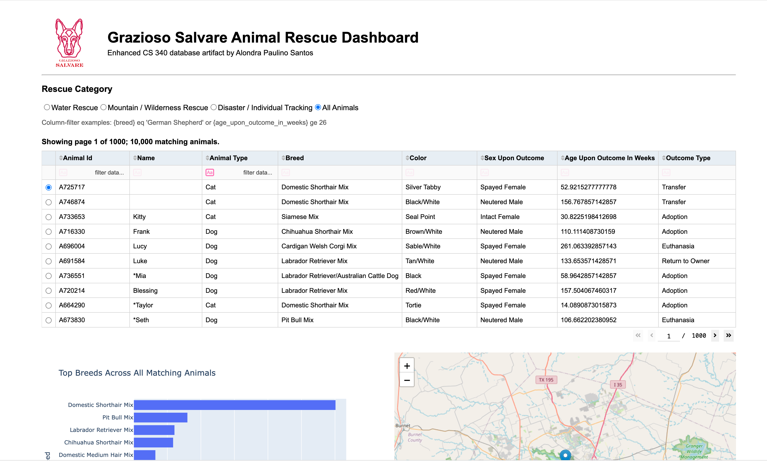
Figure 1. All Animals view showing the live 10,000-record dataset, database pagination, chart, map, and restored logo.
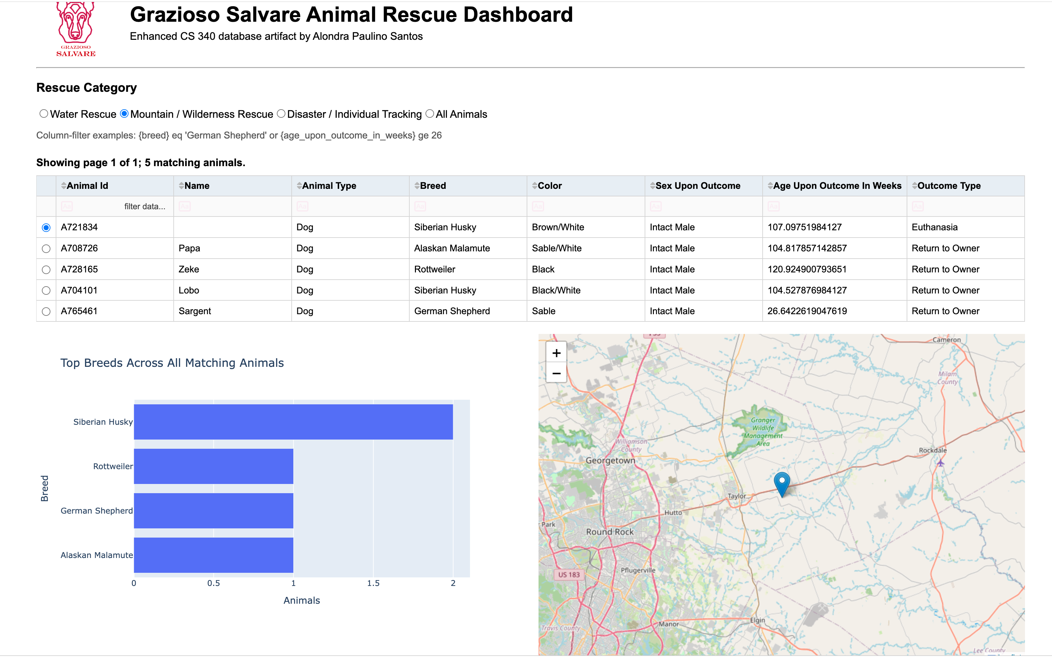
Figure 2. Mountain or Wilderness Rescue filter showing five matching animals and synchronized table, chart, and map results.
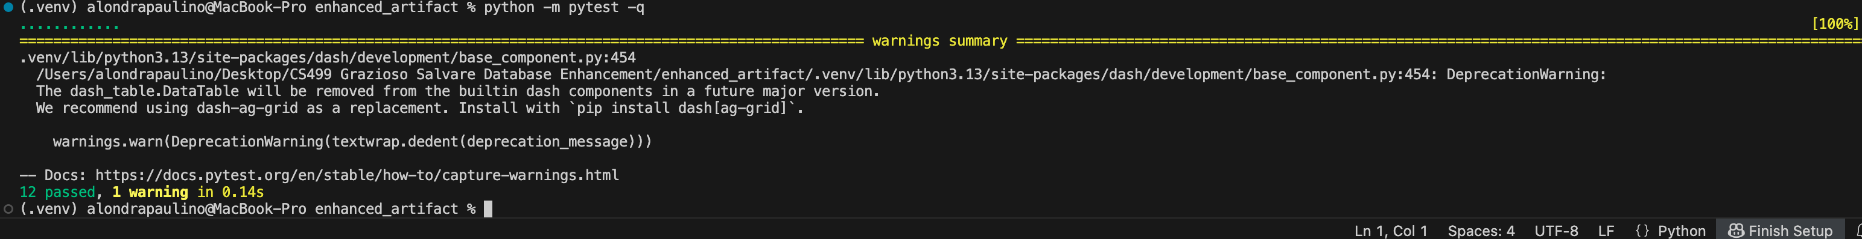
Figure 3. Automated test evidence showing 12 passing tests and one nonfailing Dash deprecation warning.

