CS 300 Algorithms and Data Structures Enhancement Narrative
Alondra Paulino Santos
CS 499 Computer Science Capstone

Artifact Description
The artifact I selected is the Advising Assistance Program that I originally created in 2025 for Project Two in CS 300: Data Structures and Algorithms. The original C++ command-line application loads course records from a file, stores them in a custom hash table with separate chaining, prints an alphanumeric course list, and allows a user to search for an individual course and view its prerequisites. The artifact grew out of my Project One analysis comparing vectors, hash tables, and binary search trees. I selected a hash table because it supports approximately constant-time average insertion and lookup while still allowing the records to be copied into a vector and sorted when an alphabetical display is needed.

Reason for Including the Artifact and Enhancement Summary
I included this artifact because it shows both my understanding of data-structure selection and my growth in turning an academic program into a more dependable planning tool. The custom hash table demonstrates hashing, separate-chaining collision handling, searching, and memory management. The enhanced program also uses vectors, unordered maps, unordered sets, and a queue for purposes that match their strengths. Instead of only displaying courses alphabetically, the new Capstone Course Planning Assistant models prerequisite relationships as a directed graph and generates an order in which prerequisites appear before the courses that depend on them. This gives students and academic advisers information that the original alphabetical list could not provide.
The primary enhancement is Kahn's topological-sorting algorithm. Each course is represented as a vertex, and each valid prerequisite relationship becomes a directed edge from the prerequisite to its dependent course. An adjacency list records the dependent courses, a prerequisite-count collection stores each vertex's incoming-edge count, and a queue holds courses that are ready because they have no remaining prerequisites. As each ready course is processed, the algorithm reduces the counts of its dependents and adds newly available courses to the queue. Graph construction and traversal require O(V + E) time and space, where V represents courses and E represents prerequisite relationships. This requires additional memory compared with an alphabetical list, but the trade-off provides a useful dependency-respecting sequence. The program also explains that this order does not assign semesters or account for course availability or credit limits.
I also strengthened the supporting code so the generated order can be trusted. The loader now reports malformed CSV, missing fields, invalid codes, duplicate courses, repeated prerequisites, missing prerequisites, and self-dependencies. It preserves invalid relationships for review instead of silently deleting them and producing a misleading plan. If a missing prerequisite or malformed record exists, the program refuses to generate a complete sequence. If the topological sort cannot process every course, it reports a circular dependency, identifies the unresolved courses, and does not present the partial result as a complete plan. I replaced unsafe raw-pointer ownership in the hash-table chains with unique ownership and safe move operations, added quoted-field CSV handling, normalized course codes consistently, and revised the comments so they explain the purpose and logic of the important sections.

Course Outcomes
The enhancement met the primary course outcomes identified in my Module One plan. It supports Course Outcome Three because I designed and evaluated a graph-based solution, implemented topological sorting, and considered the time and memory trade-offs of the adjacency list, prerequisite counts, and queue. It supports Course Outcome Four because I used C++ and appropriate standard-library data structures to add a practical advising capability to a working artifact. It supports Course Outcome Two through accurate code comments, validation messages, complexity explanations, testing evidence, and this narrative. These materials communicate the design to a technical audience, while the program's plain-language course order and error messages are understandable to students and advisers.
I am also expanding my outcome-coverage plan in response to instructor feedback. The artifact now provides evidence toward Course Outcome One because it gives students and advisers a shared, understandable view of course dependencies that can support collaborative academic decision-making. Nontechnical users can interpret the suggested order and its limitations, while technical users can use the line-specific validation report and unresolved-course list to correct the underlying data. The enhancement also makes progress toward Course Outcome Five. Defensive validation prevents corrupted input from producing an unreliable recommendation, and safer ownership prevents memory-management flaws such as dangling pointers or double deletion. I do not consider this single artifact complete evidence of every outcome, but it adds concrete support for collaboration, communication, algorithmic design, practical implementation, and secure development.

Reflection on the Enhancement Process
The most important thing I learned from this enhancement is that choosing a data structure is only the beginning of designing a solution. The hash table is effective for locating an individual course, but it does not represent the relationships needed to create a prerequisite order. I had to combine structures instead of expecting one structure to solve every part of the problem. The hash table remained useful for storage and lookup, while the directed graph represented dependencies and the queue controlled the topological traversal. This helped me better understand how algorithms and data structures work together as parts of a complete system.
One challenge was deciding how the application should respond to invalid data. The earlier version removed unknown and self-referencing prerequisites, which allowed the remaining records to load but could also make the data appear valid. I changed that behavior because an advising tool should not recommend an order after silently changing prerequisite requirements. Another challenge was handling duplicate prerequisite entries. If the same edge were counted twice, a course might never reach a prerequisite count of zero, so the loader now records that relationship only once and reports a warning. Circular dependencies required a similar design decision: the program may process part of the graph, but it clears that partial order and reports the unresolved courses instead of presenting incomplete output as a valid plan.
Testing helped me connect these design decisions to observable behavior. I tested independent courses, prerequisite chains, courses with multiple prerequisites, normalized searches, quoted titles, duplicate records, missing prerequisites, self-dependencies, malformed CSV, circular dependencies, and repeated file loading. I also compiled with strict warnings and used memory and undefined-behavior sanitizers. The tests confirmed that valid input produces a complete prerequisite-respecting order and that invalid input produces specific explanations without unsafe memory behavior. Overall, the enhancement strengthened my ability to design algorithms, evaluate trade-offs, validate data defensively, document technical decisions, and explain how a working program supports real users.

Implementation and Verification Evidence
The following evidence demonstrates that the enhancement moved from planning to implementation. The enhanced artifact compiles under C++17 with strict warnings treated as errors, constructs and traverses a directed prerequisite graph, rejects unsafe or unreliable input, detects circular dependencies, and completes a sanitizer-instrumented execution without reported memory or undefined-behavior faults.
Algorithm and efficiency. The implemented approach is Kahn's topological-sort algorithm. Building the adjacency list and incoming-edge counts visits every course and prerequisite relationship once, and the traversal processes each vertex and edge once. Therefore, the algorithm requires O(V + E) time and O(V + E) additional space. The trade-off is extra graph storage, but it produces a dependency-respecting sequence that an alphabetical sort cannot provide.
Design and validation decisions. The loader preserves and reports invalid relationships instead of silently changing academic requirements. It identifies duplicate course codes, repeated prerequisite edges, missing fields, invalid codes, undefined prerequisites, and self-dependencies. Course-order generation is blocked when those errors could make the result misleading. If no zero-in-degree traversal can process every course, the program reports the unresolved vertices as evidence of a cycle rather than presenting a partial result as a complete plan.
Figure | Verification area | Observed result
1 | Strict compilation | C++17 build completed with -Wall, -Wextra, -Wpedantic, and -Werror.
2 | Valid input loading | Six valid records loaded with zero duplicates or prerequisite-reference errors.
3 | Topological ordering | The generated order placed every prerequisite before its dependent course.
4 | Cycle detection | A three-course cycle was rejected and all unresolved courses were identified.
5 | Relationship validation | Missing and self-referencing prerequisites were reported and planning was blocked.
6 | Record validation | Duplicate and malformed records were reported with line-specific diagnostics.
7 | Runtime safety | AddressSanitizer and UndefinedBehaviorSanitizer execution completed cleanly.

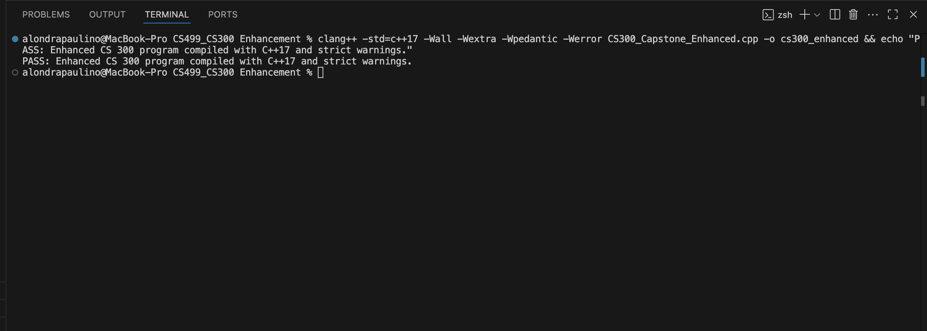
Figure 1. Strict C++17 compilation completed with warnings treated as errors.
This build verifies that the enhanced source satisfies strict compiler diagnostics without warnings or errors.

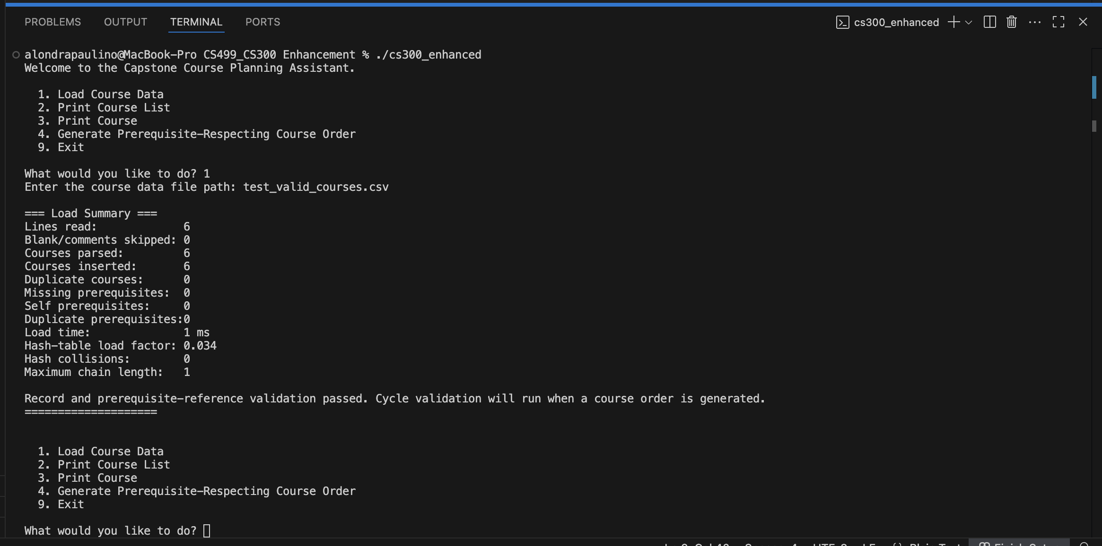
Figure 2. Valid-input load summary showing six inserted courses and zero validation defects.
The summary confirms that clean input passes record and prerequisite-reference validation before cycle analysis.

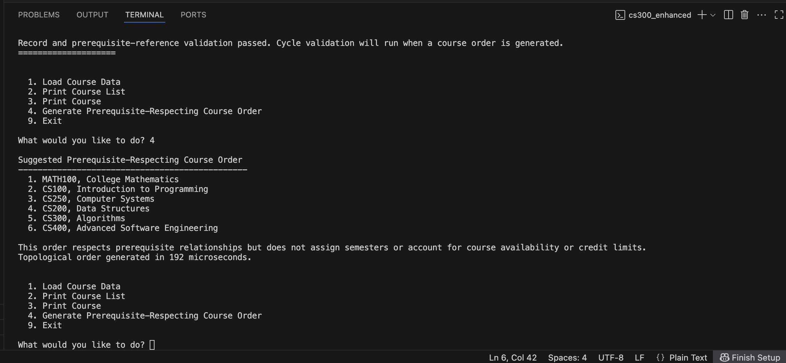
Figure 3. Successful prerequisite-respecting order produced by the graph and queue implementation.
CS100 precedes CS200 and CS250; both precede CS300; and CS300 precedes CS400, confirming the required dependency constraints.

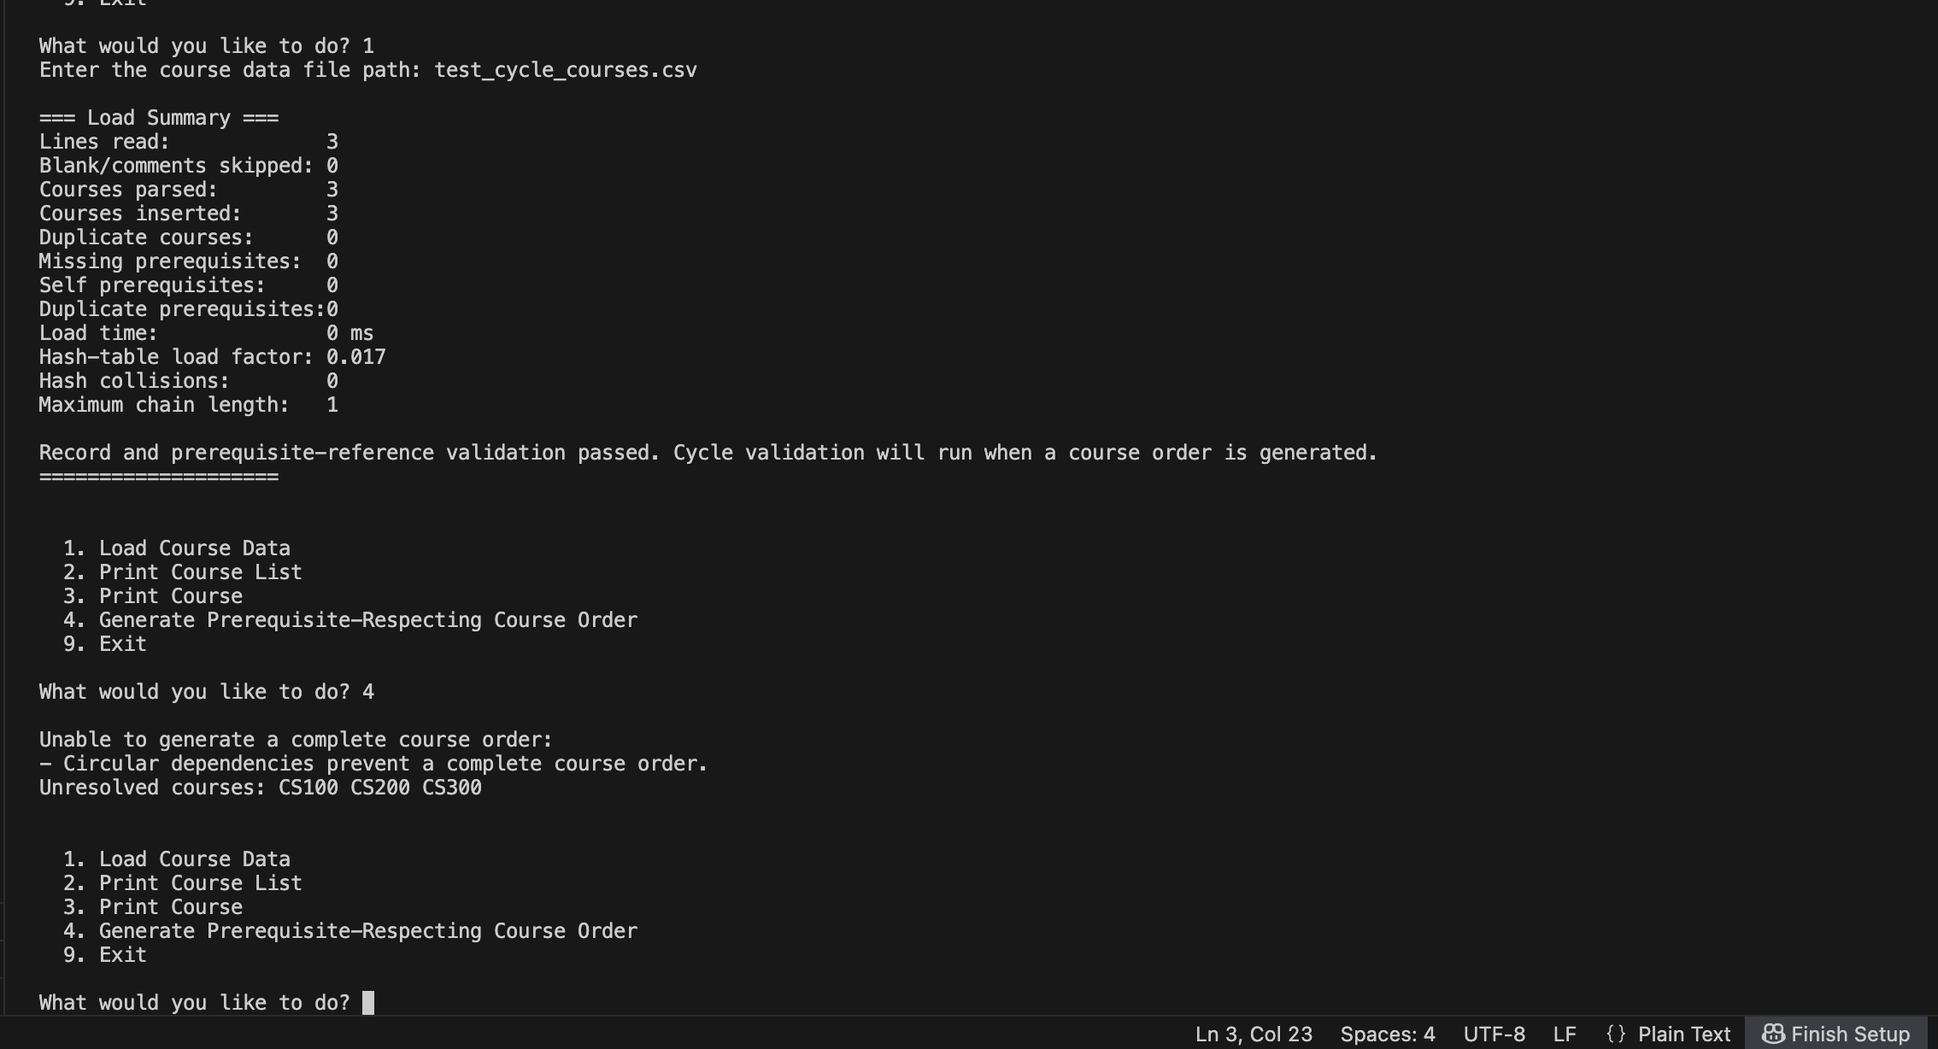
Figure 4. Circular dependency detection identifying CS100, CS200, and CS300 as unresolved.
Because Kahn's algorithm could not process all three vertices, the program rejected the incomplete result and reported the unresolved cycle participants.

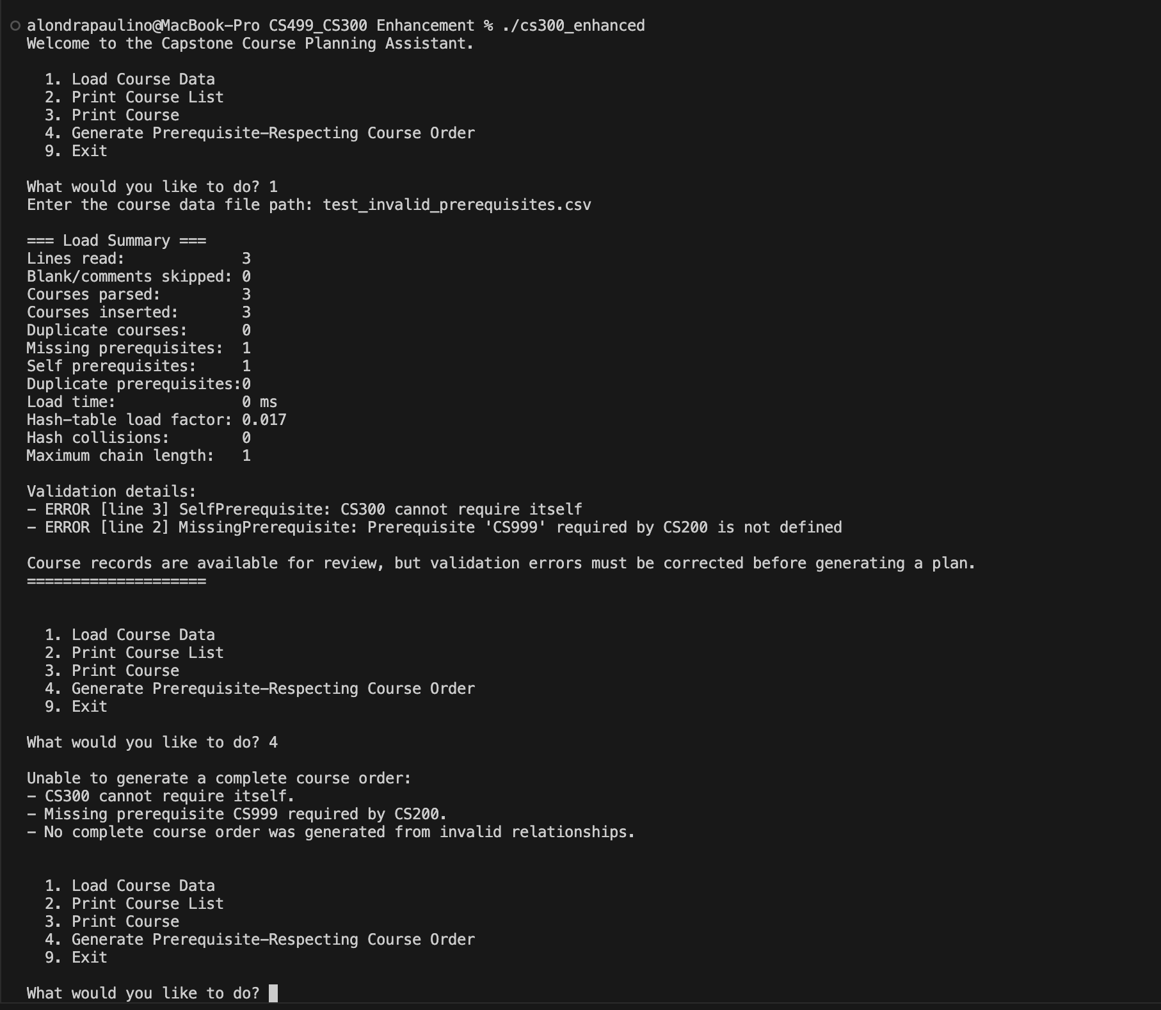
Figure 5. Missing and self-referencing prerequisite validation with generation blocked.
The loader reported the undefined CS999 prerequisite and the CS300 self-dependency, then prevented an unreliable recommendation.

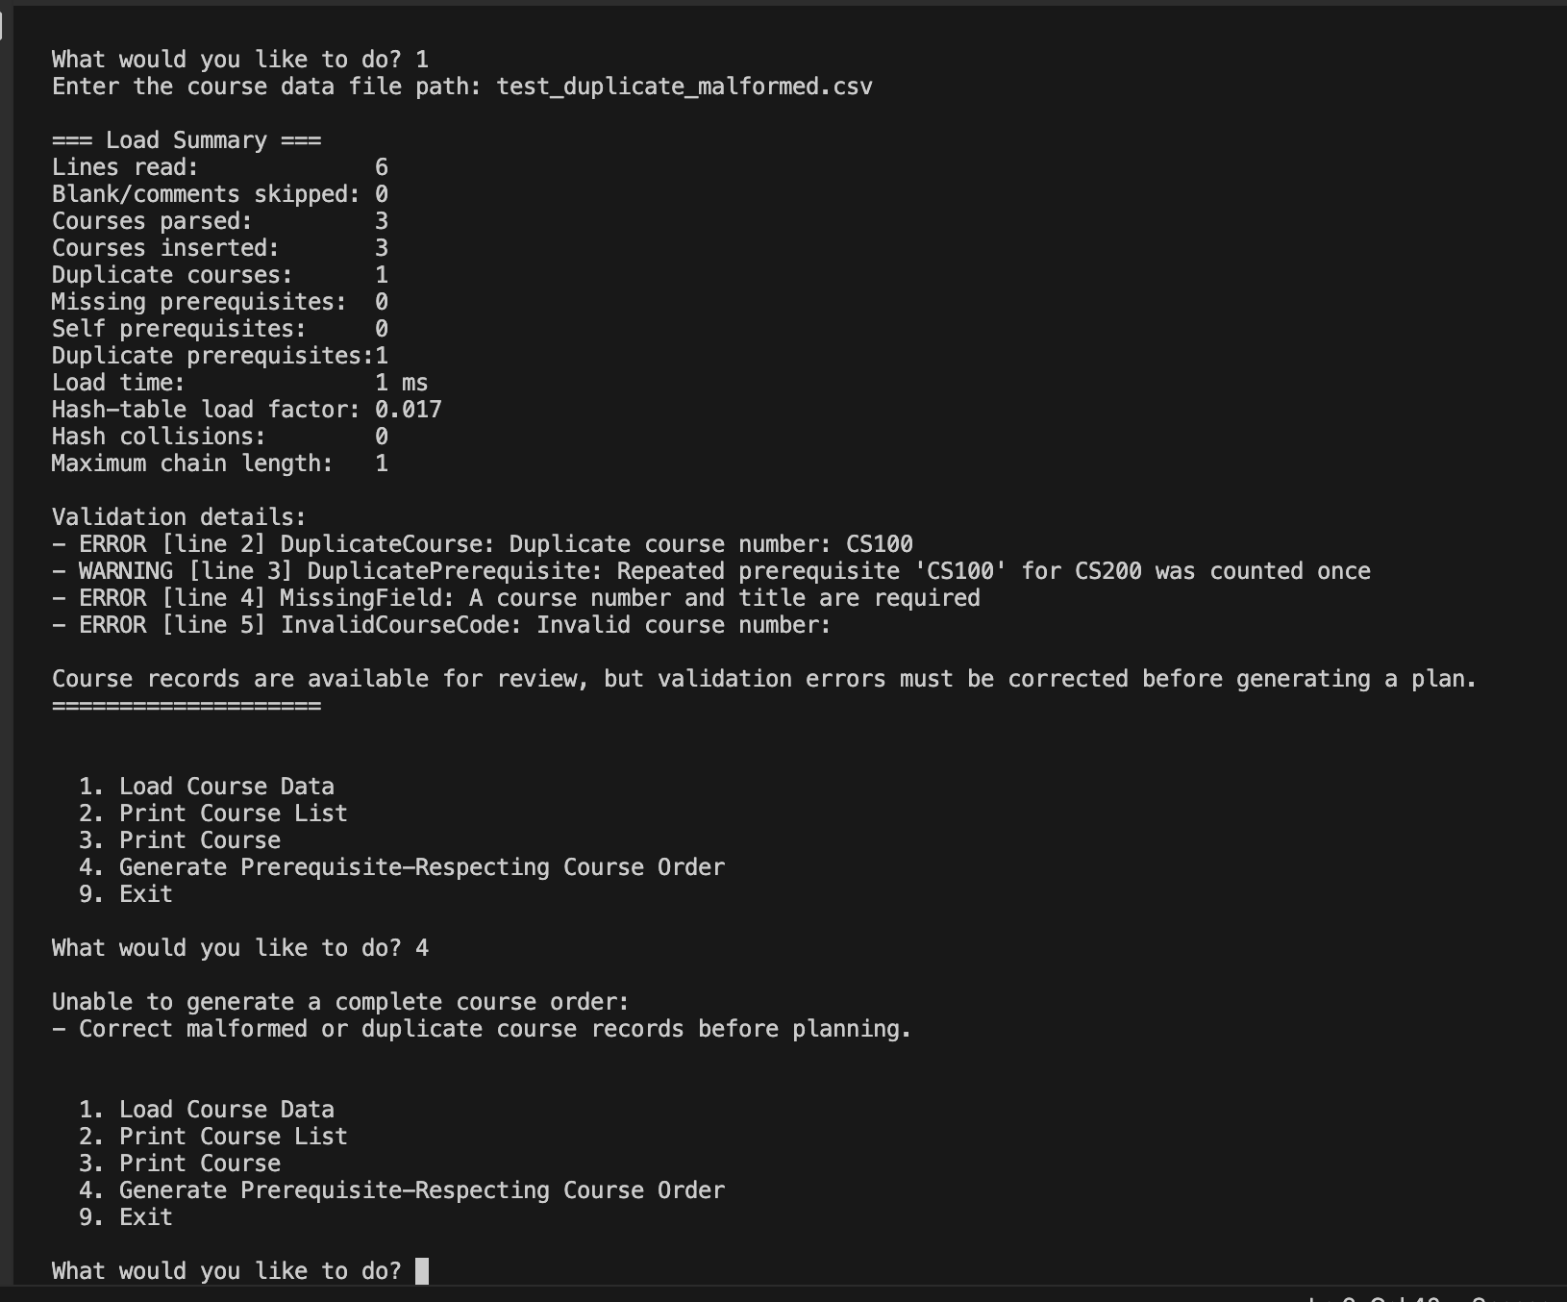
Figure 6. Duplicate and malformed record diagnostics with exact line references.
The program distinguished errors from the repeated-edge warning, identified the affected lines, and blocked planning until the data is corrected.

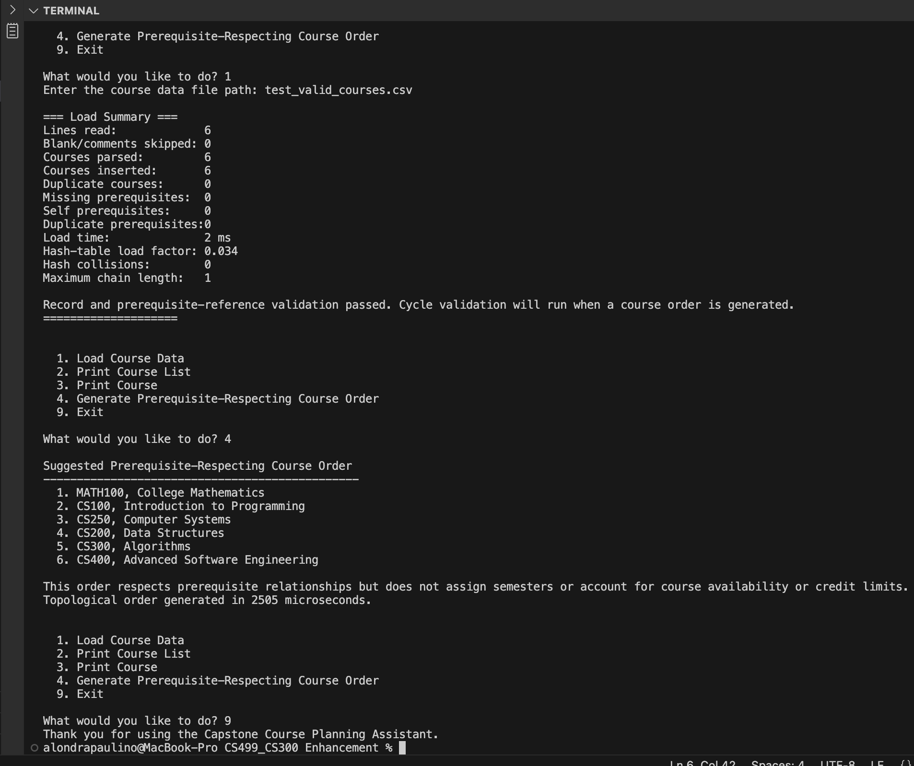
Figure 7. Sanitizer-instrumented valid run completing normally without reported runtime faults.
The program loaded valid data, generated the order, and exited normally under AddressSanitizer and UndefinedBehaviorSanitizer instrumentation.

