1.1 Competitive Advantage Analysis
Cost Leadership
Oatly has established a significant brand presence in the plant-based dairy market, operating in over 20 countries across North America, Europe, and Asia. vegclubmagazine.com
In the United States, Oatly holds a 17% market share in the plant-based milk sector, ranking second behind Almond Breeze.
evidnt.co
However, Oatly faces challenges with higher production costs compared to other plant-based dairy companies. For instance, in the UK, a liter of chilled Oatly is priced at £1.80, while a liter of cow's milk costs approximately £0.48.
Additionally, Oatly's production facilities require significant capital investment; as of 2023, the company's total property, plant, and equipment were valued at $378.4 million.
dcfmodeling.com
These higher production costs can impact Oatly's price competitiveness in the market.
Oatly has implemented strategies to optimize its supply chain and scale production. However, the company continues to face challenges with high production costs compared to traditional dairy products.
Oatly: net sales 2023 | Statista
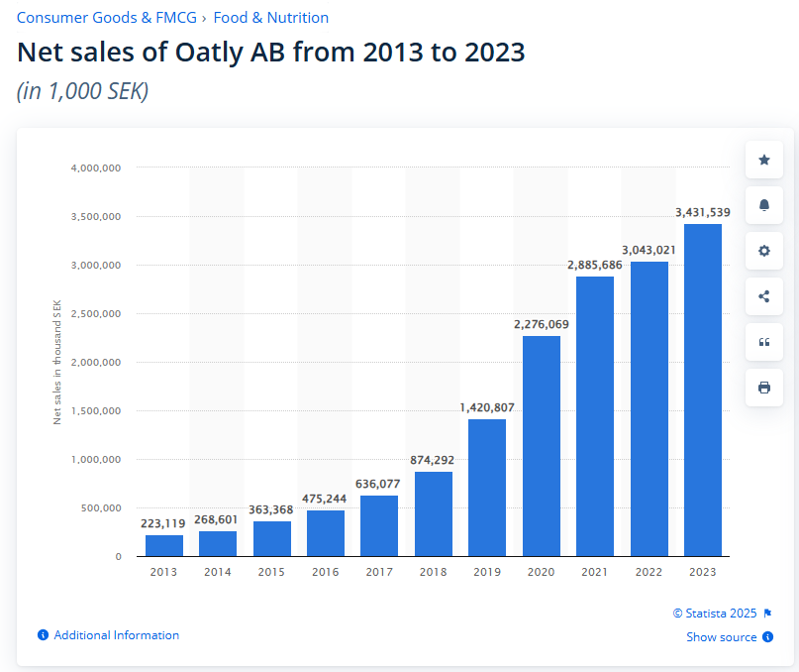
Oatly's SWOT analysis: plant-based pioneer faces growth hurdles By Investing.com
Financial Data:In 2023, Oatly reported net sales of approximately 3.4 billion Swedish kronor but incurred a net loss of around 4.8 billion Swedish kronor, indicating ongoing profitability challenges.
Overall, oatly is more costly than other dairy companies, and there is also more pressure on margins, which does not stand out in terms of cost leadership.

Differentiation
Oatly's differentiation strategy is evident through its distinctive brand positioning and innovative marketing approaches. The company employs straightforward and quirky messaging on its packaging to attract younger consumers, setting it apart from competitors.
brandvm.com
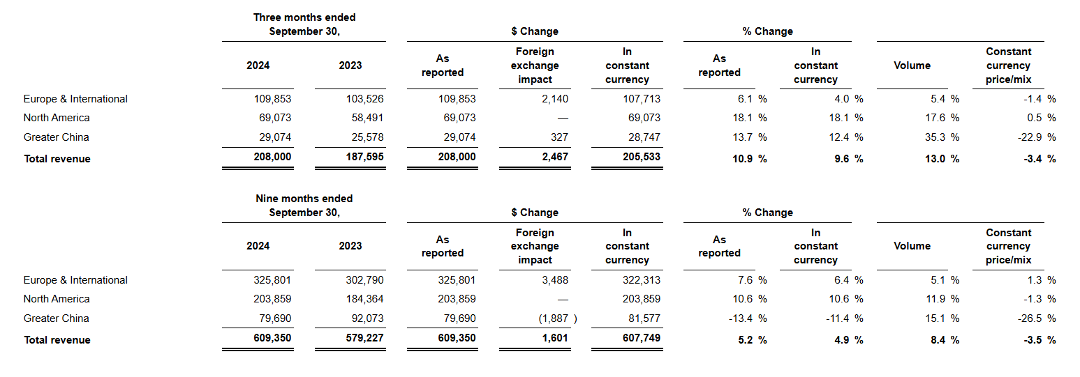
Financially, despite significant net losses, Oatly has demonstrated strong performance in key markets. In North America, the company reported revenue of $69.1 million for the third quarter of 2024, an 18.1% increase compared to the prior year period. Similarly, in Greater China, revenue increased by 13.7% to $29.1 million in the same quarter.
investors.oatly.com
These results suggest that Oatly's differentiation strategy is yielding positive outcomes in these regions.
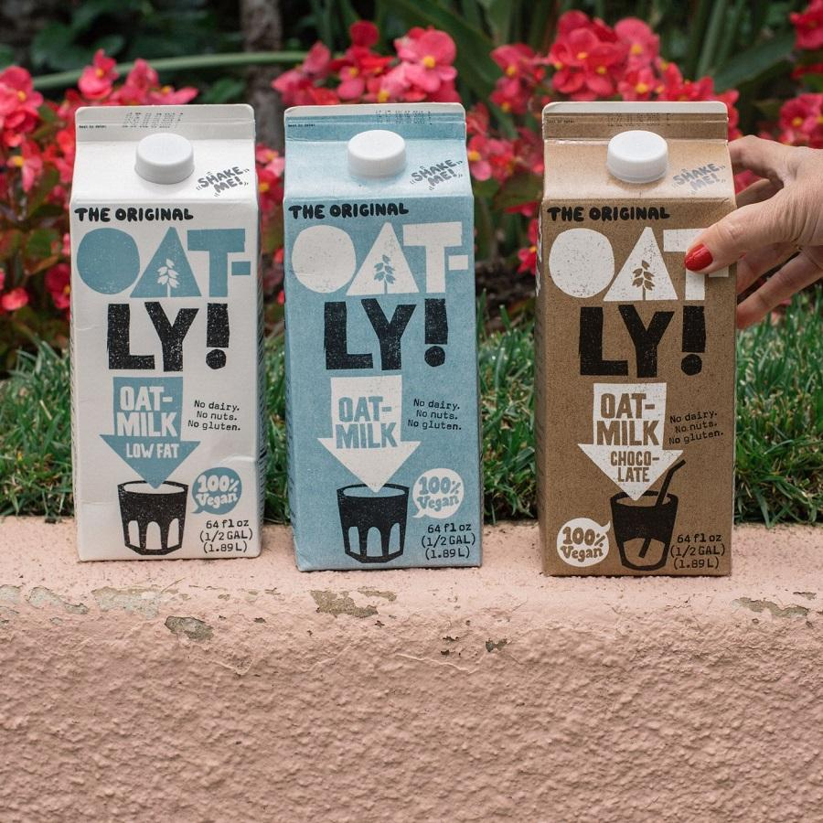

Furthermore, Oatly's modern and environmentally conscious brand image distinguishes it from traditional dairy brands, effectively appealing to health-conscious and sustainability-focused consumers. The company's commitment to sustainability is a core aspect of its brand identity, resonating with a growing segment of consumers seeking eco-friendly alternatives.
In summary, Oatly's unique brand positioning, innovative marketing strategies, and commitment to sustainability have contributed to its success in various markets, despite the challenges of higher production costs.

Sustainability Strategy
Oatly's differentiation strategy is deeply rooted in its commitment to sustainability, which resonates with environmentally conscious consumers. The company emphasizes the environmental benefits of its products through transparent carbon footprint labeling and sustainable production processes. For instance, Oatly's oat drinks have been shown to have between 44% and 80% lower climate impact compared to cow's milk, according to multiple studies.
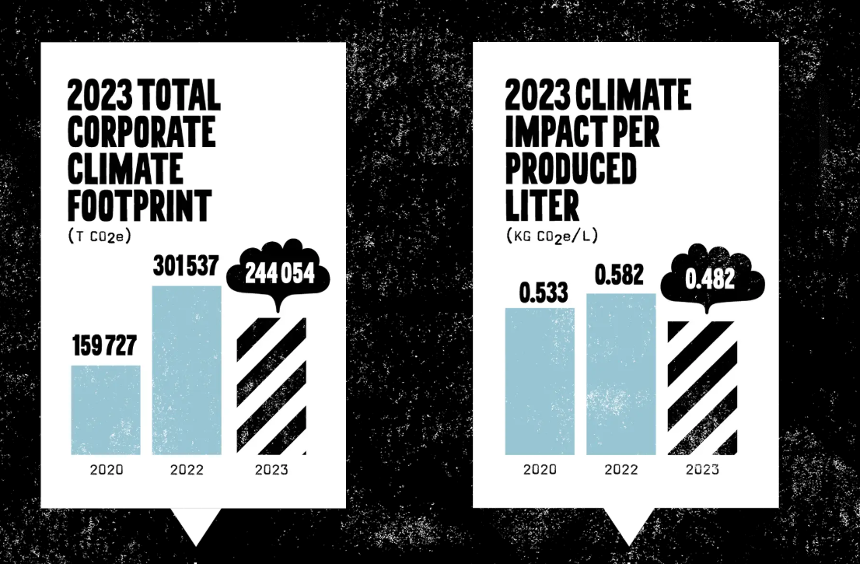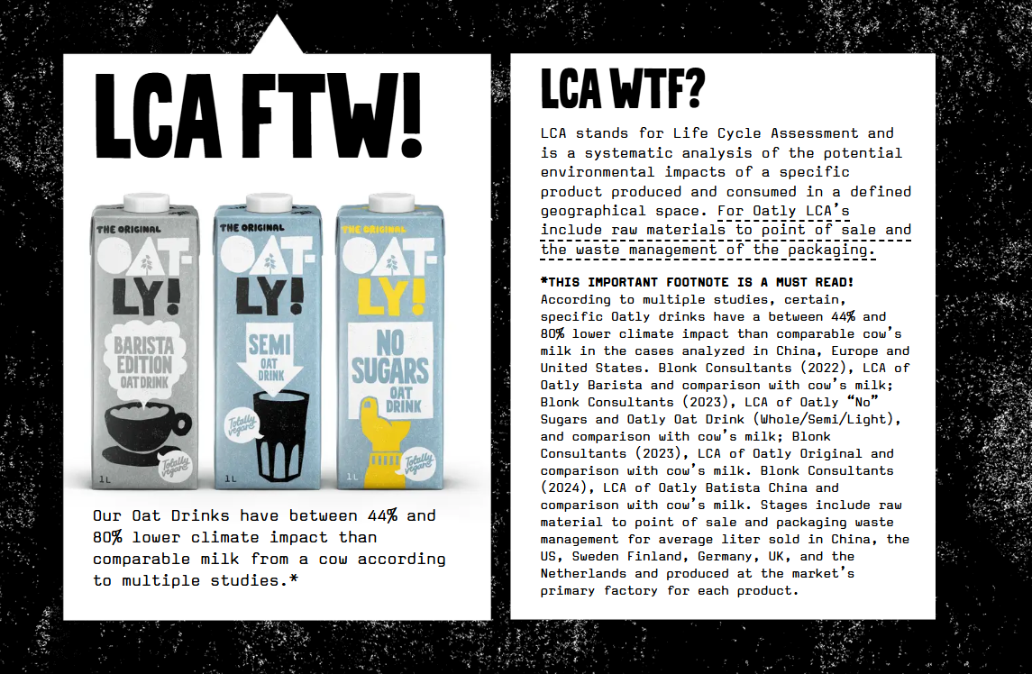
oatly.com
Financially, while Oatly's sustainability initiatives enhance its brand value, they also contribute to increased operational costs, impacting overall profitability. The company's focus on sustainable practices, such as sourcing renewable energy and implementing regenerative agriculture, requires significant investment. These efforts, while aligning with consumer values, can lead to higher production costs.
oatly.com
Within the plant-based dairy industry, Oatly's commitment to sustainability distinguishes it as a leader in environmental responsibility. The company's proactive approach to reducing its environmental footprint sets it apart from competitors and appeals to health-conscious and sustainability-focused consumers.
circularx.eu
In summary, Oatly's unique brand positioning, innovative marketing strategies, and dedication to sustainability have contributed to its success in various markets, despite the challenges of higher production costs.

1.2 Cost Analysis
Production Costs:
Oatly's use of high-quality oats and proprietary enzymatic processing enhances product quality but leads to higher production costs. As of December 31, 2024, the company reported an annual net loss of $201.95 million, highlighting challenges in managing these costs.
investors.oatly.com
Compared to other plant-based dairy producers, Oatly's production expenses are relatively high, potentially affecting its pricing strategy and market competitiveness.
a-insights.eu

Marketing costs:
Oatly has developed a global supply chain to meet increasing demand but faces efficiency challenges in certain markets. For instance, the company recently closed its Singapore manufacturing facility, opting to support the Asia-Pacific region's growth through existing European facilities. This move aims to improve cost structures and reduce future capital expenditures but may add logistical complexities to the European supply chain.
investors.oatly.com
Enhancing supply chain efficiency could help Oatly reduce operational costs. The company is shifting toward an asset-light supply chain strategy, consolidating production in European facilities to increase capacity utilization and reduce fixed costs. This approach is expected to improve gross margins and strengthen the company's path to profitability.
stocktitan.net
In contrast, some competitors in the plant-based dairy industry have achieved lower supply chain costs through localized production and sourcing strategies. By establishing production facilities closer to key markets and sourcing raw materials locally, these companies have enhanced efficiency and reduced transportation costs. For example, prioritizing clean labels and local sourcing of new products aligns with health-conscious trends and improves scale ability.
proveg.org
In summary, while Oatly's global supply chain supports its expansive market reach, addressing efficiency challenges, particularly in Europe, and considering localized production strategies could enhance its operational efficiency and cost management.

Supply Chain Efficiency:
Oatly has a global supply chain but faces efficiency challenges, particularly in Europe, due to logistical complexities. The recent closure of its Singapore facility aims to streamline operations but may add strain to European logistics. (investors.oatly.com)
Improving supply chain efficiency could help reduce costs. Oatly is shifting to an asset-light model, consolidating production in Europe to optimize capacity and lower fixed costs. (investors.oatly.com)
Some competitors achieve lower costs through localized production and sourcing strategies, reducing transportation expenses and improving efficiency. (proveg.org)

1.3 Differentiation & Brand Positioning
Product Innovation:
Oatly has diversified its product line to include oat-based items such as ice cream, yogurt, and cooking creams, catering to various consumer preferences. In 2024, the company expanded its North American beverage portfolio by introducing flavored oatmilk creamers, available in retailers nationwide.
investors.oatly.com
This product diversification has contributed to revenue growth. In 2024, Oatly reported net sales of approximately $823.67 million, up from $783.35 million in 2023.
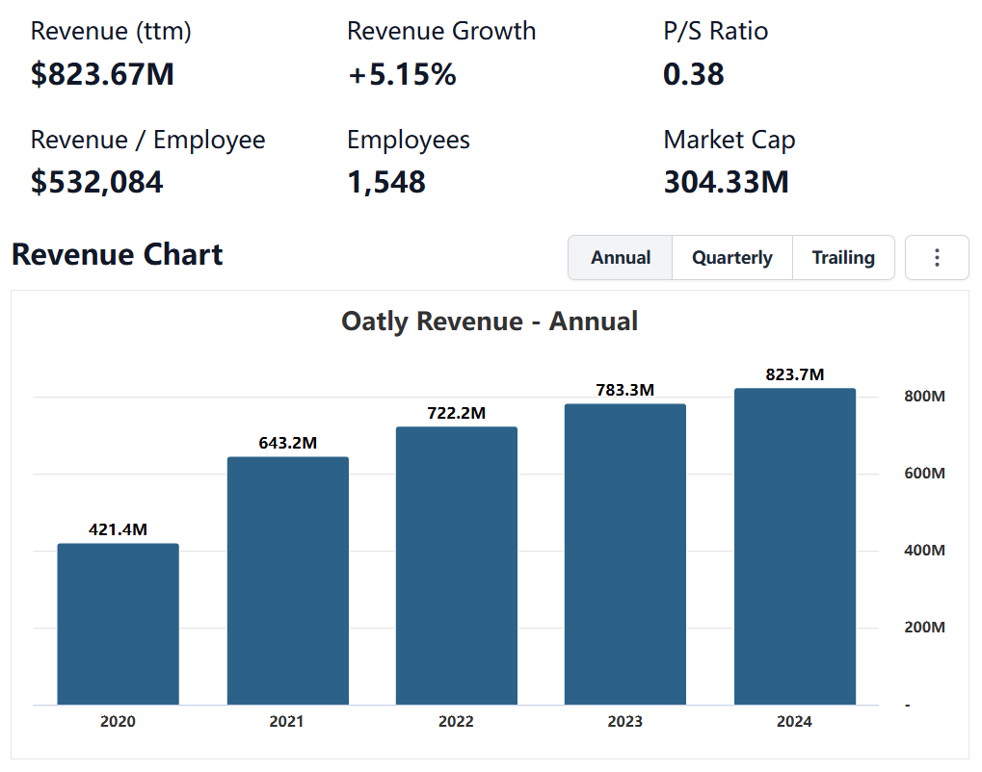
stockanalysis.com
Oatly's rapid product innovation and diverse offerings distinguish it from competitors, keeping it at the forefront of the plant-based dairy market. The company's expansion into various product categories demonstrates its commitment to meeting evolving consumer demands.

Branding & Customer Loyalty:
Oatly has successfully established a unique market presence through its distinctive brand voice, visual identity, and active consumer engagement. The company's playful and conversational tone, combined with minimalist design, makes its products easily recognizable and appealing. Oatly further fosters a loyal customer base by leveraging social media and interactive campaigns, such as the 'Je Ne Sais Quoi of the Month,' which honors individuals making positive contributions to the planet and their communities. 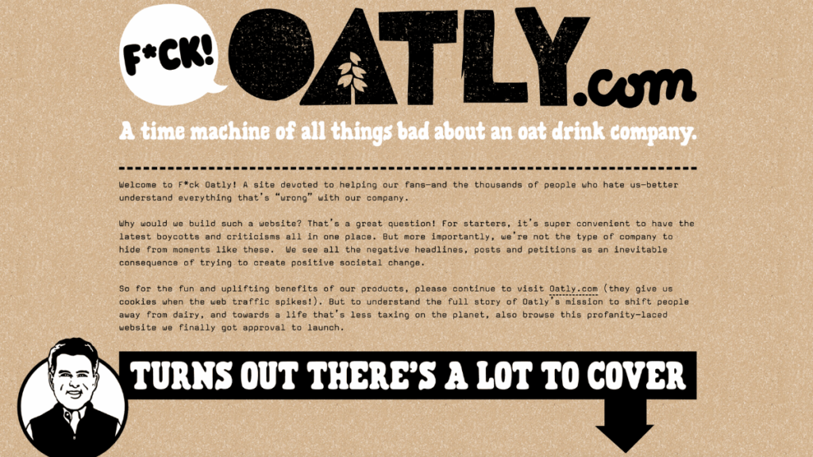
social-republic.co.uk
This strong brand positioning enables Oatly to command premium pricing, contributing to increased sales. In 2024, the company reported net sales of approximately $823.67 million, up from $783.35 million in 2023.
investors.oatly.com
Positive customer experiences and high engagement have also led to higher retention rates, reducing costs associated with acquiring new customers.
In contrast, other brands often adopt more traditional positioning, lacking the distinctive appeal that Oatly offers. Oatly's focus on building a strong brand community through innovative marketing and customer engagement sets it apart from competitors in the plant-based dairy market.

2. Corporate Strategy Analysis

2.1 Business Scope Analysis
Oatly has diversified its product offerings beyond oat milk to include items such as ice cream, yogurt, and cooking creams, catering to a wide range of consumer preferences. This strategic expansion has contributed to revenue growth, with net sales reaching approximately $214.3 million in the fourth quarter of 2024, a 5.0% increase compared to the prior year period.
investors.oatly.com
By broadening its product portfolio, Oatly has strengthened its market position relative to competitors that focus on single product lines.
Internationally, Oatly has experienced significant growth in markets like China. The company partnered with major coffee chains, including Starbucks, to increase brand presence. In 2020, Oatly entered into a partnership with Starbucks in China, significantly boosting its brand exposure.
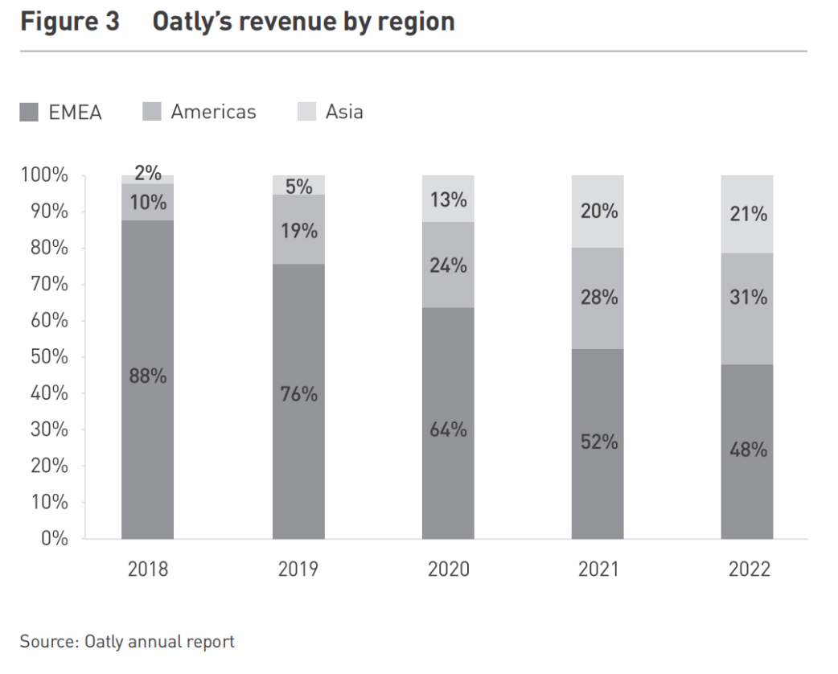
english.ckgsb.edu.cn
Additionally, Oatly collaborated with Tim Hortons to launch oat-milk coffee ready-to-drink products in China, further expanding its footprint in the market.
just-food.com
These initiatives have enhanced Oatly's brand recognition and market share in the plant-based dairy industry.

2.2 Diversification Strategy

Oatly’s Diversification Strategy

Related Diversification
Oatly has expanded beyond oat milk to include yogurts, ice creams, and cooking creams, catering to broader consumer preferences. This strategy has driven revenue growth, with net sales reaching $813 million in the last twelve months. (Investing.com)

Competitive Edge
By diversifying within the plant-based dairy sector, Oatly strengthens its market position compared to competitors focusing on a single product line, reducing dependency on a single revenue stream.

Unrelated Diversification
Oatly has maintained its focus on plant-based food and beverages, avoiding ventures into unrelated industries.

Strategic Benefit
This focus enables efficient resource allocation, strengthening brand identity and avoiding dilution seen in competitors expanding into unrelated markets.

Conclusion
Oatly’s related diversification fuels growth and strengthens its brand, while its focused approach prevents inefficiencies. This strategy positions it strongly against competitors, balancing expansion with brand integrity.

2.3 Vertical Integration
Oatly employs vertical integration strategies to enhance its market position and operational efficiency.
Backward Integration
Oatly manages its oat sourcing and processing, ensuring control over the quality and supply of its primary raw material. This approach mitigates risks associated with raw material shortages and price fluctuations, contributing to cost stability. In contrast, competitors relying on third-party suppliers may face greater variability in raw material quality and pricing.
Forward Integration
Oatly has expanded its distribution channels by partnering with coffee shops and establishing a presence in retail outlets, enhancing its market reach. Notable collaborations include partnerships with The Coffee Bean & Tea Leaf® in the U.S.
and Coffee Fellows across Europe . These alliances have driven sales growth, with the company reporting strong momentum in key markets such as North America and China. By integrating forward into distribution, Oatly gains better market visibility and customer engagement compared to competitors that rely solely on third-party distributors.
As of February 14, 2025, Oatly Group AB (OTLY) is trading at $0.505 per share, reflecting a decrease of 4.74% from the previous close.

3. Value Creation Assessment
Oatly's strategic focus on rapid market expansion has led to significant investments in production capacity and marketing to establish a global presence. Despite generating substantial revenue, the company reported an adjusted EBITDA loss of $35.3 million for the year ending December 31, 2024, an improvement from losses of $158 million in 2023 and $268 million in 2022.
worldcoffeeportal.com
This reflects the challenges of balancing growth and profitability, a common issue in the plant-based industry where companies invest heavily to capture market share.
Oatly's distinctive branding and marketing campaigns have solidified its position as a leading name in the plant-based dairy market. The company's commitment to sustainability and innovative product offerings have fostered strong brand recognition, enabling premium pricing and customer loyalty, which contribute to sustained revenue growth.
brandvm.com
This brand strength provides a competitive edge over less recognizable plant-based dairy brands.
Oatly's emphasis on sustainability and continuous product innovation positions it favorably for long-term success. The company's oat drinks have a 44% to 80% lower climate impact compared to cow's milk, according to multiple studies.
oatly.com
Investments in sustainable practices and new product development are expected to yield long-term returns, despite short-term costs. Companies prioritizing sustainability and innovation are better positioned to meet evolving consumer preferences and regulatory standards.
As of February 14, 2025, Oatly Group AB (OTLY) is trading at $0.502 per share, reflecting a decrease of 5.3% from the previous close.

Final Recommendations for Oatly

Business Strategy Improvement
- Optimize Cost Structure – Improve supply chain efficiency and automate production to reduce operational costs and enhance profitability.
- Enhance Digital Marketing – Shift from high-cost campaigns to more cost-effective influencer-based and social media-driven marketing strategies.
- Invest in Product Innovation – Strengthen technological advancements in oat processing and product development to maintain a competitive edge.

Corporate Strategy Improvement
- Expand Strategically – Prioritize high-growth markets such as Asia and focus on high-margin products to maximize revenue potential.
- Strengthen Vertical Integration – Secure oat supply through partnerships or direct sourcing to stabilize raw material costs and reduce dependency on external suppliers.
- Improve Sustainability Practices – Increase transparency in sustainability efforts and reinforce Oatly’s eco-friendly brand positioning to appeal to environmentally conscious consumers.
By implementing these strategies, Oatly can enhance profitability, strengthen market presence, and ensure long-term competitive success in the plant-based dairy industry.

Plant-Based Milk Market Size, Growth Statistics 2030
Oatly Reports Third Quarter 2024 Financial Results | Oatly Group AB
Oatly Reports Fourth Quarter and Full Year 2023 Financial Results | Oatly Group AB
Plant-based Milk Market Size, Share & Growth Report, 2030
Plant-based Dairy Market Size, Growth & Forecast to 2034

