# Rafting Site Planning Document

## Website Purpose

The purpose of this website is to promote rafting as a fun and unique experience for families, teams, and special occasions. It encourages visitors to step out of their routine, explore the outdoors, and create lasting memories.

## Target Audience

The target audience for this website includes:  
- Families looking for fun and safe activities for all ages.  
- Groups of friends seeking exciting outdoor adventures.  
- Corporate teams interested in outdoor team-building experiences.  
  
Scenario questions:  
- Are they looking for a beginner-friendly rafting trip or a more extreme adventure?  
- Do they want to make a weekend trip or just a single-day experience?  
- Are they looking for family-friendly options with safety as a priority?  
- Detailed descriptions of what to expect during the trip?

## Logo

Logo selected: (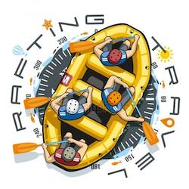)

## Color Palette

primary-color: #9EBACE  
secondary-color: #476278  
accent1-color: #FFFFFF  
accent2-color: #4B5354

Color Palette URL: https://coolors.co/9ebace-476278-ffffff-4b5354

## Typography

heading-font: Inter Semi Bold  
subheading-font: Inter Medium  
text-font: Inter Regular  
title-font: Inter Bold