**密碼工程Quiz2**

**Problem-1**

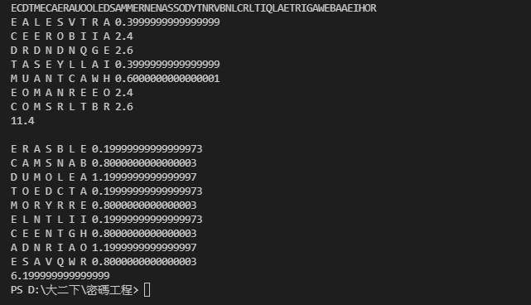From the result, we can easily find that the sum of the difference of dimension 7x9 is 11.4, and the sum of the difference of dimension 9x7 is approximately 6.2. So, we consider that the 9x7 rectangle is more likely.

**Problem-2**

LASERBE

AMSCANB

EMODULA

TEDTDCA

RRYMORE

INTELLI

BENCETH

ANRADIO

WAVESRR

**Problem-3**

IOC in Message1 is approximately 0.064.

IOC in Message2 is approximately 0.067.

IOC in Message3 is approximately 0.049.

IOC in Message4 is approximately 0.064.



**Problem-4**

Using the analysis of index of coincidence, this message has the IOC approximately 0.04. As we know the IOC of English is about 0.066. So, we can have the conclusion that this message is used polyalphabetic cipher.

Because if this message is used monoalphabetic cipher, the IOC of the cipher text would also approximately at 0.066.