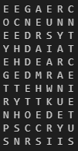**Quiz4**

At first, I using the method we have used in the Quiz2 to find the size of the rectangle with approximately 40% of plaintext consists of vowels in each row.

And the result of the size of rectangle is 11x7.

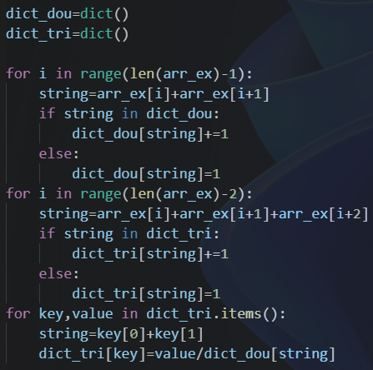

Then I create two dictionaries to store two characters and three characters in the training message. And divide the value of three characters by the value of two characters. For example, the value of ‘GRE’ is 3 and the value of ‘GR’ is 5. The result of this case is 0.6.

After that I calculate the value each combination in each row, and find the biggest value to determine the correct plaintext.

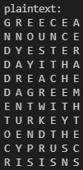

(The plaintext)