**Quiz-5**

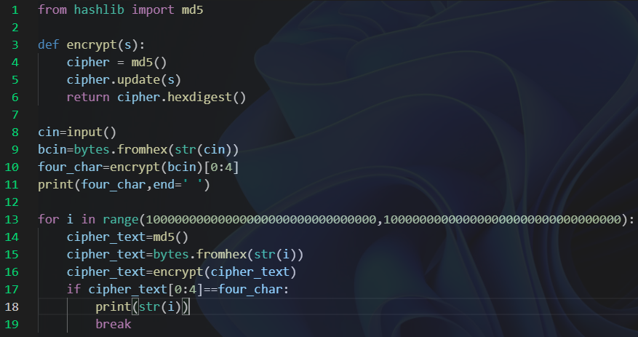 At first, I defined a function as “encrypt” with using MD5. Then, I transformed the input from “string” into “byte”, and printed the 4 MSB.

To find the string that 4 MSB was equal to the printed 4 MSB, I used a “for” loop to find the value. If the 4 MSB of the cipher text was as same as the 4 MSB before, we find the plaintext which was we wanted.

 Using the example, the 4 MSB of the example plaintext is “9cc7”. And with using the program, we could find “100000000000000000000000000078229” is also the plaintext that could be encrypted as “9cc7xxxxxxxxxxxxxxxxxxxxxxxxxxx”.