DwayaTech

Application for medicament products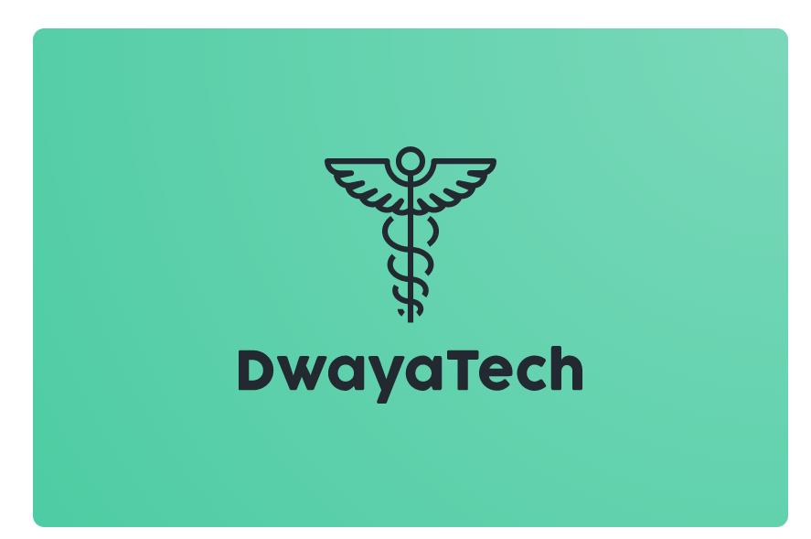

**Touré Alousseyni**

05.06.2022

4TH year ENTTIC

Table Of Contents

GENERAL INTRODUCTION

PRESENTATION OF THE APPLICATION

I. GENERAL INTRODUCTION

1. Problématique ...........................................................................3

2. Besoin d’une technologie .........................................................................3

3. Project presentation……........................................................................4

II. STRATEGIC ANALYSIS

1. The goal of the company............................................................3

2. SWOT Analysis.........................................................................3

3. Diagnostic ……...........................................4

4. Financial overview ……...........................................4

5. Business plan ………………………………….5

III. APPLICATION OVERVIEW

1. Application structure (Frontend & backend) ......................3

2. Usage and Collaboration rules……………………………4

3. How the model or algorithm works in the background……………………........6

IV. Development perspectives

1. Increasing the performance of the application..............................................7

2. Premium version.............................................................8

3. others ............................................................................9

V. CONCLUSION

1. *GENERAL INTRODUCTION*

# *PROBLEMATIC*

The Algerian market is young especially in the technical sector and the need for digital solutions becomes a matter of time. The distribution of medical products in the country happens without being tracked and finding the right drug seems to be impossible online; the search for those products happens only by the traditional way.

# *The need of the technology*

1. Online market is taking over the traditional one which creates the urge of making all the services that are already in the physical market to be available in the digital one as well.
2. The difficulty of finding a specific medicament in some cases
3. Easier segmentation of the targeted consumers.

# *PRESENTATION OF THE PROJECT*

Our project is an application, which gathers the pharmacist's information around the local area; to make the search of each and any medication easier than ever before.

The project was founded by **Touré Alousseyni.**

# 

*II*. *Strategic analysis*

# *The main purpose*

The vision behind this project is to ensure the availability of medicines that patients urgently need and wherever they can be found through using automatic solutions.

*SWOT analysis*

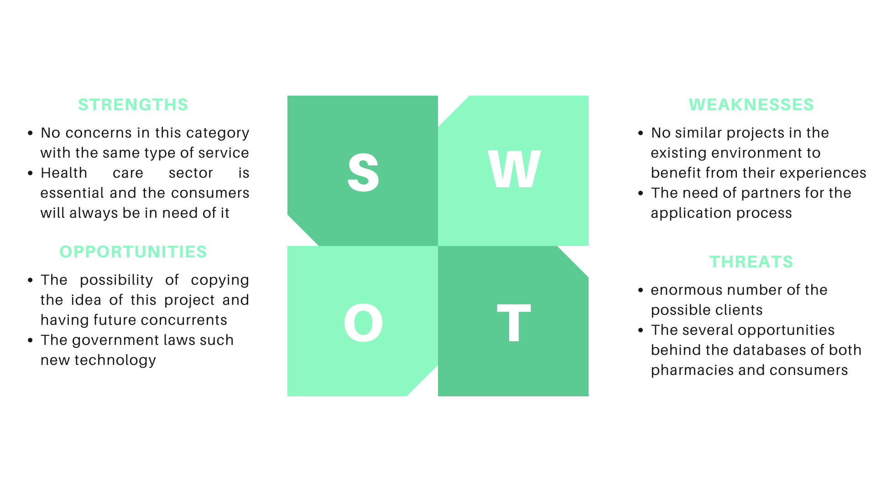

*Diagnostic*

Micro-environment:

Suppliers and distributors: pharmacies and drugs Manufacture

Paramedical products companies Competitors pharmacies

Macro-environment

The legal situation of the project

The technological environment (social media & websites ads)

Socio-cultural image of the company

*Financial overview*

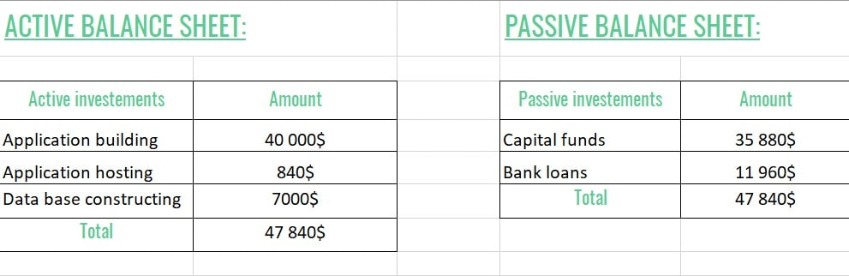

*The business model & business plan*

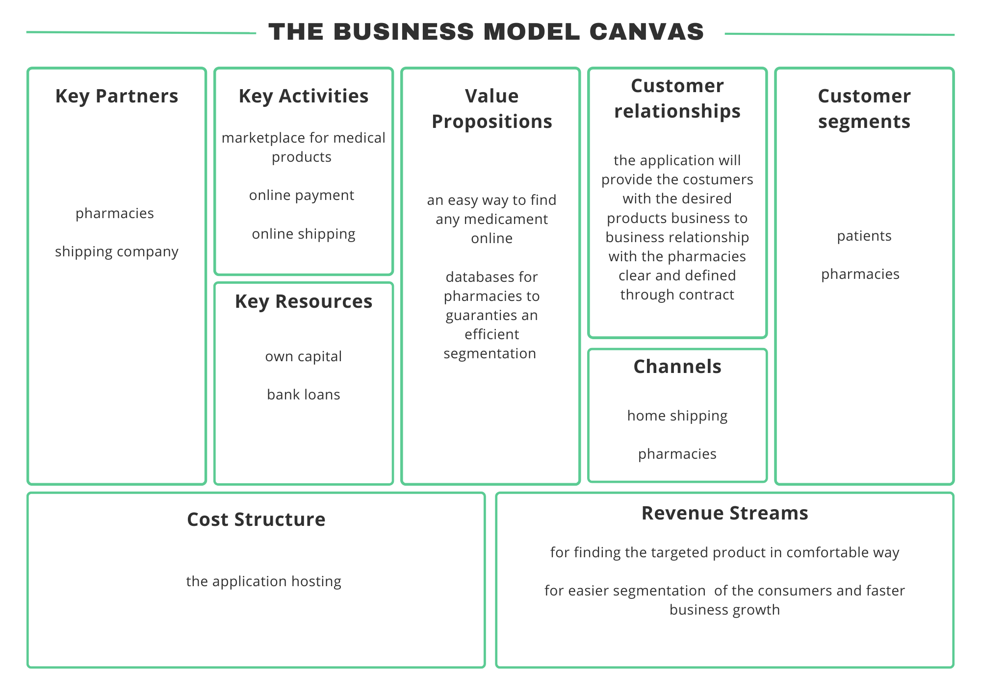

*Business Plan*

Our business plan will be mainly based on 3 main parts:

* This part answers the questions of how we will finance the project

At first, we have in mind that with the idea that we have, that is based not only with its huge revenues but also an aid that will be able to innovate the health sector by grouping them into a single organization with the same goals. Banks won't think twice after hearing about this new strategy for investing

* It is true that any project at the start has issues, but in our case the only and

A fundamental one is the lack of investment and the geolocation of certain pharmacies located in areas beyond our reach, areas with no connection and the fact that they cannot use our application for their needs being given so this problem must be managed by the state or the telephone operator.

* The income of this project will be mainly from:

the pharmacies that will be partners with the application and pay specific percentage for each successful sell operation that made by the consumers through the application Monthly rent for the pharmacies that are visible in the application

Advertisement section in the application homepage and the strategy that your pharmacy appears on the top of suggestion while searching for drugs

From all those income sources we will be sure of one thing that the profitability of our project is assured.

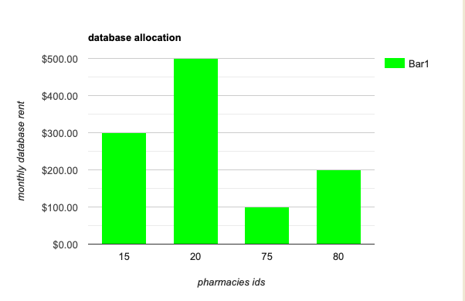

*III.* *Application overview*

*Application structure*

*The application which we want to develop consists of 2 main parts with different modules in each part:* frontend and backend

***Frontend part:*** is the user interface where the user will provide its needed request

***Backend part:*** *this part is the abstract part to the user this part includes:*

*• Safety and maintenance tasks*

*• The management of the products of the different users*

*A dashboard will be submitted to each pharmacy with an appropriate access right so that they can update, add and delete their products.*

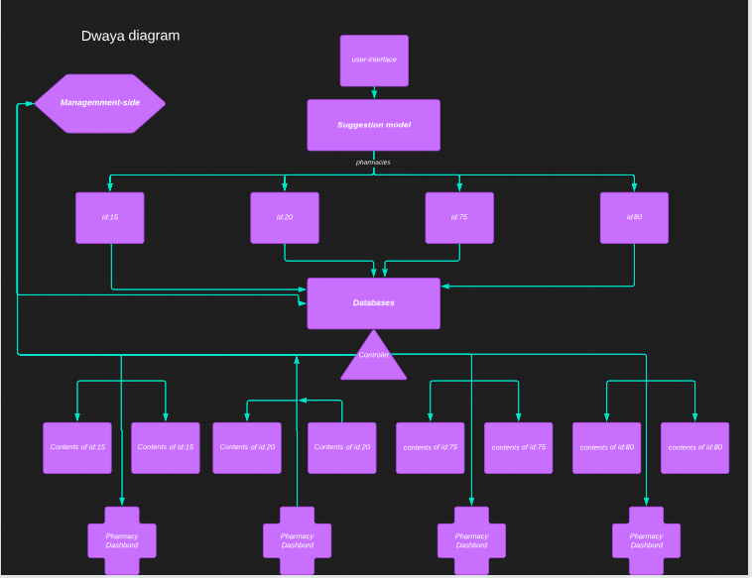

*Application usage and collaboration rules*

*In the way to use the app you may need to download the application in the Appstore, after downloading access to the user interface which is designed in such a way that even a novice can use it. Then access the form section to fill out the form with the required information and submit.*

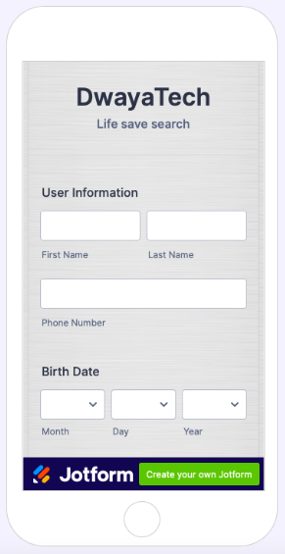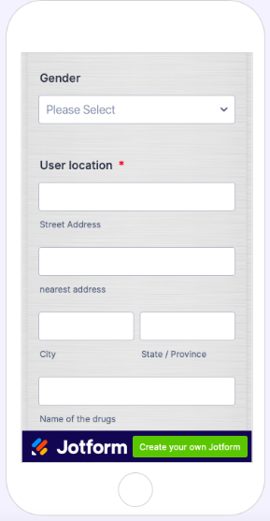

***Collaboration rules***

*The collaboration rules do not envisage collaboration within the framework of a new company to be created or societal relations, but rather collaboration according to situations and projects with common goals. Other collaborations are also due to the difficulties linked to the crisis, which have had the effect of pushing leaders to think about the possibility of building partnerships, collaborations or even business combinations in order to be stronger and more sustainable together. These collaborative processes often aim to increase the share of added value by offering broader and in line with the expectations of their customers. However, it is true that our application is really dependent on the different pharmaceutical companies. We can say that collaboration is the second oxygen of our project, but this doesn’t make it open to any pharmacy without the slightest constraint or privilege for reasons of security and privacy policy of different pharmacies. These rules of collaboration dictate to the different pharmacists how to integrate this new technology as well as to digitize their economic strategy. In order to integrate the collaboration of our application a contract must be signed which constitutes adequate proof in the event of an inconvenience problem.*

***The performance of our suggestion model***

*Due to the multiple areas, the pharmacy, the number of drugs and each area having its own pharmacies we may need a classification model which will classify our product as a cluster based on the area. The particularity of our model is that it is trained on real data and specific to the specific area. This allows him to boost his speed in terms of searching and filtering in the database in order to suggest the pharmacy containing the nearest drug.*

*IV.* *Development perspectives*

*For the development we plan to create a more sophisticated version, that is to say a premium version which in addition to locating the store containing the drugs. We deduce from its suggestions of the most suitable medicine, by fixing appointments with doctors and also increasing the capacity to search, that is to say offering him closer shops even if they are outside our area. Through automated learning of data from different years (past and present) we go as far as offered to our shops(pharmacy) to buy such medicine through diseases that are the most common over the years. The goal is to design a really smart model. Likely to solve this problem which is the cause of loss of human life.*

*V. Conclusion*

*Our efforts are aimed at the satisfaction of our customers, who are not only provided with assistance in finding what they are looking for, but also with resource optimization and can go so far as to save lives by providing them what they are looking for more quickly and effectively.*