Answers to questions in

Lab 1: Filtering operations

Name: __________Adel Bavey____ Program: Cdate5

Instructions: Complete the lab according to the instructions in the notes and respond to the questions stated below. Keep the answers short and focus on what is essential. Illustrate with figures only when explicitly requested.

Good luck!

___________________________________________________________________________

Question 1: Repeat this exercise with the coordinates p and q set to (5, 9), (9, 5), (17, 9),
(17, 121), (5, 1) and (125, 1) respectively. What do you observe?

Answers:

A higher value in the fourier space leads to a higher frequency for the respective wave in the image space.

Question 2: Explain how a position (p, q) in the Fourier domain will be projected as a sine wave in the spatial domain. Illustrate with a Matlab figure.

Answers:
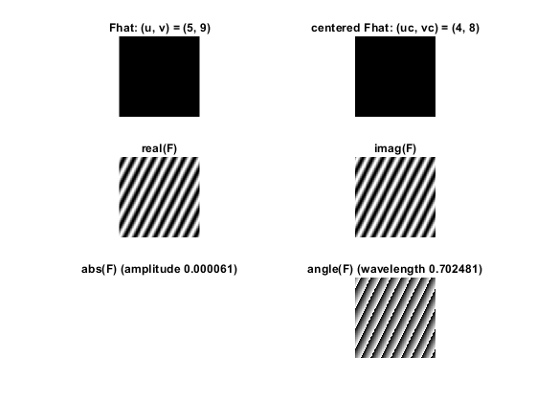
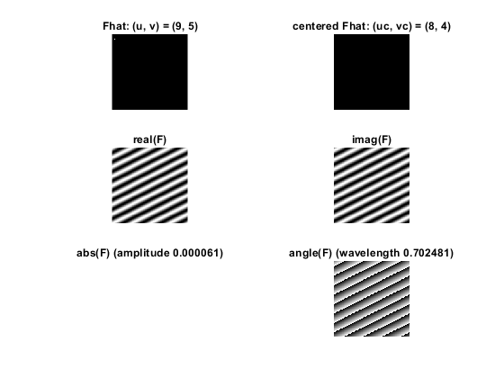
A higher p (in relation to the origin) value results in a higher frequency in the vertical axis in the projected sine wave, and a higher q (in relation to the origin) value results in the same for the horizontal axis.

Question 3: How large is the amplitude? Write down the expression derived from Equation (4) in the notes. Complement the code (variable amplitude) accordingly.

Answers:
a = (2*pi*i*u^T*x)/N
F(x) = (1/n)Fhat(u)e^(2*pi*i*u^T*x)/N=1/n*(cos(a)+isin(a)) => 1/n is the amplitude (given only one point is non-zero).

Since Matlab uses 1/N^2 during the inverse fourier transform, the amplitude we get in the code is 1/N^2.

Question 4: How does the direction and length of the sine wave depend on p and q? Write down the explicit expression that can be found in the lecture notes. Complement the code (variable wavelength) accordingly.

Answers:

frequency = (p,q)/2pi
wavelength = 2pi/sqrt(p^2+q^2)

The sine wave follows the direction of (p,q), whereas the white lines appearing in the image are orthogonal to (p,q). The size of the wavelength is inversely proportional to the square root of the sum of the squared p and squared q.

Question 5: What happens when we pass the point in the center and either p or q exceeds half the image size? Explain and illustrate graphically with Matlab!

Answers:

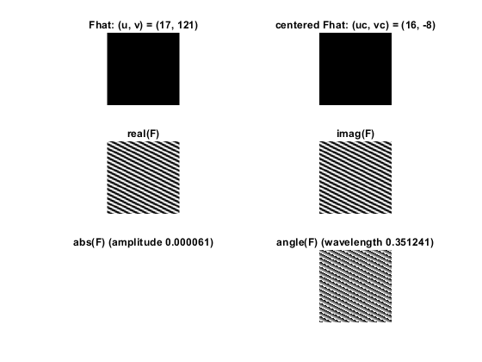
When one of the variables passes the center, the size of the image is subtracted. This is to keep the variables within [-size/2,size/2], which is centered on origo.

Question 6: What is the purpose of the instructions following the question What is done by these instructions? in the code?

Answers:

Answered in Q.5.

Question 7: Why are these Fourier spectra concentrated to the borders of the images? Can you give a mathematical interpretation? Hint: think of the frequencies in the source image and consider the resulting image as a Fourier transform applied to a 2D function. It might be easier to analyze each dimension separately!

Answers:

___________________________________________________________________________

Question 8: Why is the logarithm function applied?

Answers:

The logarithm “pushes down” high values so the entire spectrum is more easily observable.

Question 9: What conclusions can be drawn regarding linearity? From your observations can you derive a mathematical expression in the general case?

Answers:

FT(F+G) = FT(F)+FT(G)

Question 10: Are there any other ways to compute the last image? Remember what multiplication in Fourier domain equals to in the spatial domain! Perform these alternative computations in practice.

Answers:

___________________________________________________________________________

Question 11: What conclusions can be drawn from comparing the results with those in the previous exercise? See how the source images have changed and analyze the effects of scaling.

Answers:

___________________________________________________________________________

Question 12: What can be said about possible similarities and differences? Hint: think of the frequencies and how they are affected by the rotation.

Answers:

Rotation in the spatial dimension means the same rotation in the frequency dimension.

Question 13: What information is contained in the phase and in the magnitude of the Fourier transform?

Answers:

___________________________________________________________________________

Question 14: Show the impulse response and variance for the above-mentioned t-values. What are the variances of your discretized Gaussian kernel for t = 0.1, 0.3, 1.0, 10.0 and
100.0?

Answers:

___________________________________________________________________________

Question 15: Are the results different from or similar to the estimated variance? How does the result correspond to the ideal continuous case? Lead: think of the relation between spatial and Fourier domains for different values of t.

Answers:

___________________________________________________________________________

Question 16: Convolve a couple of images with Gaussian functions of different variances (like t = 1.0, 4.0, 16.0, 64.0 and 256.0) and present your results. What effects can you observe?

Answers:

___________________________________________________________________________

Question 17: What are the positive and negative effects for each type of filter? Describe what you observe and name the effects that you recognize. How do the results depend on the filter parameters? Illustrate with Matlab figure(s).

Answers:

___________________________________________________________________________

Question 18: What conclusions can you draw from comparing the results of the respective methods?

Answers:

___________________________________________________________________________

Question 19: What effects do you observe when subsampling the original image and the smoothed variants? Illustrate both filters with the best results found for iteration i = 4.

Answers:

___________________________________________________________________________

Question 20: What conclusions can you draw regarding the effects of smoothing when combined with subsampling? Hint: think in terms of frequencies and side effects.

Answers:

___________________________________________________________________________

