**Purpose**

* To consolidate my learning thus far on languages, frameworks and libraries including HTML/CSS/Bootstrap5/JavaScript/jQuery/Node.js/Express.js as well as APIs.
* To strengthen google search term skills, read documentation, and browse stack overflow for when I encounter problems/looking for insight on ideas during the development process.
* To create a full stack website from scratch and learn/experience the process

**Goal**

* To learn about core principles of web design such as UI/UX, typography, and color theory. ✅
* Have a back-end server ✅
* Use a simple API to demonstrate front/back-end connection ✅
* Connect the front- and back-end and ✅
* Deploy on Heroku (learning about PaaS/intro to cloud development). ✅

**The Process**

**APIs**

* Wanted this project to focus on introduction to back-end
* Looked into public APIs on GitHub and saw the kinds of data some APIs would bring
* Chose APIs that generated quotes e.g. Kanye REST seemed fun
* Postman – how to check/build/use into APIs
  + API keys

**Design Research**

* After deciding I wanted to build my website around quotes generated by APIs
* Wanted to keep it simple/extend my ability but not overextend
* Websites that helped inspire:
  + Awwwards, collectui.com, dribbble, css-tricks
* Chose low-fidelity wireframe (i.e. pen and paper), but became aware of how important UI/UX designers and high-fidelity wireframes can be in web development/team-based environment
  + Got stuck on how I wanted to demonstrate my skills while making an appealing website

**Font Color**

Color palette - <https://colorhunt.co/palette/53bf9df94c66bd4291ffc54d>

* Wanted to match anime images by @helloclonion, came across the artwork and was very interested/matched the API theme

**Font Typing**

Merriweather – wanted to choose a serif-type font for headings/titles (‘old’, ‘serious’, ‘authoritative’, like quotes) while…

Montserrat – … contrasting with a sans-serif for body/footers for more humanist type-face

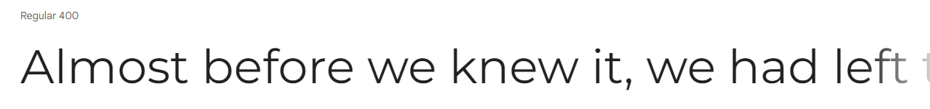

**What did I learn?**

* Planning needed for web design/development
* Strengthened HTML/CSS/Bootstrap5/JavaScript/jQuery/Node.js/Express.js
  + In particular, Node/Exprses.js connecting front/back-ends, template engines, CSS animations, jQuery HTTP requests
* Strengthened documentation reading/searching on the internet
* Git/GitHub/Heroku, version control/branching/forking