# CHAPTER 1

# INTRODUCTION

# 1.1 WIRELESS SENSOR NETWORKS

In WSN, sensor nodes are deployed to operate autonomously in remote environments. Depending on the network orientation, WSN can be of two types: flat network and hierarchical or cluster-based network. Various advantages of cluster-based WSN are energy efficiency, better network communication, efficient topology management, minimized delay, and so forth. Consequently, clustering has become a key research area in WSN. Different approaches for WSN, using cluster concepts, have been proposed. At the same time, security analytics based on big data also receive great attention from both academic and industry. In general, higher device densities result in more connections among user devices. This has recently begun to interest researchers for employing big data generated from various levels of wireless networks with dense devices to support both physical layer transmission and network optimization. These researchers believe that potential connections within wireless networks can be extracted from big data to help manage resources and enhance user cooperation to achieve higher utilization of wireless resources. A scheme of big-data- driven clustering, through which bandwidth can be efficiently allocated and used will have improvement in user quality of experience achieved by integrating big data analytics with network optimization.

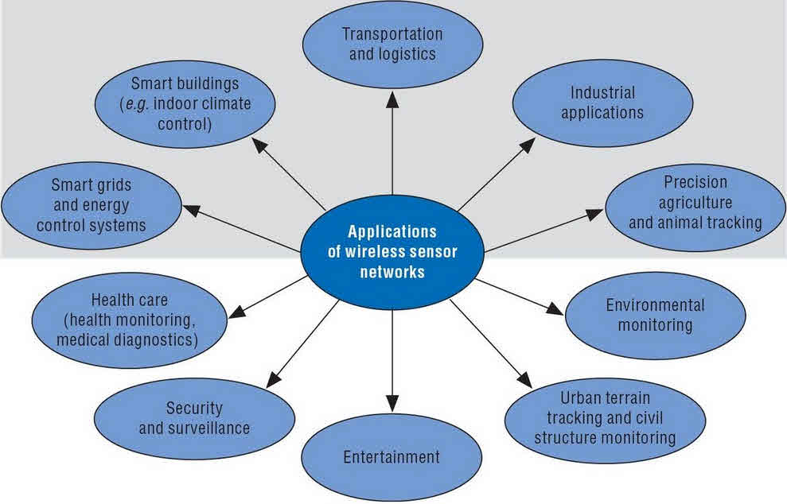

**1.1.1 Wireless Sensor Networks**

# 1.2 SYSTEM OVERVIEW

A Clustering based Energy Efficient and Reliable Routing Protocol is used to form data clusters. Clustering is the grouping of a particular set of objects based on their characteristics, aggregating them according to their similarities. It can prevent the problem of data duplication by the sensor nodes. Clustering algorithms have gained more importance, in increasing the life time of the WSN, because of their approach in cluster head selection and data aggregation. A clustering based Honey Bee algorithm is used to transfer data from nodes to base station. Here the Cluster Head is present near the base station which transfers data packets without energy loss. Hence the throughput of the proposed system has been improved.

* 1. **SCOPE OF THE PROJECT**

The main goal is to minimize the energy consumption and maximize the network lifetime in Wireless Sensor Networks. CH selection Algorithm named Honey Bee is used for minimizing the secrecy loss. Queuing Model Analysis is used for transferring data packets between nodes. With the help of Average queue length and Average waiting time, average transmission delay of the packet can be calculated.

# CHAPTER 2

# LITERATURE SURVEY

**[1] Shuai Han, SaiXu, WeixiaoMeng, and Cheng Li “Dense-Device-Enabled Cooperative Networks for Efficient and Secured Transmission”, 2018.**

Considering various challenges and opportunities, attempts to enhance user cooperation utilizing big data generated from wireless networks toward achieving efficient and secure transmission has been proposed. Big data is viewed as a resource or tool, is employed to find potential connections among user devices, being followed by user cluster formation. Preliminary results demonstrated that big-data-driven user cooperation facilitates the utilization of wireless resources and reduces the secrecy loss originating from high device densities. A network model of big-data-driven user cooperation, which can utilize wireless resources efficiently while reducing secrecy loss was implemented. Two cases for evaluating the performance of the proposed strategy were discussed, in which user cooperation based on big data is applied to improve the utilization of wireless resources and transmission confidentiality.

**[2] SadiaDin, AwaisAhmad, Anand Paul “A Cluster-Based Data Fusion Technique to Analyze Big Data in Wireless Multi-Sensor System”, 2017.**

The multi-sensors are integrated in a way that produces an overwhelming amount of data, termed as big data. The multi-sensor system created several challenges, which include getting actual information from big data with high accuracy, increasing processing efficiency, reducing power consumption, providing a reliable route toward destination using minimum bandwidth. Such shortcomings are implemented by exploiting some novel techniques, such as clustering, data fusion, and coding schemes. Data fusion and clustering techniques are proven architectures that are used for efficient data processing; resultant data have less uncertainty, providing energy-aware routing protocols. Because of the limited resources of the multi-sensor system, it was a challenging task to reduce the energy consumption to survive a network for a longer period. It presented a novel technique by using a hybrid algorithm for clustering and cluster member selection in the wireless multi-sensor system. After the selection of cluster heads and member nodes, the data fusion technique had been used for partitioning and processing the data. It efficiently reduced the blind broadcast messages but also decreased the signal overhead as the result of cluster formation. The routing technique was provided based on the layered architecture. The layered architecture efficiently minimized the routing paths toward the base station. Comprehensive analysis was performed with state-of-the-art centralized clustering and distributed clustering techniques.

**[3] S. Bi *et al* “Wireless Communications in the Era of Big Data”, IEEE Communication Magazine vol. 53, no. 10,pp.190–99, 2017.**

The rapidly growing wave of wireless data service was pushing against the boundary of our communication network’s processing power. The pervasive and exponentially increasing data traffic present imminent challenges to all aspects of wireless system design, such as spectrum efficiency, computing capabilities, and fronthaul or backhaul link capacity. The challenges and opportunities in the design of scalable wireless system had been to embrace the big data era. The state-of-the-art networking architectures and signal processing techniques adaptable for managing big data traffic in wireless networks. It introduced methods to capitalize on the vast data traffic, for building a big-data ware wireless network with better wireless service quality and new mobile applications.

**[4] Y. Liu, H. H. Chen, and L. Wang “Physical Layer Security for Next Generation Wireless Networks: Theories, Technologies, and Challenges”, IEEE Communication Surveys and Tutorials, 2016.**

Physical layer security took the advantages of channel randomness nature of transmission media to achieve communication confidentiality and authentication. Wiretap coding and signal processing technologies were expected to play vital roles in security mechanism. PHY-security attracted a lot of attention due to its unique features and the fact that daily life relies heavily on wireless communications for sensitive and private information transmissions. Conventional cryptography worked to ensure all involved entities to load proper and authenticated cryptographic information, PHY-security technologies perform security functions without considering about how those security protocols are executed. The fundamental theories of PHY-security, covering confidentiality and authentication, and provided an overview on the state-of-the-art works on PHY-security technologies that provided secure communications in wireless systems, along with the discussions on challenges.

**[5] Y.Qiaoetal “Mobility Analytical Framework for Big Mobile Data in Densely Populated Area”, IEEE Transaction Vehicular Technology, 2017.**

Due to the pervasiveness of mobile devices, a vast amount of geo located data was generated, which allows us to gain deep insight into human behavior. The analysis of data traffic from mobile Internet enables the study of mobile subscribers' movements over long time periods at large scales, which was paramount to research over a wide range of disciplines, e.g., sociology, transportation, epidemiology, networking. To efficiently analyze the massive data traffic from the view of user mobility, several technical challenges had to be tackled before releasing the full potential of such data sources, including data collection, trajectory construction, data noise removing, data storage, and methods for analyzing user mobility. It introduced a mobility analytical framework for big mobile data, based on real data traffic collected from second, third and fourth-generation networks, which covered nearly 7 million people. It constructed a user's history trajectories, applying different rules to extract users' locations from different data sources and reduce oscillations between the cell towers. The comparison of mobility characteristics between mobile data and other existing data sources showed the large potential of mobile Internet data traffic to study human mobility. It discovered the changing of city hotspots, the movement patterns during peak hours, and people with similar history trajectories, which uncover the common rules that exist among huge populations in a city.

**[6] B.Fan, S. Leng, and K. Yang “A Dynamic Bandwidth Allocation Algorithm in Mobile Networks with Big Data of Users and Networks”, IEEE Transaction networks, 2016.**

Data collection had become easy due to the rapid development of both mobile devices and wireless networks. Numerous data are generated by user devices and collected through wireless networks. These data, carrying user and network related information, are invaluable for network management. They were seldom employed to improve network performance in existing research work. A bandwidth allocation algorithm had been implemented to increase the throughput of cellular network users by exploring user and network data collected from user devices. With the aid of these data, users were categorized into clusters and share bandwidth to improve the resource utilization of the network.

**[7] K. Zhenget al “Big Data-Driven Optimization for Mobile Networks toward 5G”, IEEE Transaction networks, 2016.**

Big data offers a plethora of opportunities to mobile network operators for improving quality of service. It explored various means of integrating big data analytics with network optimization toward the objective of improving the user quality of experience. The characteristics of big data that are collected from user equipment and mobile networks. The application of the framework for improving network performance were also given to demonstrate the feasibility of the framework. With the integration of the emerging fifth generation (5G) mobile networks with big data analytics, the quality of the daily mobile life has been expected to be tremendously enhanced.

**[8] S. Han et al “An Agile Confidential Transmission Strategy Combining Big Data Driven Cluster and OBF”, IEEE Transaction Vehicular Technology, 2016.**

The investigation is on agile confidential transmission strategy combining big data driven cluster and opportunistic beam forming (OBF) where the same huge content is downloaded simultaneously by many users from the same base station. Instead of a burden from the traditional perspective, big data can be viewed as a resource. With the help of big data, data driven cluster taking into account security issues can be formed. Due to some obvious advantages, physical layer security (PHY-security) techniques as an alternative to the traditional high complexity cryptography-based secrecy methods are employed to achieve confidential transmission. For the purpose of superior secrecy performance, the scheme combining big data driven cluster and OBF, each of which can configure limited communication resources agilely and effectively in a dynamically changing network environment, number of authorized users increases in the system, not only the channel vectors of cluster heads can tend to match with beam forming vectors with a high probability, but also more authorized users can be added into clusters and attain confidential content. These advantages ensure the combination of these two techniques as an attractive approach to transmit confidential message at a high rate. Based on different demand cases, multiple versions of the scheme combining cluster and OBF are put forward. Numerical simulations are carried out and the results show that a significant performance gain over both the average secrecy sum-capacity and the average number of authorized users accessing the system is achieved.

**[9 A. Sabharwalet al “In-Band Full-Duplex Wireless: Challenges and Opportunities”, IEEE Transaction JSAC, 2014.**

In-band full-duplex (IBFD) operation had emerged as an attractive solution for increasing the throughput of wireless communication systems and networks. With IBFD, a wireless terminal was allowed to transmit and receive simultaneously in the same frequency band. One of the biggest practical impediments to IBFD operation was the presence of self-interference, i.e., the interference that the modem's transmitter causes to its own receiver. It surveyed a wide range of IBFD self-interference mitigation techniques. Numerous other research challenges and opportunities in the design and analysis of IBFD wireless systems.

**[10 Y. Liu, H. H. Chen, and L. Wang “Secrecy Capacity Analysis of Artificial Noisy MIMO Channels - An Approach Based on Ordered Eigen values of Wishart Matrices”, IEEE Transaction Information Forensics and Security, 2016.**

Artificial noise (AN) are used to confuse eavesdroppers in a physical layer security system. One of the main issues concerned in AN schemes is how to improve secrecy capacities. Most existing AN schemes were proposed based on an assumption that the number of transmit antennas is larger than that of receiver antennas, such that they can utilize all Eigen sub channels of a multiple-output multiple-input (MIMO) system to send messages, and use remaining null spaces for transmitting AN signals. These AN signals null out legitimate receivers and degrade eavesdropper channels. However, transmitting messages in all Eigen sub channels was not always a good strategy. In particular, when the number of transmit antennas is constrained or even smaller than those of receivers, the secrecy capacities of legitimate receivers were impaired significantly using all Eigen-sub channels for message transmission. To improve secrecy capacity, where messages are encoded in the strongest Eigen sub channels based on ordered Eigen values of Wishart matrices, while AN signals are generated in remaining spaces. The average secrecy capacity of a single-user MIMO wiretap channel in the presence of an eavesdropper with multiple antennas. The numerical results were in a good agreement with simulation results.

# CHAPTER 3

# SYSTEM ANALYSIS

**3.1 EXISTING SYSTEM**

LEACH is a self-organizing, adaptive clustering protocol that uses randomization to distribute the energy load evenly among the sensors in the network. In LEACH, the nodes organize themselves into local clusters, with one node acting as the local base station or cluster-head. If the cluster heads were chosen a priori and fixed throughout the system lifetime, as in conventional clustering algorithms, it is easy to see that the unlucky sensors chosen to be cluster-heads would die quickly, ending the useful lifetime of all nodes belonging to those clusters.

Thus LEACH includes randomized rotation of the high-energy cluster-head position such that it rotates among the various sensors in order to not drain the battery of a single sensor. In addition, LEACH performs local data fusion to “compress” the amount of data being sent from the clusters to the base station, further reducing energy dissipation and enhancing system lifetime. Sensors elect themselves to be local cluster-heads at any given time with a certain probability. These cluster head nodes broadcast their status to the other sensors in the network. Each sensor node determines to which cluster it wants to belong by choosing the cluster-head that requires the minimum communication energy. Once all the nodes are organized into clusters, each cluster-head creates a schedule for the nodes in its cluster.

This allows the radio components of each non-cluster-head node to be turned off at all times except during its transmit time, thus minimizing the energy dissipated in the individual sensors. Once the cluster-head has all the data from the nodes in its cluster, the cluster-head node aggregates the data and then transmits the compressed data to the base station. Since the base station is far away in the scenario we are examining, this is a high energy transmission. However, since there are only a few cluster-heads, this only affects a small number of nodes.

**3.1.1 Disadvantage of the Existing System**

* In LEACH protocol, there is no cluster head present between the nodes and the Base Station.
* During transfer of packets from nodes to BS, energy loss occurs.
* Delay occurs during the transmission of data packets.
* Minimum throughput is achieved.

**3.2 PROPOSED SYSTEM**

In this paper, a novel routing protocol, which is called *Energy-Efficient and Reliable Routing protocol for wireless sensor network (E2R2)*, is proposed. The proposed protocol is a hierarchical one. Our major goal is to achieve energy efficiency and to provide connectivity to the nodes.

The mobility of the nodes is considered while routing decisions are made. The objective behind such routing is that the data packets need to move through suitable routes in spite of node mobility and in presence of subsequent link failures.

During self organization phase the clusters are formed and cluster head set, current Cluster Head, Deputy Cluster Head are selected by the Base Station. Initially the Base Station collects the current location information from each of the sensor nodes and then prepares a sensor field map. The Base Station collects the location information from each of the sensor nodes before the formal routes are established by the routing protocol. The sensor nodes transmit this location information towards the Base Station by broadcast and forwarding mechanism.

Based on the velocity of a sensor node the Base Station can prepare a rough estimate of the zone in which the sensor node is going to be in the next time interval. The value of the next time interval can be set manually depending on the type of the application and this value is critical as most of the computations e.g., cluster setup validity period, medium access slot etc are dependent on the next time interval. Using this information the Base Station can compute the topology. Once the Base Station creates the sensor field map, it forms the clusters. The cluster formation approach is simple. Basic idea is to maintain geographically uniformly distributed clusters so that coverage is uniform and also the Cluster Head nodes are uniformly distributed over the entire sensor field. Therefore, the entire sensor field is geographically uniformly divided into n clusters where n is approximately 5% of the total number of nodes deployed in the field.

After formation of the clusters the Base Station identifies a set of suitable nodes i.e., cluster head panel from within each cluster which can take role of Cluster Head node and Deputy Cluster Head node. This selection is based on cumulative credit point earned from the three parameters namely residual energy level of the node, degree of the node (i.e., the number of neighbours) and mobility level of the node (high, moderate, low). The designer can use a suitable normalization function to compute cumulative credit point earned by a node through these three non-homogeneous parameters. An ideal node suitable for CH role should have higher residual energy, higher degree (i.e., higher neighborhood), and low mobility.

Then the Base Station prepares the cluster head panel consisting of nodes having a cumulative credit point above a threshold value. Again this threshold value can be set manually at the time of implementation and also depending on the application of the MANET under consideration and the normalization function. Then the node with highest credit point is selected as the current Cluster Head. The next two nodes in the list with second and third highest credit point respectively are selected as Deputy Cluster Heads for the same cluster. Role of Cluster Head node: The Cluster Head node is responsible for gathering sensory data from the cluster members, aggregate those and forward to the Base Station either directly or in a multi-hop fashion according to the communication pattern distributed by the Base Station. Role of Deputy Cluster Head node: The Deputy Cluster Head nodes keep monitoring the sensor nodes’ mobility pattern.

Deputy Cluster Head nodes are also called cluster management nodes as they take a major responsibility of collecting current location information from the cluster members and communicating it to the Base Station. Based on this information the Base Station computes the actual current topology and previously what the Base Station had is an estimate only. Moreover in the event of the immediate link or node failure in the route of the CH towards the Base Station, the Cluster Head may seek aid of one of the Deputy Cluster Head nodes to forward the data towards the Base Station. CH-BS network creation: Since the location information of each of the CH node is available with the BS, the BS computes different alternate multi-hop routes for each of the CH node. These routes are computed only considering the CH nodes spread throughout the sensor network.

All the CH nodes create a graph G based on their respective radio ranges. The BS then computes different spanning tree based routes (from the graph G) for each of the CH nodes to the BS itself. Then BS distributes the most energy efficient route for each of the CH node. This route is also called communication pattern and it is valid only for a duration t. After this time interval the BS distributes another suitable and energy efficient route to the CH. This is because of the fact that if all traffics keep on transmitting through the same route, the nodes in the route will deplete their energy very fast and eventually it may lead to network partition.

DCH-BS (Deputy Cluster Head-Base Station): Similar to the CH-BS network creation process the BS also creates the DCH-BS networks. In this situation, only the DCH nodes in the sensor field are considered. Alternate routes are also created for the DCH and also switched intelligently by the BS. Current Cluster Setup Cycle Length: An important and critical issue is how long a particular cluster setup will remain valid. Depending on the initial energy level of the sensor nodes as well as the kind of application, optimal time duration is fixed as Cycle Length and the current cluster setup remains valid till the end of Cycle Length. But exception may occur for example, due to mobility severe link failures may occur and also nodes may die out due to depletion of energy which may together cause network partition. In such situations current cluster validity may become outdated and re-clustering may get initiated by the Base Station. Use of the cluster head panel: The cluster head panel is selected initially and remains valid till the end of Cycle Length or till the re-clustering is initiated. If the current Cluster Head (CH) loses connectivity with most of its cluster members due to which throughput at the Base Station degrades, the Cluster Head may be asked to relinquish the charge of cluster headship. Even a Cluster Head node may drain out its energy beyond a threshold and becomes useless; in this situation also a new Cluster Head is necessary. Under such circumstances the Base Station may give the charge of headship either to one of the two Deputy Cluster Head (DCH) nodes or to a node from within the cluster head panel. This saves lot of cost and time involved in the process of selecting Cluster Head. An instance of shifting the charge of Cluster Head from CH to DCH. The BS also instructs the sensor nodes to join the DCH as their new CH.

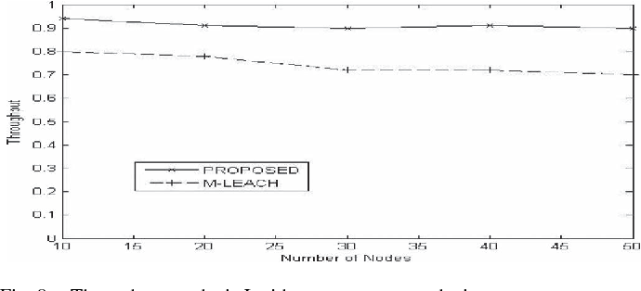

**Figure 3.2.1 Throuhput Difference in Proposed System**

* + 1. **Advantage of proposed System**
* The notion of deputy cluster head (DCH) is used, which increases the lifetime of the network.
* The notion of cluster head (CH) panel is used, which also increases the lifetime of the network.
* The notion of feedback by the BS regarding data delivery in it is considered.
* The protocol ensures reliability in terms of data delivery at the BS; this is achieved through the use of multiple routes and switching of the routes as decided by the BS.
* A probability-based mathematical model that can be used for identifying the most suitable path for data forwarding.

**3.3 REQUIREMENTS SPECIFICATION**

**3.3.1 Software Requirements**

* Operating system : Linux.
* Simulation Language : NS2.
* Coding Language : TCL.

**3.3.2 Hardware Requirements**

* Processor : Intel Pentium 4.
* Speed : 3.0 GHz.
* Hard Disk : 80 GB.
* Ram : 512 MB.

# LANGUAGE SPECIFICATION

# Network Simulator 2.28(NS2)

Ns-2 is a packet-level simulator and essentially a centric discrete event scheduler to schedule the events such as packet and timer expiration. Centric event scheduler cannot accurately emulate “events handled at the same time” in real world, that is, events are handled one by one. This is not a serious problem in most network simulations, because the events here are often transitory. Beyond the event scheduler, ns-2 implements a variety of network components and protocols. Notably, the wireless extension, derived from CMU Monarch Project, has 2 assumptions simplifying the physical world: Nodes do not move significantly over the length of time they transmit or receive a packet. This assumption holds only for mobile nodes of high-rate and low-speed. Consider a node with the sending rate of 10Kbps and moving speed of 10m/s, during its receiving a packet of 1500B, the node moves 12m. Thus, the surrounding can change significantly and cause reception failure. Node velocity is insignificant compared to the speed of light. In particular, none of the provided propagation models include Doppler effects, although they could.

**Mobile networking in Ns-allinone2.28:**

A mobile ad-hoc network (MANET) is a kind of wireless ad-hoc network, and is a self-configuring network of mobile routers (and associated hosts) connected by wireless links – the union of which form an arbitrary topology. The routers are free to move randomly and organize themselves arbitrarily; thus, the network’s wireless topology may change rapidly and unpredictably. Such a network may operate in a standalone fashion, or may be connected to the larger Internet.

Mobile ad-hoc networks became a popular subject for research as laptops and 802.11/Wi-Fi wireless networking became widespread in the mid- to late 1990s. Many of the academic papers evaluate protocols and abilities assuming varying degrees of mobility within a bounded space, usually with all nodes within a few hops of each other, and usually with nodes sending data at a constant rate. Different protocols are then evaluated based on the packet drop rate, the overhead introduced by the routing protocol, and other measures.

In the next generation of wireless communication systems, there will be a need for the rapid deployment of independent mobile users. Significant examples include establishing survivable, efficient, dynamic communication for emergency/rescue operations, disaster relief efforts, and military networks. Such network scenarios cannot rely on centralized and organized connectivity, and can be conceived as applications of Mobile Ad Hoc Networks.

A MANET is an autonomous collection of mobile users that communicate over relatively bandwidth constrained wireless links. Since the nodes are mobile, the network topology may change rapidly and unpredictably overtime. The network is decentralized; where all network activity including discovering the topology and delivering messages must be executed by the nodes.

The set of applications for MANETs is diverse, ranging from small, static networks that are constrained by power sources, to large-scale, mobile, highly dynamic networks. The design of network protocols for these networks is a complex issue. Regardless of the application, MANETs need efficient distributed algorithms to determine network organization, link scheduling, and routing. However, determining viable routing paths and delivering messages in a decentralized environment where network topology fluctuates is not a well-defined problem.

**CHAPTER 4**

**SYSTEM DESIGN**

**4.1 SYSTEM ARCHITECTURE:**

**MULTIPLE NODE CREATION (n0,n1…)**

**DEPUTY CLUSTER HEAD FORMATION**

**NODES (N) CLUSTER HEAD (CH) SELECTION**

**YES**

**NO**

**WAIT FOR CH ANNOUNCEMENTS**

**DATA TRANSMIT THROUGH CH**

**DATA TRANSMISSION BY USING TCP, FTP**

**DATA TRANSMISSION TO SENSOR NODES**

**E2R2 PROTCOL**

**SELECTION BASED ON ENERGY**

**NEIGHBOUR NODES (nn0, nn1…) SELECTION**

**SENDER NODE SELECTION AND DATA TRANSMIT**

**TRACE F**

**PACKET DROP**

**TRUST BASED PROTOCOL**

**RETRANSMIT OF DATA BY FINDING LOCATION**

**IMPROVING PARAMETER:**

**1. THROUGHPUT, 2.ENERGY EFFICIENT.**

Based on the velocity of a sensor node the Base Station can prepare a rough estimate of the zone in which the sensor node is going to be in the next time interval. The value of the next time interval can be set manually depending on the type of the application and this value is critical as most of the computations e.g., cluster setup validity period, medium access slot etc are dependent on the next time interval. Using this information the Base Station can compute the topology. Once the Base Station creates the sensor field map, it forms the clusters. The cluster formation approach is simple. Basic idea is to maintain geographically uniformly distributed clusters so that coverage is uniform and also the Cluster Head nodes are uniformly distributed over the entire sensor field. Therefore, the entire sensor field is geographically uniformly divided into n clusters where n is approximately 5% of the total number of nodes deployed in the field.

After formation of the clusters the Base Station identifies a set of suitable nodes i.e., cluster head panel from within each cluster which can take role of Cluster Head node and Deputy Cluster Head node. This selection is based on cumulative credit point earned from the three parameters namely residual energy level of the node, degree of the node (i.e., the number of neighbours) and mobility level of the node (high, moderate, low). The designer can use a suitable normalization function to compute cumulative credit point earned by a node through these three non-homogeneous parameters. An ideal node suitable for CH role should have higher residual energy, higher degree (i.e., higher neighbourhood), and low mobility.

Then the Base Station prepares the cluster head panel consisting of nodes having a cumulative credit point above a threshold value. Again this threshold value can be set manually at the time of implementation and also depending on the application of the WSN under consideration and the normalization function. Then the node with highest credit point is selected as the current Cluster Head. The next two nodes in the list with second and third highest credit point respectively are selected as Deputy Cluster Heads for the same cluster. Role of Cluster Head node: The Cluster Head node is responsible for gathering sensory data from the cluster members, aggregate those and forward to the Base Station either directly or in a multi-hop fashion according to the communication pattern distributed by the Base Station. Role of Deputy Cluster Head node: The Deputy Cluster Head nodes keep monitoring the sensor nodes’ mobility pattern.

Deputy Cluster Head nodes are also called cluster management nodes as they take a major responsibility of collecting current location information from the cluster members and communicating it to the Base Station. Based on this information the Base Station computes the actual current topology and previously what the Base Station had is an estimate only. Moreover in the event of the immediate link or node failure in the route of the CH towards the Base Station, the Cluster Head may seek aid of one of the Deputy Cluster Head nodes to forward the data towards the Base Station. CH-BS network creation: Since the location information of each of the CH node is available with the BS, the BS computes different alternate multi-hop routes for each of the CH node. These routes are computed only considering the CH nodes spread throughout the sensor network.

**4.2 SEQUENCE DIAGRAM**

PRIMARY

CLUSTER HEAD

DATA

1 : CLUSTER HEAD()

2 : CH1()

3 : CH2()

4 : CH3()

5 : DATA TRANSMISSION()

6 : DATA TRANSMISSION()

7 : PACKETS()

8 : ENERGY EFFICIENT()

9 : THROUGHPUT ANALYSIS()

**Figure 4.2.1 Sequence Diagram**

In the figure 4.2.1, the sequence diagram explains the process of transmission of network from primary to Cluster Head.Sequence of Cluster Heads are formed in primary node and the data is transmitted.From the formed Cluster Heads the data are transmitted in form of data packets therefore the energy efficiency is improved and calculated and throughput analysis takesplace.

**4.3 USE CASE DIAGRAM**

**PRIMARY**

**SECONDARY**

**CLUSTER HEAD**

**CH1**

**CH2**

**CH3**

ROUTING PATH FOR ACTIVATION FLOW

ROUTE REQUEST

DATA TRANSMISSION

**Figure 4.3.1 Use Case Diagram**

In the figure 4.3.1, the use case diagram explains the relationship of the data transmission between primary and secondary nodes. A routing request is made by the cluster head of primary node to secondary node in which routing path activates cluster heads like CH1,CH2,CH3,…thus the energy efficiency is maximized accordingly and the secrecy loss is minimized.

**4.4 COLLABORATION DIAGRAM**

PRIMARY

CLUSTER HEAD

DATA

1 : CLUSTER HEAD()

2 : CH1()

3 : CH3()

4 : CH4()

5 : DATA TRANSMISSION()

6 : DATA TRANSMISSION()

7 : PACKETS()

8 : ENERGY EFFICIENT()

9 : THROUGHPUT ANALYSIS()

**Figure 4.4.1 Collaboration Diagram**

In the figure 4.3.1,.the collaboration diagram explains the process of transmission of network from primary to Cluster Head.Sequence of Cluster Heads are formed in primary node and the data is transmitted.From the formed Cluster Heads the data are transmitted in form of data packets therefore the energy efficiency is improved and calculated and throughput analysis takesplace.

**CHAPTER 5**

**SYSTEM IMPLEMENTATION**

**5.1 MODULES**

1. CREATING A GROUP OF NODES IN THE NETWORK.
2. PACKET TRANSMISSION BETWEEN THE NODES.
3. RECEIVER.

**5.1.1 CREATING A GROUP OF NODES IN THE D2D NETWORK:**

In D2D communication,Mobile Node is the basic ns Node object with added functionalities like movement, ability to transmit and receive on a channel that allows it to be used to create mobile, wireless simulation environments. The class Mobile Node is derived from the base class Node. Mobile Node is a split object. The mobility features including node movement, periodic position updates, maintaining topology boundary etc are implemented in C++ while plumbing of network components within Mobile Node itself (like classifiers, dmux , LL, Mac, Channel etc) have been implemented in Otcl.

The network consists of a beginning node (n1), a termination node (n2), a Simple Link connecting n1–n2, a source transport layer agent (UDP), and a sink transport layer agent (null). This network can be created using the following TCL simulation script:

**EXAMPLE TO CREATE NODES IN D2D:**

Set ns [new Simulator]

Set n1 [$ns node]

Set n2 [$ns node]

$ns simplex-link $n1 $n2 Drop Tail

Set udp [new Agent/UDP]

Set null [new Agent/Null]

$ns attach-agent $n1 $udp

$ns attach-agent $n2 $null

Here, command $ns node creates a Node object. The internal mechanism of the node construction process was described. The statement $ns simplex-link $n1 $n2 Drop Tail creates a unidirectional Simple Link object, which connects node n1 to node n2.

**5.1.2 PACKET TRANSMISSION BETWEEN THE NODES.**

In a wireless network, nodes communicate using the communication model that consists of UDP agent, Null agent, and CBR traffic. The sender node is attached to the UDP agent while the receiver node is attached to the Null agent. The connection between UDP agent and a Null agent is established using the keyword “connect”. Transport agent (UDP) and application (CBR) are connected using the keyword “attach-agent”. The CBR traffic object generates the data packet (traffic) based on a deterministic rate. The generated data packets are constant in size.

The coding in Tcl illustrates the data transmission between two nodes.

**5.1.3 ALGORITHM DETAILS:**

**HONEY BEE ALGORITHM:**

In this project we proposed an improvement in LEACH protocol which is optimized for the mobile nodes considered as primary and secondary nodes. This proposed modification is made on the basis of CH selection algorithm to ensure that power resource is equally distributed among the sensor nodes and every sensor node has an ability to become cluster head. Random way point mobility (RWP) model is adapted by all the mobile sensor nodes. The rest of the project is organized as follows: CH describes the working for basic leach and Mobile WSNs, discusses the simulation of proposed algorithm and comparison of both routing algorithms defining some performance metrics and finally CH compares the performance and behaviour of routing algorithms with various parameters.

**SPECTRUM ALLOCATION ALGORITHM IN CRNS:**

In CRNs, SUs can obtain large amount of wireless frequency band for data transmission, and the spectrum utilization can be improved dramatically. Recently, more and more work focus on spectrum allocations in CRNs. The most commonly used methods in spectrum allocations are queuing theory, game theory, and information theory, etc. Here we mainly make some discussions on the queuing theory. We can classify the queuing based spectrum allocations into two types:

(1) The PUs accesses the licensed channels with a *ON/OFF* model, which describes the PU occupying the licensed channel or not. In this model, SUs are allowed to opportunistically access licensed channel after confirming that PU is idle using spectrum sensing algorithm;

(2) PUs and SUs are allowed to transmit their packets simultaneously on the same channel. Such schemes assume that successful interference cancelling technique adopted, in order to minimize the SUs’ inference to PUs.

**QUEUING MODEL ANALYSIS**

Recently, most work on queuing based spectrum allocations in CRNs are mainly considering M/G/1 model which assumes that each channel forms a transmission queue with the arriving packets from PUs and SUs. The transmission delay of the packets will be caused when they are allocated to one licensed channel. In this scenario, we can derive the performance achievable in each channel. Based on above analysis, we propose a spectrum allocation strategy using M/M/c model in which all packets from SUs can be treated as one virtual queue, and dynamically allocate these packets to the licensed channels. As follow, we simply present the M/G/1 model and introduce the M/M/c model in detail.

*A. M/G/1 Model*

Three parameters are considered to describe the M/G/1 model, where ‘*M*’ means that the users’ packets arriving obeys a Poisson process, and thus the interval of packets’ arrival obeys to a negative exponential distribution; ‘G’ means the service time of every packet obeys to a general distribution; and ‘1’ means only one server in the system. In this queue model, the packet who comes first will be served immediately, and the other users will wait in a virtual queue and continue be served when the server is idle.

Several parameters are considered to describe the performance of the queue system:

(1) Average queue length of system, which is defined as the number of waiting packets in system;

(2) Average length of system, which is defined as the number of systems with the serving included;

(3) Average waiting time in the system, which refers to the average time waiting for serving;

(4) Average sojourn time in system, which means the time interval between the packet arrival at system and departure from system. In general, most related research on spectrum allocation in cognitive radio networks achieve a better QoS and allocation strategies combined with M/G/1 model.

In traditional CRNs, SUs’ packets will be allocated to the available channels which regarded as servers in M/G/1 model and every packet queue up at the same channel can be seen as the customers. With the help of above parameters defined, we can derive the average transmission delay of SUs’ packets.

**NODE FORMATION**

**CH2**

**1. PRIMARY NODES (3)**

**2. SECONDARY NODES (6)**

**CH1**

**1. PRIMARY NODES (3)**

**2. SECONDARY NODES (6)**

**5.1.3 NODE FORMATION**

**EXAMPLE FOR COMMUNICATION BETWEEN THE NODES IN D2D:**

#****defining Communication between node0 and all nodes ****#

# defining a transport agent for sending  
set udp [new Agent/UDP]

# Attaching transport agent to sender node  
$ns attach-agent $node_(0) $udp

# defining a transport agent for receiving  
set null [new Agent/Null]

# Attaching transport agent to receiver node  
$ns attach-agent $node_(1) $null

#connecting sending and receiving transport agents  
$ns connect $udp $null

#defining Application instance  
set cbr [new Application/Traffic/CBR]

# attaching transport agent to application agent  
$cbr attach-agent $udp

#Packet size in bytes and interval in seconds definition  
$cbr set packet Size_ 512  
$cbr set interval_ 0.1

# Data packet generation starting time  
$ns at 1.0 "$cbr start"

# Data packet generation ending time  
#$ns at 6.0 "$cbr stop

* + 1. **RECEIVER:**

LEACH protocol that can be extended further for other protocols. Basically, we introduce two techniques to raise network life time and throughput. To understand our proposed scheme, we have to understand mechanism given by LEACH. This protocol changes the cluster head at every round and once a cluster head is formed, it will not get another chance for next 1/p rounds. For every round, cluster heads are replaced and whole cluster formation process is undertaken. We, in this work, modify LEACH by introducing “efficient cluster head replacement scheme”. It is a threshold in cluster head formation for very next round. If existing cluster has not spent much energy during its tenure and has more energy than required threshold, it will remain cluster head for the next round as well. This is how, energy wasted in routing packets for new cluster head and cluster formation can be saved. If cluster head has less energy than required threshold, it will be replaced according to LEACH algorithm. Besides limiting energy utilization in cluster formation, we also introduce two different levels of power to amplify signals according to nature of transmission. Basically there can be three modes of transmission in a cluster based network.

1) Intra Cluster Transmission

2) Inter Cluster Transmission

3) Cluster Head to Base Station Transmission.

Intra Cluster Transmission deals with all the communication within a cluster i.e. cluster member’s sense data and report sensed data to cluster head. The transmission/ reception between two clusters heads can be termed as inter cluster transmission while a cluster head transmitting its data straight to base station lies under the caption of cluster head to base station transmission.

Resource allocation in computing systems deals with the allocation of available system resources to the various tasks ready to be executed. This is a process that significantly affects the overall performance of the system. Typically, resource allocation algorithms take as input a list of tasks or processes that are ready to be executed at some particular time as provided by a system scheduler. The scheduler considers a task flow graph in order to resolve task dependencies. Traditionally, resource allocation in off chip multiprocessor systems concentrates on the allocation of software tasks to each of the processor nodes (usually individual processors with local caches and memory), such that the overall performance of the system is maximized.

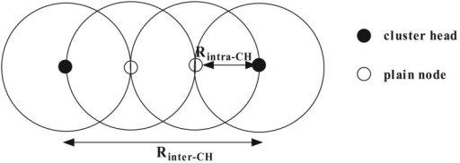

**Figure 5.1.3.1 Inter and Intra cluster**

**CHAPTER 6**

**CONCLUSION AND FUTURE ENHANCEMENT**

**6.1 CONCLUSION**

Increasing the number of devices in wireless networks can result in high device density, therein presenting both opportunities and challenges simultaneously. As an emerging and promising method, big data is explored to strengthen user cooperation. Using big data, users satisfying an established condition can cluster. Through these formed clusters, not only are wireless resources utilized efficiently, but also the secrecy loss due to high correlations can be effectively mitigated with AN produced by cluster members.

**6.2 FUTURE ENHANCEMENT**

Usually, the nodes involve in the network requires high energy power throughout during the communication period. And due to the inherent properties of the network, it is really difficult to survive the network in such environment. Therefore, keeping in view the above limitations, we proposed a novel architecture for wireless ad-hoc and sensor network. The proposed architecture is based on the hierarchical deployment of clustering technique, which is followed by the routing scheme. And finally, simulation results show that the proposed scheme conserve energy in all the circumstances as compared with other competing algorithms.

**APPENDIX 1**

**SAMPLE CODING**

#===================================

# Simulation parameters setup

#===================================

set val(chan) Channel/WirelessChannel ;# channel type

set val(prop) Propagation/TwoRayGround ;# radio-propagation model

set val(netif) Phy/WirelessPhy ;# network interface type

set val(mac) Mac/802_11 ;# MAC type

set val(ifq) Queue/DropTail/PriQueue ;# interface queue type

set val(ll) LL ;# link layer type

set val(ant) Antenna/OmniAntenna ;# antenna model

set val(ifqlen) 50 ;# max packet in ifq

set val(nn) 101 ;# number of mobilenodes

set val(rp) DSDV ;# routing protocol

set val(x) 1455 ;# X dimension of topography

set val(y) 100 ;# Y dimension of topography

set val(stop) 10.0 ;# time of simulation end

#===================================

# Initialization

#===================================

#Create a ns simulator

set ns [new Simulator]

#Setup topography object

set topo [new Topography]

$topo load_flatgrid $val(x) $val(y)

create-god $val(nn)

#Open the NS trace file

set tracefile [open out.tr w]

$ns trace-all $tracefile

#Open the NAM trace file

set namfile [open out.nam w]

$ns namtrace-all $namfile

$ns namtrace-all-wireless $namfile $val(x) $val(y)

set chan [new $val(chan)];#Create wireless channel

#===================================

# Mobile node parameter setup

#===================================

$ns node-config -adhocRouting $val(rp) \

-llType $val(ll) \

-macType $val(mac) \

-ifqType $val(ifq) \

-ifqLen $val(ifqlen) \

-antType $val(ant) \

-propType $val(prop) \

-phyType $val(netif) \

-channel $chan \

-topoInstance $topo \

-initialEnergy 10 \

-rxPower 0.5 \

-txPower 1.0 \

-idlePower 0.0 \

-sensePower 0.3 \

-agentTrace ON \

-routerTrace ON \

-macTrace ON \

-movementTrace ON

for {set i 0} {$i < $val(nn) } { incr i } {

set nenergy($i) 200

$ns node-config -initialEnergy $nenergy($i) \

-rxPower 0.5 \

-txPower 1.0 \

-idlePower 0.0 \

-sensePower 0.3

}

source ./node

#Setup a UDP connection

set udp [new Agent/UDP]

$ns attach-agent $n9 $udp

set null [new Agent/Null]

$ns attach-agent $n21 $null

$ns connect $udp $null

$udp set fid_ 2

#Setup a CBR over UDP connection

set cbr [new Application/Traffic/CBR]

$cbr attach-agent $udp

$cbr set type_ CBR

$cbr set packet_size_ 1000

$cbr set rate_ 1mb

$cbr set random_ false

#Schedule events for the CBR and FTP agents

$ns at 0.1 "$cbr start"

#Setup a UDP connection

set udp [new Agent/UDP]

$ns attach-agent $n0 $udp

set null [new Agent/Null]

$ns attach-agent $n21 $null

$ns connect $udp $null

$udp set fid_ 2

#Setup a CBR over UDP connection

set cbr [new Application/Traffic/CBR]

$cbr attach-agent $udp

$cbr set type_ CBR

$cbr set packet_size_ 1000

$cbr set rate_ 1mb

$cbr set random_ false

#Schedule events for the CBR and FTP agents

$ns at 0.1 "$cbr start"

#Setup a UDP connection

set udp [new Agent/UDP]

$ns attach-agent $n0 $udp

set null [new Agent/Null]

$ns attach-agent $n20 $null

$ns connect $udp $null

$udp set fid_ 2

#Setup a CBR over UDP connection

set cbr [new Application/Traffic/CBR]

$cbr attach-agent $udp

$cbr set type_ CBR

$cbr set packet_size_ 1000

$cbr set rate_ 1mb

$cbr set random_ false

#Schedule events for the CBR and FTP agents

$ns at 0.1 "$cbr start"

#Setup a UDP connection

set udp [new Agent/UDP]

$ns attach-agent $n4 $udp

set null [new Agent/Null]

$ns attach-agent $n15 $null

$ns connect $udp $null

$udp set fid_ 2

#Setup a CBR over UDP connection

set cbr [new Application/Traffic/CBR]

$cbr attach-agent $udp

$cbr set type_ CBR

$cbr set packet_size_ 1000

$cbr set rate_ 1mb

$cbr set random_ false

#Schedule events for the CBR and FTP agents

$ns at 0.1 "$cbr start"

#Setup a UDP connection

set udp [new Agent/UDP]

$ns attach-agent $n15 $udp

set null [new Agent/Null]

$ns attach-agent $n100 $null

$ns connect $udp $null

$udp set fid_ 2

#Setup a CBR over UDP connection

set cbr [new Application/Traffic/CBR]

$cbr attach-agent $udp

$cbr set type_ CBR

$cbr set packet_size_ 1000

$cbr set rate_ 1mb

$cbr set random_ false

#Schedule events for the CBR and FTP agents

$ns at 2.1 "$cbr start"

#===================================

# Agents Definition

#===================================

#===================================

# Applications Definition

#===================================

#===================================

# Termination

#===================================

#Define a 'finish' procedure

proc finish {} {

global ns tracefile namfile

$ns flush-trace

close $tracefile

close $namfile

exec nam out.nam &

exit 0

}

for {set i 0} {$i < $val(nn) } { incr i } {

$ns at $val(stop) "\$n$i reset"

}

$ns at $val(stop) "$ns nam-end-wireless $val(stop)"

$ns at $val(stop) "finish"

$ns at $val(stop) "puts \"done\" ; $ns halt"

$ns run

**APPENDIX 2**

**SCREENSHOTS**

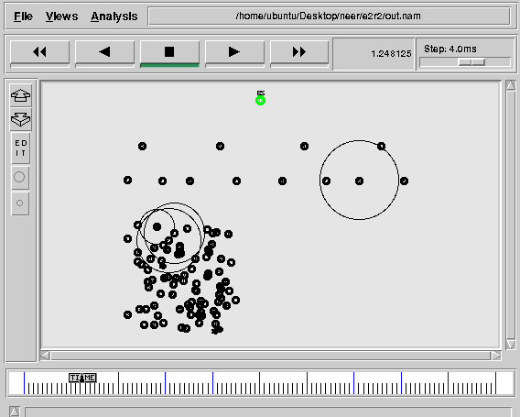

**Creation of Group of Nodes**

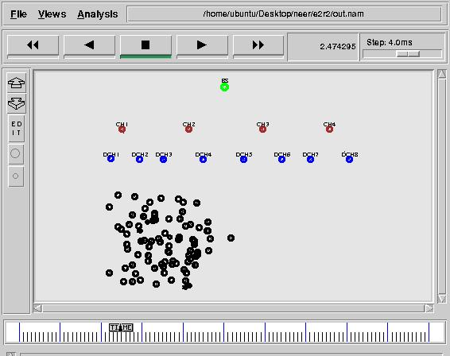

**Creation of cluster heads**

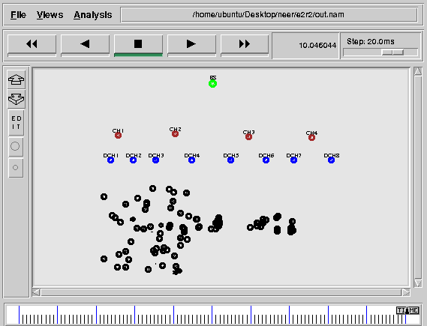

**Packet Data Transmission**

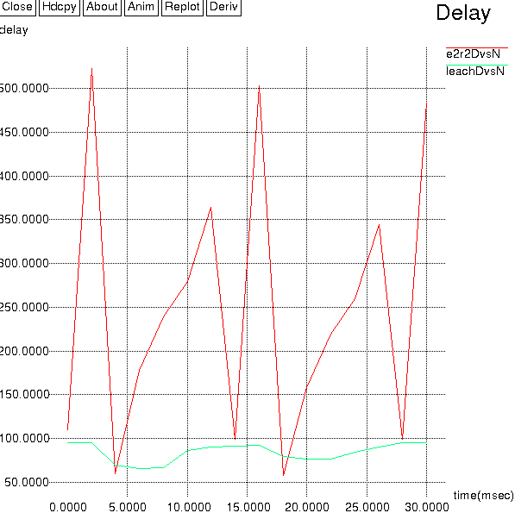

**PACKET** **DELAY**

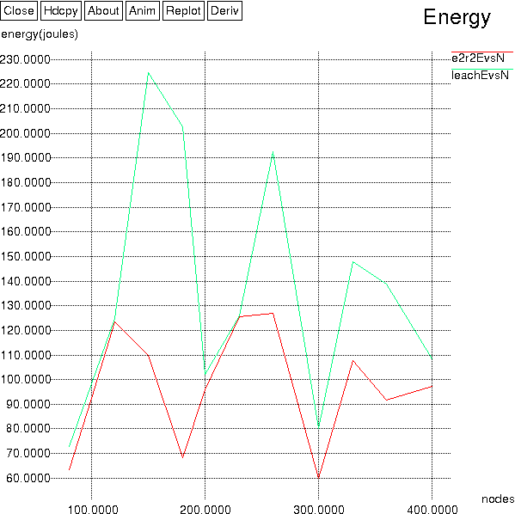

**ENERGY DIFFERENCE**

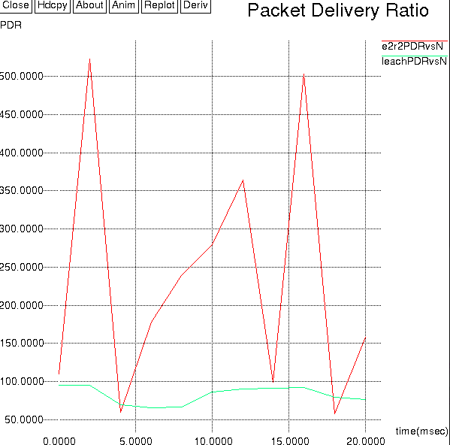

**PACKET DELIVERY RATIO**

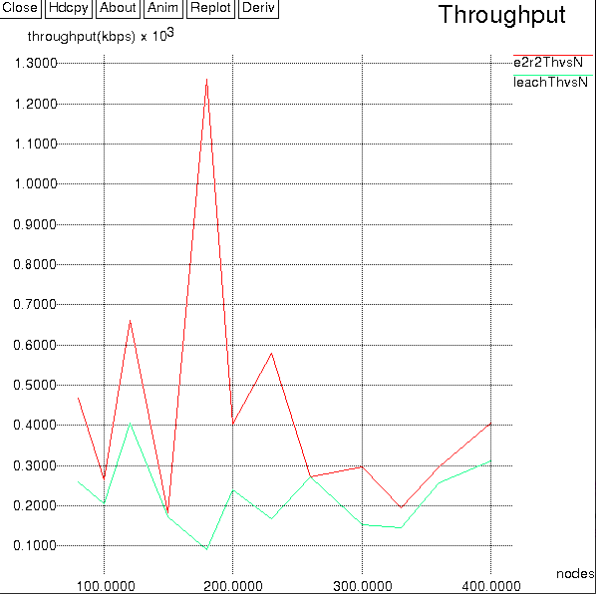

**PACKET THROUGHPUT**

**REFERENCES:**

1. Dense-Device-Enabled Cooperative Networks for Efficient and Secured Transmission, Shuai Han, SaiXu, Weixiao Meng, and Cheng Li,2018,IEEE Networks.
2. A Cluster-Based Data Fusion Technique to Analyze Big Data in Wireless Multi-Sensor System, SadiaDin,AwaisAhmad, Anand Paul, 2017.
3. Wireless Communications in the Era of Big Data,S. Bi *et al,* 2015,IEEE Communication Magazine vol. 53, no. 10, pp.190–99.
4. Physical Layer Security for Next Generation Wireless Networks: Theories, Technologies, and Challenges, Y. Liu, H. H. Chen, and L. Wang,2016,IEEE Communication Surveys and Tutorials**.**
5. Mobility Analytical Framework for Big Mobile Data in Densely Populated Area, Y.Qiaoetal,2017,IEEE Transaction Vehicular Technology
6. A Dynamic Bandwidth Allocation Algorithm in Mobile Networks with Big Data of Users and Network, B.Fan, S. Leng, and K. Yang,2016,IEEE Transaction networks**.**
7. Big Data-Driven Optimization for Mobile Networks toward 5G,K.Zhenget al,2016, IEEE Transaction networks .
8. An Agile Confidential Transmission Strategy Combining Big Data Driven Cluster and OBF, S. Han et al,2016,IEEE Transaction Vehicular Technology.
9. In-Band Full-Duplex Wireless: Challenges and Opportunities,
10. Sabharwalet al, 2014, IEEE Transaction JSAC.
11. Secrecy Capacity Analysis of Artificial Noisy MIMO Channels - An Approach Based on Ordered Eigen values of WishartMatrice, Y. Liu, H. H. Chen, and L. Wang,2016,IEEE Transaction Information Forensics and Security.