**# Applying basic steps**

1. Checking total rows and columns in the dataset

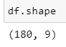

* There are total **180 rows** and **9 columns** in the entire dataset.

1. Acquiring dataset info like columns and their data type, total null-values in each column, etc.

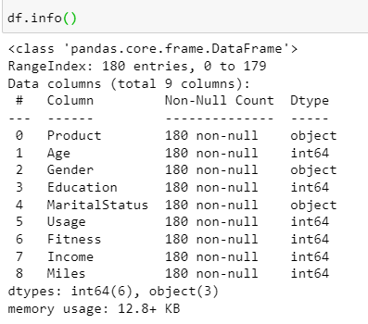

**Observations:**

1. Product, Gender and Marital Status have ‘object’ datatype i.e. they have categorical values. Remaining columns have int64 datatype i.e. they have numerical values.
2. The dataset does not contain any null values.

**Missing/Null values**

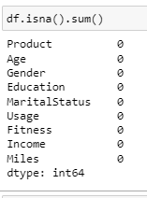

**Observation –**

* No missing values found in the dataset.

**# Getting statistical info about the dataset**

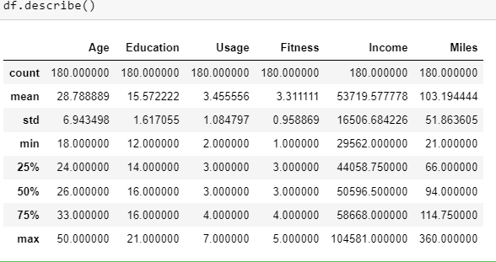

* Mean Age of the customers is 28-29 yrs having fitness level of 3 and average annual income of 50K to 60K.
* Minimum customer age using the aerofit treadmill is 18yrs while maximum age is 50yrs. Hence, customers of all age group use the aerofit treadmill.
* From the above dataset, a large standard deviation of 18.5K is observed in the ‘Income’ column.

**# Outlier detection using boxplots**

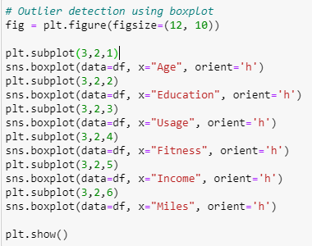

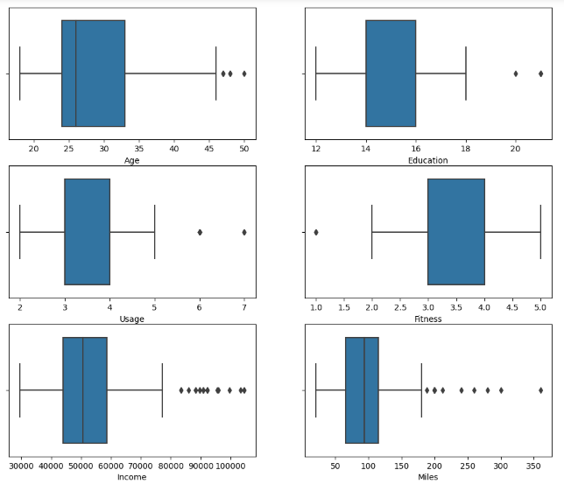

**Observations –**

* From the above boxplots, we can conclude that a maximum number of outliers are observed in Income and Miles.

**# Number of unique products in the dataset**

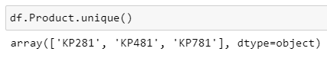

There are 3 unique products/ treadmills:

1. KP281
2. KP481
3. KP781

**# No of customer purchases based on Product-type**

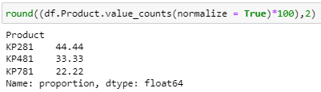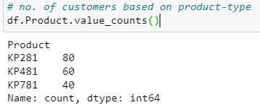

**Insights:**

* 44.44% customers purchased KP281
* 33.33% customers purchased KP481
* 22.22% customers purchased KP781
* Thus, least popular product among the customers is KP781 and the most popular is KP281 based on customer purchase.

**# Customer purchase based on Age and Income**

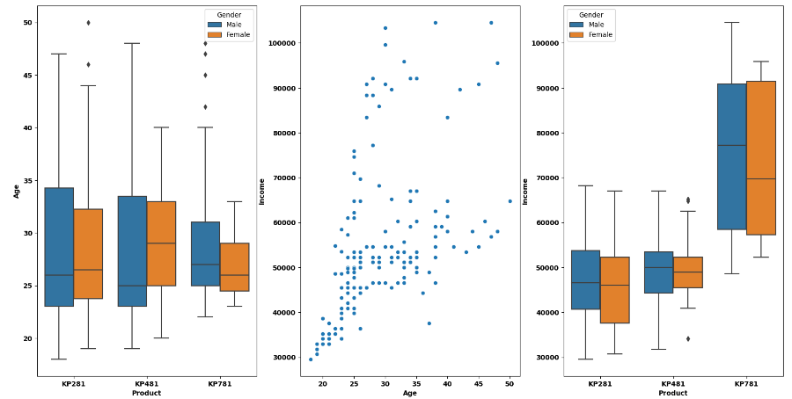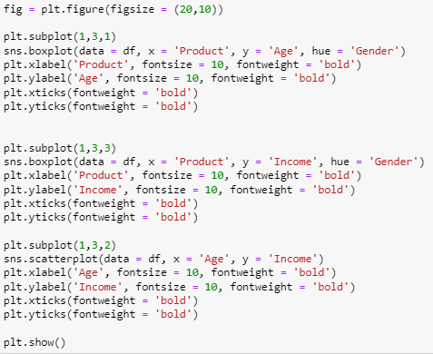

**Insights:**

* Customers having average age between 25 to 35 years and average income of 40K to 60K annually are the maximum buyers of aerofit products.
* Premium product like KP781 is bought only by customers having high income of 60K and above.

**Recommendations:**

* All Aerofit products must target only middle-aged customers below 35yrs with an average income of 40K-50K.
* Cost of premium product like KP781 should be lowered to increase the sales.

**# Countplots of product based on gender and marital-status**

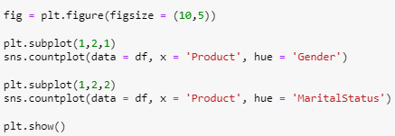

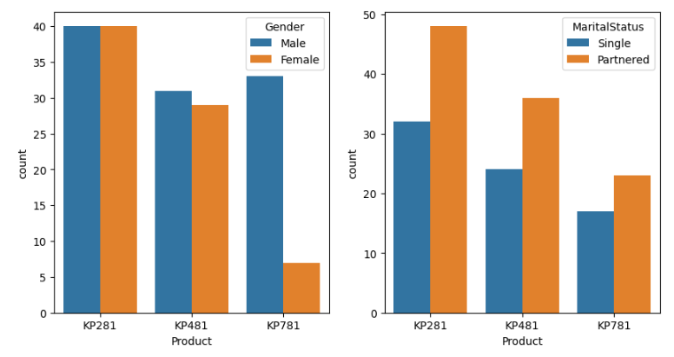

**Insights:**

* Max purchase of Aerofit products are from Male customers.
* Almost similar purchases is done by both Male and Female customers for products KP281 and KP481, however, KP781 is purchased by mostly male customers.
* While analyzing the purchases based on Marital-Status of the customers, Partnered customers are the maximum buyers of Aerofit products compared to Single customers based on the given dataset.

**Recommendations:**

* Target customers must be Partnered customers. Hence, special discounts could be given to Partnered customers for increasing the sales.
* Also, in order to increase the sales of the premium product like KP781, special discount offers could be provided targeting Female customers.

**# No of customers based on Fitness-level**

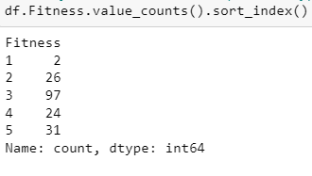

**Insights:**

* Max customers are at fitness level 3.

**# No of Single and Partnered Customers**

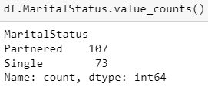

**Insights:**

* Max purchases are from Partnered customers.

**# Comparison between Product and Income**

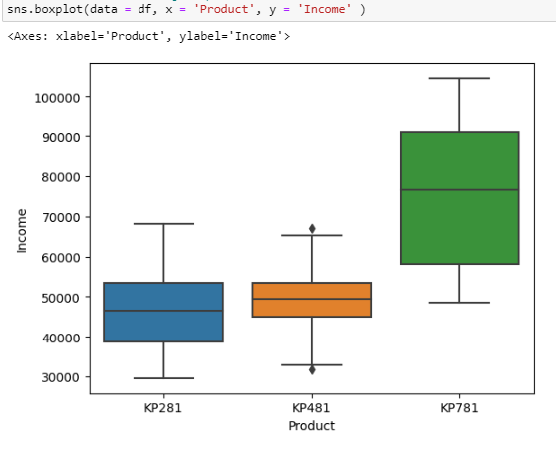

* The above boxplot gives a comparison chart of Product and Income.
* Here, higher income customers purchase KP781 while lower income purchase KP281 and KP481 as there is no much difference in the mean and median of products KP281 and KP481.
* However, a large variation is observed between products (KP281 & KP781) and (KP481 & KP781).

**# Checking the dependency of Product over Income using Hypothesis Testing.**

Using ANOVA, we can find the variation in the mean of the income for all three products for 5% significance.

H0: All means are similar

Ha: Means are different.

Alpha = 0.05

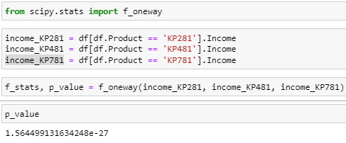

Since, p_value < alpha, We reject the Null Hypothesis (H0).

Hence, we can conclude that with a 95% Confidence Level, all means are different.

**# Finding marginal probabilities using crosstab**

1. **Product vs Gender**

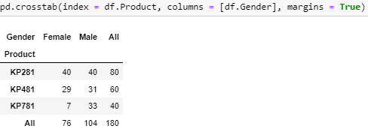

* Prob P(KP281) for Male:

**Creating age-group categories**

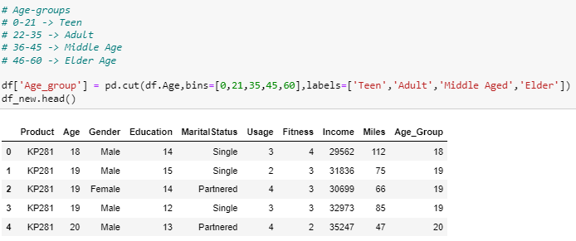

**Objective: Customer Profiling for Each Product**

Customer profiling based on the 3 product categories provided

**KP281**

* Easily affordable entry level product, which is also the maximum selling product.
* KP281 is the most popular product among the entry level customers.
* This product is easily afforded by both Male and Female customers.
* Average distance covered in this model is around 70 to 90 miles.
* Product is used 3 to 4 times a week.
* Most of the customer who have purchased the product have rated Average shape as the fitness rating.
* Younger to Elder beginner level customers prefer this product.
* Single female & Partnered male customers bought this product more than single male customers.
* Income range between 39K to 53K have preferred this product.

**KP481**

* This is an Intermediate level Product.
* KP481 is the second most popular product among the customers.
* Fitness Level of this product users varies from Bad to Average Shape depending on their usage.
* Customers Prefer this product mostly to cover more miles than fitness.
* Average distance covered in this product is from 70 to 130 miles per week.
* More Female customers prefer this product than males.
* Probability of Female customer buying KP481 is significantly higher than male.
* KP481 product is specifically recommended for Female customers who are intermediate user.
* Three different age groups prefer this product - Teen, Adult and middle aged.
* Average Income of the customer who buys KP481 is 49K.
* Average Usage of this product is 3 days per week.
* More Partnered customers prefer this product.
* There are slightly more male buyers of the KP481.
* The distance travelled on the KP481 treadmill is roughly between 75 - 100 Miles. It is also the 2nd most distance travelled model.
* The buyers of KP481 in Single & Partnered, Male & Female are same.
* The age range of KP481 treadmill customers is roughly between 24-34 years.

**KP781**

* Due to the High Price & being the advanced type, customer prefers less of this product.
* Customers use this product mainly to cover more distance.
* Customers who use this product have rated excelled shape as fitness rating.
* Customer walk/run average 120 to 200 or more miles per week on his product.
* Customers use 4 to 5 times a week at least.
* Female Customers who are running average 180 miles (extensive exercise) , are using product KP781, which is higher than Male average using same product.
* Probability of Male customer buying Product KP781(31.73%) is way more than female(9.21%).
* Probability of a single person buying KP781 is higher than Married customers. So , KP781 is also recommended for people who are single and exercises more.
* Middle aged to higher age customers tend to use this model to cover more distance.
* Average Income of KP781 buyers are over 75K per annum
* Partnered Female bought KP781 treadmill compared to Partnered Male.
* Customers who have more experience with previous aerofit products tend to buy this product
* This product is preferred by the customer where the correlation between Education and Income is High.

**Recommendation**

* Female who prefer exercising equipments are very low here. Hence, we should run a marketing campaign on to encourage women to exercise more
* KP281 & KP481 treadmills are preferred by the customers whose annual income lies in the range of 39K - 53K Dollars. These models should promoted as budget treadmills.
* As KP781 provides more features and functionalities, the treadmill should be marketed for professionals and athletes.
* KP781 product should be promotted using influencers and other international atheletes.
* Research required for expanding market beyond 50 years of age considering health pros and cons.
* Provide customer support and recommend users to upgrade from lower versions to next level versions after consistent usages.
* KP781 can be recommended for Female customers who exercises extensively along with easy usage guidance since this type is advanced.
* Target the Age group above 40 years to recommend Product KP781.