Kelompok 2 :

William Ongky Wijaya / 210711141

Nicholas Yang / 210711153

Gregory Wilson Wijaya / 210711167

Aloysius Gonzaga Seto Galih Damarjati / 210711180

Samuel Juang / 210711201

PBO B

# ERD dan Class Diagram Apotek

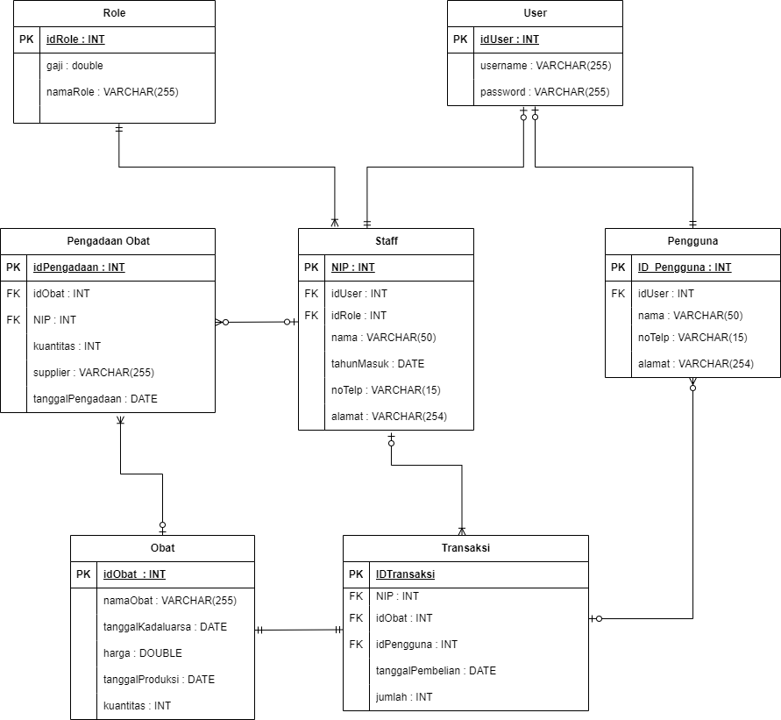**ERD** **Apotek**

## Class Diagram Apotek

