**Scenario Based Walkthrough**

*Persona Explanation:*

*As a <Current foundation year student>*

*I want <A program which will help me analyse data >*

*So that<I can use graphical outputs to confirm theory’s in my laboratory experiments>*

1- Students can access and Launch the application by opening the AC Circuit Lab file.

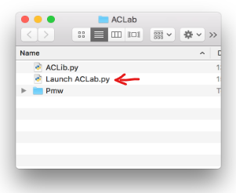

2- Student Launches the Application using “Launch AC Lab.py”

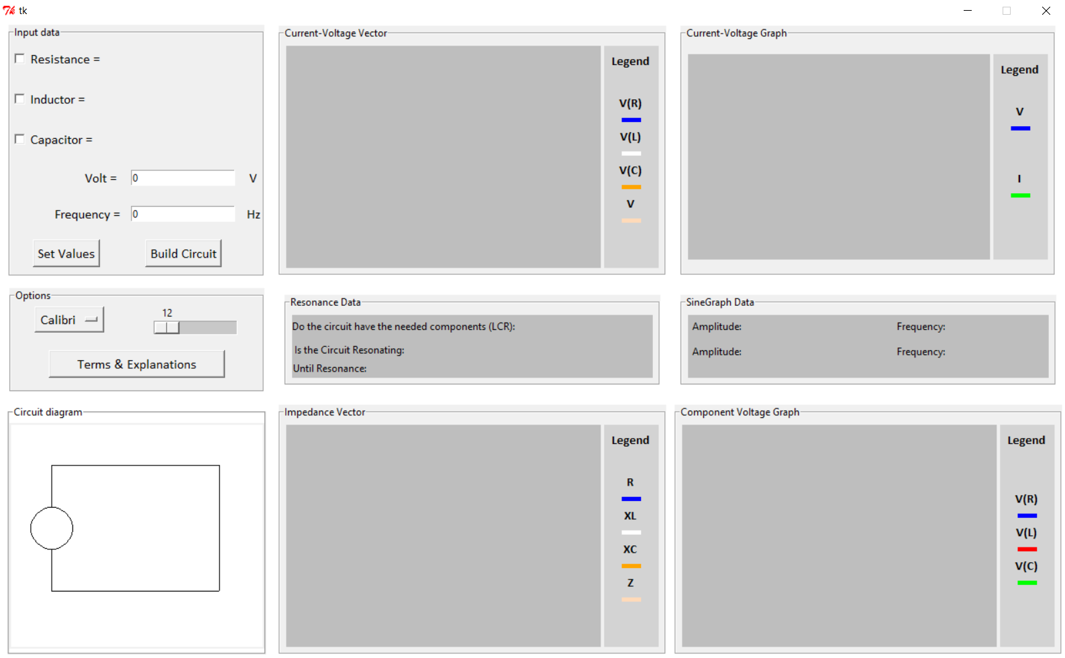

3- Students enter the related values from their experiment to the entry boxes on the input data part of the program.

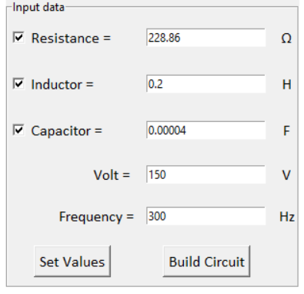

4- The Info Page shows up displaying relative calculation results to the student.

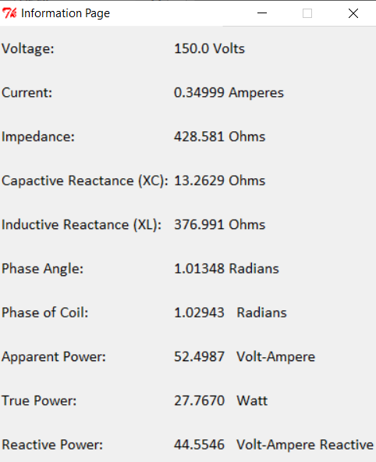

5- They observe the sine and vector graphs.

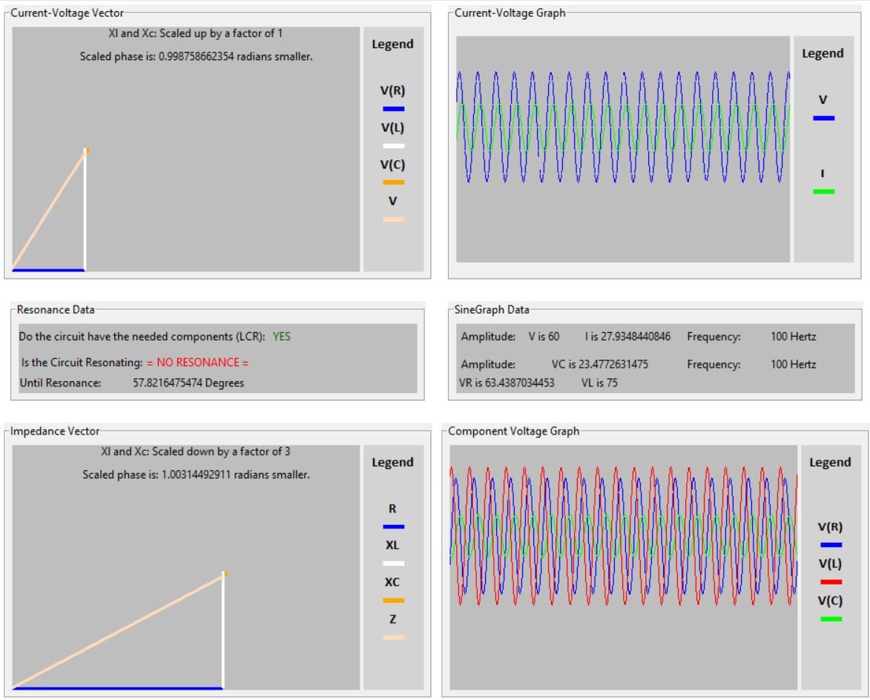

6- In the case that the student forgets the definition of key words and concepts such as the phase angle, and how it is applied to the sinus function, they can click on the “Terms and Explanations” button to check the definition of it.

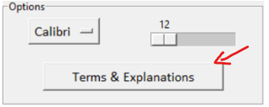

8- The help window opens up and reveals relevant definitions are shown.

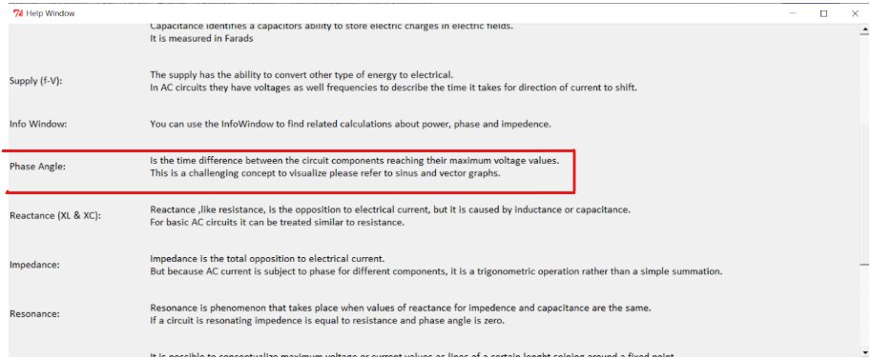

7- The student can then adjust the font size to make the text easier to read and get a clearer understanding of the relevant parts of their lab experiment.

