CEG3136 Lab 4 Report
Alp Tatar – 300241739
Ekin Sarp – 300237014

1. Code Snips
svc.h:
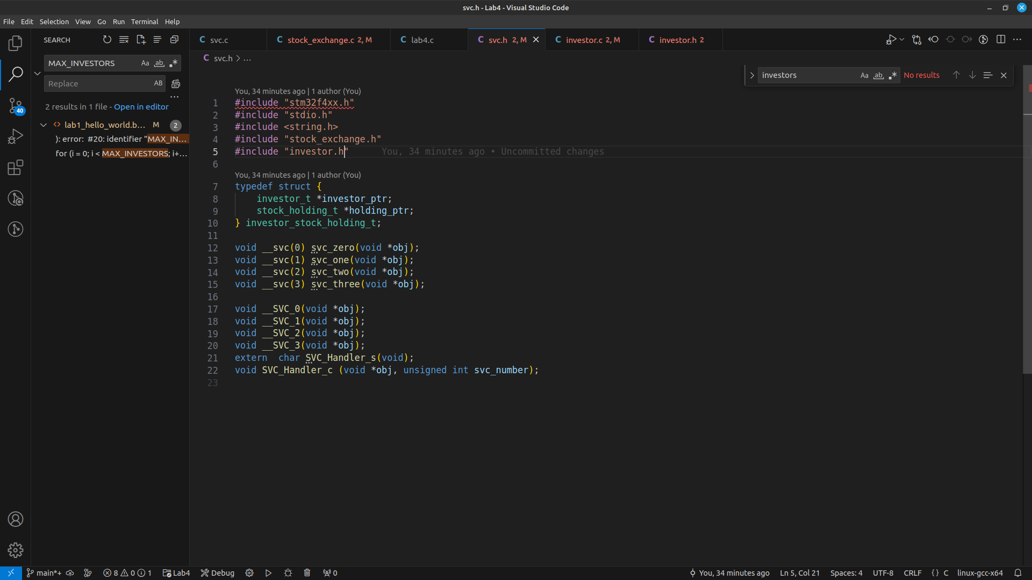
svc.s:
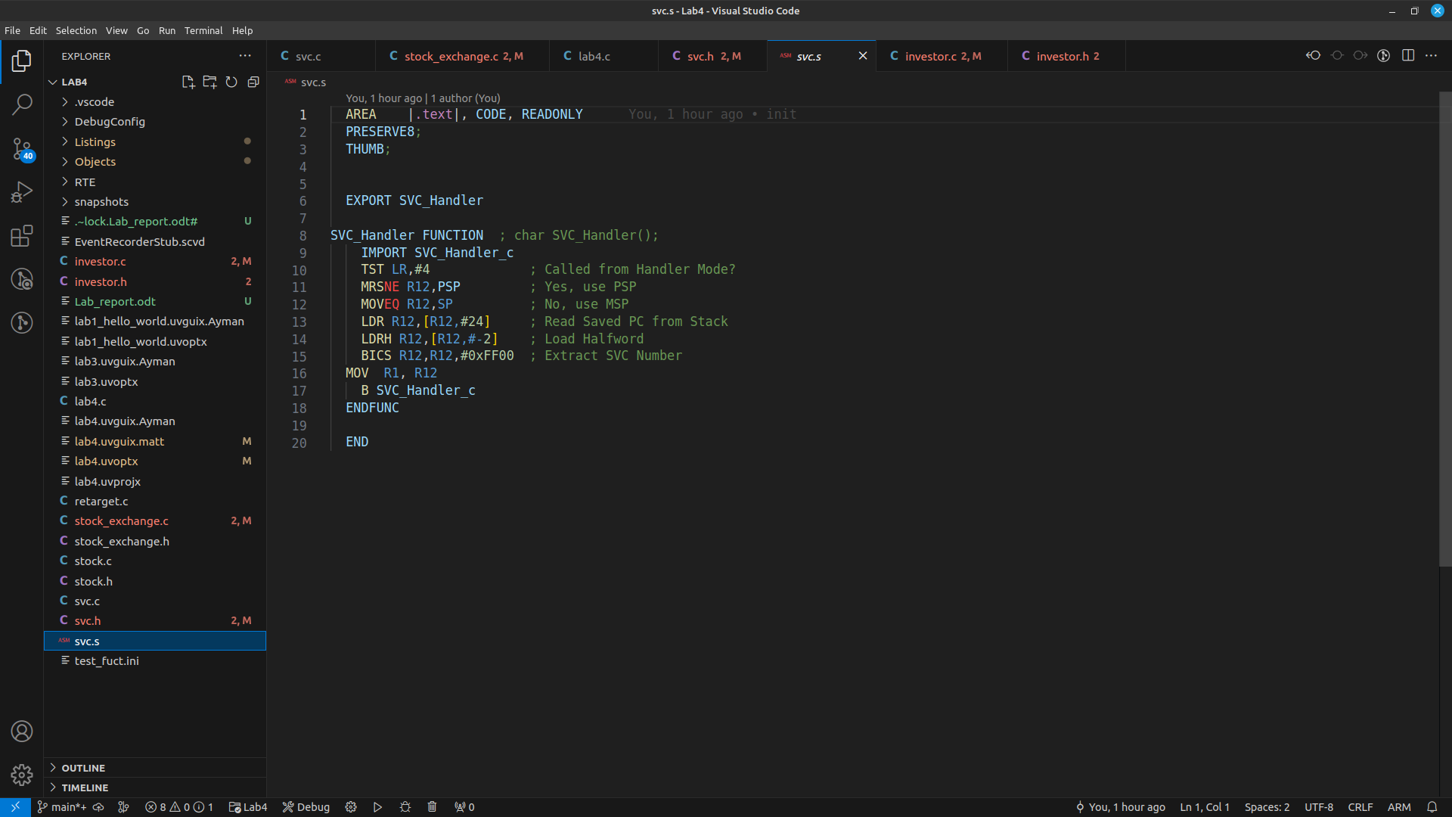

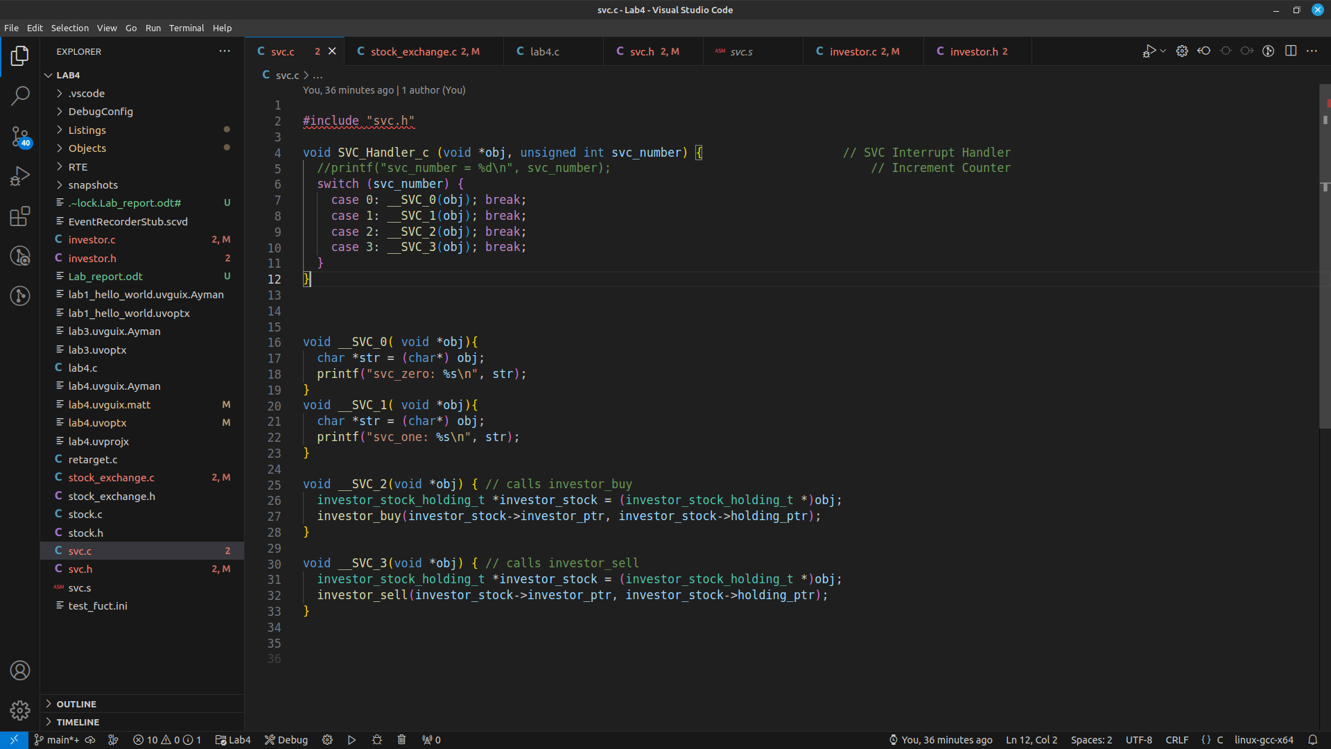
svc.c:

2. Screenshots at breakpoints at buy/sell functions
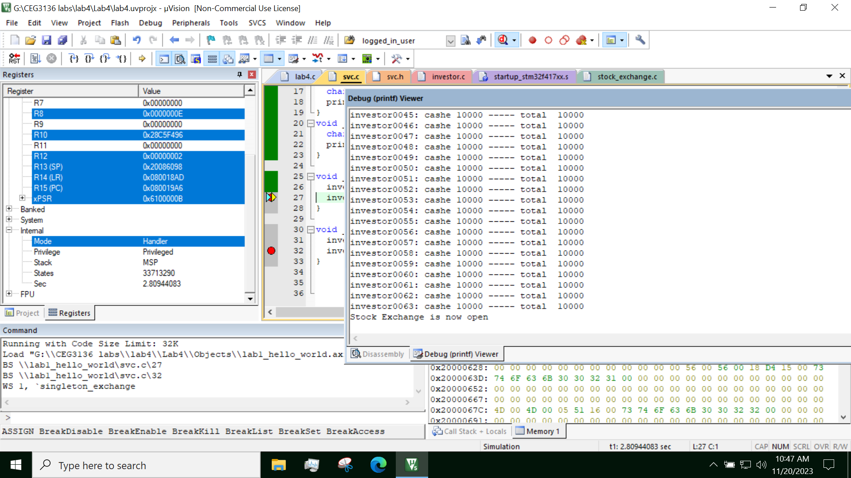
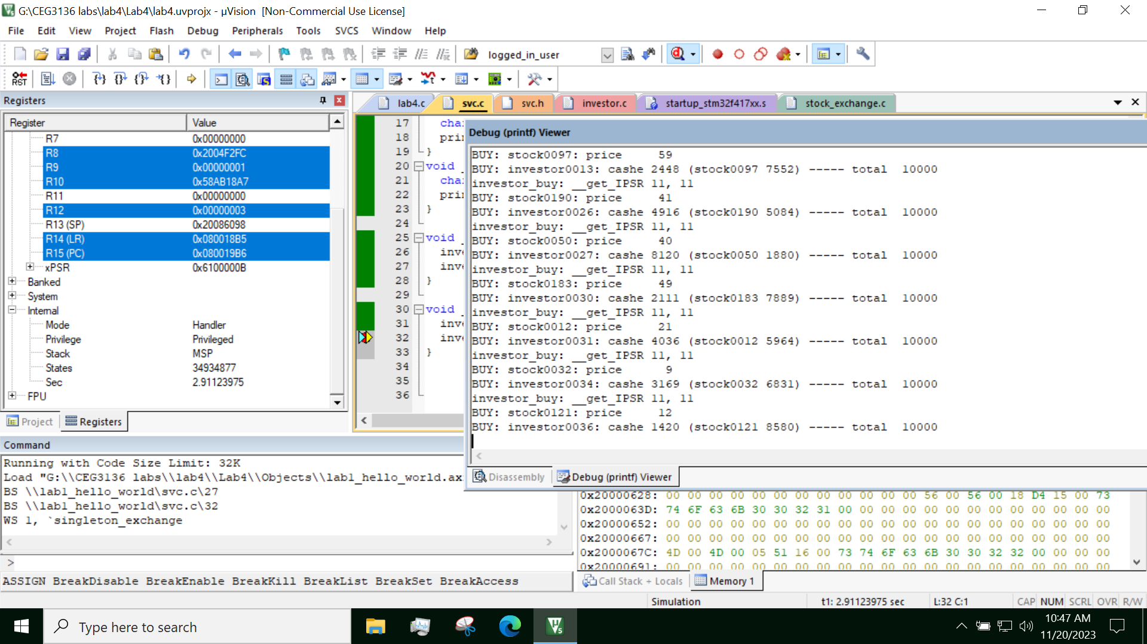
Buy:
Sell:

3 & 4 Simulation Log and Source Code

The entire simulation of one run has been included in simulation.txt file found in the zip with the rest of the source code and in the same directory as this report pdf.

