A Server-Side Web Framework for Smartphone-Based Traffic Sign Detection,
Geospatial De-duplication, and Inventory Management
Abdullah Salih Oner
Department of Computer Science, Aalborg University, Aalborg, Denmark
Email: [to be added]
Abstract—Traffic-sign inventories are important for road safety, navigation, municipal road-asset management, and intelligent transportation applications. Existing object-detection models can produce per-frame traffic-sign detections, but raw detections are not directly usable as an inventory because repeated observations, GPS noise, uncertain image evidence, and administrative validation must be handled. This paper presents a server-side web framework that connects a mobile browser-based data-collection workflow to a traffic-sign detection API and converts the resulting detections into geospatial, de-duplicated, reviewable inventory records. The framework stores raw observations, validates model responses, refines sign locations using confidence- and accuracy-weighted observations, groups repeated detections of the same physical sign, and exposes change-layer records through an administrative dashboard. The implemented application uses Next.js 14, TypeScript, Tailwind CSS, Supabase Authentication, PostgreSQL, private object storage, row-level security, signed media access, and Playwright-based end-to-end validation. The contribution is not a new detector or dataset; it is the web, geospatial, security, and inventory-management layer that turns detection outputs into operational traffic-sign records.
Index Terms—traffic sign detection, road asset management, geospatial data fusion, de-duplication, change layer, web mapping, Supabase, PostGIS, server-side API.

I. INTRODUCTION
Traffic signs are among the most important physical elements of a road environment. They communicate regulatory, warning, and guidance information to drivers, cyclists, pedestrians, road authorities, and increasingly to digital navigation and intelligent-transportation systems. An inventory of signs is therefore not only a visual record; it is an operational road-asset layer that supports maintenance, compliance, and planning.
Manual traffic-sign inventory creation is time-consuming and difficult to keep current. Specialized mobile mapping systems, LiDAR platforms, and calibrated multi-camera vehicles can achieve strong localization quality, but their cost, setup, and operational requirements limit frequent deployment. At the same time, consumer smartphones and web applications are broadly available and can capture imagery, GPS coordinates, heading when available, and timestamps with low deployment cost.
However, a traffic-sign detector alone does not solve the inventory problem. A detector produces class labels, bounding boxes, and confidence values for an image or frame. An inventory system must additionally determine whether a detection is new or already known, estimate a stable location for the physical sign, preserve image evidence, group repeated observations, track review status, and expose the result to an administrator. This gap between detection and inventory management is the focus of this paper.
The proposed framework uses a mobile web client as a lightweight data-collection interface and executes detection, geospatial processing, grouping, storage, and review workflows on the server. The implemented application follows a production-shaped architecture: browser-based capture, server-side route handlers, private storage, signed media delivery, row-level security, audit logging, analytics, administrative review, and end-to-end tests against a Supabase-backed environment.
The remainder of this paper is organized as follows. Section II reviews related work. Section III defines the problem and system requirements. Section IV presents the server-side web framework. Section V describes the methodology for candidate generation, matching, and fusion. Section VI presents the implementation design. Section VII describes evaluation metrics and validation. Section VIII reports the current system-validation results. Sections IX-XI discuss implications, limitations, future work, and conclusions.
II. RELATED WORK
A. Traffic Sign Detection and Mobile Mapping
Traffic-sign recognition and detection have been widely studied with benchmark datasets and modern object detectors. Traffic-sign recognition benchmarks such as GTSRB and detection benchmarks such as GTSDB provide structured evaluation settings for classifying and localizing signs in images [1], [2]. General-purpose detectors such as YOLO, Faster R-CNN, and SSD have also shaped object-detection pipelines used in traffic-sign applications [3]-[5].
Existing detection research establishes that traffic signs can be found and classified in imagery, but the output of a detector remains an image-level result. For road-asset use, these detections must be transformed into stable geospatial records. Mobile mapping studies address this need by combining imagery with vehicle position, calibrated sensors, and sometimes point clouds. Soilán et al. used mobile mapping data and point clouds for road-sign inventory [6], while Balado et al. combined image-based deep learning with mobile-mapping geometry to detect, classify, and locate signs [7].
Low-cost and open-source mobile mapping approaches are also relevant. Gaspari et al. showed that open-source mobile GIS tools can support public-administration road cadastre workflows and improve data collection quality compared with field-paper processes [8]. This paper builds on that operational view but focuses on a web platform that receives detector outputs and manages geospatial inventory updates.
B. Traffic Sign Geolocation, Fusion, and Inventory Updating
Geolocation is the step that turns a detected sign into a map object. Pedersen and Torp investigated geolocating traffic signs from large imagery datasets and emphasized that both position and direction are important when transforming road imagery into traffic-sign map records [9]. Their crowd-sourced imagery work also illustrates the need to cluster repeated observations before creating final sign records [10].
More geometry-intensive localization methods use multi-view reconstruction, calibrated cameras, or structure-from-motion. These approaches can improve localization but also increase implementation complexity and data requirements. For a web-based system intended for practical deployment, the framework should support repeated observations and confidence-based fusion while remaining compatible with ordinary browser-based data collection.
Incremental map updating and change-layer concepts are especially relevant. Hu et al. proposed an incremental crowd-source update method for HD-map traffic-sign layers in which detections are matched against existing signs, fused across trajectories, and placed into a traffic-sign change layer before updating the authoritative layer [11]. This design principle is adopted here: uncertain observations enter a reviewable change layer instead of directly overwriting validated inventory records.
C. Road Cadastre, Security, and Dashboard-Based Management
Road authorities require more than detection accuracy; they need a maintainable inventory model. Gaspari et al. modeled traffic-sign information through a relationship between sign holders and traffic signs, reflecting the practical case where several sign panels can be attached to the same support [8]. The implementation in this paper similarly separates raw observations, detection events, candidate signs, fused sign instances, and administrative actions.
Web mapping and storage infrastructure are central to an operational dashboard. The implemented application uses Leaflet with OpenStreetMap tiles for map visualization [12], [13]. Supabase provides authentication, PostgreSQL, private object storage, and row-level-security support [14], [15]. PostGIS is identified as a scalable extension path for spatial indexing and server-side spatial operations [16]. Human-in-the-loop review is also relevant because administrative validation can improve the operational quality of machine-learning outputs before they are trusted as inventory records [17].
III. PROBLEM DEFINITION AND SYSTEM REQUIREMENTS
The problem addressed in this paper is the transformation of raw traffic-sign detections into a reliable, de-duplicated, location-refined, and reviewable traffic-sign inventory. The input is a stream of web-collected observations. Each observation contains an image or frame, GPS coordinates, timestamp, optional heading and speed, and the response of a detection API. Each detection contains a predicted class, confidence score, and bounding box.
The output is not a list of detections but a set of inventory candidates and validated sign instances. Each inventory candidate should include sign type, representative location, confidence score, observation count, image evidence, review status, and audit history. The system should also preserve complete raw detection history so that administrative decisions can be inspected later.
The functional requirements include user authentication, role-based administration, device registration, web-based image capture or upload, detection API integration, persistence of raw observations, duplicate grouping, location refinement, private media delivery, map visualization, administrative review, analytics, and demo/testing support. Non-functional requirements include secure server-side secret handling, row-level security, signed media URLs, response validation, bounded external API calls, maintainable migrations, and reproducible end-to-end tests.
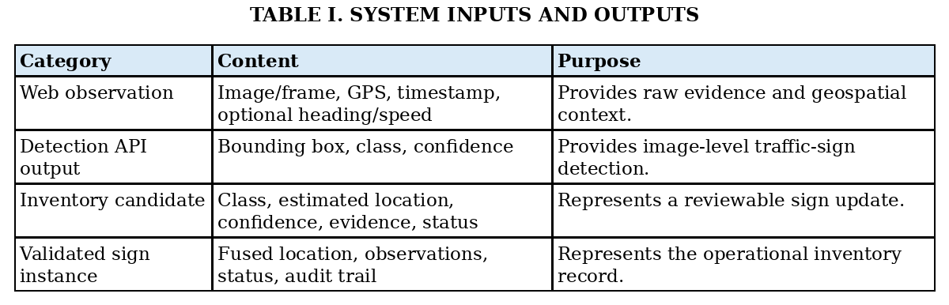
IV. PROPOSED WEB-BASED SERVER-SIDE INVENTORY FRAMEWORK
A. Mobile Web Collection and Detection API Workflow
The mobile web client is the entry point of the system. A field user captures or uploads a road-scene image through the browser and attaches available GPS metadata. The client sends the image and metadata to the backend. The backend stores the media object in a private bucket, creates a short-lived signed URL for server-side inference, invokes the detection API, validates the response, and persists one detection-event row per returned detection.
The detector is exposed through a canonical API contract. The framework supports a real external detector and a deterministic mock detector for development, demonstration, and automated tests. In both cases, the rest of the platform receives the same normalized structure: class label, confidence, bounding box, raw response, and source observation metadata.
B. Geospatial Processing and De-duplication
After the detection response is normalized, the backend creates geospatial candidates. Each candidate begins with the observation position and is enriched with sign class, detector confidence, timestamp, image evidence, and optional heading. Candidate records are compared against existing sign instances to determine whether they represent a new physical sign or an additional observation of an existing one.
De-duplication is essential because the same sign may be detected across multiple frames, sessions, devices, or trips. Candidate comparison uses spatial proximity, semantic class, confidence, observation count, and direction when available. If a candidate matches an existing sign instance, the observation is attached to that sign and the representative location is recalculated. Otherwise, a new candidate or sign instance is created.
C. Change Layer and Administrative Dashboard
The change layer separates uncertain updates from validated inventory records. New signs, suspected duplicates, low-confidence detections, possible relocations, possible removals, and semantic changes can be stored as reviewable records. This avoids treating a single uncertain detection as a direct change to the operational inventory.
The administrative dashboard exposes this workflow through a map, candidate lists, detail panels, image evidence, filters, review actions, analytics, AI integration checks, and storage governance tools. Administrators can approve, reject, merge, split, correct, or mark candidates. Every action is treated as an administrative event so that the inventory lifecycle remains auditable.
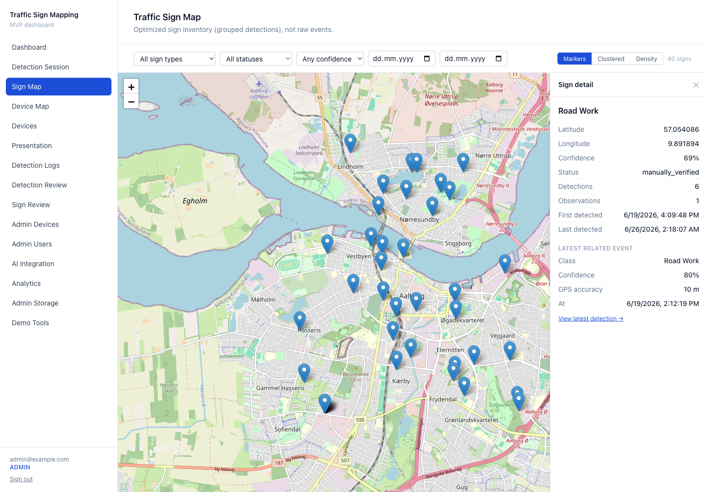
Fig. 1. Traffic-sign inventory map with selected sign detail panel from the implemented web dashboard.
V. METHODOLOGY
A. Detection Processing and Candidate Generation
Let an observation O consist of image I, position p, timestamp t, and optional heading h. The detection API returns a set of detections D = {d1, d2, ..., dn}. Each detection di contains a bounding box b_i, predicted class c_i, and confidence score s_i. For each detection, the backend creates a candidate record that links the source image, observation metadata, and normalized detection fields.
Candidate generation is deliberately separated from detection. This allows the framework to remain compatible with different detector backends as long as they respect the same API contract. The inventory pipeline therefore depends on normalized outputs rather than on a particular model architecture.
B. Matching, Confidence Scoring, and Fusion
The matching step compares a new candidate with existing candidate clusters and validated sign instances. A candidate is associated with an existing sign if the combined matching score exceeds a configured threshold. The score combines spatial, semantic, directional, road-context, and temporal evidence:
S_match = w1*S_spatial + w2*S_semantic + w3*S_direction + w4*S_road + w5*S_temporal. (1)
The spatial component measures distance between locations. The semantic component compares sign classes or broader sign categories. The directional component uses heading when available. The road-context component evaluates whether candidates are plausible relative to nearby road segments. The temporal component helps distinguish repeated observations from long-term inventory changes.
For localization, the implementation refines the representative position of a sign through confidence- and accuracy-weighted observations:
weight = confidence / max(gps_accuracy, 1), (2)
refined_location = sum(weight * position) / sum(weight). (3)
This formulation reduces the influence of low-confidence detections and imprecise GPS readings. It also preserves all raw observations, so that the fused inventory record remains traceable.
C. Human Validation Workflow
The inventory workflow moves records from raw observations to candidates, from candidates to fused sign instances, and from fused sign instances to validated inventory records. Review states include pending, auto-verified, manually verified, rejected, duplicate, and low-confidence. Additional change-layer labels can represent new candidates, possible relocations, possible removals, semantic changes, and damage reports.
Human validation is required because detector confidence and geospatial consistency do not guarantee correctness in every case. The dashboard gives administrators access to the original image evidence, detection metadata, cluster context, and current inventory status before approving or rejecting a candidate.
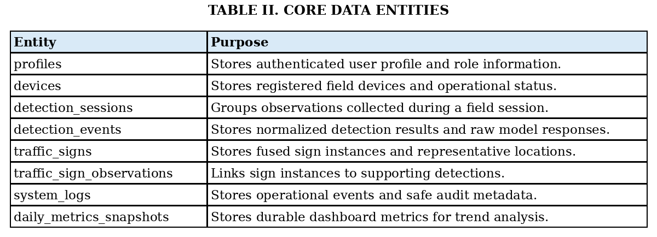
VI. IMPLEMENTATION DESIGN
A. Backend, API, and Database Design
The implemented system uses Next.js 14 with the App Router, TypeScript, and Tailwind CSS. Server Components and Route Handlers execute trusted operations on the server, while client components handle interactive camera, map, table, and form behavior. Supabase provides authentication, PostgreSQL, private object storage, and row-level security.
The database schema is organized through ordered migrations. The current application report identifies migrations 0001-0006, covering core tables, secure image object paths, legacy path backfill, analytics RPC functions, storage quarantine governance, and daily metrics snapshots. The design uses UUID primary keys, timestamp fields, and JSON fields for raw model responses and metadata.
The AI integration layer supports mock, external, and automatic modes. A request carries a short-lived signed image URL and observation metadata. Responses are validated before any write: detections must be an array, confidence values must lie in [0,1], class names must be non-empty, and bounding boxes must be well-formed. External calls use timeouts and bounded retry behavior for transient failures.
B. Dashboard and User Interaction Design
The dashboard is organized around inventory operation. It includes an inventory map, sign detail panels, detection review tables, device views, analytics, presentation mode, AI integration health checks, and storage governance screens. Maps are loaded dynamically on the client to avoid server-rendering issues and use OpenStreetMap tiles through Leaflet.
Image delivery is designed around private storage. The database stores object paths rather than permanent public URLs. When a user is authorized to view an image, the server creates a short-lived signed URL. CSV exports include storage object references and availability status rather than reusable signed URLs.

Fig. 2. Implemented dashboard overview showing sign, device, detection, and verification summaries.
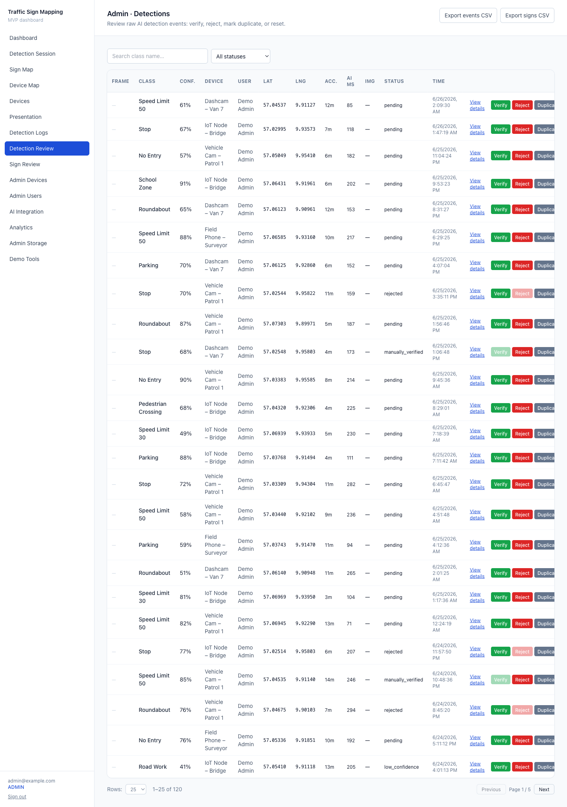
Fig. 3. Administrative per-detection review table used for inspection and validation of model outputs.
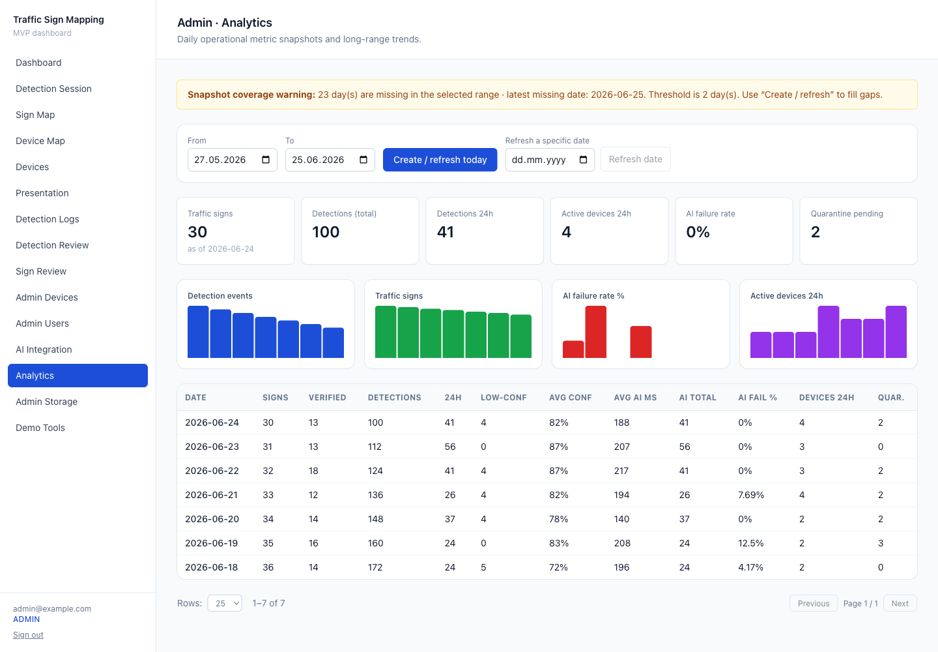
Fig. 4. Analytics screen with durable daily metrics, trends, and verification statistics.
VII. EXPERIMENTAL EVALUATION
A. Web/API Performance Evaluation
The first evaluation dimension concerns observable behavior of the web/API workflow. Relevant metrics are capture-to-upload time, upload latency, detection API response time, end-to-end processing time, dashboard update delay, average request payload size, failed upload rate, successful detection response rate, and browser compatibility.
End-to-end time is measured from the moment an observation is submitted by the web client to the moment the corresponding candidate becomes visible in the dashboard. This metric captures the practical responsiveness of the system as experienced by field users and administrators.
B. Geolocation, De-duplication, and Inventory Update Evaluation
The second evaluation dimension concerns the quality of inventory transformation. Relevant metrics include raw detection count, candidate sign count, final sign instance count, duplicate reduction ratio, observation count per sign, confidence distribution, approved candidate count, rejected candidate count, pending review count, and change-layer status distribution.
If labelled ground-truth sign positions are available, localization quality can be evaluated through mean error, median error, and the percentage of signs below fixed thresholds such as 5 m and 10 m. Without labelled ground truth, the system can still be evaluated for workflow correctness, de-duplication behavior, review traceability, and implementation validation.
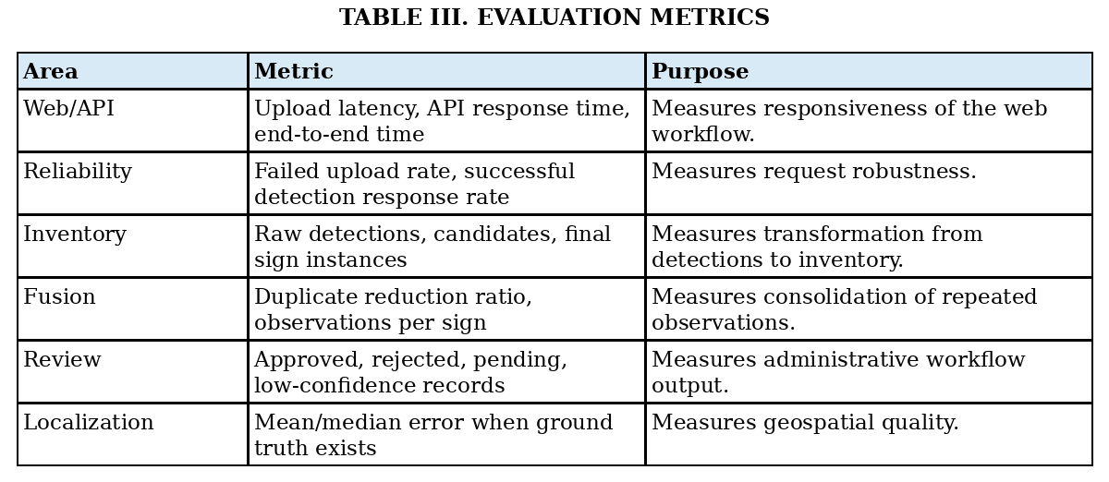
VIII. RESULTS AND ANALYSIS
The current implementation was validated as a working web platform rather than as a detector benchmark. The application was tested against a real Supabase backend with migrations 0001-0006 applied, the expected tables and analytics functions present, a private storage bucket configured, an administrator account available, and demo data seeded for presentation and testing.
A representative seeded run contains 4 devices, 6 sessions, 120 detection events, 35 signs, and 7 daily metric snapshots. These counts demonstrate data-flow coverage and dashboard population; they are not detection-performance measurements. The end-to-end Playwright suite passed 24 of 24 cases, and the project completed linting, type checking, and production build with 54 application routes built.
The implemented dashboard demonstrates the core workflow: detections are ingested, persisted, grouped into sign records, visualized on an interactive map, and exposed for administrative review. The storage design avoids permanent public image URLs and uses server-generated signed URLs. The analytics layer provides durable daily snapshots and trend views. The review interface supports inspection of individual detection records and sign-level decisions.
The results indicate that the proposed architecture is technically feasible for transforming detection outputs into a web-managed inventory workflow. The next experimental step is to collect field data with labelled reference signs and compute localization and de-duplication metrics using the evaluation protocol in Section VII.
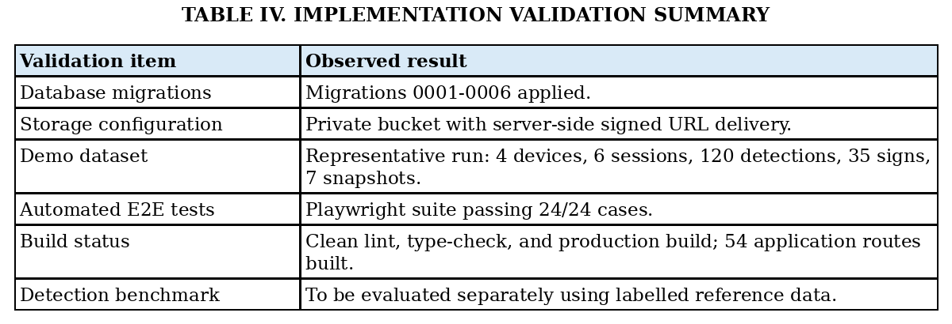
IX. DISCUSSION
The main observation from the implementation is that inventory management requires a broader pipeline than image detection. Even when a detection API returns useful sign classes and confidence values, the system must still manage location uncertainty, repeated observations, duplicate grouping, evidence storage, user roles, administrative validation, analytics, and data lifecycle governance.
The server-side web architecture is suitable for this type of system because it centralizes security-sensitive operations. Object storage remains private, secrets stay on the server, model responses are validated before persistence, and administrative operations are role-gated. The web client remains a deployable interface for data collection and dashboard interaction, while the backend controls the inventory workflow.
The change-layer approach is also important for trust. A single observation should not immediately modify an operational traffic-sign inventory. Instead, uncertain changes are represented as candidates that can be reviewed, merged, corrected, or rejected. This design is consistent with the uncertainty of crowd-source or mobile observations and with practical public-administration workflows.
X. LIMITATIONS AND FUTURE WORK
The current implementation uses same-type proximity matching and application-level grouping. Larger inventories would benefit from spatial indexing and server-side spatial clustering, for example through PostGIS. The map currently loads bounded data volumes; larger deployments should introduce server-side tiling or aggregation. Demo detections may not include real image evidence in every case, so field-data evaluation should use real captured images and reference signs.
The detector is used through an API contract, and this paper evaluates the surrounding inventory-management framework. A separate labelled evaluation should measure model accuracy, sign localization error, duplicate reduction, and review outcomes under real field conditions. Future work should also support model versioning, multiple detector backends, active learning from low-confidence cases, trajectory-based validation, and improved road-network matching.
XI. CONCLUSION
This paper presented a server-side web framework for converting traffic-sign detection outputs into a geospatial, de-duplicated, reviewable, and dashboard-managed inventory. The framework uses a mobile browser-based collection workflow, a detection API, secure media handling, geospatial candidate generation, duplicate grouping, location refinement, administrative review, and analytics. The implementation demonstrates that traffic-sign detection can be operationalized as an inventory system when combined with storage security, backend validation, map visualization, change-layer management, and human-in-the-loop review.
The resulting contribution is a practical system layer around traffic-sign detection: it transforms image-level predictions into auditable road-asset records and prepares the foundation for future field evaluation using measured web/API response, localization, and inventory-update metrics.
REFERENCES
[1] J. Stallkamp, M. Schlipsing, J. Salmen, and C. Igel, "Man vs. computer: Benchmarking machine learning algorithms for traffic sign recognition," Neural Networks, vol. 32, pp. 323-332, 2012.
[2] S. Houben, J. Stallkamp, J. Salmen, M. Schlipsing, and C. Igel, "Detection of traffic signs in real-world images: The German Traffic Sign Detection Benchmark," in Proc. IEEE Int. Joint Conf. Neural Networks, 2013.
[3] J. Redmon, S. Divvala, R. Girshick, and A. Farhadi, "You Only Look Once: Unified, Real-Time Object Detection," in Proc. IEEE Conf. Computer Vision and Pattern Recognition, 2016, pp. 779-788.
[4] S. Ren, K. He, R. Girshick, and J. Sun, "Faster R-CNN: Towards Real-Time Object Detection with Region Proposal Networks," in Advances in Neural Information Processing Systems, 2015.
[5] W. Liu et al., "SSD: Single Shot MultiBox Detector," in Proc. European Conf. Computer Vision, 2016, pp. 21-37.
[6] M. Soilán, B. Riveiro, J. Martínez-Sánchez, and P. Arias, "Automatic road sign inventory using mobile mapping systems," Int. Arch. Photogramm. Remote Sens. Spatial Inf. Sci., vol. XLI-B3, 2016.
[7] J. Balado, M. Díaz-Vilariño, L. Meijers, and P. Arias, "Automatic traffic signs inventory using a mobile mapping system," Remote Sensing, vol. 12, no. 3, 2020.
[8] F. Gaspari et al., "Mobile mapping solutions for the update and management of traffic signs in a road cadastre free open-source GIS architecture," Int. Arch. Photogramm. Remote Sens. Spatial Inf. Sci., vol. XLVIII-4/W7-2023, pp. 61-66, 2023.
[9] C. M. Pedersen and K. Torp, "Geolocating traffic signs using large imagery datasets," in Proc. ACM SIGSPATIAL Int. Conf. Advances in Geographic Information Systems, 2021.
[10] C. M. Pedersen and K. Torp, "Geolocating traffic signs using crowd-sourced imagery," in Proc. ACM SIGSPATIAL, 2020.
[11] H. Hu, H. Wu, S. Huang, W. Huang, and C. Liu, "Incremental crowd-source data fusion and map update method based on driving data for traffic signs," Int. Arch. Photogramm. Remote Sens. Spatial Inf. Sci., vol. XLVIII-G-2025, pp. 641-647, 2025.
[12] Leaflet, "Leaflet Documentation," https://leafletjs.com, accessed 2026.
[13] OpenStreetMap Foundation, "OpenStreetMap," https://www.openstreetmap.org, accessed 2026.
[14] Supabase, "Supabase Documentation," https://supabase.com/docs, accessed 2026.
[15] PostgreSQL Global Development Group, "Row Security Policies," PostgreSQL Documentation, https://www.postgresql.org/docs/current/ddl-rowsecurity.html, accessed 2026.
[16] PostGIS Project, "PostGIS Documentation," https://postgis.net/documentation/, accessed 2026.
[17] X. Wu, L. Xiao, Y. Sun, J. Zhang, T. Ma, and L. He, "A survey of human-in-the-loop for machine learning," Future Generation Computer Systems, vol. 135, pp. 364-381, 2022.
[18] World Health Organization, Global Status Report on Road Safety 2023, Geneva, Switzerland: WHO, 2023.

