Trail Making Test Experiment Report
Method:
both participant B and A (Participant A is me) did the same TMT tasks twice, and the results and the participant’s thought process has been interviewed and taken notes. In their first attempt they did the TMT test exactly as intended, and in the 2nd TMT test they were given a cheat sheet where they can look to the order of the alphabet. And don’t have to spend time actively recalling the order of the letters.

Participant | Attempt | Task | Duration | Mistakes
Subject A | 1 | a | 24 sec | 1
Subject A | 1 | b | 73 sec | 6
Subject A | 2 | a | 29 sec | 2
Subject A | 2 | b | 52 sec | 0
Subject B | 1 | a | 20 sec | 0
Subject B | 1 | b | 53 sec | 1
Subject B | 2 | a | 18 sec | 0
Subject B | 2 | b | 52 sec | 1
Subject C | 1 | a | 14 sec | 1
Subject C | 1 | b | 36 sec | 0
Table 1: TMT results Subject A being myself
Assumed Mental Model for TMT-A:
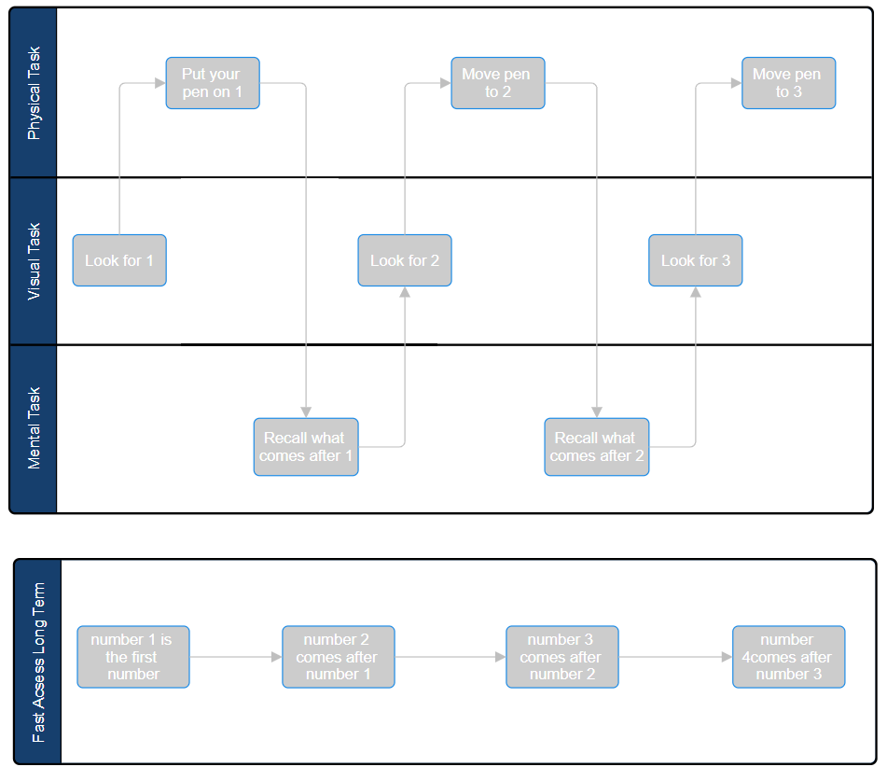
Flowchart 1: the initial assumed mental model for TMT-A task, the participant first looks for number 1 to start then he looks moves his pen to that location, then he fast recalls the number after 1 (this is a very fast recalling process so it also doesn’t need to be specified in time consuming cases) then he looks for that number, then he moves their pen to that location and so on

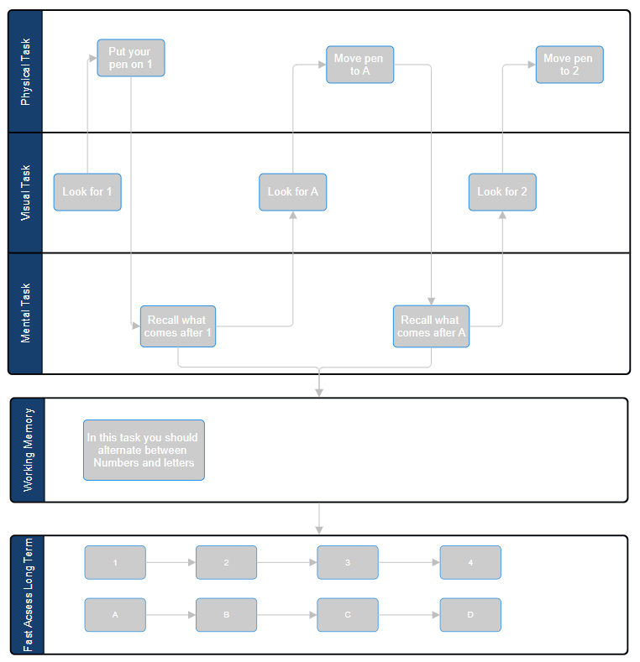Flowchart 2: the initial assumed mental model for task TMT-B task. The person first stores the knowledge in his working memory that the order goes number -> letter -> number -> letter. With that stored information he searches for one, then he recalls the next element, he quickly accesses the information that he will be looking for a letter now, and he recalls the first letter. Then does the same visual search and physical movement task. Then he recalls he will be looking for a number next. He repeats the steps for the TMT-B task.

Thought Process of participants
Subject A:
personal notes on my thought process (Subject A): Participant A claimed that he thought sequentially and didn’t consider the positions on every point in the TMT map (Meaning he only looked for the next number when he was doing area search).
However, He claimed that in TMT-B task he in addition thought about the next letter or the number in the task (if he is looking for point 3, he also stores the knowledge that he will be looking for C next). The reason he claimed is that he doesn’t store the knowledge of the order of the alphabet in a very fast access memory, so he said he prepares for the next mental recalls of the alphabet when he is searching (In a way like he is multitasking, searching for a point and trying to recall on the next number/letter to make the next task faster)

Commentary on Subject A:
I realized that the speed of recall for alphabetical order might be slower for some participants, in addition some participants recall the order of the alphabet beforehand and store the short order (e.g. storing only the knowledge L comes after K) when doing a visual search task.
For this participant we can assume a parallel mental model (or a sequential but parallel looking (such as quickly changing the attention of the brain between tasks)) that when doing a visual search for a number/letter or a physical task some part of the brain can look for the next order of the letters and store them in the working memory.

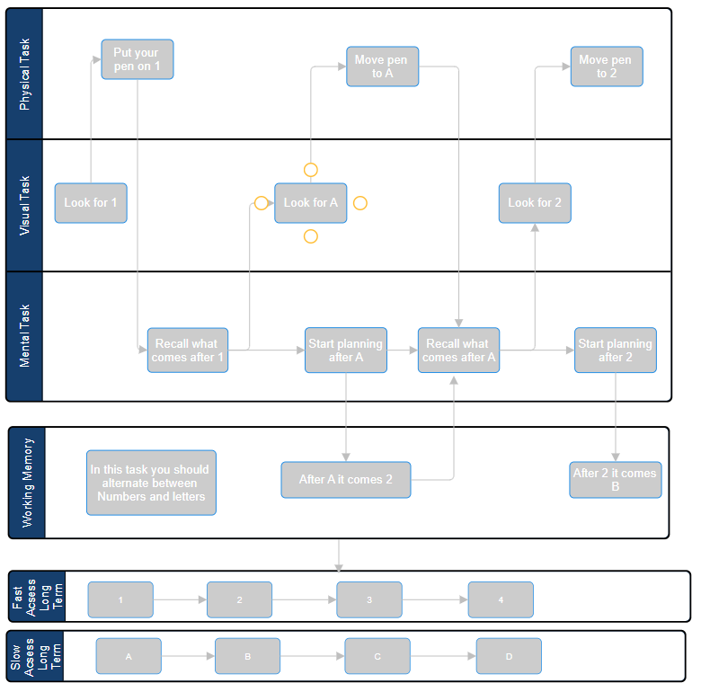
Flowchart 3: Updated TMT-B flowchart model for the participant A

Subject B:
Participant claimed that he separated his brain into 2 parts; he claimed that 1st part did the visual that tracks the next point to make a trail on. The 2nd part activated when he saw clustered sequential points (e.g. number 12,13,14 all in close similar locations), and he claimed that he recorded the positions of the patterns to his memory so he can save time and directly recall the positions of the clustered numbers.
For task TMT-B he claimed that he couldn’t do the clustering as easy as the TMT-A task. Instead he focused on one part of his brain In doing visual search and the other part in remembering the next location of the points.

Commentary on Subject B:
While the task TMT-B was similar between the two subjects, Subject B claimed to follow a different method of solving in the TMT-A task. My opinion about this approach is that the participant may have used his visual memory to store more info about the position of the clusters sacrificing his visual search capacity (Due to visual memory holding only around 3+-1 items). One other hypothesis that comes to mind is that instead of visual memory, he used his working memory to store the locations of the clusters.
Another opinion on this matter is that, he might have sacrificed his capability to find the next element while he was also looking for patterns. (he divided his attention between two thing which might halt his efficiency in searching for specific element).
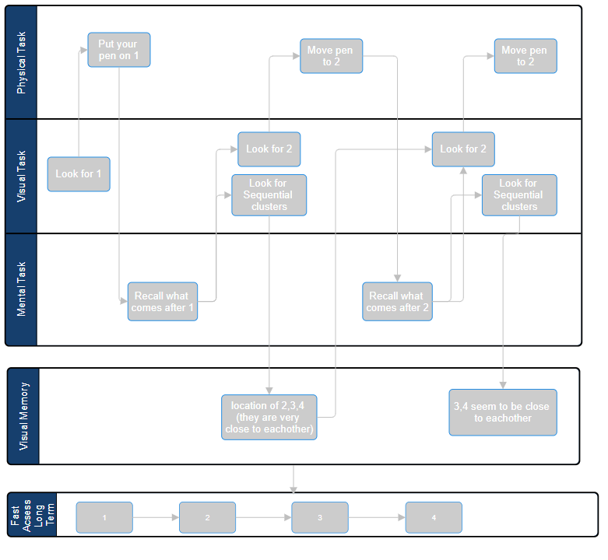
Flowchart 4: Updated TMT-A flowchart model for the participant B

Parameters that might affect TMT scores:
speed of the pen, speed of the recalling memory, number of visual items seen, knowledge about the order, search method used (for example only looking for the next number, or creating a map of the sequential numbers as well so it can be faster later).

References:
The Trail Making Test (TMT): https://www.cognifit.com/battery-of-tests/trail-making-test?srsltid=AfmBOoo3EPifdOVobDrhzNLCzwVTaY4GESsdLXaIbLb2ZWpBw9Y9RCCB

P.S
One thing I am having difficulty is to know weather the long term memory might have difficulty recalling elements from its inside. And does the knowledge 2 comes after 1 stored in the long term memory.

Literature Scanning:
Administration and interpretation of the Trail Making Test
Accessible At: https://www.researchgate.net/publication/6416422_Administration_and_interpretation_of_Trail_Making_Test
Errors aren’t usually contributed much to the result and ignored. While part A is focused on the visual search task. The Part B has the challenge of ability to switch tasks and mental flexibility. And part B demands more visual search. Even if you told the patient to ignore the letters it would be still difficult to complete the task because of the presence of unwanted stimuli
TMT can be used in intelligence test and detection of cognitive impairment
TMT is also correlated with aged related declines.
In addition to Age and Intelligence, the Occupation and Education level can also affect the TMT results.
The TMT-B showed that in EEG test the brain activated the left dorsolateral prefrontal cortex and supplementary motor area/cingulate sulcus, which are areas postulated to be sensitive to executive functioning, particularly cognitive ﬂexibility (Personal Note: I believe EEG signals aren’t much accurate in the tasks that related to attention do to wavelengths of attention being in gamma band and EEGs cannot capture that band)
There is also Cohort TMTs however the TMT part B isn’t compatible with colours. (On personal note: results of colour-based TMTs can be drastically different than Numbers Due to colours having Bottom-Up type of attention)

VALIDITY OF TMT AS AN ORGANIC BRAIN DAMAGE
https://www.scribd.com/document/467521813/reitan1958-TMT (THERE ARE ADS IN THE PAGES)

there was a 200 group of patients with diagnosed symptoms and 84 patients with complaints on brain damage but no diagnosed. As expected, the mean of the 84 undiagnosed patients was significantly greater than the mean of brain-damaged 200 patients.
(Personal Note: upon further inspection of the data, I see that SD of the brain-damage group is 3.11 and Control group is only 1.13. meaning that although means have a noticeable difference, the correlation would not work from other way. In other words, it wouldn’t be accurate to diagnose someone with brain damage just by looking at the TMT score)

