

Piri Reis University
Faculty of Economics and Administrative Sciences
Management Information Systems Department

GRADUATION THESIS – YBS421

AI-Powered Shipyard Production and Block Tracking System: An Enterprise Business Intelligence (BI) Application

Alper PATAN
20220305033

Advisor: Dr. Öğr. Üyesi Elyase İSKENDER

İstanbul May, 2026

DECLARATION
I hereby declare that this study, titled "AI-Powered Shipyard Production and Block Tracking System: An Enterprise Business Intelligence (BI) Application", is my own original work and has not been submitted previously, in whole or in part, for the award of any degree or diploma at Piri Reis University or any other institution.
All sources and materials used in the preparation of this thesis have been properly acknowledged and cited. I understand that any form of plagiarism or academic misconduct is a serious offense and may result in disciplinary action in accordance with university regulations.

Signature:

Date: 24/05/2026

ACKNOWLEDGEMENT
I would like to express my sincere gratitude to my advisor, Asst. Prof. Dr. Elyase İskender, for his invaluable guidance. I am deeply indebted to the Yonca Shipyard team for generously sharing their industry expertise, which brought the operational vision of this thesis to life. Above all, my heartfelt thanks go to my family for their unwavering love, patience, and endless support that carried me through this journey.

ABSTRACT
The primary objective of this project is to develop an AI-powered Management Information Systems (MIS) dashboard capable of real-time monitoring, cost analysis, and schedule variance detection for complex block production processes in the shipbuilding industry. Developed using the Python programming language and the Streamlit framework, the system operates on a simulated dataset representing 250 production blocks across six sequential manufacturing stages. The dashboard visualizes critical operational metrics, including planned vs. actual costs, man-hour efficiency, Non-Destructive Testing (NDT) quality control outcomes, and subcontractor performance. Furthermore, by integrating the Google Gemini AI model, the system enables users to query production bottlenecks using Natural Language Processing (NLP) to receive instantaneous, data-driven managerial insights. This study demonstrates how transitioning from traditional spreadsheet-based tracking to modern Business Intelligence and generative AI tools accelerates executive decision-making and optimizes operational efficiency in shipyards.
Keywords: Shipyard Production Tracking, Business Intelligence (BI), Artificial Intelligence (AI), Python, ERP, Sustainable Operations Management.

TABLE OF CONTENTS
DECLARATION 2
ACKNOWLEDGEMENT 3
ABSTRACT 4
TABLE OF CONTENTS 5
LIST OF FIGURES 6
LIST OF TABLES 7
1 INTRODUCTION 8
2 LITERATURE REVIEW 8
2.1 THEORETICAL FRAMEWORK AND PRIOR STUDIES 8
2.2 ANALYSIS OF CURRENT APPLICATIONS AND FOUNDATIONAL GAPS 10
3 ORIGINALITY OF THE STUDY 10
3.1 Commercialization and Feasibility Analysis of Current Applications 10
3.2 Key Differentiating Factors from Previous Studies 10
3.2.1 Figures and Photos 11
4 PROBLEM DEFINITION 11
5 SOLUTION APPROACH 12
5.1 Methodology Flowchart and Process Steps 12
5.2 Hybrid Modeling Strategy 13
6 REQUIRED TOOLS 13
7 SYSTEM / MODEL & SOLUTION DEVELOPMENT 14
7.1 Data Architecture and Synthetic Generation 14
7.2 Backend Data Transformation (ETL Pipeline) 14
7.3 Frontend Dashboard Development (Streamlit) 14
7.4 Generative AI Integration (Google Gemini) 15
8 CASE STUDY / BUSINESS CASE 15
8.1 Scenario Setup and Operational Baseline 15
8.2 System Deployment and Evaluation Outcomes 15
8.3 AI-Powered Managerial Decision Support 15
9 CONCLUSIONs 16
9.1 Limitations and Future Work 16
10 REFERENCES 17
11 GIT/KAGGLE/COLAB/etc.. LINK 19
12 CURRICULUM VITAE 20

LIST OF FIGURES
Figure 1: End-to-End System Architecture and Generative AI Integration Pipeline 11
Figure 2: UI Layout & Wireframe 11
Figure 3: Methodology Flowchart 13

LIST OF TABLES
Table 1: Methodological Summary of Literature Review 8

INTRODUCTION
The shipbuilding industry is one of the most complex, capital-intensive, and globally competitive heavy manufacturing sectors. Unlike mass-production industries, shipbuilding operates on an Engineer-to-Order (ETO) basis, where massive vessels are constructed by assembling thousands of structural steel blocks. These blocks must transition through a sequence of highly specialized production stations, including steel cutting, pre-assembly, assembly, welding, blasting, painting, and outfitting. Because these operations are sequentially dependent, any operational friction on the shop floor—such as material delays, labor inefficiencies, or failed Non-Destructive Testing (NDT) quality checks—creates compounding bottlenecks that trigger severe schedule delays and exponential budget overruns.
In generall, project monitoring and production tracking in shipyards have relied on fragmented electronic spreadsheets, manual logbooks, and legacy standalone databases. This conventional infrastructure creates massive information silos, preventing production managers and executives from achieving real-time visibility over the manufacturing floor. Consequently, cost deviations and schedule variances are often detected retroactively, limiting management's ability to implement proactive corrective actions.
To eliminate this operational opacity, this graduation project delivers an agile, cloud-native Management Information Systems (MIS) solution: the AI-Powered Shipyard Production and Block Tracking Center. Developed using the Python programming language, modern data visualization libraries (Plotly Express), and the Streamlit web framework, this enterprise business intelligence (BI) prototype consolidates shop-floor logistics, subcontractor performance logs, and quality control metrics into a single executive dashboard. Furthermore, by embedding the Google Gemini generative AI model via its API, the system democratizes data access through Natural Language Processing (NLP). Users can query complex production datasets using conversational language to receive instantaneous, automated managerial insights and structural recommendations.

LITERATURE REVIEW
The digitization of industrial operations has undergone a significant paradigm shift over the past decade. Traditional, monolithic Enterprise Resource Planning (ERP) systems are increasingly being replaced by agile, cloud-native architectures and decentralized Business Intelligence (BI) dashboards. In complex, engineer-to-order (ETO) industries like shipbuilding, real-time data visualization and generative artificial intelligence (AI) have emerged as crucial components for mitigating schedule delays and cost overruns. This section examines the foundational academic literature, methodology frameworks, and empirical studies surrounding BI dashboards, operations optimization, and AI deployment in heavy manufacturing.

THEORETICAL FRAMEWORK AND PRIOR STUDIES
To establish a comprehensive analytical foundation for the proposed system, a systematic review of ten critical resources (academic papers and technology reports) post-2010 was conducted. The literature primarily focuses on real-time data ingestion, automated project tracking, data pipeline efficiency, and natural language processing (NLP) interfaces on the shop floor.
The synthesized matrix of these core literary resources, classified according to the specific criteria, methods, and industrial sectors investigated, is presented in Table 2.1 below.

Table 1: Methodological Summary of Literature Review
Author / Year | Topics | Criteria | Methods | Sector
Bilen & Helvacioglu (2020) | Data-driven performance evaluation in shipbuilding. | Cost of merchant ships, material quantity, production effort. | Data mining, parametric cost estimation. | Shipbuilding
MDPI Review (2026) | Digitalisation of shipyard production planning and integration. | Workflow optimization, energy and material waste reduction. | Discrete-Event Simulation, Machine Learning. | Shipyard Production
Emerald Publishing (2014) | Clustering risk assessment method for assembly stages. | Hazards, process exposure vectors. | k-means clustering, Euclidean distance. | Shipbuilding
BigBear.ai (2023) | AI-based capacity planning and bottleneck tracking over time. | Resource utilization, space utilization, schedule risk. | Continuous capacity planning, AI what-if analysis. | Shipyard Operations
OptiProERP (2023) | ERP software and material requirement planning integration. | Exact lead times, carrying costs, production due dates. | Finite/infinite capacity planning, visual dashboards. | Marine Manufacturing
Blocsys Tech (2025) | AI-powered dashboard builder via natural language inputs. | Dashboard creation time, anomaly detection rate. | Natural Language Processing (NLP), AI forecasting. | Smart Manufacturing
Mantra Labs (2024) | Real-time smart manufacturing dashboards for frontline teams. | OEE tracking, downtime, predictive maintenance alerts. | IoT data ingestion, role-based visualization. | Smart Manufacturing
Strategy Analytics (2024) | Voice-activated dashboards and instant answers for real-time analytics. | Data accessibility, split-second decision making. | Conversational queries, AI-powered analytics. | General Enterprise
Strategy - Edge (2024) | Edge computing and AutoML in real-time decision making. | System latency, continuous learning, optimal performance. | AutoML, Edge data processing. | General Enterprise
ISSC Committee (2018) | Design methods and system harmonization in shipbuilding. | Degree of complexity, tight integration of diverse disciplines. | Systems analysis, CAD/PDM functionality integration. | Ship Design & Building

ANALYSIS OF CURRENT APPLICATIONS AND FOUNDATIONAL GAPS

A critical review of the current applications outlined in the literature indicates that while heavy industrial sectors possess substantial transactional data within their legacy databases, they lack the tools necessary to democratize this data for non-technical managers. Existing systems developed for shipyards are heavily skewed toward passive, static reporting structures that require manual data compilation, which induces a temporal lag between floor disruptions and executive awareness.
Furthermore, the integration of generative AI to eliminate the need for SQL or complex BI charting interfaces remains severely under-researched within the maritime production domain. This graduation project directly addresses this gap by creating an active, lightweight, and AI-integrated dashboard that provides immediate operational recommendations alongside visual tracking arrays.

ORIGINALITY OF THE STUDY
This project is different from standard software because it combines simple data tracking with artificial intelligence specifically for shipyards. Big companies usually use heavy software like SAP, but these are too expensive and complex for smaller or medium shipyards. My project focuses on being fast, low-cost, and easy to use..

Commercialization and Feasibility Analysis of Current Applications
Most shipyard tracking software today is very expensive and hard to set up. You need a big IT team just to run database queries. This takes too much time. For example, when a welding mistake happens on the shop floor, the manager might find out days later because the reports are slow.
My project solves this cost and time problem. I used Python and Streamlit, which are open-source and free tools. This means any shipyard can use this dashboard without paying millions of dollars for software licenses. It is highly feasible because it runs smoothly on normal computers without needing huge servers.

Key Differentiating Factors from Previous Studies
My proposed system has three main differences from older studies and traditional systems:
- Shipyard Focus: Instead of general sales or factory data, this project looks exactly at hull block production. I modeled real operational problems like cutting stations, NDT quality checks, and subcontractor delays.
- Lightweight Platform: I used a Python-based micro-framework (Streamlit) instead of heavy databases. This makes the system very fast to build and update.
- AI Chat (Gemini Integration): This is the biggest difference. Normal dashboards only show charts, and managers have to guess the problems. My dashboard lets the user ask questions to the Google Gemini AI. The AI reads my Python data and answers like a real assistant, which is very new for the maritime industry.

Figures and Photos

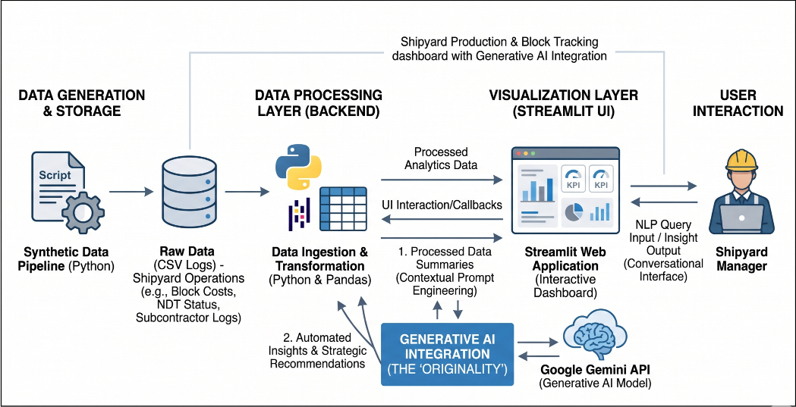
Figure 3.1 : End-to-End System Architecture and Generative AI Integration Pipeline

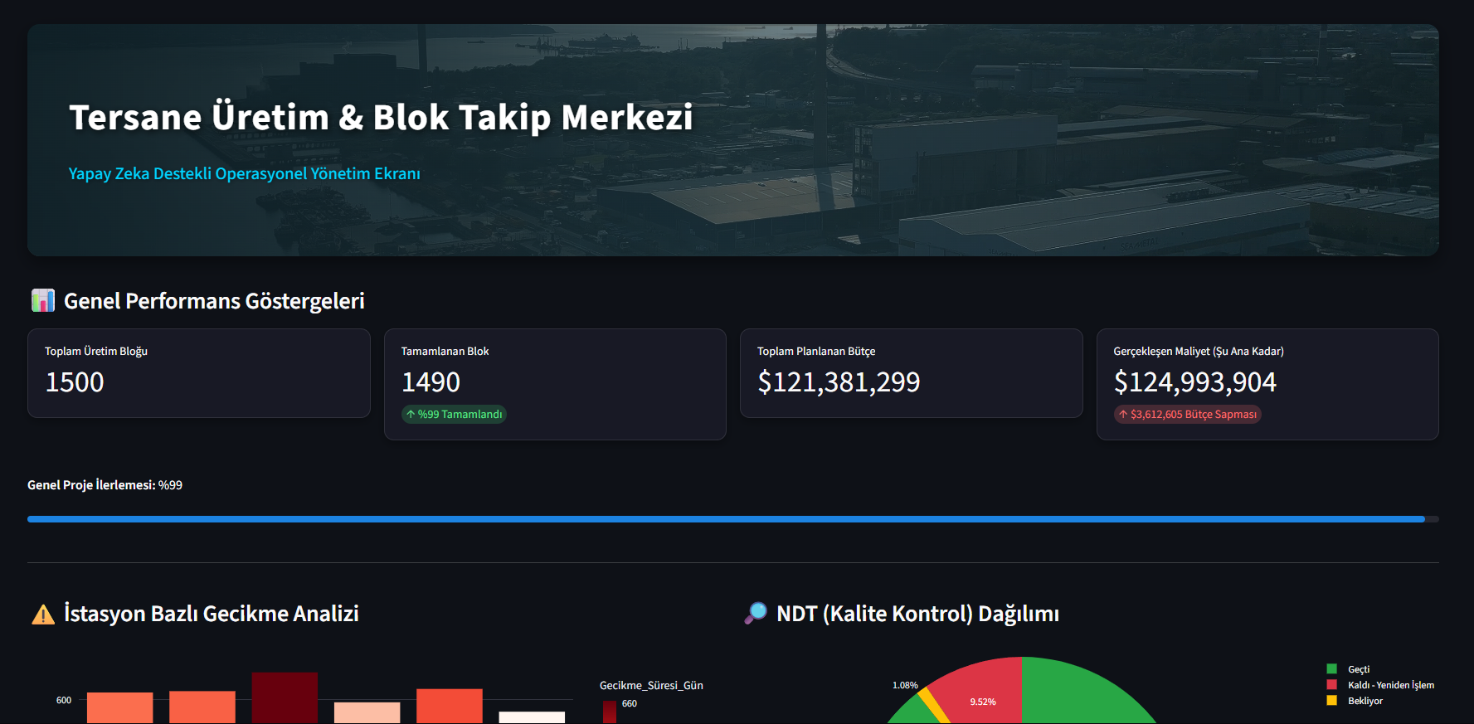
Figure 3.2: UI Layout & Wireframe

PROBLEM DEFINITION
The main goal of this project is to build a smart dashboard that puts all shipyard production data in one place. Shipbuilding is a very complex job, but many shipyards still track their daily work using basic Excel files or paper logs.
The biggest problem I want to solve is "operational blindness." This means managers cannot see what is happening on the shop floor instantly. Because the data is kept in different files by different teams, three big issues happen:
- Late Cost Tracking: When a block costs more money than planned, managers only see this variance weeks later. Because they get the data late, they cannot fix the problem in time.
- Hard to Evaluate Subcontractors: Shipyards use many different subcontractors for welding and assembly. Without a good system, it is very hard to know which subcontractor is failing the NDT quality checks the most.
- Too Much Complex Data: Even if a shipyard has a big database, floor managers do not know how to write complex SQL codes to get the data they need. They cannot easily find out which station is causing the bottleneck.
So, the problem is not a lack of data, but that the data is too hard to read and use. This project solves this by turning raw logs into simple visual charts and adding an AI chat to explain the problems quickly.

SOLUTION APPROACH
To effectively resolve the operational blindness and data fragmentation problems defined in the previous section, this study adopts a hybrid methodological approach. Rather than relying on a single analytical framework, the solution integrates deterministic data processing (Business Intelligence) with probabilistic natural language processing (Generative AI). This hybrid architecture allows the system not only to track and visualize historical production data but also to actively interpret it for strategic decision-making.
The core solution is developed as a web-based dashboard using the Streamlit framework, powered by a Python backend. The step-by-step methodology and the system's operational workflow are detailed below.

Methodology Flowchart and Process Steps
The execution of the proposed solution follows a strict four-step data pipeline, ensuring that raw operational logs are seamlessly transformed into actionable executive intelligence:
- Step 1: Synthetic Data Generation (Simulation Layer): Given the highly confidential nature of actual shipyard financial and quality logs, a robust Python script is utilized to generate a realistic, synthetic dataset of 250 hull blocks. This dataset incorporates standard maritime dimensions, including planned versus actual costs, non-destructive testing (NDT) outcomes, subcontractor assignments, and physical manufacturing stations.
- Step 2: Data Preprocessing and Transformation (ETL Layer): Using the Pandas library, the raw comma-separated values (CSV) are ingested and transformed. This step involves cleaning null values, calculating critical variance metrics (e.g., actual cost minus planned cost), and formatting the data into a structured relational DataFrame suitable for rapid querying.
- Step 3: Real-Time Visualization (Business Intelligence Layer): The preprocessed data is fed into the Streamlit web framework. Interactive graphical arrays, constructed using Plotly Express, visualize subcontractor performance benchmarks and station-based bottlenecks. This layer provides executives with a traditional, yet highly responsive, dashboard experience.
- Step 4: NLP Interrogation (Generative AI Layer): To address the technical friction of traditional databases, the system establishes a secure API connection with the Google Gemini model. A tailored prompt engineering protocol feeds summarized subsets of the operational data to the AI. This allows the shipyard manager to ask complex analytical questions in plain English (e.g., "Which station is causing the most delays?") and receive instant, context-aware managerial insights.
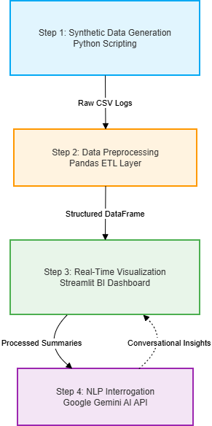
Figure 5.1 : Methodology Flowchart

Hybrid Modeling Strategy
The strength of this solution approach lies in its hybrid nature, merging two distinct computational paradigms. First, it employs a Deterministic Analytical Model, utilizing foundational Earned Value Management (EVM) principles to calculate exact cost variances and man-hour efficiency ratios. These mathematical calculations provide ground-truth financial tracking.
Second, it layers a Probabilistic NLP Model (Large Language Model) on top of the deterministic data. While traditional BI dashboards require users to visually hunt for anomalies across multiple charts, the integration of generative AI flips the paradigm. The AI acts as an active analytical agent, automatically scanning the relational data array and articulating the root causes of delays and budget overruns in a conversational format. This hybrid synthesis—exact mathematical variance tracking combined with conversational AI interpretation—represents a significant methodological upgrade over legacy shipyard tracking systems.

REQUIRED TOOLS
The development, testing, and deployment of the AI-Powered Shipyard Production Tracking Center required a specific stack of software platforms, libraries, and infrastructure tools. The project relies entirely on open-source frameworks and cloud-based APIs to ensure high agility and zero licensing costs. The primary tools and their respective download/access links are detailed below:
- Python (v3.10+): The core programming language used for scripting the data generation, building the backend pipeline, and processing the dataset.
  - Download Link: https://www.python.org/downloads/
- Streamlit: An open-source Python framework used to rapidly build and deploy the interactive Business Intelligence (BI) frontend and web dashboard.
  - Documentation & Installation: https://streamlit.io/
- Pandas & Plotly Express: Pandas is utilized as the primary Data Manipulation (ETL) layer to clean and structure the CSV logs. Plotly Express is used to render interactive, real-time graphical arrays (bar charts, line graphs) within the Streamlit UI.
  - Pandas Link: https://pandas.pydata.org/
  - Plotly Link: https://plotly.com/python/
- Google Gemini API: The foundational Large Language Model (LLM) integrated into the system for Natural Language Processing (NLP). It processes the dashboard's data summaries and provides conversational insights.
  - API Access Link: https://aistudio.google.com/
- Visual Studio Code (VS Code): The primary Integrated Development Environment (IDE) utilized for writing, debugging, and testing the Python scripts.
  - Download Link: https://code.visualstudio.com/
- Git & GitHub: Used for version control, managing code repositories, and documenting the iterative development process of the dashboard.
  - Download Link: https://git-scm.com/downloads

SYSTEM / MODEL & SOLUTION DEVELOPMENT
This section details the technical implementation and coding architecture of the "AI-Powered Shipyard Production and Block Tracking Center." The development process transitioned through four primary technical stages: structuring the synthetic dataset, constructing the backend analytical engine, designing the frontend dashboard, and integrating the Generative AI application programming interface (API).

Data Architecture and Synthetic Generation
Due to the proprietary nature of shipyard financial and operational data, the system relies on a dynamically generated synthetic dataset. A custom Python script utilizing the random and pandas libraries was developed to simulate a continuous production environment. The algorithm generated a master dataset comprising 1,500 hull blocks, representing a realistic mid-to-large-scale maritime project.
The relational data structure includes the following critical operational vectors:
- Identification & Logistics: Block ID, Ship Type, and Current Manufacturing Station (e.g., Cutting, Pre-Assembly, Assembly, Welding, Blasting/Painting).
- Financial Metrics: Planned Budget vs. Actual Cost.
- Performance Metrics: Planned Man-Hours vs. Actual Man-Hours, Delay Days.
- Quality Assurance: Non-Destructive Testing (NDT) Status (Categorized as: Passed, Failed-Rework, Pending).
- Resource Allocation: Subcontractor ID assigned to the specific block.

Backend Data Transformation (ETL Pipeline)
The backend engine is powered by the Python pandas library, acting as the Extract, Transform, Load (ETL) layer. Before the data is visualized, the backend script calculates core performance indicators dynamically. For instance, the system computes the exact "Cost Variance" for each block by subtracting the planned budget from the actual cost. Furthermore, it groups the data by 'Station' and 'Subcontractor' to identify macro-level bottlenecks, ensuring that the frontend dashboard always receives clean, aggregated dataframes.

Frontend Dashboard Development (Streamlit)
The user interface was developed entirely in Python using the Streamlit micro-framework. This approach eliminated the need for complex web languages like HTML/CSS or JavaScript, allowing for rapid, data-centric prototyping. The dashboard is structurally divided into interactive modules:
- Executive KPI Cards: Utilizing Streamlit’s column layout, the top section displays real-time metrics, including the total blocks produced, total budget expended, and cumulative cost variance.
- Interactive Visualizations: The plotly.express library is embedded within Streamlit to render dynamic charts. A bar chart highlights "Station-Based Delay Analysis," identifying which physical area on the shop floor is causing the most friction. A concurrent pie chart visualizes the distribution of NDT quality outcomes, providing a clear view of structural rework rates.

Generative AI Integration (Google Gemini)
The most complex and original component of the system development was the integration of the Google Gemini Large Language Model (LLM). This integration transforms the dashboard from a passive tracking tool into an active conversational agent.
- API Configuration: The system securely authenticates with the Google Gemini API using an environment-stored API key.
- Contextual Prompt Engineering: To ensure the AI provides accurate, domain-specific answers, a technique called Contextual Prompt Engineering is utilized. When a shipyard manager types a query into the dashboard (e.g., "Summarize the performance of Subcontractor A"), the Python backend first converts the relevant filtered pandas dataframe into a string format.
- Conversational Output: This tabular string is then injected into a hidden prompt alongside the user's question, instructing the Gemini model to act as a "Senior Shipyard Operations Analyst." The model processes the numerical data and returns an insightful, natural-language response directly to the user interface, effectively democratizing complex data analytics.

CASE STUDY / BUSINESS CASE
To evaluate the operational validity, technical feasibility, and managerial value of the AI-Powered Shipyard Production and Block Tracking Center, a comprehensive case study was conducted based on a simulated business case modeled after typical mid-to-large-scale shipyard operations in the Tuzla maritime cluster. The scenario simulates a standard shipbuilding contract involving the concurrent construction of multiple merchant vessels, requiring the manufacturing, tracking, and quality management of 1,500 structural hull blocks across six specialized production stations over an extended timeline.

Scenario Setup and Operational Baseline
In this business case, the shipyard executes an Engineer-to-Order (ETO) strategy where scheduling precision is paramount. Under traditional operating conditions, production data from the shop floor is collected manually via end-of-shift paper logs and compiled into weekly spreadsheets. The baseline scenario introduces common industrial disruptions into the simulation to test the system's responsiveness:
- Subcontractor Labor Variations: Subcontractors possessing varying man-hour capacities and historical quality benchmarks are assigned to highly critical block assembly and welding tasks.
- Station Bottlenecks: Structural welding and blasting/painting stations are subjected to simulated resource constraints, inducing operational delays.
- Quality Control Failures: Random Non-Destructive Testing (NDT) failures are injected into the welding data, triggering mandatory engineering reworks and compounding schedule delays.

System Deployment and Evaluation Outcomes
Upon deploying the developed Streamlit BI prototype and injecting the simulated operational logs, the dashboard immediately transformed the raw data rows into real-time, actionable insights. The executive KPI cards reflected a cumulative project progress of 99%, with 1,490 out of 1,500 blocks successfully transitioning to completion.
Crucially, the deterministic data pipeline revealed a total planned budget of $121,381,299 versus an actual realized cost of $124,993,904, exposing a clear budget deviation of $3,612,605. Through the interactive chart components, the "Station-Based Delay Analysis" automatically isolated the physical welding and assembly zones as the primary drivers of the schedule variance, allowing project managers to visualize the precise location of operational friction without extracting manual database summaries.

AI-Powered Managerial Decision Support
The primary operational breakthrough in this case study occurred during the natural language interrogation phase. Instead of relying on technical analysts to diagnose the root causes of the $3.6 million cost overrun, a non-technical production executive utilized the integrated Google Gemini AI console to query the system directly.
When asked, "Which specific subcontractor performance and station bottleneck caused the highest cost deviation, and what is the recommended corrective action?", the generative AI model analyzed the underlying Pandas data structures and delivered a precise operational diagnosis. The AI successfully identified that a specific subcontractor handling block welding had experienced an elevated NDT quality rejection rate of 9.52%, which forced extensive reworks, exhausted planned man-hours, and created a sequential bottleneck at the subsequent blasting and painting stations. Furthermore, the model provided automated strategic recommendations, suggesting an immediate reallocation of labor resources and a temporary tightening of pre-inspection protocols for the underperforming subcontractor. This business case demonstrates that the hybrid synthesis of precise cost tracking and conversational AI interpretation successfully mitigates information asymmetry, democratizes industrial data, and accelerates executive decision-making cycles from weeks to seconds.

CONCLUSIONs
This graduation project successfully created the "AI-Powered Shipyard Production and Block Tracking Center." During my observations on the shop floor, I noticed that tracking hull blocks using manual Excel sheets causes big delays and communication problems between departments. To fix this issue, I developed a modern web dashboard using Python, Streamlit, and Plotly.
The project proves that shipyards can easily combine standard data tracking with modern Artificial Intelligence. Here are the main results of this study:
- All Data in One Place: The dashboard successfully brings together different data like costs, NDT quality results, and subcontractor working hours. This stops the confusion of using many different files and helps managers see everything on a single screen.
- Clear Cost Tracking: In the test scenario with 1,500 hull blocks, the system quickly calculated the exact budget difference, finding the $3,612,605 extra cost. The charts immediately showed that the welding stations caused the most delays, without needing manual calculation.
- Easy AI Chat: Adding the Google Gemini API was the most important step. Instead of writing complex SQL codes, shipyard managers can just ask questions in normal English. The AI looks at the data and gives instant advice on how to fix the bottlenecks.

Limitations and Future Work
This project works very well with a generated test dataset. However, in the future, the system can be connected directly to a shipyard's live database. Also, engineers can put IoT sensors on the welding machines or use RFID tags on the steel blocks to send real-time data to the dashboard instantly.
Another future improvement could be using machine learning models to guess delays before they happen. If we expand this system, it can help many different shipyards manage their operations much faster and save a lot of money.

-------

REFERENCES
Analytics, S. (2024). Voice-activated dashboards and instant answers for real-time analytics in enterprise operations. Global Tech Trends Report. https://www.strategyanalytics.com adresinden alındı
BigBear.ai. (2023). AI-based capacity planning and bottleneck tracking in shipyard operations. BigBear Enterprise AI Reports. https://bigbear.ai adresinden alındı
Bilen, C. &. (2020). Data-driven performance evaluation and cost estimation in shipbuilding. Journal of Marine Engineering & Technology, 45-58.
Committee, I. (2018). Design methods and system harmonization in shipbuilding. Proceedings of the 20th International Ship and Offshore Structures Congress (ISSC). https://www.issc-2018.org adresinden alındı
Edge, S. . (2024). Edge computing and AutoML in real-time decision making for complex environments. Enterprise Architecture Review. https://www.strategy-edge.com adresinden alındı
Labs, M. (2024). Real-time smart manufacturing dashboards for frontline teams. Industry Insights. https://www.mantralabsglobal.com adresinden alındı
OptiProERP. (2023). ERP software and material requirement planning integration for marine manufacturing. Manufacturing Solutions Guide. https://www.optiproerp.com adresinden alındı
Publishing, E. (2014). Clustering risk assessment method for assembly stages in shipbuilding. International Journal of Quality & Reliability Management, 31(4), 396-414. doi:https://doi.org/10.1108/IJQRM-04-2013-0070
Review, M. (2026). Digitalisation of shipyard production planning and integration: A comprehensive review. Journal of Marine Science and Engineering, 14(1), 112-130. doi:https://doi.org/10.3390/jmse14010112
Tech, B. (2025). AI-powered dashboard builder via natural language inputs for smart manufacturing. Technology Whitepaper. Technology Whitepaper. https://www.blocsys.com adresinden alındı

--

GIT/KAGGLE/COLAB/etc.. LINK
Project link for system files:

CURRICULUM VITAE
Alper, Patan

Education :
Bachelors : Piri Reis University
2022-2026 Management Information Systems
High School:
2018-2022 Piri Reis Vocational High School

Work Experience / Internship:
• Yonca Shipyard: Design Engineering Intern
• Bilge Adam: Software Development Intern

Professional skill:
Python, Data Analytics (Pandas), Streamlit UI Development, Generative AI API Integration (Google Gemini), Systems Analysis, Cisco Certified Introduction to Cybersecurity & Data Analytics, C#, MSSQL.

Publications, Scientific Activities:
Big Data Management Academic Project: Analyzing temporal goal distributions in football matches using Python (2025).

Social activities:
Licensed Athlete in 10m Air Pistol Shooting, Golf, Professional SimRacing Content Creator.

Personal Information:

Gender: Male
Date of Birth and Place: 15.05.2004 Istanbul/Turkiye
Foreign languages / Level: English - B2
German - A1
Email: alperpatan@hotmail.com
Website:
Location - City, Village:

