This Project builded for lecture work and the Project is an house control application with arduino and C#.

House Control

Programming Languages C#

Alperen KAYA / 2016514043

Cukurova University

26.12.2020

**Ev Kontrol**

**Form1: Main Screen**

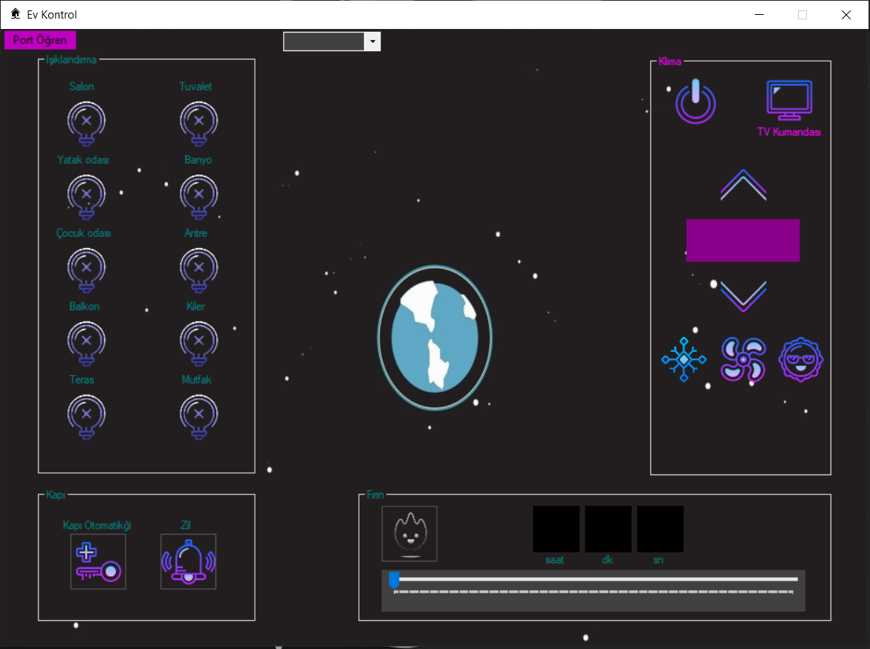

**Figure_1: Form1**

**Tool List:**

x20 butons

1 Menu Strip

1 Combo Box

1 Track Bar

x4 Group Boxes

x4 Text Boxes

x16 Labels

1 Timer

1 Serial Port

1 Image List

**Code:**



**Form1: Tagged**

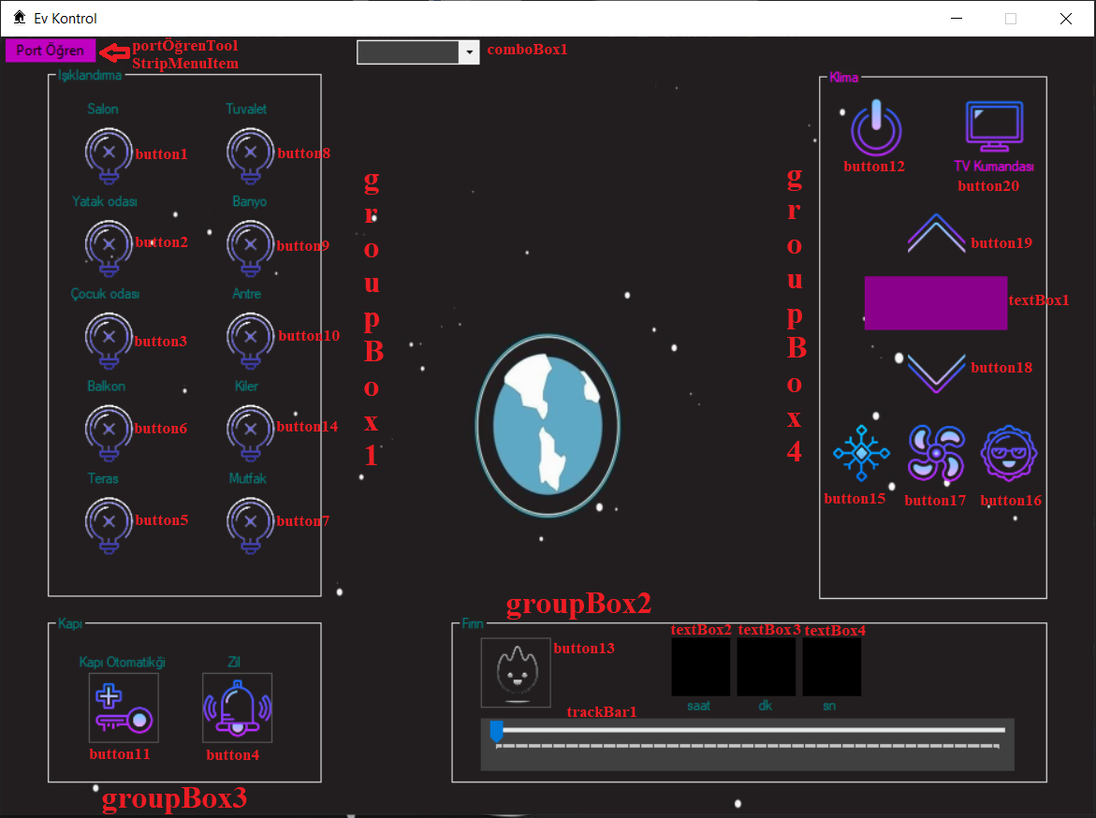

**Figure_2: Form1 Tagged**

**Form2: TV Remote Control Screen**

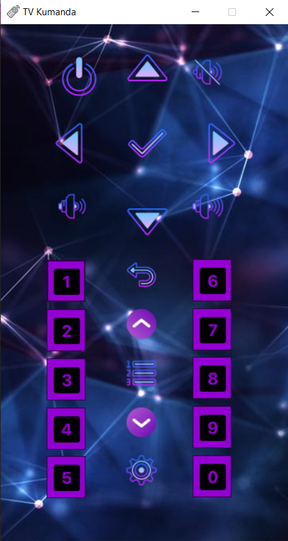 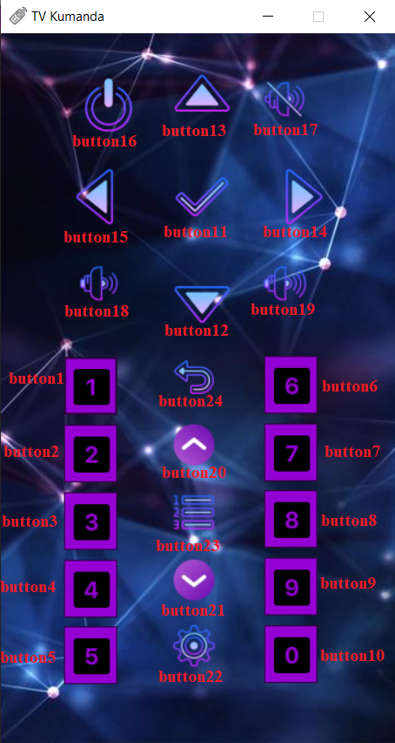

**Figure_3: TV Remote Control Figure_4: Form2 Tagged**

**Tool List:**

x24 Buttons

**Code:**



**Form3: Port Finding Guide Screen**

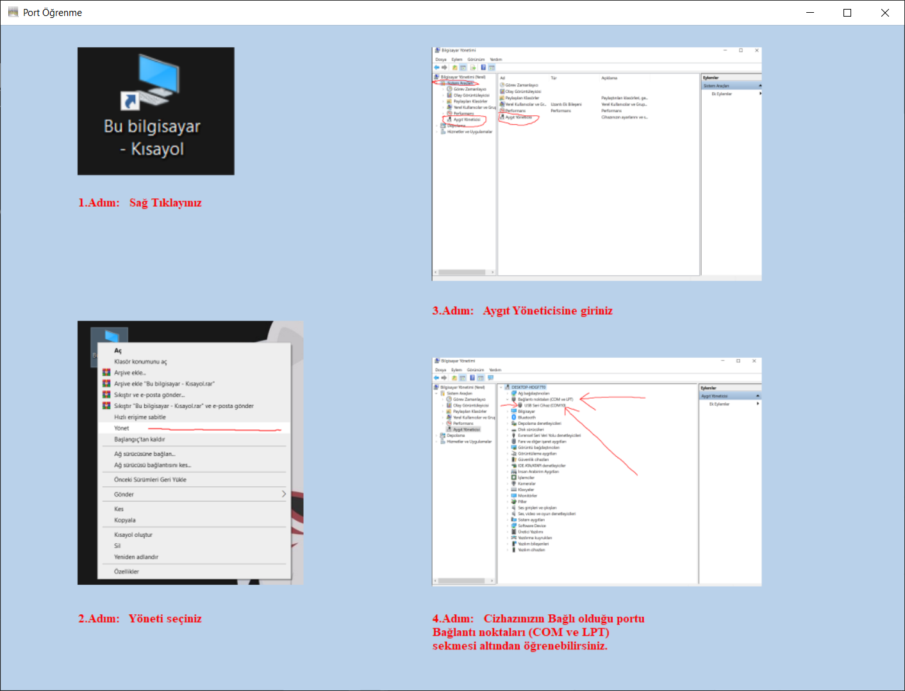

**Figure_5: Form3**

**Tool List:**

x4 Picture Box

x4 Label

**Arduino Part:**

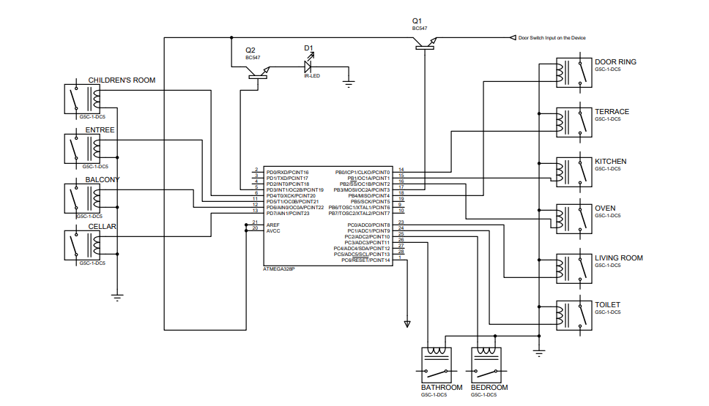

**External Library:**

IRremote-master



**References:**

* <https://docs.microsoft.com/tr-tr/dotnet/csharp/>
* <https://www.youtube.com/playlist?list=PLSuhOGv534vTFRq9dFB9Yn7su-4hIc0xg>
* <https://stackoverflow.com/questions/12617116/using-same-serial-port-instances-on-multiple-forms>
* <https://social.msdn.microsoft.com/Forums/vstudio/en-US/7b7e3a25-cf9a-4d08-b390-1ca1104897e1/how-to-share-variables-and-a-serial-port-between-two-forms?forum=csharpgeneral>
* <https://www.pjrc.com/teensy/td_libs_IRremote.html>

**Images from Working Places:**

