AYDIN Alperen
MACIEL HOFF Vinicius

Compte-rendu de TP3 TSA :

Partie 1 :

Ex11 : Le code pour les exercices de 1.1 a 1.3 sans la correction

clear all; close all;

Fs = 500;
B = 160;
v0 = 100;
Dnu = 16;
T = 100;
ordre= 6;
sigma= sqrt(5);

%% Exercice 1.1:
figure(1);
Xp = struct('sigma',sigma,'Fs',Fs,'B',B,'T',T) ;
[X,Xp] = CGN(Xp);

moyX = mean(X.data);
varianceX = (std(X.data))^2;
sig0 = varianceX/(2*B);

rep11 = sprintf('Rep1.1:\n La moyenne = %d \n La variance = %d \n sig0 = %d',moyX,varianceX,sig0);
disp(rep11);
%% Exercice 1.2:
figure(2);
Fp = struct('Fs',Fs,'F0',v0,'Dnu',Dnu,'order',ordre,'class','BP filter');
[Y,Fp ] = BPF(X,Fp);

moyY = mean(Y.data);
varianceY = (std(Y.data))^2;
densite = varianceY/(2*Dnu);

rep11 = sprintf('Rep1.2:\n La moyenne = %d \n La variance = %d \n Densite = %d',moyY,varianceY,densite);
disp(rep11);

%% Exercice 1.3:
figure(3);
[Z] = SquareSig(Y);
prod = [2,20,100];

for i=1:length(prod)
figure(3+i);
RC = prod(i)/Dnu;
RCFp = struct('Fs',Fs,'RC',RC);
[W,RCFp] = RCF (Z,RCFp);

moyW = mean(W.data);
varianceW = (std(W.data))^2;
kurt = kurtosis(W.data);
rep13 = sprintf('Rep1.3: \n Dnu x RC = %d, \n RC = %d \n La moyenne = %d \n La variance = %d \n Kurtosis = %d',prod(i),RC,moyW,varianceW,kurt);
disp(rep13);
end

Figure 1 :
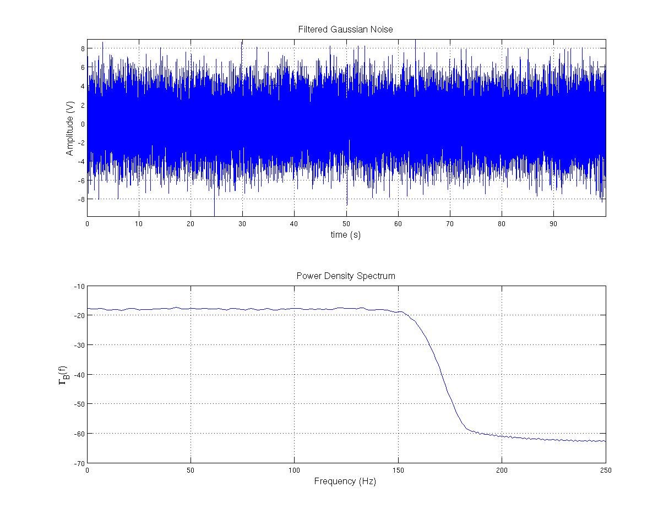
Figure 2 :

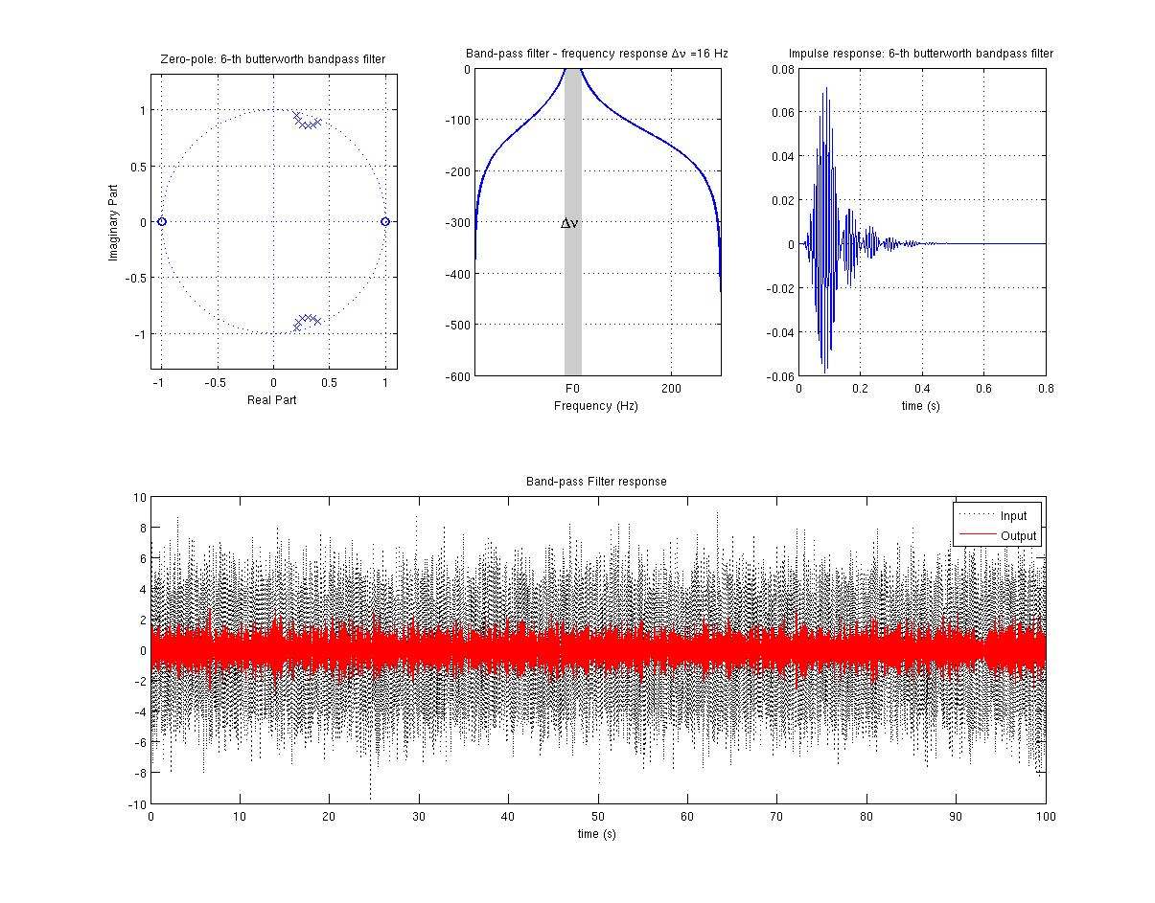
Ex11 : Le code pour les exercices de 1.1 a 1.3 avec la correction

clear all; close all;

Fs = 500;
B = 160;
v0 = 100;
Dnu = 16;
T = 100;
ordre= 6;
sigma= sqrt(5);

%% Exercice 1.1:
figure(1);
Xp = struct('sigma',sigma,'Fs',Fs,'B',B,'T',T) ;
[X,Xp] = CGN(Xp);

moyX = mean(X.data);
varianceX = (std(X.data))^2;
sig0 = varianceX/(2*B);

rep11 = sprintf('Rep1.1:\n La moyenne = %d \n La variance = %d \n sig0 = %d',moyX,varianceX,sig0);
disp(rep11);
%% Exercice 1.2:
figure(2);
Fp = struct('Fs',Fs,'F0',v0,'Dnu',Dnu,'order',ordre,'class','BP filter');
[Y,Fp ] = BPF(X,Fp);

moyY = mean(Y.data);
varianceY = (std(Y.data))^2;
densite = varianceY/(2*Dnu);

rep11 = sprintf('Rep1.2:\n La moyenne = %d \n La variance = %d \n Densite = %d',moyY,varianceY,densite);
disp(rep11);

%% Exercice 1.3:
[Z] = SquareSig(Y);
prod = [2,20,100];

for i=1:length(prod)
figure(2+i);
RC = prod(i)/Dnu;
RCFp = struct('Fs',Fs,'RC',RC);
[W,RCFp] = RCF (Z,RCFp);

W_c = W.data( find(W.time > 5*RC) );

moyW = mean(W_c);
varianceW = (std(W_c))^2;
kurt = kurtosis(W_c);
rep13 = sprintf('Rep1.3: \n Dnu x RC = %d, \n RC = %d \n La moyenne = %d \n La variance = %d \n Kurtosis = %d',prod(i),RC,moyW,varianceW,kurt);
disp(rep13);
end

Figure 3 :

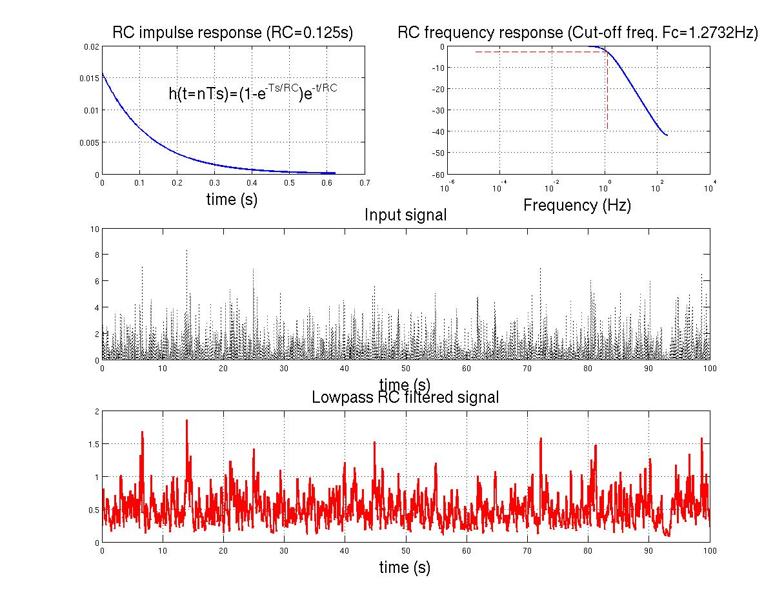
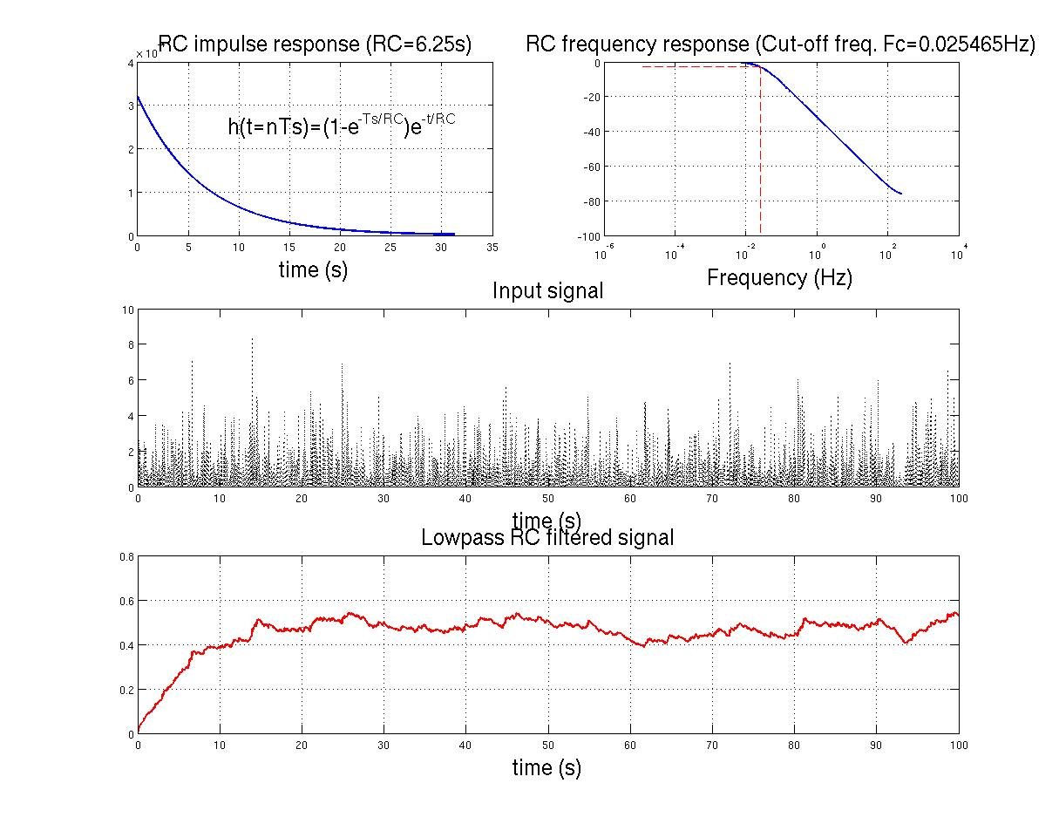

Partie 2 :

ex21 :
clear all; close all;

Fs = 500;
B = 160;
v0 = 100;
Dnu = 16;
T = 100;
ordre= 6;
sigma= sqrt(5);
A = 1;

%% Generation du signal sinusoidal 100Hz
figure(1);

Sp = struct('Fs',Fs,'A',A,'Fc',v0,'FM',0,'Phi',0,'T',100,'W',[]);
[S,Sp,M] = OOK(Sp) ;

%% Passage du signal par un filtre passe-bande
figure(2);
Fp = struct('Fs',Fs,'F0',v0,'Dnu',Dnu,'order',ordre,'class','BP filter');
[Y,Fp] = BPF(S,Fp);

moyY = mean(Y.data);
varianceY = (std(Y.data))^2;
densite = varianceY/(2*Dnu);

rep21 = sprintf('Rep21:\n La moyenne = %d \n La variance = %d \n Densite = %d',moyY,varianceY,densite);
disp(rep21);

Ex22 :
clear all; close all;

Fs = 500;
B = 160;
v0 = 100;
Dnu = 16;
T = 100;
ordre= 6;
sigma= sqrt(5);
A = 1;

%% Generation de S(t):
figure(1);

Sp = struct('Fs',Fs,'A',A,'Fc',v0,'FM',0,'Phi',0,'T',100,'W',[]);
[S,Sp,M] = OOK(Sp) ;

%% Generation du bruit:
figure(2);
Xp = struct('sigma',sigma,'Fs',Fs,'B',B,'T',T) ;
[B,Xp] = CGN(Xp);

%% Addition des signaux:
[X] = AddSig(S,B);

%% Filtrage bande-passante
figure(3);
Fp = struct('Fs',Fs,'F0',v0,'Dnu',Dnu,'order',ordre,'class','BP filter');
[Y,Fp] = BPF(X,Fp);

%% Quadrateur + filtrage passe-bas
[Z] = SquareSig(Y);
prod = [2,20,100];

for i=1:length(prod)
figure(3+i);
RC = prod(i)/Dnu;
RCFp = struct('Fs',Fs,'RC',RC);
[W,RCFp] = RCF (Z,RCFp);

W_c = W.data( find(W.time > 5*RC) );

moyW = mean(W_c);
B_s = std(W_c);
rep = sprintf('Rep: \n RC x Dnu = %d \n RC = %d \n Moyenne W_S+B = %d \n B_s = %d',prod(i),RC, moyW, B_s);
disp(rep);
end

Figure 4 :

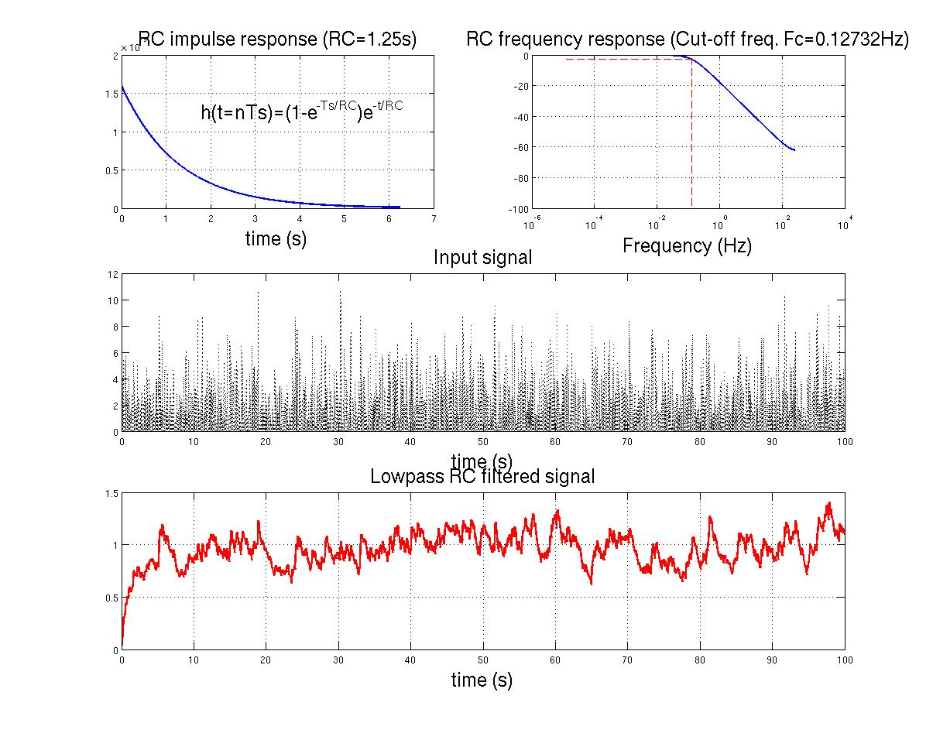

Partie 3 :

Ex31 :
clear all; close all;

Fs = 500;
B = 160;
v0 = 100;
FM = 0.05;
Dnu = 16;
T = 100;
ordre= 6;
sigma= sqrt(5);
A = 1;

%% Generation de S(t):
figure(1);

Sp = struct('Fs',Fs,'A',A,'Fc',v0,'FM',FM,'Phi',0,'T',100,'W',[]);
[S,Sp,M] = OOK(Sp) ;

%% Generation du bruit:
figure(2);
Xp = struct('sigma',sigma,'Fs',Fs,'B',B,'T',T) ;
[B,Xp] = CGN(Xp);

%% Addition des signaux:
[X] = AddSig(S,B);

%% Filtrage bande-passante
figure(3);
Fp = struct('Fs',Fs,'F0',v0,'Dnu',Dnu,'order',ordre,'class','BP filter');
[Y,Fp] = BPF(X,Fp);

%% Quadrateur + filtrage passe-bas
[Z] = SquareSig(Y);
prod = [2,20,100];

for i=1:length(prod)
figure(3+i);
RC = prod(i)/Dnu;
RCFp = struct('Fs',Fs,'RC',RC);
[W,RCFp] = RCF (Z,RCFp);

W_c = W.data( find(W.time > 5*RC) );

moyW = mean(W_c);
B_s = std(W_c);
rep = sprintf('Rep: \n RC x Dnu = %d \n RC = %d \n Moyenne W_S+B = %d \n B_s = %d',prod(i),RC, moyW, B_s);
disp(rep);
end

%% Comparaison
seuil= 0.7;
M = W.data>seuil;

figure(7);

subplot(4,1,1);
plot(S.time,S.data);
xlabel('time(s)');
title('Le signal original');

subplot(4,1,2);
plot(X.time,X.data);
xlabel('time(s)');
title('Le signal bruite')

subplot(4,1,3);
plot(W.time,W.data);
xlabel('time(s)');
title('L estimation du Puissance');

subplot(4,1,4);
area(W.time,M);
xlabel('time(s)');
title('L estimation seuillee');

Figure 5 :
