



Essay / Assignment Title:
Time Series Forecasting: A Practical Approach to Data-Driven Decision Making

Programme title: Fundamentals of Data Analytics

Name: Alperen Icke

Year: 2025

List of Contents

List of Contents 2
INTRODUCTION 4
Task 1: Dataset Selection and Exploration 5
Task 2: Data Preprocessing and Feature Engineering 7
Task 3: Regression Model Development and Evaluation 12
Task 4: Conclusions and Business Recommendations 20
REFERENCES 22
APPENDIX 23

Statement of compliance with academic ethics and the avoidance of plagiarism

I honestly declare that this dissertation is entirely my own work and none of its part has been copied from printed or electronic sources, translated from foreign sources and reproduced from essays of other researchers or students. Wherever I have been based on ideas or other people’s texts I clearly declare it through the good use of references following academic ethics.
(In the case that is proved that part of the essay does not constitute an original work, but a copy of an already published essay or from another source, the student will be expelled permanently from the program).

Name and Surname (Capital letters):
ALPEREN ICKE

Date: 17/06/2025

INTRODUCTION

The stability and efficiency of modern power grids are linked to the ability to accurately forecast electricity demand. Time series forecasting plays a critical role in strategic planning across industries. Like weather forecasting, supply and demand forecasting in many industries, or health sickness treatment. In the energy sector it is critical to ensure reliability, efficiency, and sustainability of electric supply by forecasting future demand (Singh et. al., 2013).
The importance of using regression techniques in this field is vital because electricity must be consumed at the same as it is generated. Accurate forecasting helps operators to match supply and demand in real-time; it also prevents blackouts or overloading on systems. Other advantages of forecasting are economic efficiency and dynamic pricing. Energy providers can reduce operating costs by optimizing electricity generation and purchases. Predicting the peak of the demand allows operators to better plan for the use of calculations to minimize cost inefficiency at power plants.
Additionally, time series forecasting provides information to utility companies to implement demand-based pricing. It also helps utility companies with long-term investment decisions. They can plan upgrades, maintenance, and expansions based on forecasts including the integration of renewable energy. It plays a crucial role in energy sources. Accurate demand predictions give more options in optimizing sources into the grid with stability.
This assignment contains relevant information on the topic of supply and demand forecasting. It applies time series regression techniques like linear regression and random forest regression to forecast electricity demand.

Task 1: Dataset Selection and Exploration

I have selected my dataset through Kaggle (Arvidsson, 2023). The dataset is received by the Australian Energy Market Operator (AEMO) and contains 30-minute increments of electricity demand and price in NSW, Australia from 2018 to 2023. This data was made publicly available by AMEO, as per their Copyright Permissions (AEMO, 2023). I have picked the 6th month of 2018’s dataset through this library.
The dataset contains electricity price (RRP), total demand (TOTALDEMAND), and settlement timestaps at 30-minute intervals. A continuous numeric feature and target variable for regression are "TOTALDEMAND". I have selected this dataset because it includes over 1000 data points, time-based features, and continuous target variables mentioned. These qualities make this dataset suitable for predictive modeling.
I've uploaded the data to Colab and checked the data using the functions shown in Figure 1.
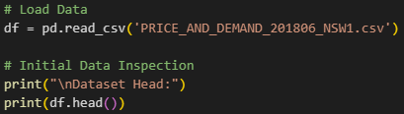
Figure 1
The first 5 columns of the dataset are shown in Figure 2 below.
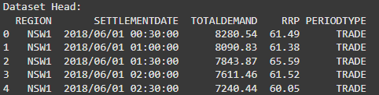
Figure 2

- Settlementdate: Timestamps for marking each 30-minute interval. It is important to extract time-based features.
- Totaldemand: Represents aggregated electricity demand in Megawatt(MW). Electricity demand can be affected by weather, economic activity, and time-related patterns.
- RRP: Spot electricity price in AUD/Megawatt Hour, this represents the spot price for electricity.
- Other columns such as Region and Preiodtype provide additional information that can be useful for data filtering.
Single months of data may not fully capture annual season or long-term demand but in this project, the target is finding an optimal regression model according to using 1000 or close to 1000 data points. If more than 1 month is used it would be a lot of data points, and I could be moving away from the project's target.

Task 2: Data Preprocessing and Feature Engineering

2.1. Data Preprocessing
After uploading the data I used simple data cleaning and basic preprocessing before doing feature engineering. The settlement date column was converted to DateTime objects to be used as time-based features and set as the data frame's index. Also, data frames are sorted chronologically for optimal time series analysis. The used functions are shown in Figure 3 below.
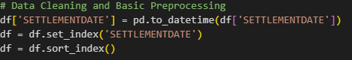
Figure 3
Therefore, using the forward-fill function to fill missing values on TOTALDEMAND and RRP. Shown in Figure 4 below.
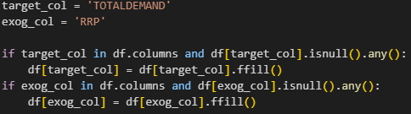
Figure 4
If any rows where the TOTALDEMAND still contains missing values use the dropna function to get rid of missing values. Shown in Figure 5 below.
Figure 5
2.2. Exploratory Data Analysis (EDA)
After these cleaning steps dataset is ready to be done feature engineering. Before that, exploratory data analysis was performed to understand the data set and TOTALDEMAND’s relationship with potential variables. This understanding is critical for model selection and feature engineering.
Used time series plot of demand to understand peaks in demands and it would be expected during working hours on weekdays and evening hours with lower demand overnight maybe different outcomes on weekends. It can also show some week-to-week profiles. I've created the plot using the functions shown in Figure 6 below.
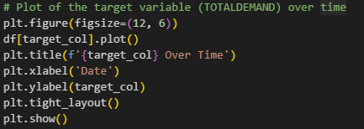
Figure 6
Through these functions, a TOTALDEMAND plot has been generated and gives an understanding of the dataset. The plot is shown in Figure 7 below.
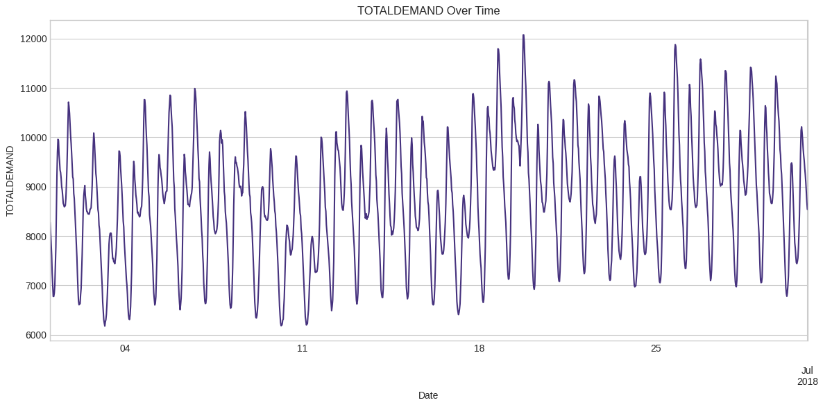
Figure 7

Another analysis that has been done on the data set is the distribution plot of demand. A histogram plot was generated. Using functions which are shown in figure 8 below.
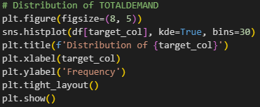
Figure 8
Through these functions, a distribution plot has been generated. The plot is shown in Figure 9 below.
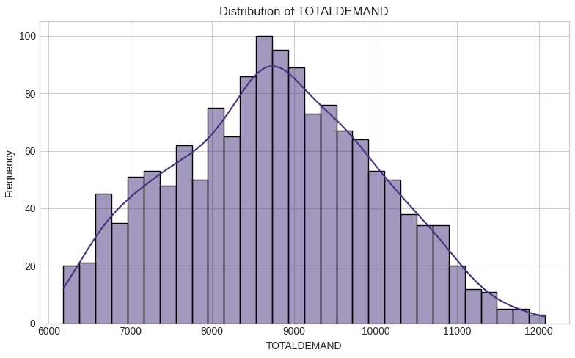
Figure 9

This would likely show closer to a normal or slightly skewed distribution, reflecting more regular consumption patterns. It is expected that TOTALDEMAND will show a strong positive correlation with its own lagged values (Lai, H.Y., 2024).
2.3. Feature Engineering
After fore some useful features are added to a copy of the original data frame to help the regression models better predict TOTALDEMAND. I’ve used df_feat function to add these features which are shown in Figure 9 below.
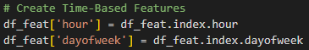
Figure 10
These features were created using the SETTLEMENTDATE index and TOTALDEMAND values. Used df_feat.index hour to make the model understand typical changes in demand through the hours of the day (from 0 to 23). After that I used df_feat.index.dayofweek to make models understand electricity demand between weekdays and weekends.
After creating time-based features lagged features were created to model and predict future demands using past demand values since electricity usage often follows past trends. These were created using the shift method as shown in Figure 11 below.
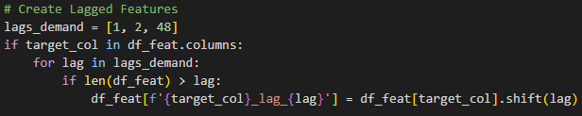
Figure 11
Created total demand lag_1, lag_2 and lag_48. These are demand values from 30 minutes before, 1 hour before, and 24 hours before to catch patterns. This feature setup aims to give the model correct information to make better predictions.
Creating these lagged features causes rows containing NaN values to appear at the beginning of the dataset. These were removed using df_feat.dropna function as shown in Figure 12 below.
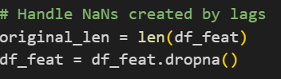
Figure 12
This step is very important because most machine learning models can’t handle missing values.

Task 3: Regression Model Development and Evaluation

3.1. Data Splitting and Scaling
We need to check how well the models can perform on new data and a real-world forecasting scenario. To do that, we need to split the dataset chronologically and create validation and test for understanding the performance of algorithms. I’ve split the dataset using functions which are shown in Figure 13 below.
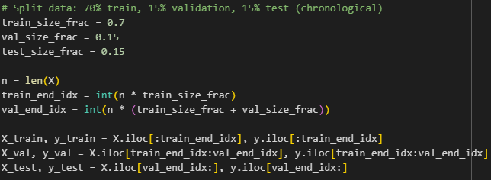
Figure 13
%70 of the datasets were used for the training, the next 15 of the datasets were used for a model performance check and the final %15 of the datasets were used for testing and understanding how the model will perform on new data.
When working with time series datasets, it's critical to split them into chronological order (James, D.A. and Pregibon, D., 1992). Unlike other data, we shouldn’t mix time series data before splitting it into train, test, and validation parts. If we do that prediction models might learn future information and going, try predicting the past which makes the project unrealistic. To make this work I've used features to calculate index numbers where training and validation splits need to start and end. After that, I created train, test, and validation splits according to these indexes.
We need one more step before training regression models. For correct model performance training, test and validation splits need to be standardized using the StandartScaler function which can be seen in Figure 14 below.
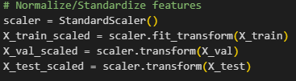
Figure 14
Standardizing the data helps because it makes all the features have a similar scale a mean of zero and a standard deviation of one which can be sensitive to different feature scales. It also helps the model learn faster and more effectively.
I choose two common regression models to forecast total demand.
3.2. Linear Regression Model
The linear regression model predicts a linear relationship between engineered features and future demand which is in our case total demand. Its simplicity allows us to understand easily, and the model’s coefficients show how much demand could change with one unit change in each feature. Linear regression can be the best model to use as a baseline to compare with other models.
I have trained my model with linear regression as shown in Figure 15 shown below.
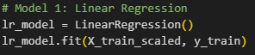
Figure 15
3.3. Random Forest Regression
Random Forest Regression is a model that builds multiple decision trees to make predictions. In my case, 100 trees were used to make predictions. Each tree is slightly different because it uses a random group of features at each step. The final prediction is the average of all trees' predictions. My code for implementing random forest regression can be found in Figure 16 below.
Figure 16
I've used max_depth=10, min_samples_leaf=5, and random_state=42 to make sure when the model runs, it gives consistent results each time.
3.4. Evaluation Metrics
I have used the following standard metrics to measure how both models predicted total demand:
- Mean Absolute Error (MAE):
This metric shows the average difference between the predicted and actual demand. Units are in MW. The formula can be seen in Figure 17 below.
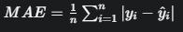
Figure 17
- Mean Squared Error (MSE):
This metric shows the average squared difference between predicted and actual demand. Units are in MW². The formula can be seen in Figure 18 below.
Figure 18
- R-Squared (R²):
This metric shows the proportion of the variance in total demand that is predictable from the features. If a score is closer to 1, it indicates a better fit. The formula can be seen in Figure 19 below.
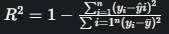
Figure 19
I have calculated these metrics for both models on the validation set and test set. I have implemented the code that can be seen in Figure 20 below.
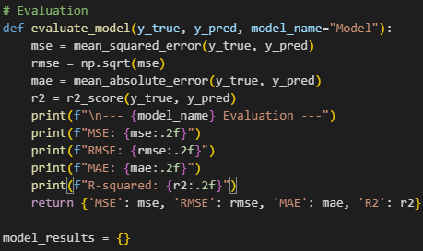
Figure 20
3.5. Results for Both Models
I have trained both Linear Regression and Random Forest Regression models on the scaled training data as shown in Figures 15 and 16 before. Both models' prediction performance was assessed on the validation set and test set. I have implemented the codes below for the linear regression model's validation set performance in Figure 21 shown below.
Figure 21
Also implemented the codes below for random forest regression’s validation set performance metrics in Figure 22 below.
Figure 22
The output of these codes shows us how both models perform on the validation set. For the Linear regression model performance metrics are shown in Figure 23 below.
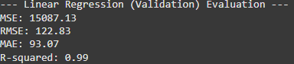
Figure 23
Also, Random Forest Regression model performance metrics are shown in Figure 24 below.
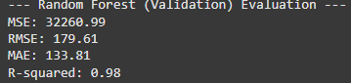
Figure 24
As we can see in these Figures the validation set Linear Regression model demonstrated slightly better predictions but what happens if we look at the performance on test sets?
Performance metrics for both models on test sets can be seen in Figure 25 below.
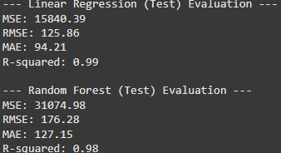
Figure 25
The Linear Regression achieved a R² score of 0.99 while Random Forest achieved a R² score of 0.98. This outcome shows us Linear Regression was better at applying learned to new data. The Mean Absolute Error (MAE) of the Random Forest model with 127.15 shows that its demand predictions were off by actual values. These results demonstrate that Linear Regression gave slightly better performance than another model.
3.5. Feature Importance
Firstly, in Figure 26 I have implemented the codes for understanding coefficients in the Linear Regression model.
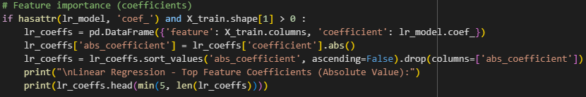
Figure 26
As a result of these functions, we can see coefficients for Linear regression in Figure 27 below.
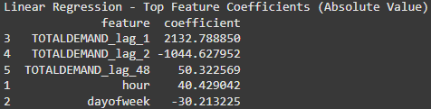
Figure 27
Totaldemand_lag_1 which is demand for 30 minutes ago is the most important factor for forecasting a Linear Regression model.
Secondly, I have implemented the same functions but used feature importance this time for a better understanding of feature factors in the Random Forest Regression model. The codes I have used can be seen in Figure 28 below.
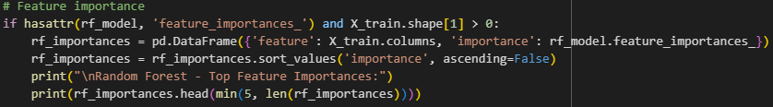
Figure 28

The output of these functions can be seen in Figure 29 below.
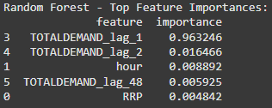
Figure 28
We can see the same pattern here. Totaldemand_lag_1 is the most important feature of the Random Forest Regression model.
Why have I used coefficients for Linear Regression but feature importance for Random Forest Regression? Because coefficients are specific to linear models and show linear relationships (Cornell, J.A. and Berger, R.D., 1987), feature importance in tree-based models like Random Forest Regression can be more useful given a better understanding.
3.6. Prediction vs Actual
A plot comparison of the total demand values between predicted values from the Linear Regression model on the test would show how well the model performs. For this plot, I used functions that select the best model according to their R² score which is Linear Regression in our case and made a graph for that model to compare with actual values. Implemented codes can be seen in Figure 29 below.
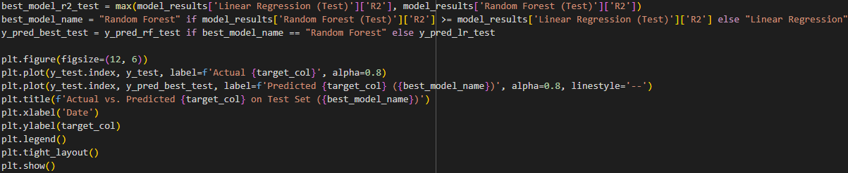
Figure 29
We can see the plot for Linear Regression's predictions on test set comparison to actual values as an output of these codes in Figure 30 below.
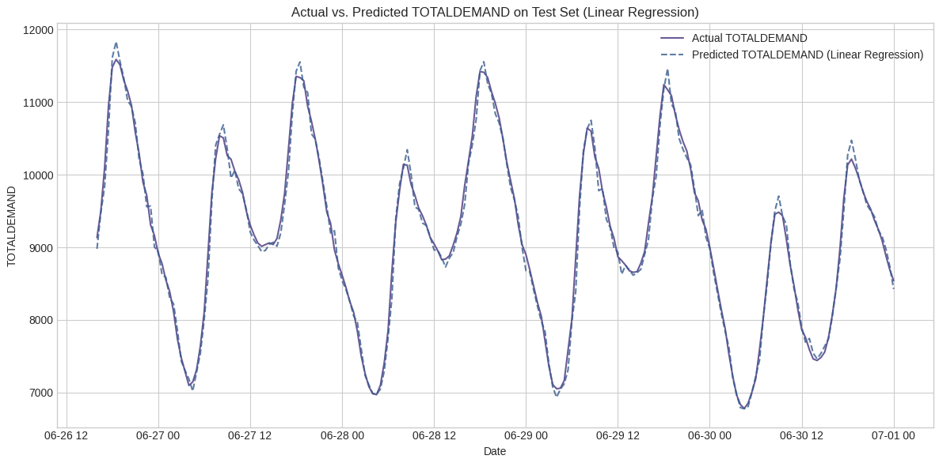
Figure 30
Demand is generally less prone to extreme, however accurately predicting the exact peak demand or sudden ramps can be challenging as we can see in the plot.

Task 4: Conclusions and Business Recommendations

This study demonstrated a methodological approach to forecasting short-term electricity demand in NSW using time series regression techniques. By systematically preprocessing the 6th month of the 2018 electricity demand dataset, engineering relevant temporal and lagged features, and applying Linear Regression and Random Forest Regression models.
The results from the test set show that the Linear Regression model provided slightly better results achieving an R² score of 0.99. Also, feature importance analysis from the Linear Regression model highlighted the influence of recent past demands such as totaldemand_lag_1.
There are a few limitations in this study like using only one month of data limits the models’ ability to train across different seasons and long-term trends. Also, there are some missing exogenous predictors such as detailed weather forecasts or specific economic indicators. Furthermore, while standard regression models were used, more advanced models or deep learning models were not in discussion for this study. According to these limitations, the findings from this study lead to the following strategic recommendations for energy efficiency, stakeholders, grid operators, and generation companies to improve their business:
- Use Weather Data to Improve Forecasting: Predictable daily patterns can easily be confirmed by the model, but the next crucial step could be implementing real-time weather forecast data into machine learning models. This system could allow more precise short-term demand predictions and give grid operators the chance to optimize load capacity (Taylor, J.W. and Buizza, R., 2003).
- Optime Trading with High Frequency Demand: Both models heavily rely on totaldemand_lag_1 which is demand from 30 minutes prior, market conditions change rapidly. Generation companies can build an automated system to implement algorithmic trading strategies for markets. Therefore, this system can provide them with adjusting bids near real-time and optimize fuel buying to prevent anticipated short-term spending. That way they can maximize revenue and minimize unnecessary buying costs (Peters et. al., 2013).

- Make Smarter Investment Choices: Models that I use can identify the peak times during the day or week. This information can be used to plan future investments. For example, companies can calculate potential savings from investment in batteries and make an optimization for these situations.
In conclusion, this study demonstrates building data-driven models for electricity demand forecasting. Methodologies and insights are essential for the efficient and reliable operations of modern power systems and all participants in the electricity market. It's crucial to use machine learning models in the electricity demand market (Gajowniczek, K. and Ząbkowski, T., 2017). Energy companies can easily make smart plans, operate more efficiently, and make better decisions in the market by using machine learning models for their business.

REFERENCES

Singh, A.K., Ibraheem, S.K., Muazzam, M. and Chaturvedi, 2013. An overview of electricity demand forecasting techniques.. Network and complex systems, 3(3), pp. 33-48.
Arvidsson, J., 2023. NSW, AUS, Electricity Price & Demand 2018-2023. [Online] Available at: https://www.kaggle.com/datasets/joebeachcapital/nsw-australia-electricity-demand-2018-2023 [Accessed 01 06 2025].
AEMO, 2023. AEMO. [Online] Available at: https://aemo.com.au/privacy-and-legal-notices/copyright-permissions [Accessed 01 06 2025].
Lai, H.Y., 2024. A machine learning study for predicting driver goals in contingencies with leading and lagging features during goal determination. Expert Systems with Applications, 238, p.121864.
James, D.A. and Pregibon, D., 1992. Chronological objects for data analysis. sort (dts), 4, pp.27-05876157.
Cornell, J.A. and Berger, R.D., 1987. Factors that influence the value of the coefficient of determination in simple linear and nonlinear regression models. Phytopathology, 77(1), pp.63-70.
Taylor, J.W. and Buizza, R., 2003. Using weather ensemble predictions in electricity demand forecasting. International Journal of Forecasting, 19(1), pp.57-70.
Peters, M., Ketter, W., Saar-Tsechansky, M. and Collins, J., 2013. A reinforcement learning approach to autonomous decision-making in smart electricity markets. Machine learning, 92, pp.5-39.
Gajowniczek, K. and Ząbkowski, T., 2017. Two-stage electricity demands modeling using machine learning algorithms. Energies, 10(10), p.1547

APPENDIX

Google Colab Notebook:
https://colab.research.google.com/drive/1ex28KJfShxmrY-ympXV9fjJHHqO0Vs6K?usp=sharing

