

MSc Data Science Project
7PAM2002
Department of Physics, Astronomy and Mathematics
Data Science FINAL PROJECT REPORT

Project Title:
Short-term NO₂ Forecasting at London Bloomsbury (CLL2) using a Naïve Baseline, XGBoost and LSTM

Student Name and SRN:
Alpesh Tribhuvan Yadav 24073394

Supervisor: Man Tang
Date Submitted: 22/04/2026
Word Count: 4671
Github link: https://github.com/Alpesh-hash/Msc_data_science/tree/main

DECLARATION STATEMENT

This report is submitted in partial fulfilment of the requirement for the degree of Master of Science in Data Science at the University of Hertfordshire.
I have read the detailed guidance to students on academic integrity, misconduct and plagiarism information at Assessment Offences and Academic Misconduct and understand the University process of dealing with suspected cases of academic misconduct and the possible penalties, which could include failing the project or course.
I certify that the work submitted is my own and that any material derived or quoted from published or unpublished work of other persons has been duly acknowledged. (Ref. UPR AS/C/6.1, section 7 and UPR AS/C/5, section 3.6)
I did not use human participants in my MSc Project.

I hereby give permission for the report to be made available on module websites provided the source is acknowledged.

Student Name printed: Alpesh Tribhuvan Yadav

Student Name signature

Student SRN number: 24073394

UNIVERSITY OF HERTFORDSHIRE
SCHOOL OF PHYSICS, ENGINEERING AND COMPUTER SCIENCE

Abstract
This project investigates one-hour-ahead forecasting of nitrogen dioxide (NO₂) concentration at the London Bloomsbury monitoring station (CLL2) using hourly UK-AIR/DEFRA observations from 2015 to 2025. The research question is whether machine-learning and deep-learning models provide meaningful improvements over a simple persistence baseline when evaluated on a strict chronological split. The workflow included timestamp standardisation, conversion to a complete hourly index, conservative interpolation of short gaps up to three hours, retention of longer gaps as missing, exploratory data analysis, and supervised forecasting using pollutant history and calendar features. Three models were compared: a naïve persistence baseline, XGBoost, and a Long Short-Term Memory (LSTM) network. Methodological refinements included gap-aware plotting, segment-aware sequence construction for the LSTM, and hyperparameter tuning with early stopping. The final results show that both learned models outperformed the persistence baseline and that the tuned LSTM achieved the best overall performance, followed by XGBoost. The report concludes that short-horizon site-level NO₂ forecasting can be improved using data-driven models, but performance is still constrained by peak-heavy episodes, missing long-run continuity, and the absence of meteorological predictors.

Contents

1. Introduction ............................................................. 5

1.1 Research question .................................................. 5

1.2 Aim and objectives ................................................ 5

1.3 Project difficulty and scope ................................. 6

2. Background and Literature Review .......................... 6

3. Dataset, Exploratory Analysis and Ethics ............. 8

4. Methodology ............................................................ 10

5. Results .................................................................... 13

6. Analysis and Discussion ........................................ 15

7. Conclusion ............................................................... 15

References .................................................................. 17

1. Introduction
In dense metropolitan areas, where transportation emissions, combustion sources, and atmospheric conditions mix to produce significant short-term variation in pollutant concentration, air pollution continues to be a serious environmental and public health concern. Because nitrogen dioxide (NO₂) is continuously detected at regulatory stations, has a strong correlation with road transportation, and is associated with detrimental respiratory effects, it is particularly significant. Public communication, local operational planning, and exposure awareness can all benefit from a short-term forecasting system that can predict the concentration of NO₂ over the next hour.
Using hourly measurements from the UK Air Information Resource, this study focuses on the London Bloomsbury monitoring station (CLL2). The job is described as one-hour-ahead forecasting: predict NO₂ at time t+1 based on information available up to time t. The mission is not easy, despite the short horizon. Noise, missing values, strong repetitive cycles, sudden spikes, and variations in distribution from year to year are all present in hourly NO₂ series. Because of these characteristics, the forecasting pipeline is sensitive to assessment design, continuity handling, feature building, and model selection.
Three modeling techniques are compared in this study. The first is a naïve persistence baseline, in which the present NO₂ value serves as the forecast for the upcoming hour. This is purposefully included since any learnt model should outperform persistence as a robust benchmark for a t+1 job in order to justify its additional complexity. The second model is XGBoost, a powerful tabular machine-learning technique that can take advantage of calendar features, rolling statistics, and lagged results. Instead of depending solely on manufactured lags, the third model is an LSTM sequence model that learns temporal structure from ordered multivariate inputs.

Research question
How well can we predict next-hour NO₂ at the London Bloomsbury (CLL2) station using historical pollutant measurements, and which method works best: an LSTM, XGBoost, or naive baseline?
1.2 Aim and objectives
The aim of the project is to build and compare short-term NO₂ forecasting models for the London Bloomsbury site using openly available regulatory monitoring data.
Objective | Evidence in the project
Collect and clean hourly NO₂/NO/NOx/O₃ data | UK-AIR/DEFRA data were cleaned, standardised, reindexed to hourly frequency, and checked for missingness.
Analyse data quality and temporal structure | EDA was carried out on missing values, long-term pattern, diurnal behaviour, and pollutant correlations.
Implement baseline and learned models | A persistence baseline, XGBoost, and LSTM were implemented and evaluated.
Tune and compare models fairly | Chronological validation, early stopping, hyperparameter tuning, and gap-safe handling were used.
Interpret results against the research question | Results, discussion, limitations, and future work sections link the findings back to the forecasting task.
Table 1. Project objectives and how they were met.
The project produced more than one model run, as Table 1 demonstrates. Because the marking criteria reward both practical execution and proof that the project objectives were reached, it was crucial to cover the entire workflow, from data collection to interpretation. Additionally, the table makes clear how each goal directly relates to the work that is presented later in the report.

1.3 Project difficulty and scope
The mix of multiyear hourly data, missing-value handling, temporal leakage risk, model comparison across various modeling paradigms, and the requirement to assess all models on future-held-out data make the project challenging. The project is additionally challenging since, aside from persistence, short-horizon forecasting gives limited opportunity for progress. As a result, small numerical advances must be properly assessed and technically justified rather than exaggerated.
2. Background and Literature Review
What not to include was also influenced by the literature. For instance, formal stationarity testing is essential to traditional ARIMA-style modeling but less important for a supervised comparison of LSTM and XGBoost. Similarly, because they alter multiple factors at once, very broad multi-model surveys might be challenging to compare. As a result, the current research concentrated on a more manageable yet logical comparison. Because each methodological decision can be directly justified in relation to the forecasting job, the data structure, or a constraint found in earlier work, this enhances the study's clarity.
Both traditional statistical models and more modern machine-learning and deep-learning techniques have been used to study air-quality forecasts. Recent review work also shows that forecasting performance depends strongly on feature richness, data design, and the choice of modelling paradigm (Bernacki and Scherer, 2025; Méndez, Merayo and Núñez, 2023). The articles discussed here were chosen because they are peer-reviewed, directly relevant to forecasting or model design, and useful for explaining the methodological decisions made in this project. Rather than attempting a comprehensive catalogue of forecasting methods, the review therefore focuses on studies that clarify model choice, feature richness, and evaluation design.
XGBoost, a scalable and regularized gradient-boosted decision tree algorithm for structured data, was first presented by Chen and Guestrin (2016). Since many environmental forecasting problems may be described using lagged values, rolling summaries, and calendar-based predictors, their work is extremely useful even though it is not specifically related to air pollution. XGBoost's primary advantage is its ability to efficiently capture non-linearity and feature interaction while maintaining computing efficiency. Its drawback is that it needs to be given that structure through manufactured characteristics because it cannot learn temporal order from raw sequences. This had a direct impact on the current project, as XGBoost was chosen as the best tabular benchmark and combined with carefully designed rolling and latency characteristics.
In order to overcome the vanishing-gradient constraints of previous recurrent neural networks, Hochreiter and Schmidhuber (1997) introduced the LSTM architecture. Because it explains why LSTM may learn dependencies across larger temporal spans than ordinary recurrent networks, this work is fundamental to any sequence-based forecasting research. The importance in the current project is evident: hourly pollutant observations are not isolated rows but rather sorted sequences. LSTM has the advantage of being able to learn from the way pollutant pathways change over time. Sensitivity to scaling, sequence continuity, training stability, and the quantity of useful sequence data are some of the architecture's significant practical drawbacks. Because this project required explicit segment-aware sequence creation due to the lack of long-run continuity, these constraints became extremely important.
Both machine-learning and deep-learning models can perform well, but feature richness is important, according to applied air-quality forecasting literature. In addition to pollutant history, recent studies frequently incorporate climatic indicators including temperature, humidity, wind direction, and speed. Broader review work also suggests that forecasting systems generally improve when pollutant history is combined with richer environmental predictors and stronger data design (Huang et al., 2021; Li et al., 2022).This is significant because it offers a reasonable framework for analyzing the project's final outcomes. Even with meticulous tweaking, performance limitations should not be interpreted as a model failure right away; instead, they can be a reflection of the restricted information set at hand. In order to evaluate the extent to which monitoring data alone can improve a short-horizon site-level forecast, the current research purposefully employs a limited feature space focused only on pollutant observations and time characteristics.
While Tırınk (2025) shows machine-learning predictions under different meteorological situations, Psaropa et al. (2025) offer a helpful example of a deep learning-oriented air-quality system. Although these investigations were not directly replicated, they served as helpful benchmarks. Although their performance is heavily dependent on the local environment, the target definition, and the available feature set, other applied studies have also reported competitive results from machine-learning and hybrid forecasting systems (Chen, Wang and Deng, 2023; Luo and Gong, 2023; Samad et al., 2023). They support the notion that data design and model selection cannot be assessed separately. When feature engineering is strong, a tree-based model can outperform more complicated architectures, while a deep model may perform worse if its sequence representation is subpar. This has an impact on the current project's model-comparison approach. Instead of assuming that deep learning will always be superior, the project considered XGBoost as a real rival and only came to the conclusion that LSTM was superior after the temporal pipeline was thoroughly developed and the comparison was made fairly.

The evaluation design was also influenced by the literature. Many forecasting studies make generalizations about the quality of their predictions without always completely disclosing the temporal split rationale. The current project, on the other hand, placed a higher priority on methodological clarity: a single site, an hour-ahead prediction, a rigid temporal divide, and a postponed future evaluation. This strengthens the study's interpretability while making it more limited than some multivariate or multi-station publications. Using a powerful tabular learner, using a sequence model, evaluating chronologically rather than randomly, and treating missing meteorological data as a possible performance restriction rather than attempting to conceal it were the four direct decisions that were influenced by the literature.

3. Dataset, Exploratory Analysis and Ethics
3.1 Dataset source and description
The UK Air Information Resource (UK-AIR), which is run by DEFRA, provided hourly pollution observations. The variables kept for modeling were NO₂, NO, NOx (as NO₂), and O₃. The site utilized was London Bloomsbury (CLL2), which is situated in the United Kingdom. The period was from 2015 to 2025. These are regulatory monitoring data gathered using standardized equipment for regular environmental monitoring, public reporting, and regulatory evaluation through an air-quality monitoring system supported by the government. The dataset was selected because it addresses the project's research topic on one-hour-ahead site-level forecasting, offers a lengthy hourly record from a single urban site, and contains several chemically related pollution variables.

3.2 Data preprocessing
The data underwent multiple levels of preprocessing. Initially, time and date fields were standardized, with "24:00" timestamps handled explicitly. Second, rather than being concealed by erratic timestamps, the records were reindexed onto a full hourly grid, making any missing periods evident. Third, faulty entries were forced to be missing and pollutant columns were transformed to numeric values. Fourth, time-aware interpolation for raw pollutant measurements only was used to conservatively fill brief gaps of up to three hours. Longer gaps were absent. This decision was made with the intention of maintaining integrity about data availability while still permitting minor disruptions to be fixed.
3.3 Exploratory data analysis
Prior to interpolation, missingness was not uniformly distributed over time and was mild rather than extreme. This was significant since the validity of sequence windows and model inputs would subsequently be impacted by extended missing blocks. In an air-quality forecasting setting, plausible peaks are part of the forecasting aim rather than values that should be automatically eliminated, therefore although outlier inspection was also performed during EDA, extremely high values were kept.
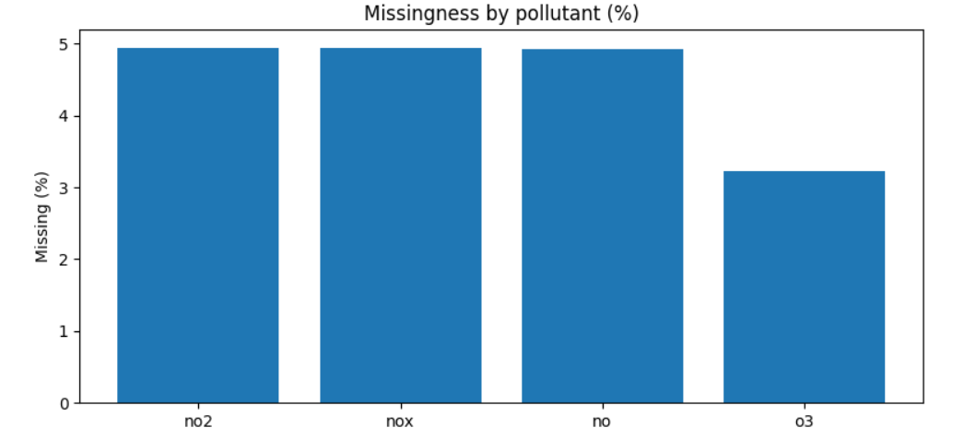
Figure 1. Missingness by pollutant (%) in the hourly data. Source: author.
Figure 1 shows the percentage of missing values in each pollutant series in the hourly dataset.
EDA looked at temporal structure as well. The diurnal cycle is the primary seasonality pattern that was kept in the report since it had a direct impact on window selection and feature engineering.
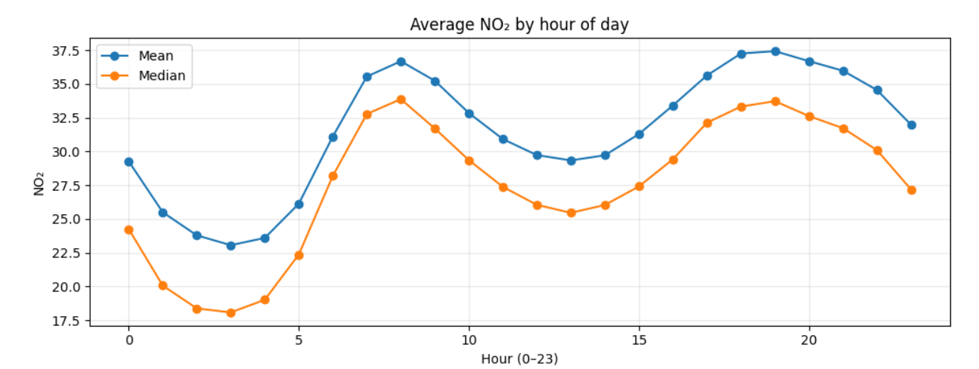Figure 2. Average NO₂ by hour of day (mean and median). Source: author.
Figure 2 shows the average NO₂ concentration by hour of day. The clear diurnal pattern informed both time-based feature engineering and LSTM window selection.
3.4 Ethical considerations
Personal information, human subjects, questionnaires, interviews, and user-generated internet content were not used in the research. As a result, there are no GDPR concerns pertaining to personal identifiers, and university ethical approval was not necessary. Instead of using an unofficial third-party repost, the initiative employed an original public regulatory source, the UK Air Information Resource (UK-AIR), which is maintained by DEFRA. The Open Government Licence, which permits research usage with attribution, makes the data available for reuse; payment was not necessary. A snapshot of the pertinent license information should be included in the appendix of the final submission as proof of permission for public usage. Transparency and responsible communication are therefore the primary ethical concerns. First, it was crucial to avoid aggressively filling in lengthy gaps in order to make the series appear cleaner than it actually was. Second, rather than being exact replacements for future measured values, projections should be given as modelled estimates with limits. Third, there is no proof that the underlying measurements were obtained unethically because the data originates from a reliable monitoring resource supported by the government.
4. Methodology
4.1 Forecasting task and evaluation design
I described the project as a supervised one-hour-ahead forecasting exercise where information up to time t was used to estimate the target at time t+1. I contrasted three methods: an LSTM, XGBoost, and a naïve persistence baseline. The objective was to determine whether learnt models could enhance persistence in a practical forecasting environment.
I adopted a rigorous chronological divide to prevent information leaks. Training took place in earlier years, validation took place in 2022–2023, and final testing took place in 2024–2025. Because random splitting would combine past and future structure and result in an overly optimistic evaluation of model performance, I chose not to utilize it.

4.2 Data preparation and preprocessing
I created a single hourly time-indexed dataset spanning 2015–2025 by combining the annual London Bloomsbury (CLL2) UK-AIR files. In order to make the missing periods obvious, I reindexed the data to a full hourly grid and standardized the timestamps, including the explicit handling of "24:00" entries. For modeling, I kept four pollutant variables: NO₂, NO, NOx (as NO₂), and O₃.
The values of the pollutants were transformed into a numerical format, and any faulty entries were forced to become missing values. After that, I used cautious missing-value handling. On the raw pollutant series alone, time-aware interpolation was used to fill short gaps up to three hours, leaving longer gaps unfilled. I applied this restriction because the tabular and sequence models could be misled by filling in lengthy gaps, which would produce fake continuity. I also looked at extreme results during exploratory analysis, but I did not immediately eliminate possible high NO₂ peaks because they might indicate actual pollution occurrences rather than mistakes.

4.3 Baseline model
I implemented a naïve persistence baseline in which the forecast for the next hour is equal to the current NO₂ value:
$${\hat{y}}_{t+1}=y_{t}$$
This is a strong benchmark for a short-horizon forecasting problem because the most recent value already contains substantial predictive information. Any more complex model therefore needed to improve on persistence to justify its added complexity.
4.4 XGBoost pipeline
I used a structured tabular regression challenge to express the forecasting problem for the machine-learning model. Although boosted trees can not directly describe sequence order, I created predictors from the pollutant series so that XGBoost could leverage temporal information. I developed cyclical calendar features like hour-of-day encodings, rolling summary statistics, exponentially weighted features, and lagged features in code.
Because XGBoost is a powerful non-linear learner for structured data and works well with interactions between time-based predictors and lagged pollutant values, I decided to employ it. The purpose of the constructed feature set was to reveal regular diurnal structure, persistence, and recent mobility in a way that boosted trees could successfully exploit.
4.5 LSTM pipeline
I utilized an LSTM to learn directly from ordered multivariate input windows for the deep learning model. Hourly pollutant concentrations are real time series with substantial temporal dependency and distinct diurnal pattern, therefore this was appropriate.
Sequence continuity was the most significant implementation problem in the LSTM pipeline. Observations separated by a number of missing hours may be regarded as neighboring if rows with missing values are simply eliminated. In order to avoid this, I separated the data into consecutive hourly segments, found rows with all necessary inputs, and only constructed sequence windows inside those segments. This prevented the LSTM from picking up incorrect temporal adjacency across extended distances.
I performed the same transformation to validation and test data after scaling the LSTM inputs using parameters that were only fitted on the training split. Using the scaled pollutant series, I created multivariate input windows and used those ordered sequences to train the network. Instead of depending solely on manually created lag features, this enabled the LSTM to natively acquire temporal context.
4.6 Hyperparameter tuning and optimisation
I tuned the XGBoost model using a staged validation-based search with early stopping. The search covered learning rate, max depth, min child weight, subsample, column subsample, gamma, and regularisation, because these settings control tree complexity, robustness, and the balance between fit and generalisation. The final model was selected using validation MAE, with early stopping identifying a best iteration at approximately 271 boosting rounds. I used MAE as the main tuning criterion because it is directly interpretable in original NO₂ units and is less dominated by rare extreme values than RMSE.
I tuned the LSTM using KerasTuner RandomSearch. The search space included window length, hidden units, dropout, L2 regularisation, learning rate, batch size, loss function, and single-layer versus stacked architecture. Window length was treated as a hyperparameter because it controls how much historical context is available to the sequence model. This was important in this dataset because the EDA showed a strong diurnal pattern. The best final LSTM configuration used a 48-hour input window, 96 hidden units, dropout of 0.0, learning rate 0.001, batch size 64, MAE loss, and stacked architecture.
To improve optimisation stability, I used EarlyStopping and ReduceLROnPlateau. These controls were especially useful for the LSTM, which was more sensitive than XGBoost to training stability and input design. Table 2 summarises the main hyperparameters explored for XGBoost and LSTM and records the final selected settings used in the reported comparison.
4.7 Evaluation metrics
I evaluated all three models using MAE and RMSE in the original NO₂ units. MAE was the primary comparison metric because it measures typical absolute forecasting error and is directly interpretable. RMSE was retained because it penalises larger misses more strongly and is therefore useful for assessing performance during sharper pollution peaks.
I also used prediction plots for the final LSTM model to assess whether the model tracked short-term rises and falls realistically or simply smoothed the series.
4.8 Final comparison
I used future-held-out data just to compare the naïve baseline, XGBoost, and LSTM on the validation and test periods after training and tuning. In addition to achieving low error values, the methodology was created to objectively assess the models in realistic forecasting scenarios. As a result, the study topic may be addressed in terms of both methodological reliability and prediction accuracy.

Model | Hyperparameters explored | Tuning method | Final selected setting
XGBoost | learning rate, max depth, min child weight, subsample, colsample, gamma, regularisation | Validation MAE with early stopping | Best iteration at approximately 271 boosting rounds
LSTM | window length, hidden units, dropout, learning rate, L2 regularisation, batch size, loss function, stacked/non-stacked | KerasTuner RandomSearch with validation loss, EarlyStopping, ReduceLROnPlateau | 48-hour window, 96 units, dropout 0.0, learning rate 0.001, batch size 64, MAE loss, stacked

Table 2 summarizes the main hyperparameters explored for XGBoost and LSTM and records the final selected settings used in the reported comparison.

5. Results
The fact that the models differ significantly but not significantly is a significant finding in and of itself. No model was anticipated to generate unrealistic headline benefits because persistence is already high at a t+1 horizon. Therefore, rather than remarkable numerical separation, the results' practical value resides in persistent progress. Because it appears in a situation where the baseline is already difficult to surpass, the LSTM's advantage is believable.
Model | Val MAE | Val RMSE | Test MAE | Test RMSE
Naïve persistence | 4.0436 | 6.0033 | 3.6270 | 5.3670
XGBoost | 3.7464 | 5.5293 | 3.4720 | 5.0286
LSTM | 3.5373 | 5.3198 | 3.2418 | 4.8441
Table 3. Final validation and test performance in original NO₂ units.
The project's primary quantitative outcome is shown in Table 3. Not only did the trained models outperform persistence, but the final tuned LSTM produced the greatest results on both MAE and RMSE, with XGBoost emerging as a formidable second-best model. As a result, the table provides a numerical response to the primary research question.
The table also explains the need for many metrics. While RMSE lends greater weight to large misses and so demonstrates sensitivity to peak occurrences, MAE captures average forecast variation. The conclusion that the gains are not the result of a single measurement decision is strengthened by the fact that both learnt models outperformed the baseline under both metrics.

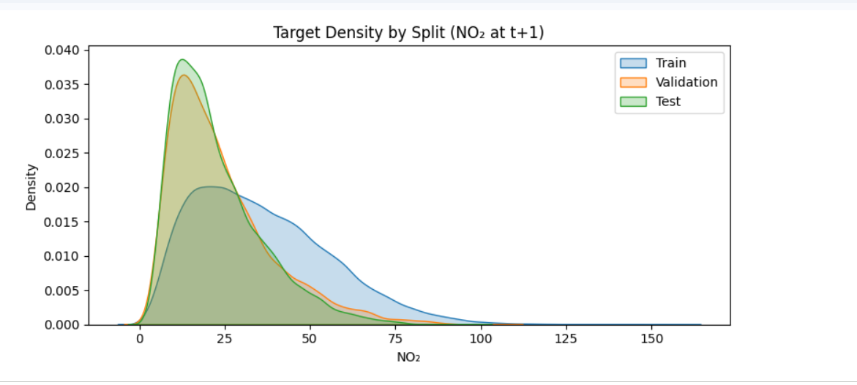
Figure 3. Density of NO₂ target values across the training, validation, and test splits. Source: author.
Figure 3 shows the density of NO₂ target values across the training, validation, and test splits. The training distribution is broader and has a heavier upper tail, while the validation and test distributions are more concentrated at lower values. This indicates moderate distribution shift across time, which is relevant when interpreting model performance.
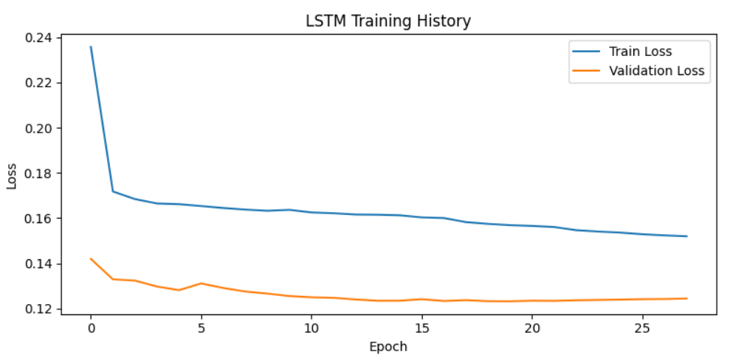
Figure 4. LSTM training history (training and validation loss). Source: author.
Figure 4 shows the LSTM training and validation loss across epochs. It is included to illustrate optimisation behaviour rather than to compare directly with XGBoost MAE.
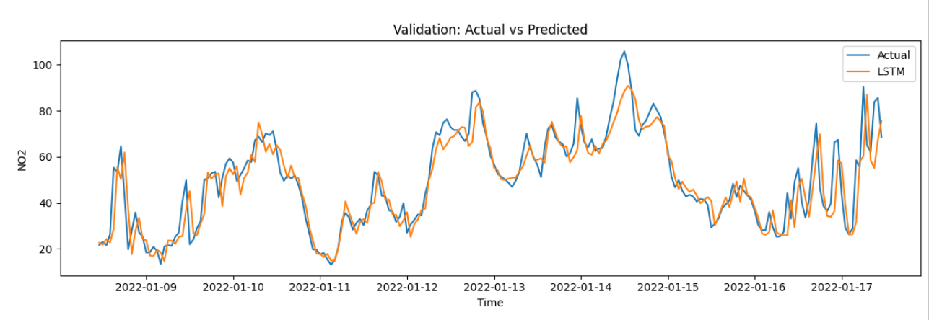
Figure 5. LSTM actual vs predicted values on a validation segment. Source: author.
Figure 5 shows the LSTM actual and predicted NO₂ values on a validation segment. The plot shows that the model follows local rises and falls closely, with slight smoothing of some peaks.
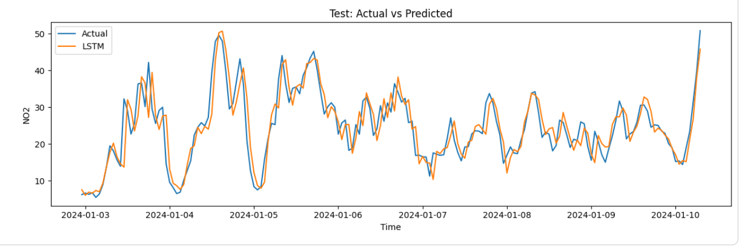
Figure 6. LSTM actual vs predicted values on a test segment. Source: author.
Figure 6 shows the LSTM actual and predicted NO₂ values on a held-out test segment. The plot supports the numerical results by showing that most short-term movement is tracked reasonably well.

6. Analysis and Discussion
6.1 Interpretation of the main results
For one-hour-ahead NO₂ forecasting, the results demonstrate that both trained models outperformed the persistence baseline, with the final tuned LSTM achieving the best overall performance. Persistence is already a strong benchmark at a t+1 horizon, when the present hour frequently supplies significant information about the upcoming hour, making this conclusion significant. Therefore, rather than overly big headline increases, the learnt models' actual worth resides in their continuous improvement over an already competitive baseline.
6.2 Why XGBoost performed well
Because the predicting problem can be efficiently stated as structured regression, XGBoost worked well. Calendar encodings, rolling summaries, and lagged pollutant data all offer a powerful depiction of repetitive temporal pattern and short-term persistence. This explains why XGBoost performed noticeably better than the naïve baseline. The outcome is also in line with Chen and Guestrin's (2016) research, which demonstrates that boosted trees are particularly powerful in the presence of informative structural features.
6.3 Why LSTM performed best
In the end comparison, the LSTM produced the best outcomes. Since hourly pollutant observations represent actual temporal sequences rather than isolated rows, this is consistent with the nature of the data. The LSTM was able to directly learn this temporal dependence using ordered multivariate input windows, and the EDA demonstrated a distinct diurnal structure. Hochreiter and Schmidhuber (1997) demonstrated the effectiveness of LSTM architectures in learning dependencies over ordered time steps, which is consistent with this interpretation.
The LSTM results rely on proper temporal management, which is a crucial methodological element. Long gaps were not considered continuous history in this project, and sequence windows were only built inside adjacent hourly segments. Because the model was prevented from learning from spurious adjacency across missing time periods, the final LSTM findings are more dependable. Therefore, the improved end performance of the LSTM should be understood as the outcome of employing a sequence model with a suitable temporal pipeline rather than only as a consequence of model complexity.
6.4 Learning-curve interpretation and remaining errors
Careful interpretation of the learning curves is also necessary. Although training loss is higher than validation loss in Figure 3, this does not always indicate detrimental underfitting. The depicted loss is not directly comparable to the original-unit MAE used for XGBoost because it was generated under a different optimization setup, with dropout active only during training. Because of this, the final validation and test MAE/RMSE values are more significant than the training-loss curve's initial look.
The remaining inaccuracies indicate that the most challenging aspect of the challenge is still peak forecasting. Some steeper peaks are nevertheless softened even though Figures 4 and 5 demonstrate that the final LSTM closely reflects the observed trend. Because larger misses are penalized more severely, RMSE continues to be considerably higher than MAE. Practically speaking, the models are helpful for short-term forecasting, but they are still less trustworthy during the worst pollution occurrences.
6.5 Limitations and comparison with the literature
The limited feature set is probably the cause of the remaining performance constraint. Pollutant history and calendar structure are used in the notebook, but climatic factors like temperature, humidity, pressure, wind direction, and speed are not. The amount that the models can explain from pollutant history alone is limited by the absence of these parameters, which are known to affect NO₂ dispersion and chemistry. This also explains why the current findings are probably less significant than those of research that employ better environmental data, as Psaropa et al. (2025) and Tırınk (2025).
6.6 Relation to project objectives and practical use
Additionally, these results have a direct bearing on the project's goals. The project's methodological and practical goals were accomplished since the baseline and learnt models were applied, adjusted, and fairly compared using future-held-out data. From an application standpoint, the final LSTM delivers the best short-term forecasting performance, XGBoost provides an interpretable machine-learning option, and persistence is still a valuable benchmark.
Overall, the findings provide a positive response to the research question. For one-hour-ahead NO₂ forecasting at the London Bloomsbury site under a rigorous temporal split, machine-learning and deep-learning models do offer a significant improvement over a basic persistence baseline. The final tuned LSTM outperformed all other examined methods, with XGBoost continuing to be a reliable and understandable second-best model.

7. Conclusion
Using UK-AIR/DEFRA hourly data, this project created and assessed an end-to-end pipeline for one-hour-ahead NO₂ forecasting at the London Bloomsbury monitoring station. Significant preprocessing, exploratory data analysis, installation of three forecasting models, hyperparameter tuning, evaluation on future-held-out data, and ethical consideration of public data use were all part of the study.
The primary conclusion is that the final tuned LSTM has the best overall performance, and both learnt models outperform the persistent baseline. Engineered tabular features are very competitive for short-horizon environmental forecasting, as demonstrated by XGBoost's continued strength and interpretability as a benchmark. However, the LSTM produced the best results when continuity-safe sequence building and tuning were done correctly. This provides a good answer to the research question: for t+1 NO₂ forecasting at this site, data-driven models can significantly outperform simple persistence.
The experiment also made it clear that the difficulty of severe peaks and limited feature information, not just model class, are the best explanations for the remaining mistake. Therefore, better peak-aware training, longer-horizon extensions like t+24 forecasting, and meteorological predictors should be given priority in future studies.

References
Bernacki, J. and Scherer, R. (2025) ‘A comprehensive review of data-driven techniques for air pollution concentration forecasting’, Sensors, 25(19), 6044. (Available at: https://www.mdpi.com/1424-8220/25/19/6044 )
Chen, F., Wang, L. and Deng, H. (2023) ‘A novel combined model for air quality index forecasting in Changchun’, Atmosphere, 14(10), 1475. (Available at: https://www.mdpi.com/2073-4433/14/10/1475 )
Chen, T. and Guestrin, C. (2016) ‘XGBoost: A scalable tree boosting system’, in Proceedings of the 22nd ACM SIGKDD International Conference on Knowledge Discovery and Data Mining, pp. 785–794. (Available at: https://dl.acm.org/doi/10.1145/2939672.2939785 )
Hochreiter, S. and Schmidhuber, J. (1997) ‘Long short-term memory’, Neural Computation, 9(8), pp. 1735–1780. (Available at: https://direct.mit.edu/neco/article-abstract/9/8/1735/6109/Long-Short-Term-Memory?redirectedFrom=fulltext )
Huang, W., Li, T., Liu, J., Xie, P., Du, S. and Teng, F. (2021) ‘An overview of air quality analysis by big data techniques: Monitoring, forecasting, and traceability’, Information Fusion, 75, pp. 28–40. (Available at: https://www.sciencedirect.com/science/article/abs/pii/S1566253521000658 )
Li, Y., Guo, J.-e., Sun, S., Li, J., Wang, S. and Zhang, C. (2022) ‘Air quality forecasting with artificial intelligence techniques: A scientometric and content analysis’, Environmental Modelling &Software, 149, 105329. (Available at: https://www.sciencedirect.com/science/article/abs/pii/S1364815222000354 )
Luo, J. and Gong, Y. (2023) ‘Air pollutant prediction based on ARIMA-WOA-LSTM model’, Atmospheric Pollution Research, 14(6), 101761. (Available at: https://www.sciencedirect.com/science/article/pii/S1309104223001150 )
Méndez, M., Merayo, M.G. and Núñez, M. (2023) ‘Machine learning algorithms to forecast air quality: A survey’, Artificial Intelligence Review, 56(9), pp. 10031–10066. (Available at: https://link.springer.com/article/10.1007/s10462-023-10424-4 )
Psaropa, M.X., Kontogiannis, S., Lolis, C.J., Hatzianastassiou, N. and Pikridas, C. (2025) ‘A proposed deep learning framework for air quality forecasts, combining localized particle concentration measurements and meteorological data’, Applied Sciences, 15(13), 7432. (Available at: https://www.mdpi.com/2076-3417/15/13/7432 )
Samad, A., Garuda, S., Vogt, U. and Yang, B. (2023) ‘Air pollution prediction using machine learning techniques – An approach to replace existing monitoring stations with virtual monitoring stations’, Atmospheric Environment, 310, 119987. (Available at: https://www.sciencedirect.com/science/article/pii/S1352231023004132 )
The National Archives (2014) ‘Open Government Licence v3.0’ [Online]. (Available at: https://www.nationalarchives.gov.uk/doc/open-government-licence/version/3/) [Accessed 17 April 2026].
Tırınk, S. (2025) ‘Machine learning-based forecasting of air quality index under long-term environmental patterns: A comparative approach with XGBoost, LightGBM, and SVM’, PLOS ONE, 20(10), e0334252. (Available at: https://journals.plos.org/plosone/article?id=10.1371/journal.pone.0334252 )
UK-AIR (n.d.) ‘CSV data files for London Bloomsbury monitoring site’ [Online]. (Available at: https://uk-air.defra.gov.uk/data/flat_files?site_id=CLL2 ) [Accessed 17 April 2026].

