**Define cloud computing:**

Cloud computing is the delivery of computing services over the internet. Computing services includes common IT infrastructure such as virtual machines (VM), storage, database and networking. It also offers services such as Internet of Things (IoT), machine learning (ML) and artificial intelligence (AI). We only pay for the services we use.

Using cloud computing services we can rapidly increase or decreases IT infrastructure whenever we want to.

**Describe the shared responsibility model:**

In order to understand the shared responsibility concept. We have to start understanding the responsibility of traditional corporate datacenter.

In a traditional corporate datacenter, the company is responsible for everything such as physical space, security, maintaining and replacing of servers if anything happens. But with cloud computing, responsibilities are shared between the cloud provider and the consumer.

The cloud provider is responsible for physical security, power, cooling, and network connectivity. The consumer is responsible for their data and access of data stored in the cloud.

Responsibilities can depends on the cloud computing services:

* Infrastructure as a Services (IaaS) which places more responsibility on the consumer.
* Platform as a Service (PaaS) is somewhere in the middle.
* Software as a Service (SaaS) places more responsibility on the provider.

The following diagram from Microsoft highlights how the Shared Responsibility Model shows the responsibility:

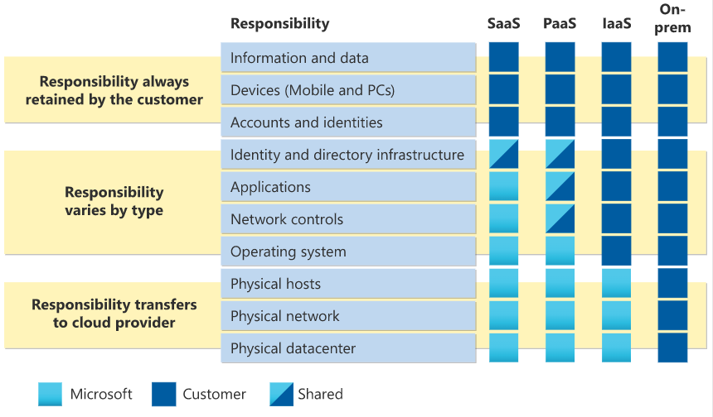

Define cloud models:

There are 3 main cloud models:

Private cloud:

Public cloud:

Hybrid cloud:

Multi-cloud:

Azure Arc:

Azure VMware Solution: