# ASSIGNMENT

Implement below section before next class

Reviews Section

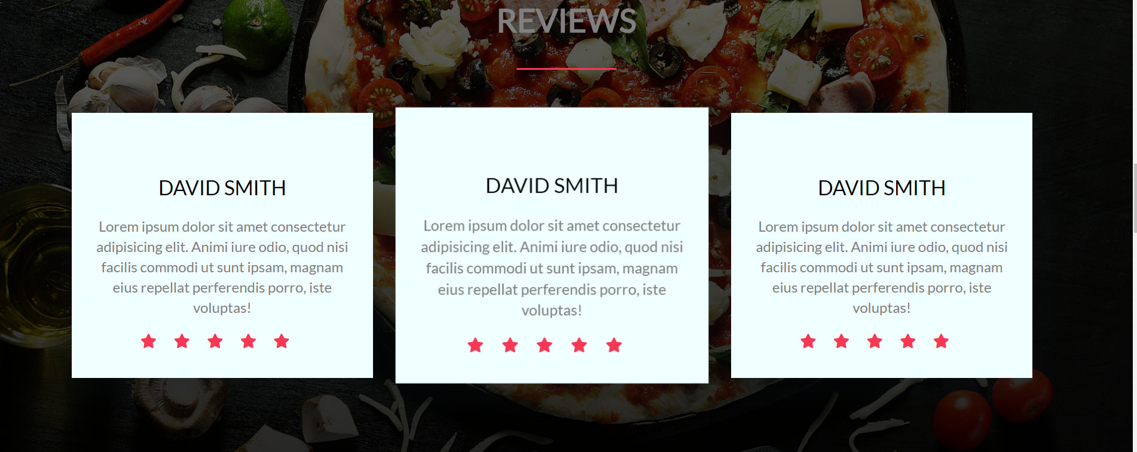

Plans Section

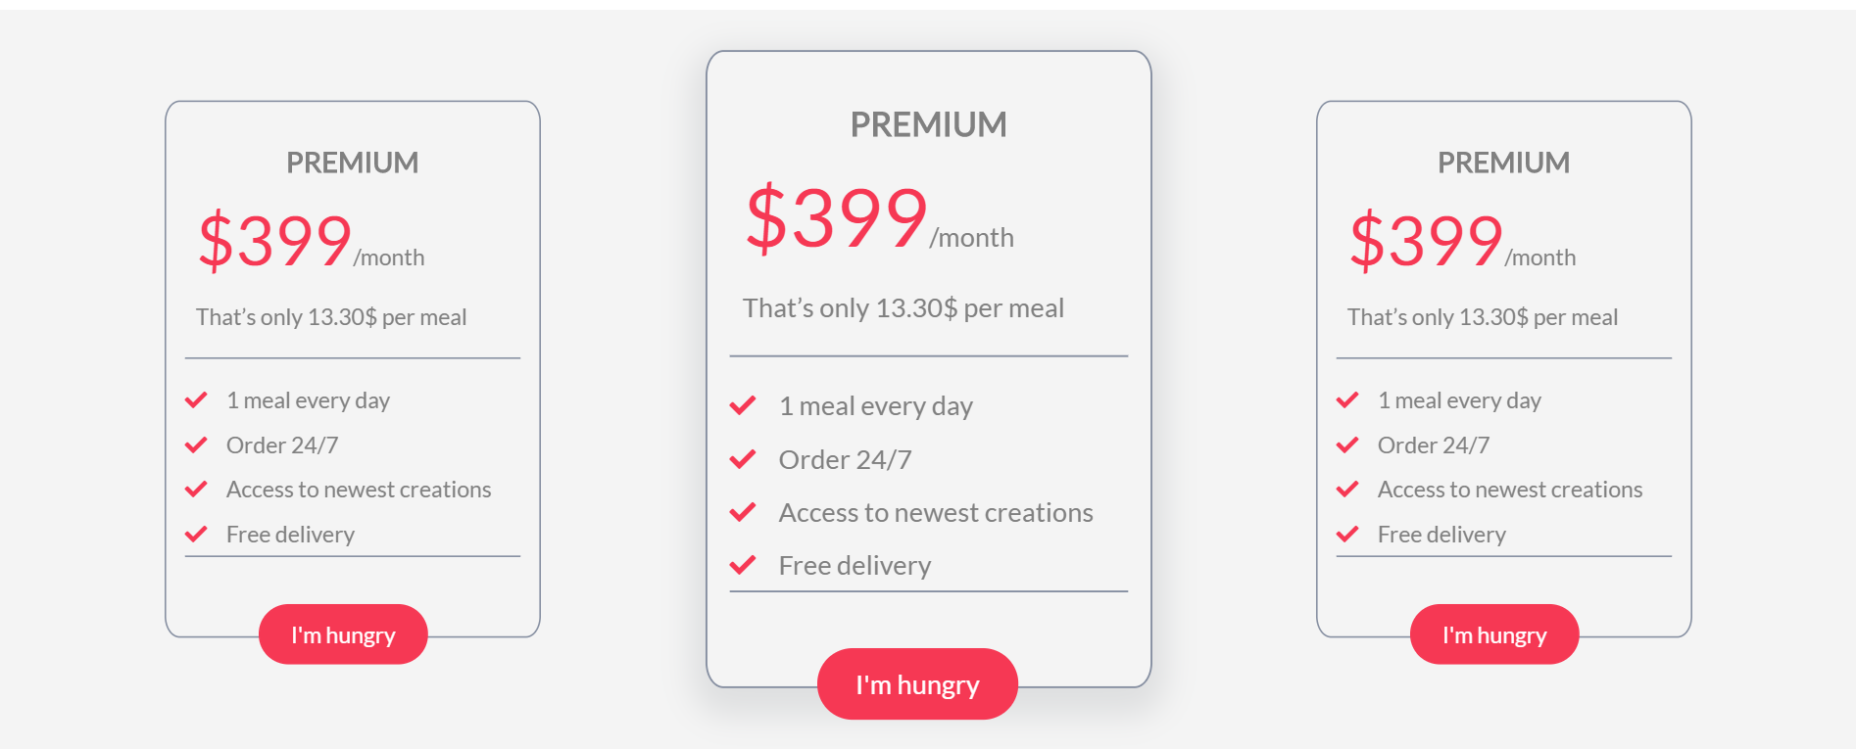

Footer Section



## Pages to Design

### You need to implements following UIs

* Login ,Signup
* Forget Password,reset password

### Articles to refer

* <https://developer.mozilla.org/en-US/docs/Learn/CSS/First_steps/How_CSS_works>
* <https://developer.mozilla.org/en-US/docs/Learn/CSS/Building_blocks/Cascade_and_inheritance>
* <https://developer.mozilla.org/en-US/docs/Learn/CSS/Building_blocks/The_box_model>
* <https://developer.mozilla.org/en-US/docs/Learn/CSS/Building_blocks/Backgrounds_and_borders>
* <https://developer.mozilla.org/en-US/docs/Learn/CSS/Building_blocks/Sizing_items_in_CSS>

## Node

### Articles to refer

* <https://expressjs.com/en/starter/basic-routing.html>
* <https://expressjs.com/en/guide/routing.html>
* <https://expressjs.com/en/guide/writing-middleware.html>
* <https://docs.mongodb.com/manual/crud/>
* https://mongoosejs.com/docs/guides.html
* https://mongoosejs.com/docs/guide.html
* https://mongoosejs.com/docs/schematypes.html
* https://mongoosejs.com/docs/connections.html
* https://mongoosejs.com/docs/models.html
* https://mongoosejs.com/docs/queries.html
* https://mongoosejs.com/docs/documents.html
* https://mongoosejs.com/docs/validation.html